**0. The “blocked mirror” issue is resolved by adding a “dummy mirror” in maven’s settings.xml**

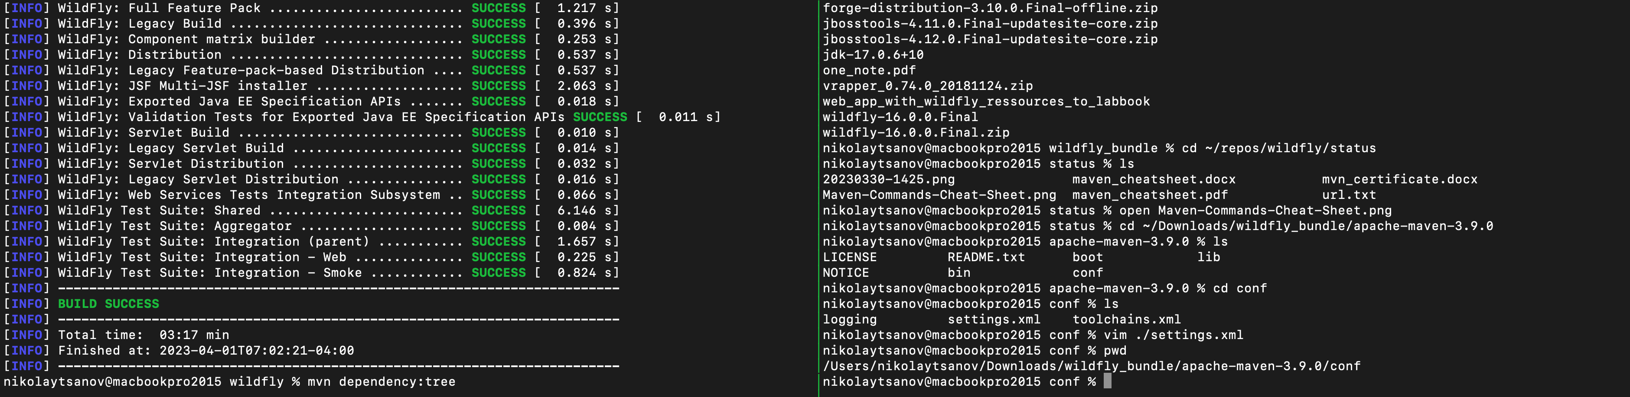

**1. The error**

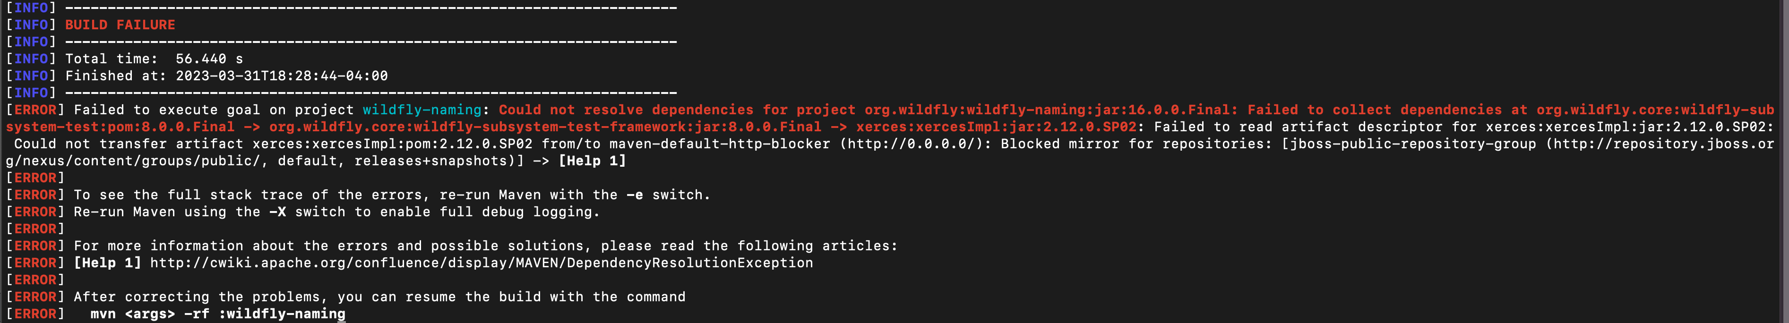

**[INFO**] **------------------------------------------------------------------------**

[**INFO**] **BUILD FAILURE**

[**INFO**] **------------------------------------------------------------------------**

[**INFO**] Total time: 56.440 s

[**INFO**] Finished at: 2023-03-31T18:28:44-04:00

[**INFO**] **------------------------------------------------------------------------**

[**ERROR**] Failed to execute goal on project wildfly-naming: **Could not resolve dependencies for project org.wildfly:wildfly-naming:jar:16.0.0.Final: Failed to collect dependencies at org.wildfly.core:wildfly-subsystem-test:pom:8.0.0.Final -> org.wildfly.core:wildfly-subsystem-test-framework:jar:8.0.0.Final -> xerces:xercesImpl:jar:2.12.0.SP02**: Failed to read artifact descriptor for xerces:xercesImpl:jar:2.12.0.SP02: Could not transfer artifact xerces:xercesImpl:pom:2.12.0.SP02 from/to maven-default-http-blocker (http://0.0.0.0/):

Blocked mirror for repositories:

[jboss-public-repository-group (http://repository.jboss.org/nexus/content/groups/public/, default, releases+snapshots)] -> **[Help 1]**

[**ERROR**]

[**ERROR**] To see the full stack trace of the errors, re-run Maven with the **-e** switch.

[**ERROR**] Re-run Maven using the **-X** switch to enable full debug logging.

[**ERROR**]

[**ERROR**] For more information about the errors and possible solutions, please read the following articles:

[**ERROR**] **[Help 1]** http://cwiki.apache.org/confluence/display/MAVEN/DependencyResolutionException

[**ERROR**]

[**ERROR**] After correcting the problems, you can resume the build with the command

[**ERROR**] **mvn <args> -rf :wildfly-naming**

**--------------------------------------**

**google [Blocked mirror for repositories: [jboss-public-repository-group (http://repository.jboss.org/nexus/content/groups/public/, default, releases+snapshots)] -> [Help 1]]:**

**https://backstage.forgerock.com/knowledge/kb/article/a15127846**

**Plan:**

**1. I will add a new mirrors section with the following mirrors to your settings.xml file; I will place this after the servers section :**

<mirror>

<id>jboss-public-repository-group-mirror</id>

<name>Jboss Public Repository Group mirror</name>

<url>https://repository.jboss.org/nexus/content/groups/public/</url>

<mirrorOf>jboss-public-repository-group</mirrorOf>

</mirror>

2. I will add entry in the servers section

<server>

<username>xxxx</username>

<password>xxxx</password>

<id>jboss-public-repository-group</id>

</server>