**20+ Maven Commands and Options (Cheat Sheet)**

Published on August 3, 2022 · Updated on February 10, 2023

* [Maven](https://www.digitalocean.com/community/tags/maven)



By Pankaj

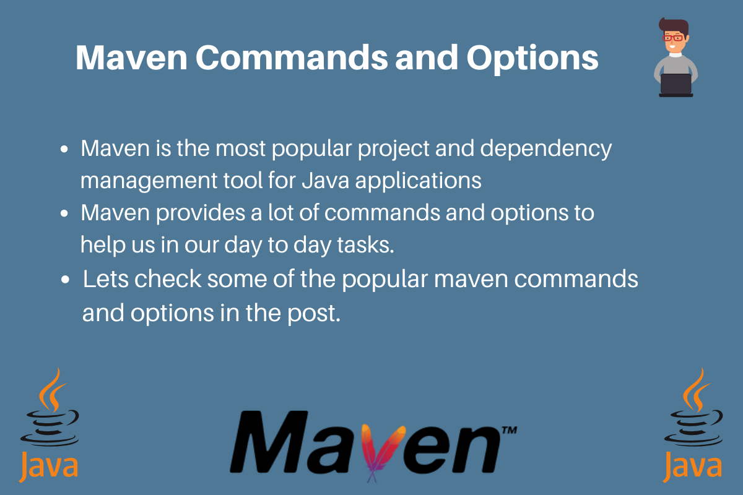

**Introduction**

Maven is one of the most popular project and dependency management tools for Java applications. Maven provides a lot of commands and options to help you in your day to day tasks.

This cheat sheet uses a sample Maven project to demonstrate some useful Maven commands. It was originally written for OpenJDK 13.0.1 and Maven 3.6.3. These commands have been verified with OpenJDK 19.0.1 and Maven 3.8.7.

**Maven Commands Cheat Sheet**

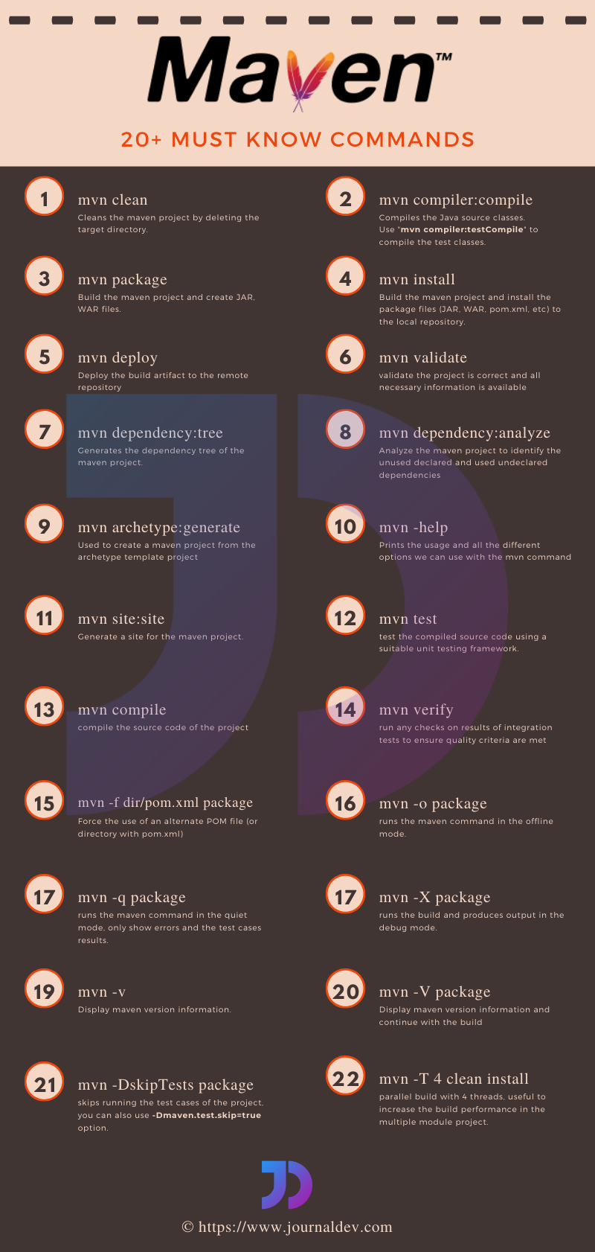Maven Commands Cheat Sheet

**mvn clean**

This command cleans the Maven project by deleting the target directory:

1. mvn clean

Copy

Example of the output:

Output

[INFO] --- maven-clean-plugin:2.5:clean (default-clean) @ maven-example-jar ---

[INFO] Deleting /Users/sammy/Desktop/maven-examples/maven-example-jar/target

[INFO] ------------------------------------------------------------------------

[INFO] BUILD SUCCESS

[INFO] ------------------------------------------------------------------------

**mvn compiler:compile**

This command compiles the Java source classes of the Maven project:

1. mvn compiler:compile

Copy

Example of the output:

Output

[INFO] --- maven-compiler-plugin:3.8.1:compile (default-cli) @ maven-example-jar ---

[INFO] Changes detected - recompiling the module!

[INFO] Compiling 1 source file to /Users/sammy/Desktop/maven-examples/maven-example-jar/target/classes

[INFO] ------------------------------------------------------------------------

[INFO] BUILD SUCCESS

[INFO] ------------------------------------------------------------------------

**mvn compiler:testCompile**

This command compiles the test classes of the Maven project:

1. mvn compiler:testCompile

Copy

Example of the output:

Output

[INFO] --- maven-compiler-plugin:3.8.1:testCompile (default-cli) @ maven-example-jar ---

[INFO] Changes detected - recompiling the module!

[INFO] Compiling 1 source file to /Users/sammy/Desktop/maven-examples/maven-example-jar/target/test-classes

[INFO] ------------------------------------------------------------------------

[INFO] BUILD SUCCESS

[INFO] ------------------------------------------------------------------------

**mvn package**

This command builds the Maven project and packages it into a JAR, WAR, etc.:

1. mvn package

Copy

Example of the output:

Output

[INFO] --- maven-compiler-plugin:3.8.1:compile (default-compile) @ maven-example-jar ---

[INFO] Changes detected - recompiling the module!

[INFO] Compiling 1 source file to /Users/sammy/Desktop/maven-examples/maven-example-jar/target/classes

...

[INFO] --- maven-compiler-plugin:3.8.1:testCompile (default-testCompile) @ maven-example-jar ---

[INFO] Changes detected - recompiling the module!

[INFO] Compiling 1 source file to /Users/sammy/Desktop/maven-examples/maven-example-jar/target/test-classes

...

[INFO] --- maven-surefire-plugin:2.12.4:test (default-test) @ maven-example-jar ---

[INFO] Surefire report directory: /Users/sammy/Desktop/maven-examples/maven-example-jar/target/surefire-reports

-------------------------------------------------------

T E S T S

-------------------------------------------------------

Running com.example.maven.classes.AppTest

Tests run: 1, Failures: 0, Errors: 0, Skipped: 0, Time elapsed: 0.005 sec

Results :

Tests run: 1, Failures: 0, Errors: 0, Skipped: 0

[INFO]

[INFO] --- maven-jar-plugin:2.4:jar (default-jar) @ maven-example-jar ---

[INFO] Building jar: /Users/sammy/Desktop/maven-examples/maven-example-jar/target/maven-example-jar-0.0.1-SNAPSHOT.jar

[INFO] ------------------------------------------------------------------------

[INFO] BUILD SUCCESS

The output shows the location of the JAR file just before the "BUILD SUCCESS" message. Notice the package goal executes compile, testCompile, and test goals before packaging the build.

**mvn install**

This command builds the Maven project and installs the project files (JAR, WAR, pom.xml, etc.) to the local repository:

1. mvn install

Copy

Example of the output:

Output

[INFO] --- maven-resources-plugin:2.6:resources (default-resources) @ maven-example-jar ---

...

[INFO] --- maven-compiler-plugin:3.8.1:compile (default-compile) @ maven-example-jar ---

...

[INFO] --- maven-resources-plugin:2.6:testResources (default-testResources) @ maven-example-jar ---

...

[INFO] --- maven-compiler-plugin:3.8.1:testCompile (default-testCompile) @ maven-example-jar ---

...

[INFO] --- maven-surefire-plugin:2.12.4:test (default-test) @ maven-example-jar ---

...

[INFO] --- maven-jar-plugin:2.4:jar (default-jar) @ maven-example-jar ---

...

[INFO] --- maven-install-plugin:2.4:install (default-install) @ maven-example-jar ---

[INFO] Installing /Users/sammy/Desktop/maven-examples/maven-example-jar/target/maven-example-jar-0.0.1-SNAPSHOT.jar to /Users/sammy/.m2/repository/com/example/maven/maven-example-jar/0.0.1-SNAPSHOT/maven-example-jar-0.0.1-SNAPSHOT.jar

[INFO] Installing /Users/sammy/Desktop/maven-examples/maven-example-jar/pom.xml to /Users/sammy/.m2/repository/com/example/maven/maven-example-jar/0.0.1-SNAPSHOT/maven-example-jar-0.0.1-SNAPSHOT.pom

[INFO] ------------------------------------------------------------------------

[INFO] BUILD SUCCESS

**mvn deploy**

This command deploys the artifact to the remote repository:

1. mvn deploy

Copy

The remote repository should be configured properly in the project pom.xml file distributionManagement tag. The server entries in the Maven settings.xml file are used to provide authentication details.

**mvn validate**

This command validates the Maven project to ensure that everything is correct and all the necessary information is available:

1. mvn validate

Copy

**mvn dependency:tree**

This command generates the dependency tree of the Maven project:

1. mvn dependency:tree

Copy

Example of the output:

Output

[INFO] --- maven-dependency-plugin:2.8:tree (default-cli) @ Mockito-Examples ---

[INFO] com.example.mockito:Mockito-Examples:jar:1.0-SNAPSHOT

[INFO] +- org.junit.platform:junit-platform-runner:jar:1.2.0:test

[INFO] | +- org.apiguardian:apiguardian-api:jar:1.0.0:test

[INFO] | +- org.junit.platform:junit-platform-launcher:jar:1.2.0:test

[INFO] | \- org.junit.platform:junit-platform-suite-api:jar:1.2.0:test

[INFO] | \- org.junit.platform:junit-platform-commons:jar:1.2.0:test

[INFO] +- org.junit.jupiter:junit-jupiter-engine:jar:5.2.0:test

[INFO] | +- org.junit.platform:junit-platform-engine:jar:1.2.0:test

[INFO] | | \- org.opentest4j:opentest4j:jar:1.1.0:test

[INFO] | \- org.junit.jupiter:junit-jupiter-api:jar:5.2.0:test

[INFO] +- org.mockito:mockito-junit-jupiter:jar:2.19.0:test

[INFO] | \- org.mockito:mockito-core:jar:2.19.0:test

[INFO] | +- net.bytebuddy:byte-buddy:jar:1.8.10:test

[INFO] | +- net.bytebuddy:byte-buddy-agent:jar:1.8.10:test

[INFO] | \- org.objenesis:objenesis:jar:2.6:test

[INFO] \- org.testng:testng:jar:6.14.3:test

[INFO] +- com.beust:jcommander:jar:1.72:test

[INFO] \- org.apache-extras.beanshell:bsh:jar:2.0b6:test

**mvn dependency:analyze**

This command analyzes the maven project to identify the unused declared and used undeclared dependencies:

1. mvn dependency:analyze

Copy

Example of the output:

Output

[INFO] --- maven-dependency-plugin:2.8:analyze (default-cli) @ Mockito-Examples ---

[WARNING] Used undeclared dependencies found:

[WARNING] org.junit.jupiter:junit-jupiter-api:jar:5.2.0:test

[WARNING] org.mockito:mockito-core:jar:2.19.0:test

[WARNING] Unused declared dependencies found:

[WARNING] org.junit.platform:junit-platform-runner:jar:1.2.0:test

[WARNING] org.junit.jupiter:junit-jupiter-engine:jar:5.2.0:test

[WARNING] org.mockito:mockito-junit-jupiter:jar:2.19.0:test

It’s useful in reducing the build size by identifying the unused dependencies and removing them from the pom.xml file.

**mvn archetype:generate**

This command generates skeleton Maven projects of different types, such as JAR, web application, Maven site, etc:

1. mvn archetype:generate

Copy

Example of the output:

Output

[INFO] ----------------------------------------------------------------------------

[INFO] Using following parameters for creating project from Archetype: maven-archetype-quickstart:1.4

[INFO] ----------------------------------------------------------------------------

...

[INFO] Project created from Archetype in dir: /Users/sammy/Desktop/maven-examples/maven-example-jar

[INFO] ------------------------------------------------------------------------

[INFO] BUILD SUCCESS

Recommended Reading: [Creating a Java Project using Maven Archetypes](https://maven.apache.org/archetypes/maven-archetype-quickstart/)

**mvn site:site**

This command generates a site for the project:

1. mvn site:site

Copy

You will notice a site directory in the target directory after executing this command.

/Users/sammy/Desktop/maven-examples/maven-example-jar/target/site/index.html

There will be multiple HTML files inside the site directory that provide information related to the project.

**mvn test**

This command runs the test cases of the project:

1. mvn test

Copy

Example of the output:

Output

[INFO] -------------------------------------------------------

[INFO] T E S T S

[INFO] -------------------------------------------------------

[INFO] Running TestSuite

first-element

second-element

Employee setName Argument = Sammy

...

[INFO] Results:

[INFO]

[INFO] Tests run: 5, Failures: 0, Errors: 0, Skipped: 0

[INFO]

[INFO] ------------------------------------------------------------------------

[INFO] BUILD SUCCESS

**mvn compile**

This command compiles the source Java classes of the project:

1. mvn compile

Copy

Example of the output:

Output

[INFO] --- maven-compiler-plugin:3.7.0:compile (default-compile) @ Mockito-Examples ---

[INFO] Changes detected - recompiling the module!

[WARNING] File encoding has not been set, using platform encoding UTF-8, i.e. build is platform dependent!

[INFO] Compiling 10 source files to /Users/sammy/Desktop/maven-examples/Mockito-Examples/target/classes

It is similar to the previous mvn compiler:compile command, but runs the entire Maven lifecycle up to compile.

**mvn verify**

This command builds the project, runs all the test cases and run any checks on the results of the integration tests to ensure quality criteria are met:

1. mvn verify

Copy

**Maven Options**

Maven provides a lot of command-line options to alter the Maven build process:

**mvn -help**

This command-line option prints the Maven usage and all the available options:

1. mvn -help

Copy

Example of the output:

Output

usage: mvn [options] [<goal(s)>] [<phase(s)>]

Options:

-am,--also-make If project list is specified, also

build projects required by the

list

-amd,--also-make-dependents If project list is specified, also

build projects that depend on

projects on the list

-B,--batch-mode Run in non-interactive (batch)

mode (disables output color)

-b,--builder <arg> The id of the build strategy to

use

-C,--strict-checksums Fail the build if checksums don't

match

-c,--lax-checksums Warn if checksums don't match

-cpu,--check-plugin-updates Ineffective, only kept for

backward compatibility

**mvn -f dir/pom.xml package**

This command-line option builds a project from a different location:

1. mvn -f dir/pom.xml package

Copy

Provide the pom.xml file location to build the project. It’s useful when you have to run a Maven build from a script.

**mvn -o package**

This command-line option runs the Maven build in *offline mode*:

1. mvn -o package

Copy

It’s useful when you have all the required JARs downloaded in the local repository and you don’t want Maven to look for any JARs in the remote repository.

**mvn -q package**

This command-line option runs the Maven build in *quiet mode*, so that only the test case results and errors are displayed:

1. mvn -q package

Copy

**mvn -X package**

This command-line option prints the Maven version and runs the build in *debug mode*, so that all messages are displayed:

1. mvn -X package

Copy

Example of the output:

Output

Apache Maven 3.6.3 (cecedd343002696d0abb50b32b541b8a6ba2883f)

Maven home: /Users/sammy/Downloads/apache-maven-3.6.3

Java version: 13.0.1, vendor: Oracle Corporation, runtime: /Library/Java/JavaVirtualMachines/jdk-13.0.1.jdk/Contents/Home

Default locale: en_IN, platform encoding: UTF-8

OS name: "mac os x", version: "10.15.1", arch: "x86_64", family: "mac"

[DEBUG] Created new class realm maven.api

[DEBUG] Importing foreign pacakges into class realm maven.api

[DEBUG] Imported: javax.annotation.* < plexus.core

[DEBUG] Imported: javax.annotation.security.* < plexus.core

[DEBUG] Imported: javax.enterprise.inject.* < plexus.core

[DEBUG] Imported: javax.enterprise.util.* < plexus.core

[DEBUG] Imported: javax.inject.* < plexus.core

**mvn -v**

This command-line option displays the Maven version information:

1. mvn -v

Copy

Example of the output:

Output

Apache Maven 3.6.3 (cecedd343002696d0abb50b32b541b8a6ba2883f)

Maven home: /Users/sammy/Downloads/apache-maven-3.6.3

Java version: 13.0.1, vendor: Oracle Corporation, runtime: /Library/Java/JavaVirtualMachines/jdk-13.0.1.jdk/Contents/Home

Default locale: en_IN, platform encoding: UTF-8

OS name: "mac os x", version: "10.15.1", arch: "x86_64", family: "mac"

**mvn -V package**

This command-line option prints the Maven version and then continues with the build:

1. mvn -V package

Copy

It’s equivalent to the commands:

1. mvn -v;mvn package

Copy

**mvn -DskipTests package**

This command-line option applies the skipTests system property to skip the unit test cases from the build cycle:

1. mvn -DskipTests package

Copy

You can also skip the test cases execution:

1. mvn -Dmaven.test.skip=true package

Copy

**mvn -T 4 clean install**

This command-line option tells Maven to run parallel builds using the specified thread count:

1. mvn -T 4 clean install

Copy

It’s useful in multiple module projects where modules can be built in parallel. It can reduce the build time of the project.

**References**

* [Maven Plugins](https://maven.apache.org/plugins/index.html)
* [Maven CLI Options Reference](https://maven.apache.org/ref/3-LATEST/maven-embedder/cli.html)