Google [mvn PKIX path building failed: sun.security.provider.certpath.SunCertPathBuilderException: unable to find valid certification path to requested target]:

1. From this answer, I got to download the certificate:

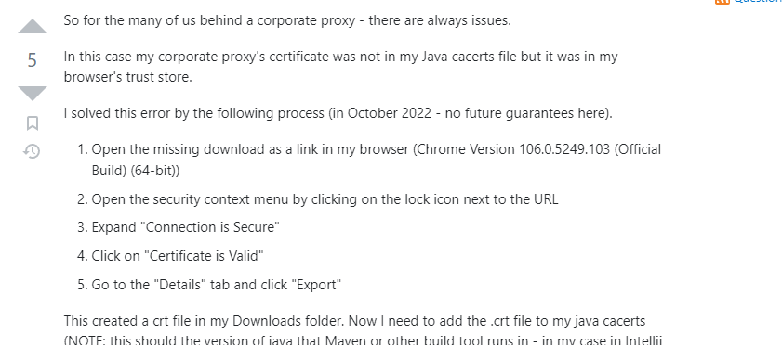

Copy-pasted the address to the pom from the mvn error message, then opened it, the the following:

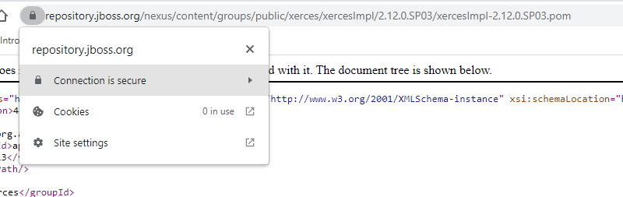

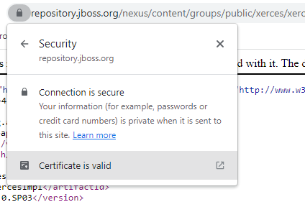

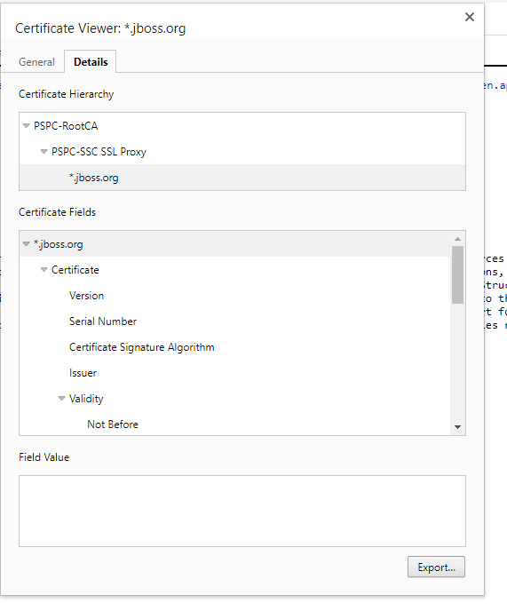

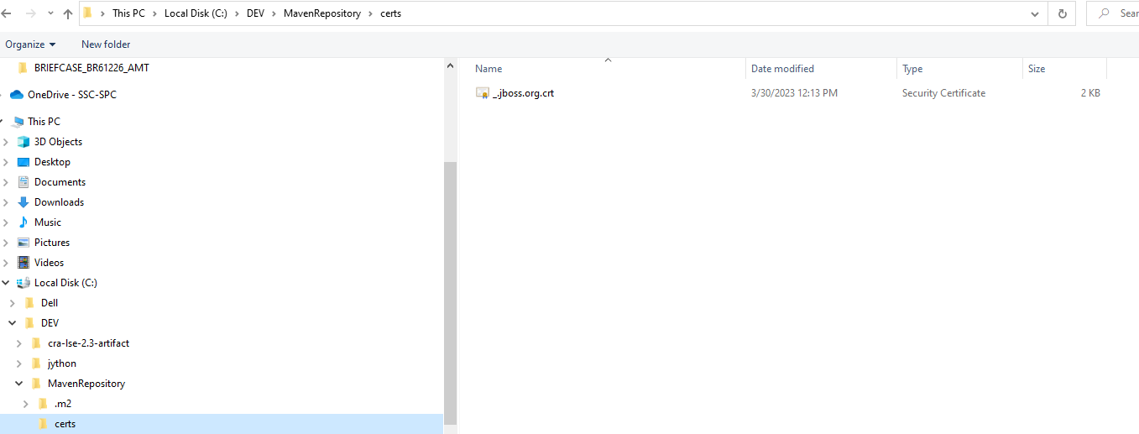

1. From this answer, I got to import the certificate (caution, the security/cacerts directory is different)

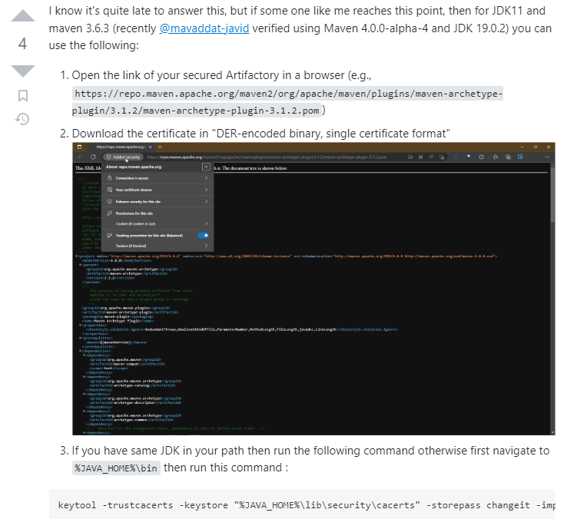

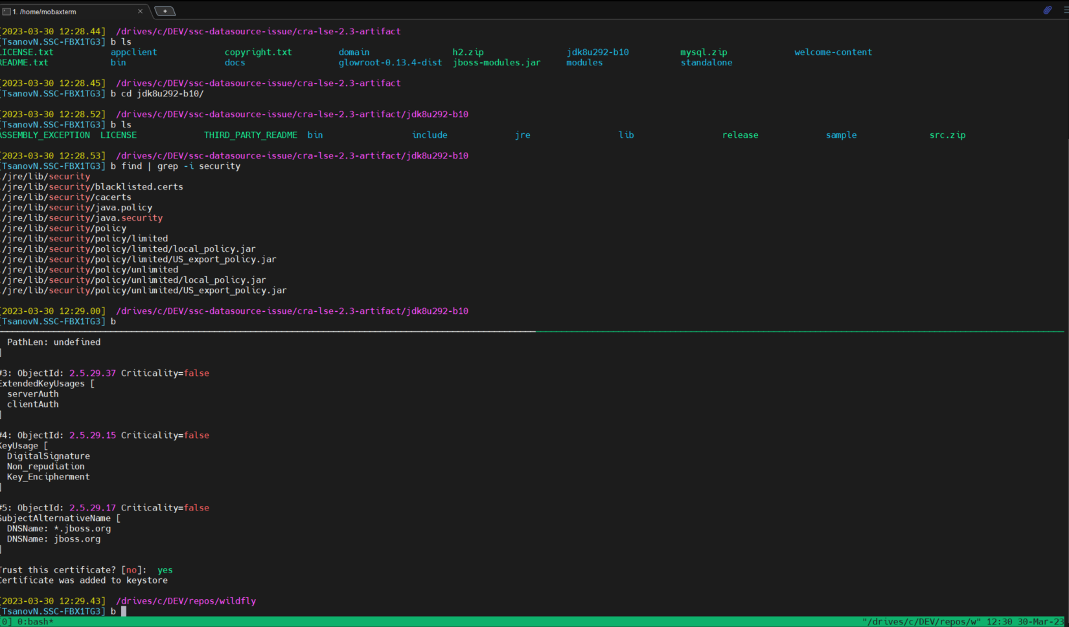

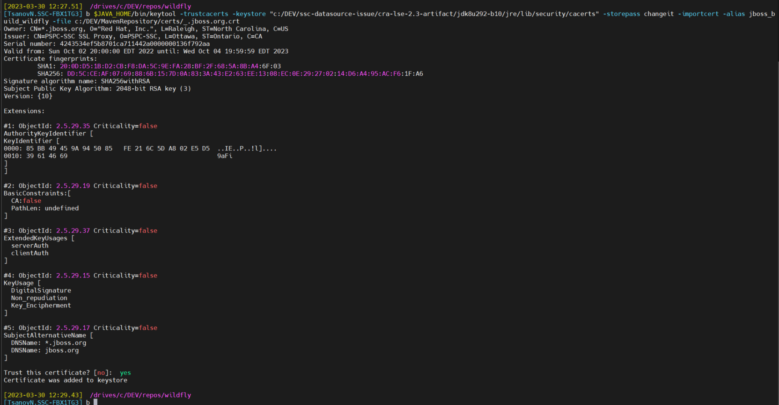

The above in text:

[2023-03-30 12:27.51] /drives/c/DEV/repos/wildfly

[TsanovN.SSC-FBX1TG3] b $JAVA_HOME/bin/keytool -trustcacerts -keystore "c:/DEV/ssc-datasource-issue/cra-lse-2.3-artifact/jdk8u292-b10/jre/lib/security/cacerts" -storepass changeit -importcert -alias jboss_b

uild_wildfly -file c:/DEV/MavenRepository/certs/_.jboss.org.crt

Owner: CN=*.jboss.org, O="Red Hat, Inc.", L=Raleigh, ST=North Carolina, C=US

Issuer: CN=PSPC-SSC SSL Proxy, O=PSPC-SSC, L=Ottawa, ST=Ontario, C=CA

Serial number: 4243534ef5b8701ca711442a0000000136f792aa

Valid from: Sun Oct 02 20:00:00 EDT 2022 until: Wed Oct 04 19:59:59 EDT 2023

Certificate fingerprints:

SHA1: 20:0D:D5:1B:D2:CB:F8:DA:5C:9E:FA:28:BF:2F:68:5A:8B:A4:6F:03

SHA256: DD:5C:CE:AF:07:69:88:6B:15:7D:0A:83:3A:43:E2:63:EE:13:08:EC:0E:29:27:02:14:D6:A4:95:AC:F6:1F:A6

Signature algorithm name: SHA256withRSA

Subject Public Key Algorithm: 2048-bit RSA key (3)

Version: {10}

Extensions:

#1: ObjectId: 2.5.29.35 Criticality=false

AuthorityKeyIdentifier [

KeyIdentifier [

0000: 85 BB 49 45 9A 94 50 85 FE 21 6C 5D A8 02 E5 D5 ..IE..P..!l]....

0010: 39 61 46 69 9aFi

]

]

#2: ObjectId: 2.5.29.19 Criticality=false

BasicConstraints:[

CA:false

PathLen: undefined

]

#3: ObjectId: 2.5.29.37 Criticality=false

ExtendedKeyUsages [

serverAuth

clientAuth

]

#4: ObjectId: 2.5.29.15 Criticality=false

KeyUsage [

DigitalSignature

Non_repudiation

Key_Encipherment

]

#5: ObjectId: 2.5.29.17 Criticality=false

SubjectAlternativeName [

DNSName: *.jboss.org

DNSName: jboss.org

]

Trust this certificate? [no]: yes

Certificate was added to keystore