The present analysis utilized jupyter notebook to visualize trends in two initial datasets called ‘schools_complete.csv’ and ‘students_complete.csv’ with school and students’ data, respectively. These datasets were then merged and further analyzed by district and school. See results interpretation and conclusions below.

**District Summary**

In terms of the district summary, a total of **15** unique schools were identified in the merged dataset, with a total of **39,170** (unique) students, and a total budget of **$2,649,928.00**. The analysis also included the average math (**78.99**) and reading scores (**81.88**), and the percentages of students with average math and reading scores greater than 70%. Results showed that **74.98%** and **85.81%** of the students met this requirement for math and reading, respectively. When considering the percentage of students that passed both math and reading with a 70% or more, approximately **65.17%** met this requirement. A summary of these results is shown below.

**School Summary**

In terms of the analysis by school, the total number of students ranged from **427 to 4,976**, depending on the school. The per student budget ranged from **$578.00 to $655.00**, depending on the school. The analysis also included the average math and reading scores per school, which ranged from **76.63 to 83.84** for math, and from **80.74 to 84.04** for reading, depending on the school. When considering the percentage of students passing math and reading with a 70% or more, approximately **65.68% to 94.13%** of the students met that requirement for math, and **79.30% to 97.04%** of the students met that requirement for reading. When considering the percentage of students that passed both math and reading with a 70% or more, these ranged from **52.99% to 91.33%,** depending on the school. A summary of these results is shown below.

***Highest and lowest performing schools***

The results above also indicate that the top 5 performing schools by % Overall Passing include Cabrera, Thomas, Griffin, Wilson and Pena High Schools, whereas the top 5 lowest performing schools include Rodriguez, Figueroa, Huang, Hernandez and Johnson High Schools. A summary of the results is show below for highest (top) and lowest (bottom) performing schools.

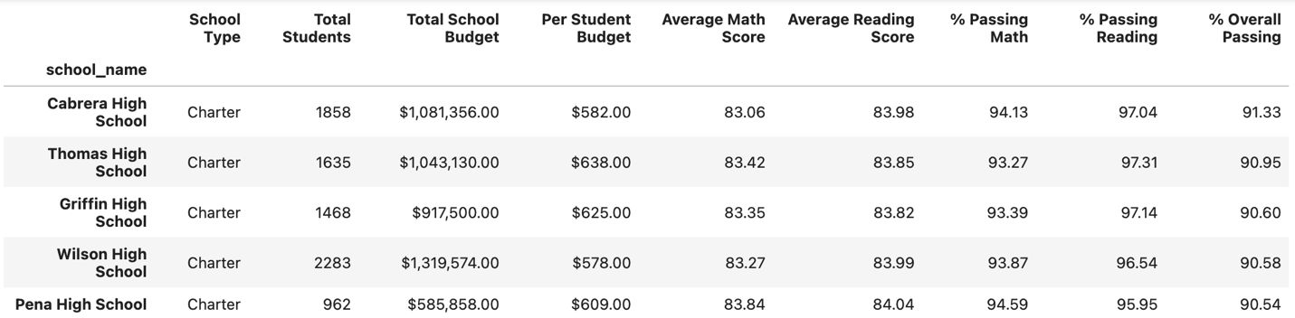

***Math and reading scores by grade***

Math scores by grade were also calculated. Results showed that math scores ranged from **76.40 to 83.79** for 9th grade; **75.91 to 84.23** for 10th grade; **76.45 to 84.33** for 11th grade; and **76.18 to 84.12** for 12th grade. These results show that math score ranges depend on the school grade, but overall seem to show similar trends.

Reading scores by grade were also calculated. Results showed that math scores ranged from **80.63 to 84.12** for 9th grade; **80.63 to 84.25** for 10th grade; **80.40 to 84.34** for 11th grade; and **80.31 to 84.70** for 12th grade. These results show that reading score ranges depend on the school grade, but like math scores by grade, seem to show similar trends.

***Scores by school spending***

The scores by school spending show interesting aspects on how spending may not be associated with performance. For instance, while Hernandez and Huang High Schools had among the highest budget per student, they were among the lowest performing schools by % Overall Passing. Cabrera High School, on the other hand, had one of the lowest spending ranges per student, and was one of the top 5 performing schools. A summary sample of the results is shown below.

Regardless of school, there seemed to be a trend where the **higher the spending ranges per student, the lower was the % Overall Passing.** Interestingly, **higher math and reading scores were also associated with lower spending ranges per student.**

***Scores by school size***

While there was no specific trend in terms of % Overall Passing based on the school size, it was noteworthy that several large high schools, including Bailey, Figueroa, Ford, Hernandez, Huang, Johnson and Rodriguez, showed the lowest % Overall Passing. Interestingly, small and medium sized high schools, including Cabrera, Griffin, Holden, Pena, Shelton, Thomas and Wright showed the highest % Overall Passing. Also noteworthy is that Wilson High School was the only large school with one of the highest % Overall Passing. A summary sample of the results is shown below.

Regardless of school, there seemed to be a trend where the **smaller the school size, the higher was the % Overall Passing**, and better math and reading seem to also be associated with a smaller school size.

***Scores by school type***

Overall, data suggested that Charter schools performed petter than District schools in math, and their % Overall Passing was also higher compared to District schools.

**Conclusions**

There are several results that were highlighted throughout this report, but two findings were particularly interesting:

* Higher budget and spending ranges per student were not necessarily associated with better performance. Results from this analysis showed that several of the high schools with the highest budget and spending ranges per student had lower % Overall Passing, and lower math and reading scores and percentages. The opposite was true for most schools that had lower budgets and spending values per student.
* School size and type matter. Results from this analysis showed that, overall, large high schools showed lower % Overall Passing, as well as math and reading scores and percentages. The opposite was true for medium- and small-sized schools, which showed higher % Overall Passing, and math and reading scores and percentages. Similarly, results from this analysis showed that the type of school matters, where Charter schools seemed to have performed better than District schools in terms of % Overall Passing, and other metrics included in this analysis.