
Architecture
Change request: Include OA automation and include other OA in the sewerage billing
Request | Service desk #47155, Change ID 1004
System | Sewerage & Irrigation Meter Reading (DIP Field Service)
Version | 1.0
Date | 18 October 2026

Prepared by | Reviewed by | Approved by
Nayyar Jawaid | Imtiyaz Hussain | Nidhi Singhvi
Signature / date: | Signature / date: | Signature / date:

Architecture
The phone talks only to the zApps gateway, which passes a fixed list of calls to the mApps API; the API reads PMS through views and writes readings and billing rows to MRDB.
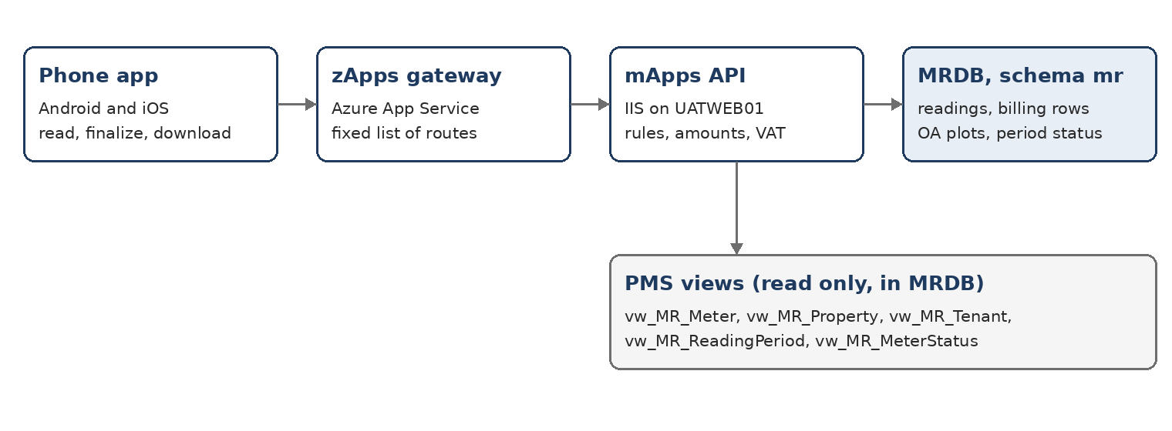
Figure 1 – System architecture, phone to database

Components
Component | Where | Role
Phone app (DIP Field Service) | Android and iOS phones | Reads meters, finalizes properties, works offline and sends when online
zApps gateway | Azure App Service | Only part in the DMZ; passes a fixed list of routes to the API; stores nothing
mApps API | IIS on UATWEB01 | Business rules: checks readings, amounts, VAT, billing rows, period close
MRDB, schema mr | SQL Server | Readings, photos, finalized billing rows, OA plots, period status
PMS views | MRDB wrappers over PropertyManagementSystem | Read only: meters, properties, tenants, reading period, meter statuses

Finalize flow
- The reader presses Finalize property.
- The API checks every meter of the property is read.
- It pairs sewerage and irrigation meters by number.
- It prices them with FloatValue and RateFactor from vw_MR_Meter, adds VAT and applies the irrigation rules.
- It looks up TenantCode, BaanCode, TranCode and CompanyName in the PMS views at that moment. For an OA plot (FR-038) the tenant comes from mr.OwnersAssociationPlot.
- It writes the rows to mr.MaintainFinalizedMeter.
- If it was the last property of the period, it closes the period in mr.ReadingPeriodStatus.

Security
- Phones authenticate as registered devices; IT approves each phone in SQL.
- The firewall lets only the gateway reach the API; gateway to API is https only.
- PMS views are never written to.

