DIP Field Service – reading Sewerage & Irrigation meters
One page for meter readers and supervisors · App 1.0.0 · 1 November 2026
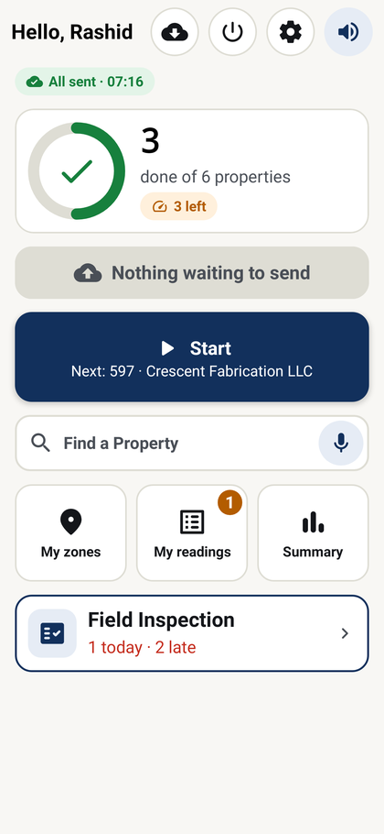 | 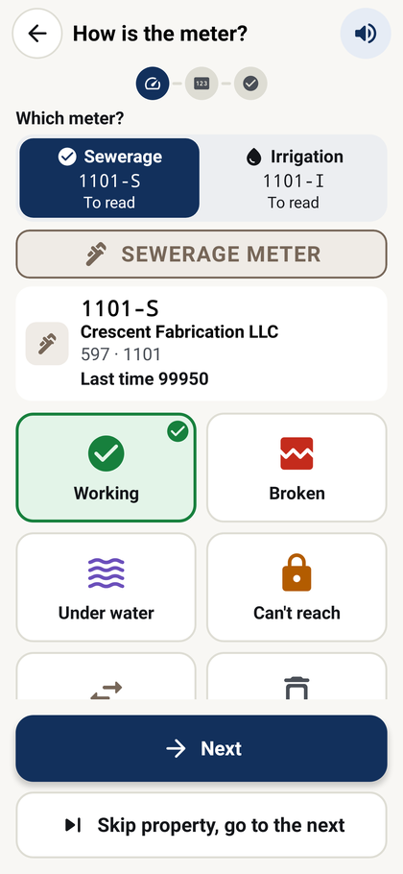 | 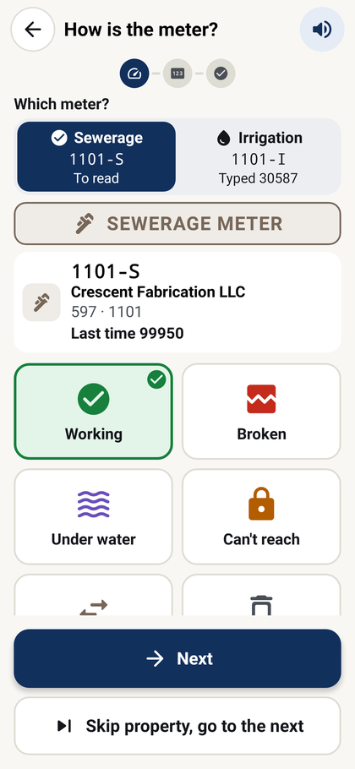 | 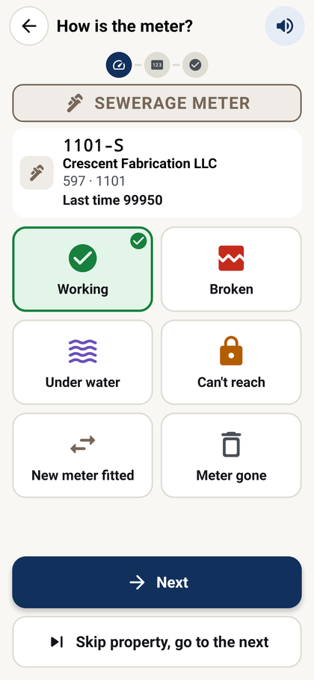 | 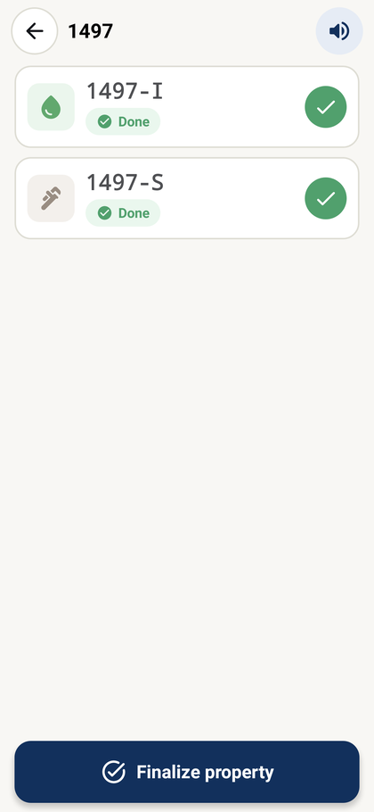 | 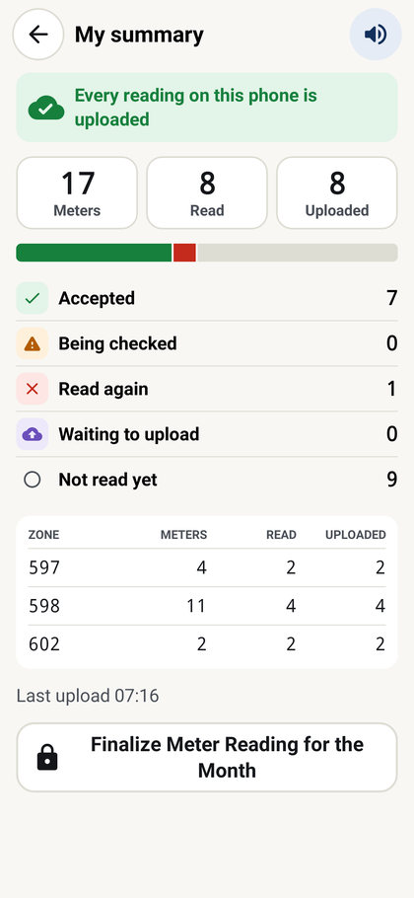
Home | How is the meter? | Type the number | Sent | Finalize property | Finalize the month
Step by step
1. Open the app | Tap DIP Field Service. A new phone shows its ID and a code: give both to IT. After IT approves it, tap Check again. Then tap Download on Home for today's list.
2. Go to the meter | Home shows the next meter in your route. Or use Zones, or Find (property code or tenant name).
3. Check which meter | The banner says SEWERAGE METER or IRRIGATION METER. With two meters, tap the tab you are reading.
4. How is the meter? | Tap OK if it works, or the picture that matches (Faulty, Damaged, Covered with water, Meter changed). Not ready to read this plot? Tap Skip property, go to the next.
5. Photo and number | Take a clear photo of the dial. Type the reading as a whole number, no commas. If a warning shows, check the number.
6. Check and send | Check the tenant and tap Send. With no signal the reading is kept on the phone and sent later. The app moves to the next meter.
7. Finalize the property | When every meter of the property is read, open the property and tap Finalize property, then Finalize. Wait for the message.
8. End of month (supervisor) | My summary → Finalize Meter Reading for the Month → supervisor PIN → Finalize and generate invoices. Wait: this can take a few minutes. The month closes for everyone.
Good to know
- Read a meter again: open it and tap Read again; the new reading replaces the old one.
- Purple means readings are still on the phone: tap Upload now on My summary when you have signal.
- Messages at the bottom close with ✕ or a tap. The speaker button reads each screen aloud.
- Problems: "This phone has been blocked" or "waiting for IT" → call IT. "Meters left to read" → read or mark "can't reach" first.

