Functional Requirements Document (FRD)
Request | Service desk #47155, Change ID 1004
System | Sewerage & Irrigation Meter Reading (DIP Field Service)
Version | 1.0
Date | 18 October 2026

This change lets the meter reader finish a property on the phone and have the bill figures worked out automatically, so Finance no longer prepares them by hand. It also lets Owners Association plots, such as plot 598-1319, be read and billed like every other plot.
- The reader reads every meter of a property on the phone, as today.
- When all meters are read, a Finalize property button appears. Until then the phone shows how many meters are still left.
- The reader presses Finalize property. The system works out the bill figures and saves them for Finance.
- If a meter was read wrongly, the reader can read it again and finalize again. The new figures replace the old ones; the old ones are kept for the record.
- When every property of the month is finalized, the month is closed. The phone shows a message and accepts no new readings until IT opens the month again.

Functional requirements

A. Finalizing a property
Requirement
Each property has a Finalize property button on the phone. Pressing it saves the property's readings for the month as bill figures for Finance.
The button can only be used when every meter of the property has been read (or marked as not accessible). The phone shows how many meters are left, and the system checks again before saving.
A property's sewerage meter and irrigation meter with the same meter number appear together on one line. A meter with no partner appears on its own line.
If a property is finalized a second time, the new figures are used and the earlier figures are kept for the record, not deleted.

What the reader sees
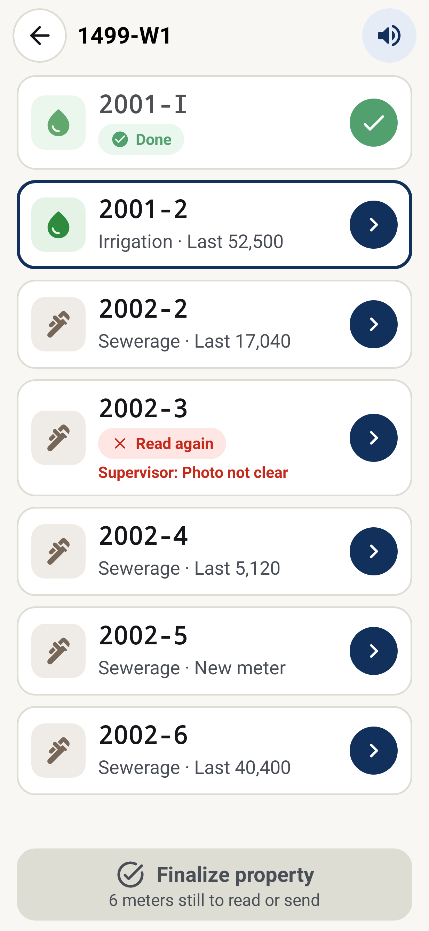 | 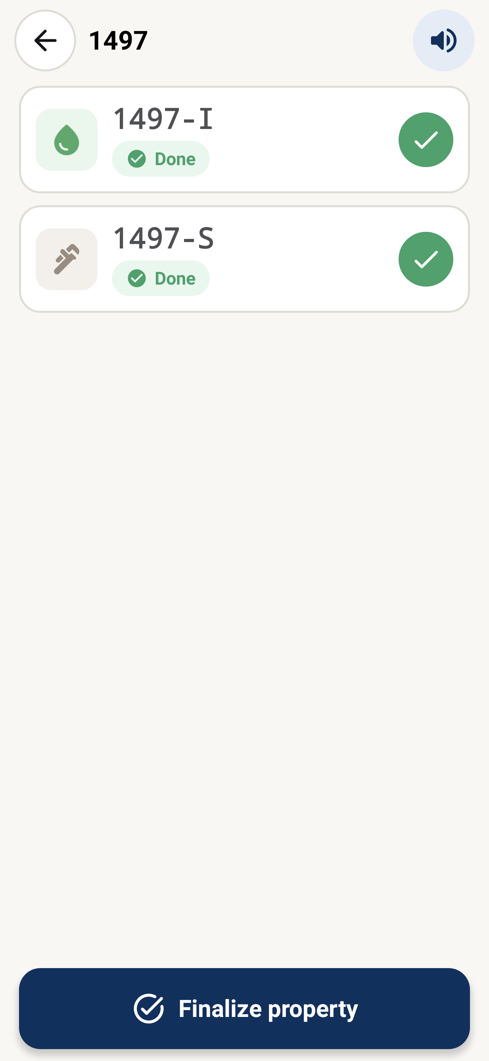 | 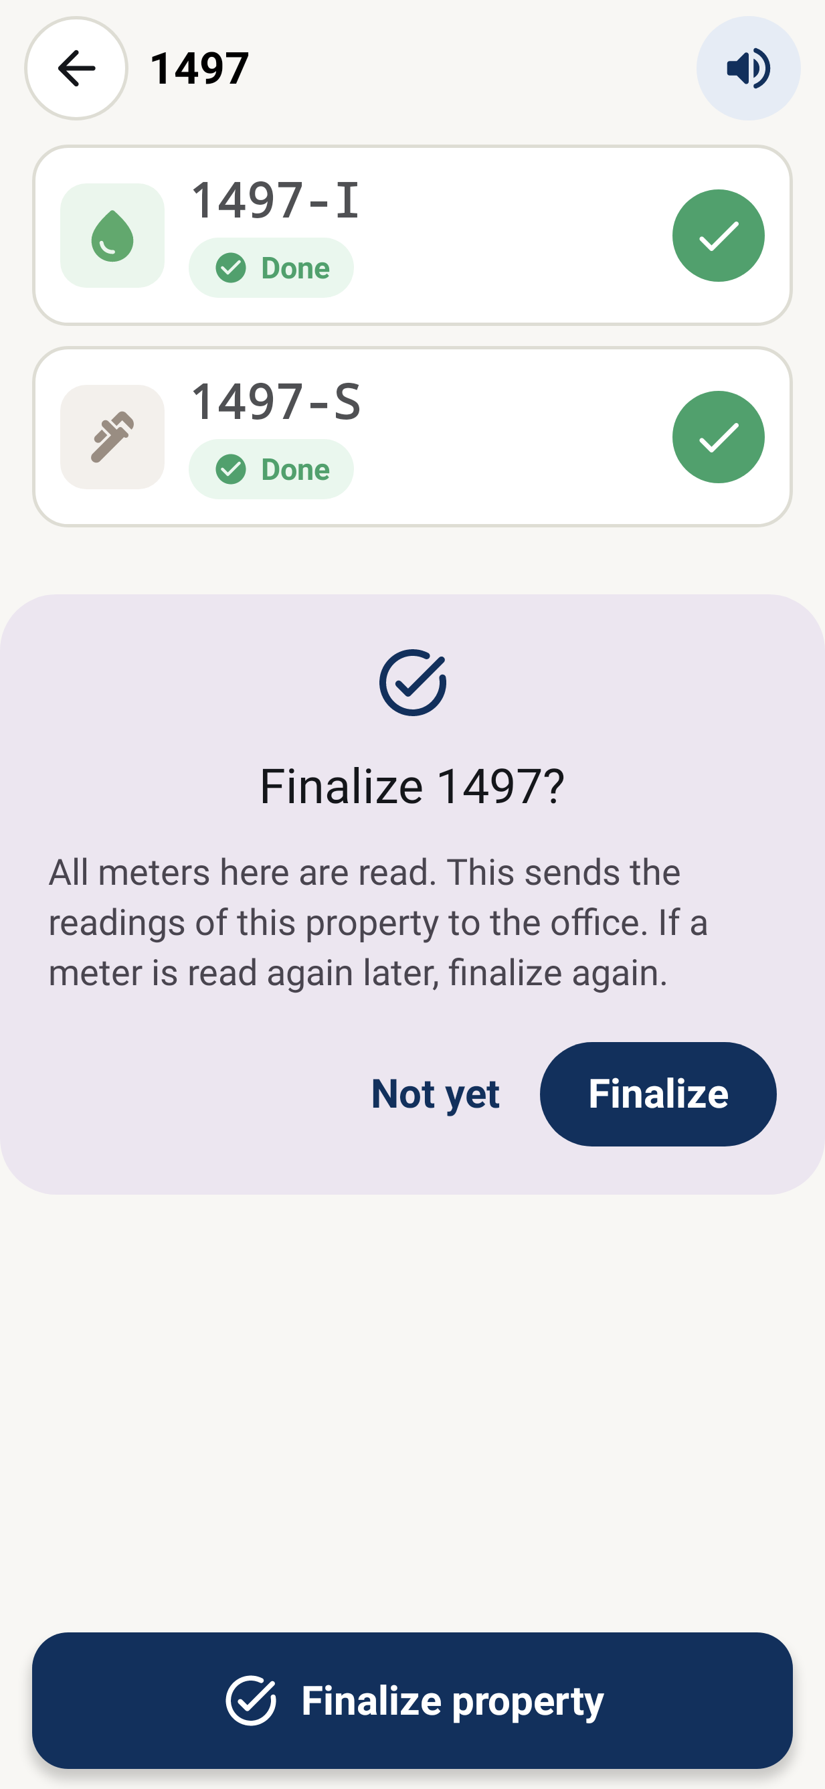
1. Meters still to read: the button is grey and shows how many are left. | 2. Every meter is read: the button can be pressed. | 3. The phone asks once more before sending the property to the office.
Screens from the app with sample data.

B. Working out the amounts
Requirement
Sewerage amount = water used × the property's rate × 1.2 × the rate factor (as a percentage). The irrigation amount is worked out the same way. Amounts are rounded to 2 decimals.
VAT is 5% of the sewerage amount and 5% of the irrigation amount. The total is both amounts plus both VAT amounts.
Some plots are not charged for irrigation after an agreed date. The first is plot 597-905, from 1 March 2025. IT keeps this list.
Each line also shows 10% of the sewerage amount.
Minimum irrigation charge: if the irrigation amount is lower than 10% of the sewerage amount, the plot is charged 10% of the sewerage amount instead, but never more than 500.

C. Customer and billing details
Requirement
Each line carries the tenant, the tenant's Baan code, the company name and the transaction code, taken from the property system at the moment the property is finalized. This makes sure the latest Baan code is used, even if it changed during the month.
Each line carries the billing month's start and end dates, taken from the reading period set up in the property system.
Each line carries the fixed billing codes: VAT code SSD, sewerage charge type "sew" and irrigation charge type "Irri".

D. Owners Association plots (new in this request)
Requirement
Plots whose tenant is an Owners Association (OA) have no booking form or customer record today, so the phone refuses their readings. IT will keep a list of these plots with the OA's name and Baan code.
For a plot on this list, the phone shows the OA as the tenant and accepts its readings.
When an OA plot is finalized, its lines carry the OA's name and Baan code, so Finance bills it like every other plot, with no manual invoice.
The first plot on the list is 598-1319 (request #47155). Other OA plots are added to the same list.

E. Technology upgrade
The phone app is built with Kotlin, a programming language, and a set of building blocks (libraries) that draw the screens, talk to the server and store files. The version the app was first planned on, Kotlin 1.7, dates from 2022 and is no longer updated by its makers. This change moves the app to the latest releases so it stays supported, secure and accepted by Google Play and the Apple App Store.
Requirement
The app is moved to the latest stable release of Kotlin (2.4.21) and of each building block it uses.
Nothing changes in how the reader takes a reading: the screens, steps and buttons stay the same.
The upgraded app must pass all existing automatic tests and the UAT test cases before it is released.
The upgraded app is released as version 2.1.0.

Upgrade scope
The phone app's language and main libraries move to their latest stable releases; nothing changes for the reader except fixes.
Component | Current | Target
Kotlin | 2.1.0 | 2.4.21
Compose Multiplatform (screens) | 1.7.3 | 1.12.2
Ktor (server calls) | 3.0.3 | 3.6.0
kotlinx-coroutines | 1.9.0 | 1.11.0
kotlinx-serialization | 1.7.3 | 1.11.0
Okio (files) | 3.9.1 | 3.18.2
kotlinx-datetime | 0.6.1 | 0.6.2

Not in this change: kotlinx-datetime 0.7+ (moves date types into Kotlin itself; a separate code change) and Android Gradle Plugin 9 (needs the app split into separate modules). Both are proposed as a later CR.

F. Comparison: 2022 version and now
The table compares the 2022 generation of the platform, what the app runs on today, and what it will run on after this change.
Area | 2022 version | Today | After this change
Programming language (Kotlin) | 1.7.x (2022) | 2.1.0 (late 2024) | 2.4.21 (latest)
Screens (Compose) | Jetpack Compose 1.2, Android only | Compose Multiplatform 1.7.3, Android and iPhone | Compose Multiplatform 1.12.2
Server connection (Ktor) | 2.1 | 3.0.3 | 3.6.0
Background work (coroutines) | 1.6 | 1.9.0 | 1.11.0
Data exchange (serialization) | 1.4 | 1.7.3 | 1.11.0
File storage (Okio) | 3.2 | 3.9.1 | 3.18.2
Dates and times (kotlinx-datetime) | 0.4 | 0.6.1 | 0.6.2
Android version targeted | Android 12–13 (API 32–33) | Android 16 (API 36) | Android 16 (API 36)
Phones supported | Android only | Android, iPhone and iPad | Android, iPhone and iPad
Maker support | Ended | Ending | Current

What the upgrade means for the business:
- Supported: the makers fix security and other problems only in current releases.
- Store rules: Google Play and the App Store require apps to be built with recent tools to accept updates.
- Faster and more stable: newer releases start faster, use less battery and fix known faults.
- One app for all phones: the same app runs on Android phones, iPhones and iPads.
- Lower future cost: small regular upgrades are cheaper than one large jump after several years.

Reviewed by : Approved by :

Imtiyaz Hussain Nidhi Singhvi

Signature Signature

