Few more points we want to update or enhance:

- In address Tab, Bus. Contact number - the country code is not working, please assist to update it.

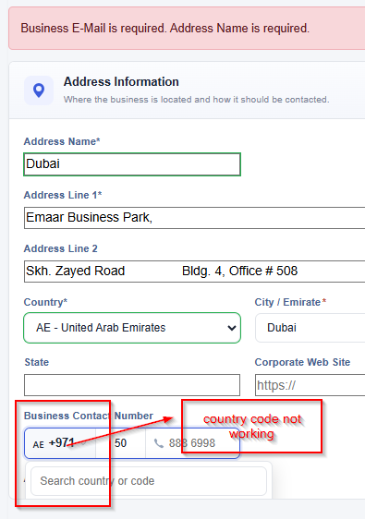

- In the Site / Business Unit, kindly remove the option “Wire”
If the supplier, selects “Electronic” – bank account data in payment/banking tab should be required.
If supplier selects “Cheque” – bank account data will be optional

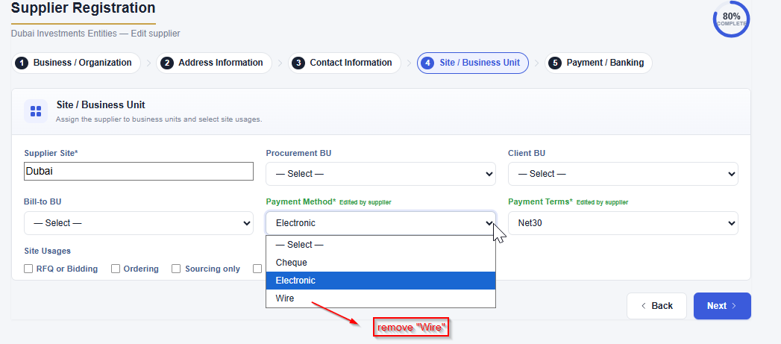

- 3.1The trigger for the missing Trade license is in the last part, it should be at Business / Organization tab.
3.2 Please can we also add a trigger to add the VAT registration certificate if they add TRN/VAT Registration number.

4.) Please can we extract per status or add the supplier portal status column on the report.

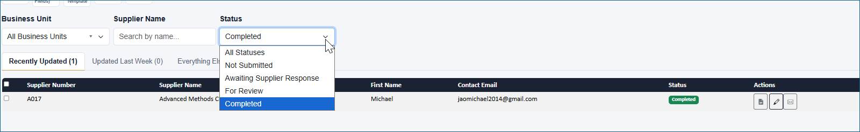

- The upload file was not working when I tested it, is not allowing me to update the supplier, error is saying Supplier number already exists.

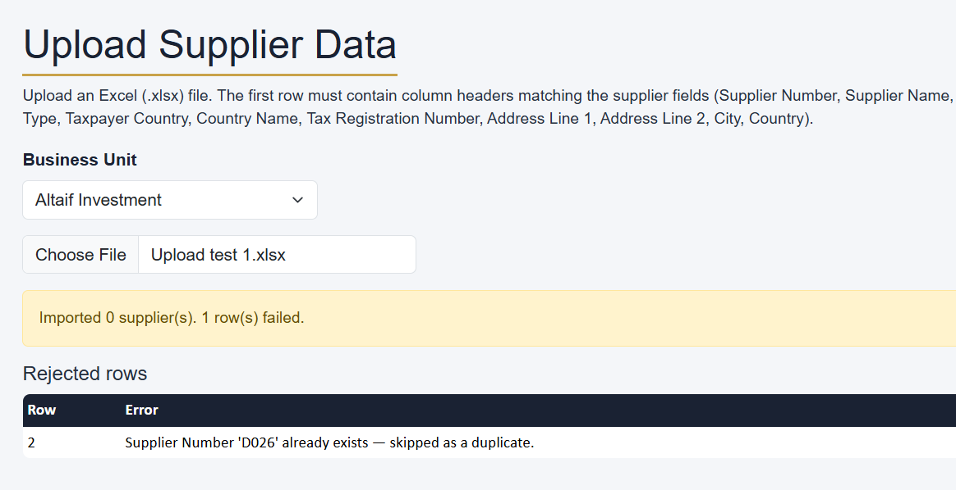

- When the status is completed and MDM reviews it again, please have an option to send the request to the user with status as “Rejected”, MDM should be able to write comments and remarks, and the user should be able to resubmit the request back to the supplier.

