|  |  |  |  |  |  |  |  |
| --- | --- | --- | --- | --- | --- | --- | --- |
| |  | | --- | | C:\Users\rhoyler\AppData\Local\Microsoft\Windows\INetCache\Content.Word\YETI Logo 2017.jpg | | 2020-2021 Season Ver 1.0 Overview Congratulations on being selected to be a part of YETI Robotics and the Queen City Robotics Alliance (QCRA). If you are back from last year then welcome back to your next awesome season with us.  This manual is a guide to how YETI Robotics operates and will allow new members insight on how to contribute to the team. If you have any questions ask a veteran student or a mentor! | |  | |  | | --- | | YETI ROBOTICSFIRST Robotics Team 3506900 Pressley RDCharlotte, NC 28217Team Handbook Rules Included | |  | | Queen city Robotics ALLIANCE, INC. P.O. Box 31483 Charlotte, NC 28231  Yetirobotics.org  QueenCityRobotics.org | |

1. Introduction

Welcome to FIRST Robotics Team 3506, YETI. This guide seeks to give you a brief overview of what to expect while on the team. YETI Robotics started in 2010 and met with early success. YETI expanded the team from 17 students in 2011 to over 30 students in 2020-2021.

YETI’s first regional was the 2011 North Carolina Regional where the team won the Rookie Inspiration Award, and earned a spot on the 2nd seeded alliance going into the elimination bracket. This alliance went on undefeated to win the NC regional and a ticket to the 2011 World Championships in St. Louis, MO.

Since 2011, YETI has had many successes including four championship plays, 10 Blue Banner titles, and over 30 Awards. Entering 2017 YETI Robotics was the undisputed 2016 State Champion of North Carolina after a three title sweep for the state Championship in 2016 (Chairman’s, Winner, WFFA). The team has continued this history of excellence by winning Chairman’s again in 2018 at the NC State Championship!

Skills that students learn on the team are lifelong skills that prepare them for the real world, including problem solving, team work, communication, and collaboration. The YETI Team is structured with a student leadership group and many different functions or jobs for students to participate in: engineering, CAD, outreach, math, programming, electrical wiring, photography, marketing, fundraising, leadership, and writing.

YETI is a part of the Queen City Robotics Alliance and calls the FIRST Zone - CLT home with two other FRC teams, and several FTC and FLL teams. This collaborative facility nestled inside the heart of Charlotte is a one of a kind robotics fabrication lab complete with machine shop and regulation size fields for all levels of FIRST Robotics.

The YETI Community is not only about building robots, we build robots to build character and make an impact on the community.

1. Rules & expectations
   1. Student Expectations:
2. Exhibits Gracious Professionalism (GP) at all times and events
   1. No Tolerance for ethnic, gender, religion, age degradation
   2. Respect all students, parents, mentors, and volunteers
3. Two deep rule: Two students or two mentors present whenever mentors and students in same room
4. NO HORSEPLAY - AT ANY TIME!
   1. 1st offence - parents called to take you home.
   2. 2nd offence - suspended from team for 2 meetings
   3. 3rd offence - suspended from the team for the season
5. Students are expected to actively participate in all activities throughout the year i.e. NO playing games/talking on cell phones during meetings/lectures, pay attention to instructions, etc.
6. Each student must participate in at least three outreach events and contribute to the marketing of the team. We ask that each student pioneer their own approved outreach event.
7. 75% Attendance required of students and mentors at weekly meetings between Sept and April, schedule posted on the team calendar and listed at the beginning of the handbook. *travel expenses will not be covered by the team for those not meeting these levels. Student Leadership must maintain 85% (170 hours) attendance the entire year, attend Kick Off and at least 2 tournaments and go beyond the minimum requirements of outreach showing leadership in serving as job requirement
8. All veteran students will apply for their positions/jobs for student leadership
9. New students can float between work areas until build season begins
10. All students attend at least one competition (*ALL DAYS, not just one*)
11. Maintain passing grades
12. Turn in documents and FIRST Online registration on time
13. All students MUST pass annual safety test before working in shop
14. Dress Code:
    1. All students must wear closed toed shoes when working with any tools or machines.
    2. All team members must purchase a pair of OSHA certified safety glasses. (see below for details)
    3. All long hair must be tied back or worn up. YETI Robotics is not responsible for supplying hair ties.
    4. No loose clothing (hoodies, long sleeve shirts, etc.) around machines.
    5. No long dangling earrings around machines.
    6. In general, dress modestly to maintain a professional atmosphere.
    7. For safety reasons, expose as little skin as possible (no shorts or low-cut shirts as metal shavings can be hot and painful.
    8. Students not dressed appropriately will be sent home
15. Team etiquette online and via mobile must be upheld. Taking disrespectful photos, sending offensive material, and posting cringe worthy posts online are not a part of YETI culture.
16. Student automobile drivers are to obey all rules of the road, drive modestly, and are only allowed to park where designated when on TPM property. The FIRST Zone is in a busy manufacturing district with large trucks so security is very strict and, in some cases, governed by Federal Regulation. ***Failure to comply with YETI vehicle regulation will result in students losing the privilege of driving to the Zone. If necessary, Mentors will review video of the parking lot with TPM and share with parents. Additionally, if needed the student car will be towed from the Zone at the owner's expense***. Being obnoxious with the car stereo, doing burnouts, and generally driving recklessly count as failure to comply. General safety for the area dictates that all vehicles should remain locked and personal property stowed out of sight to deter theft or damage to a vehicle.
17. All suspicious actions or crimes should be reported immediately to a mentor.
18. Students and mentors are expressly forbidden from entering any part of the TPM facility or other sublease holder spaces at any time except when accompanied by a TPM employee or QCRA mentor. This permission will be defined clearly for each team on a case by case basis.
19. Property in the other tenants’ space at TPM such as chairs, paper, carts, or machinery are not to be touched at any time.
20. The FIRST Zone Charlotte shares bathroom facilities with the landlord TPM Inc. Breaks will occur in shifts to use the facilities with select mentors present to open the bay doors to allow access into the TPM part of the building. This CANNOT be done by a student or unapproved mentor.
21. YETI acknowledges that relationships occur on the team and this is natural. However, PDA (Public Displays of Affection) is NOT appropriate at the Zone. Treat this as a work environment. If you don’t understand what appropriate behavior in a work environment looks like, speak with your parents (or we will).

2.2 Parent Expectations:

1. Everyone exhibits GP at all times

* No tolerance for ethnic, gender, religion, or age degradation
* Respect all students, parents, mentors, and volunteers

2. Inform Iaiela Dumitrescu, or Robbie Hoyler of any academic or personal issues that may interfere with son/daughter participating fully with the team. This includes emotional or learning disabilities, especially if it involves a student needing to take medication. YETI is willing to work with anyone and may require parents to participate and help if needed.

3. Please respect all mentors as volunteers here to help your students learn

4. Make sure your students understand all team expectations

5. Turn in documents and registration on time

6.  Registration fee and lab fees are non-refundable

7. Sign FIRST and QCR photo release for your students

8. Parents are encouraged to be involved with the operation of the team however the leadership team has final discretion with the direction of this mature program

2.3 Mentor Expectations:

1. Everyone exhibits GP at all times

* No tolerance for ethnic, gender, religion, or age degradation
* Respect all students, parents, mentors, and volunteers

2. Two deep rule: Two students or two mentors are present whenever a mentor and student are in the same room.

3. Provide a safe, fun, creative environment to guide students’ learning.

4. Conduct ourselves professionally as an example for students to emulate.

6. Sign FIRST and YETI photo release and other required volunteer forms.

7.  Complete FIRST YPP and background check

8.  Mentors must pass the 1st year probationary period to be invited back.

1. Safety

3.1 FIRST’s Youth Protection Program

1. Mentors will complete FIRST’s YPP Training and background check
2. YETI Robotics will strive to have all mentors go through the Youth Protection Program Screening following FIRST guidelines.
3. YETI Robotics as a team will review the YPP and watch the YPP video within the first 6-8 weeks of the start of fall meetings – Parents are invited to participate.
4. Any students and parents not present will be asked to review the video on their own time.
5. YETI Robotics will follow the rule of two – meaning at least two mentors are present with any students in a team gathering OR two or more students are present in a room with any one mentor. NO one on one unless the student and mentor are related as parent and child
6. Information on FIRST Youth Protection Program can be found here: <http://www.firstinspires.org/resource-library/youth-protection-policy>

3.2 YETI Robotics Safety, Conduct, and Support Committee Procedure

The Safety Conduct and Support Committee exists to review, mediate, and advise the leadership of the team and Queen City Robotics on recommended actions.

1. Final decisions on actions taken rests with the team leadership and/or QCRA leadership.
2. All safety and conduct incidents, concerns will be reported immediately. YETI Robotics interprets that to mean within 48 hours by all involved including witness reports and the CSC Committee will make an initial response within 1-2 weeks.
3. The CSC Committee may conduct interviews of all parties involved to better understand the incident.
4. YETI Robotics will maintain an online reporting system for all safety and conduct incidents.

**Incidents of a serious or sensitive nature can be brought directly to the Safety, Conduct, and Support Committee. Speak with Robbie Hoyler or Iaiela Dumitrescu.

3.3 YETI Robotics Safety Rules and Tips

3.3.1 Apparel

1. Safety Glasses
   1. Must be worn in the shop or the work area at all times. Working on the robot counts as a work area and safety glasses must be worn at all times when operating the robot.
   2. Must NOT be tinted. (colored lenses are a no-go at competitions)
   3. Must be ANSI Z187.1 compliant and marked on the glasses (OSHA)
   4. Prescription lenses are not safety glasses. Safety guards for them are sold but use these at your own risk.
   5. Required in the pits at competition at all times.
2. Closed-toe shoes must be worn at all YETI functions and events. To prevent chips from entering your shoes and socks, wear high top shoes (not Converse sneakers) and long pants to cover the tops of your shoes. Robots can hurt your feet.
3. No loose or baggy clothing.
4. Long hair must be tied back to prevent entanglement in the robot or machines. Please provide your own hair ties.
5. No rings, long earrings, neckties, bracelets, or dangling necklaces in the shop when machining or working on the robot. If they are caught in a machine, so are you.
6. When machining or working on the robot, never use gloves. This prevents the glove from taking your entire hand into moving parts if it gets caught.
7. No long sleeve shirts with loose fit in the shop, if you wear a long sleeve shirt the sleeves must be rolled up tightly to comply.
8. No skirts, shorts, tank tops, spaghetti straps, low riding pants, or low-cut cleavage shirts. No frontal or rear cleavage in a machine shop. Bad idea.
9. Use common sense about what you wear at all times, metal chips can get anywhere so the better you cover up the less splinters and hot chip injuries you will receive.

3.3.2 Shop and Tools

1. Never work alone. EVER! Mentors too!
2. The gated area in the back with the CNC and Lathe are restricted at all times.
3. Never work without a mentor present, even if you are 18 as this is YETI policy.
4. Nobody gets to leave until the shop is clean. Break this rule and you will get to clean the shop alone next time while everyone watches.
5. No food or drink in the shop, we have a break area.
6. If you do not know how to operate a tool or the tool is behaving in a way that is not normal to expectation, ask a mentor on the proper operation of that tool. ALWAYS ASK - there are no stupid questions.
7. Do not ask fellow students how to operate power tools properly, consult an approved mentor!
8. Never try to stop a machine with your hands, it will win a battle of force and injure you.
9. Put tools back where they belong, if you found them misplaced put them back anyway.
10. Clean up all chips, dust, debris, loose fasteners, parts, and tooling before leaving that station and upon completion of the task.
11. Do not leave tooling in the machine (bits in the drills, tools on the lathe)
12. Do not remove any saw blade from the miter saw or band saws.
13. Always properly clamp the workpiece before drilling, sawing, cutting, tapping, grinding, welding, or any situation that could cause the part to move. Use common sense here!
14. Do not remove any machine guards because the machines were designed to operate with them installed.
15. If you see a broken tool or personally break a tool, inform a mentor and make sure that tool does not get used again. You will not be in trouble for breaking a tool unless you fail to inform a mentor about it.
16. Do not try to break chips away with the machine on. Turn it off and wait for the machine to completely STOP to complete this task. Ask a mentor how to break chips using a technique called peking.
17. Use proper masks when cutting carbon fiber or plastics.
18. Do not inhale torch MAPP GAS as this may render you unconscious in seconds.
19. Do not use a torch without direct supervision and a mask.
20. Do not look at a welding arc without a welding mask. (flashes from welding can burn your eyes)
21. Do not use a power tool with a severed electrical cable and do not try to repair it without a mentor.
22. Do NOT open the large rolling doors unless instructed to do so!
23. Always wrap electrical terminals in electrical tape only!
24. Always leave the machines in a safe state. Cleaned of debris, no chuck key in the spindles, no tooling left in the machine, unplugged, and no parts left in the machine.
    1. Some often-missed safety concerns regarding safe states include:
    2. Angle grinder left disk down and plugged in
    3. Chuck key left in the lathe or drill press (very dangerous!!)
    4. Drills left on the floor with bits inside them
    5. Saws plugged in and unattended
    6. Hand tools scattered around the floor
    7. Tools stored in higher places than they should be
    8. Chips left on the tool act as whips when the machine starts back up, always remove debris!
    9. Soldering irons plugged in and left unattended
    10. Heat gun not stored in a proper place to cool
    11. Damaged or dull saw blades being used
    12. Use common sense!

3.3.3 Robot Safety

1. Know your **Robot Cell**: A robot cell is defined as any distance where any part of the robot can travel in one second.
2. A robot that shoot projectiles has a robot cell as big as the room it is in and therefore extra caution must be used
3. If a robot can travel at a top speed of 15 feet per second, 15 feet in any direction of that robot is considered unsafe. Add two feet for safety and the robot cell would be 34 feet in diameter.
4. If a robot has a tall arm or actuator this counts toward the robot cell in case of toppling. If a robot with an 8-foot-tall arm has a top speed of 15 feet per second then the robot cell is 50 feet in diameter in case it falls over.
5. Know the capability of the robot! Know what can go wrong!
6. Know where all pinch points on the robots exist and where entanglement is possible
7. Beware of dead loads such as large arms and powered devices
8. Make sure the robot is powered off before working on it. If the robot is on make sure the driver station is disabled and that nobody will enable the robot.
9. Similarly, if operating the robot to drive it, announce when the robot is powered on and that everyone is clear of the machine. If the robot is enabled to drive announce that it is enabled CLEARLY and audibly so that anyone in the room can hear.
10. If you are running autonomous mode extra care must be taken and the operator needs to prepare to disable immediately at any time during autonomous operation.
11. Never operate the robot near unaware people and use extra caution at events
12. Never operate the robot in anything less than prime condition. Bad grinding or driving sounds indicate a problem with a gearbox or something broken with another actuator on the robot.
13. Any robot with pneumatics should be vented to the atmosphere when turned off to be put away. EVERY TIME!

1. The robot should never be stored with a plugged-in battery
2. Know what the caution light on the robot means. Blinking typically means on. Solid typically means enabled.
3. Never leave an enabled robot drivers’ station unattended and never leave the drivers station in a place subject to disturbances (such as five toddlers wanting to press buttons or move the joysticks)
4. Beware of spring loads on the robot; a flying part is a hazard.
5. Always try to drive the robot with competition bumpers installed, especially when driving two robots together.
6. If you do not know how the robot functions, you are not allowed to operate or power on a robot.
7. Robots are only to be driven with approved mentor supervision
8. Always use two people to lift and transport a robot, lift with your knees not your back.
9. Tall robots are awkward to carry, make sure you coordinate lifting so the robot does not hit someone in the head. 3, 2, 1, lift.
10. Keep all appendages out of the robot when it is on and away from the path of any device that can move.
11. Do not try to stop a robot from moving, simply get clear. Do not try to save the robot components with your hands. Only when a person is in danger is trying to manually stop a robot by force with your hands even considered an option.
12. Always store and transport robot batteries with the safety plug installed, the only time the plug should come out is when charging the battery or using it in the robot.
13. A ruptured robot battery is a serious hazard! Tell students and mentors immediately if you see one and do not use it further.
14. All robots may be disabled via the driver station using the ENTER key or SPACEBAR for absolute emergency stop.
15. Do not carry the robot battery by the cables!
16. Use common sense with the robot at all times!!!

3.4 tournament Specific Safety:

3.4.1 pit Rule and Safety

1. The Mechanical Lead will be in charge of the pit at the FIRST Zone and at competition unless they pass this responsibility to another student.
2. Rookies are not allowed in the pit unless expressly allowed by a mentor
3. The pit breaker switch must be turned off at the end of each work day
4. All tools must be plugged in through the main pit breaker strip
5. Beware the 5 Amp limit for Pits at Competition (No Heat Guns)
6. All tools, materials, paper, marketing material must be off of the floor at competition at all times
7. All wires must be taped down to the floor at competition where they will not be tripping hazards
8. Only one fancy trunk is allotted for marketing material. If it does not fit in that space it must NOT be stored in the pit! Period! ....and no giant mascot head either!
9. Parts and tools must be organized and stored prior to departure to competition
10. If parts and tools are packed for competition, do not remove them from their locations.
11. Parts ordered from a sponsor must be submitted in a timely fashion. Not the week after you found out you needed it
12. Non-COTS assembly items in total must be under the current rule limit of 30 pounds. These must be weighed before packed for competition
13. Water is the only beverage allowed in the pit and only in a sealed lid container
14. Battery management is excruciatingly important during the tournament. Never touch batteries in the pit unless you are assigned to do so.
15. Batteries need to be cycled and tested before each competition to ensure functionality. No old batteries are allowed for use in competition.
16. No practice robots should be packed for competition
17. Each tool or part borrowed from or to other teams needs to be recorded in the pit
18. Nothing that can pull more than 10 amps is allowed in the pit
19. No running is ever allowed in the pits at competition
20. No discussing strategy unless you are the drive coach
21. Please do not partake in the “clothespin game” as it makes many people uncomfortable and is frowned upon by judges. The “circle game” can also award an alliance a red car.
22. If you are not assigned to be in the pit, please do not loiter in or around the pit
23. Only talk to judges if you are assigned to do so, if approached by a judge at competition make sure you can pull in experienced team members to discuss the topic. Competitions are won and lost on these conversations. Don’t just ditch the judge either!
24. The pit must be in perfect order as much as physically possible!
25. Remember Safety Advisors have the right to issue yellow and red penalty flags at competition the same as referees. Do not cross an event official!

#### 3.4.2 Travel and Hotel Policies for traveling/tournaments:

1. Team members will not leave the facility during tournament times unless for an emergency or specific situation which has been communicated to and approved by one of the Lead Mentors beforehand. **This includes taking an Uber to a different location.**
2. No adults will stay in rooms with students unless parent/child
3. Lights out at 10 pm.
4. Students in rooms of opposite sex before 10 pm will leave doors open for propriety.
5. No students in rooms of opposite sex/unassigned rooms after 10 pm.
6. Students will not leave the hotel without the team or Lead Mentor’s approval.
7. Respect your travel and team mates – arrive at breakfast and departure places on time.
8. No student will stay behind in the hotel without the team during a tournament day unless expressly allowed by a Lead Mentor.
9. Report any damage in the hotel to a Lead Mentor or you will be charged for the damage
10. Students are to stay for the entirety of the competition until all awards are handed out. This is Gracious Professionalism. Teams have been embarrassed by leaving and missing an award. Students will not receive an award/medal if they leave early.
11. There will be no saving seats at competition because it is expressly forbidden in the rules of *FIRST*.
12. Throwing paper airplanes, debris, or leaving debris behind is expressly forbidden at competition by *FIRST*
13. Team members will clean up the team area in the stands, lunch location, and pit during each tournament day.
14. Build season routines

Every build season consists of six weeks and 3 days from the day that the game is announced until the day that we must stop work and bag and tag the robot. The team will work 20-40 hours a week on the robot – certainly not a light commitment! The members who attend these hours and work intensely will be rewarded with personal growth and additional responsibility. The build season’s weekly work breakdown generally follows the schedule in Table 1.

Table 1

|  |  |  |
| --- | --- | --- |
| Week |  | Activities |
| 1 |  | Game released  Strategy sessions and prototyping early in week  Deliver design choices and build field elements  Start CAD and fabrication of parts and continue prototyping |
| 2 |  | Continue prototyping and failing out ideas  Development of ideas into designs  Programming plan for the robot  Chassis and drivetrain complete |
| 3 |  | Continue parts fabrication and plan electronics  All processed parts from sponsors received |
| 4 |  | Assemble and wire practice robot, final parts fabrication  Base code programming  Field test drive of robot  Building of final robot |
| 5 |  | Fully functional practice robot, final robot assembly  Troubleshoot design and part iterations  Autonomous programming done  Drive team practice |
| 6 |  | Competition robot finished and bagged, practice bot matches  Autonomous programming tweaked  Drive team practice with practice bot  Bag and tag, robot is done |
| 7+ |  | Final programming for autonomous  Drive team practice and troubleshooting  Fabrication of spare parts, design iterations  Preparation for competitions |

This workflow is variable with holidays, weather, and part orders. A good successful build season will still follow this schedule.

1. Team Structure and Committees

During the build and competition season, it is important that the sub-teams break down the task of creating the final robot and preparing the team for competition. Members may belong to more than one committee, but everyone should understand their role. All teams participate in the initial design phase requiring good coordination and communication between sub-teams.

Below is our team structure chart that shows general responsibility.

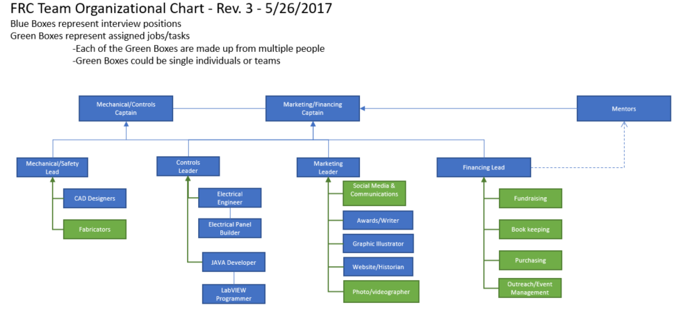

#### Team Captains:

To split the responsibility at the top of our structure, we have two team captains to represent Engineering and Operations. The Engineering Captain will oversee Mechanical and Controls while the Operations Captain will oversee Marketing and Financing in parallel with the team mentors.

#### 5.1 Mechanical/Safety Team

The mechanical team focuses on the design, fabrication, assembly, and iteration of the robot’s mechanical systems. This includes shop work, troubleshooting functional design, and maintenance of parts. They must coordinate with the controls teams to communicate any requested changes that are needed or completed. 3D CAD using SOLIDWORKS product design software is also included as part of the mechanical team.

#### 5.2 Controls Team

The controls team implements the electronics, controls, and pneumatics systems for the robot. This includes wiring, troubleshooting communications, power, and maintenance of the robot.

The controls team also designs the software and controls for the robot’s tele operated and Autonomous modes. This includes coding, driver interfacing, and troubleshooting – especially for autonomous programs. They must seek feedback from the mechanical team on performance, and design the controls with the drive team.

#### 5.3 Marketing Team

Marketing team members play key roles on the team by taking on tasks such as social media, awards, website content creation, graphic illustration, photography, videography, and team management. They must communicate with the other teams, sponsors, and the community in a wide variety of ways and prepare the team to be successful on and off the field.

All team members are part of marketing YETI Robotics during several activities: Fundraising, representing the team by doing outreach, and at all events.

#### 5.4 Financing Team

The financing team is responsible for a good deal of the operations here at YETI Robotics. Fundraising, outreach, event management, book keeping, and purchasing for the team all routes through this department in an effort to stay sustainable. All members of the team are responsible for the budget at YETI Robotics by bringing in funds or materials.

#### 5.5 Strategy Committee

The Strategy Committee makes key decisions on the direction the design team will go during build season. The strategy drives robot design and all modifications working alongside the engineering teams to ensure design choices meet the game strategy. The Strategy Team is a small group who spends the first few days after Kick-Off immersing themselves in reading the game manual to understand all the minutiae of the game rules. Ideally, the strategy team finds an unusual aspect of the game to exploit for best scoring in the game. The strategy team also works to prepare scouting resources, study rule changes, and pre-scout the competition. Their communication is periodic with the engineering team. The strategy team is not open for Rookie team members.

#### 5.6 Drive Team

The drive team is responsible for learning to operate the robot at a high level and translating that into successful robot performances at events. It is the responsibility of the drivers to give feedback to the engineering teams about the robot and test changes. Drivers should know the robot inside and out.

The drive team is chosen based on skill and compatibility through an audition process. The final decision rests with a panel of mentors and the student strategist. Historically, the drive team is a very competitive job and the intensity of build season will push tryouts back to week 5 and 6 with notices for tryouts completely dependent on the state of the robot. Failure to be at a tryout means that your nomination for driver will be overlooked. Rookies (besides the drive coach) are eligible to drive as much as veterans because we only take the BEST team member for each task. We have had many rookies on the drive team in the past!

To try out for the drive team, a student must be able to attend ALL competitions for ALL days, have an attendance of 75% or higher, must have passing academic standing, and work well with the strategy team.

Because of the nature of these tasks mentioned below, a student must do well under pressure, be able to communicate clearly with all team members, and be graciously professional at all times with other teams, referees, judges, mentors and students alike.

**LEAD DRIVER:** Because of the competitive nature of this job the best driver is chosen by the competition coach of the drive team and the lead mechanical mentor. The driver must be fast but not reckless and cautious but not slow. Students who intend to try out should practice driving on one of our many robots from previous years and attend off-season events such as THOR and SCRIW. High performance with one type of game/robot does not guarantee selection as driver for another year’s game.

**SECONDARY DRIVER:** Must work in tandem with the coach and lead driver. The same conditions apply to the secondary driver as the lead driver.

**HUMAN PLAYER:** This is usually an athletic task that requires an absurd amount of practice. Where most teams overlook their human player, we take this position very seriously and have people practice all season. In 2015 we had the best human player in the world and in 2016 we discovered a devastating strategy using our human player.

**Strategist/Coach:** This is the most important member of the drive team and this cannot be overstated. The drive coach makes ALL on field decisions for the drivers so that they can focus on the robot. The coach is a position that is earned and given by the team leadership. The coach must know all of the game rules and potential penalties and be a part of the strategy team due to the intensity of the decisions on and off the field. This position requires previous FRC experience with YETI and is the only job not open to Rookie team members.

6. Robot Design

6.1 Design Philosophy

At YETI we strive to design robots that have certain characteristics. Something common to most of our robots is simplicity, uniqueness, robustness, and high quality. Blue fur is also common.

Each game has its own set of challenges and it is up to the Strategy Team to find the best solution that meets the overall strategic requirements to compete in competition. Strategy drives design and all design modifications and additions must first satisfy the design criteria.

While going through this document think about these ideas in the context of robot design:

**SIMPLICITY:** Instead of building a complex moving arm, create a stationary fixture that can do the same task with less motions.

**ROBUSTNESS:** Design the robot to withstand tipping, unexpected collisions, and forces several times larger than normal so that nothing needs to be repaired.

**QUALITY:** Thoroughly design and build parts to specification. Make it look professional and well thought out.

**UNIQUENESS:** Sometimes the crazy ideas are the best but sometimes we choose to not reinvent the wheel. YETI solves the problems in ways that nobody else could think of and our robots are usually unique in design.

6.2 Ideal robot attributes

While the game changes every year, there are some attributes that are always a design priority for our team. These include:

**STABLE:** This means having a low center-of-gravity (CoG) so that the robot will not tip in a collision or while climbing over things. Weight should be as centered and close to the ground as possible.

**STRONG AND AGILE:** The robot should be able to get around the field as quickly as possible while still having the ability to push other robots or field elements. The robot should have the necessary traction and drivetrain gearing.

**SHORTEST CYCLE TIME:** As defined by iSixSigma: **“*Cycle time****is the total****time****from the beginning to the end of your process, as defined by you and your customer.****Cycle time****includes process****time****, during which a unit is acted upon to bring it closer to an output, and delay****time****, during which a unit of work is spent waiting to take the next action”.* In competition this means the time it takes the robot to complete a score and be ready to score again. The shorter the cycle time, the more often a robot can score.

**PRECISE:** No matter what the design challenge is, the robot should function in a highly accurate and repeatable way. The robot should perform as designed, with precision.

**VISUALLY ATTRACTIVE:** A clean, well-finished robot will not only be easy to service but also be excellent to present to judges and function as our team’s image on the field.

As with our fundamental principles, these attributes aren’t easy to achieve and require discipline in design.

6.3 How YETI DESIGNs

Once a Strategy is decided, each design session on Team 3506 has a similar style and follows team culture. This culture requires intense thinking and dedication from students and mentors alike. Everyone has the responsibility to share his or her ideas and be active participants. Team members should respect all contributions and work to collectively raise our standard of excellence. The team roles in robot design fall into four general groups:

**VETERAN STUDENTS:** Team members with an exceptional amount of experience and activity on the team are expected to bring their knowledge and leadership to the forefront. They should partner with less experienced students and encourage growth amongst the team.

**JUNIOR STUDENTS:** Team members who are newer to the team (one season only) are expected to seek out opportunities to observe, learn, and begin to practice the skills of their senior counterparts. They should seek guidance and be unafraid to offer their ideas for consideration.

**ROOKIE STUDENTS:** Team members who are new to the team and have not been through a competition season. Like Junior students, Rookies are expected to seek out opportunities to learn and build their desired practices.

**MENTORS:** The mentors serve as teachers and advisors to the students. They share their engineering and operations experience in order to elevate student skills and guide the team in reaching its goals.

In design meetings, we use brainstorming, discussion, and prototyping to help the team arrive at its final robot concept. When brainstorming components, students should offer all ideas and grow them collectively. Discussion and prototyping sessions will allow the team to narrow its choices and begin to prove the design of a select set of top design candidates.

1. mechanical design

Thoughtful mechanical design of our robot’s most critical parts directly affects how we drive and complete the other important tasks of the game. While the other systems of the robot are no less important to being functional, mechanical design helps to distinguish the good robots from the great robots.

7.1 drivetrains

The purpose of a drivetrain is to give the robot mobility; this is the most basic necessity in FRC. It allows us to move between the different areas of the field and accomplish the game’s challenges. Drivetrains define how well we can interact with both objects and other robots. They also define how we climb over things or maneuver around obstacles. The drivetrain must be durable and reliable. If it fails, the rest of the robot is essentially useless. We must balance key attributes including speed, pushing force, and agility with our desire to be simple and robust.

#### 7.1.1 Types of Drivetrains

There are three categories of drivetrains that are most commonly found in FRC. These include:

**TANK:** This drivetrain, also improperly called skid steer, is the most common in FRC; see Figure 1.

The right and left sides of the robot are driven independently. By changing the direction of each side, you can go in all directions. It is simple, cheap, and easy to program. Tank is also very easy to drive and can generally give the highest speed and/or pushing strength outputs found in FRC. It is slightly less agile than the other options, however this is balanced by its effectiveness in other areas. Most of the YETI Robots are “West Coast Style” tank drive, a particularly powerful design.

#### 

*Figure 1- Tank Drivetrain (AM)* *Figure 2 – Swerve Drive from 221*

**SWERVE**: This drivetrain (also called crab drive), in Figure 2, uses independently powered wheels that can be rotated. Wheels drive forward and backward in unison and the wheel modules are rotated to move in each direction. It can have the same high speed and/or pushing power of the tank drive, but increases agility substantially. However, it is far more complex and expensive to design and requires much more weight to be dedicated to the drivetrain. Generally, it is also harder to control and maintain than tank drive. We have not previously experimented with this drivetrain.

**MECANUM**: This is a variation of tank drive that uses special “Mecanum” wheels; see Figure 3. These wheels have small, diagonal rollers around the circumference that allow the robot to move in all directions. It does so by powering each wheel independently and in special combinations for each direction. While this improves upon the agility of tank drive, it is both expensive to design and hard to program and drive. It also has very little pushing force and adds weight to the robot. This drivetrain adds mobility at the cost of power and speed. The 2011 and 2014 robots were Mecanum drive. 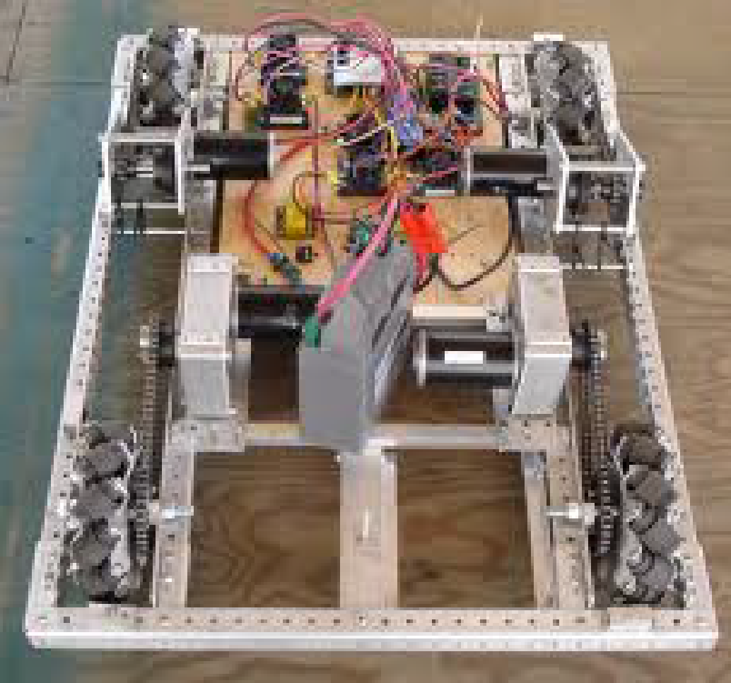

**OTHER**: There are many custom variations of the drivetrains above and some others that are entirely different. Each added layer of customization adds complexity, but it can potentially give teams the drivetrain attributes they deem most critical to their success in a particular game.

#### 7.1.2 Types of Wheels

The secondary component that greatly expands the variety of FRC drivetrains is the wheel type. This choice can heavily influence the performance of a drive system. These types are:

**STANDARD**: These are the most basic wheels and make up the vast majority of those used both in FRC and daily life. They consist of a simple wheel hub surrounded by a traction material. They are simple, reliable, and relatively low cost. The common varieties of standard wheels found in FRC are described in Table 2.

|  |  |  |  |
| --- | --- | --- | --- |
| Type | Traction | Strength | Weight |
| Kit of Parts (KOP) | Medium | Medium | Low |
| Traction | Medium/High | High | Low |
| Pneumatic | High | High | High |
| Slick (White) | Medium/Low | Medium | Low |

**OMNI**: These are specialized wheels that have rollers perpendicular to the wheel direction. They allow the wheel to slide sideways without any force. This is used most often for tank drivetrains suffering from turning issues or for specialized designs. They have medium traction forward, medium strength, and medium weight.

**MECANUM**: Another type of specialized wheel only used in the matching drive system detailed above. They allow travel in all directions when oriented correctly with one another. They have low traction in all directions, medium strength, and high weight. Images of all of the above wheel types can be found in Appendix A for better reference.

7.2 Mechanisms and manipulators

The mechanisms and manipulators on the robot are what give it the ability to play the game. They are new and unique each year with the changing game challenge. However, there are still a few basic designs that work well in FRC and have appeared in a number of games.

#### 7.2.1 Mechanisms

We generally classify systems that provide motion outside of the drivetrain under the title of mechanisms. These provide movement and functionality to the robot, but are not directly handling game pieces or interacting with field elements. The most common robot mechanisms are:

**ARMS**: Arms contain one or more linkages that pivot around a point on the robot’s frame or another linkage. The motion is circular around the pivot point. Arms are useful in applications such as lifting objects, reaching outside the frame perimeter, and scoring over opponents. They can be very simple and reliable when designed properly. They can, however, be a bit difficult to program into controls and often raise the center-of-gravity. We have lots of experience with arms, such as on our 2011, 2015, and 2018 robots.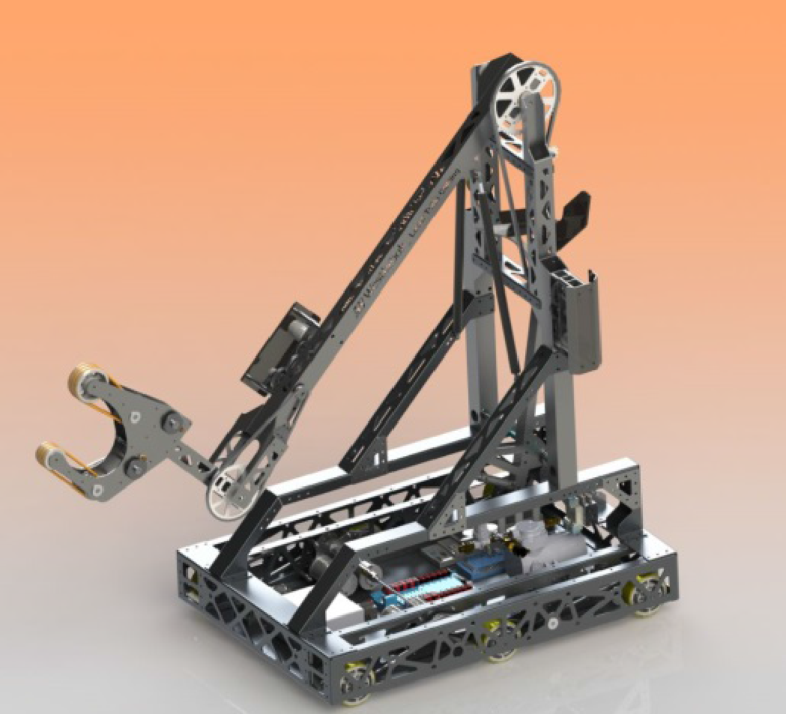

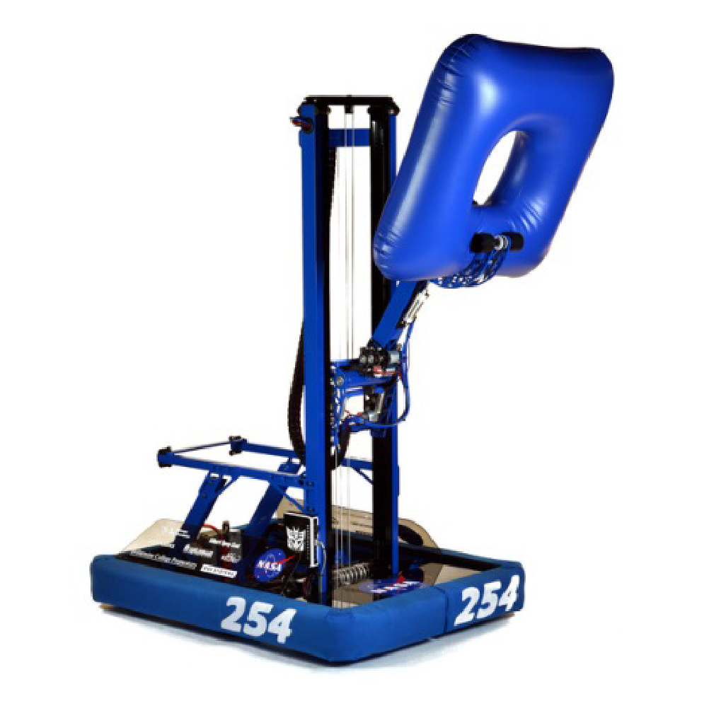

**ELEVATOR**: Elevators are composed of tubing or sheet metal that slides sections within or beside one another to raise and lower; see Figure 5. The motion is linear and the amount of motion per segment can be varied. They are useful for lifting action. Elevators are generally faster than arms, more compact, and keep the center-of-gravity lower. However, they are much more complex to design and require accurate fabrication. We have created elevators on our 2011, 2015, 2018, and 2019 robots.



**TELESCOPING ARM**: These are a sort of hybrid between arms and elevators. Generally, sections of the arm form an elevator that extends and collapses while pivoting around a point. This allows for potential advantages over standard arms including longer reach, lower center-of-gravity, and compactness. They are even more complex than simple elevators and can be a challenge to program for. We used this design in 2011.

#### 7.2.2 Manipulators

These are the systems that interact with the game pieces and field elements. Often, they are the end-effectors coupled with one of the mechanisms described above. These are often even more varied than the mechanisms, as they must match a particular object in a game. Still, there are a few common manipulators.

**CLAW**: Similar to your fingers, these manipulators use two or more surfaces to grab onto a game piece or field element. These are very useful for picking up and placing objects, such as the tube shown in Figure 6. They are very simple to design and maintain. Claws tend to be harder to operate as they require precision and they generally rely on larger mechanisms to move them and their game piece around the robot. We have used claws on our robots in 2011, 2013 (to climb), 2015, 2016, and 2018.

**ROLLERS**: One or more spinning surfaces are used to move a game piece. These are commonly belts or cords spread across rods in a number of sections, as shown in Figure 7. The rods are spun in each direction to track the roller back and forth, just like conveyors in a factory. These are useful for both obtaining game pieces from the floor and moving them within the robot. If sped up, they can also be used to shoot game pieces a short distance. They can be a bit complex to design and require service to make sure alignment and tension is correct. However, they are extremely useful and we have used them on the 2012, 2015, 2016, and 2017 robots. 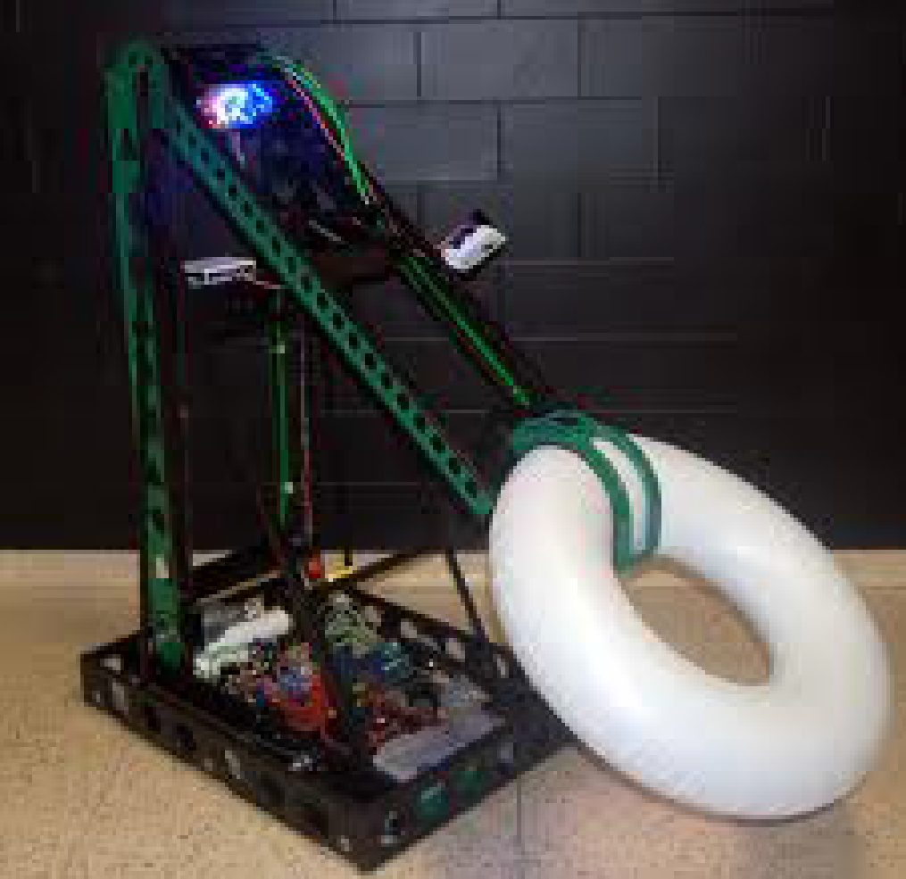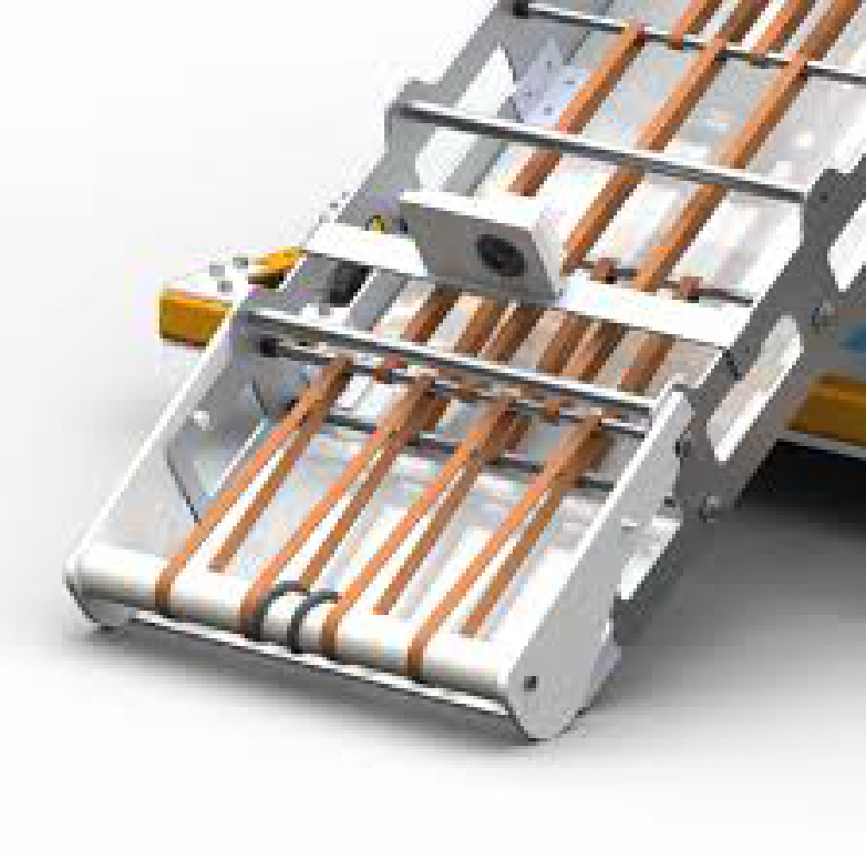

**SHOOTER**: These manipulators give game pieces high projectile velocity. They come in many different designs but are based upon transferring energy from the shooter to the game piece. This can be done using wheels, punches, or a variety of other devices. Shooters can vary greatly in complexity and maintainability and are a challenge to tune correctly due to the precision of the energy transferred. Sometimes though, they are the key to the game challenge. We have used these before on our robots in 2012, 2013, 2014, 2016, and 2017.

A common thing to note about robot manipulators is that we usually use a combination of these techniques to create what we call a “touch it, own it” style mechanism that intakes the game piece without much driver steering.

8. Electrical and pneumaTic

The control system allows the robot’s mechanisms to function at their best. It includes the electrical, pneumatic, programming, and human interface components of the robot. While not the focus of initial design sessions, the control system plays an equally critical role in reaching the simple, robust, and high-quality robot we desire.

The ideal electrical and pneumatic design aims to create a clean, organized, and easy to service product. Teams often overlook the importance of this. Messy wiring and tubing look unprofessional and can be very hard to troubleshoot. An effective design not only improves the robot’s power usage but also results in a reliable, presentable robot.

8.1 power

The robot runs on a 12-volt battery from which power is distributed to all sub-systems. This is done through a variety of components that control, limit, and utilize the power in different ways. These include:

**MAIN BREAKER**: Every robot has an on/off switch. This is perhaps an obvious component, but it is also the main safeguard that prevents the robot from drawing too much current.

**POWER DISTRIBUTION BOARD**: This is where the main power splitting is done from the battery to the robot systems. In addition to limiting the current and voltage, the board also has many different connections for each section.

**SPEED CONTROLLERS**: These devices control the amount of current delivered to motors to vary their speed from zero to maximum. They translate a pulsed signal into a range of current throughput.

**RELAYS**: These are simple on/off controllers for switched components. They also use a pulsed signal to change state.

**SOLENOIDS**: These are the same as relays, but they control the pneumatic actuators. There are varied types for different actuating actions.

**WIRE**: Wires are the interconnecting material for the electrical system. Sizes must match the current demands while following color and labelling convention.

**MOTORS**: Motors change electricity into mechanical motion. They come in many different sizes, speeds, and power levels, each with a certain application.

A visual guide to these parts is included in Appendix B at the end of the manual.

8.2 pneumatics

Pneumatics use air pressure to provide mechanical energy for robot motion. This is a good system to use when we desire simple two-position control of a mechanism. It greatly simplifies the motion control, can remain in the position without continuous power input, and can provide high strength. There exist two main components in this system:

**ACTUATORS**: Simple actuators convert air pressure into linear motion by entering compressed air on either side of a piston head. Some more specialized types exist.

**COMPRESSOR**: Compressors provide the air pressure stored in the system tubing and tanks. It converts electrical power into stored energy in the compressed air.

Images of these two components can also be found in Appendix B.

8.3 Controls

The robot control system is similar to the nervous system in your body, providing controls over each part of the robot. It translates the code we program and the commands we give it into action. The key parts of this system are:

**ROBOT RIO**: The ROBOT RIO is the robot controller. We load our code onto it, which is then converted into control signals. The ROBOT RIO connects to the Wi-Fi router to receive the driver input and breaks out control to the pneumatics, analog devices, and digital units.

**DIGITAL Module**: These components are connected to the ROBOT RIO. It breaks out signals for the speed controllers, relays, and other specialized systems into their respective channels.

**WIRELESS BRIDGE**: This is the device that acts as the connection to the field wireless network.

**LAPTOP**: The laptop uses a specialized “Driver Station” program to interface the robot and human communication. This program sends and receives data with the robot.

**JOYSTICKS/INPUT**: The drive input interface usually consists of one or more joysticks and in some cases other customized inputs such as button boxes.

Images of several of these components are found in Appendix B.

8.4 Sensors

We use a wide variety of sensors to provide information to the robot for use in programming commands in both the tele operated and autonomous modes. These sensors include the following:

**GYROSCOPES**: “Gyros” are used to measure changes in the orientation of the robot in three dimensions from its starting position. These are critical for tracking robot movement and giving waypoints in autonomous mode.

**ENCODERS**: Encoders are used to measure the continuous rotational position of a shaft. These are typically attached to the output of a drive system to measure the rotations of a wheel. They are critical in our autonomous modes as well.

**POTENTIOMETERS**: “Pots” are also used to measure rotational position. However, they have a limited range of rotation and are therefore used in systems with limited motion such as an arm joint.

**LIMIT SWITCHES**: These switches are essentially buttons that indicate when something has reached a physical position when they are pressed. This is useful for observing the presence of a game piece or deployment of a robot mechanism.

**INFRARED SENSORS**: These sensors are used to detect the presence of an object. Typically, an infrared beam is reflected off a piece of retro-reflective tape or the beam is broken between the emitter and the receiver. They are useful for detecting the presence of an object.

Of course, there are many more sensors available and many versions of the ones above. When solving particularly tough challenges we may need to go beyond these five to get the best result.

1. Programming

Programming is an essential part of any robot system. It is the set of instructions that guide the robot to perform as designed. The basic functionality of a mechanism must be proven, but programming can enhance the control of the mechanism. This is achieved through two methods: by making the mechanism more efficient (i.e. faster) and more effective (i.e. accurate) than normal driver control allows. The following includes the general code structure and planning practices.

9.1 Code Structure

Our code is generally organized based on the template provided by FIRST and is separated into four main sections: initialization, disabled, tele operated, and autonomous. The initialization routines are for declarations and definitions. This is where the electrical input/output (I/O) is mapped to the various motors, sensors and pneumatics. A virtual “object” is created and named to represent each physical component. The following three modes have two sub-sections: an initialization, which only occurs once when that mode is entered; and a periodic section, which is run and updated every controller clock cycle. They include:

**DISABLED**: The robot is removed from human control but still powered on. In the initialization all motors are turned off and the pneumatics are reset. The only thing left running during this state is the compressor so that the pneumatic system charges.

**AUTONOMOUS**: In this state, the robot is controlled by pre-programmed instructions without any human interaction. More information on this is covered below.

**TELEOPERATED**: One or more human drivers control the robot. The controls should feel natural and flow logically. This design changes depending on the number of robot mechanisms and how common robot actions can be automated together.

YETI uses JAVA for vision systems and LABView for programing basic programming languages.

9.2 design practices

When planning, we write out all the subsystems and how they interact. Then we must figure out what each button and joystick on our controller will do. These mappings must be logical and easy to follow. The selected controller inputs and other sensory inputs are then added as transitions in state diagrams. Motors and sensors are then added to the subsystems to create a skeleton of how the code will work. Later on, automation will be added to increase efficiency and simplify the driver control. During this time we also plan the multiple autonomous modes that will be required to for the various situations that will be encountered throughout the season.

9.3 Automation

In recent years the autonomous period has typically played a large role in the scoring capabilities of our robots. This is because tasks in this period are often worth more points and have no defense to contend with.

In order to best utilize this opportunity, numerous sensors are employed to guide the robot and improve its accuracy. Other tools include timers and loops that are implemented in software to move on to the next task after a certain amount of time has passed. These elements can be combined to have the robot perform a pre-set routine and score points without driver control.

We can also use the methods outlined above to control the robot during tele operated mode through the automation of processes. These processes range from moving conveyors a certain distance, to holding a shooter wheel at a constant velocity, to completing full scoring actions with the coordination of several subsystems.

However, just because a process can be automated does not mean that it should be! Simplicity is key in the planning of autonomous routines and the level of human control that is automated. For any automated process you must have a way to override it at any time since you never know what might happen at a competition. It’s critical to have this option for when a sensor inevitably fails to ensure you don’t lose robot functionality (it is also a safety measure).

1. Strategy

In order to be successful, we need to have a clear goal from the beginning of the season. A strategic approach to the robotics season will help our team understand where we're going and what we need to get there. This is a fundamental principle of our team culture. At the beginning of each build season our veteran strategists will enter a room and decide the game winning strategy that defines the robot.

10.1 understanding the challenge

In order to build a good robot we need to understand the game, it will be playing. There are three key steps to develop that understanding:

**READ THE GAME MANUAL**: You need to know the game inside-out to be able to helpfully contribute to designing our robot. From scoring to penalties every detail is critical. Never start design without this knowledge.

**UNDERSTAND SCORING**: Since scoring points wins matches, knowing how to do it (and, equally importantly, how to stop it) will help you to come up with the most effective robot. We need to extract the maximum points in the most efficient way.

**KNOW THE TOURNAMENT SYSTEM**: The only way to win an event is to understand what you have to do to get there. Our strategy evolves from what we must do to get to the top of the rankings.

10.2 applying your analysis

With the knowledge of how the game works, we can start evaluating how difficult something is to do versus how rewarding it is to do it. This helps the team to create a prioritized list of desired qualities for our robot. We use this to determine how our resources are allocated throughout the season when making design decisions. Our team has limited time, skills, and finances so we must maximize our use of all three.

10.3 scouting

Even a perfectly built robot is not enough to win on its own. Once the build season is done, there is a limited amount that can be done to make your robot better. However, we can gain a significant advantage by knowing whom we are playing and what ways are best to play with and against them.

All the hard work of the rest of the season only works well if scouting is done well and takes the entire team’s support to work!

Without knowing what other teams are doing, we would be clueless when developing match strategies or figuring out who to pick in the elimination rounds. Whether it’s watching matches on the Blue Alliance, talking to a team in the pits, or taking notes during live matches, being able to accurately collect scouting information is an extremely important task. Our team excels in competition because we take this seriously.

Scouting is a demanding job and takes a lot of focus and concentration. It is also one of the most rewarding jobs on the team when done right because it directly contributes to our successes at competitions.

Scouting can also be lots of fun! Do not just mindlessly record statistics. Talk to each other about interesting designs, strategy, and exciting matches and try to predict outcomes. This is a chance to really understand and enjoy the game, just like a sport!

1. Marketing and awards

There is more to being a successful and sustainable FRC Team than just designing high-performance robots. Our team aims to be well rounded and support the objective of FIRST in our school and community. This requires team members to take on the roles that bring us to that higher level. YETI has won the highest possible award 6 times in the last 5 years and is the most decorated team in the state of NC for outreach.

11.1 community outreach

The aim of FIRST is to create heroes in science and technology. We do this in two ways. First, we aim to celebrate science and technology education and careers in our community. We do this through sponsoring FIRST LEGO League (FLL) and FIRST Tech Challenge (FTC) teams, local outreach events, school visits, and presentations. We believe that by sharing FIRST and its ideals with others, we are giving them the opportunity to be champions in this mission as well. Secondly, we want to act like heroes ourselves. We do this through activities such as food and clothing drives, mentoring other teams, hosting camps, and participating in local festivals. We believe that it is important for us to serve those in our community and thank them for all the ways they have helped us.

11.2 website

Team 3506’s website (on the front page) is a hub for all kinds of activity, information, and resources. We are always looking to expand the content on the website and add functionality. It is designed by students, just like the robot, and is our main interface with external parties. Our calendar, sponsors, and media are posted on the website as well as our Twitter and YouTube account. We share emails and collaborate through Google Drive in the YETI ROBOTICS group as well as the LINE Messenger app for Android and iOS.

* 1. finances and COSTS

2020-2021 fee structure for YETI Robotics:

$100 QCRA Non-refundable Shop Fee due Oct 15, 2020

$100 YETI Robotics Non-refundable Registration Fee due Oct 15, 2020

$500 Student Contribution/Fundraising of Team Expenses due Dec. 17, 2020.

$ 250 Student Contribution/Fundraising of Team Expenses due Feb. 4, 2021.

These funds cover: one dinner at each tournament, team T-shirt, team swag, NC hotel costs, NC tournament registration fees, tournament display materials, robot parts and material, tools and YETI portion of Zone expenses.

The $500 and $ 250 can be paid out of pocket or the student can fundraise this expense. Mentors strongly encourage students to fundraise these fees and get the experience that comes from learning this soft skill. There will be two specific mentors and one student lead assigned to help team members with this.

The Student Contribution of Team Expenses can be paid totally out of pocket or partially paid and partially fundraised or fully obtained through fundraising.

A promise note or email for a company received before December 17, 2020 stating the company will pay the funds during the season will count towards the Student Contribution.

Donated robot building materials count if the student brings in an estimate or invoice from the donating company stating the value of materials donated and this value is approved by a mentor. Please check with Robbie before approaching a company for materials to see what materials we need.

Any student whose Student Contribution, Registration Fee, Shop Fees are **not paid in full by Jan 1, 2021 may not participate in Build or Competition Season.** If you have extenuating circumstances, you may talk with your lead mentors.

Additional Costs: Food: Students will pay for their food during tournaments. Mrs. Iaiela will typically collect funds and purchase lunches from a restaurant like Chick-fil-a. The team will pay for one dinner at each tournament.

World Championships: The budget for attending World Championships is about $30,000 on a team of 30 students or about $1000 each. This includes transportation, food, lodging, and tournament fees. Each year that YETI attends FIRST World Championships, the team engages in a crowdfunding effort. All students and families are encouraged to participate by sharing the info on social media, by word of mouth, etc. Each student is required to contribute an additional $250 towards team expenses for World Championships. If a student has raised over $750 as part of their Team Contribution for the regular season, then those funds can be applied to the cost of attending Worlds.

* 1. AWARDS

There are only three trophies at every regional competition for the champions, with the rest awarding technical and non-technical achievements. As a team we commit a great deal of time to applying and competing for several of these awards.

#### 11.4.1 The Chairman’s Award (Advance to Worlds)

The most prestigious award in all of FIRST is the Chairman’s Award. This award recognizes the efforts of teams on and off the field in serving as a role model for all other FIRST Teams. YETI documents all activities and initiatives and effects on our community, companies, and other teams. The Chairman’s Award requires a creative, professional, and inspired communication of our team’s work to engineering leaders through writing, oral and video presentations. YETI won this award in 2015, 2016, and 2018 which allowed us to attend Championships each time.

#### 11.4.2 Engineering Inspiration Award (Advance to Worlds)

Celebrates outstanding success in advancing respect and appreciation for engineering within a team’s school and community. YETI is a strong Engineering Inspiration team which will still allow the team entrance to World Championships. YETI won this award in 2017

#### 11.4.3 Woodie Flowers Award (Advance to Worlds for Mentor)

Every year, students have the opportunity to write a short essay about an exceptional mentor and their contribution to Team 3506. This essay can capture such things as the mentor’s teaching strategies, their excitement about FIRST, and their relationship with team members.

Lia Schwinghammer, YETI Lead Mentor, received this award in 2016.

#### 11.4.4 Dean’s List Award (Advance to Worlds for Students)

FIRST teams can nominate two exemplary students each year to make the FIRST Dean’s List. On Team 3506, the team picks the nominated students and a group of students and mentors write the submissions. Nominees are recognized for their exceptional efforts that go above and beyond what is expected of a team member. They are not only exemplary pupils of FIRST but also a mentor to younger students and champions of science and technology in the school community.

#### 11.4.5 Other Awards

There are a wide variety of other technical and non-technical awards that are presented at regionals and the world championship. While they are too numerous to describe here, we always aspire to be recognized for these awards while maintaining our current success. They are all described in the game manual in detail. Any student with initiative can set out to improve the part of our team that pertains to an award they would like us to strive for!

1. Glossary of terms

**Autonomous Mode**: The 15 seconds at the start of the match where the robots operate under pre-programmed control via sensors.

**Bag and Tag**: The stop-work day at the end of build season where the competition robot must be sealed in a bag until the first regional.

**Build Season**: The six weeks allotted for design, fabrication, and testing of the competition robot before bag and tag.

**Competition Season**: Generally, the whole timespan from kick-off in January to end of the world championships in April.

**Gracious Professionalism (GP):** part of the ethos of FIRST. It's a way of doing things that encourages high-quality work, emphasizes the value of others, and respects individuals and the community. With **Gracious Professionalism**, fierce competition and mutual gain are not separate notions.

**FIRST**: For Inspiration and Recognition of Science and Technology

**FRC**: FIRST Robotics Competition

**Kick-off**: The first day of Build Season where the game is released to all the teams in FIRST.

**Regionals**: Qualifying competitions for the World Championships held over 7 weekends in March and April.

**Tele operated Mode**: The 2-minute period of the match where the drivers control the robot using their input on joysticks, game pads, etc.

**World Championships**: The final competition held in Houston and Detroit where the world champions are crowned and the top awards are presented - also known as “The Big Show.”

1. websites

Here is a list of websites that you should check out in order to learn more beyond this manual. You can never take in too much information!

**Chief Delphi**: [www.chiefdelphi.com](http://www.chiefdelphi.com)

This is the central forum for FIRST where people post about everything about robotics. You are highly encouraged to read what is here though and keep up to date! However, team members MUST have posts reviewed by a mentor if it pertains to the team or can be viewed as controversial. Please do not represent the team poorly online.

**The Blue Alliance**: [www.thebluealliance.com](http://www.thebluealliance.com)

This site has profiles for every team containing past event scores and videos, future events registered, and links to team websites. This is an essential scouting resource.

**FIRST**: [www.usfirst.org](http://www.usfirst.org)

This is the main website of FIRST robotics, including FRC. Information on events and the organization is all here.

**Team 1114**: [www.simbotics.org/resources](http://www.simbotics.org/resources)

Check out the “Resources” section on the Simbotics website for more information on the topics we discussed above. We design under similar principles and the information on robot parts here is a great start.

**Compass Alliance:** <https://www.thecompassalliance.org/>

Huge pile of FRC Resources that will soon have some YETI content as well.

