# CSE-142 JAVA TERM PROJECT REPORT 2015-2016

# Project Name: SNAKE : Eating is bless !

## GUI DESIGN

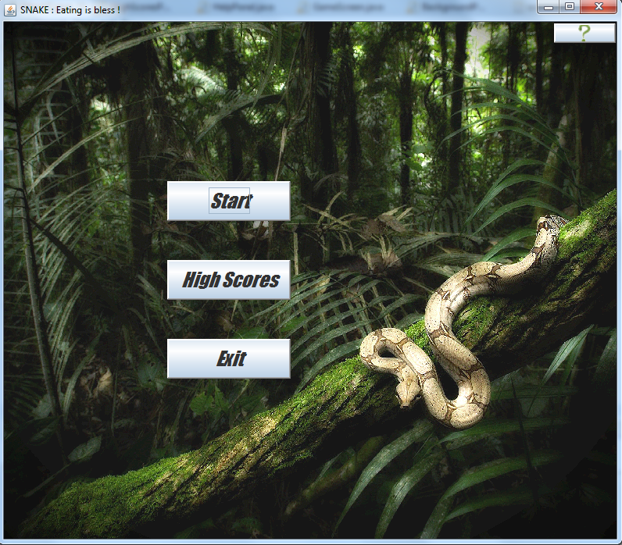

Start of the game we meet the beginning screen which has four different options with buttons.  
  
-Start button leads you to the login section.  
-Exit button provide us to quit from the game.  
-High Scores Button leads you to high scores panel which show us top three scores.  
-Help Button which is seen like question mark leads you to help panel which has useful info.  
When we was working on the help button at first we did the button like the others.Then we try to use an image icon for help button.You can see it at the right and top side of the picture which has question mark.

The size of the beginning screen is 800x700 and it can be maximized.For a better looking ,first we decide to use a background image include snake and forest behind it.Second we put border to button for explicit looking.

## Login Screen

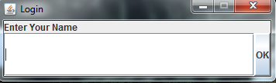  
When an user click on the start button,user meet the login screen which is shown above.Player need to write something and click on the “OK” button for play.We decide to use BorderLayout for this panel because it’s a unobtrusive panel and most of the player pass this panel quick.We try to do this panel simple and steady. ☺

## Help Screen C:\Users\12\Desktop\Java Gui Images\JavaGUI-3.png

As you can see Help Screen provide necessary and basic information about the game to player.

High Scores Panel  
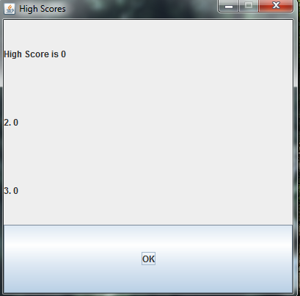

In high scores panel we used “GridLayout” for better and regular listing.We don’t want to use background for it.

## Game Screen

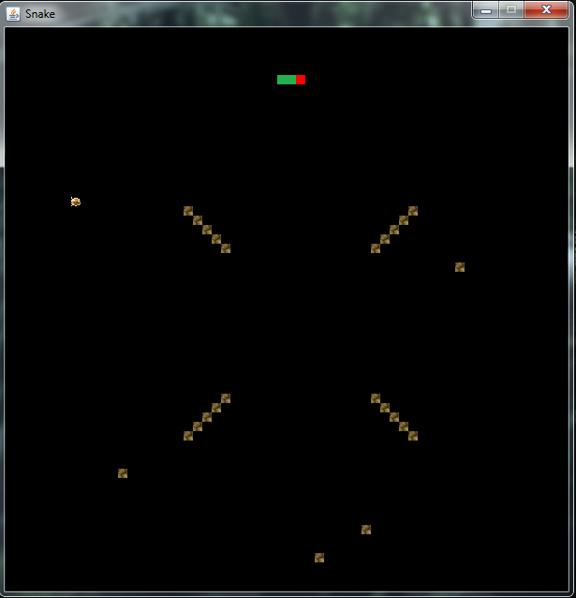

For game screen we used square objects for snake,food and obstacles.Every object has 10x10 pixels area.Previously we just use a random food on entire map.Then we try to at some random obstacles taking examples and we added four of them.After,using array we added ordered obstacles and we create a map like above.We called it “Ladder Obstacles”.

On the other hand, beginning of the game snake has three square parts.Two of them is it’s own body and one of them is the head of the snake.As food we use little delicious hamburgers ☺Besides we choose different color for the head of the snake for a better playing opportunity.

We tried to accelerate snake when it ate food but we could not handle it.But it’s all about delay value.If you decrease delay value in the code snake will move faster.Anyway we think we found the most appropriate velocity for the game.

For background we tried a lot of super beautiful picture including gif's.

## Game Over Screen C:\Users\Berserker\Desktop\GameOverScreen.png

When snake eats its own body and hits the wall or obstacle,game is over.Score counted respect to food.If player achived to eat a food with snake , player earns one score point.  
GameScreen shows username and it's score.We use I/O handling for that.

# To Sum Up

We achived to create a basic snake game with Java.(We used Eclipse for IDE).We made mistakes and took lessons from them.Especially our time management gone wrong.We gonna try a lot of things for the game becacuse it's always open for an update.If we had time we gonna try add music to game while playing,different level sections,accelerate the snake during the time,different maps and different image icons for the buttons...etc.Last of all , this is our first java project and it gave us many information and experience and still giving. :)

# 