Robotics assignments and simulation results
  - Omar Zid
Informatics in Robotics | 14 October 2026
This collection covers the introductory environment scanner, both laboratory reports, four robot projects, and the coordinate transformation exercises. It includes worked calculations with units, simulation results, performance checks, and implementation notes.
All robot measurements in this collection are simulated. The package includes reproducible numerical models and separate NXC sources for physical testing. No physical robot run, sensor calibration, or Bluetooth hardware exchange is claimed.

Contents
1. Introduction - Environment scanner demonstration
2. Report 1 - Exploring motors
3. Report 2 - Exploring sonar and color sensors
4. Project 1 - Clean the Ring
5. Project 2 - SCANNER
6. Project 3 - Obstacle Avoidance
7. Project 4 - Single-Sensor PID Line Follower
8. Kinematics exercise solutions

Using the package
Start_Here.html provides the demonstration and links to the individual reports. Each assignment has an editable Word document and a PDF. The code folder contains the NXC programs. The data folder retains raw measurements, event traces, plots and check results. Use the simulation scripts to reproduce the numerical results.

Introduction Environment scanner demonstration
  - Omar Zid
Informatics in Robotics | 14 October 2026
Simulation study. All numerical measurements are generated by the supplied software models. They are not measurements from a physical LEGO NXT robot. Hardware behavior requires calibration and testing.
Omar Zid | Working numerical demonstration. Scanned 36 headings; selected 30°; stopped on the simulated red strip at 678.0 mm. This optional evidence note supports the introduction's final task; the supplied page says no formal report.
Assignment source: Screenshot_1.png: Introduction (2h - none reports)

1 Task and demonstrable outcome
The introduction requests a 360° environment scanner that logs observations, visualizes them on the screen, chooses the most free direction, drives that way and stops on red. The supplied page labels this session ‘none reports’. This short evidence note accompanies the code and data so the teacher can inspect the complete calculation and outcome.
The demonstration models a differential-drive robot using NXC-style motor/sensor control concepts. The scan, chosen direction and stopping trace are numerically executed. All environment distances, sensor observations and timing are simulated. A BricxCC installation, brick connection, download, physical screen and device memory operation are not claimed as completed hardware tasks.

2 Geometry environment and scan method
Wheel diameter is assumed D = 56 mm; wheel-centre track is assumed B = 120 mm. The model room spans x = -1000 to 2000 mm and y = -1200 to 1500 mm. Two circular obstacles are centred at (900, 0) mm with radius 200 mm and (-500, -500) mm with radius 180 mm. The initial robot centre is (0, 0); heading zero points along +x and positive angles are counterclockwise.
An exact geometric ray cast provides simulator truth. Every 10° heading has three sonar observations, generated with the same scale/offset/noise form as Report 2. The three-reading mean is stored with its sample standard deviation. A whole-body in-place rotation is used conceptually, not a sensor turret; scanning therefore requires opposite wheel movements and a settled read after each turn.
The score at each heading is the minimum mean clearance of that heading and its adjacent ±10° headings. This avoids choosing a narrow isolated maximum. A three-sample smoothing rule does not prove that a real robot fits through a gap; body width, sensor offset, obstacle shape and angular uncertainty still require margin and checks.
$Body heading step ψ = 10° = 0.174533 rad. Wheel travel magnitude = Bψ/2 = 120 × 0.174533/2 = 10.472 mm.$
Wheel shaft step magnitude = 360 × 10.472/(π × 56) = 21.429°. Rotate opposite wheels by ±21.429° for one ideal 10° body turn.
A 360° body scan requires 36 steps and ±771.429° wheel-shaft rotation in this geometry. Shaft angle is not body heading.
$Score(θi) = min[mean d(θi-10°), mean d(θi), mean d(θi+10°)] with circular indexing.$
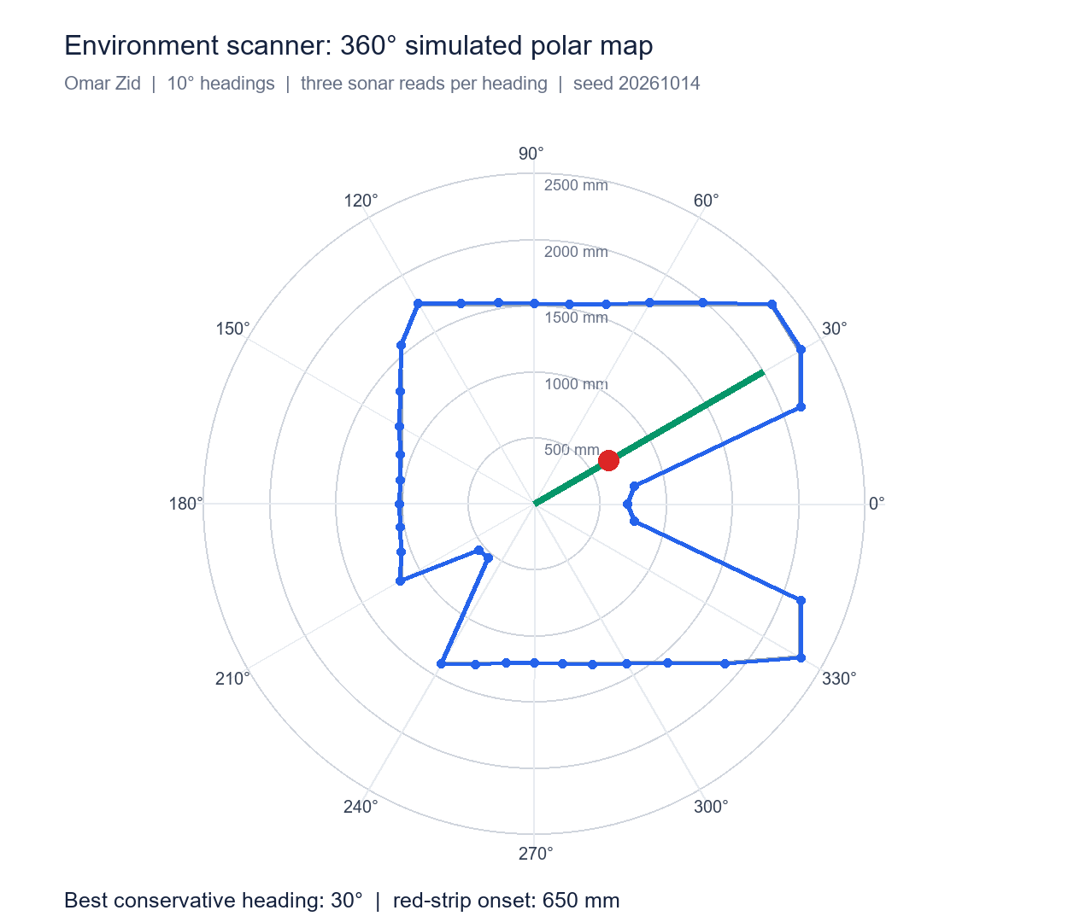
The grey outline is ray-cast truth; blue points are observed three-read means. The green line marks the selected heading and the red point marks the strip's onset.

3 Scan selection and logged evidence
The selected direction is 30°. Its mean observed clearance is 232.67 cm and its conservative neighboring score is 214.33 cm. Geometric truth along that ray is 2309.4 mm. The observed and true values differ because the declared sensor model includes scale, offset, noise and integer-centimeter reporting.
Store heading in degrees and range in centimeters in an on-brick file, with consistent column labels. The desktop simulation saves every raw trial in intro_scan_trials.csv and all means/scores in intro_scan_summary.csv. A simple brick display can show current heading/range, selected heading and motion state; the polar figure here is the detailed teacher-facing visualization.
When a real sonar returns a missing or invalid echo, label it unknown and do not treat it as guaranteed clear space. This scenario remains within the declared model's useful range. A real scanner also needs obstacle monitoring during the drive, a maximum travel limit, a manual stop and safe handling of failed sensor reads.
Quantity | Simulated result
Headings / observations | 36 / 108
Angle spacing | 10°
Selected heading | 30°
Mean range at chosen heading | 232.67 cm
Conservative score | 214.33 cm
True ray clearance | 2309.4 mm

4 Red detection delay and stopping distance
The robot drives at an assumed 120 mm/s. A red strip spans 650-740 mm along the chosen ray. Color is checked every 50 ms with an assumed 40 ms physical color delay. Two consecutive red observations command braking; deceleration is 600 mm/s². Speed and stopping-distance values are chosen for this simulation and are not motor power-to-speed specifications.
The brake command occurred at t = 5.55 s; the robot reached zero velocity at t = 5.75 s and x = 678.0 mm. The terminal point lies within the red strip. Remaining ray clearance was 163.1 cm. The red stop has a finite overrun and cannot be modeled as an instantaneous halt at 650 mm.
The complete event trace records physical surface, observed color, confirmation count, control state, velocity, traveled distance and remaining clearance. It distinguishes red detection from the final mechanical stop. The report's terminal distance refers to the robot centre; a physical sensor mounted ahead of the axle introduces an additional geometric offset.
$Nominal braking time = v/a = 120/600 = 0.200 s.$
$Braking distance = v²/(2a) = 120²/(2 × 600) = 12.0 mm.$
Additional sensing/confirmation travel depends on phase: one 40 ms response delay contributes 4.8 mm; one 50 ms confirmation interval contributes 6.0 mm; polling phase can add up to 6.0 mm.
$Terminal overrun beyond strip onset = 678.0 - 650 = 28.0 mm; observed finite-phase trace determines this value.$
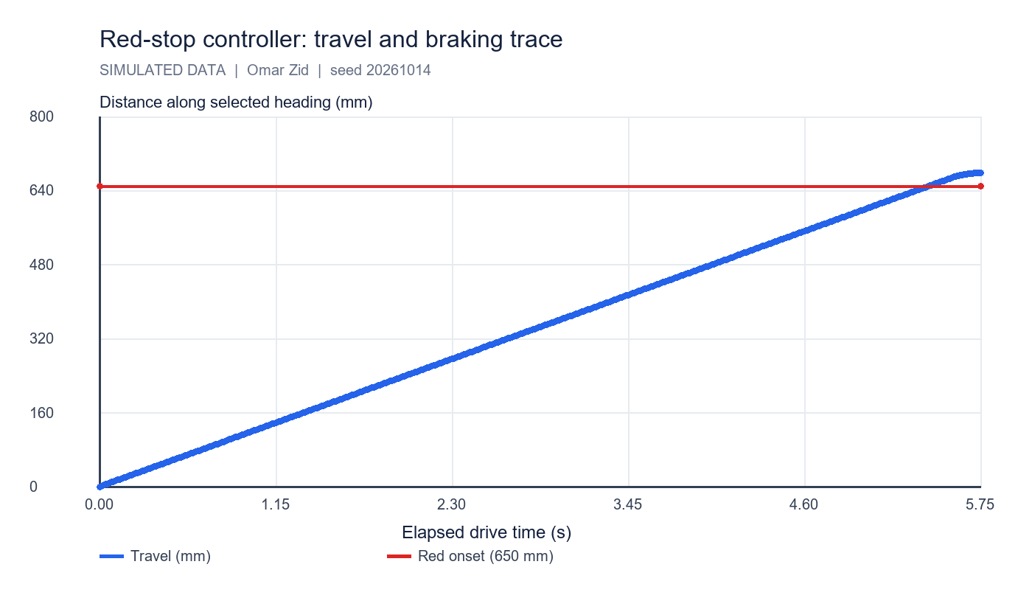
Travel rises at the modeled drive speed and flattens during braking. The controller stops inside the red strip.

5 Concurrent tasks I O and file handling
A sensor/logging task can read sensors and update shared state while a movement task issues drive commands. Guard a shared snapshot with a mutex: acquire the lock, copy or update the small state structure, release the lock, then perform slow display/file operations outside the critical section. A mutex prevents inconsistent concurrent access; it does not make sensor data newer.
Buttons should provide start/stop or trial selection; the display should expose state and units. BricxCC offers brick tests, file management and a remote NXT Screen with polling, which supports inspecting a robot with a damaged or inaccessible screen. Files should be opened with a checked status, sized to hold the intended log, closed after writing and downloaded for analysis.
In a simulation, desktop CSV writing demonstrates logging successfully. The NXT file-system capacity, free space and BricxCC transfer remain hardware validation steps. The supplied short guide contains older timing notation; use the full tutorial/API millisecond convention consistently when implementing Wait and timers.

6 Reproducibility and conclusion
All scan, score and stop-state checks passed. Seed 20261014 reproduces the same 30° selection and 678.0 mm terminal travel. The demonstration satisfies the introduction's functional sequence in the model and provides the teacher with visible calculations, plots and raw event data.
Run simulation/lab_simulations.py. Evidence files: intro_scan_trials.csv, intro_scan_summary.csv and intro_red_stop_trace.csv; plots: intro_scan_polar.png and intro_stop_trace.png. Hardware reproduction should replace room assumptions, wheel geometry, sensor offset and timing values with measured inputs while retaining the same logging and analysis method.

References
Supplied Screenshot_1.png: Introduction (2h - none reports), final Environment Scanner task.
Supplied __NXC_tutorial.pdf: sensors, tasks, mutexes and file operations.
Supplied _NXC_min.pdf: BricxCC basics; compare timing notation with the full tutorial before use.

Files for reproducing and demonstrating the result
NXC source: 00_intro_scan.nxc and 00a_intro_io_parallel.nxc. Shared configuration: common_config.nxc.
Open Start_Here.html in the package for visual results and file links. Run the scripts in the simulation folder to regenerate the data and checks. The code folder contains the NXC source program and hardware configuration notes. The simulation implements a separate software model; it does not execute the NXC binary.

Report 1 Exploring motors
  - Omar Zid
Informatics in Robotics | 14 October 2026
Simulation study. All numerical measurements are generated by the supplied software models. They are not measurements from a physical LEGO NXT robot. Hardware behavior requires calibration and testing.
Omar Zid | Reproducible simulation | 60 test trials. Largest mean signed angle error: -1.60° at -450° and power 80%. No physical experiment is claimed.
Assignment source: Screenshot_2.png; __NXC_tutorial.pdf, pp. 31-34

1 Aim and measurement plan
The assignment asks for a program that displays the current motor-shaft position, checks commands of 45°, 450° and 650°, and investigates counter resets. A negative command and three powers are added to test direction and the effect of speed. The supplied tutorial explains limited-angle movement, braking and feedback regulation.
One motor represents a wheel-driven NXT system. Each angle/power combination has five simulated repetitions from a reset zero. An independent angle fixture provides the reference observation. Command angle, ideal simulator truth, integer tacho observation and external observation are stored in separate columns so agreement of two tacho-based values cannot masquerade as independent verification.
These are software-generated observations. The model tests calculation, logging and control logic, while the actual brick, loading, battery condition, friction and firmware behavior still require a hardware check. All numerical precision and uncertainty assumptions below belong to this model.

2 Declared model and calibration
Geometry: wheel diameter D = 56 mm and wheel-centre track B = 120 mm are assumed construction values. Shaft angle is unwrapped; 450° and 650° represent more than one revolution. A power value is a control setting, not a measured angular velocity.
Injected tacho relation: raw = round(1.003 × true angle + 0.65° + noise), noise standard deviation 0.24°. The independent fixture has 0.35° noise and a 0.5° reporting step. The assumed tacho output step is 1°; neither step proves the physical hardware's accuracy. Calibration uses 35 independent readings at seven reference positions from -720° to +720°.
Least-squares calibration gave raw = 1.0031537 × external + 0.72880°. The residual standard deviation was 0.613°. Apply θcal = (raw - 0.72880)/1.0031537. The commanded angles are not used as the calibration response, preventing command error from being calibrated away.
Position truth includes a small power-dependent overshoot: signed mean increment 0.12° + 0.012° × power, plus trial noise σ = 0.12° + 0.007° × power. Motion time is |θ|/(5.6 × power) + 0.15 + 0.0015 × power seconds, plus 0.008 s noise, rounded to 1 ms. These constants are chosen for an illustrative simulation, not fitted to a real motor.

3 Results angle repeatability and motion time
The reference mean is the average of five external observations. The signed error is mean reference - commanded angle. Sample standard deviation describes trial repeatability; it does not remove a systematic offset. Expanded uncertainty U with coverage factor k = 2 is calculated below and retained for every condition in motor_summary.csv.
Higher power shortened the modeled motion duration and generally increased overshoot and scatter. A small 45° command can have a noticeably larger percentage error than a 650° command even when the absolute error is similar. Thus angle error and time must both be reported.
Command (°) | Power (%) | Ref. mean (°) | s (°) | Error (°) | Time (s)
45 | 30 | 45.30 | 0.27 | 0.30 | 0.463
45 | 50 | 45.70 | 1.04 | 0.70 | 0.388
45 | 80 | 46.20 | 0.84 | 1.20 | 0.378
450 | 30 | 450.50 | 0.35 | 0.50 | 2.877
450 | 50 | 450.50 | 0.35 | 0.50 | 1.839
450 | 80 | 450.50 | 0.94 | 0.50 | 1.277
650 | 30 | 650.80 | 0.84 | 0.80 | 4.067
650 | 50 | 651.00 | 0.35 | 1.00 | 2.550
650 | 80 | 650.80 | 0.45 | 0.80 | 1.722
-450 | 30 | -450.40 | 0.42 | -0.40 | 2.879
-450 | 50 | -450.50 | 0.61 | -0.50 | 1.827
-450 | 80 | -451.60 | 0.42 | -1.60 | 1.281

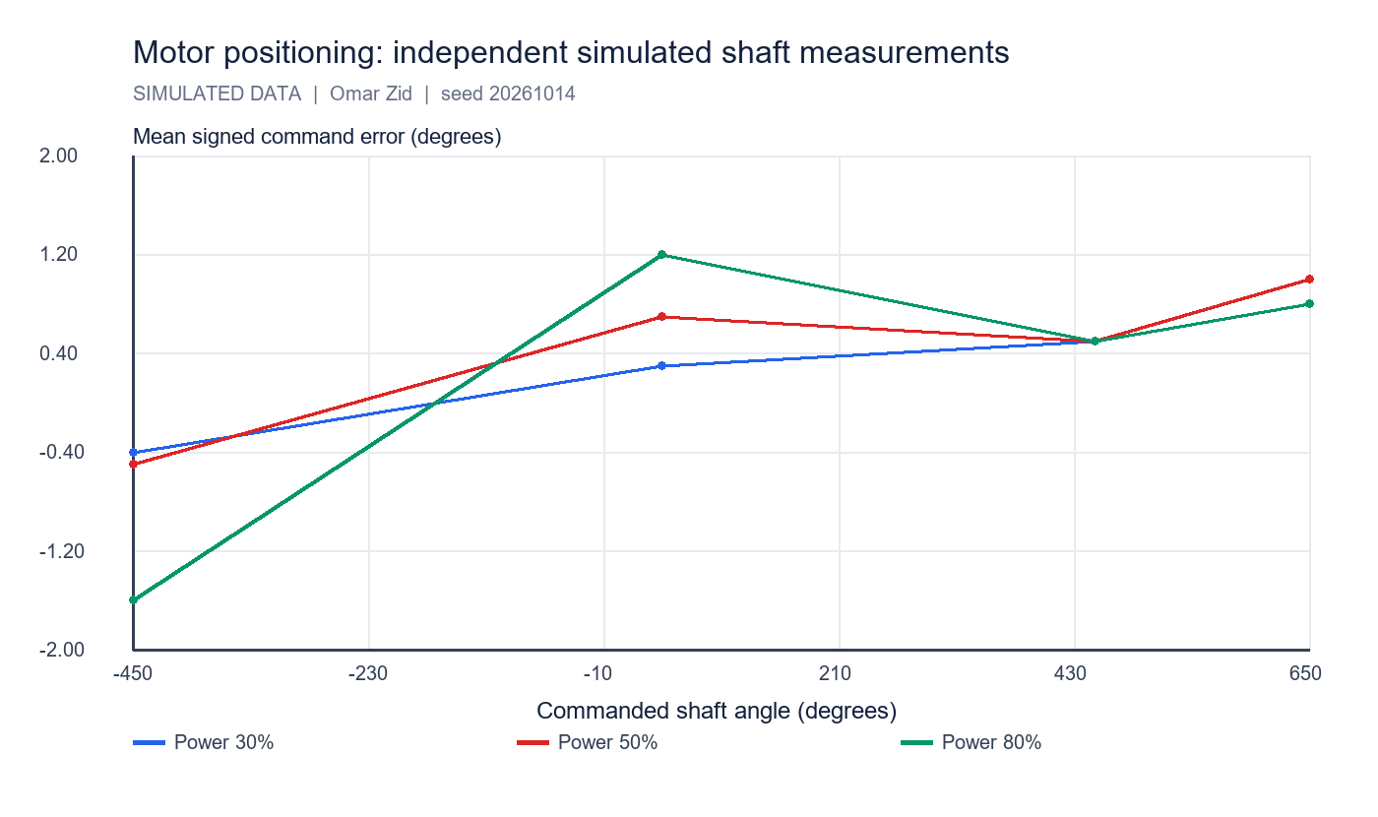
Mean command errors use the independent reference, not the calibrated tacho itself. Each point represents five simulated trials.

4 Worked calculations and uncertainty
For the 450° command at power 50%, mean external angle = 450.50°, s = 0.354°, mean duration = 1.839 s. Raw rows are retained in motor_trials.csv so all means and scatter can be recalculated.
The uncertainty calculation treats the independent reference noise/reporting step as an additional conservative type-B component. Quantization of the tacho is already present in the calibration residuals; it is not added again to the external-reference uncertainty. This simplified budget excludes real mounting error, backlash, drift and load-dependent deformation.
$x̄ = Σxi/n; s = √[Σ(xi - x̄)²/(n - 1)].$
$e = 450.50° - 450° = 0.50°; relative error = 100 e/450 = 0.111\%.$
$u_ref = √(0.35² + 0.5²/12) = 0.379°; U = 2√(s²/5 + u_ref²) = 0.82°.$
$s_wheel = πD θ/360 = π × 56 mm × 450.50/360 = 220.16 mm.$
One degree at D = 56 mm corresponds to π × 56/360 = 0.489 mm of nominal rolling travel. This conversion assumes no slip.
For an in-place body turn ψ = 10°, each wheel travels ±Bψ/2 = ±10.472 mm (ψ in radians); required shaft angle = ±Bψ(deg)/D = ±21.429°. Body heading and shaft angle are different quantities.

5 Counter resets and displayed position
The official NXC API distinguishes the tachometer count/limit reset from the program-relative rotation count reset. ResetTachoCount acts on the tacho counter and its limit goal. ResetRotationCount acts on the program-relative position counter read with MotorRotationCount. Resetting a counter changes its zero reference; it does not physically return the shaft to zero.
The exact trace below isolates reset semantics with relative movement increments. In a brick program, movement helpers may request their own counter resets; read values before and after the helper and verify which counter is displayed. Apply resets while stopped and allow the firmware update to complete before interpreting the result.
For a readable screen show target angle, current relative tacho angle, unwrapped program-relative angle and trial time with units. To show orientation within one revolution use ((angle % 360) + 360) % 360; retain the unwrapped angle in the file.
Event | Physical shaft (°) | Tacho (°) | Program relative (°)
Initial | 0 | 0 | 0
Relative move +450 | 450 | 450 | 450
ResetTachoCount only | 450 | 0 | 450
Relative move -45 (no automatic reset) | 405 | -45 | 405
ResetRotationCount only | 405 | -45 | 0
Relative move +650 (no automatic reset) | 1055 | 605 | 650

6 Conclusion and reproducibility
The modeled motor performed both directions and all requested rotations. Across the 60 trials, mean absolute command error of the independent observations was 0.783°. This is a simulator result, not a real NXT accuracy claim.
The useful result is a traceable test method: an independent angle check, a calibration equation, repeated observations, signed/relative errors, uncertainty and elapsed time. Counter-reset behavior is explicit, so the screen can show what its zero means. For physical validation mark the shaft, measure the true rotation independently, repeat the same matrix and replace the generated CSVs with logged readings.
Reproduce with simulation/lab_simulations.py. Seed = 20261014. Files: motor_calibration.csv, motor_trials.csv, motor_summary.csv and motor_counter_reset_trace.csv. Self-checks cover trial count, independent readings, gain recovery, negative direction and zero-reference behavior.

References
Supplied Screenshot_2.png: Report_1 Exploring motors (4h).
Supplied __NXC_tutorial.pdf, pp. 31-34: limited-angle motion, sign convention and PID explanation.
NXC official API, Output module functions: https://bricxcc.sourceforge.net/nbc/nxcdoc/nxcapi/group___output_module_functions.html
NXC official API, ResetTachoCount: https://bricxcc.sourceforge.net/nbc/nxcdoc/nxcapi/group___output_module_functions_ga89b494fec2591253658a55cc74d7c6e7.html
NXC official API, ResetRotationCount: https://bricxcc.sourceforge.net/nbc/nxcdoc/nxcapi/group___output_module_functions_ga1f07b7f5f06116fffe738f699d0ce83f.html

Files for reproducing and demonstrating the result
NXC source: 01_motor_measurements.nxc. Shared configuration: common_config.nxc.
Open Start_Here.html in the package for visual results and file links. Run the scripts in the simulation folder to regenerate the data and checks. The code folder contains the NXC source program and hardware configuration notes. The simulation implements a separate software model; it does not execute the NXC binary.

Report 2 Exploring sonar and color sensors
  - Omar Zid
Informatics in Robotics | 14 October 2026
Simulation study. All numerical measurements are generated by the supplied software models. They are not measurements from a physical LEGO NXT robot. Hardware behavior requires calibration and testing.
Omar Zid | Reproducible simulation | 80 sonar distance trials, 340 angular trials and 270 color trials. Color classification: 97.0% in the declared model. Software read time, fresh sampling and physical response are reported separately.
Assignment source: Screenshot_3.png; __NXC_tutorial.pdf, p. 21

1 Aim apparatus model and procedure
The task asks for sonar speed, accuracy and field of action; color speed, resolution, response to color and illumination; and the operating principle and uses of one further sensor. This report selects a single-axis rate gyroscope for the final part.
A simulated stationary rig positions a broad target at 5-240 cm, then sweeps a 20 cm target through -40° to +40° at two distances. A color rig varies six matte swatches, assumed ambient illumination 100/300/800 lux and sensor standoff 10/20/30 mm. Ten sonar and five color repetitions per condition retain raw readings. The target geometry, timing constants, signal steps and noise values below are assumptions, not verified LEGO specifications.
Distance references have an assumed standard uncertainty 0.20 cm. Lux values are controlled simulator inputs, not measured light-meter readings. Separate calibration data are generated before test trials. A fixed random seed makes every observation reproducible and identifiable as simulated.

2 Sonar calibration accuracy and uncertainty
The valid-range model returns round(1.006d + 0.30 cm + Gaussian noise), with noise σ = 0.25 cm + 0.004d. It deliberately returns a no-echo sentinel at d < 8 cm or d ≥ 250 cm. These boundaries and the 1 cm output step are illustrative model settings. No-echo values are not averaged as if they were target distances.
Thirty calibration observations at 20, 40 and 80 cm yielded y = 1.007567d + 0.00849 cm; residual standard deviation 0.538 cm. Correct distances using dcal = (y - b)/a. The independent test matrix shows maximum raw mean bias 1.90 cm; mean absolute calibrated individual error is 0.598 cm.
Sample s describes repeatability of the raw distance observations. Corrected bias compares the calibrated mean with the known model distance. Expanded uncertainty U uses k = 2 and includes mean repeatability, assumed reference uncertainty and linear-calibration prediction uncertainty. Long-distance values extrapolate beyond the 80 cm calibration range; their larger uncertainty and sensitivity to slope are retained.
$e = x̄ - dref; MAE = Σ|xi - dref|/n; s = √[Σ(xi - x̄)²/(n - 1)].$
$u_cal(d) = (s_fit/a)√[1/Ncal + (d - d̄cal)²/Σ(dj - d̄cal)²].$
U = 2√[s_corrected²/n + (0.20 cm)² + u_cal(d)²]. Output quantization is present in trial scatter and calibration residuals, so it is not added twice.
A 1 cm reporting step does not imply ±1 cm accuracy. Systematic bias, reflectivity, target angle, multiple echoes and temperature can affect a physical sensor.
Truth cm (n) | Raw mean (cm) | s (cm) | Raw bias (cm) | Cal. bias (cm) | U cal. (cm)
5 (0/10) | No echo | - | - | - | -
10 (10/10) | 10.40 | 0.52 | 0.40 | 0.31 | 0.62
20 (10/10) | 20.50 | 0.53 | 0.50 | 0.34 | 0.59
40 (10/10) | 40.50 | 0.53 | 0.50 | 0.19 | 0.56
80 (10/10) | 80.70 | 0.67 | 0.70 | 0.09 | 0.67
120 (10/10) | 120.80 | 0.63 | 0.80 | -0.12 | 0.83
180 (10/10) | 181.00 | 1.05 | 1.00 | -0.37 | 1.31
240 (10/10) | 241.90 | 1.52 | 1.90 | 0.07 | 1.84

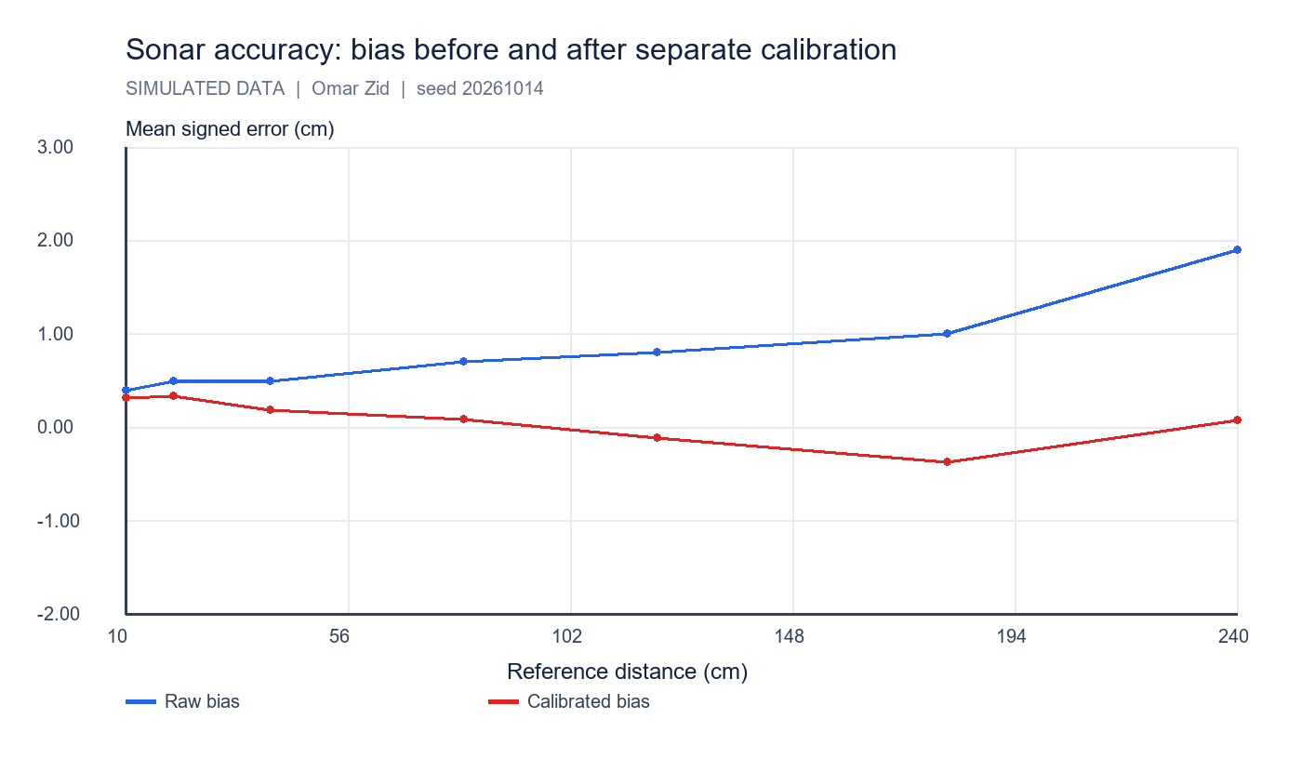
Separate calibration reduces the injected scale/offset error. It does not guarantee real-world accuracy.

3 Angular field of action
Detection is generated using P = 1/[1 + exp((|α| - h)/2.5°)], where h = 12° + atan(10 cm/d) in degrees. The assumed 12° core and 2.5° transition width are model constants. Target width contributes to the apparent field, so a measured detection cone is specific to this target and range.
At least 8 detections out of 10 defined the operational threshold. For the 20 cm target at 50 cm, accepted sampled angles ran from -15° to 15°; at 100 cm they ran from -10° to 15°. The sweep spacing is 5°; threshold boundaries are therefore only localized to approximately one angular sample, and finite trials add binomial uncertainty.
A physical field-of-view test must use a fixed object and a repeatable turntable, record misses and repeated hits, and state target material, dimensions, distance and criterion. A single sonar reading cannot prove that the entire surrounding region is clear.
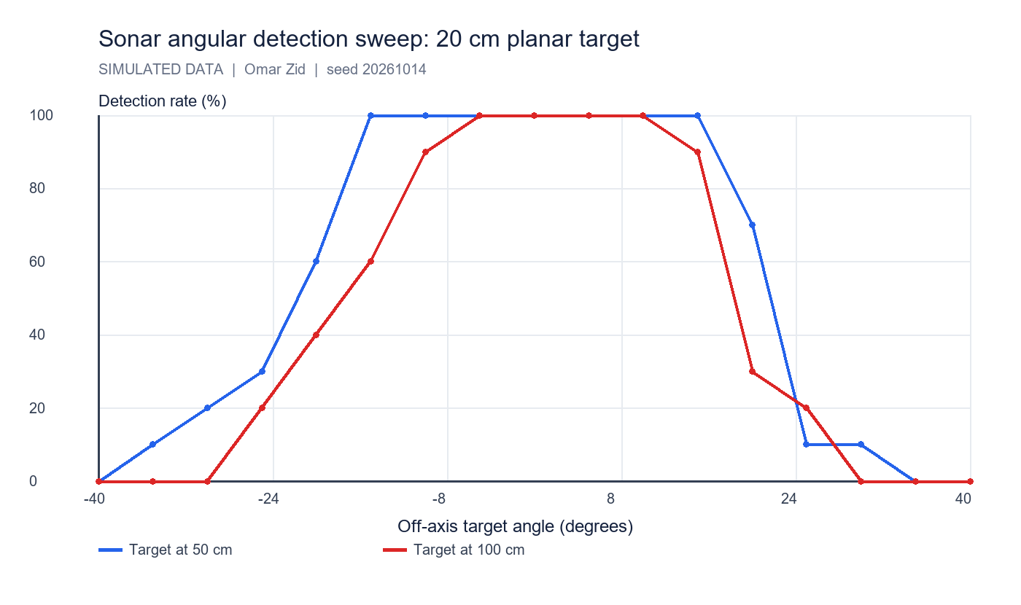
Detection percentage versus off-axis angle for two distances. These curves are generated by the declared model and do not assert a manufacturer's beam specification.

4 Speed software read update interval and physical response
Mean simulated sonar read-call latency is 3.18 ms. A software loop reads every 20 ms, while the assumed sonar state refreshes every 80 ms. Faster polling repeats cached data. A target step from 120 to 40 cm occurs at 250 ms; response delay is 40 ms and time constant 25 ms. The first changed observation appears after 70 ms, and the reading reaches ±2 cm of its final value after 150 ms.
These three times answer different questions: how long a function call blocks; how often fresh measurements become available; and how quickly a changed physical target affects the reported output. Only the latter two constrain a stopping controller. Reading faster is useful for scheduling but does not manufacture fresh sensor information.
For the color step test, software reads average 2.11 ms; assumed fresh updates occur every 40 ms. The physical model has 30 ms delay and 20 ms time constant. A white-to-red step at 250 ms is first classified red after 70 ms. The sampled 10-90% green-channel transition spans 40 ms; 40 ms sampling limits its time resolution.
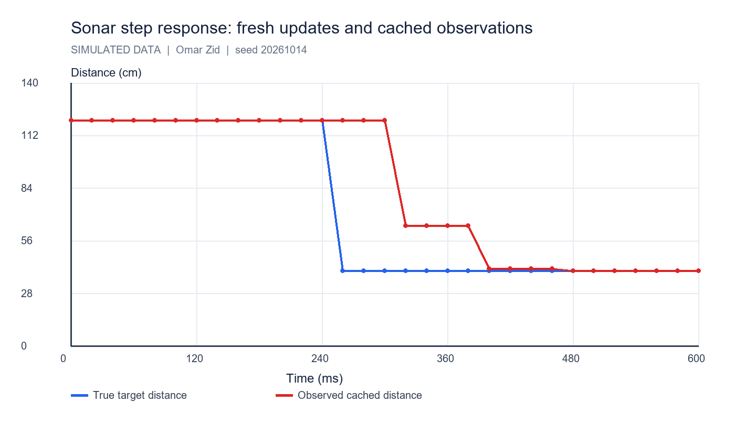
A 20 ms polling loop repeatedly sees the same value between fresh 80 ms updates. The physical response time is much longer than the read-call latency.

5 Color channels calibration and lighting response
Full-color logs contain simulated raw red/green/blue and a blank ambient channel. Per-channel dark offsets are (22, 25, 21) counts and gains (1.00, 0.91, 1.07). Raw counts follow dark + 0.18 × lux + gain × 800 × ρ/[1 + (h/18 mm)²] + noise. Channel noise σ = 4.5 + 0.006 × lux counts. A white reference under the same light and standoff normalizes each channel.
The ratio norm = (raw - dark - blank)/(white - dark - blank) estimates reflectance in the model. Raw RGB responds to mounting distance and ambient light; subtracting the blank and dividing by a matched white reduces these changes. Normalized ratios are custom calculated values. They are not claimed to be the firmware's normalized arrays or its built-in classifier.
NXC exposes full-color, red/green/blue illumination and no-light configurations. ReadSensorColorEx returns a color value plus raw, normalized and scaled arrays; the raw/array API requires compatible NXT 2.0 firmware. The custom CSV separately records our reproducible classifier. Red-only illumination yields an intensity measurement; no-light mode supports ambient measurement and comparison.
$ρR = (Rraw - Rdark - blank)/(Rwhite - Rdark - blank); equivalent expressions for G and B.$
$Red at 300 lux and 20 mm: normalized R mean = 0.810, sample s = 0.0232. Mean standard error = s/√5 = 0.0104.$
The assumed raw output step is one model count; trial σR = 5.15 counts. A 3s discrimination criterion is approximately 15.4 counts or 0.069 in normalized R under this condition. This is practical modeled resolution, not sensor ADC bit depth.
Swatch | Raw R mean ± s | Norm R | Norm G | Norm B | Correct n
red | 365.0 ± 5.15 | 0.810 | 0.104 | 0.076 | 5/5
green | 119.4 ± 4.83 | 0.125 | 0.697 | 0.112 | 5/5
blue | 105.8 ± 3.03 | 0.085 | 0.153 | 0.780 | 5/5
yellow | 348.6 ± 8.91 | 0.764 | 0.677 | 0.075 | 5/5
white | 376.2 ± 8.07 | 0.840 | 0.847 | 0.837 | 5/5
black | 87.0 ± 4.85 | 0.036 | 0.042 | 0.044 | 5/5

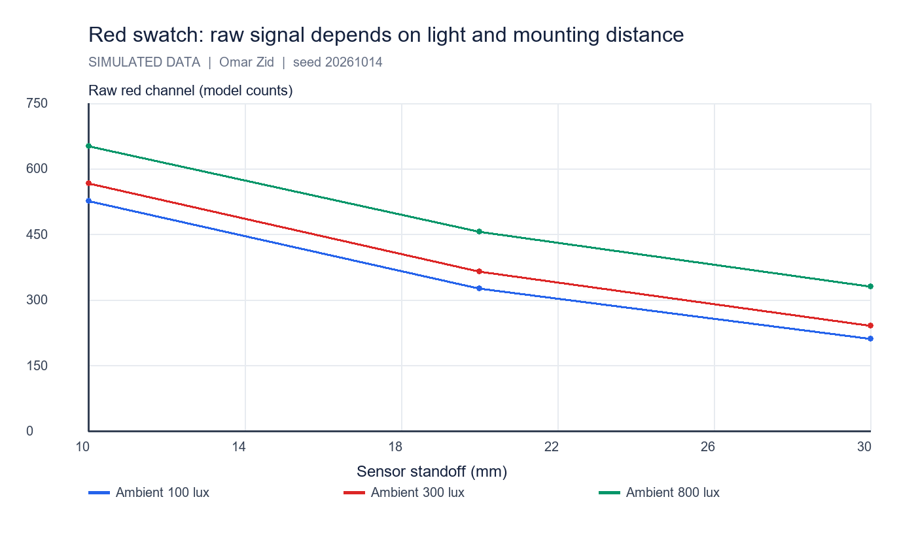
Each point averages five red-swatch trials. Ambient light raises raw readings and larger standoff reduces active reflection.

6 Classification and resolution limits
The classifier first separates black (all normalized channels < 0.085), white (minimum > 0.58 with channel spread < 0.15) and yellow (R > 0.35, G > 0.30, B < 0.20). Otherwise the strongest RGB channel must represent > 55% of total signal; ambiguous outputs are marked unknown. These thresholds are declared design choices, not calibrated real LEGO color IDs.
The 270 trials achieved 97.04% correct classifications in the declared model. All individual errors remain in color_trials.csv and the full confusion matrix. A high classification score for these separated swatches does not establish the number of colors a real sensor can distinguish or its smallest intensity increment.
Resolution is evaluated from within-condition scatter and the reporting step. Color identification, reflectance resolution and light intensity are separate outputs. Larger standoff weakens the reflected signal; larger ambient illumination raises noise in this model. For a real test, include near-threshold shades, glossy surfaces and shadow changes, and replace assumed lux with a light-meter observation.
Ambient (lux) | Standoff (mm) | Correct / trials | Accuracy (%)
100 | 10 | 30/30 | 100.0
100 | 20 | 30/30 | 100.0
100 | 30 | 28/30 | 93.3
300 | 10 | 30/30 | 100.0
300 | 20 | 30/30 | 100.0
300 | 30 | 30/30 | 100.0
800 | 10 | 30/30 | 100.0
800 | 20 | 28/30 | 93.3
800 | 30 | 26/30 | 86.7

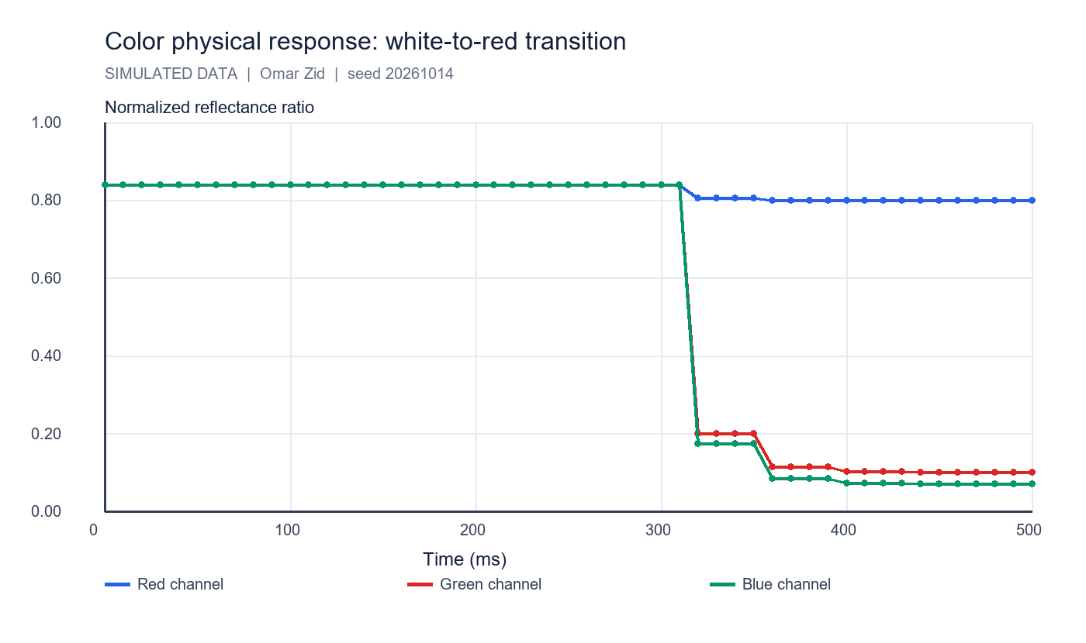
Normalized channels converge after the modeled physical white-to-red step; successful classification is a threshold event during that transition.

7 Further sensor single axis rate gyroscope
A rate gyroscope measures angular velocity about its sensitive axis. With a known starting orientation, numerical integration estimates the change of heading. It does not directly provide an absolute compass heading. The official FIRST implementation documentation for the legacy HiTechnic NXT gyro describes a single-axis rate output; this report uses its operating principle without assuming that such a sensor is physically present.
In a separate illustrative model, stationary rate bias is +0.8°/s with noise σ = 0.18°/s. Average 100 stationary samples before motion: estimated bias 0.8039°/s, s = 0.1737°/s. Sample at an assumed 100 Hz. A true 45°/s turn lasting 2 s gives 90°. Over the complete 5 s trace, uncorrected integration gives 94.080°; bias-corrected integration gives 90.061°.
Applications include turn-angle feedback, detecting unintended rotation, balancing control and comparing wheel odometry with body rotation. Remaining bias causes heading drift proportional to elapsed time; vibration, temperature changes and axis alignment require calibration. Combine rate with wheel encoders or a compass for longer-term orientation. Compass readings can be disturbed by local magnetic fields; an accelerometer measures specific force and cannot separate tilt from all vehicle accelerations without further assumptions.
$b̂ = (1/N)Σωstationary; ωcorrected = ωraw - b̂.$
$θk = θk-1 + ωcorrected,k Δt; units: (degrees/second) × seconds = degrees.$
Residual bias 0.1°/s accumulates 6° heading error in 60 s. This is a dimensional example, not a measured drift specification.

8 Conclusions and files
The models demonstrate a working test approach with separate truth, observation, calibration and error calculations. Sonar misses are explicit; angular detection is target dependent; fresh updates and physical response govern usable speed. Color calibration improves consistency, while raw intensity alone depends on illumination and geometry. The rate gyro example shows why stationary bias subtraction is essential before integration.
Reproduce with simulation/lab_simulations.py, seed 20261014. Sonar files: calibration, distance trials/summary, angular trials/summary and step response. Color files: trials/summary, confusion matrix, mode comparison and step response. Gyro files: stationary calibration and turn trace. All are CSVs under data/labs. No physical measurements, manufacturer precision or installed-device claims are implied.

References
Supplied Screenshot_3.png: Report_2 Exploring sonar and color sensor (4h).
Supplied __NXC_tutorial.pdf, p. 21: ultrasonic sensor example and low-speed configuration.
NXC official API, Input module functions: https://bricxcc.sourceforge.net/nbc/nxcdoc/nxcapi/group___input_module_functions.html
NXC official API, Color sensor array indices: https://bricxcc.sourceforge.net/nbc/nxcdoc/nxcapi/group___input_color_idx_constants.html
FIRST official legacy HiTechnic gyro implementation documentation: https://first-tech-challenge.github.io/SkyStone/com/qualcomm/hardware/hitechnic/HiTechnicNxtGyroSensor.html

Files for reproducing and demonstrating the result
NXC source: 02_sensor_measurements.nxc. Shared configuration: common_config.nxc.
Open Start_Here.html in the package for visual results and file links. Run the scripts in the simulation folder to regenerate the data and checks. The code folder contains the NXC source program and hardware configuration notes. The simulation implements a separate software model; it does not execute the NXC binary.

Project 1 Clean the Ring
  - Omar Zid
Informatics in Robotics | 14 October 2026
Simulation study. All numerical measurements are generated by the supplied software models. They are not measurements from a physical LEGO NXT robot. Hardware behavior requires calibration and testing.
Omar Zid | Simulated result: 9/9 objects expelled in 175.96 s; robot stopped after a complete empty angular scan. The chassis stayed at least 75.00 mm inside the ring. The forward pusher reaches the boundary exactly, leaving zero extension tolerance in the ideal model.
Assignment source: Screenshot_4.png

Task deliverables and declared model
All trials in this report are reproducible software simulations produced for Omar Zid. They are not physical measurements, proof of NXC compilation, or evidence of testing a LEGO robot. Motor B is the left wheel; motor C is the right wheel; the one color/light sensor is S1 and the fixed forward ultrasonic sensor is S4. Wheel diameter D = 56 mm and wheel-center track B = 120 mm are explicit assumed calibration values. Replace them with measured values before a physical demonstration.
The task is to push every object outside the ring quickly, keep the robot inside, stop when clean, and display a map of ejection locations on the robot screen. The model includes sensing, wheel movement, contact pushing, reverse movement, verification and a small LCD-style map. Objects have radius 20 mm. Ring outer radius is 600 mm, with a black boundary band from radius 580 to 600 mm. The robot is represented by a circular 75 mm chassis and a narrow 150 mm forward pusher. The color sensor is aligned with the pusher tip; S4 is 70 mm forward of the axle center. Initial object centers must be outside a 180 mm staging radius, leaving room for the 150 mm pusher, its 40 mm half-width, and the 20 mm object radius while turning.
The start is the center with heading 0 rad. Nine separate rigid circular objects form the nominal scene. No object count or object positions are supplied to the controller: it receives ultrasonic distances while turning. Object IDs in the trace label the independent simulated scene for checking and plotting.
Quantity | Value | Unit / meaning
Outer ring radius | 600 | mm
Black boundary width | 20 | mm
Chassis radius | 75 | mm
Pusher / color offset | 150 | mm forward
Object radius | 20 | mm
Ultrasonic offset | 70 | mm forward

Search push boundary response and clean stop logic
SEARCH turns the robot through headings 0°-359° in 1° increments and reads one forward range ray at each heading. SELECT chooses the smallest measured surface range, giving a bearing close to the center of the nearest visible object. ALIGN turns to that bearing. PUSH advances at 110 mm/s. A 40 mm half-width pusher captures the selected object when the front makes contact; the object then moves with the front face. The simulation integrates each wheel movement rather than jumping between waypoints.
The color sensor reaches the inner black edge when the axle is 430 mm from the center. BOUNDARY_FINISH then travels the calibrated 20 mm band width at 40 mm/s, stopping at axle radius 450 mm. The pusher tip is at 600 mm and the object center at 620 mm, so the entire radius-20 mm object is outside or tangent to the ring. RETREAT reverses 450 mm on the same heading to the center. It then searches again. A successful clean stop requires a new complete scan with no object ranges inside the 900 mm search limit; absence of a detection while merely driving is insufficient.
At the farthest ring radius, adjacent 1° rays are approximately 10.47 mm apart. This is narrower than the 40 mm object diameter. Under the ideal ray, clear staging and minimum object-size assumptions, an unoccluded object cannot hide between samples. Occlusion is handled by repeatedly clearing the nearest visible object and rescanning. An independent test checks the true remaining objects when the controller declares completion. The 32-scan safety cap is a failure budget; it does not use the true initial object count.

Calculations with dimensions and units
The calculations distinguish chassis safety from the complete forward extension. A positive chassis margin does not imply a positive pusher margin. In this ideal model the pusher touches the outer border but does not cross it. Encoder distances are calculated from wheel circumference, not from motor percentages.
Wheel circumference C = πD = π × 56 mm = 175.929 mm/revolution. Straight wheel travel s = C × encoder_degrees / 360°.
Travel to first black reading = 580 mm - 150 mm = 430 mm. Finish travel = 600 - 580 = 20 mm. Maximum axle radius = 430 + 20 = 450 mm.
$Chassis margin = 600 - (450 + 75) = 75 mm. Complete forward-extension margin = 600 - (450 + 150) = 0 mm.$
$Ejected object center radius = 450 + 150 + 20 = 620 mm; its nearest point is 620 - 20 = 600 mm.$
A 450 mm forward run requires 450 / (π × 56) × 360 = 920.825° per wheel. Nine forward-and-reverse runs cover 9 × 2 × 450 = 8100 mm, matching the exported path 8100.000 mm.
An in-place 360° turn moves each wheel πB = π × 120 = 376.991 mm in opposite directions: 771.429° per wheel. Angular rate 0.9 rad/s corresponds to wheel speeds ±54 mm/s.
$Angular sampling chord = 2 × 600 mm × sin(0.5°) = 10.472 mm < 40 mm object diameter.$

Executed validation trials and exported map
The table contains executed trials; the alternate layout and initially empty ring exercise completion logic, not only the nominal arrangement. Time includes actual in-place scan/align rotations, push travel and reverse travel. The empty case stops only after taking all 360 range readings. An empty ring permits stopping even without pushing an object.
The ejection CSV records object ID, coordinates in mm and simulated time in s. The LCD image represents a 100 × 64 pixel display enlarged five times. Coordinates use u = 50 + 25x/600 and v = 35 - 25y/600. Rounding produces pixel locations; the marker numbers are display labels. Ejection coordinates are derived from encoder pose and assumed contact geometry, so they are estimates of where the push finished rather than an external camera survey.
Scene | Objects out | Search scans | Time (s) | Path (mm) | Chassis margin (mm)
nominal | 9/9 | 10 | 175.964 | 8100.0 | 75.0
dense | 12/12 | 13 | 235.130 | 10800.0 | 75.0
empty | 0/0 | 1 | 6.962 | 0.0 | 525.0

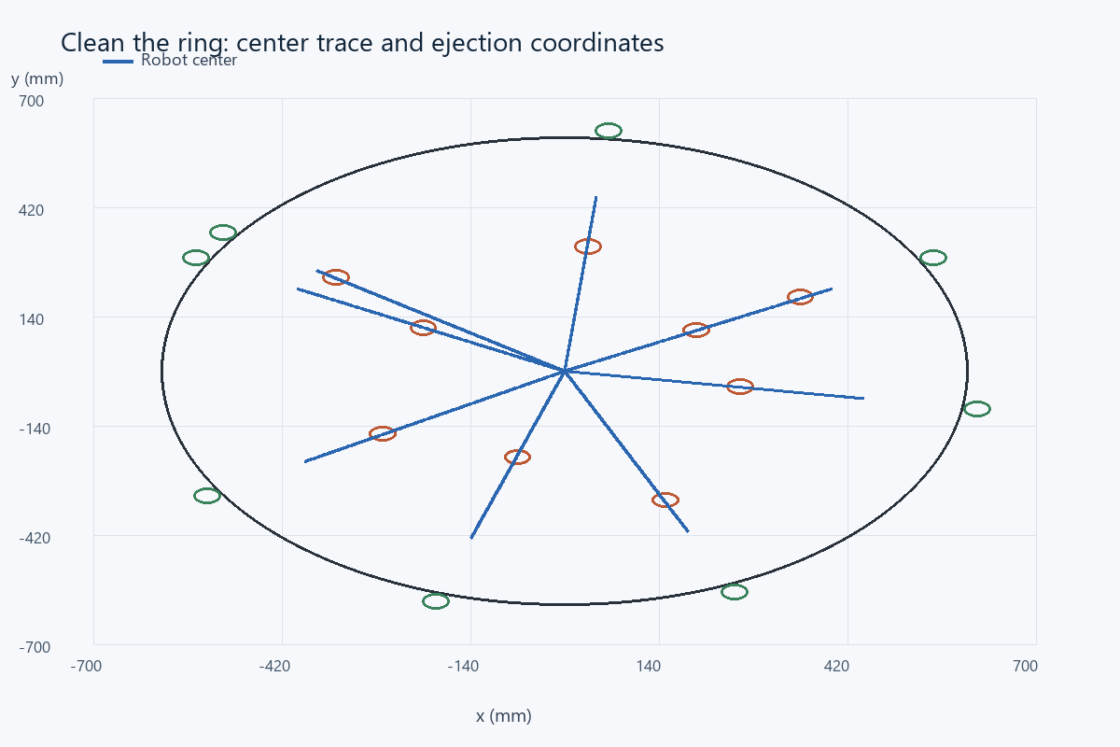
Computed robot-center trajectory. Brown circles show initial objects, green circles show the ejection coordinates, and the outer circle is the ring boundary.

Ejection coordinate evidence
All nine nominal objects reached center radius 620 mm in this geometric contact model. The object is marked ejected only after that condition is met. The robot subsequently retreats and verifies the remaining ring; it does not stop immediately after the ninth recorded ejection.
Object | x (mm) | y (mm) | Radius (mm) | Ejection time (s)
1 | 547.43 | 291.07 | 620.00 | 11.93
9 | -191.59 | -589.66 | 620.00 | 30.01
2 | -547.43 | 291.07 | 620.00 | 50.54
3 | 612.37 | -96.99 | 620.00 | 69.10
4 | -531.44 | -319.32 | 620.00 | 87.61
5 | 64.81 | 616.60 | 620.00 | 107.61
8 | 252.18 | -566.40 | 620.00 | 125.96
6 | 547.43 | 291.07 | 620.00 | 143.26
7 | -507.87 | 355.62 | 620.00 | 162.10

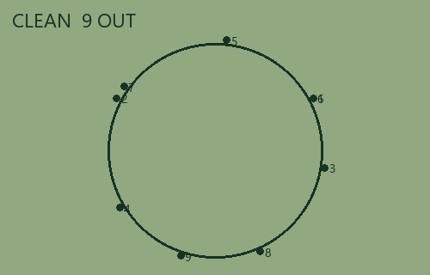
Enlarged LCD-style map generated from the ejection coordinates. Every plotted point lies outside the drawn ring.

Limits and physical demonstration procedure
This is a planar kinematic/contact model. It omits motor acceleration, braking travel, pusher flex, object rolling resistance, wheel slip, object-to-object collisions and the real sonar cone. Full expulsion while every part of the robot remains inside is achieved with zero pusher margin. It therefore has no tolerance for a smaller ring, larger forward extension or excess stopping distance. The simulated result must not be presented as physical boundary certification.
Before use, measure the ring radius, boundary-band width, chassis footprint, pusher offset, object dimensions and sensor position. Calibrate black/white readings at the actual floor height. Verify that the color sensor and pusher can reach the border together, and test braking at the 40 mm/s finish speed. If the teacher defines any contact with the border as leaving, this push geometry needs revision; the current model assumes touching the boundary is allowed. Add a guard timeout, clean-scan repetition and an obstacle-free center requirement for physical tests. Objects smaller than 40 mm, transparent or poorly reflecting objects, sonar blind zones and a center object violate the coverage assumptions.
Acceptance evidence is p1_nominal_trace.csv, p1_nominal_ejections.csv, p1_dense_trace.csv and p1_empty_trace.csv. The source simulation can be rerun; the assertions detect falsely declaring the ring clean. NXC programs are provided separately and require hardware calibration and a real toolchain check.

References
Assignment image: Screenshot_4.png - Project 1 Clean the Ring (4h).
Supplied NXC tutorial and NXC minimum reference, distributed with the source files.

Files for reproducing and demonstrating the result
NXC source: 03_project1_clean_ring.nxc. Shared configuration: common_config.nxc.
Open Start_Here.html in the package for visual results and file links. Run the scripts in the simulation folder to regenerate the data and checks. The code folder contains the NXC source program and hardware configuration notes. The simulation implements a separate software model; it does not execute the NXC binary.

Project 2 SCANNER
  - Omar Zid
Informatics in Robotics | 14 October 2026
Simulation study. All numerical measurements are generated by the supplied software models. They are not measurements from a physical LEGO NXT robot. Hardware behavior requires calibration and testing.
Omar Zid | Simulated scanner counted 14 bars in groups [4, 7, 3] over 5.000 s at 60 mm/s. All 30 noisy phase-varied runs at that speed were correct. Scanner.txt contains appended results; send and receive were verified through an explicitly emulated mailbox.
Assignment source: Screenshot_5.png

Task card fixture and sensor model
All trials in this report are reproducible software simulations produced for Omar Zid. They are not physical measurements, proof of NXC compilation, or evidence of testing a LEGO robot. Motor B is the left wheel; motor C is the right wheel; the one color/light sensor is S1 and the fixed forward ultrasonic sensor is S4. Wheel diameter D = 56 mm and wheel-center track B = 120 mm are explicit assumed calibration values. Replace them with measured values before a physical demonstration.
The supplied task asks for the number of vertical bars with maximum accuracy and minimum working time, for the count/time to appear on screen and be appended to Scanner.txt, and for the sum to be sent to another robot. Each group contains bars with common width, spacing and height; dimensions differ between groups. The simulated card therefore uses three deliberately different groups, with a known 300 mm horizontal fixture travel. The sensor scans at y = 0 mm, through all bars. A single horizontal pass can only count bars intersecting that scan line; different heights do not reveal themselves as extra events.
Black reflectance is 20 and white reflectance is 80 on a normalized 0-100 scale. A 4 mm rectangular sensing footprint averages covered black and white area along the travel direction. Gaussian sample noise has standard deviation 2 reflectance units. Different random seeds and initial sample phases test repeatability. No bar dimensions or group count enter the count state machine; the known 300 mm fixture length only defines where to stop.
Group | Bars | Width (mm) | Gap (mm) | Height (mm) | x span (mm)
1 | 4 | 8 | 7 | 35 | 20-73
2 | 7 | 5 | 6 | 55 | 108-179
3 | 3 | 12 | 10 | 25 | 214-270

Time sampled counting and grouping algorithm
The scanner samples every 0.010 s. WHITE transitions to BLACK only after three consecutive readings below 35. That stable transition increments the total exactly once. BLACK transitions back to WHITE after three consecutive readings above 65. Readings between 35 and 65 keep the current state and reset the pending confirmation. This hysteresis rejects small fluctuations, and three-sample confirmation rejects a single noisy sample. A wide black bar cannot be counted repeatedly while the sensor remains over it.
The optional group display starts a new group when the white distance between confirmed transitions exceeds 22 mm. The card has 35 mm between groups and 6-10 mm within groups; hence the threshold separates these cases. Total bar counting does not rely on grouping. All 14 bars pass through the same scan line even though their heights differ. A separate y = 18 mm test intentionally misses the 35 mm-high and 25 mm-high groups because their half-heights are 17.5 and 12.5 mm; this is a geometric failure, not a counter defect.
Elapsed time is sampled work time from the first acquisition to the stopping sample; it excludes setup and calibration. The nominal result is formatted as a screen/count-time record and appended using file append mode. A second run appends another record, preserving the first. The message COUNT=14;TIME_MS=... is placed in an in-process mailbox and read by a second receiver function. This demonstrates payload formatting and matching send/receive values. It does not demonstrate a Bluetooth radio, pairing, packet reliability or a second physical brick.

Sampling calculations and speed selection
Counting accuracy depends on usable dark and white duration, not only on a threshold. A coarse speed can skip a narrow bar entirely or provide fewer than three confirmed samples. The 90 mm/s tests show that a theoretical no-noise bound does not guarantee a robust noisy run. The selected 60 mm/s speed retains additional sampling margin and takes less time than 40 mm/s.
Sample displacement = v × Δt. At 60 mm/s × 0.010 s = 0.600 mm/sample. A 5 mm bar spans approximately 8.33 samples before footprint/threshold effects.
With black = 20, white = 80 and entry threshold 35, the required black coverage fraction is (80 - 35)/(80 - 20) = 0.75. For a 4 mm footprint, 3 mm must be black.
For the 5 mm narrowest bar, the ideal below-threshold x interval is 5 - 4/2 = 3 mm. Its duration at 60 mm/s is 3/60 = 0.050 s, giving about five samples for a three-sample debounce.
A conservative noiseless phase-independent entry bound is v ≤ usable_width/(3Δt) = 3 mm/(3 × 0.010 s) = 100 mm/s. Noise and threshold uncertainty justify choosing 60 mm/s; the experiment independently tests that decision.
At 300 mm/s, displacement is 3 mm/sample. A 3 mm usable dark interval yields about one sample, below the required three. Missed bars are therefore expected.
Nominal travel time = 300 mm / 60 mm/s = 5.000 s. The executed sampled acquisition is 5.000 s because it includes the final 10 ms stopping sample.
$At 60 mm/s, each wheel turns at 60/(π × 56) × 360 = 122.777°/s. The full 300 mm span requires 613.883° per wheel.$

Repeated noisy trials and deliberate failure test
Thirty runs at each speed use seeds 0-29 and phase offsets spanning one sample period. Every result below is generated from the state machine and noise model. Accuracy is the fraction of runs whose total equals 14, not an assertion that physical hardware has the same reliability. The high-speed trials are retained as failure evidence.
Speed (mm/s) | Correct / runs | Min count | Max count | Work time (s) | Accuracy (%)
40.0 | 30/30 | 14 | 14 | 7.510 | 100.0
60.0 | 30/30 | 14 | 14 | 5.010 | 100.0
90.0 | 28/30 | 13 | 14 | 3.340 | 93.3
150.0 | 0/30 | 7 | 9 | 2.000 | 0.0
300.0 | 0/30 | 1 | 3 | 1.000 | 0.0

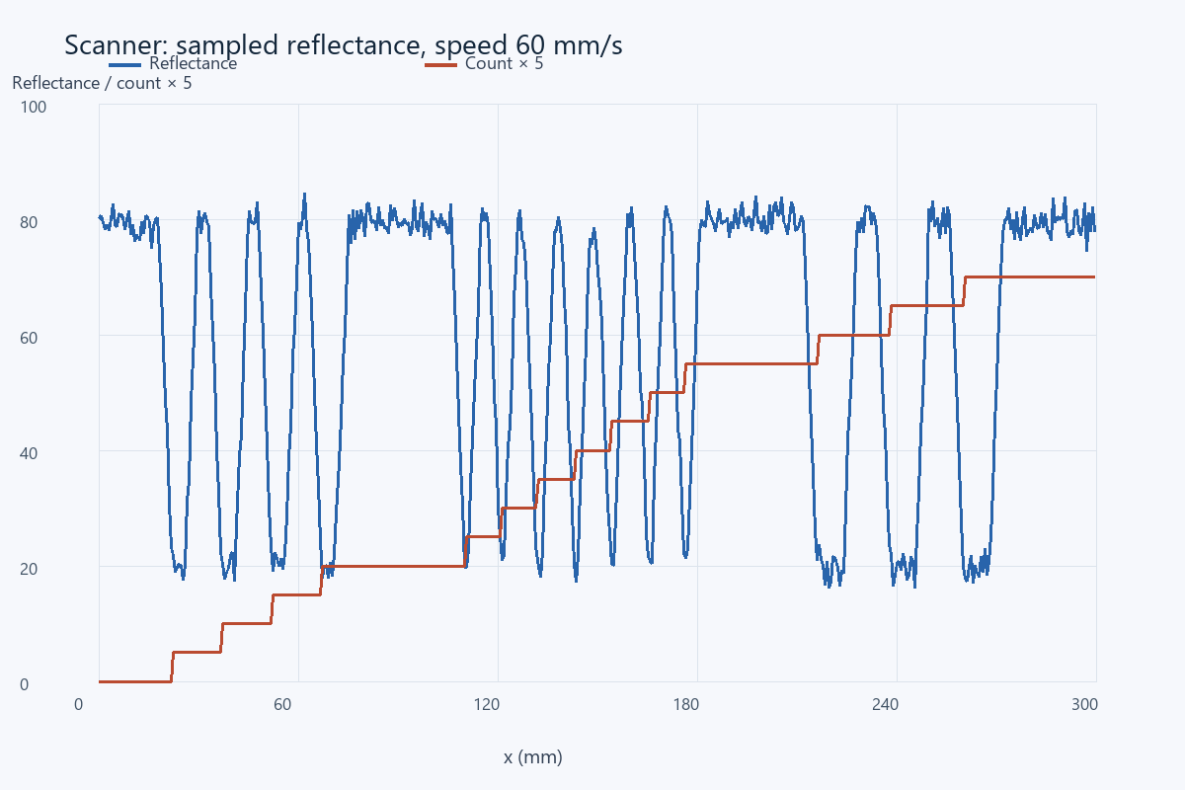
Actual nominal sampled reflectance and accumulated count. The count is multiplied by 5 only to make both traces visible on one scale.

Files receiver evidence and mounting sensitivity
Scanner.txt is regenerated as a deterministic demonstration file at the beginning of the simulation, then the two trial records are appended with append mode. Re-running the entire simulation rebuilds the demonstrator; this is separate from continuously preserving a physical brick file across power cycles. The full p2_trials.csv contains all 150 counts, speeds, sample phases and seeds, and p2_nominal_trace.csv contains every sensor reading and state transition.
At y = 18 mm, the executed mounting-offset test counted 7 bars rather than 14. That value is expected because only the 55 mm-high middle group intersects the scan line. A teacher demonstration should first show the centered successful pass, then show the speed and mounting failures to explain the measurement limits.
Sender payload | Receiver payload | Match | Transport
COUNT=14;TIME_MS=5000 | COUNT=14;TIME_MS=5000 | Yes | Emulated mailbox
COUNT=14;TIME_MS=7500 | COUNT=14;TIME_MS=7500 | Yes | Emulated mailbox

Physical checks and conclusions
The recommended simulated configuration gives 14 bars in three groups, 4 + 7 + 3 = 14, while preserving count/time records and transmitting a matching payload in software. The elapsed work time does not include Bluetooth connection setup or receiver latency. No real radio latency or loss is claimed.
For physical commissioning, measure the narrowest bar and gap with a ruler, check the sensor footprint at its mounting height, calibrate thresholds over actual black and white card, and ensure the scan line intersects the shortest bar. Check straightness with both wheel encoders and reduce speed until three stable samples are available under real noise. Confirm scanner file open/append/close behavior and a real receiver acknowledgment after pairing. The finite ray/footprint model omits uneven illumination, glossy print, motor drift, vibration, torn bars and communication failures. A white end region is not itself proof that every bar has been scanned; the known fixture travel provides that condition here.

References
Assignment image: Screenshot_5.png - Project 2 SCANNER (4h).
Supplied NXC tutorial and NXC minimum reference, distributed with the source files.

Files for reproducing and demonstrating the result
NXC source: 04_project2_barcode.nxc and 04b_barcode_receiver.nxc. Shared configuration: common_config.nxc.
Open Start_Here.html in the package for visual results and file links. Run the scripts in the simulation folder to regenerate the data and checks. The code folder contains the NXC source program and hardware configuration notes. The simulation implements a separate software model; it does not execute the NXC binary.

Project 3 Obstacle Avoidance
  - Omar Zid
Informatics in Robotics | 14 October 2026
Simulation study. All numerical measurements are generated by the supplied software models. They are not measurements from a physical LEGO NXT robot. Hardware behavior requires calibration and testing.
Omar Zid | Configurable N = 160 cm trial reached x = 1600.00 mm, y ≈ 0 mm after avoiding two unknown rectangles. Route length was 2840.00 mm. Minimum clearance of the complete circular chassis was 35.00 mm, and simulated time including physical probing turns was 247.64 s.
Assignment source: Screenshot_6.png

Task and endpoint definition
All trials in this report are reproducible software simulations produced for Omar Zid. They are not physical measurements, proof of NXC compilation, or evidence of testing a LEGO robot. Motor B is the left wheel; motor C is the right wheel; the one color/light sensor is S1 and the fixed forward ultrasonic sensor is S4. Wheel diameter D = 56 mm and wheel-center track B = 120 mm are explicit assumed calibration values. Replace them with measured values before a physical demonstration.
The assignment requests forward progress of configurable N cm while avoiding one or more parallelepiped obstacles of unknown size and keeping close to the original straight line. This report defines the requested endpoint as x = 10N mm on the original y = 0 mm line. The total curved/detour route is a separate measurement. Stopping after only N cm of wheel travel would end short of the requested forward endpoint when obstacles require detours.
The environment is a planar top view of rigid rectangles. The controller is given N, its start pose and encoder calibration. Rectangle coordinates are known only to the simulated sensor and collision checker; the controller does not read their widths, heights, near edges or far edges. The robot has a circular collision footprint of radius 75 mm. The ultrasonic sensor lies 70 mm forward of the axle and is fixed to the chassis. To probe a side wall, the whole robot stops and rotates, takes a forward measurement, and rotates back. Those turns consume time and appear in the wheel trace.

Measured corner avoidance state machine
FORWARD advances in 10 mm steps with encoder heading feedback while the forward range exceeds 200 mm. If range is at most 200 mm, TURN_RIGHT rotates to -90°. FIND_NEAR_CORNER moves south in 25 mm increments. Between steps, a real simulated chassis rotation faces east and probes the obstacle; it then restores the south heading. Once the east ray becomes clear, the robot travels a further 110 mm south before turning east. This margin consists of the 75 mm chassis radius plus 35 mm clearance.
FOLLOW_SIDE progresses east in 25 mm steps, with chassis rotations to probe north. It must first observe a wall and later observe that wall has ended; an initially clear north reading is insufficient to declare the far corner. After the far-corner observation, it travels another 110 mm east, turns north, and uses encoder y to return to y = 0. It turns east and resumes forward progress. Heading feedback applies ω = clamp[4(θtarget - θodo), -0.7, +0.7] rad/s; straight speed is 120 mm/s and detour speed is 100 mm/s.
Search budgets prevent endless movement when the assumed geometry fails: at most 80 near-corner increments and 100 side increments. Such a timeout is reported as failure, not a successful avoidance. The modeled scenes have isolated convex rectangles and enough clear ground below them. Turning is safe here because the collision footprint is circular; a long real chassis needs a swept-footprint check.

Odometry unit conversions and safety calculations
Wheel increments produce both the true kinematic pose and independent encoder odometry. With no slip or encoder quantization in these baseline trials, they coincide. Each interval uses the exact constant-wheel-speed differential-drive arc; small-angle straight movement is handled separately. Heading is in radians internally and encoder rotation is in degrees.
$N_mm = 10 × N_cm. For N = 160 cm, endpoint x = 1600 mm. This does not constrain total route length to 1600 mm.$
$ΔsL = πD × ΔencoderL/360; ΔsR = πD × ΔencoderR/360. Δs = (ΔsR + ΔsL)/2; Δθ = (ΔsR - ΔsL)/B.$
$For Δθ ≠ 0: xnew = x + (Δs/Δθ)[sin(θ+Δθ) - sin θ]; ynew = y - (Δs/Δθ)[cos(θ+Δθ) - cos θ].$
The first nominal front face is x = 420 mm. A 200 mm range from a sensor 70 mm forward corresponds to center x ≈ 420 - 200 - 70 = 150 mm. Chassis-front clearance before turning is 420 - 150 - 75 = 195 mm.
Required side center spacing is 75 + 35 = 110 mm. The chassis clearance is distance(center, rectangle) - 75 mm; center distance by itself would overstate safety by 75 mm.
$Nominal path excess = 2840 - 1600 = 1240 mm; route/forward-progress ratio = 1.775.$
One wheel encoder degree corresponds to π × 56/360 = 0.4887 mm. A 1° differential error between wheels changes estimated heading by 0.4887/120 = 0.004072 rad = 0.2333°. Over 1.6 m, an uncompensated constant 0.2333° heading error gives about 6.51 mm lateral drift.

Executed scenarios and complete chassis clearance
The nominal two-obstacle scene has rectangles x = 420-650 mm, y = -100-100 mm and x = 1050-1250 mm, y = -180-80 mm. The alternate wide/tall scene has x = 400-710 mm, y = -240-120 mm and adds uniform ultrasonic noise within ±2 mm. These dimensions are disclosed for validation and reproduction; the controller discovers the corners from range transitions. The clear-path case confirms N can change without changing the control algorithm.
Clearance is evaluated over every simulated trace sample, including physical probing rotations. All recorded chassis clearances exceed 30 mm. The simulator uses exact local arcs with a maximum moving step of 2.4 mm. The nominal minimum 35 mm occurs in a straight segment parallel to the obstacle, so the reported minimum is not merely a distance from a few waypoint vertices. The circular body can rotate in place without increasing its footprint.
Trial | N (cm) | Endpoint (mm) | Path (mm) | Min clearance (mm) | Time (s)
two_obstacles | 160 | (1600.0, 0.0) | 2840.0 | 35.0 | 247.64
wide_tall | 120 | (1200.0, 0.0) | 1920.0 | 45.0 | 151.03
clear | 80 | (800.0, 0.0) | 800.0 | No obstacles | 6.67

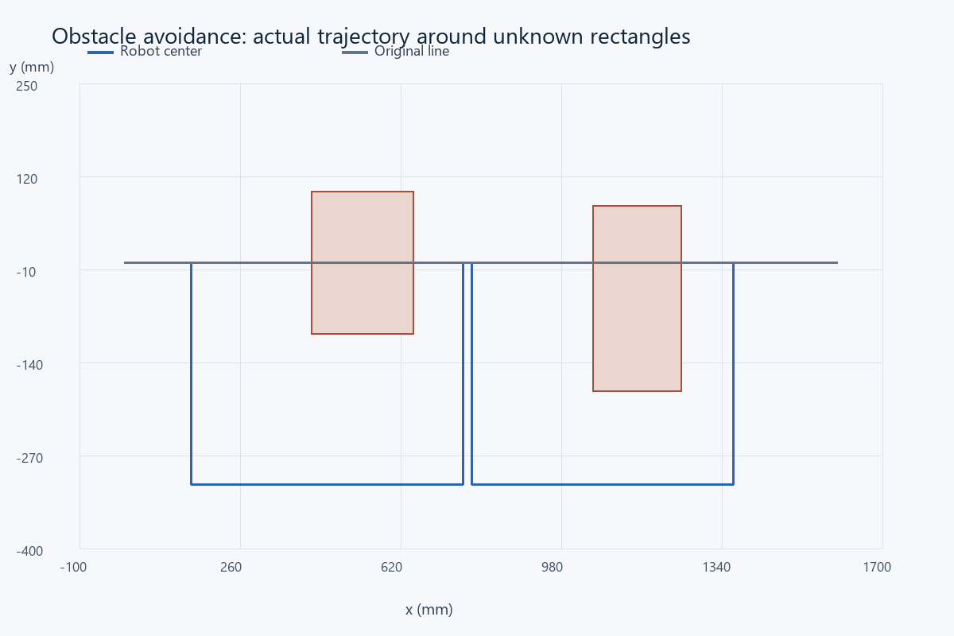
Actual wheel-integrated trajectory. Shaded rectangles are the unknown-size objects in the sensor environment; the gray horizontal trace is the original y = 0 line.

Performance tradeoffs and exported observations
The nominal maximum lateral displacement was 310.0 mm. The robot returns to the original line after each obstacle rather than continuing a parallel offset to the end. This is a feasible conservative strategy; the report does not claim it is the global shortest route or the fastest possible avoidance. The 247.64 s runtime is dominated by rotating a fixed sonar to take side measurements. A movable sensor or additional side sensor would reduce this overhead but would change the hardware assumption.
The CSV trace includes time, true x/y, encoder x/y, heading, both wheel degrees, commanded speed/angular rate, state and chassis clearance. The separate sonar CSV contains every forward and side-probe reading with time and pose. The +∞ no-return condition is encoded as the modeled 2550 mm out-of-range reading. Because this is a ray sensor, a rectangle edge produces a sharp change from a finite range to no return; a real ultrasonic cone will produce a broader transition.
The one-noisy-trial example is a deterministic sensitivity check, not a statistical physical reliability claim. Encoder calibration bias, wheel slip, an obstacle moving during a scan and nonrectangular or concave shapes require additional tests. An obstacle too near the final endpoint can force an overshooting detour; the simulation treats that as a failure of the configured route instead of claiming successful N progress.

Physical readiness and acceptance criteria
Before a classroom hardware demonstration, measure the full footprint and sensor offset; calibrate encoder distance and turn direction; verify zero range versus out-of-range handling; and test braking before the 200 mm threshold. Use heading correction only after wheel directions are confirmed. Validate the detection threshold under the actual sonar beam cone and permit additional clearance for noise and braking.
A physical run passes when the requested endpoint is reached near y = 0, no part of the chassis contacts any obstacle, the avoidance does not use manually entered obstacle dimensions, and a log shows both endpoint progress and total route length. The provided simulation passes those geometric checks under its stated assumptions. Its near-zero endpoint error is the expected consequence of ideal encoders and no slip, not an attainable measured accuracy claim for a real NXT. The separately provided NXC implementation follows the same sensing principle but has not been executed by this Python model.

References
Assignment image: Screenshot_6.png - Project 3 Obstacle Avoidance (6h).
Supplied NXC tutorial and NXC minimum reference, distributed with the source files.

Files for reproducing and demonstrating the result
NXC source: 05_project3_obstacle_navigation.nxc. Shared configuration: common_config.nxc.
Open Start_Here.html in the package for visual results and file links. Run the scripts in the simulation folder to regenerate the data and checks. The code folder contains the NXC source program and hardware configuration notes. The simulation implements a separate software model; it does not execute the NXC binary.

Project 4 Single Sensor PID Line Follower
  - Omar Zid
Informatics in Robotics | 14 October 2026
Simulation study. All numerical measurements are generated by the supplied software models. They are not measurements from a physical LEGO NXT robot. Hardware behavior requires calibration and testing.
Omar Zid | Simulated PID completed one marker-to-marker lap in 20.880 s. Sensor-edge RMS error was 0.639 mm, compared with 1.712 mm for P and 0.782 mm for PI. Wheel dynamics, saturation, noise, bias and a repeatable heading disturbance are included.
Assignment source: Screenshot_7.png

Task track geometry and one sensor observation
All trials in this report are reproducible software simulations produced for Omar Zid. They are not physical measurements, proof of NXC compilation, or evidence of testing a LEGO robot. Motor B is the left wheel; motor C is the right wheel; the one color/light sensor is S1 and the fixed forward ultrasonic sensor is S4. Wheel diameter D = 56 mm and wheel-center track B = 120 mm are explicit assumed calibration values. Replace them with measured values before a physical demonstration.
The assignment requires a robot with only one color sensor to follow a line for one round using PID regulation. The software test uses a circular black line of centerline radius 350 mm and width 20 mm, so its inner and outer edges are radii 340 and 360 mm. The sensor is 35 mm ahead of the axle. The robot follows the outer edge at target reflectance 50, between calibrated black 20 and white 80. A smooth 2 mm edge transition models the sensor footprint. The reading has Gaussian noise σ = 1.2 reflectance units and a slow ±1.2-unit lighting drift.
A broad 18 mm transverse black marker crosses the normal line once per circuit. The starting pose aligns the same forward sensor with this marker. Initial marker readings cannot end the run. Lap detection is armed only after encoder path exceeds 1500 mm; after arming, ten consecutive 10 ms readings below 25 trigger braking. The marker is wider than normal transient dark readings and its expected dwell is about 0.164 s at 110 mm/s. No second color sensor or hidden ground-truth track angle controls termination.
The independent checker unwraps the true polar angle of the axle center and verifies that angular travel is at least 2π rad. That measurement validates the result after the controller stops; it is not supplied to PID or the stop condition. The start-marker alignment matters because a forward sensor crosses the finish before the axle center reaches the same position. Starting with the sensor on the marker makes the next encounter a full sensor-to-sensor circuit.

Time discrete PID saturation and anti windup
Error is e = (reading - 50)/30, a dimensionless normalized reflectance difference. Positive error means the outer-edge sensor is too far onto white; the command turns left to return toward black. Integral state I accumulates eΔt in seconds, and the derivative has units s⁻¹. A first-order filtered derivative is d[k] = 0.80d[k-1] + 0.20(e[k] - e[k-1])/Δt. This reduces differentiation of sample noise.
The PID command is ω = Kp e + Ki I + Kd d, in rad/s. Integral state is clamped to ±2 s, and conditional integration rejects a proposed update if the command is saturated and the current error would drive it further into saturation. During the broad marker, the previous angular command is held and integration is frozen so the marker does not produce a steering kick. At startup the known entry command is 0.31 rad/s while the sensor leaves the marker.
Base translational command is 110 mm/s. Wheel commands are vL = 110 - 60ω and vR = 110 + 60ω mm/s. Angular command is limited to ±1.1667 rad/s, and wheel commands to -50-180 mm/s. Each motor follows a first-order lag τ = 0.10 s. The right motor produces 97% of its command, introducing a repeatable speed bias. At t = 8.00 s an external 8° heading disturbance is injected into the true pose; encoder heading does not observe this bump. The color feedback must recover.
Controller | Kp (s⁻¹) | Ki (s⁻²) | Kd | Sample period (s) | Filter
P | 0.85 | 0.0 | 0.0 | 0.01 | 0.80 / 0.20
PI | 0.7 | 0.28 | 0.0 | 0.01 | 0.80 / 0.20
PID | 0.8 | 0.25 | 0.035 | 0.01 | 0.80 / 0.20

Worked geometry and gain unit calculations
Radians are treated as dimensionless in the unit table: Kp produces rad/s per normalized error, Ki rad/s² per normalized accumulated error, and Kd rad per normalized derivative. These numerical gains are valid for the defined normalization, 10 ms loop and wheel-speed mapping; copying them into a raw 0-100 reflectance or motor-percentage loop changes the controller.
Tracking error is the actual sensor-point radius minus the outer edge radius, in mm. It is computed from the independent simulated pose for evaluation. PID itself receives only reflectance. Because the sensor lies ahead of the axle, axle radius 360 mm is not the zero sensor-error trajectory.
$Zero-error axle radius = √(360² - 35²) = 358.295 mm.$
Desired circular angular rate at nominal speed ≈ 110/358.295 = 0.3070 rad/s. Corresponding wheel speeds are 110 ± 60 × 0.3070 = 91.58 and 128.42 mm/s.
For reading 56: e = (56 - 50)/30 = 0.20. If I = 0.40 s and filtered derivative d = 0.50 s⁻¹, PID command = 0.80 × 0.20 + 0.25 × 0.40 + 0.035 × 0.50 = 0.2775 rad/s.
For that worked command, vL = 110 - 60 × 0.2775 = 93.35 mm/s and vR = 126.65 mm/s. Encoder speeds are 191.02 and 259.16 degrees/s respectively for 56 mm wheels.
Angular saturation = (180 - 110)/(120/2) = 1.1667 rad/s. Integral clamp |I| ≤ 2 s prevents an integral term larger than 0.25 × 2 = 0.50 rad/s in PID.
Expected marker dwell = 18 mm/110 mm/s ≈ 0.164 s. Required dark confirmation = 10 × 0.010 = 0.100 s, leaving about 64 ms nominal margin.
Reference axle-circle circumference = 2π × 358.295 = 2251.23 mm; actual route is measured from wheel increments and varies with tracking error, startup and stop location.

P PI and PID executed comparison
Each comparison uses the same starting geometry, random seed, wheel lag, 3% right-motor command bias, lighting drift and 8° heading disturbance. Only controller gains change. Error statistics include samples after the first second and exclude the broad marker, where the sensor reading intentionally represents the finish stripe instead of the normal edge. Maximum error is the largest absolute sensor-edge error in that evaluation interval.
P requires a steady reflectance error to create the sustained turn and counter the motor bias. PI reduces that steady error but its integral responds more slowly to a sudden heading disturbance. PID adds a filtered derivative and achieved the smallest RMS error in this selected scene. Its maximum transient error can still exceed P even when its overall RMS is lower; a low RMS is not a guarantee of minimum peak error. These gains are compared within one specified track, not claimed optimal for every path.
Mode | Lap time (s) | RMS (mm) | Peak (mm) | Mean (mm) | Saturated samples
P | 20.960 | 1.712 | 3.890 | 1.605 | 0
PI | 20.880 | 0.782 | 5.674 | 0.123 | 0
PID | 20.880 | 0.639 | 5.270 | 0.176 | 6

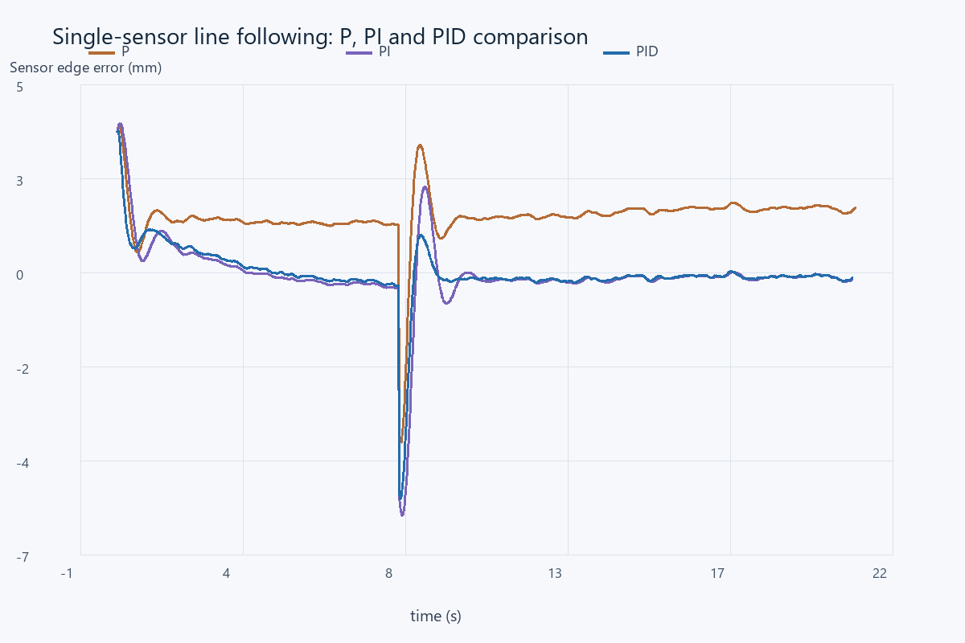
Computed sensor-edge error over time. The external heading disturbance occurs at 8.00 s. Marker samples are omitted from these error curves.

One lap evidence trajectory and trace
PID stopped after 20.880 s and 2256.36 mm of integrated wheel travel. Independent axle angular travel was 6.29179 rad, at least 2π = 6.28319 rad. The controller used its armed single-sensor marker detector for this stop. It did not stop after a fixed guessed lap time or when a precomputed angle became 360°.
The full p4_pid_trace.csv contains time, robot and encoder pose, wheel degrees, reflectance, normalized error, integral, angular command, both actual wheel speeds, saturation flags, marker flags, sensor-edge error and independent lap angle. The P and PI traces have the same schema for checking the comparison. Ground-truth error and lap angle are evaluation columns; they are not feedback inputs.
A unique finish marker and a simple track without branches or shortcuts are assumptions of this one-sensor method. Encoder arming rejects the initial marker but cannot mathematically prove a full lap on any unknown track. For a course with repeated black patches, intersections or a shorter loop, the arming distance and marker design must be changed and independently checked.
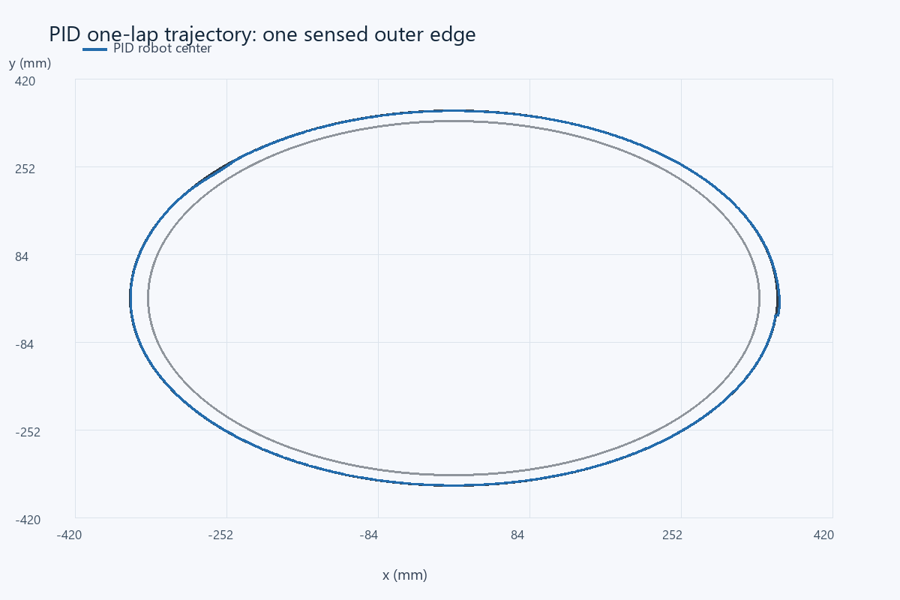
Actual PID axle-center trajectory, with the inner and outer black-stripe edges drawn at 340 and 360 mm radius.

Hardware tuning and model limits
For physical use, mount the one sensor 35 mm ahead at consistent height, measure black/white calibration, set the sensor on the intended edge, and confirm that positive correction turns toward black. Start with low forward power and Ki = Kd = 0; increase Kp until tracking is responsive, then add a small derivative to reduce overshoot and a small integral only if sustained bias remains. Keep the loop period fixed and include the real Δt in integral and derivative calculations. Motor percentages require measured speed conversion before these mm/s gains can be reused.
The simulation includes realistic control complications but remains a planar model: it omits stiction, battery changes, cable drag, uneven floors, sensor spectral behavior, wheel slip and noncircular sharp track corners. Braking at the finish is idealized. The intentional heading bump demonstrates recovery in this model and is not a measured bump test on hardware. A real lap should be timed separately, its sensor log saved, and its completion observed by the teacher. The computed gains and traces supply a reproducible starting point rather than physical performance certification.

References
Assignment image: Screenshot_7.png - Project 4 LineFollower (6h).
Supplied NXC tutorial and NXC minimum reference, distributed with the source files.
Assignment-supplied PID help link: http://www.inpharmix.com/jps/PID_Controller_For_Lego_Mindstorms_Robots.html (reference link reproduced from the brief; not a measured hardware source).

Files for reproducing and demonstrating the result
NXC source: 06_project4_pid_line.nxc. Shared configuration: common_config.nxc.
Open Start_Here.html in the package for visual results and file links. Run the scripts in the simulation folder to regenerate the data and checks. The code folder contains the NXC source program and hardware configuration notes. The simulation implements a separate software model; it does not execute the NXC binary.

Kinematics exercise solutions
  - Omar Zid
Informatics in Robotics | 14 October 2026
The four coordinate transformation tasks and all visible frame exercises are solved below. Worked substitutions retain angle and length units. B and D relationships are given symbolically because those frames are absent from the supplied drawing.
Assignment source: 02 Basis of kinematics.pdf pages 23 and 27; 03 Direct Kinematics cont.pdf page 4

Basis of kinematics task 1
Given a 30 degree rotation about positive Z_A, a point on positive Y_B has p_B = [0, 7, 0]^T u. The positive direction is confirmed by the counterclockwise drawing.
The transformation taking B coordinates into A coordinates is
$\left[\begin{matrix}0.866025 & -0.5 & 0 & 0 \\ 0.5 & 0.866025 & 0 & 0 \\ 0 & 0 & 1 & 0 \\ 0 & 0 & 0 & 1\end{matrix}\right]$
$x_A = 0 cos(30 deg) - 7 sin(30 deg) = -3.500000 u$
$y_A = 0 sin(30 deg) + 7 cos(30 deg) = 6.062178 u$
$z_A = 0 u$
Quantity | Final result
Point in frame A | [-3.500000, 6.062178, 0.000000]^T u
Inverse substitution residual | Less than 1e-12 u
Rotation determinant | 1.000000

Basis of kinematics task 2
Given a positive 90 degree rotation about Y_A and p_B = [-3, 5, -8]^T u, the origins coincide.
The transformation taking B coordinates into A coordinates is
$\left[\begin{matrix}0 & 0 & 1 & 0 \\ 0 & 1 & 0 & 0 \\ -1 & 0 & 0 & 0 \\ 0 & 0 & 0 & 1\end{matrix}\right]$
$x_A = 0(-3) + 1(-8) = -8 u$
$y_A = 5 u$
$z_A = -1(-3) + 0(-8) = 3 u$
Quantity | Final result
Point in frame A | [-8.000000, 5.000000, 3.000000]^T u
Inverse substitution residual | Less than 1e-12 u
Rotation determinant | 1.000000

Basis of kinematics task 3
Given a positive 30 degree rotation about Z_A and p_B = [-1, -39, 5]^T u, the origin translation is [-2, -8, 0]^T u, expressed in A. The translation is added after rotating the point.
The transformation taking B coordinates into A coordinates is
$\left[\begin{matrix}0.866025 & -0.5 & 0 & -2 \\ 0.5 & 0.866025 & 0 & -8 \\ 0 & 0 & 1 & 0 \\ 0 & 0 & 0 & 1\end{matrix}\right]$
$x_A = -1 cos(30 deg) - (-39) sin(30 deg) - 2 = 16.633975 u$
$y_A = -1 sin(30 deg) + (-39) cos(30 deg) - 8 = -42.274991 u$
$z_A = 5 + 0 = 5 u$
Quantity | Final result
Point in frame A | [16.633975, -42.274991, 5.000000]^T u
Inverse substitution residual | Less than 1e-12 u
Rotation determinant | 1.000000

Basis of kinematics task 4
Given a positive 45 degree rotation about X_A and p_B = [4, -2, 17]^T u, the origin translation is [0, 5, -8]^T u, expressed in A.
The transformation taking B coordinates into A coordinates is
$\left[\begin{matrix}1 & 0 & 0 & 0 \\ 0 & 0.707107 & -0.707107 & 5 \\ 0 & 0.707107 & 0.707107 & -8 \\ 0 & 0 & 0 & 1\end{matrix}\right]$
$x_A = 4 u$
$y_A = -2 cos(45 deg) - 17 sin(45 deg) + 5 = -8.435029 u$
$z_A = -2 sin(45 deg) + 17 cos(45 deg) - 8 = 2.606602 u$
Quantity | Final result
Point in frame A | [4.000000, -8.435029, 2.606602]^T u
Inverse substitution residual | Less than 1e-12 u
Rotation determinant | 1.000000

Direct kinematics missing axes
Use a right handed frame: X cross Y = Z, Y cross Z = X, and Z cross X = Y. Set the drawing basis to X_A toward the right, Y_A toward the back, and Z_A upward. The dimensions are interpreted as front width 4 u, tall width 7 u, front depth 3 u, rear depth 2 u, front height 5 u, and tall height 6 u.
The origin of F is read at the front left upper corner of the tall section, C at the front left corner at height 5 u, I at the front right upper corner, and E at the front right lower corner of the tall section.
Frame | Missing axis in A coordinates | Right hand check
A | Y_A = (0,1,0) | X_A cross Y_A = Z_A
C | Z_C = Y_A | Z_A cross X_A = Y_A
F | X_F = Z_A | Y_F cross Z_F = X_A cross Y_A
I | X_I = Y_A | (-X_A) cross Z_A = Y_A
E | Y_E = X_A | Z_A cross (-Y_A) = X_A

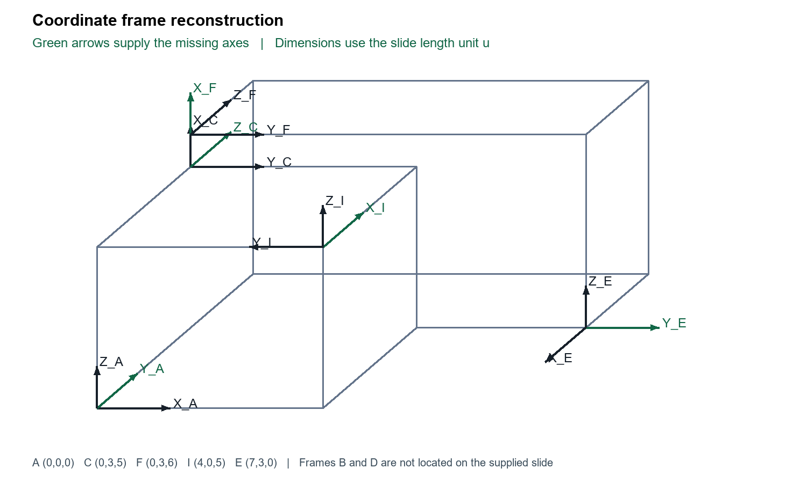
Reconstruction of the visible slide geometry. Newly supplied axes appear in green.

Direct kinematics frame data
A_from_B denotes the matrix that maps coordinates expressed in B to coordinates expressed in A. Its three rotation columns are the B unit axes expressed in A; the last column is the B origin expressed in A.
Frame | Origin in A in u | X axis in A | Y axis in A | Z axis in A
A | [0, 0, 0] | [1, 0, 0] | [0, 1, 0] | [0, 0, 1]
C | [0, 3, 5] | [0, 0, 1] | [1, 0, 0] | [0, 1, 0]
F | [0, 3, 6] | [0, 0, 1] | [1, 0, 0] | [0, 1, 0]
I | [4, 0, 5] | [0, 1, 0] | [-1, 0, 0] | [0, 0, 1]
E | [7, 3, 0] | [0, -1, 0] | [1, 0, 0] | [0, 0, 1]

A from E
Calculated from the visible coordinate frames using target_from_source = inverse(A_from_target) times A_from_source.
$\left[\begin{matrix}0 & 1 & 0 & 7 \\ -1 & 0 & 0 & 3 \\ 0 & 0 & 1 & 0 \\ 0 & 0 & 0 & 1\end{matrix}\right]$
$Check: target_from_source times source_from_target = identity to numerical tolerance 1e-12.$

C from I
Calculated from the visible coordinate frames using target_from_source = inverse(A_from_target) times A_from_source.
$\left[\begin{matrix}0 & 0 & 1 & 0 \\ 0 & -1 & 0 & 4 \\ 1 & 0 & 0 & -3 \\ 0 & 0 & 0 & 1\end{matrix}\right]$
$Check: target_from_source times source_from_target = identity to numerical tolerance 1e-12.$

F from A
Calculated from the visible coordinate frames using target_from_source = inverse(A_from_target) times A_from_source.
$\left[\begin{matrix}0 & 0 & 1 & -6 \\ 1 & 0 & 0 & 0 \\ 0 & 1 & 0 & -3 \\ 0 & 0 & 0 & 1\end{matrix}\right]$
$Check: target_from_source times source_from_target = identity to numerical tolerance 1e-12.$

Transforms involving frames B and D
The slide requests A_from_B, B_from_A and D_from_B, but its figure does not define the locations or orientations of frames B and D. A_from_E is requested twice and has the same answer both times. Numerical B or D matrices are not uniquely determined by the supplied figure. The following symbolic answers completely express the relationships without assigning invented frame positions.
Let B have orientation R_B and origin b expressed in A; let D have orientation R_D and origin d expressed in A. Then the requested matrices are
$A_from_B = block matrix [R_B, b; 0 0 0, 1]$
$B_from_A = block matrix [R_B transpose, -R_B transpose times b; 0 0 0, 1]$
$D_from_B = block matrix [R_D transpose times R_B, R_D transpose times (b - d); 0 0 0, 1]$
Enter the missing axes and origins into kinematics.py to obtain numeric values when the complete figure is available.

Rotation conventions and verification
The degree symbols in the tasks are inconsistently typed as a backtick or prime. They are interpreted as degrees, consistent with the illustrated 30 degree frame rotation and the 90 degree task. Treating them as arcminutes would produce different answers.
No centimetre or millimetre unit is supplied for the lecture coordinates, so u denotes the unspecified length unit used in the slides. This preserves dimensional consistency without inventing a scale.
For fixed axis rotations used here, R_z(beta) rotates the frame axes positively by the right hand rule. A_from_B times p_B returns p_A. The translation is expressed in A. For the lecture X Y Z example, multiplication order R_x(gamma) R_y(beta) R_z(alpha) matters; reverse multiplication describes a different convention.
Numerical checks confirm rotation orthogonality, determinant +1, homogeneous inverse consistency, and the four point transformation round trips. The printed lecture extraction appears to repeat beta where a third angle is expected in the angle recovery formulas; derive angles from the chosen matrix convention instead of copying that label.
Verification | Result
Four point round trips | PASS below 1e-12 u
Visible frame rotations | PASS orthogonal determinant +1
Three calculated frame transforms | PASS inverse products
Missing B and D definitions | Symbolic solution supplied

References
02 Basis of kinematics.pdf, supplied lecture, pages 21 to 27.
03 Direct Kinematics cont.pdf, supplied lecture, pages 1 to 6.
01 Introduction to robotics.pdf, supplied lecture, contextual reading.

