Introduction Environment scanner demonstration
  - Omar Zid
Informatics in Robotics | 14 October 2026
Simulation study. All numerical measurements are generated by the supplied software models. They are not measurements from a physical LEGO NXT robot. Hardware behavior requires calibration and testing.
Omar Zid | Working numerical demonstration. Scanned 36 headings; selected 30°; stopped on the simulated red strip at 678.0 mm. This optional evidence note supports the introduction's final task; the supplied page says no formal report.
Assignment source: Screenshot_1.png: Introduction (2h - none reports)

1 Task and demonstrable outcome
The introduction requests a 360° environment scanner that logs observations, visualizes them on the screen, chooses the most free direction, drives that way and stops on red. The supplied page labels this session ‘none reports’. This short evidence note accompanies the code and data so the teacher can inspect the complete calculation and outcome.
The demonstration models a differential-drive robot using NXC-style motor/sensor control concepts. The scan, chosen direction and stopping trace are numerically executed. All environment distances, sensor observations and timing are simulated. A BricxCC installation, brick connection, download, physical screen and device memory operation are not claimed as completed hardware tasks.

2 Geometry environment and scan method
Wheel diameter is assumed D = 56 mm; wheel-centre track is assumed B = 120 mm. The model room spans x = -1000 to 2000 mm and y = -1200 to 1500 mm. Two circular obstacles are centred at (900, 0) mm with radius 200 mm and (-500, -500) mm with radius 180 mm. The initial robot centre is (0, 0); heading zero points along +x and positive angles are counterclockwise.
An exact geometric ray cast provides simulator truth. Every 10° heading has three sonar observations, generated with the same scale/offset/noise form as Report 2. The three-reading mean is stored with its sample standard deviation. A whole-body in-place rotation is used conceptually, not a sensor turret; scanning therefore requires opposite wheel movements and a settled read after each turn.
The score at each heading is the minimum mean clearance of that heading and its adjacent ±10° headings. This avoids choosing a narrow isolated maximum. A three-sample smoothing rule does not prove that a real robot fits through a gap; body width, sensor offset, obstacle shape and angular uncertainty still require margin and checks.
$Body heading step ψ = 10° = 0.174533 rad. Wheel travel magnitude = Bψ/2 = 120 × 0.174533/2 = 10.472 mm.$
Wheel shaft step magnitude = 360 × 10.472/(π × 56) = 21.429°. Rotate opposite wheels by ±21.429° for one ideal 10° body turn.
A 360° body scan requires 36 steps and ±771.429° wheel-shaft rotation in this geometry. Shaft angle is not body heading.
$Score(θi) = min[mean d(θi-10°), mean d(θi), mean d(θi+10°)] with circular indexing.$
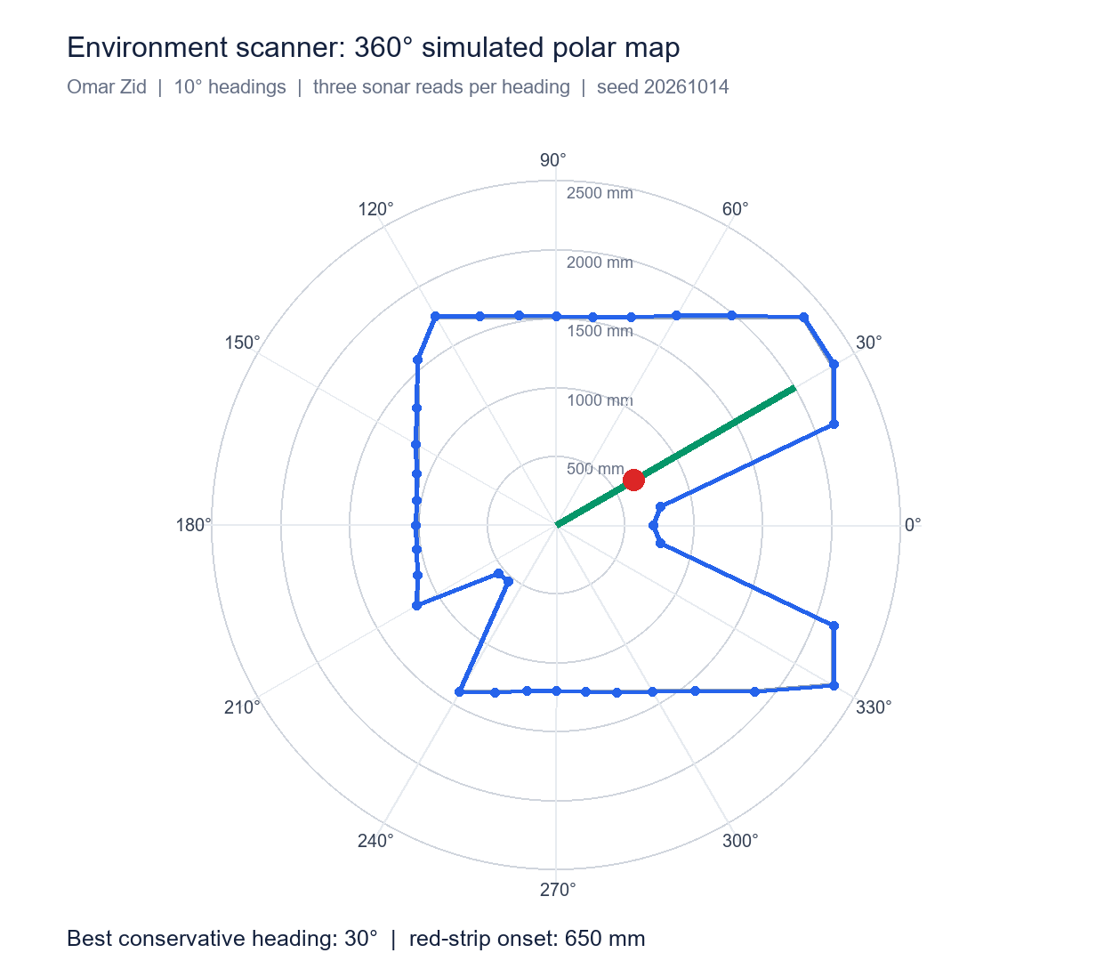
The grey outline is ray-cast truth; blue points are observed three-read means. The green line marks the selected heading and the red point marks the strip's onset.

3 Scan selection and logged evidence
The selected direction is 30°. Its mean observed clearance is 232.67 cm and its conservative neighboring score is 214.33 cm. Geometric truth along that ray is 2309.4 mm. The observed and true values differ because the declared sensor model includes scale, offset, noise and integer-centimeter reporting.
Store heading in degrees and range in centimeters in an on-brick file, with consistent column labels. The desktop simulation saves every raw trial in intro_scan_trials.csv and all means/scores in intro_scan_summary.csv. A simple brick display can show current heading/range, selected heading and motion state; the polar figure here is the detailed teacher-facing visualization.
When a real sonar returns a missing or invalid echo, label it unknown and do not treat it as guaranteed clear space. This scenario remains within the declared model's useful range. A real scanner also needs obstacle monitoring during the drive, a maximum travel limit, a manual stop and safe handling of failed sensor reads.
Quantity | Simulated result
Headings / observations | 36 / 108
Angle spacing | 10°
Selected heading | 30°
Mean range at chosen heading | 232.67 cm
Conservative score | 214.33 cm
True ray clearance | 2309.4 mm

4 Red detection delay and stopping distance
The robot drives at an assumed 120 mm/s. A red strip spans 650-740 mm along the chosen ray. Color is checked every 50 ms with an assumed 40 ms physical color delay. Two consecutive red observations command braking; deceleration is 600 mm/s². Speed and stopping-distance values are chosen for this simulation and are not motor power-to-speed specifications.
The brake command occurred at t = 5.55 s; the robot reached zero velocity at t = 5.75 s and x = 678.0 mm. The terminal point lies within the red strip. Remaining ray clearance was 163.1 cm. The red stop has a finite overrun and cannot be modeled as an instantaneous halt at 650 mm.
The complete event trace records physical surface, observed color, confirmation count, control state, velocity, traveled distance and remaining clearance. It distinguishes red detection from the final mechanical stop. The report's terminal distance refers to the robot centre; a physical sensor mounted ahead of the axle introduces an additional geometric offset.
$Nominal braking time = v/a = 120/600 = 0.200 s.$
$Braking distance = v²/(2a) = 120²/(2 × 600) = 12.0 mm.$
Additional sensing/confirmation travel depends on phase: one 40 ms response delay contributes 4.8 mm; one 50 ms confirmation interval contributes 6.0 mm; polling phase can add up to 6.0 mm.
$Terminal overrun beyond strip onset = 678.0 - 650 = 28.0 mm; observed finite-phase trace determines this value.$
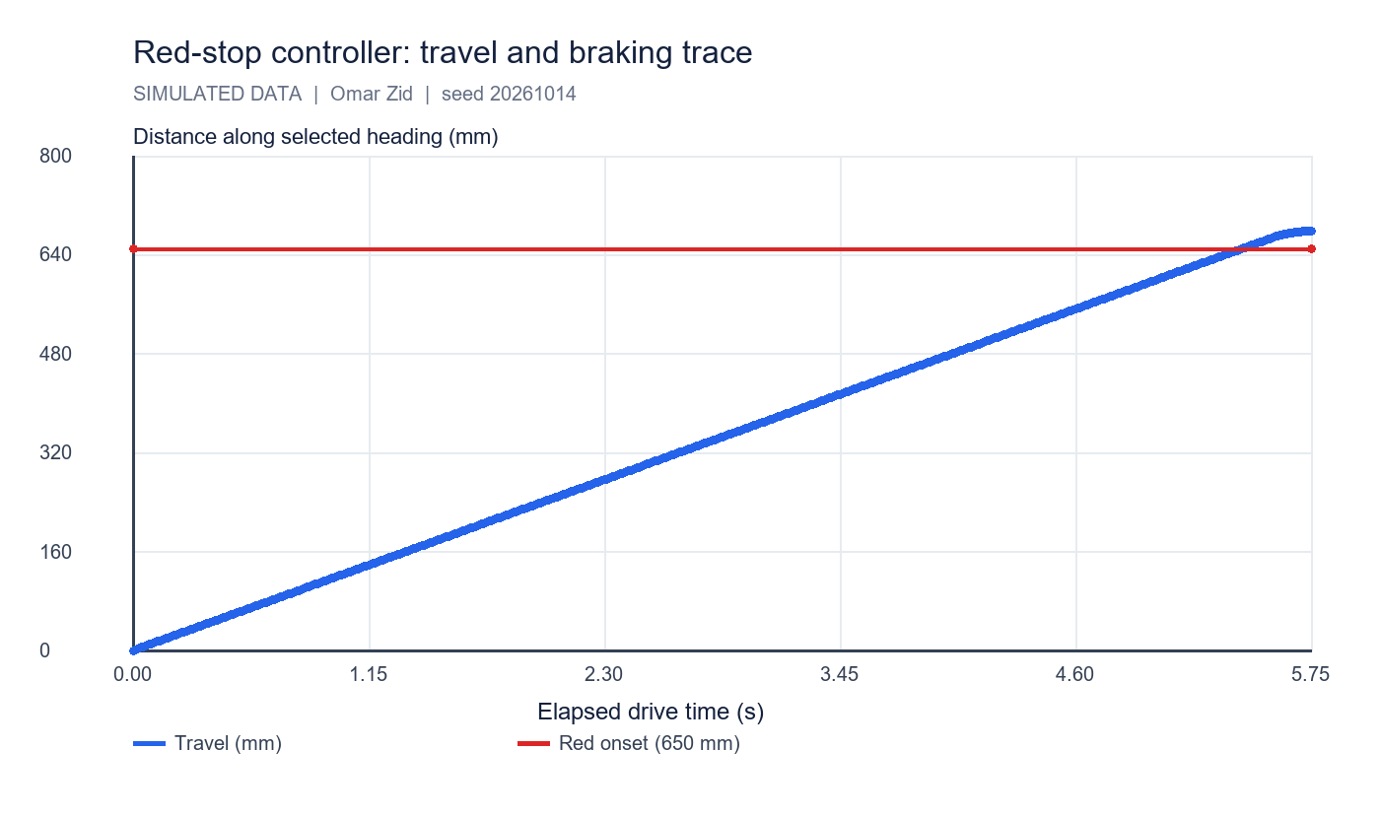
Travel rises at the modeled drive speed and flattens during braking. The controller stops inside the red strip.

5 Concurrent tasks I O and file handling
A sensor/logging task can read sensors and update shared state while a movement task issues drive commands. Guard a shared snapshot with a mutex: acquire the lock, copy or update the small state structure, release the lock, then perform slow display/file operations outside the critical section. A mutex prevents inconsistent concurrent access; it does not make sensor data newer.
Buttons should provide start/stop or trial selection; the display should expose state and units. BricxCC offers brick tests, file management and a remote NXT Screen with polling, which supports inspecting a robot with a damaged or inaccessible screen. Files should be opened with a checked status, sized to hold the intended log, closed after writing and downloaded for analysis.
In a simulation, desktop CSV writing demonstrates logging successfully. The NXT file-system capacity, free space and BricxCC transfer remain hardware validation steps. The supplied short guide contains older timing notation; use the full tutorial/API millisecond convention consistently when implementing Wait and timers.

6 Reproducibility and conclusion
All scan, score and stop-state checks passed. Seed 20261014 reproduces the same 30° selection and 678.0 mm terminal travel. The demonstration satisfies the introduction's functional sequence in the model and provides the teacher with visible calculations, plots and raw event data.
Run simulation/lab_simulations.py. Evidence files: intro_scan_trials.csv, intro_scan_summary.csv and intro_red_stop_trace.csv; plots: intro_scan_polar.png and intro_stop_trace.png. Hardware reproduction should replace room assumptions, wheel geometry, sensor offset and timing values with measured inputs while retaining the same logging and analysis method.

References
Supplied Screenshot_1.png: Introduction (2h - none reports), final Environment Scanner task.
Supplied __NXC_tutorial.pdf: sensors, tasks, mutexes and file operations.
Supplied _NXC_min.pdf: BricxCC basics; compare timing notation with the full tutorial before use.

Files for reproducing and demonstrating the result
NXC source: 00_intro_scan.nxc and 00a_intro_io_parallel.nxc. Shared configuration: common_config.nxc.
Open Start_Here.html in the package for visual results and file links. Run the scripts in the simulation folder to regenerate the data and checks. The code folder contains the NXC source program and hardware configuration notes. The simulation implements a separate software model; it does not execute the NXC binary.

