Report 1 Exploring motors
  - Omar Zid
Informatics in Robotics | 14 October 2026
Simulation study. All numerical measurements are generated by the supplied software models. They are not measurements from a physical LEGO NXT robot. Hardware behavior requires calibration and testing.
Omar Zid | Reproducible simulation | 60 test trials. Largest mean signed angle error: -1.60° at -450° and power 80%. No physical experiment is claimed.
Assignment source: Screenshot_2.png; __NXC_tutorial.pdf, pp. 31-34

1 Aim and measurement plan
The assignment asks for a program that displays the current motor-shaft position, checks commands of 45°, 450° and 650°, and investigates counter resets. A negative command and three powers are added to test direction and the effect of speed. The supplied tutorial explains limited-angle movement, braking and feedback regulation.
One motor represents a wheel-driven NXT system. Each angle/power combination has five simulated repetitions from a reset zero. An independent angle fixture provides the reference observation. Command angle, ideal simulator truth, integer tacho observation and external observation are stored in separate columns so agreement of two tacho-based values cannot masquerade as independent verification.
These are software-generated observations. The model tests calculation, logging and control logic, while the actual brick, loading, battery condition, friction and firmware behavior still require a hardware check. All numerical precision and uncertainty assumptions below belong to this model.

2 Declared model and calibration
Geometry: wheel diameter D = 56 mm and wheel-centre track B = 120 mm are assumed construction values. Shaft angle is unwrapped; 450° and 650° represent more than one revolution. A power value is a control setting, not a measured angular velocity.
Injected tacho relation: raw = round(1.003 × true angle + 0.65° + noise), noise standard deviation 0.24°. The independent fixture has 0.35° noise and a 0.5° reporting step. The assumed tacho output step is 1°; neither step proves the physical hardware's accuracy. Calibration uses 35 independent readings at seven reference positions from -720° to +720°.
Least-squares calibration gave raw = 1.0031537 × external + 0.72880°. The residual standard deviation was 0.613°. Apply θcal = (raw - 0.72880)/1.0031537. The commanded angles are not used as the calibration response, preventing command error from being calibrated away.
Position truth includes a small power-dependent overshoot: signed mean increment 0.12° + 0.012° × power, plus trial noise σ = 0.12° + 0.007° × power. Motion time is |θ|/(5.6 × power) + 0.15 + 0.0015 × power seconds, plus 0.008 s noise, rounded to 1 ms. These constants are chosen for an illustrative simulation, not fitted to a real motor.

3 Results angle repeatability and motion time
The reference mean is the average of five external observations. The signed error is mean reference - commanded angle. Sample standard deviation describes trial repeatability; it does not remove a systematic offset. Expanded uncertainty U with coverage factor k = 2 is calculated below and retained for every condition in motor_summary.csv.
Higher power shortened the modeled motion duration and generally increased overshoot and scatter. A small 45° command can have a noticeably larger percentage error than a 650° command even when the absolute error is similar. Thus angle error and time must both be reported.
Command (°) | Power (%) | Ref. mean (°) | s (°) | Error (°) | Time (s)
45 | 30 | 45.30 | 0.27 | 0.30 | 0.463
45 | 50 | 45.70 | 1.04 | 0.70 | 0.388
45 | 80 | 46.20 | 0.84 | 1.20 | 0.378
450 | 30 | 450.50 | 0.35 | 0.50 | 2.877
450 | 50 | 450.50 | 0.35 | 0.50 | 1.839
450 | 80 | 450.50 | 0.94 | 0.50 | 1.277
650 | 30 | 650.80 | 0.84 | 0.80 | 4.067
650 | 50 | 651.00 | 0.35 | 1.00 | 2.550
650 | 80 | 650.80 | 0.45 | 0.80 | 1.722
-450 | 30 | -450.40 | 0.42 | -0.40 | 2.879
-450 | 50 | -450.50 | 0.61 | -0.50 | 1.827
-450 | 80 | -451.60 | 0.42 | -1.60 | 1.281

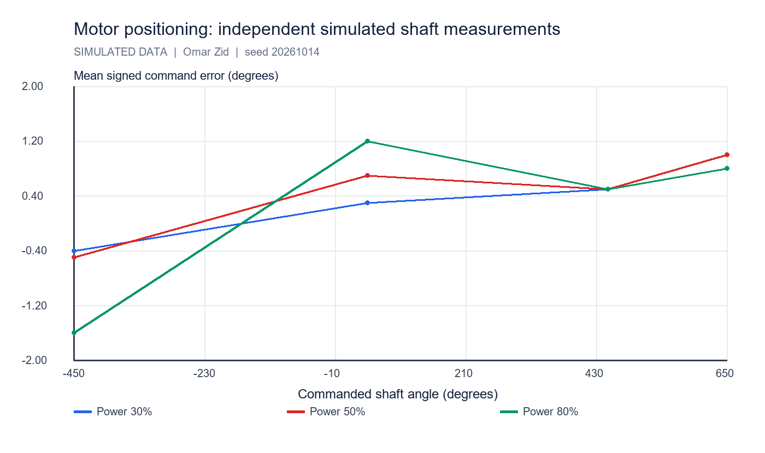
Mean command errors use the independent reference, not the calibrated tacho itself. Each point represents five simulated trials.

4 Worked calculations and uncertainty
For the 450° command at power 50%, mean external angle = 450.50°, s = 0.354°, mean duration = 1.839 s. Raw rows are retained in motor_trials.csv so all means and scatter can be recalculated.
The uncertainty calculation treats the independent reference noise/reporting step as an additional conservative type-B component. Quantization of the tacho is already present in the calibration residuals; it is not added again to the external-reference uncertainty. This simplified budget excludes real mounting error, backlash, drift and load-dependent deformation.
$x̄ = Σxi/n; s = √[Σ(xi - x̄)²/(n - 1)].$
$e = 450.50° - 450° = 0.50°; relative error = 100 e/450 = 0.111\%.$
$u_ref = √(0.35² + 0.5²/12) = 0.379°; U = 2√(s²/5 + u_ref²) = 0.82°.$
$s_wheel = πD θ/360 = π × 56 mm × 450.50/360 = 220.16 mm.$
One degree at D = 56 mm corresponds to π × 56/360 = 0.489 mm of nominal rolling travel. This conversion assumes no slip.
For an in-place body turn ψ = 10°, each wheel travels ±Bψ/2 = ±10.472 mm (ψ in radians); required shaft angle = ±Bψ(deg)/D = ±21.429°. Body heading and shaft angle are different quantities.

5 Counter resets and displayed position
The official NXC API distinguishes the tachometer count/limit reset from the program-relative rotation count reset. ResetTachoCount acts on the tacho counter and its limit goal. ResetRotationCount acts on the program-relative position counter read with MotorRotationCount. Resetting a counter changes its zero reference; it does not physically return the shaft to zero.
The exact trace below isolates reset semantics with relative movement increments. In a brick program, movement helpers may request their own counter resets; read values before and after the helper and verify which counter is displayed. Apply resets while stopped and allow the firmware update to complete before interpreting the result.
For a readable screen show target angle, current relative tacho angle, unwrapped program-relative angle and trial time with units. To show orientation within one revolution use ((angle % 360) + 360) % 360; retain the unwrapped angle in the file.
Event | Physical shaft (°) | Tacho (°) | Program relative (°)
Initial | 0 | 0 | 0
Relative move +450 | 450 | 450 | 450
ResetTachoCount only | 450 | 0 | 450
Relative move -45 (no automatic reset) | 405 | -45 | 405
ResetRotationCount only | 405 | -45 | 0
Relative move +650 (no automatic reset) | 1055 | 605 | 650

6 Conclusion and reproducibility
The modeled motor performed both directions and all requested rotations. Across the 60 trials, mean absolute command error of the independent observations was 0.783°. This is a simulator result, not a real NXT accuracy claim.
The useful result is a traceable test method: an independent angle check, a calibration equation, repeated observations, signed/relative errors, uncertainty and elapsed time. Counter-reset behavior is explicit, so the screen can show what its zero means. For physical validation mark the shaft, measure the true rotation independently, repeat the same matrix and replace the generated CSVs with logged readings.
Reproduce with simulation/lab_simulations.py. Seed = 20261014. Files: motor_calibration.csv, motor_trials.csv, motor_summary.csv and motor_counter_reset_trace.csv. Self-checks cover trial count, independent readings, gain recovery, negative direction and zero-reference behavior.

References
Supplied Screenshot_2.png: Report_1 Exploring motors (4h).
Supplied __NXC_tutorial.pdf, pp. 31-34: limited-angle motion, sign convention and PID explanation.
NXC official API, Output module functions: https://bricxcc.sourceforge.net/nbc/nxcdoc/nxcapi/group___output_module_functions.html
NXC official API, ResetTachoCount: https://bricxcc.sourceforge.net/nbc/nxcdoc/nxcapi/group___output_module_functions_ga89b494fec2591253658a55cc74d7c6e7.html
NXC official API, ResetRotationCount: https://bricxcc.sourceforge.net/nbc/nxcdoc/nxcapi/group___output_module_functions_ga1f07b7f5f06116fffe738f699d0ce83f.html

Files for reproducing and demonstrating the result
NXC source: 01_motor_measurements.nxc. Shared configuration: common_config.nxc.
Open Start_Here.html in the package for visual results and file links. Run the scripts in the simulation folder to regenerate the data and checks. The code folder contains the NXC source program and hardware configuration notes. The simulation implements a separate software model; it does not execute the NXC binary.

