Report 2 Exploring sonar and color sensors
  - Omar Zid
Informatics in Robotics | 14 October 2026
Simulation study. All numerical measurements are generated by the supplied software models. They are not measurements from a physical LEGO NXT robot. Hardware behavior requires calibration and testing.
Omar Zid | Reproducible simulation | 80 sonar distance trials, 340 angular trials and 270 color trials. Color classification: 97.0% in the declared model. Software read time, fresh sampling and physical response are reported separately.
Assignment source: Screenshot_3.png; __NXC_tutorial.pdf, p. 21

1 Aim apparatus model and procedure
The task asks for sonar speed, accuracy and field of action; color speed, resolution, response to color and illumination; and the operating principle and uses of one further sensor. This report selects a single-axis rate gyroscope for the final part.
A simulated stationary rig positions a broad target at 5-240 cm, then sweeps a 20 cm target through -40° to +40° at two distances. A color rig varies six matte swatches, assumed ambient illumination 100/300/800 lux and sensor standoff 10/20/30 mm. Ten sonar and five color repetitions per condition retain raw readings. The target geometry, timing constants, signal steps and noise values below are assumptions, not verified LEGO specifications.
Distance references have an assumed standard uncertainty 0.20 cm. Lux values are controlled simulator inputs, not measured light-meter readings. Separate calibration data are generated before test trials. A fixed random seed makes every observation reproducible and identifiable as simulated.

2 Sonar calibration accuracy and uncertainty
The valid-range model returns round(1.006d + 0.30 cm + Gaussian noise), with noise σ = 0.25 cm + 0.004d. It deliberately returns a no-echo sentinel at d < 8 cm or d ≥ 250 cm. These boundaries and the 1 cm output step are illustrative model settings. No-echo values are not averaged as if they were target distances.
Thirty calibration observations at 20, 40 and 80 cm yielded y = 1.007567d + 0.00849 cm; residual standard deviation 0.538 cm. Correct distances using dcal = (y - b)/a. The independent test matrix shows maximum raw mean bias 1.90 cm; mean absolute calibrated individual error is 0.598 cm.
Sample s describes repeatability of the raw distance observations. Corrected bias compares the calibrated mean with the known model distance. Expanded uncertainty U uses k = 2 and includes mean repeatability, assumed reference uncertainty and linear-calibration prediction uncertainty. Long-distance values extrapolate beyond the 80 cm calibration range; their larger uncertainty and sensitivity to slope are retained.
$e = x̄ - dref; MAE = Σ|xi - dref|/n; s = √[Σ(xi - x̄)²/(n - 1)].$
$u_cal(d) = (s_fit/a)√[1/Ncal + (d - d̄cal)²/Σ(dj - d̄cal)²].$
U = 2√[s_corrected²/n + (0.20 cm)² + u_cal(d)²]. Output quantization is present in trial scatter and calibration residuals, so it is not added twice.
A 1 cm reporting step does not imply ±1 cm accuracy. Systematic bias, reflectivity, target angle, multiple echoes and temperature can affect a physical sensor.
Truth cm (n) | Raw mean (cm) | s (cm) | Raw bias (cm) | Cal. bias (cm) | U cal. (cm)
5 (0/10) | No echo | - | - | - | -
10 (10/10) | 10.40 | 0.52 | 0.40 | 0.31 | 0.62
20 (10/10) | 20.50 | 0.53 | 0.50 | 0.34 | 0.59
40 (10/10) | 40.50 | 0.53 | 0.50 | 0.19 | 0.56
80 (10/10) | 80.70 | 0.67 | 0.70 | 0.09 | 0.67
120 (10/10) | 120.80 | 0.63 | 0.80 | -0.12 | 0.83
180 (10/10) | 181.00 | 1.05 | 1.00 | -0.37 | 1.31
240 (10/10) | 241.90 | 1.52 | 1.90 | 0.07 | 1.84

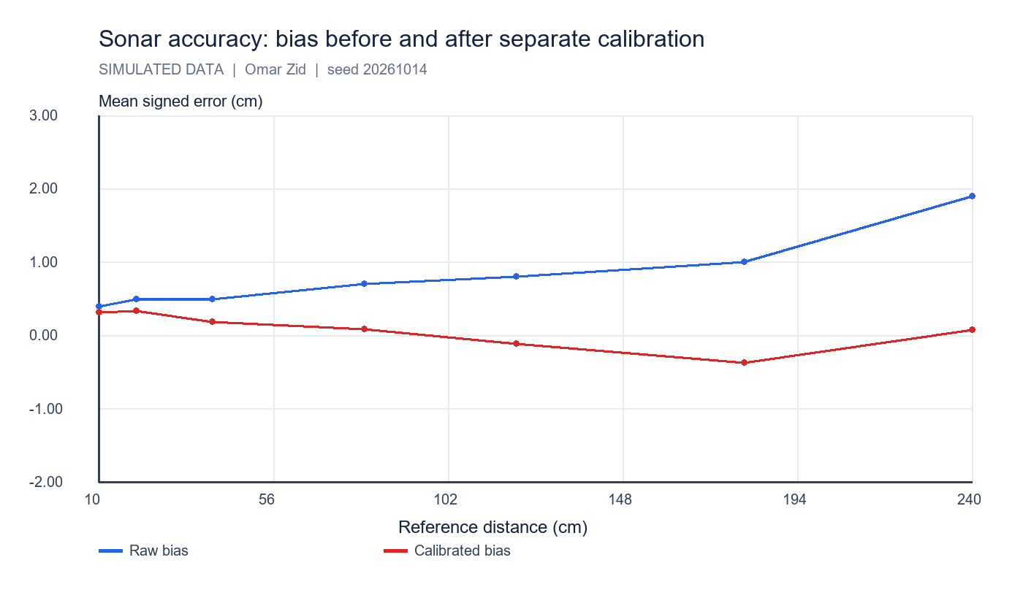
Separate calibration reduces the injected scale/offset error. It does not guarantee real-world accuracy.

3 Angular field of action
Detection is generated using P = 1/[1 + exp((|α| - h)/2.5°)], where h = 12° + atan(10 cm/d) in degrees. The assumed 12° core and 2.5° transition width are model constants. Target width contributes to the apparent field, so a measured detection cone is specific to this target and range.
At least 8 detections out of 10 defined the operational threshold. For the 20 cm target at 50 cm, accepted sampled angles ran from -15° to 15°; at 100 cm they ran from -10° to 15°. The sweep spacing is 5°; threshold boundaries are therefore only localized to approximately one angular sample, and finite trials add binomial uncertainty.
A physical field-of-view test must use a fixed object and a repeatable turntable, record misses and repeated hits, and state target material, dimensions, distance and criterion. A single sonar reading cannot prove that the entire surrounding region is clear.
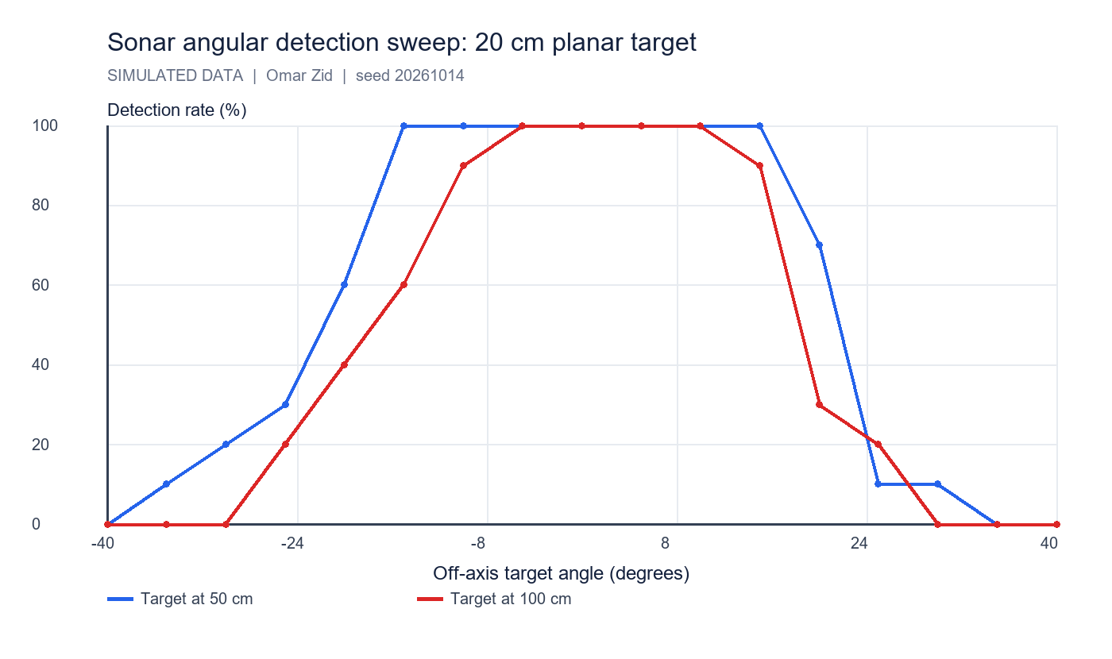
Detection percentage versus off-axis angle for two distances. These curves are generated by the declared model and do not assert a manufacturer's beam specification.

4 Speed software read update interval and physical response
Mean simulated sonar read-call latency is 3.18 ms. A software loop reads every 20 ms, while the assumed sonar state refreshes every 80 ms. Faster polling repeats cached data. A target step from 120 to 40 cm occurs at 250 ms; response delay is 40 ms and time constant 25 ms. The first changed observation appears after 70 ms, and the reading reaches ±2 cm of its final value after 150 ms.
These three times answer different questions: how long a function call blocks; how often fresh measurements become available; and how quickly a changed physical target affects the reported output. Only the latter two constrain a stopping controller. Reading faster is useful for scheduling but does not manufacture fresh sensor information.
For the color step test, software reads average 2.11 ms; assumed fresh updates occur every 40 ms. The physical model has 30 ms delay and 20 ms time constant. A white-to-red step at 250 ms is first classified red after 70 ms. The sampled 10-90% green-channel transition spans 40 ms; 40 ms sampling limits its time resolution.
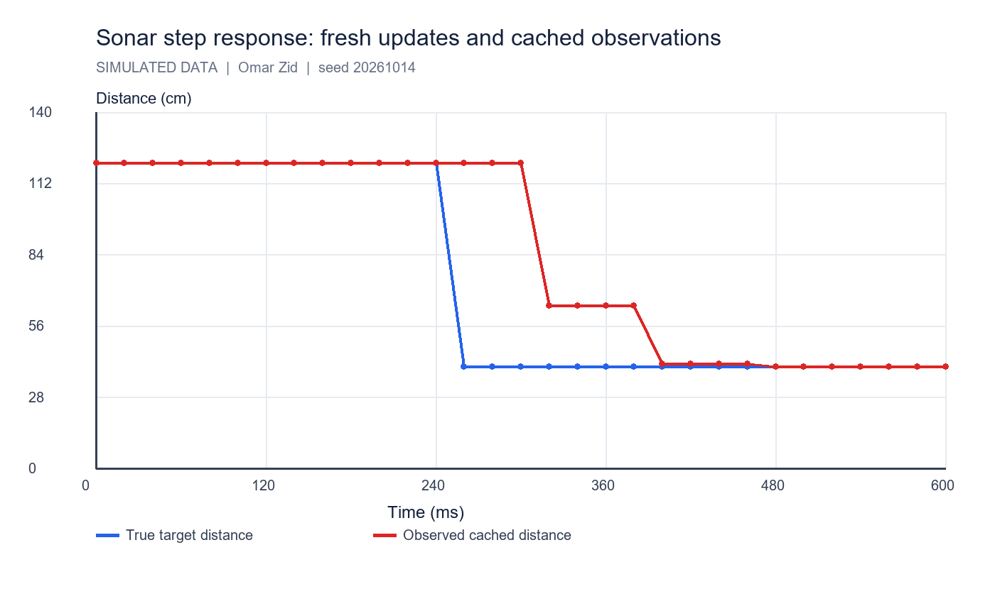
A 20 ms polling loop repeatedly sees the same value between fresh 80 ms updates. The physical response time is much longer than the read-call latency.

5 Color channels calibration and lighting response
Full-color logs contain simulated raw red/green/blue and a blank ambient channel. Per-channel dark offsets are (22, 25, 21) counts and gains (1.00, 0.91, 1.07). Raw counts follow dark + 0.18 × lux + gain × 800 × ρ/[1 + (h/18 mm)²] + noise. Channel noise σ = 4.5 + 0.006 × lux counts. A white reference under the same light and standoff normalizes each channel.
The ratio norm = (raw - dark - blank)/(white - dark - blank) estimates reflectance in the model. Raw RGB responds to mounting distance and ambient light; subtracting the blank and dividing by a matched white reduces these changes. Normalized ratios are custom calculated values. They are not claimed to be the firmware's normalized arrays or its built-in classifier.
NXC exposes full-color, red/green/blue illumination and no-light configurations. ReadSensorColorEx returns a color value plus raw, normalized and scaled arrays; the raw/array API requires compatible NXT 2.0 firmware. The custom CSV separately records our reproducible classifier. Red-only illumination yields an intensity measurement; no-light mode supports ambient measurement and comparison.
$ρR = (Rraw - Rdark - blank)/(Rwhite - Rdark - blank); equivalent expressions for G and B.$
$Red at 300 lux and 20 mm: normalized R mean = 0.810, sample s = 0.0232. Mean standard error = s/√5 = 0.0104.$
The assumed raw output step is one model count; trial σR = 5.15 counts. A 3s discrimination criterion is approximately 15.4 counts or 0.069 in normalized R under this condition. This is practical modeled resolution, not sensor ADC bit depth.
Swatch | Raw R mean ± s | Norm R | Norm G | Norm B | Correct n
red | 365.0 ± 5.15 | 0.810 | 0.104 | 0.076 | 5/5
green | 119.4 ± 4.83 | 0.125 | 0.697 | 0.112 | 5/5
blue | 105.8 ± 3.03 | 0.085 | 0.153 | 0.780 | 5/5
yellow | 348.6 ± 8.91 | 0.764 | 0.677 | 0.075 | 5/5
white | 376.2 ± 8.07 | 0.840 | 0.847 | 0.837 | 5/5
black | 87.0 ± 4.85 | 0.036 | 0.042 | 0.044 | 5/5

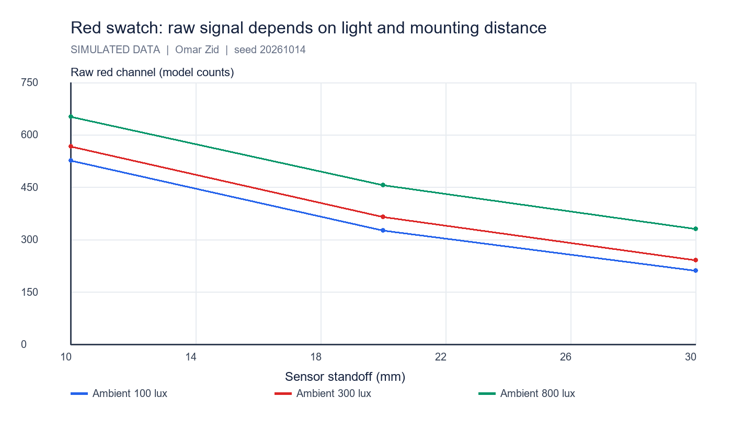
Each point averages five red-swatch trials. Ambient light raises raw readings and larger standoff reduces active reflection.

6 Classification and resolution limits
The classifier first separates black (all normalized channels < 0.085), white (minimum > 0.58 with channel spread < 0.15) and yellow (R > 0.35, G > 0.30, B < 0.20). Otherwise the strongest RGB channel must represent > 55% of total signal; ambiguous outputs are marked unknown. These thresholds are declared design choices, not calibrated real LEGO color IDs.
The 270 trials achieved 97.04% correct classifications in the declared model. All individual errors remain in color_trials.csv and the full confusion matrix. A high classification score for these separated swatches does not establish the number of colors a real sensor can distinguish or its smallest intensity increment.
Resolution is evaluated from within-condition scatter and the reporting step. Color identification, reflectance resolution and light intensity are separate outputs. Larger standoff weakens the reflected signal; larger ambient illumination raises noise in this model. For a real test, include near-threshold shades, glossy surfaces and shadow changes, and replace assumed lux with a light-meter observation.
Ambient (lux) | Standoff (mm) | Correct / trials | Accuracy (%)
100 | 10 | 30/30 | 100.0
100 | 20 | 30/30 | 100.0
100 | 30 | 28/30 | 93.3
300 | 10 | 30/30 | 100.0
300 | 20 | 30/30 | 100.0
300 | 30 | 30/30 | 100.0
800 | 10 | 30/30 | 100.0
800 | 20 | 28/30 | 93.3
800 | 30 | 26/30 | 86.7

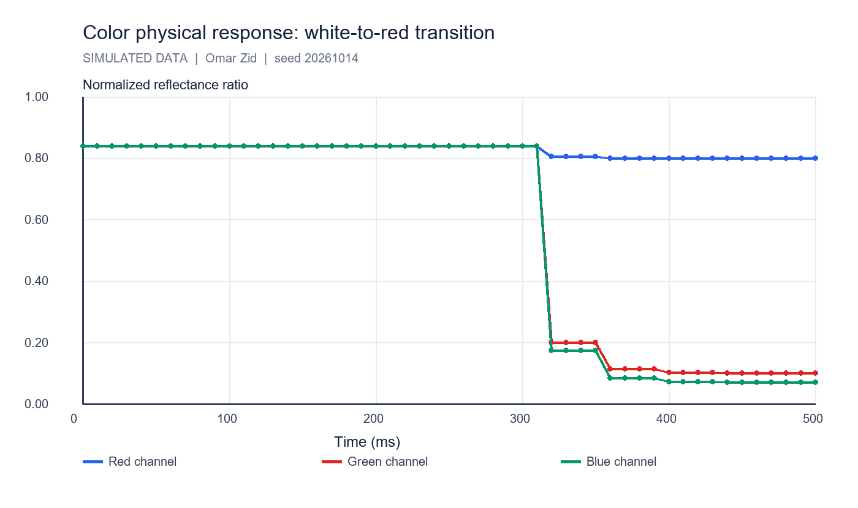
Normalized channels converge after the modeled physical white-to-red step; successful classification is a threshold event during that transition.

7 Further sensor single axis rate gyroscope
A rate gyroscope measures angular velocity about its sensitive axis. With a known starting orientation, numerical integration estimates the change of heading. It does not directly provide an absolute compass heading. The official FIRST implementation documentation for the legacy HiTechnic NXT gyro describes a single-axis rate output; this report uses its operating principle without assuming that such a sensor is physically present.
In a separate illustrative model, stationary rate bias is +0.8°/s with noise σ = 0.18°/s. Average 100 stationary samples before motion: estimated bias 0.8039°/s, s = 0.1737°/s. Sample at an assumed 100 Hz. A true 45°/s turn lasting 2 s gives 90°. Over the complete 5 s trace, uncorrected integration gives 94.080°; bias-corrected integration gives 90.061°.
Applications include turn-angle feedback, detecting unintended rotation, balancing control and comparing wheel odometry with body rotation. Remaining bias causes heading drift proportional to elapsed time; vibration, temperature changes and axis alignment require calibration. Combine rate with wheel encoders or a compass for longer-term orientation. Compass readings can be disturbed by local magnetic fields; an accelerometer measures specific force and cannot separate tilt from all vehicle accelerations without further assumptions.
$b̂ = (1/N)Σωstationary; ωcorrected = ωraw - b̂.$
$θk = θk-1 + ωcorrected,k Δt; units: (degrees/second) × seconds = degrees.$
Residual bias 0.1°/s accumulates 6° heading error in 60 s. This is a dimensional example, not a measured drift specification.

8 Conclusions and files
The models demonstrate a working test approach with separate truth, observation, calibration and error calculations. Sonar misses are explicit; angular detection is target dependent; fresh updates and physical response govern usable speed. Color calibration improves consistency, while raw intensity alone depends on illumination and geometry. The rate gyro example shows why stationary bias subtraction is essential before integration.
Reproduce with simulation/lab_simulations.py, seed 20261014. Sonar files: calibration, distance trials/summary, angular trials/summary and step response. Color files: trials/summary, confusion matrix, mode comparison and step response. Gyro files: stationary calibration and turn trace. All are CSVs under data/labs. No physical measurements, manufacturer precision or installed-device claims are implied.

References
Supplied Screenshot_3.png: Report_2 Exploring sonar and color sensor (4h).
Supplied __NXC_tutorial.pdf, p. 21: ultrasonic sensor example and low-speed configuration.
NXC official API, Input module functions: https://bricxcc.sourceforge.net/nbc/nxcdoc/nxcapi/group___input_module_functions.html
NXC official API, Color sensor array indices: https://bricxcc.sourceforge.net/nbc/nxcdoc/nxcapi/group___input_color_idx_constants.html
FIRST official legacy HiTechnic gyro implementation documentation: https://first-tech-challenge.github.io/SkyStone/com/qualcomm/hardware/hitechnic/HiTechnicNxtGyroSensor.html

Files for reproducing and demonstrating the result
NXC source: 02_sensor_measurements.nxc. Shared configuration: common_config.nxc.
Open Start_Here.html in the package for visual results and file links. Run the scripts in the simulation folder to regenerate the data and checks. The code folder contains the NXC source program and hardware configuration notes. The simulation implements a separate software model; it does not execute the NXC binary.

