Project 1 Clean the Ring
  - Omar Zid
Informatics in Robotics | 14 October 2026
Simulation study. All numerical measurements are generated by the supplied software models. They are not measurements from a physical LEGO NXT robot. Hardware behavior requires calibration and testing.
Omar Zid | Simulated result: 9/9 objects expelled in 175.96 s; robot stopped after a complete empty angular scan. The chassis stayed at least 75.00 mm inside the ring. The forward pusher reaches the boundary exactly, leaving zero extension tolerance in the ideal model.
Assignment source: Screenshot_4.png

Task deliverables and declared model
All trials in this report are reproducible software simulations produced for Omar Zid. They are not physical measurements, proof of NXC compilation, or evidence of testing a LEGO robot. Motor B is the left wheel; motor C is the right wheel; the one color/light sensor is S1 and the fixed forward ultrasonic sensor is S4. Wheel diameter D = 56 mm and wheel-center track B = 120 mm are explicit assumed calibration values. Replace them with measured values before a physical demonstration.
The task is to push every object outside the ring quickly, keep the robot inside, stop when clean, and display a map of ejection locations on the robot screen. The model includes sensing, wheel movement, contact pushing, reverse movement, verification and a small LCD-style map. Objects have radius 20 mm. Ring outer radius is 600 mm, with a black boundary band from radius 580 to 600 mm. The robot is represented by a circular 75 mm chassis and a narrow 150 mm forward pusher. The color sensor is aligned with the pusher tip; S4 is 70 mm forward of the axle center. Initial object centers must be outside a 180 mm staging radius, leaving room for the 150 mm pusher, its 40 mm half-width, and the 20 mm object radius while turning.
The start is the center with heading 0 rad. Nine separate rigid circular objects form the nominal scene. No object count or object positions are supplied to the controller: it receives ultrasonic distances while turning. Object IDs in the trace label the independent simulated scene for checking and plotting.
Quantity | Value | Unit / meaning
Outer ring radius | 600 | mm
Black boundary width | 20 | mm
Chassis radius | 75 | mm
Pusher / color offset | 150 | mm forward
Object radius | 20 | mm
Ultrasonic offset | 70 | mm forward

Search push boundary response and clean stop logic
SEARCH turns the robot through headings 0°-359° in 1° increments and reads one forward range ray at each heading. SELECT chooses the smallest measured surface range, giving a bearing close to the center of the nearest visible object. ALIGN turns to that bearing. PUSH advances at 110 mm/s. A 40 mm half-width pusher captures the selected object when the front makes contact; the object then moves with the front face. The simulation integrates each wheel movement rather than jumping between waypoints.
The color sensor reaches the inner black edge when the axle is 430 mm from the center. BOUNDARY_FINISH then travels the calibrated 20 mm band width at 40 mm/s, stopping at axle radius 450 mm. The pusher tip is at 600 mm and the object center at 620 mm, so the entire radius-20 mm object is outside or tangent to the ring. RETREAT reverses 450 mm on the same heading to the center. It then searches again. A successful clean stop requires a new complete scan with no object ranges inside the 900 mm search limit; absence of a detection while merely driving is insufficient.
At the farthest ring radius, adjacent 1° rays are approximately 10.47 mm apart. This is narrower than the 40 mm object diameter. Under the ideal ray, clear staging and minimum object-size assumptions, an unoccluded object cannot hide between samples. Occlusion is handled by repeatedly clearing the nearest visible object and rescanning. An independent test checks the true remaining objects when the controller declares completion. The 32-scan safety cap is a failure budget; it does not use the true initial object count.

Calculations with dimensions and units
The calculations distinguish chassis safety from the complete forward extension. A positive chassis margin does not imply a positive pusher margin. In this ideal model the pusher touches the outer border but does not cross it. Encoder distances are calculated from wheel circumference, not from motor percentages.
Wheel circumference C = πD = π × 56 mm = 175.929 mm/revolution. Straight wheel travel s = C × encoder_degrees / 360°.
Travel to first black reading = 580 mm - 150 mm = 430 mm. Finish travel = 600 - 580 = 20 mm. Maximum axle radius = 430 + 20 = 450 mm.
$Chassis margin = 600 - (450 + 75) = 75 mm. Complete forward-extension margin = 600 - (450 + 150) = 0 mm.$
$Ejected object center radius = 450 + 150 + 20 = 620 mm; its nearest point is 620 - 20 = 600 mm.$
A 450 mm forward run requires 450 / (π × 56) × 360 = 920.825° per wheel. Nine forward-and-reverse runs cover 9 × 2 × 450 = 8100 mm, matching the exported path 8100.000 mm.
An in-place 360° turn moves each wheel πB = π × 120 = 376.991 mm in opposite directions: 771.429° per wheel. Angular rate 0.9 rad/s corresponds to wheel speeds ±54 mm/s.
$Angular sampling chord = 2 × 600 mm × sin(0.5°) = 10.472 mm < 40 mm object diameter.$

Executed validation trials and exported map
The table contains executed trials; the alternate layout and initially empty ring exercise completion logic, not only the nominal arrangement. Time includes actual in-place scan/align rotations, push travel and reverse travel. The empty case stops only after taking all 360 range readings. An empty ring permits stopping even without pushing an object.
The ejection CSV records object ID, coordinates in mm and simulated time in s. The LCD image represents a 100 × 64 pixel display enlarged five times. Coordinates use u = 50 + 25x/600 and v = 35 - 25y/600. Rounding produces pixel locations; the marker numbers are display labels. Ejection coordinates are derived from encoder pose and assumed contact geometry, so they are estimates of where the push finished rather than an external camera survey.
Scene | Objects out | Search scans | Time (s) | Path (mm) | Chassis margin (mm)
nominal | 9/9 | 10 | 175.964 | 8100.0 | 75.0
dense | 12/12 | 13 | 235.130 | 10800.0 | 75.0
empty | 0/0 | 1 | 6.962 | 0.0 | 525.0

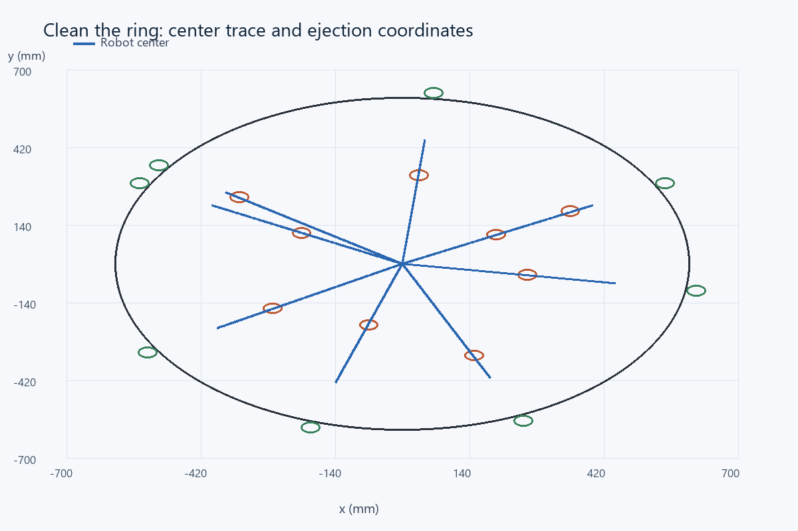
Computed robot-center trajectory. Brown circles show initial objects, green circles show the ejection coordinates, and the outer circle is the ring boundary.

Ejection coordinate evidence
All nine nominal objects reached center radius 620 mm in this geometric contact model. The object is marked ejected only after that condition is met. The robot subsequently retreats and verifies the remaining ring; it does not stop immediately after the ninth recorded ejection.
Object | x (mm) | y (mm) | Radius (mm) | Ejection time (s)
1 | 547.43 | 291.07 | 620.00 | 11.93
9 | -191.59 | -589.66 | 620.00 | 30.01
2 | -547.43 | 291.07 | 620.00 | 50.54
3 | 612.37 | -96.99 | 620.00 | 69.10
4 | -531.44 | -319.32 | 620.00 | 87.61
5 | 64.81 | 616.60 | 620.00 | 107.61
8 | 252.18 | -566.40 | 620.00 | 125.96
6 | 547.43 | 291.07 | 620.00 | 143.26
7 | -507.87 | 355.62 | 620.00 | 162.10

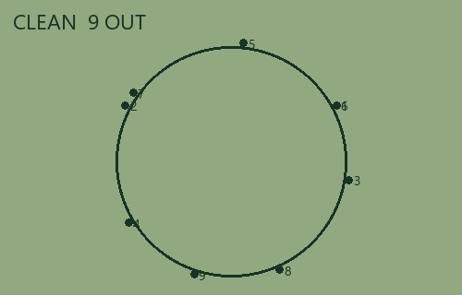
Enlarged LCD-style map generated from the ejection coordinates. Every plotted point lies outside the drawn ring.

Limits and physical demonstration procedure
This is a planar kinematic/contact model. It omits motor acceleration, braking travel, pusher flex, object rolling resistance, wheel slip, object-to-object collisions and the real sonar cone. Full expulsion while every part of the robot remains inside is achieved with zero pusher margin. It therefore has no tolerance for a smaller ring, larger forward extension or excess stopping distance. The simulated result must not be presented as physical boundary certification.
Before use, measure the ring radius, boundary-band width, chassis footprint, pusher offset, object dimensions and sensor position. Calibrate black/white readings at the actual floor height. Verify that the color sensor and pusher can reach the border together, and test braking at the 40 mm/s finish speed. If the teacher defines any contact with the border as leaving, this push geometry needs revision; the current model assumes touching the boundary is allowed. Add a guard timeout, clean-scan repetition and an obstacle-free center requirement for physical tests. Objects smaller than 40 mm, transparent or poorly reflecting objects, sonar blind zones and a center object violate the coverage assumptions.
Acceptance evidence is p1_nominal_trace.csv, p1_nominal_ejections.csv, p1_dense_trace.csv and p1_empty_trace.csv. The source simulation can be rerun; the assertions detect falsely declaring the ring clean. NXC programs are provided separately and require hardware calibration and a real toolchain check.

References
Assignment image: Screenshot_4.png - Project 1 Clean the Ring (4h).
Supplied NXC tutorial and NXC minimum reference, distributed with the source files.

Files for reproducing and demonstrating the result
NXC source: 03_project1_clean_ring.nxc. Shared configuration: common_config.nxc.
Open Start_Here.html in the package for visual results and file links. Run the scripts in the simulation folder to regenerate the data and checks. The code folder contains the NXC source program and hardware configuration notes. The simulation implements a separate software model; it does not execute the NXC binary.

