Project 2 SCANNER
  - Omar Zid
Informatics in Robotics | 14 October 2026
Simulation study. All numerical measurements are generated by the supplied software models. They are not measurements from a physical LEGO NXT robot. Hardware behavior requires calibration and testing.
Omar Zid | Simulated scanner counted 14 bars in groups [4, 7, 3] over 5.000 s at 60 mm/s. All 30 noisy phase-varied runs at that speed were correct. Scanner.txt contains appended results; send and receive were verified through an explicitly emulated mailbox.
Assignment source: Screenshot_5.png

Task card fixture and sensor model
All trials in this report are reproducible software simulations produced for Omar Zid. They are not physical measurements, proof of NXC compilation, or evidence of testing a LEGO robot. Motor B is the left wheel; motor C is the right wheel; the one color/light sensor is S1 and the fixed forward ultrasonic sensor is S4. Wheel diameter D = 56 mm and wheel-center track B = 120 mm are explicit assumed calibration values. Replace them with measured values before a physical demonstration.
The supplied task asks for the number of vertical bars with maximum accuracy and minimum working time, for the count/time to appear on screen and be appended to Scanner.txt, and for the sum to be sent to another robot. Each group contains bars with common width, spacing and height; dimensions differ between groups. The simulated card therefore uses three deliberately different groups, with a known 300 mm horizontal fixture travel. The sensor scans at y = 0 mm, through all bars. A single horizontal pass can only count bars intersecting that scan line; different heights do not reveal themselves as extra events.
Black reflectance is 20 and white reflectance is 80 on a normalized 0-100 scale. A 4 mm rectangular sensing footprint averages covered black and white area along the travel direction. Gaussian sample noise has standard deviation 2 reflectance units. Different random seeds and initial sample phases test repeatability. No bar dimensions or group count enter the count state machine; the known 300 mm fixture length only defines where to stop.
Group | Bars | Width (mm) | Gap (mm) | Height (mm) | x span (mm)
1 | 4 | 8 | 7 | 35 | 20-73
2 | 7 | 5 | 6 | 55 | 108-179
3 | 3 | 12 | 10 | 25 | 214-270

Time sampled counting and grouping algorithm
The scanner samples every 0.010 s. WHITE transitions to BLACK only after three consecutive readings below 35. That stable transition increments the total exactly once. BLACK transitions back to WHITE after three consecutive readings above 65. Readings between 35 and 65 keep the current state and reset the pending confirmation. This hysteresis rejects small fluctuations, and three-sample confirmation rejects a single noisy sample. A wide black bar cannot be counted repeatedly while the sensor remains over it.
The optional group display starts a new group when the white distance between confirmed transitions exceeds 22 mm. The card has 35 mm between groups and 6-10 mm within groups; hence the threshold separates these cases. Total bar counting does not rely on grouping. All 14 bars pass through the same scan line even though their heights differ. A separate y = 18 mm test intentionally misses the 35 mm-high and 25 mm-high groups because their half-heights are 17.5 and 12.5 mm; this is a geometric failure, not a counter defect.
Elapsed time is sampled work time from the first acquisition to the stopping sample; it excludes setup and calibration. The nominal result is formatted as a screen/count-time record and appended using file append mode. A second run appends another record, preserving the first. The message COUNT=14;TIME_MS=... is placed in an in-process mailbox and read by a second receiver function. This demonstrates payload formatting and matching send/receive values. It does not demonstrate a Bluetooth radio, pairing, packet reliability or a second physical brick.

Sampling calculations and speed selection
Counting accuracy depends on usable dark and white duration, not only on a threshold. A coarse speed can skip a narrow bar entirely or provide fewer than three confirmed samples. The 90 mm/s tests show that a theoretical no-noise bound does not guarantee a robust noisy run. The selected 60 mm/s speed retains additional sampling margin and takes less time than 40 mm/s.
Sample displacement = v × Δt. At 60 mm/s × 0.010 s = 0.600 mm/sample. A 5 mm bar spans approximately 8.33 samples before footprint/threshold effects.
With black = 20, white = 80 and entry threshold 35, the required black coverage fraction is (80 - 35)/(80 - 20) = 0.75. For a 4 mm footprint, 3 mm must be black.
For the 5 mm narrowest bar, the ideal below-threshold x interval is 5 - 4/2 = 3 mm. Its duration at 60 mm/s is 3/60 = 0.050 s, giving about five samples for a three-sample debounce.
A conservative noiseless phase-independent entry bound is v ≤ usable_width/(3Δt) = 3 mm/(3 × 0.010 s) = 100 mm/s. Noise and threshold uncertainty justify choosing 60 mm/s; the experiment independently tests that decision.
At 300 mm/s, displacement is 3 mm/sample. A 3 mm usable dark interval yields about one sample, below the required three. Missed bars are therefore expected.
Nominal travel time = 300 mm / 60 mm/s = 5.000 s. The executed sampled acquisition is 5.000 s because it includes the final 10 ms stopping sample.
$At 60 mm/s, each wheel turns at 60/(π × 56) × 360 = 122.777°/s. The full 300 mm span requires 613.883° per wheel.$

Repeated noisy trials and deliberate failure test
Thirty runs at each speed use seeds 0-29 and phase offsets spanning one sample period. Every result below is generated from the state machine and noise model. Accuracy is the fraction of runs whose total equals 14, not an assertion that physical hardware has the same reliability. The high-speed trials are retained as failure evidence.
Speed (mm/s) | Correct / runs | Min count | Max count | Work time (s) | Accuracy (%)
40.0 | 30/30 | 14 | 14 | 7.510 | 100.0
60.0 | 30/30 | 14 | 14 | 5.010 | 100.0
90.0 | 28/30 | 13 | 14 | 3.340 | 93.3
150.0 | 0/30 | 7 | 9 | 2.000 | 0.0
300.0 | 0/30 | 1 | 3 | 1.000 | 0.0

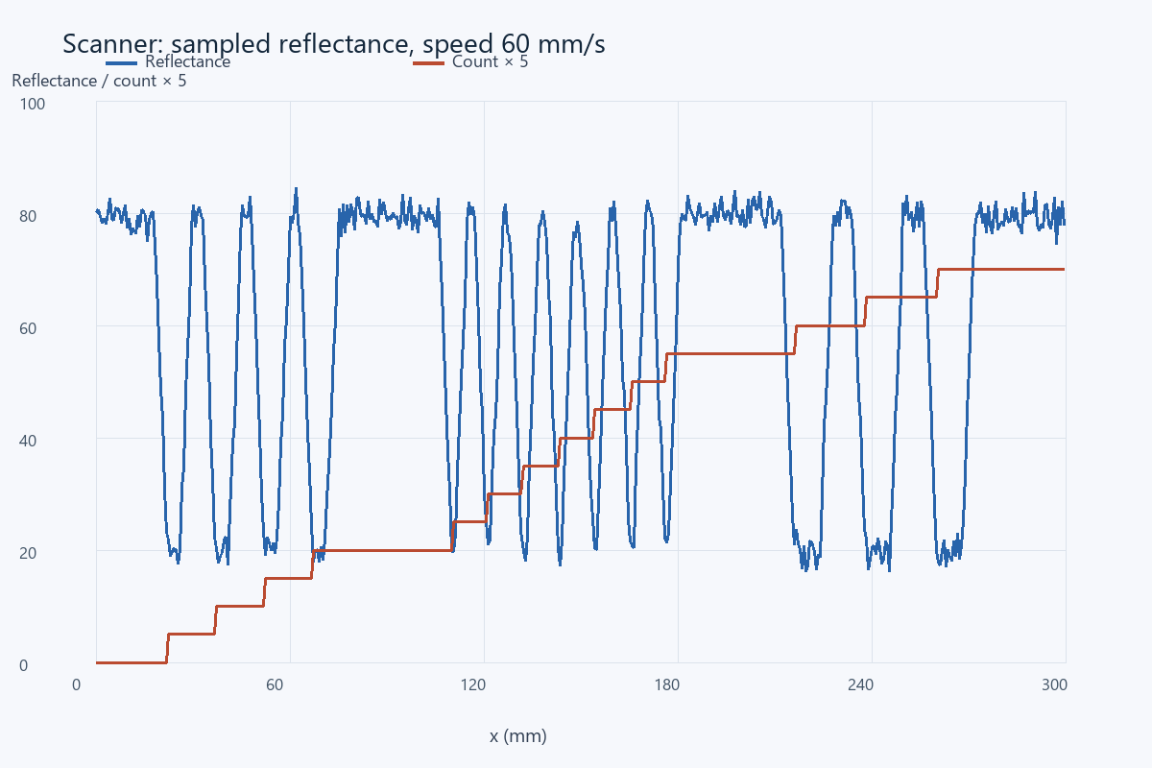
Actual nominal sampled reflectance and accumulated count. The count is multiplied by 5 only to make both traces visible on one scale.

Files receiver evidence and mounting sensitivity
Scanner.txt is regenerated as a deterministic demonstration file at the beginning of the simulation, then the two trial records are appended with append mode. Re-running the entire simulation rebuilds the demonstrator; this is separate from continuously preserving a physical brick file across power cycles. The full p2_trials.csv contains all 150 counts, speeds, sample phases and seeds, and p2_nominal_trace.csv contains every sensor reading and state transition.
At y = 18 mm, the executed mounting-offset test counted 7 bars rather than 14. That value is expected because only the 55 mm-high middle group intersects the scan line. A teacher demonstration should first show the centered successful pass, then show the speed and mounting failures to explain the measurement limits.
Sender payload | Receiver payload | Match | Transport
COUNT=14;TIME_MS=5000 | COUNT=14;TIME_MS=5000 | Yes | Emulated mailbox
COUNT=14;TIME_MS=7500 | COUNT=14;TIME_MS=7500 | Yes | Emulated mailbox

Physical checks and conclusions
The recommended simulated configuration gives 14 bars in three groups, 4 + 7 + 3 = 14, while preserving count/time records and transmitting a matching payload in software. The elapsed work time does not include Bluetooth connection setup or receiver latency. No real radio latency or loss is claimed.
For physical commissioning, measure the narrowest bar and gap with a ruler, check the sensor footprint at its mounting height, calibrate thresholds over actual black and white card, and ensure the scan line intersects the shortest bar. Check straightness with both wheel encoders and reduce speed until three stable samples are available under real noise. Confirm scanner file open/append/close behavior and a real receiver acknowledgment after pairing. The finite ray/footprint model omits uneven illumination, glossy print, motor drift, vibration, torn bars and communication failures. A white end region is not itself proof that every bar has been scanned; the known fixture travel provides that condition here.

References
Assignment image: Screenshot_5.png - Project 2 SCANNER (4h).
Supplied NXC tutorial and NXC minimum reference, distributed with the source files.

Files for reproducing and demonstrating the result
NXC source: 04_project2_barcode.nxc and 04b_barcode_receiver.nxc. Shared configuration: common_config.nxc.
Open Start_Here.html in the package for visual results and file links. Run the scripts in the simulation folder to regenerate the data and checks. The code folder contains the NXC source program and hardware configuration notes. The simulation implements a separate software model; it does not execute the NXC binary.

