Project 3 Obstacle Avoidance
  - Omar Zid
Informatics in Robotics | 14 October 2026
Simulation study. All numerical measurements are generated by the supplied software models. They are not measurements from a physical LEGO NXT robot. Hardware behavior requires calibration and testing.
Omar Zid | Configurable N = 160 cm trial reached x = 1600.00 mm, y ≈ 0 mm after avoiding two unknown rectangles. Route length was 2840.00 mm. Minimum clearance of the complete circular chassis was 35.00 mm, and simulated time including physical probing turns was 247.64 s.
Assignment source: Screenshot_6.png

Task and endpoint definition
All trials in this report are reproducible software simulations produced for Omar Zid. They are not physical measurements, proof of NXC compilation, or evidence of testing a LEGO robot. Motor B is the left wheel; motor C is the right wheel; the one color/light sensor is S1 and the fixed forward ultrasonic sensor is S4. Wheel diameter D = 56 mm and wheel-center track B = 120 mm are explicit assumed calibration values. Replace them with measured values before a physical demonstration.
The assignment requests forward progress of configurable N cm while avoiding one or more parallelepiped obstacles of unknown size and keeping close to the original straight line. This report defines the requested endpoint as x = 10N mm on the original y = 0 mm line. The total curved/detour route is a separate measurement. Stopping after only N cm of wheel travel would end short of the requested forward endpoint when obstacles require detours.
The environment is a planar top view of rigid rectangles. The controller is given N, its start pose and encoder calibration. Rectangle coordinates are known only to the simulated sensor and collision checker; the controller does not read their widths, heights, near edges or far edges. The robot has a circular collision footprint of radius 75 mm. The ultrasonic sensor lies 70 mm forward of the axle and is fixed to the chassis. To probe a side wall, the whole robot stops and rotates, takes a forward measurement, and rotates back. Those turns consume time and appear in the wheel trace.

Measured corner avoidance state machine
FORWARD advances in 10 mm steps with encoder heading feedback while the forward range exceeds 200 mm. If range is at most 200 mm, TURN_RIGHT rotates to -90°. FIND_NEAR_CORNER moves south in 25 mm increments. Between steps, a real simulated chassis rotation faces east and probes the obstacle; it then restores the south heading. Once the east ray becomes clear, the robot travels a further 110 mm south before turning east. This margin consists of the 75 mm chassis radius plus 35 mm clearance.
FOLLOW_SIDE progresses east in 25 mm steps, with chassis rotations to probe north. It must first observe a wall and later observe that wall has ended; an initially clear north reading is insufficient to declare the far corner. After the far-corner observation, it travels another 110 mm east, turns north, and uses encoder y to return to y = 0. It turns east and resumes forward progress. Heading feedback applies ω = clamp[4(θtarget - θodo), -0.7, +0.7] rad/s; straight speed is 120 mm/s and detour speed is 100 mm/s.
Search budgets prevent endless movement when the assumed geometry fails: at most 80 near-corner increments and 100 side increments. Such a timeout is reported as failure, not a successful avoidance. The modeled scenes have isolated convex rectangles and enough clear ground below them. Turning is safe here because the collision footprint is circular; a long real chassis needs a swept-footprint check.

Odometry unit conversions and safety calculations
Wheel increments produce both the true kinematic pose and independent encoder odometry. With no slip or encoder quantization in these baseline trials, they coincide. Each interval uses the exact constant-wheel-speed differential-drive arc; small-angle straight movement is handled separately. Heading is in radians internally and encoder rotation is in degrees.
$N_mm = 10 × N_cm. For N = 160 cm, endpoint x = 1600 mm. This does not constrain total route length to 1600 mm.$
$ΔsL = πD × ΔencoderL/360; ΔsR = πD × ΔencoderR/360. Δs = (ΔsR + ΔsL)/2; Δθ = (ΔsR - ΔsL)/B.$
$For Δθ ≠ 0: xnew = x + (Δs/Δθ)[sin(θ+Δθ) - sin θ]; ynew = y - (Δs/Δθ)[cos(θ+Δθ) - cos θ].$
The first nominal front face is x = 420 mm. A 200 mm range from a sensor 70 mm forward corresponds to center x ≈ 420 - 200 - 70 = 150 mm. Chassis-front clearance before turning is 420 - 150 - 75 = 195 mm.
Required side center spacing is 75 + 35 = 110 mm. The chassis clearance is distance(center, rectangle) - 75 mm; center distance by itself would overstate safety by 75 mm.
$Nominal path excess = 2840 - 1600 = 1240 mm; route/forward-progress ratio = 1.775.$
One wheel encoder degree corresponds to π × 56/360 = 0.4887 mm. A 1° differential error between wheels changes estimated heading by 0.4887/120 = 0.004072 rad = 0.2333°. Over 1.6 m, an uncompensated constant 0.2333° heading error gives about 6.51 mm lateral drift.

Executed scenarios and complete chassis clearance
The nominal two-obstacle scene has rectangles x = 420-650 mm, y = -100-100 mm and x = 1050-1250 mm, y = -180-80 mm. The alternate wide/tall scene has x = 400-710 mm, y = -240-120 mm and adds uniform ultrasonic noise within ±2 mm. These dimensions are disclosed for validation and reproduction; the controller discovers the corners from range transitions. The clear-path case confirms N can change without changing the control algorithm.
Clearance is evaluated over every simulated trace sample, including physical probing rotations. All recorded chassis clearances exceed 30 mm. The simulator uses exact local arcs with a maximum moving step of 2.4 mm. The nominal minimum 35 mm occurs in a straight segment parallel to the obstacle, so the reported minimum is not merely a distance from a few waypoint vertices. The circular body can rotate in place without increasing its footprint.
Trial | N (cm) | Endpoint (mm) | Path (mm) | Min clearance (mm) | Time (s)
two_obstacles | 160 | (1600.0, 0.0) | 2840.0 | 35.0 | 247.64
wide_tall | 120 | (1200.0, 0.0) | 1920.0 | 45.0 | 151.03
clear | 80 | (800.0, 0.0) | 800.0 | No obstacles | 6.67

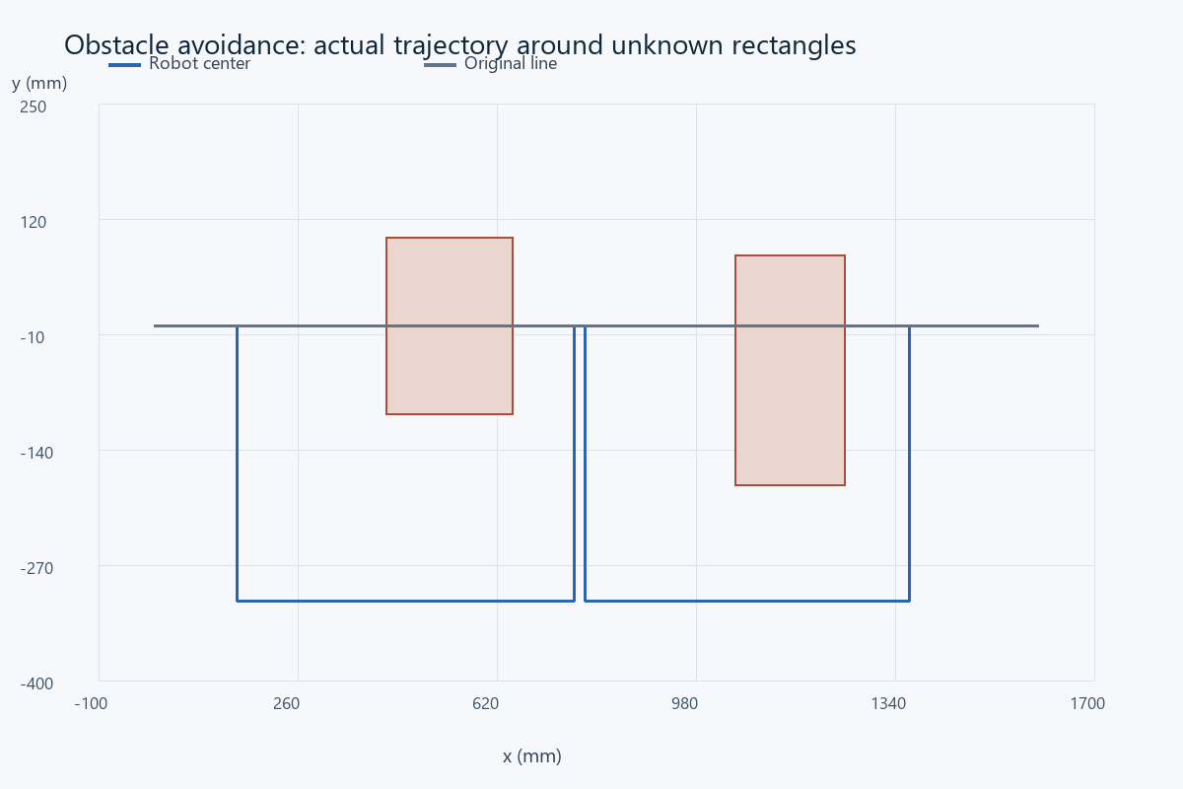
Actual wheel-integrated trajectory. Shaded rectangles are the unknown-size objects in the sensor environment; the gray horizontal trace is the original y = 0 line.

Performance tradeoffs and exported observations
The nominal maximum lateral displacement was 310.0 mm. The robot returns to the original line after each obstacle rather than continuing a parallel offset to the end. This is a feasible conservative strategy; the report does not claim it is the global shortest route or the fastest possible avoidance. The 247.64 s runtime is dominated by rotating a fixed sonar to take side measurements. A movable sensor or additional side sensor would reduce this overhead but would change the hardware assumption.
The CSV trace includes time, true x/y, encoder x/y, heading, both wheel degrees, commanded speed/angular rate, state and chassis clearance. The separate sonar CSV contains every forward and side-probe reading with time and pose. The +∞ no-return condition is encoded as the modeled 2550 mm out-of-range reading. Because this is a ray sensor, a rectangle edge produces a sharp change from a finite range to no return; a real ultrasonic cone will produce a broader transition.
The one-noisy-trial example is a deterministic sensitivity check, not a statistical physical reliability claim. Encoder calibration bias, wheel slip, an obstacle moving during a scan and nonrectangular or concave shapes require additional tests. An obstacle too near the final endpoint can force an overshooting detour; the simulation treats that as a failure of the configured route instead of claiming successful N progress.

Physical readiness and acceptance criteria
Before a classroom hardware demonstration, measure the full footprint and sensor offset; calibrate encoder distance and turn direction; verify zero range versus out-of-range handling; and test braking before the 200 mm threshold. Use heading correction only after wheel directions are confirmed. Validate the detection threshold under the actual sonar beam cone and permit additional clearance for noise and braking.
A physical run passes when the requested endpoint is reached near y = 0, no part of the chassis contacts any obstacle, the avoidance does not use manually entered obstacle dimensions, and a log shows both endpoint progress and total route length. The provided simulation passes those geometric checks under its stated assumptions. Its near-zero endpoint error is the expected consequence of ideal encoders and no slip, not an attainable measured accuracy claim for a real NXT. The separately provided NXC implementation follows the same sensing principle but has not been executed by this Python model.

References
Assignment image: Screenshot_6.png - Project 3 Obstacle Avoidance (6h).
Supplied NXC tutorial and NXC minimum reference, distributed with the source files.

Files for reproducing and demonstrating the result
NXC source: 05_project3_obstacle_navigation.nxc. Shared configuration: common_config.nxc.
Open Start_Here.html in the package for visual results and file links. Run the scripts in the simulation folder to regenerate the data and checks. The code folder contains the NXC source program and hardware configuration notes. The simulation implements a separate software model; it does not execute the NXC binary.

