CBE504, Homework 1, due Nov. 12, in class.

Problem 1: Consider the case when both CO and O₂ adsorb on the catalyst surface reversibly. Furthermore assume that reaction between CO and O is slow compared to the adsorption steps, which can be considered in equilibrium. Derive the expression for the rate of CO oxidation under these assumptions. Show that steady state multiplicity is impossible in this case.

Problem 2: Consider a simplified version of the Langmuir-Hinshelwood mechanism analyzed in this section, when both CO and O₂ adsorb irreversibly. This corresponds to 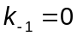. In this regime, analyze the dependence of the rate of CO oxidation as function of CO pressure (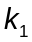in the model). Compare your results quantitatively to the parametric plot of reaction rate obtained with 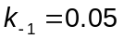.

Problem 3: Find all steady states of the model for a specific set of model parameters: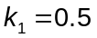, ,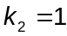, and 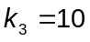. This can be done numerically in Matlab, using the ‘roots’ subroutine for solving polynomial equations. Add small random perturbations to each of the four steady states and use the result as an initial condition for the time dependent problem. Plot the results in the 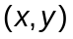plane. Perform linear stability analysis of all steady states.

