Project Proposal
Date Night Planner
A web app that pairs local things-to-do with things-to-stream, so planning a date night takes minutes, not hours.
Built with HTML, CSS, and vanilla JavaScript

1. Overview
Planning a date night is oddly time-consuming: one partner opens five streaming apps looking for something "good," the other is scrolling three different event sites, and twenty minutes later nobody has decided anything. Date Night Planner solves that by putting both halves of the decision — going out and staying in — into a single, filterable feed, so a couple can go from "what should we do tonight?" to a concrete plan in under a minute.
The motivation for this project is personal and practical: it is a real decision-fatigue problem that most couples run into weekly, it maps cleanly onto two rich, free-tier-friendly APIs (one for local events, one for streaming availability), and it gives room to practice combining and normalizing two very differently-shaped data sources into one coherent user experience using only vanilla JavaScript, which is exactly the challenge this course asks us to take on.

2. Target Audience
The primary audience is couples — whether newly dating or long-together — who want a low-effort way to decide what to do together on a given night. Within that group, the app is aimed especially at:
- Busy professionals and students who have limited free time to plan and don't want to browse multiple apps.
- Couples trying to break out of a "we always just watch TV" or "we always just go to the same restaurant" routine.
- New or long-distance-turned-local couples looking for structured ideas for a specific area.
- Budget-conscious users who want to filter by free/cheap options as easily as by premium ones.
The app serves this audience by removing the two most tedious parts of date planning — finding out what's actually happening nearby, and finding out what's actually worth watching — and letting users filter both by mood and budget instead of researching from scratch.

3. Major Functions
The table below lists the major functions planned for the initial build. All ten are considered part of the core, required feature set.
Function | Description
1. Location-Based Event Discovery | Queries the Global Hyper-Local Events API for events (concerts, comedy, art, food, outdoor, etc.) near the user's location and displays them as browsable cards with image, name, category, venue, and price.
2. Streaming "Stay In" Suggestions | Queries the Streaming Availability API for movies and series currently available on the user's chosen platforms (Netflix, Hulu, Disney+, Max, Prime Video, Apple TV) and displays title, poster, genre, and deep link.
3. Mode Toggle (Go Out / Stay In) | A single switch that re-scopes the discovery feed between local in-person events and at-home streaming options, so the two very different data sources feel like one unified experience.
4. Mood / Vibe Filtering | Lets users filter both events and titles by a small set of mood tags (Romantic, Chill, Foodie, Adventurous, Funny). Because neither API exposes a native "mood" field, the app maps each item's category/genre onto these tags using a lookup table maintained in JSON.
5. Budget & Distance Filters | Filters events by price tier (Free / $ / $$ / $$$, parsed from event pricing data) and by distance radius using latitude/longitude from the Events API, and filters streaming picks by which subscriptions the user already has.
6. Date Plan Builder | Lets a user combine one or more discovered items (e.g., an event plus a movie, or dinner plus a show) into a single named "Date Plan" with a date/time, notes, and an ordered list of stops.
7. Save / Favorite Items & Plans | Users can heart individual events or titles, or save whole Date Plans, all persisted in the browser via localStorage so favorites survive page reloads without a backend.
8. Surprise Me Generator | A single button that randomly assembles a complete date-night plan (one event or one title, matched to the user's current mood/budget filters) for users who don't want to browse.
9. Calendar / Upcoming View | Displays all saved Date Plans that have a future date/time in a simple list-by-date view, so users can see what's coming up and edit or cancel a plan.
10. Search & Sort | A text search box plus sort controls (soonest first, closest first, price low-to-high) that operate over whichever data set (events or streaming) is currently active.

4. Wireframes
Two primary views are wireframed below: the desktop "Discover" page (filters + mixed event/streaming results + a persistent plan tray) and the mobile "Discover" view (mood chips, stacked cards, a floating Surprise Me button, and bottom navigation). Both wireframes represent the same core screen adapted to its breakpoint; the Plan Builder, Saved, and Calendar views will follow the same visual language.

Desktop Wireframe — Discover Page
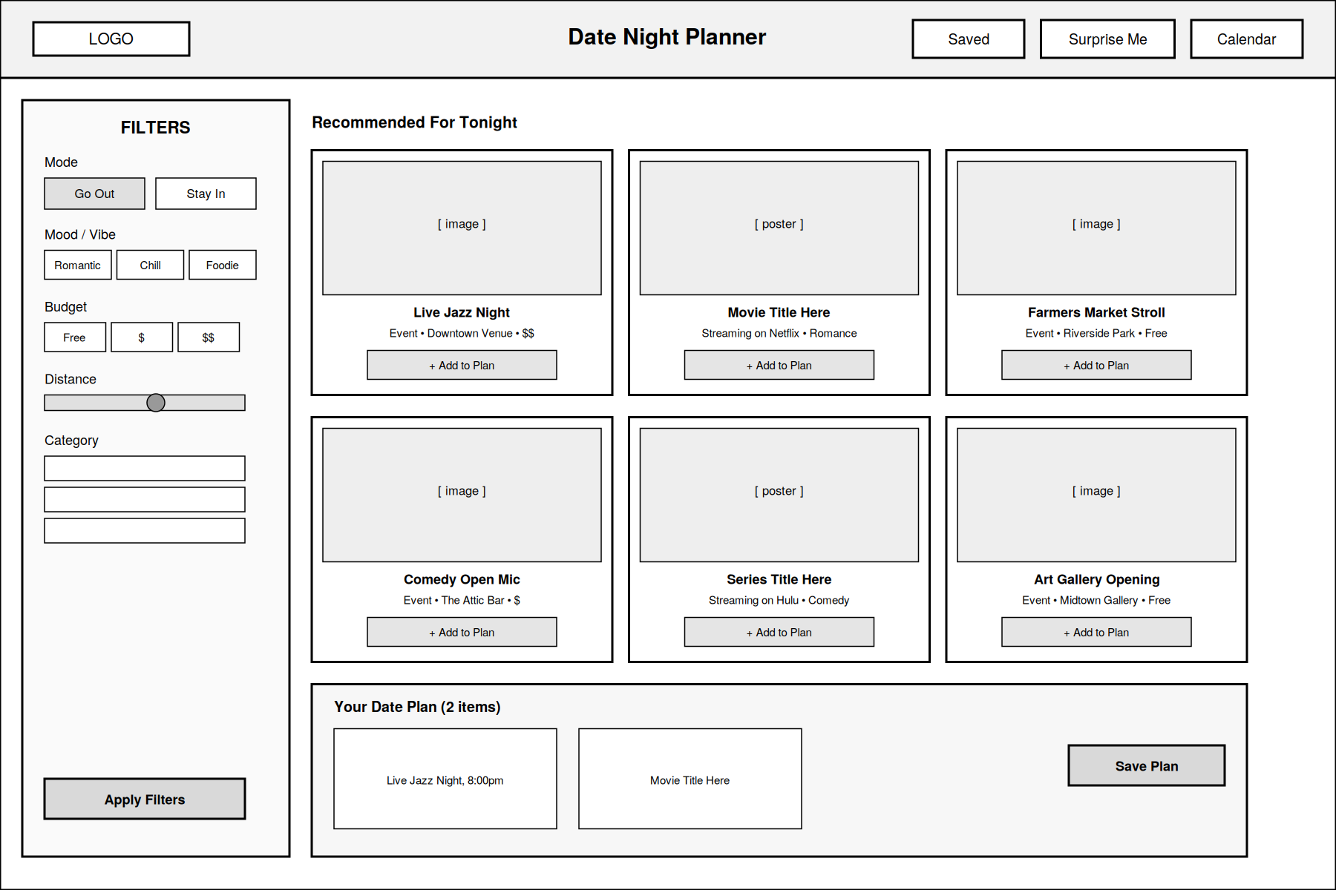
Figure 1. Desktop layout: sidebar filters, mixed event/streaming card grid, persistent plan tray.

Mobile Wireframe — Discover Page
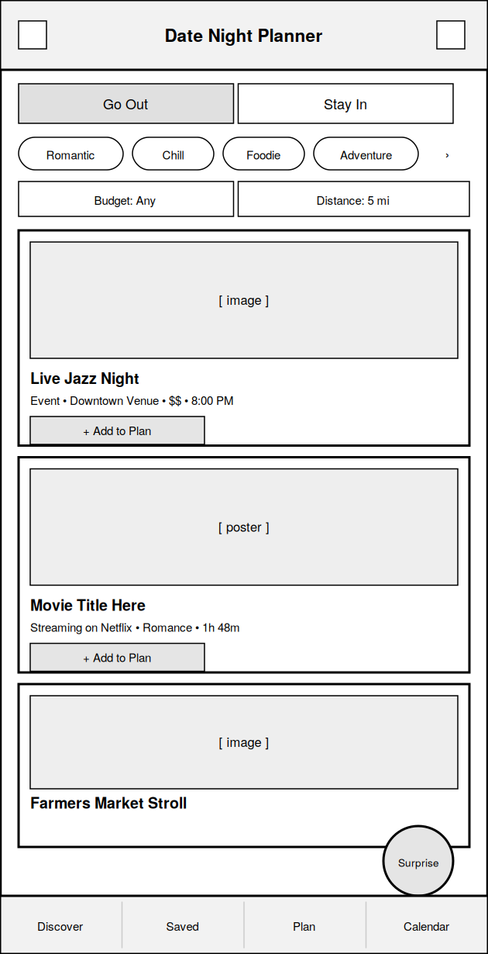
Figure 2. Mobile layout: mode toggle, scrollable mood chips, stacked cards, floating Surprise Me button, bottom nav.

5. External Data

API 1: Global Hyper-Local Events (RapidAPI — LotaData)
Used to power the "Go Out" side of the feed. Returns local events across categories such as Music, Comedy, Food, Outdoor, Art, Sports, and Classes, filterable by location and radius. Each event record supplies well over the required six attributes, including:
- event_name
- category (e.g., Music, Comedy, Food, Outdoor)
- description
- start_datetime / end_datetime
- venue_name
- address / latitude & longitude
- price_info (free or ticketed)
- image_url
- source/ticket URL

API 2: Streaming Availability (RapidAPI — Movie of the Night)
Used to power the "Stay In" side of the feed. Returns movies and series available on services like Netflix, Disney+, Max, Hulu, Prime Video, and Apple TV, filterable by service, genre, and type. Each title record supplies:
- title
- overview/description
- streaming_service(s) + deep link URL
- poster/image_url
- genres
- cast
- user_rating
- release_year
- runtime

Data Storage
The app has no backend, so all persistent data lives in the browser's localStorage as JSON. This includes:
- Saved/favorited individual events and titles (their normalized IDs plus a snapshot of key display fields).
- Saved Date Plans — an ordered list of items plus a date/time and free-text notes.
- User's last-used filter preferences (mood, budget, distance, preferred streaming services) so the app remembers them between visits.
- A small cache of recent API responses (with a timestamp) to reduce repeat calls against RapidAPI's free-tier rate limits.

6. Module List
The app is a single HTML page whose static shell (header, filter panel skeleton, empty modals) is written by hand in index.html, while the results grid, plan tray, favorites, and calendar entries are all generated dynamically at runtime by JS from API and localStorage data — a real mix of static and dynamically generated markup, with no server-side rendering.
All JavaScript is written as native ES Modules (import/export across files, no bundler required) and organized around small classes where state is involved — for example an EventsAPI class and StreamingAPI class encapsulating fetch logic, a DatePlan class modeling a single plan, and a Store class wrapping localStorage — rather than one large script. Initial file/module breakdown:
File / Module | Purpose
index.html | Single-page app shell: header, mode toggle, filter panel, results grid, plan tray, modals for Plan Builder and Calendar view.
css/styles.css | Global styles, color variables, typography, layout grid, card component styles.
css/responsive.css | Media queries for tablet and mobile breakpoints; converts sidebar filters into a mobile filter-chip bar and bottom navigation.
js/app.js | Application entry point. Initializes the app, wires up event listeners, and coordinates the other modules.
js/eventsAPI.js | Fetch wrapper for the Global Hyper-Local Events API: builds requests, handles pagination/errors, normalizes event objects.
js/streamingAPI.js | Fetch wrapper for the Streaming Availability API: builds requests by service/genre, normalizes title objects.
js/filters.js | Applies mood, budget, distance, and search/sort filters to whichever normalized data set is active.
js/planner.js | Logic for building, editing, and validating a Date Plan object (list of items + date/time + notes).
js/storage.js | Small wrapper around localStorage for saving/loading favorites, plans, and user filter preferences as JSON.
js/ui.js | DOM rendering functions: builds card elements, the plan tray, the calendar list, and modal dialogs from data.
js/random.js | "Surprise Me" logic that randomly selects a qualifying event/title combination from the currently filtered data.
json/moods.json | Static lookup table mapping event categories and streaming genres to the app's five mood tags.
json/sampleData.json | Fallback/sample data used for local development and demoing when API rate limits are reached.

Code Quality & Standards
- ESLint (recommended config) runs throughout development, not just at the end, so the codebase stays warning-free rather than needing a last-minute cleanup.
- Code is commented at the function/class level (purpose, params, return) and at any non-obvious logic, such as the mood-mapping heuristic.
- Markup uses semantic HTML5 elements (header, nav, main, section, article, footer) instead of generic divs wherever a semantic tag fits, and is checked against the W3C HTML/CSS validators.
- Pages include descriptive title/meta description tags, alt text on all images, and a logical heading hierarchy to cover basic SEO and screen-reader needs, in line with the course's web frontend development standards.

7. Graphic Identity

Color Scheme
- Deep Plum #3A2E39 — headers, primary text, nav background.
- Dusty Rose #B75D69 — primary accent, buttons, active filters.
- Warm Cream #FBF3EF — page and card backgrounds.
- Antique Gold #C9A227 — small accents: dividers, the Surprise Me button, saved-item hearts.
- Charcoal Grey #6B6B6B — secondary/meta text (dates, prices, captions).

Typography
- Headings: Playfair Display (serif) — gives the "date night" feel a little romance and formality.
- Body text: Poppins (sans-serif) — clean and highly legible at small sizes for card metadata and filters, used for all UI labels, buttons, and body copy.

Application Icon
A rounded-square icon on a deep plum background containing a single line-art heart shape whose left half is drawn as a small crescent moon (representing "stay in" / evening) and whose right half is drawn as a rounded play-button triangle (representing streaming), joined at the heart's center point with a thin gold outline. The mark is meant to read clearly as a heart from a distance while hinting at both halves of the app (go out under the stars, or stay in and press play) up close.

Motion / CSS Animation
- Result cards fade and slide in from below (staggered by a few milliseconds each) when a new filtered feed loads, using CSS keyframes rather than JS-driven animation.
- Cards lift slightly with a soft shadow transition on hover/focus, signaling they're interactive.
- The heart/favorite icon plays a quick scale-and-color pulse (CSS keyframe) when toggled, giving instant feedback without a page refresh.
- The mood chips and mode toggle animate their selected state with a smooth background/color transition instead of snapping instantly.
- The Surprise Me button has a subtle continuous pulse animation to draw the eye, and a short "shuffle" spin animation plays the moment it's clicked, before the result appears.

8. Timeline (Weeks 5–7)
Week | Planned Work & Deliverables
Week 5 | Finalize wireframes and graphic identity (color/type applied to a static HTML mock).  Build static HTML/CSS shell: header, filter panel, card grid, plan tray, responsive breakpoints.  Register for both RapidAPI keys and confirm successful test calls (Postman or console.log).  Deliverable: static, styled, non-functional UI shell + confirmed working API test calls.
Week 6 | Implement eventsAPI.js and streamingAPI.js to fetch and normalize live data into the card grid.  Implement mood/budget/distance filters and the mode toggle between Go Out / Stay In.  Implement storage.js and favoriting (heart icon) with localStorage persistence.  Deliverable: working, filterable, data-driven discovery feed for both data sources.
Week 7 | Implement Date Plan Builder, Surprise Me generator, and Calendar/Upcoming view.  Full responsive pass (mobile nav, chip filters), accessibility check, cross-browser test.  Bug fixing, empty-state/error handling for API failures, write README, deploy (e.g., GitHub Pages).  Deliverable: feature-complete, deployed application ready for final submission.

9. Project Planning
Trello board: [ADD YOUR TRELLO BOARD LINK HERE — e.g., https://trello.com/b/your-board-id/date-night-planner]
The board is organized into five lists — Backlog, To Do, In Progress, Testing, Done — and is seeded with the following cards as a starting point (to be refined weekly):

List: Backlog / Setup
- Create GitHub repo and file/folder structure
- Register RapidAPI account and subscribe to both APIs
- Store API keys safely (config file, gitignored)
- Finalize color palette and type scale as CSS variables
- Build moods.json category/genre-to-mood mapping

List: To Do — Structure & Style
- Build header + mode toggle markup and styles
- Build filter panel (mood, budget, distance, category)
- Build card component markup and styles (shared by both data types)
- Build persistent plan tray component
- Build mobile bottom nav and chip filter bar

List: To Do — Data & Logic
- Write eventsAPI.js fetch + normalize function
- Write streamingAPI.js fetch + normalize function
- Write filters.js (mood, budget, distance, search, sort)
- Write storage.js localStorage read/write helpers
- Write planner.js Date Plan create/edit/delete logic
- Write random.js Surprise Me selection logic
- Wire up favoriting (heart icon) end-to-end
- Build Calendar/Upcoming view

List: Testing
- Test both APIs' error/empty states (no events nearby, no titles for a service)
- Cross-browser check (Chrome, Firefox, Safari)
- Mobile responsive check on at least two screen widths
- Accessibility pass: color contrast, alt text, keyboard nav

List: Done / Launch
- Write README with setup instructions
- Deploy to GitHub Pages (or similar static host)
- Final walkthrough / demo recording

10. Challenges
- Normalizing two data sources: Reconciling two very differently shaped API responses into one consistent card/data model without a backend to pre-process them.
- Designing the mood-tagging system: Neither API has a native concept of "date night mood," so building an accurate, non-generic category/genre-to-mood mapping will take iteration and testing.
- Working within API rate limits: RapidAPI free tiers cap daily requests; the app needs sensible client-side caching so demoing and grading don't exhaust the quota.
- State management without a server: With no backend, all favorites, plans, and preferences must be reliably stored and migrated in localStorage without a database.
- Responsive design across two very different layouts: Making the sidebar-filter desktop layout collapse cleanly into mobile chips and a bottom nav without duplicating logic.
- Empty and error states: Gracefully handling zero results (e.g., no local events tonight, or a service with no matching titles) so the app never feels broken.

