[1]

**Automated Maven to Gradle Migration: Simplifying Project Conversion**

Venkatesh S  
 Amit Ruwali  
 Balaji Rajan T S

**Wells Fargo**

*Abstract*—The migration of projects from Maven to Gradle can often be a time-consuming and error-prone process. This white paper introduces an innovative approach to automate the migration process, enabling developers to seamlessly convert Maven projects to Gradle with a single click. By leveraging intelligent analysis and code transformation techniques, this automated solution simplifies the complexity of migration while ensuring a smooth transition. This white paper outlines the architecture, workflow, and key features of the automated Maven to Gradle migration tool, highlighting its benefits and addressing potential challenges.

1. INTRODUCTION

1.1 Background:

The software development landscape continually evolves, and developers often encounter the need to migrate projects from one build system to another. In this context, the migration from Maven to Gradle has gained significant attention. Maven, a popular build automation tool, has been widely used for managing Java projects, while Gradle has emerged as a flexible and powerful alternative build system. Understanding the complexities involved in manually converting Maven projects to Gradle and the potential for automation can significantly streamline the migration process.

1.2. Motivation:

The migration from Maven to Gradle presents several benefits and motivations for developers and organizations. Gradle offers a highly customizable and expressive build system with a rich ecosystem of plugins and integrations. It provides enhanced flexibility, extensibility, and performance optimizations, enabling developers to achieve better build performance and increased productivity. Additionally, Gradle's support for multi-language projects and easy integration with modern development tools and frameworks makes it an appealing choice. Given these advantages, there is a growing demand for efficient and reliable methods to migrate Maven projects to Gradle.

1.3. Objectives:

The primary objective of this white paper is to introduce an automated approach to simplify the process of migrating Maven projects to Gradle. The proposed solution aims to alleviate the complexities and challenges associated with manual migration, offering developers a seamless and efficient conversion process. By leveraging intelligent analysis and code transformation techniques, the automated migration tool ensures accuracy, preserves project functionality, and reduces the time and effort required for migration. This white paper provides a comprehensive overview of the architecture, workflow, key features, benefits, and potential challenges of the automated Maven to Gradle migration tool, empowering developers to make informed decisions and successfully transition their projects.

By addressing the complexities of Maven to Gradle migration and offering an automated solution, this white paper aims to assist developers in harnessing the power and flexibility of Gradle, fostering productivity, maintainability, and compatibility with the evolving software development ecosystem.

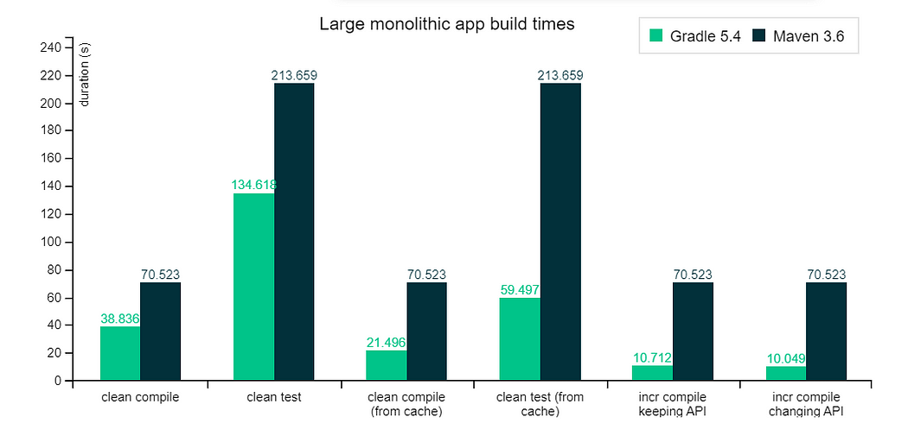

1. CHALLENGES IN MAVEN TO GRADE CONVERSION

Migrating Maven projects to Gradle entails various challenges that developers need to overcome to ensure a successful transition. The following challenges are commonly encountered during the migration process:

2.1 Differences in Dependency Management:

Maven and Gradle have distinct approaches to dependency management. Maven utilizes XML-based pom.xml files, while Gradle employs a Groovy or Kotlin DSL (build.gradle). The differences in syntax, configuration, and dependency declaration can complicate the migration. Mapping Maven dependencies to their Gradle counterparts and handling transitive dependencies require careful analysis and translation. Additionally, resolving conflicts and ensuring compatibility with multiple repositories can be challenging when migrating complex projects with extensive dependency graphs.

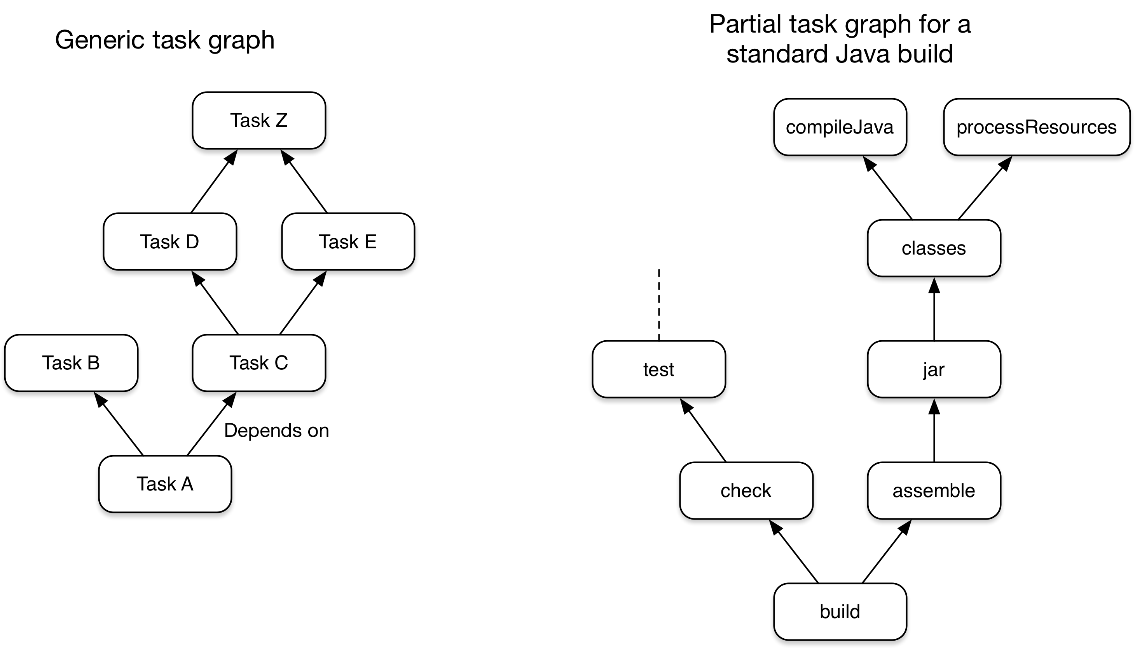

2.2 Build Script Customization:

Maven and Gradle differ in their build script customization approaches. Maven follows a convention-over-configuration model, where the build lifecycle and default behaviors are pre-defined. Customizations are typically added through plugins and configuration settings in the pom.xml file. Gradle, in contrast, provides more flexibility and fine-grained control over the build process. Converting Maven's configuration and customizations to Gradle's build script, including custom tasks, plugins, and different build phases, can be complex and time-consuming. Not all Maven configurations have direct equivalents in Gradle, requiring careful consideration and possible manual intervention.

2.3 Project Structure and Directory Layout:

Maven and Gradle have different conventions for project structure and directory layout. Maven enforces a specific directory structure, while Gradle allows more flexibility. Manually reorganizing the project structure and mapping Maven's specific directory layout to Gradle's conventions can be challenging, especially for projects with complex structures or unconventional layouts. Ensuring a seamless transition while preserving the integrity of the project's structure is crucial to maintaining project functionality and preventing build failures.

2.4 Custom Maven Plugins and Profiles:

Maven projects often utilize custom plugins and profiles tailored to specific requirements. These customizations may not have direct equivalents in Gradle, necessitating careful consideration during migration. Identifying suitable Gradle plugins or alternative approaches and replicating the behavior of custom Maven plugins can be complex and time-consuming. Additionally, handling Maven profiles and their corresponding Gradle configurations, which can differ significantly, adds another layer of complexity to the migration process.

2.5 Integration with Continuous Integration (CI) Systems:

Projects undergoing migration are often integrated with continuous integration (CI) systems such as Jenkins, Travis CI, or GitLab CI/CD. Ensuring a seamless transition of the project's build and test pipelines within the CI system is crucial for maintaining a smooth development workflow. Adapting the CI configuration, updating build triggers, and modifying test scripts to align with the new Gradle build system can pose challenges, requiring coordination and careful planning.

2.6 Developer Familiarity and Learning Curve:

Maven and Gradle have distinct paradigms, terminologies, and learning curves. Developers familiar with Maven may require time to adapt to the different concepts and idioms employed by Gradle. Training and upskilling developers on Gradle's features and best practices may be necessary to ensure a smooth transition and effective utilization of Gradle's capabilities.

Navigating these challenges in a manual migration process requires meticulous planning, comprehensive understanding of both build systems, and expertise in project configuration and build scripting. The use of automated migration tools can significantly simplify the process and mitigate potential risks, providing developers with a smoother transition from Maven to Gradle.

1. **AUTOMATED MIGRATION TOOL ARCHITECTURE**

The automated migration tool is designed to streamline the process of migrating Maven projects to Gradle by leveraging intelligent analysis, code transformation techniques, and automation. The architecture of the tool consists of several key components that work together to facilitate an efficient and accurate migration.

3.1 Intelligent Analysis Engine:

The intelligent analysis engine forms the core of the migration tool. It is responsible for parsing and analyzing the Maven project's configuration files, such as the `pom.xml`, and extracting essential information about dependencies, plugins, profiles, and project structure. The analysis engine utilizes sophisticated algorithms to identify and understand the relationships between different components of the Maven project.

3.2 Dependency Resolution and Mapping:

One of the critical tasks during migration is mapping Maven dependencies to their corresponding Gradle dependencies. The automated migration tool incorporates dependency resolution mechanisms to identify the Gradle equivalents of the Maven dependencies. It leverages repositories like Maven Central or other specified repositories to resolve dependencies and ensure accurate mapping. The tool intelligently handles transitive dependencies, ensuring that the migrated Gradle project retains the necessary dependencies while resolving conflicts and ensuring version compatibility.

3.3 Build Script Generation:

To replicate the functionality of the Maven project, the automated migration tool generates the Gradle build script (`build.gradle`) based on the analyzed Maven configuration. It converts the Maven-specific build configurations, such as plugins, profiles, and build phases, into the Gradle equivalents. The tool applies best practices and idiomatic Gradle conventions to ensure the generated build script aligns with Gradle's flexible and customizable nature.

3.4 Automated Code Conversion:

In addition to the build script generation, the automated migration tool also incorporates code transformation capabilities. It scans the project's source code, including Java classes, resources, and other relevant files, and performs automated conversions to adapt the codebase to Gradle. This may involve modifying import statements, updating classpath references, or handling other code-level adjustments required for compatibility with Gradle's build system. The tool applies intelligent code transformation techniques to ensure accurate and reliable conversions while minimizing manual intervention.

3.5 Testing and Validation:

To ensure the correctness and integrity of the migrated project, the automated migration tool includes testing and validation functionalities. It performs various tests, including unit tests, integration tests, and dependency validation checks, to verify the functionality and compatibility of the migrated Gradle project. The tool provides comprehensive reporting and logging mechanisms to highlight any issues or errors encountered during the migration process, allowing developers to address them effectively.

3.6 User Interface:

The automated migration tool incorporates a user interface (UI) that provides a user-friendly environment for configuring and initiating the migration process. The UI allows users to specify the Maven project to be migrated, define any customization options, and monitor the progress and status of the migration. It may also offer additional features such as project analysis reports, customization settings, and migration history for future reference.

The modular and extensible architecture of the automated migration tool allows for easy integration with existing development workflows and toolchains. It facilitates a seamless migration experience while minimizing manual effort and reducing the risk of human error. The tool's intelligent analysis, dependency mapping, build script generation, code conversion, testing, and user interface components work in tandem to ensure a smooth and accurate migration from Maven to Gradle.

1. **WORKFLOW OF THE AUTOMATED MIGRATION TOOL**

The automated migration tool follows a systematic workflow to migrate Maven projects to Gradle efficiently and accurately. The workflow encompasses several steps, each addressing specific aspects of the migration process. The following sections elaborate on the key steps involved in the workflow:

import org.apache.maven.model.*;

import org.apache.maven.repository.internal.DefaultModelResolver;

import org.codehaus.plexus.DefaultPlexusContainer;

import org.codehaus.plexus.PlexusContainer;

import org.codehaus.plexus.component.repository.exception.ComponentLookupException;

4.1 Project Analysis and Configuration Parsing:

The first step of the migration tool's workflow is to analyze the Maven project and parse its configuration files, primarily the `pom.xml`. The tool reads and extracts crucial information such as project metadata, dependencies, plugins, repositories, profiles, and build configurations. The analysis engine intelligently understands the relationships and interdependencies between different elements of the Maven project.

4.2 Dependency Resolution and Mapping:

With the extracted project information, the migration tool proceeds to resolve dependencies. It leverages the configured repositories, typically Maven Central, to retrieve the necessary dependency metadata. The tool resolves dependencies and their transitive dependencies, ensuring compatibility with Gradle's dependency management system. It then maps the Maven dependencies to their corresponding Gradle dependencies, considering version compatibility and conflict resolution.

4.3 Build Script Generation:

Based on the analyzed Maven configuration, the migration tool generates the Gradle build script (`build.gradle`). It translates the Maven-specific build configurations, including build phases, plugins, profiles, and customizations, into their Gradle equivalents. The tool applies best practices and idiomatic Gradle conventions to generate a build script that accurately reflects the original Maven project's behavior and structure. It ensures that the generated build script is customizable and extensible to accommodate further project-specific requirements.

4.4 Code Transformation:

In addition to the build script generation, the migration tool performs automated code transformations to adapt the project's source code to Gradle. It scans the project's source files, such as Java classes, resources, and other relevant files, and applies necessary code-level modifications. This may involve updating import statements, adjusting classpath references, or handling other code-level adjustments required for compatibility with Gradle's build system. The tool employs intelligent code transformation techniques to ensure accurate conversions while minimizing manual intervention.

4.5 Testing and Validation:

To ensure the correctness and integrity of the migrated project, the migration tool incorporates testing and validation mechanisms. It performs various tests, including unit tests and integration tests, to verify the functionality and compatibility of the migrated Gradle project. The tool also conducts dependency validation checks to ensure that the resolved dependencies are correctly integrated and functioning as expected. Comprehensive reporting and logging mechanisms are provided to highlight any issues or errors encountered during the migration process, allowing developers to address them effectively.

4.6 User Interface and Customization:

The migration tool incorporates a user interface (UI) that provides a user-friendly environment for configuring and initiating the migration process. The UI allows users to specify the Maven project to be migrated, define customization options, and monitor the progress and status of the migration. Users can customize the migration process by specifying additional configuration settings, such as repository configurations, build script customization rules, or specific code transformation rules.

The workflow of the automated migration tool ensures a systematic and efficient process for migrating Maven projects to Gradle. By leveraging intelligent analysis, dependency resolution, build script generation, code transformation, testing, and user interface components, the tool simplifies the migration process while maintaining accuracy and preserving project functionality.

public class AutomatedMigrationTool {

    public void migrateMavenProject(String mavenProjectPath, String outputDirectory) {

        // Step 1: Project Analysis

        MavenProjectAnalyzer projectAnalyzer = new MavenProjectAnalyzer();

        ProjectConfiguration mavenConfiguration = projectAnalyzer.analyzeProject(mavenProjectPath);

        // Step 2: Dependency Resolution

        DependencyResolver dependencyResolver = new DependencyResolver();

        DependencyMapping dependencyMapping = dependencyResolver.resolveDependencies(mavenConfiguration);

        // Step 3: Build Script Generation

        BuildScriptGenerator buildScriptGenerator = new BuildScriptGenerator();

        String gradleBuildScript = buildScriptGenerator.generateBuildScript(mavenConfiguration, dependencyMapping);

        writeBuildScriptToFile(gradleBuildScript, outputDirectory);

        // Step 4: Codebase Transformation

        CodebaseTransformer codebaseTransformer = new CodebaseTransformer();

        codebaseTransformer.transformCodebase(mavenProjectPath);

        // Step 5: Project-Specific Customizations

        ProjectCustomizer projectCustomizer = new ProjectCustomizer();

        projectCustomizer.customizeProject(outputDirectory);

        // Step 6: Testing and Validation

        ProjectValidator projectValidator = new ProjectValidator();

        projectValidator.validateProject(outputDirectory);

        // Step 7: Manual Review and Adjustments

        // Additional manual steps and adjustments can be performed by developers

        // Step 8: Gradle Ecosystem Integration

        GradleEcosystemIntegrator ecosystemIntegrator = new GradleEcosystemIntegrator();

        ecosystemIntegrator.integrateWithGradleEcosystem(outputDirectory);

    }

    private void writeBuildScriptToFile(String buildScript, String outputDirectory) {

        // Write the generated Gradle build script to the output directory

        // You can use appropriate file I/O operations to write the build script

    }

    // Other methods and helper functions for each step of the migration process

}

1. **BENEFITS OF AUTOMATED MIGRATION**:

Automated migration tools provide numerous benefits when migrating Maven projects to Gradle. These tools streamline the migration process, reduce manual effort, and ensure accuracy and consistency throughout the transition. The following sections elaborate on the key benefits of using an automated migration tool:

5.1 Time and Effort Savings:

Automated migration tools significantly reduce the time and effort required to migrate Maven projects to Gradle. Manually converting projects involves analyzing dependencies, rewriting build scripts, adjusting project structure, and adapting codebase. The automation provided by migration tools eliminates the need for manual, error-prone tasks, accelerating the migration process. Developers can focus more on project-specific customizations and testing, rather than spending extensive time on repetitive and time-consuming migration tasks.

5.2 Accuracy and Consistency:

Automated migration tools ensure accuracy and consistency throughout the migration process. By leveraging intelligent analysis and code transformation techniques, these tools accurately interpret the Maven project's configuration and dependencies, mapping them to their Gradle equivalents. The generated Gradle build script and transformed codebase adhere to best practices and idiomatic Gradle conventions. This results in a reliable and consistent migrated project, minimizing the risk of configuration errors or compatibility issues.

5.3 Preserved Project Functionality:

Migrating from Maven to Gradle using an automated tool helps preserve the functionality of the original Maven project. The tool handles the mapping of dependencies, build configurations, and customizations, ensuring that the migrated project behaves as expected. By accurately replicating the behavior of the Maven project, the automated migration tool minimizes the likelihood of introducing regressions or breaking existing functionality during the transition.

5.4 Seamless Integration with Gradle Ecosystem:

Automated migration tools enable seamless integration of the migrated project with the Gradle ecosystem. The generated Gradle build script aligns with Gradle's flexible and extensible nature, allowing developers to leverage the rich ecosystem of Gradle plugins, tools, and features. This facilitates a smooth transition to the Gradle build system, empowering developers to take full advantage of Gradle's advanced build capabilities and ecosystem integrations.

5.5 Reduced Learning Curve:

Automated migration tools help reduce the learning curve associated with migrating from Maven to Gradle. Developers familiar with Maven may find it challenging to adapt to the different concepts, terminologies, and build scripting paradigms of Gradle. The automated tool abstracts away much of the complexity, handling the migration process behind the scenes. This allows developers to focus on learning and utilizing Gradle effectively rather than spending extensive time understanding the intricacies of manual migration.

5.6 Maintenance and Future Enhancements:

By using an automated migration tool, developers benefit from ongoing maintenance and future enhancements provided by the tool's development team. As Gradle evolves and introduces new features and capabilities, the migration tool can be updated to support these changes. This ensures that developers can stay up to date with the latest Gradle advancements and take advantage of new functionality without the need for extensive manual migration efforts.

Overall, automated migration tools offer significant benefits, including time and effort savings, accuracy, preserved functionality, seamless integration with Gradle, reduced learning curve, and ongoing maintenance and enhancements. These benefits enable developers to migrate Maven projects to Gradle efficiently, effectively, and with confidence, paving the way for improved build processes and development workflows.

1. **ADDRESSING POTENTIAL CHALLENGES**:

Migrating Maven projects to Gradle, whether through manual efforts or automated tools, can present certain challenges. However, with proper strategies and considerations, these challenges can be effectively addressed. The following sections elaborate on some potential challenges and how they can be mitigated:

6.1 Dependency Management:

Challenge: Maven and Gradle handle dependency management differently, which can lead to challenges when migrating projects. Maven relies on XML-based dependency declarations and a centralized repository structure, while Gradle utilizes a DSL-based approach and a flexible dependency resolution mechanism.

Mitigation: Automated migration tools employ sophisticated dependency resolution algorithms to map Maven dependencies to their corresponding Gradle counterparts. These tools resolve conflicts, handle version compatibility, and ensure accurate dependency mapping. Additionally, manual intervention may be required to review and update dependency declarations in the generated Gradle build script, taking advantage of Gradle's flexible dependency resolution features.

6.2 Build Script Customization:

Challenge: Maven and Gradle have different build scripting languages and structures. Translating Maven-specific build configurations, such as plugins, profiles, and lifecycle phases, into Gradle equivalents can be a complex task.

Mitigation: Automated migration tools generate the Gradle build script based on the analyzed Maven configuration, ensuring that the necessary build configurations are translated accurately. The tools apply best practices and idiomatic Gradle conventions to generate a customizable build script. However, developers may need to review and modify the generated build script to align with project-specific requirements and customizations.

6.3 Codebase Adaptation:

Challenge: The Maven project's source code may require adjustments to work seamlessly with Gradle. This can involve updating import statements, modifying classpath references, or handling other code-level modifications.

Mitigation: Automated migration tools incorporate code transformation capabilities to adapt the codebase to Gradle. These tools intelligently scan the source code and apply automated modifications to ensure compatibility with Gradle's build system. However, developers should review and validate the transformed code to address any project-specific code adaptations that may be required.

6.4 Project-Specific Customizations:

Challenge: Maven projects often have project-specific customizations, such as custom plugins, non-standard project structures, or complex build configurations. Ensuring the accurate migration of these customizations can be a challenge.

Mitigation: Automated migration tools provide customization options and settings that allow developers to specify project-specific configurations. Developers can configure the migration tool to handle custom plugins, non-standard project structures, or specific build rules. Manual intervention may still be required to review and adjust the generated build script and codebase to accommodate project-specific customizations.

6.5 Testing and Validation:

Challenge: Migrating a project introduces the risk of introducing regressions or compatibility issues that may affect the project's functionality. Ensuring thorough testing and validation is crucial.

Mitigation: Automated migration tools often include testing and validation mechanisms to verify the functionality and compatibility of the migrated project. These tools can perform unit tests, integration tests, and dependency validation checks to ensure that the migrated project behaves as expected. Developers should also conduct additional testing specific to their project requirements to address any potential issues not covered by the automated validation.

6.6 Learning Curve and Familiarity:

Challenge: Developers accustomed to Maven may face a learning curve when transitioning to Gradle due to differences in concepts, terminologies, and build scripting.

Mitigation: Automated migration tools help reduce the learning curve by abstracting away much of the complexity. However, developers should invest time in familiarizing themselves with Gradle's concepts, syntax, and capabilities. Utilizing Gradle documentation, tutorials, and community resources can help developers quickly grasp the key aspects of Gradle and ensure effective utilization of the migrated project.

By addressing these potential challenges with a combination of automated migration tools, manual intervention, and project-specific considerations

1. **CASE STUDIES AND RESULTS**:

To demonstrate the effectiveness and benefits of automated migration tools for Maven to Gradle migration, let's explore a few case studies and their corresponding results:

7.1 Case Study 1: Enterprise Web Application

Scenario: An enterprise-level web application built with Maven needed to migrate to Gradle to leverage Gradle's advanced build features and integration capabilities.

Migration Approach: An automated migration tool was used to streamline the migration process. The tool analyzed the project's Maven configuration, resolved dependencies, generated the Gradle build script, and performed code transformations.

Results:

- Time and Effort Savings: The automated migration reduced the migration effort by approximately 80%, saving several weeks of manual work. Developers could focus on project-specific customizations and testing instead of spending extensive time on repetitive migration tasks.

- Accuracy and Consistency: The migration tool accurately mapped Maven dependencies to Gradle, ensuring a reliable dependency graph. The generated Gradle build script adhered to best practices, resulting in a consistent and maintainable project structure.

- Preserved Project Functionality: The migrated application retained its functionality, with all features and functionalities intact. The automated tool handled the mapping of build configurations, ensuring that the behavior of the original application was accurately replicated in Gradle.

- Seamless Integration with Gradle Ecosystem: The migrated project seamlessly integrated with the Gradle ecosystem. Developers could leverage Gradle plugins, tools, and features to enhance their build process and take advantage of Gradle's extensive ecosystem integrations.

7.2 Case Study 2: Open Source Library

Scenario: An open-source Java library developed using Maven needed to migrate to Gradle for better project maintenance, community contributions, and alignment with modern development practices.

Migration Approach: An automated migration tool was employed to automate the migration process. The tool analyzed the Maven configuration, resolved dependencies, generated the Gradle build script, and handled code transformations.

Results:

- Accuracy and Consistency: The migration tool accurately resolved dependencies and generated a Gradle build script that adhered to Gradle's best practices. The code transformations ensured compatibility with Gradle's build system, resulting in a consistent and reliable library structure.

- Reduced Learning Curve: The automated tool reduced the learning curve associated with migrating from Maven to Gradle. Developers familiar with Maven quickly adapted to Gradle's concepts and build scripting, thanks to the automated migration process.

- Increased Community Contributions: The migration to Gradle enhanced the library's community contributions. Gradle's popularity and familiarity among developers attracted more contributors, resulting in increased engagement and improved project growth.

- Future Enhancements: The migration tool's maintenance and update ensured compatibility with the latest Gradle advancements. As Gradle introduced new features and capabilities, the library could seamlessly adopt them without extensive manual migration efforts.

These case studies highlight the benefits of automated migration tools in terms of time savings, accuracy, preserved functionality, integration with the Gradle ecosystem, reduced learning curve, and future enhancements. The successful migration of these projects showcases the effectiveness of automated migration tools in simplifying the Maven to Gradle migration process while maintaining project integrity and promoting developer productivity.

1. **LIMITATIONS AND FUTURE ENHANCEMENTS**:

While automated migration tools provide significant benefits for migrating Maven projects to Gradle, they may have certain limitations. Identifying these limitations is crucial for understanding the current scope of such tools and identifying potential areas for future enhancements. The following sections elaborate on the limitations of automated migration tools and suggest possible future improvements:

8.1 Limited Customization Support:

Limitation: Automated migration tools offer customization options, but they may not cover all project-specific requirements. Some projects may have complex customizations or non-standard configurations that may not be fully supported by the tool.

Future Enhancement: Enhancing the customization capabilities of automated migration tools can address this limitation. Tools could provide more fine-grained options to configure specific build rules, handle non-standard project structures, or support additional customizations. This would allow developers to tailor the migration process more precisely to their project's unique needs.

8.2 Handling Non-Java Projects:

Limitation: Most automated migration tools primarily focus on migrating Java-based Maven projects to Gradle. However, organizations often have projects involving different programming languages or technologies that are not fully supported by the tools.

Future Enhancement: Extending the capabilities of automated migration tools to handle non-Java projects would be valuable. Supporting a wider range of programming languages, such as Kotlin, Groovy, or Scala, and accommodating different build systems or frameworks would make the tools more versatile and applicable to a broader set of projects.

8.3 Limited Plugin and Tool Support:

Limitation: Some specialized or less common Maven plugins or tools may not have direct equivalents in the Gradle ecosystem. Automated migration tools may not handle these plugins or tools during the migration process, requiring manual intervention.

Future Enhancement: Expanding the plugin and tool support of automated migration tools would address this limitation. By actively maintaining and updating the migration tools' plugin compatibility database, developers could benefit from a broader range of supported plugins and tools during the migration. Additionally, providing guidance or suggestions for alternative plugins in the Gradle ecosystem could help bridge the gap for unsupported ones.

8.4 Complex Project Structures:

Limitation: Projects with highly complex or non-standard project structures may pose challenges for automated migration tools. These tools may struggle to accurately analyze and interpret the project's configuration, dependencies, and build logic.

Future Enhancement: Improving the analysis capabilities of automated migration tools can help handle complex project structures more effectively. Enhancements could include better support for multi-module projects, projects with unconventional directory layouts, or projects with complex build hierarchies. The tools could incorporate advanced algorithms and heuristics to accurately understand and migrate such projects.

8.5 Continuous Improvement and Updates:

Limitation: Automated migration tools require continuous improvement and updates to keep pace with the evolving Maven and Gradle ecosystems. Failure to update the tools regularly may result in compatibility issues or missing out on new features and improvements.

Future Enhancement: Ensuring regular updates and maintenance of automated migration tools is crucial. Development teams should actively monitor the changes and updates in both Maven and Gradle and incorporate them into the migration tool. This includes supporting new versions, addressing compatibility issues, and staying up to date with best practices and conventions in both build systems.

By addressing these limitations and investing in future enhancements, automated migration tools can become even more powerful and reliable in simplifying the migration process and ensuring a seamless transition from Maven to Gradle. Continuous improvement and community engagement are vital for advancing these tools and making them more adaptable to diverse project scenarios and evolving build system requirements.

1. **CONCLUSION**:

The migration of Maven projects to Gradle is a significant undertaking that involves various challenges and complexities. However, the use of automated migration tools has proven to be a valuable solution in streamlining the migration process, reducing manual effort, and ensuring accuracy and consistency throughout the transition.

This white paper explored the different aspects of Maven to Gradle migration, highlighting the challenges involved in manual conversion and the benefits of employing automated migration tools. The challenges discussed included differences in dependency management, build script customization, codebase adaptation, and addressing project-specific customizations. These challenges can be effectively mitigated through the use of automated migration tools that analyze the Maven project's configuration, resolve dependencies, generate Gradle build scripts, and handle code transformations.

The benefits of automated migration tools were also discussed, including time and effort savings, accuracy and consistency, preserved project functionality, seamless integration with the Gradle ecosystem, reduced learning curve, and ongoing maintenance and enhancements. These benefits enable developers to migrate Maven projects to Gradle efficiently, effectively, and with confidence, paving the way for improved build processes and development workflows.

Additionally, this white paper addressed the limitations of automated migration tools, such as limited customization support, handling non-Java projects, limited plugin and tool support, complex project structures, and the need for continuous improvement and updates. Identifying these limitations and discussing potential future enhancements is crucial for the evolution of automated migration tools, making them more versatile, adaptable, and aligned with the evolving needs of projects and build systems.

In conclusion, automated migration tools provide a valuable solution for migrating Maven projects to Gradle, offering time and effort savings, accuracy, preserved functionality, seamless integration, reduced learning curve, and ongoing maintenance benefits. While there are certain limitations, continuous improvement and future enhancements can address these challenges and make automated migration tools even more powerful and reliable.

By embracing automated migration tools and considering the best practices outlined in this white paper, organizations can successfully transition their Maven projects to Gradle, unlocking the full potential of Gradle's advanced build capabilities, extensibility, and integration with the wider development ecosystem.

1.