Hybrid Model: Zone Infiltration and People Count

Han Li

11/8/2018

## 1 Justification for Feature Update

The proposed new feature improves the current HybridModel object which utilizes inverse modeling algorithms based on the zone heat, moisture, and contaminant balance equations. The current HybridModel feature uses measured zone air temperature to inversely solve the zone internal thermal mass or air infiltration rate assuming the HVAC system is off and zone is in free-floating mode. The new HybridModel feature allows additional parameters such as the measured zone air humidity ratio and CO2 concentration as the input to the inverse modeling algorithms to solve the highly uncertain parameters such as air infiltration and people count. Depending on the availability of the measured zone supply air parameters (i.e., supply air flow rate, supply air temperature, supply air humidity ratio, and supply air CO2 concentration), the new HybridModel feature can solve air infiltration and people count for both HVAC-off mode and HVAC-on mode. The hybrid approach keeps the virtue of the physics-based model and takes advantage of more measured buildings data which become available nowadays due to the wide adoption of low-cost sensors and the needs of better controls in existing buildings. This new feature proposal provides technical details of the enhanced HybridModel object and its implementation in EnergyPlus. The proposed feature will improve simulation usability and accuracy for existing buildings, which supports more accurate analysis of energy retrofits.

## 2 Overview

### 2.1 Air Infiltration

EnergyPlus uses the object, ZoneInfiltration:DesignFlowRate, to represent the infiltration caused by the opening and closing of exterior doors, cracks around windows, and even in very small amount through building elements. Users define the infiltration design air flow rate, an infiltration schedule, and temperature and wind correction coefficients. The source code module, ZoneEquipmentManager, contains the simplified infiltration algorithm as shown in Equation (1).

*Where*:

*A* :*Constanttermcoefficient*,

*B* :*Temperaturetermcoefficient*,

*C* :*Velocitytermcoefficient*,

*D* :*Velocitysquaredcoefficient*,

The simple method has an empirical correlation that modifies the infiltration as a function of wind speed and temperature difference across the envelope. The difficulty in using this equation is determining valid coefficients for each building type in each location. The simplified infiltration models consider the wind speed on zone altitude, and the variation in infiltration heat loss based on the wind velocity. These coefficients vary and provide very different results that cause great uncertainty in determining which values to use. EnergyPlus allows users to input these coefficients, however it is not easy to identify correct ones for typical modeling practices. The infiltration hybrid model derives the time-step zone infiltration air flow rates, using the inverse zone heat balance equation, moisture balance equation, or contaminant balance equation, which consider all complexities of design flow rate, coefficients and climate conditions.

### 2.2 People Count

In EnergyPlus, people count and people activity level is represented by the People and corresponding Schedule objects. Users set the number of people calculation method, people activity level, sensible and fraction heat fractions, and CO2 generation rate in the People object. Each People object can be assigned to a zone or a zone list. A set of people related schedule objects are used to define the temporal variation of people count . In typical simulation setting, the People object is usually set to have fixed schedules. In reality, occupancy schedule is highly uncertain. Using the typical schedules for the People object can lead to inaccurate results. The new hybrid model algorithm calculates the time-step zone people count by inversely solving the zone sensible heat balance equation, moisture balance equation, or contaminant balance equation.

### 2.3 Zone Balance Equations

The hybrid model algorithms are built upon the physics-based zone heat, moisture, and contaminant balance equations reformulated to solve a partially inverse problem. The basis for the zone air system integration is to formulate balance equations for the zone air and solve the resulting ordinary differential equations. It should be noted that the hybrid algorithms to be developed are generic and can be adopted by EnergyPlus and other building energy simulation programs. Equation (2) below indicates zone heat balance relationships. It assumes that the sum of zone loads and air system output equals the change in energy stored in the zone. The infiltration airflow rate, mÌ‡ changes for different conditions depending on outdoor temperature, wind speed, and HVAC system operations. The energy provided from systems to the zone is represented as Q.

The sum of zone loads and the provided air system energy equals the change in energy stored in the zone. Typically, the capacitance would be that of the zone air only. The internal thermal masses, assumed to be in equilibrium with the zone air, are included in this term. EnergyPlus provides algorithms to solve the zone air energy and moisture balance equations defined in the ZoneAirHeatBalanceAlgorithm object. The algorithms use the finite difference approximation or analytical solution to calculate the derivative term with respect to time.

EnergyPlus provides three different heat balance solution algorithms to solve the zone air energy balance equations. These are defined in the Algorithm field in the ZoneAirHeatBalanceAlgorithm object: 3rdOrderBackwardDifference, EulerMethod and AnalyticalSolution. The first two methods to solve Equation use the finite difference approximation while the third uses an analytical solution. The hybrid modeling approach uses the 3rdOrderBackwardDifference to inversely solve the air infiltration. EnergyPlus Code for these balance algorithms are referenced to the ZoneTempPredictorCorrector module.

Similarly, EnergyPlus solves zone humidity ratio and CO2 concentration with the predictor-corrector approach. Equations (3) is the zone air moisture balance equation.

Equations (4) is the zone air CO balance equation.

## 3 Approach

This section provides technical details of solving zone balance equations via third-order backward approximation. Depending on the available number of zone air parameters (i.e., temperature, humidity ratio, and CO2 concentration), there are different inverse solution scenarios. The figure below shows the different inverse solution scenarios. Theoritically, more than one un-known parameters (i.e., zone thermal mass, air infiltration, and people count) could be solved at the same time if the measurements of zone air temperature, humidity ratio, and CO2 concentration are all available. In this new feature, we only propose the new algorithms to solve one unknown parameter at a time. The solution scenario details are described in the following sub-sections.

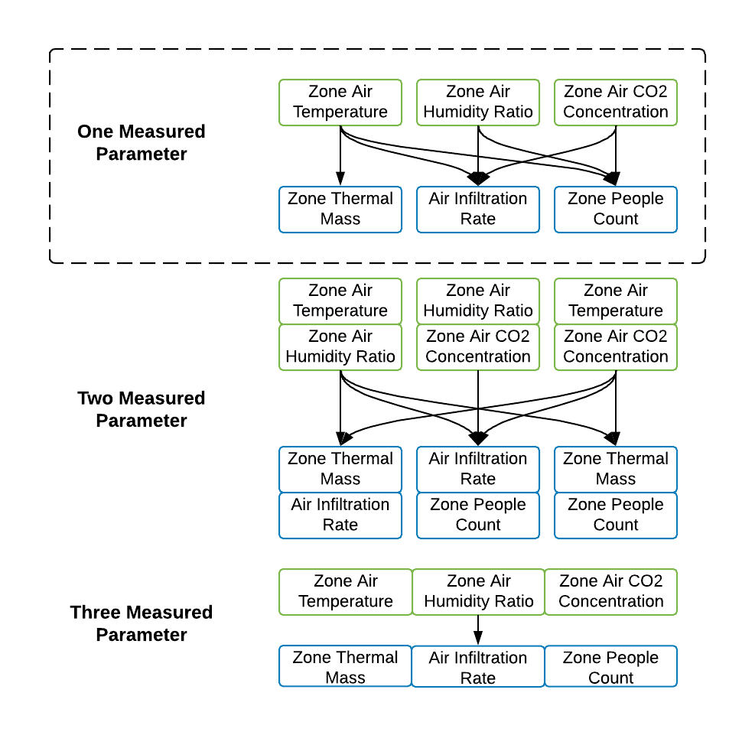

### 3.1 Infiltration Inverse Models

This sub-section shows three scenarios to solve zone air infiltration with different zone balance equations. Note that the system supply terms may or may not be included depending on the HVAC system operation status. The system supply terms should be included if the HybridModel is used to solve air infiltration when the HVAC system is on. No system supply term should be included if the HybridModel is used to solve air infiltration when the HVAC system is off.

#### 3.1.1 Solving Zone Air Infiltration Rate with Measured Zone Air Temperature

*Equation* (2) can be re-written with the third-order backward approximation:

Where:

Then the infiltration mass flow rate can be solved:

#### 3.1.2 Solving Zone Air Infiltration Rate with Measured Zone Air Humidity Ratio

*Equation* (3) can be re-written with the third-order backward approximation:

Where:

Then the infiltration mass flow rate can be solved:

#### 3.1.3 Solving Air Infiltration Rate with Measured Zone Air CO2 Concentration

*Equation* (4) can be re-written with the third-order backward approximation:

Where:

Then the infiltration mass flow rate can be solved:

### 3.2 People Count Inverse Models

This sub-section shows three scenarios to solve zone people count with different zone balance equations. Note that the system supply terms may or may not be included depending on the HVAC system operation status. The system supply terms should be included if the HybridModel is used to solve air infiltration when the HVAC system is on. No system supply term should be included if the HybridModel is used to solve air infiltration when the HVAC system is off.

#### 3.2.1 Solving Zone People Count with Measured Zone Air Temperature

*Equation* (2) can be re-written with the third-order backward approximation:

Where:

The sum of internal sensible heat gains is:

The sum of internal sensible heat gains from people is:

Finally, the number of people could be solved:

#### 3.2.2 Solving Zone People Count with Measured Zone Air Humidity Ratio

*Equation* (3) can be re-written with the third-order backward approximation:

Where:

The sum of internal moisture gains is:

The sum of internal moisture gains from people is:

Finally, the number of people could be solved:

#### 3.2.3 Solving Zone People Count with Measured Zone Air CO2 Concentration

*Equation* (4) can be re-written with the third-order backward approximation:

Where:

The sum of internal CO gains is:

The sum of internal CO gains from people is:

Finally, the number of people could be solved:

## 4 IDD Modifications

### 4.1 New Object(s)

None

### 4.2 Revised Object(s)

We propose to revise the current HybridModel:Zone. The revised object defines inputs for the new hybrid modeling algorithms for individual zones.

HybridModel:Zone,

\memo Zones with measured air temperature data and a range of dates.

\memo If the range of temperature measurement dates includes a leap day,

the weather data should include a leap day.

A1 , \field Name

\required-field

\type alpha

A2 , \field Zone Name

\required-field

\type object-list

\object-list ZoneNames

A3 , \field Calculate Zone Internal Thermal Mass

\note Use measured temperature to calculate zone temperature capacity multiplier.

\type choice

\key No

\key Yes

\default No

A4 , \field Calculate Zone Air Infiltration Rate

\note Use measured zone air parameters (temperature, humidity ratio,

or CO2 concentration) to calculate zone air infiltration air flow rate.

\note At least one measured parameter should be provided.

\type choice

\key No

\key Yes

\default No

A5 , \field Calculate Zone People Count

\note Use measured air parameters (temperature, humidity ratio,

or CO2 concentration) to calculate zone people count.

\note At least one measured parameter should be provided..

\type choice

\key No

\key Yes

\default No

A6 , \field Zone Measured Air Temperature Schedule Name

\type object-list

\object-list ScheduleNames

\note Schedule name of the measured zone air temperature.

A7 , \field Zone Measured Air Humidity Ratio Schedule Name

\type object-list

\object-list ScheduleNames

\note Schedule name of the measured zone air humidity ratio.

A8 , \field Zone Measured Air CO2 Concentration Schedule Name

\type object-list

\object-list ScheduleNames

\note Schedule name of the measured zone air CO2 concentration.

A9 , \field Zone Input People Activity Schedule Name

\type object-list

\object-list ScheduleNames

\note Schedule name of the zone people activity level

A10 , \field Zone Input People Sensible Heat Fraction Schedule Name

\type object-list

\object-list ScheduleNames

\note Schedule name of the people's sensible heat fraction.

A11 , \field Zone Input People Radiant Heat Fraction Schedule Name

\type object-list

\object-list ScheduleNames

\note Schedule name of the people's radiant heat fraction.

A12 , \field Zone Input People CO2 Generation Rate Schedule Name

\type object-list

\object-list ScheduleNames

\note Schedule name of the people's CO2 generation rate.

A13 , \field Zone Input Supply Air Temperature Schedule Name

\type object-list

\object-list ScheduleNames

\note Schedule name of the system supply air temperature of the zone.

A14 , \field Zone Input Supply Air Mass Flow Rate Schedule Name

\type object-list

\object-list ScheduleNames

\note Schedule name of the system supply air mass flow rate of the zone.

A15 , \field Zone Input Supply Air Humidity Ratio Schedule Name

\type object-list

\object-list ScheduleNames

\note Schedule name of the system supply air humidity ratio of the zone.

A16 , \field Zone Input Supply Air CO2 Concentration Schedule Name

\type object-list

\object-list ScheduleNames

\note Schedule name of the system supply air CO2 concentration of the zone.

N1 , \field Begin Month

\required-field

\minimum 1

\maximum 12

\type integer

N2 , \field Begin Day of Month

\required-field

\minimum 1

\maximum 31

\type integer

N3 , \field End Month

\required-field

\minimum 1

\maximum 12

\type integer

N4 ; \field End Day of Month

\required-field

\minimum 1

\maximum 31

\type integer

## 5 Simulation Process

The hybrid modeling feature uses a new flag, Hybrid Modeling Flag in the sizing and primary simulation in the simulation manager. Hybrid Modeling Flag is triggered by inputs in the new object, HybridModel:Zone. The flag triggers the hybrid model simulation that calculates the zone temperature capacitance multipliers, infiltration air flow rates, or people count depending on the user’s input in the object, and the measured data of the zone air temperature, humidity and CO2 concentration input in the Schedule:File objects. The simulation steps will be as follows depending on the inputs of the HybridModel:Zone object.

## 6 IO Ref

## 7 Testing/Validation/Data Source(s)

## 8 EngRef

## 9 Example File

## 10 Reference