The Operating Principles require a minimum flow in the Fryingpan River below Ruedi Dam of 39 cfs or inflow (whichever is less) from November 1 through April 30 and a minimum flow of 110 cfs or inflow (whichever is less) from May 1 through October 31 for protection of recreational benefits.

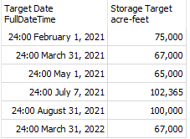

When required, releases are made from the reservoir to make up water shortages downstream on the Colorado River due to the Fryingpan-Arkansas west slope diversions to the east slope. Releases also take place to provide water for contract holders and to grant sufficient water for fish habitat along the 15-mile reach of the Colorado River in Grand Valley.

Under normal circumstances, regular changes in reservoir releases are kept at a maximum of 50 ft3/s or less. Only one flow change is normally allowed during a 24 hours period. Releases between 75 ft3/s and 250 ft3/s are regularly made using the powerplant. Controlled discharges above 250 ft3/s are infrequent and normally require a combination of powerplant and gated releases. During flooding situations, these regular operating procedures may not be followed.