Assembly Notes: Quanto+ 0309 – Quanto Testbed Mote Sensor Board
0309
==============================

GERBER

Filenames are "EpicPlus_v2" with the following extensions:

.OTL BOARD OUTLINE
.TOP TOP METAL
.BOT BOTTOM METAL
.DRL NC DRILL

.SMB SOLDER MASK BOTTOM
.SMT SOLDER MASK TOP
.SPT SOLDER PASTE TOP
.SST SILK SCREEN TOP

OTHER FILES

Instructions.doc The instructions/design notes for the board
Pick Place for EpicPlus_v2.txt Insertion/Placement file
BOM_0309_Quanto+.xls BOM in Excel format

GENERAL

This is a single-sided assembly. All through-hole and SMT parts are to be installed on/from the top side of the PCB.

Figures in the part specific notes below were taken from our last generation build of this board and do not necessarily reflect the current layout. However, the footprints for the parts have not changed so the notes appertaining insertion polarities are still relevant.

PART SPECIFIC NOTES

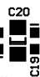
C5, C20 Polarity indicated by Anode mark (gray line on capacitor).
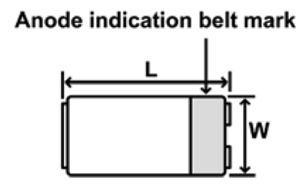
Line up Anode mark with this side on footprint!
D1 The polarity of this photo diode is indicated by its footprint. One side has two pads, the other has one pad. Line the device up according to the footprint.

D2, D3, D4 The polarity of these diodes is indicated on the silk by an image of an IEEE diode symbol. As this image may not clearly resolve, all cathodes are on the left side of the part (horizontal orientation) and additionally marked with a line.

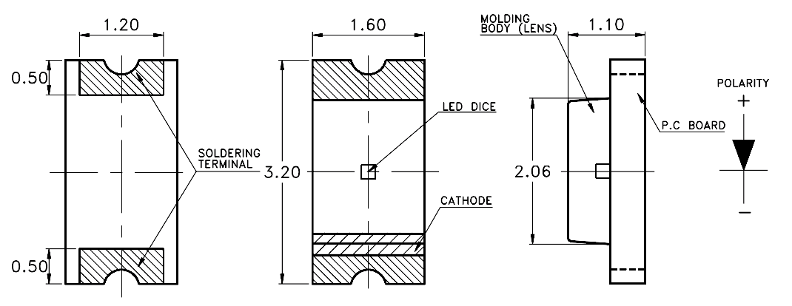

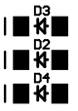
Cathode Marks
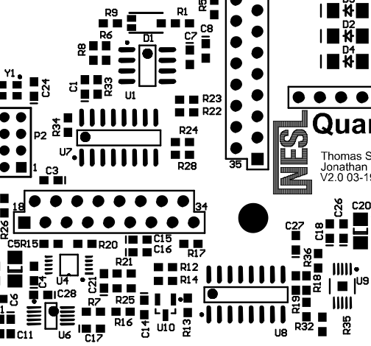
Y1, U1, U4, U6, U7, U8, U9, U10 These IC’s have their pin 1 indicated by a dot in the silk-screen (as shown in the figure below) and a dot on the actual part.

The following descriptors are all Do Nut Stuff (DNS) and marked red in the BOM:
J1, LS1, MK1, P1, P2, R35, R36, U2, U3, U5

***********************************************************************
CALL US IF YOU HAVE QUESTIONS, ANY TIME DAY OR NIGHT (INCLUDING WEEKENDS, HOLIDAYS, ETC):

UCLA NESL
Jonathan Friedman, jf@ee.ucla.edu, 404-259-8168 (cell)
***********************************************************************

