**Required Textbooks for “ICD-10 Coding” Course**

***Students need all three of the following books starting on the first day of class:***

1. **ICD-10-CM:  The Complete Official Draft Code Set (2011)** published by Ingenix<http://www.shopingenix.com/Product/36786/>   
   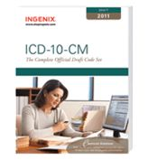
2. **ICD-10-PCS: The Complete Official Draft Code Set (2011)** published by Ingenix   
   <http://www.shopingenix.com/Product/36787/>   
   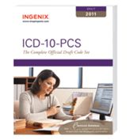
3. **ICD-10­-CM and ICD-10-PCS Coding Handbook Without Answers, 2012 Revised Edition** published by AHA authored by**Nelly Leon-Chisen      
   ISBN: 978-1-55648-373-8**<http://www.healthforum.com/healthforum/html/books/print/ICD-10-CM2012Wout_answers.html>

[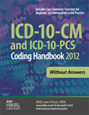](http://www.hospitalconnect.com/hospitalconnect/istore/submitForm.jsp?minisite=10020&item=5803)

|  |  |
| --- | --- |
| |  | | --- | |  | |