System Name: ROC Quick Ticket Auto Replace to Market

Support Contacts:
ROM Development: Josh Garrett (312) 244-5318
ROM Development: Zhen Cha (312) 244-5325

From the Quick Ticket, click on settings, show extended options.
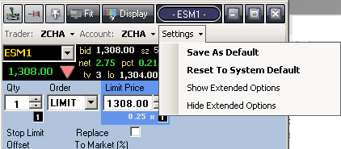

Check the Replace to market box and select your percentage.

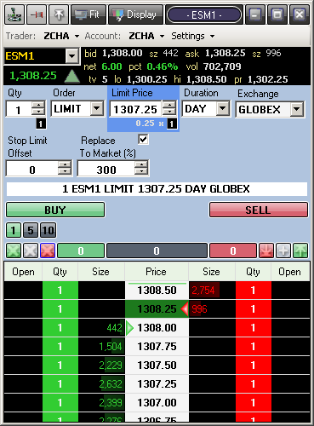

Orders place while the Replace To Market box is checked will be independently managed using the specified percentage as follows:
- If the order size is greater than the top of the bid book size multiplied by the specified % for sell orders, then the order will be replaced to market. If the order size is less than the top of the ask book size multiplied by the specified % for buy orders, then the order will be replaced to market.
- If the order had any partial fills, then the order size for condition 1 will be reduced to the leaves qty.
- If the order price is less than the top of the ask book price for sell orders, then the order will be canceled. If the order price is greater than the top of the bid book price for buy orders, then the order will be canceled.
- After condition 1 (order has been replaced to market), for sell orders, if the ask book price is greater than the ask price at the time the market order was entered, the order will be canceled. For buy orders, if the bid book price is less than the bid price at the time the market order was entered, the order will be canceled.

Note: In the Orders window, orders managed by the auto-replace function will be marked by an Order ID starting with [AR].

