System Name: ROC Auto-Spread Ticket

Support Contacts:
ROM Development: Josh Garrett (312) 244-5318
ROM Development: Zhen Cha (312) 244-5325

Setting:
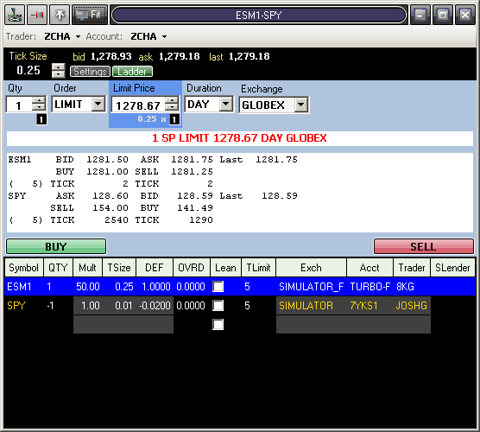

To set up the AutoSpreader, first go to the settings tab by clicking Setting at the top left of the window. Each symbol should be entered in the appropriate column at the bottom of the window. The top row will be the primary leg (future release will allow user to specify which row is primary). When adjusting the QTY for each leg, note that a positive number will indicate BUY for that leg, and a negative number will indicate sell. The default ration (DEF) will be calculated as ([Leg Qty]*[Leg Mult])/([Primary Qty]*[Primary Mult]) with the primary leg always at 1. To override the default ration, enter the desired value in the override (OVRD) column. The synthetic price will be calculated as [synthetic price] = Sum([Leg Price] * [Leg Ration]). Any legs for which the Lean box is check will be entered into the market first, and then for all other legs, the appropriate quantity will be entered into the market to maintain the ration when the first orders are filled/partially filled. The TLimit specifies a number of ticks away from the synthetic price that the leg can still be worked. The leg order price must be within TLimit ticks of ([leg bid price] - Floor(([synthetic price] – sum of each other leg([leg bid price]*[leg ration]))/([leg ration]*[leg TSize]))*[leg TSize])/[leg TSize] for buy side and ([leg ask price] - Ceiling(([synthetic price] – sum of each other leg([leg ask price]*[leg ration]))/([leg ration]*[leg TSize]))*[leg TSize])/[leg TSize] for sell side. If the market moves outside of these boundaries, the leg order will be canceled and re-entered once the market moves back within the specified range. Last, enter your Trader, Acct, and Exchange in the appropriate columns if your need to send the legs in different accounts or to different exchanges. If any of these fields are left blank, the coinciding values from the top of the window will by used.
Ladder:
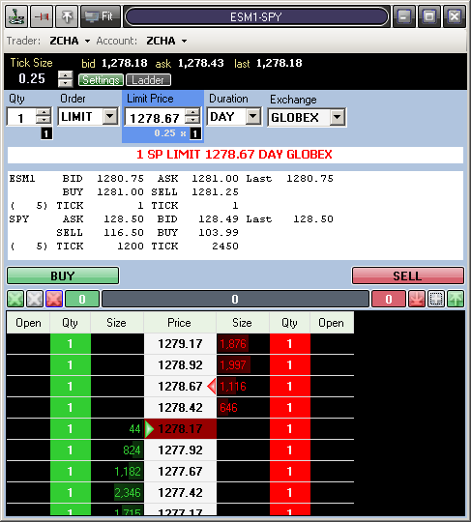

To view the synthetic prices in a format similar to the Quick Trade Ticket, click on ‘ladder’ at the top left of the ticket. From here, the ticket behaves similarly to the Quick Trade ticket. For any sell side equity orders, the side will be short sell if you right click, and a normal sell if you left click on the Qty column. Once the order is placed, the non-primary legs orders will be replaced to maintain the price ratio specified in the settings window. If you want to make any changes to your settings after the order is placed, you will need to use the white ‘X’ button under the ‘BUY’ button to cancel the spread, and then re-enter it. The following fill conditions will apply:
1.) If Filled on one leg, then all other legs will be locked (replaced) to synthetic ask and bid price.
2.) If Partial filled on one leg, then the next available Factor (qty) will be split off (cancel and new order) the original order. The locked portion will behave like the condition 1.
3.) If leg’s ask and bid price had changed, and all legs are not locked, a new leg buy and sell price will be calculated, and all legs will be replaced to the new price.

If you cancel any orders in the Orders window, this will only cancel the orders that have already been placed. To cancel the synthetic order working in the autospread window, you must cancel it from the autospread window.

