Supplementary materials

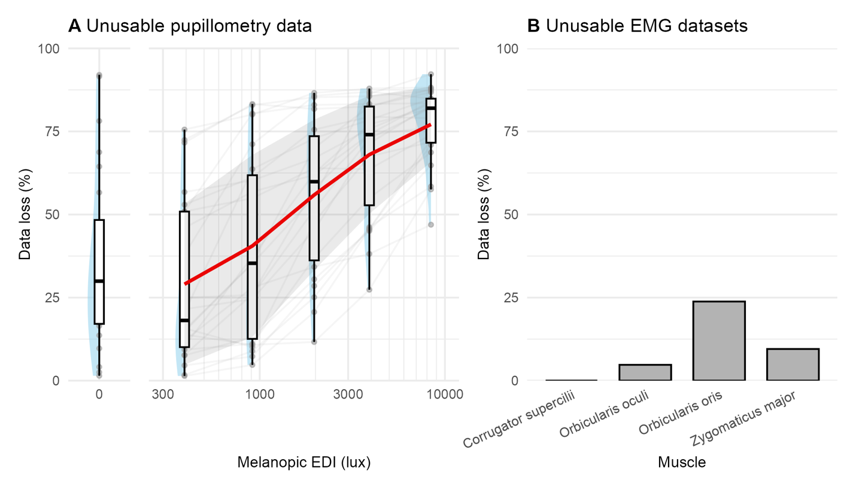
Figure S1. Data loss for pupillometry and EMG modalities, N=18. (A) For pupillometry, data loss is expressed as the proportion of pilot data remaining after filtering out data points with an associated confidence value inferior to a threshold of 0.7. Red line shows group averages and the grey ribbon the standard deviation. (B) For EMG, data loss is expressed as the proportion of pilot data sets that needed to be excluded due to an issue during data collection (electrodes detaching from the skin or computer-related error).

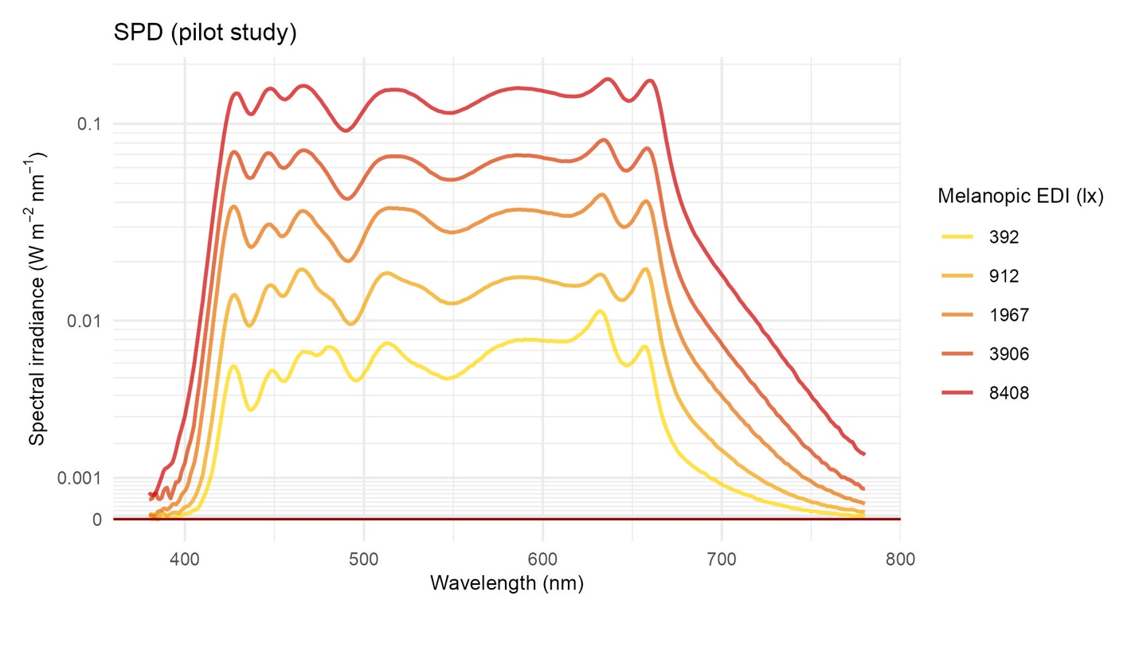
Figure S2. Spectral power distributions (SPD) of pilot study light stimuli. The plot shows absolute spectral irradiance (380-780 nm) of the primary light settings used in the pilot study (melanopic EDI = 392, 912, 1967, 3906 and 8408 lx), excluding the 0-lx condition. The y-axis was transformed using a base-10 pseudo-logarithmic transformation with a linear region around zero (σ = 0.001).

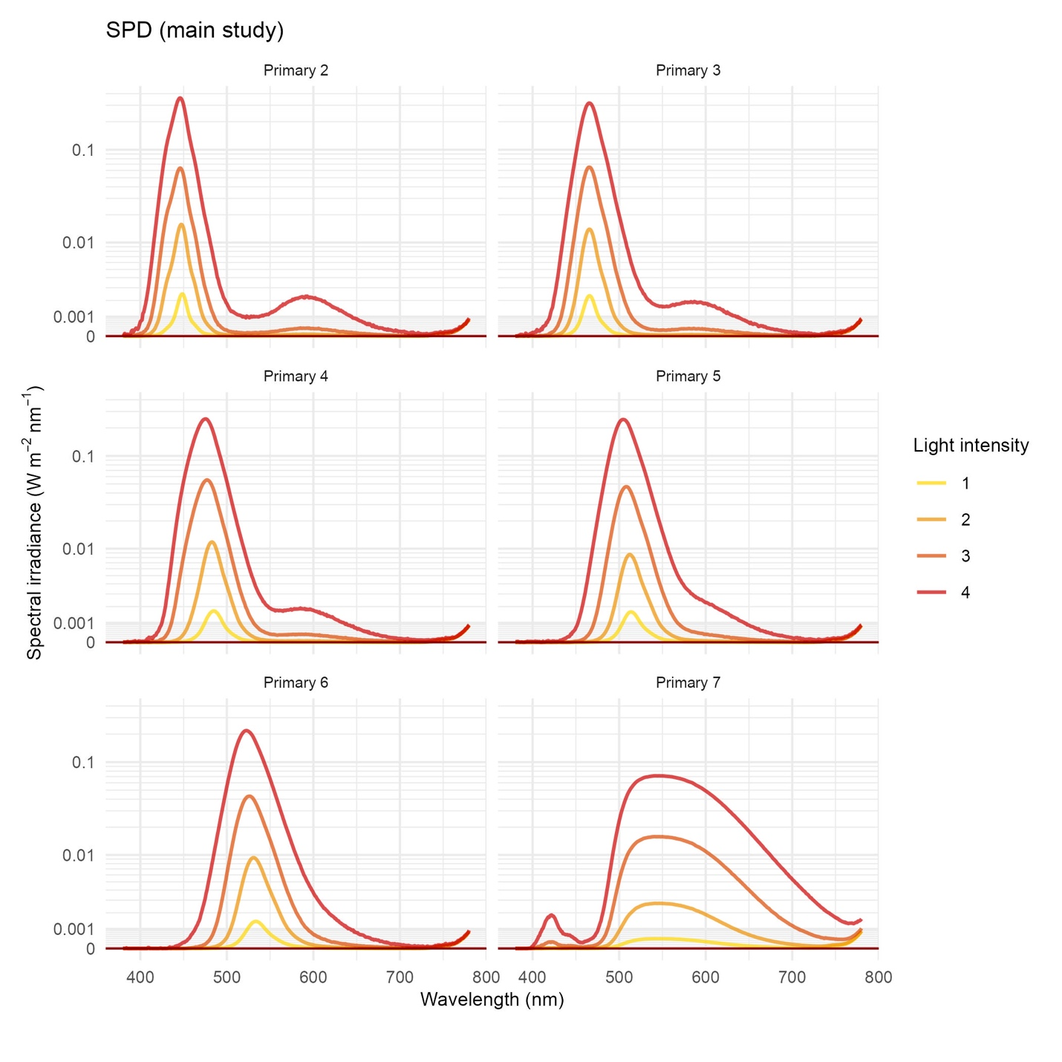
Figure S3. Spectral power distributions (SPD) of pilot study light stimuli. The plots show absolute spectral irradiance (380-780 nm) of the primary light settings used in the main study, for each primary (2 to 7) and each irradiance setting (0.06, 0.32, 1.6, 8.8 W.m⁻²). The y-axis was transformed using a base-10 pseudo-logarithmic transformation with a linear region around zero (σ = 0.001). The measurements were made with the infrared camera at the back of the integrating sphere on, which introduces radiation in the infrared range.

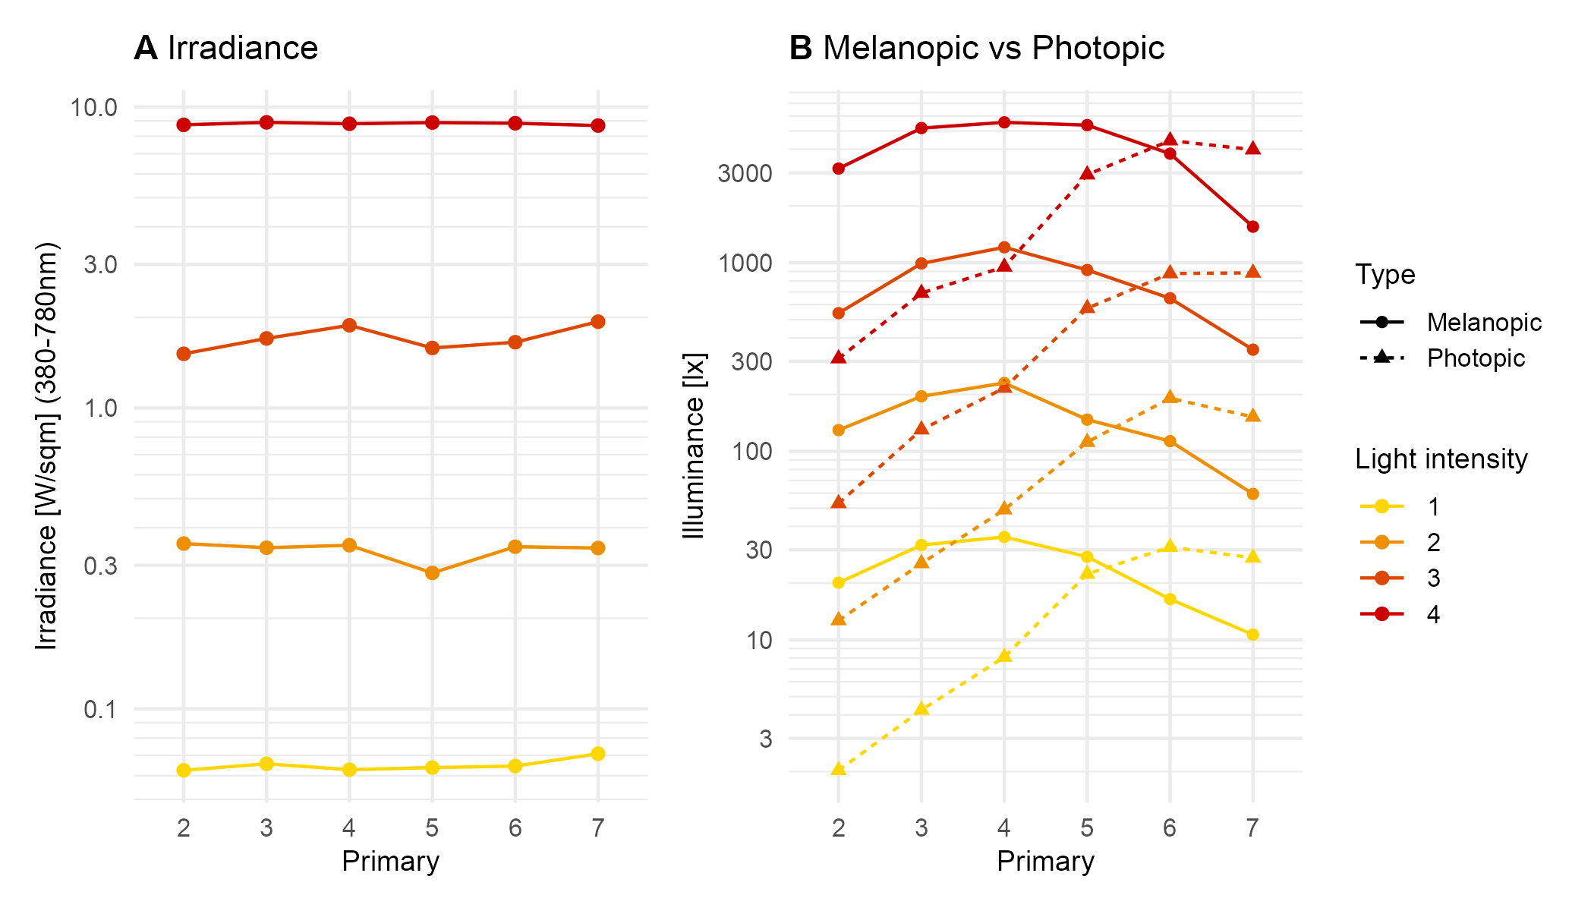
Figure S4. Calibration measurements of the light stimuli, across all possible light intensities that participants will get randomly during each of their laboratory visits. (A) Irradiance stays constant across primaries, and so for each light intensity setting. (B). Primaries with peaks at lower wavelengths show higher melanopic excitation (melanopic EDI, tuned to ipRGCs) than photopic excitation (illuminance, tuned to L+M cones) than primaries at higher wavelengths. As the wavelength increases, the trend reverses – photopic excitation increases and surpasses melanopic excitation.

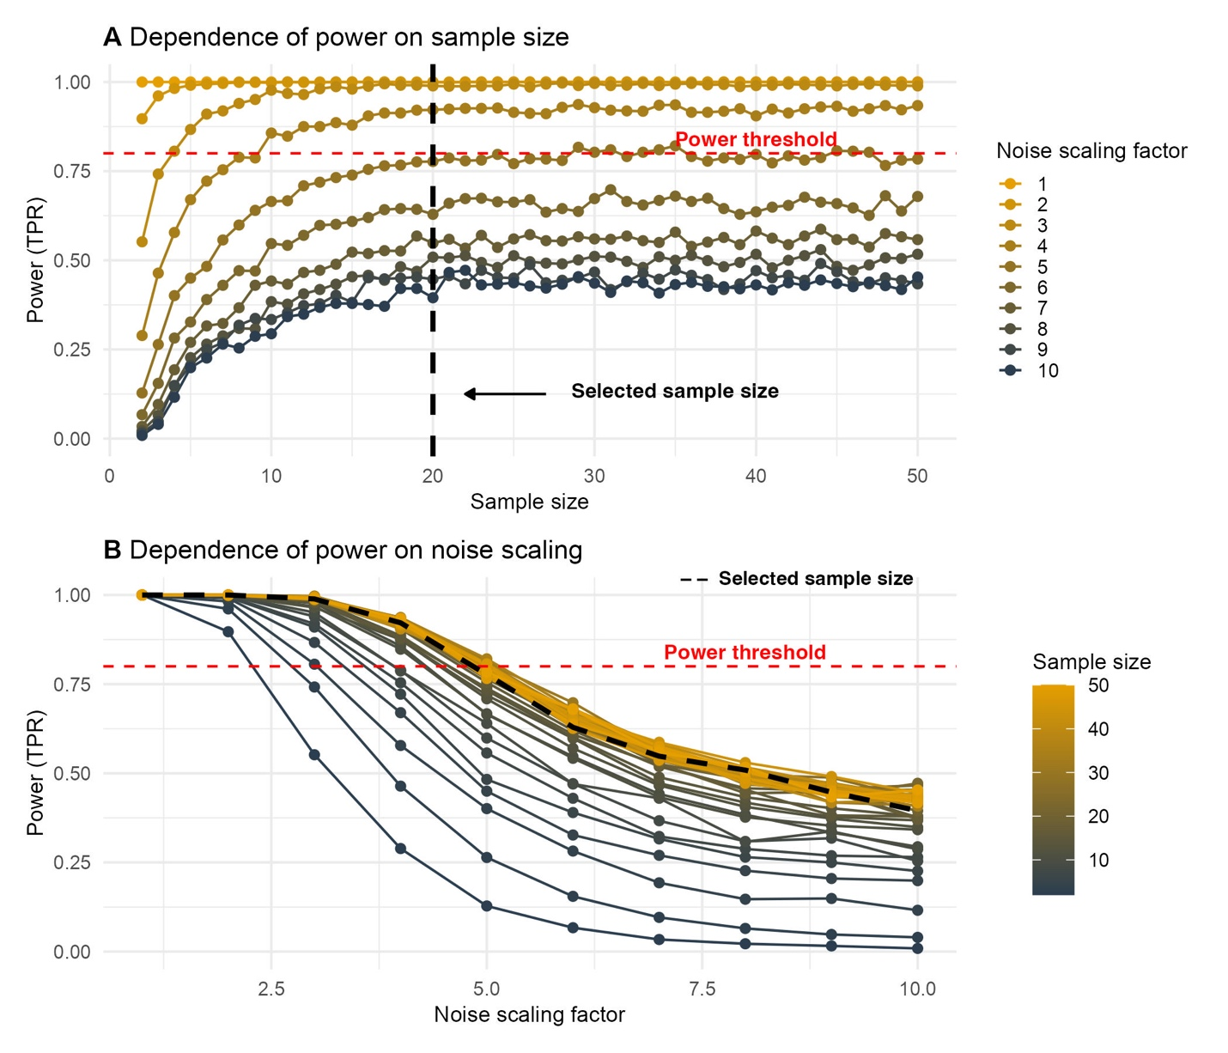
Figure S5. (A) Relationship between sample size and resulting power, using BFDA on data simulated using pilot data. The dashed red line indicates the minimum required power value of 0.8, and the dashed black line indicates the selected sample size of N=20. (B) Relationship between residual noise scaling factor and resulting power, using BFDA on simulated data. The dashed red line indicates the minimum required power value of 0.8, and the dashed black line indicates the selected sample size of N=20.

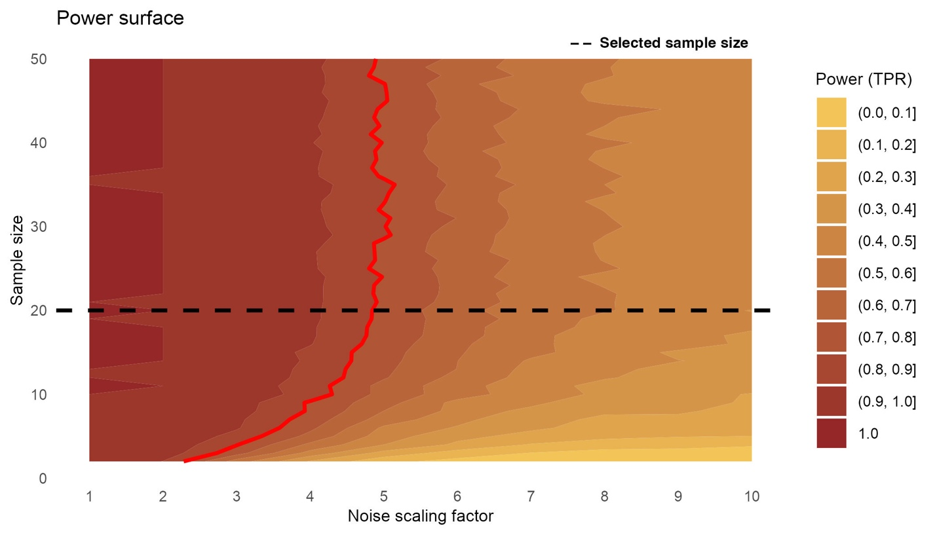
Figure S6. Power surface across the design grid. The contour map indicates power levels (10 equally spaced contour levels) for noise scaling factors ranging from 1 to 10 and sample sizes from 2 to 50. The red line indicates the minimum required power value of 0.8, and the dashed black line indicates the selected sample size of n=20.

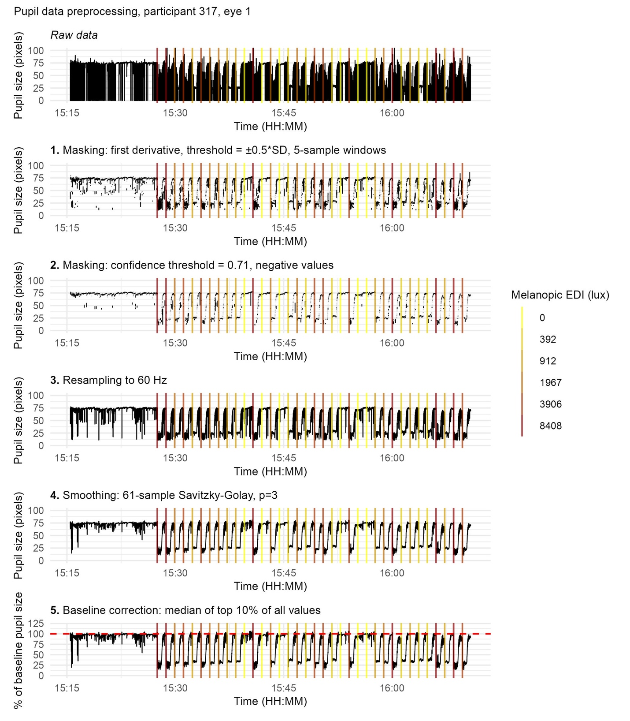
Figure S7. Pupillometry data preprocessing pipeline, for an example data set from the pilot data. Panels show (from top to bottom): raw pupillary signal; masking based on the first derivative with a threshold of ±0.5*SD to the local mean for 5-sample windows; resampling to 60 Hz; masking based on confidence threshold, defined programmatically as the 60% quantile of all confidence values in the dataset, with boundaries set from 0.6 to 0.71, and masking based on physiologically impossible values, i.e. negative values, resampling to 60 Hz, smoothing using a third-order polynomial Savitzky-Golay filter with 61-sample windows; and baseline-corrected pupil size expressed as a percentage of baseline, corresponding to the median of the top 10% values of the whole recording used for normalisation. Vertical lines indicate light onset times, colour-coded by melanopic equivalent daylight illuminance (EDI). All panels share a common time axis.

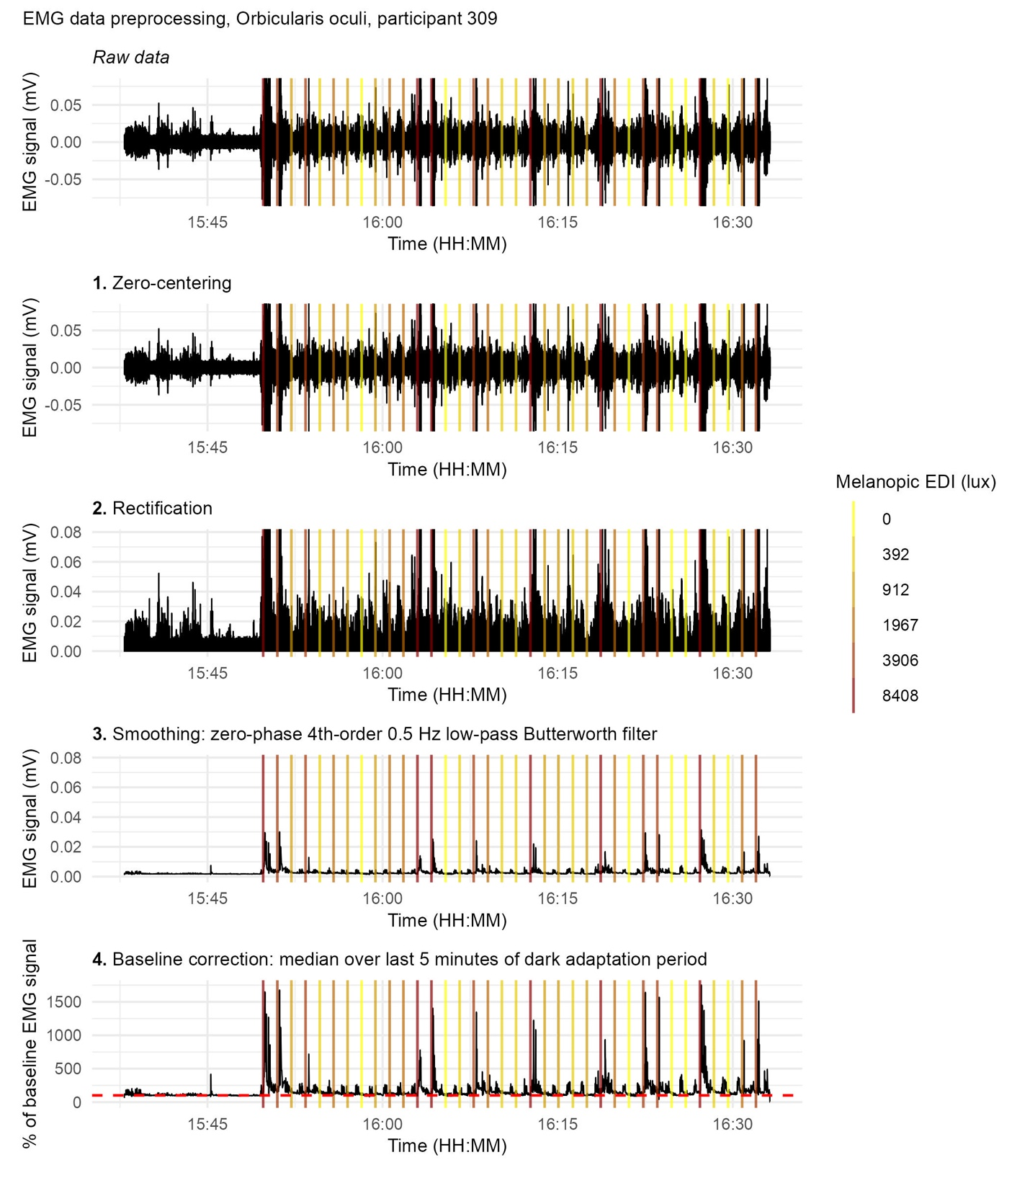
Figure S8. sEMG data signal preprocessing pipeline, for an example data set from the pilot data. Panels show (from top to bottom): raw EMG signal; zero-centred signal; rectified signal; smoothed signal obtained via zero-phase forward-backward fourth-order Butterworth low-pass filtering at 0.5 Hz; and baseline-corrected EMG expressed as a percentage of baseline, corresponding to the final five minutes of the dark adaptation period used for normalisation. Vertical lines indicate light onset times, colour-coded by melanopic equivalent daylight illuminance (EDI). All panels share a common time axis, and y-axis limits are constrained to the upper 99.99th quantile of the data to improve visualisation (removing frequent extreme outliers) while preserving relative signal dynamics.

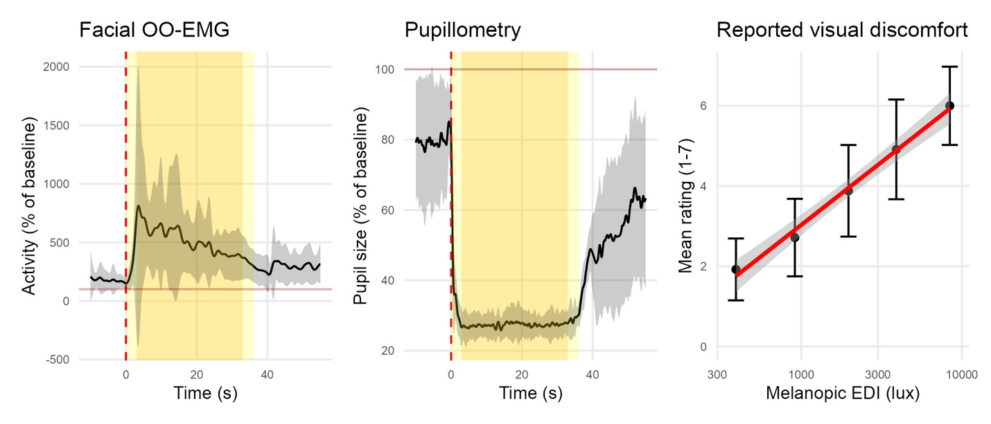
Figure S9. Pilot data, showing group averages, N=18. Panels show (from left to right): trace obtained for orbicularis oculi sEMG activity from 10 seconds before light onset to 30 seconds after light offset; typical trace obtained for pupil size from 10 seconds before light onset to 30 seconds after light offset, and self-reported visual discomfort ratings as a function of light intensity (melanopic EDI).

