Objective and subjective assessment of light sensitivity in physiological responses to bright light in humans

Lucien Bickerstaff^{1, 2*}, Josef Trinkl¹, Stephan Munkwitz¹, Johannes Zauner^{1,2} & Manuel Spitschan^{1, 2, 3, 4}
¹ Max Planck Institute for Biological Cybernetics, Translational Sensory & Circadian Neuroscience, Tübingen, Germany
² Technical University of Munich, Chronobiology & Health, TUM School of Medicine and Health, Munich, Germany
³ Technical University of Munich, TUM Institute for Advanced Study (TUM-IAS), Garching, Germany
⁴ TUMCREATE, Singapore, Singapore

* Corresponding author: Lucien Bickerstaff (lucien.bickerstaff@tuebingen.mpg.de)

Abstract

Ocular light can produce responses in the human body that are not mediated by the fundamental and more well-known functions of the human visual system, and that often involve complex and not well-understood interactions within the nervous system. Sensitivity to light shows sizeable variability between individuals, and the underlying photoreceptor mechanisms remain partially unclear. To fill in this knowledge gap, this study operationalises acute light sensitivity responses, using objective (facial surface electromyography [sEMG], pupillometry) as well as subjective (scale-measured self-reporting) approaches in healthy adults (n = 20, age range 18-35). Within each of the four sessions, 36 successive light pulses from five narrowband wavelengths are delivered through a spectrally tuneable LED based light engine (445, 465, 475, 505, 525, 545 nm) under homogenous, full field stimulation at a fixed irradiance. We hypothesise that predicting visual discomfort using melanopic EDI (tuned to ipRGCs) will provide a better fit compared to using illuminance (tuned to L+M cones).

Abbreviations

ACHOO | Autosomal Dominant Compelling Helioopthalmic Outburst
AUDIT | Alcohol Use Disorders Identification Test
BAC | Blood Alcohol Content
BF | Bayes Factor
BFDA | Bayes Factor Design Analysis
DC | Direct Current
EDI | Equivalent Daylight Illuminance
HRR | Hardy Rand and Rittler
ipRGC | Intrinsically Photosensitive Retinal Ganglion Cell
IR | Infrared
KSS | Karolinska Sleepiness Scale
LED | Light Emitting Diode
LLM | Large Language Model
LMM  OD | Linear Mixed Model  Optical Density
PCA | Principal Component Analysis
PIPR | Post Illumination Pupil Response
PLR | Pupillary Light Reflex
REML | Restricted Maximum Likelihood
RHT | Retinohypothalamic tract
SCN | Suprachiasmatic Nucleus
sEMG | Surface Electromyography
TPR | True Positive Rate

Introduction

It is well known that light is essential for many physiological functions of the human body, regulating many visual as well as non-visual processes. The latter include notably pupil size regulation, cognitive and affective processes, and circadian entrainment – all mediated by the melanopsin-containing, intrinsically photosensitive retinal ganglion cells (ipRGCs)^{1,2}. These cells affect circadian rhythms through projection to the suprachiasmatic nuclei (SCN) via the retinohypothalamic tract (RHT) but also have projections to other brains areas which directly drive behaviour and cognitive function^{2,3}. Visual discomfort as a response to bright light exposure, i.e., glare, is a phenomenon that many humans will be familiar with. It manifests under a broad range of lighting conditions and typically translates into a characteristic set of physiological responses, e.g. eye closure, pupil constriction, facial muscle contraction, and/or other light-avoiding behaviours.

Visual functions are regulated by well-known photoreceptors, namely cones and rods. These lie at the back of the retina, which is a fine layer of nerve tissue. Cones allow for colour vision, spatial detail and motion perception during daytime. They are most dense in the fovea (centre of the retina), and exist in three subtypes differing in the opsins they contain, each sensitive to varying wavelengths of light – conveniently named L (long-wavelength-sensitive, peaking at ~565 nm), M (medium-wavelength-sensitive, peaking at ~535 nm), and S (short-wavelength-sensitive, peaking at ~420 nm) cones^{2,4}. Rods allow humans to see at lower light levels (typically during nighttime), taking over from cones who perform poorly in these conditions. They do not populate the fovea (i.e., are most present in the periphery of the retina), do not contribute to colour vision, and peak at ~498 nm⁴.
By contrast, non-visual functions are mediated by the aforementioned ipRGCs. The photopigment they contain, melanopsin, was first identified in the late 1990s, and subsequent works demonstrated its many functions in regulating human physiology, behaviour, and cognition^{1,2,5,6}. There is an increasing body of evidence supporting the modulation of visual perception from melanopic input^{7–9}, thereby challenging the classical, clear distinction of cones and rod (visual) versus ipRGC (non-visual) functions.

How sensitive one is to light can differ widely between subjects. Overall, factors such as genetic background, sex, age, chronotype, time of day or lens anatomy may play a role in determining light sensitivity^{10,11}. Eye properties, such as pre-receptoral selective filtering of the short-wave (blue) part of the visible spectrum, can shift peak sensitivity of photoreceptors. Macular pigments, populating the fovea, have been shown to vary in optical density by a factor of ten in young healthy adults, whereas the crystalline lens can also vary in a sizeable manner – in 20-to-39-year-old subjects, optical density (OD) at 410 nm ranged from 0.8 to 1.8 OD, and in 60-to-80-year-olds, who are more exposed to lens yellowing, the spread of lens absorbance was even larger (up to 3.3 OD)¹². Ocular media also acts as an additional, short-wave light filter. All these differences need to be carefully considered and accounted for when running such studies.

While the physiological processes need to be understood, pathological conditions may equally be of interest to investigate the mechanistic underpinnings of light sensitivity and visual discomfort. People suffering from migraine often experience photophobia, manifesting an aversive response to light exposure typically way below the usual threshold for light discomfort observed in healthy individuals. The proposed mechanism here is light-induced activation of the trigeminal nerves at the level of the trigeminal ganglion, in turn significantly deranging vascular function leading to pain^{13,14}. Rod monochromats do not have functional cones, forcing their visual system to rely solely on rods, which leads them to total colour blindness and photophobia. The latter occurs through rod saturation and absent cone-mediated adaptation¹⁵. Another phenomenon of interest is sneezing in response to bright light exposure, referred to as the photic sneeze reflex, photic sneeze syndrome, or Autosomal Dominant Compelling Helioopthalmic Outburst (ACHOO) syndrome, reportedly affecting up to 20 to 30% of the population^{16,17}. One hypothesis explaining its occurrence is that the reflex involves a genetically determined crosstalk between the visual and trigeminal pathways^{18,19}, and photic sneezers are also interestingly more susceptible to suffer from migraine, suggesting potential mechanistic similarities between the two conditions¹⁴.

Light sensitivity itself is too broad to be defined or measured by one single outcome. Visual discomfort is most trivially assessed via explicit subjective self-report, though existing methods in theory allow to dig deeper into objective determinants of light sensitivity. A very common approach to measure light-mediated responses is pupillometry, which records the eye to capture pupil size across time. Studies have also used facial surface electromyography (sEMG), most notably at the level of the orbicularis oculi muscle, to capture muscle electrical activity at the eye level – indicative of eye closure and blinking responses²⁰.

To our knowledge, no studies have operationalised light sensitivity and visual discomfort using simultaneous pupillometry, sEMG, and self-reporting measurements, and we identify this as a research gap to fill. In this study (Figure 1), we will clarify the specific neural pathways and mechanisms underlying some of these various aspects of light sensitivity and the contribution of each photoreceptor type (rods, cones and ipRGCs) to these responses by using a combination of objective and subjective proxies of light sensitivity and visual discomfort as a response to narrowband light of varying spectra in controlled, laboratory conditions.

Our hypotheses are the following:
- Confirmatory CH₁: We hypothesise that the spectral sensitivity of light-adapted pupillary responses, i.e. pupillary light reflex (PLR) and post-illumination pupil response (PIPR), is best fit by melanopsin.
- Confirmatory CH₂: We hypothesise that the spectral sensitivity of EMG-measured squint is best fit by melanopsin.
- Exploratory EH₁: We hypothesise that the spectral sensitivity of scale-measured visual discomfort is best fit by melanopsin.
- Exploratory EH₂: We hypothesise that the spectral sensitivity of scale-measured facial sensations is best fit by melanopsin.

A note on terminology: there is an important distinction between the spectral sensitivity of melanopsin as an opsin measured in isolation, and the melanopic sensitivity of ipRGCs as defined for a reference observer^{4,21}. Therefore, it is necessary to clarify what “melanopsin” refers to – in this report, it corresponds to the melanopic spectral sensitivity function of the CIE standard observer, not the intrinsic absorption spectrum of the melanopsin molecule.
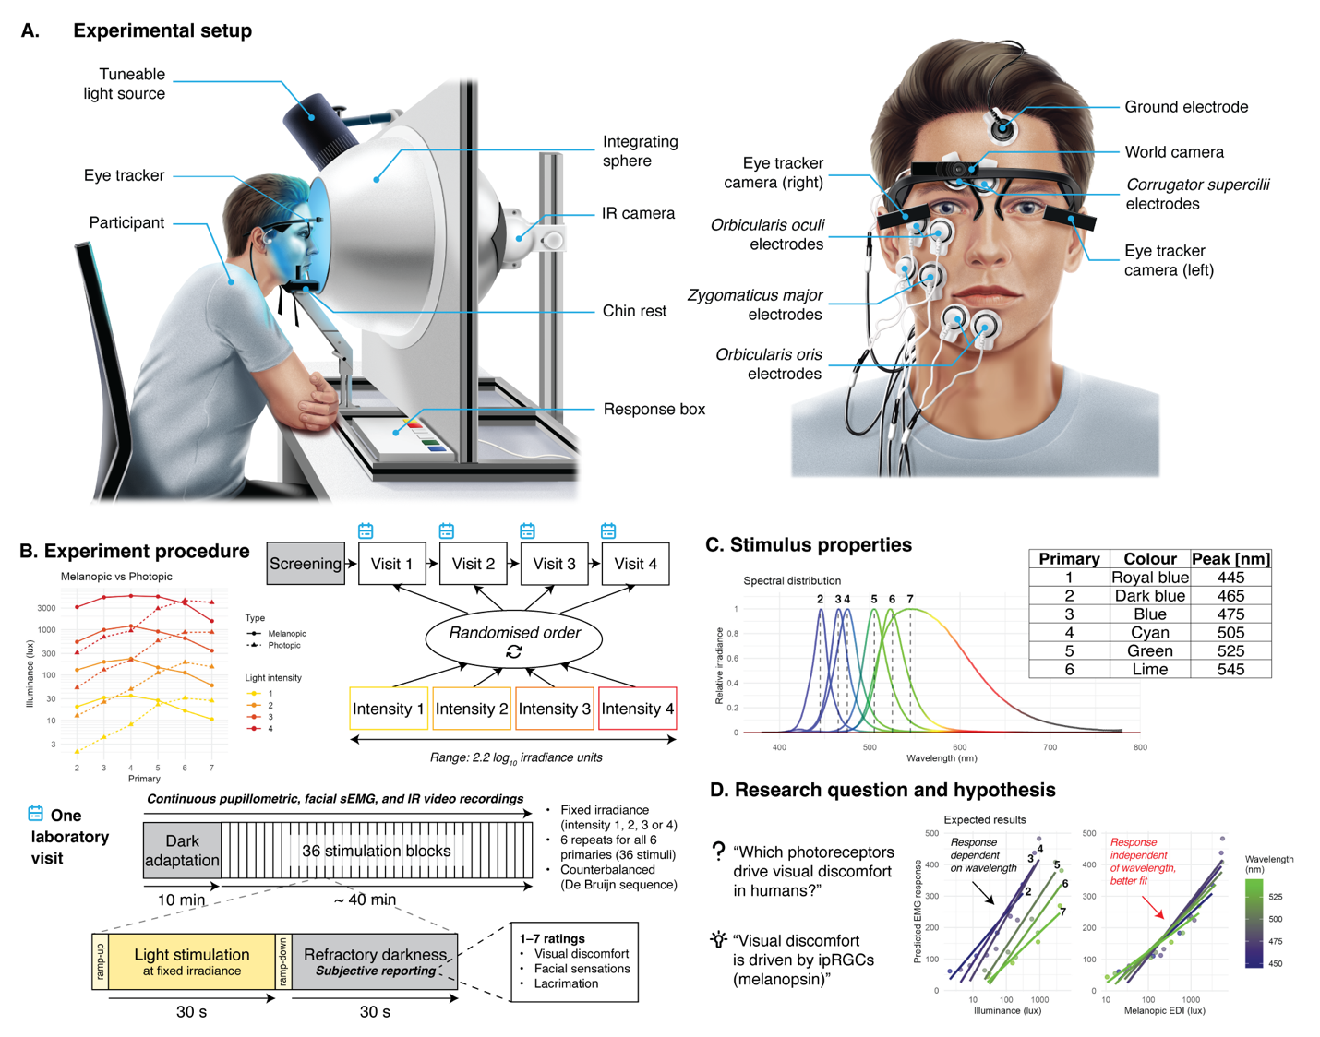
Figure 1. Overview of study design. (A) Participants sit in front of an integrating sphere and rest their head on a chin rest. A spectrally tuneable, 10-primary LED light source shine light into the sphere from above. While participants are exposed to light, binocular pupillometry, facial sEMG and infrared (IR) video recordings are performed. For sEMG, bipolar electrodes capture the electrical activity of four facial muscles on the right side of the face: corrugator supercilii, orbicularis oculi, zygomaticus major and orbicularis oris (sometimes impossible, due to e.g. beard). (B) Participants enrol for four laboratory visits, including a screening session during the first visit to confirm eligibility. One visit consists of 10 min of dark adaptation followed by 36 stimulation blocks. Each stimulation consists of a 3-s linear ramp-up, a 30-s light stimulation phase, a 3-s linear ramp-down, and a 30-s refractory darkness period, during which participants report their subjective experience of visual discomfort, facial sensations, and lacrimation using ratings on a 1-7 integer scale. Each of the four visits is randomly assigned a fixed irradiance, assigned to all the stimuli regardless of the wavelength. This allows to present stimuli with varying ratios of melanopic EDI to photopic illuminance, exposing the photoreceptors mechanisms at play in the measured responses. (C) The light stimuli have 6 different set wavelengths, spanning most of the short and medium part of the visible spectrum, with peaks from 445 to 545 nm. (D) We formulate the hypothesis that an ipRGC-tuned metric such as melanopic EDI (weighted to melanopsin sensitivity) provides a better fit than an L+M-cone-tuned metric such as photopic illuminance when predicting visual discomfort responses. This would mean that using illuminance as a predictor of visual discomfort does not capture the whole mechanisms at play, leaving the responses dependent on stimulus wavelength. Using melanopic EDI as a predictor would, on the other hand, fully and reliably characterise visual discomfort responses.

Methods

Ethics information

This study complies with all relevant ethical regulations and has received ethical approval from the Technical University of Munich Ethics Committee. During the in-person screening, participants will provide written informed consent before any experimental procedures. The study will be performed in line with the principles of the Declaration of Helsinki. Participants will receive remuneration for their time – the details of which are described in the Sampling plan section.

Pilot data

A pilot study was designed and carried out to assess the feasibility of the protocol and inform stage 1 of this PCI Registered Report. The aim was to obtain data to characterise the dose-response curves for the modalities of interest, effect sizes, fit a model and use this model to perform a Bayes Factor Design Analysis (BFDA)^{22,23} to determine the power achievable with this spectral sensitivity study. The results of which are detailed in the Sample size calculation section.
The pilot study followed a similar design as the one described in the following sections – the deviations from this protocol are described in Table 1. Given the hypotheses tested in this spectral sensitivity study were already formulated, the pilot data was collected using white light of a correlated colour temperature (CCT) of 5000 K – not narrowband lights, to avoid data overlap and redundancy, therefore reducing bias when designing the final protocol, as formulating hypotheses after analysing data from the exact same protocol would go against the purpose of preregistering the study. It also allows generation of diverse data which may provide distinct information and insights into the mechanisms at play.

Table 1. Changes between the pilot and preregistered protocols
Property | Pilot protocol | Final protocol
Number of laboratory visits | 1 | 4
Stimuli | Varying intensity  “White light”: all 10 primaries on, constant spectra: CCT = 5000 K | Varying spectrum  Individual primaries at fixed irradiance for each laboratory visit
Melanopic equivalent daylight illuminance (melanopic EDI) | Range: 392 – 8408 lx  (~1.3 log10 units)  + dark condition (0 lx) | Range: 10 – 5552 lx  (~2.7 log10 units)
Photopic illuminance | Range: 486 – 9821 lx  (~1.3 log10 units)  + dark condition (0 lx) | Range: 2 – 4443 lx  (~3.3 log10 units)
Illuminance/Mel EDI ratio | Fixed  ~1.2 | Variable  Range: 0.1 – 2.56  (~1.4 log10 units)
Irradiance range | Range: 1.6 – 35.6 W.m⁻²  (~1.3 log10 units)  + dark condition (0 W.m⁻²) | Range: 0.06 – 8.8 W.m⁻²  (~2.2 log10 units)

33 participants were recruited, and 22 were eligible to take part in the experiment. After exclusion of incomplete or problematic data sets, 18 participants were finally included in the analysis of the EMG data.
The modality chosen for conducting the BFDA is the sEMG blinking/squinting muscle (orbicularis oculi) activity. The rationale for using sEMG over pupillometry data is that it constitutes the most reliable and stable outcome, using data loss as a proxy – considered as the overall proportion of datasets where an issue arose during data collection for each muscle. There was no data loss for the corrugator supercilii, around 5% for the orbicularis oculi, around 10 % for the zygomaticus major, and around 24% for the orbicularis oris muscles. Pupillometric measurements, on the other hand, display from 29 % of data loss (expressed as the data lost during masking based on confidence at a threshold of 0.7 – see the Analysis plan section for more details) at the lowest light level (392 mel EDI) to 77 % at the brightest light levels (8408 mel EDI), on average, with high within-group variability. On a side note, there is on average more pupillometry data loss at 0 lux than at 392 lux, since the pupil is bigger in complete darkness and can be therefore harder to detect since its edges can be covered by the eyelids.
The sEMG data was preprocessed using the pipeline described in the Analysis plan section.
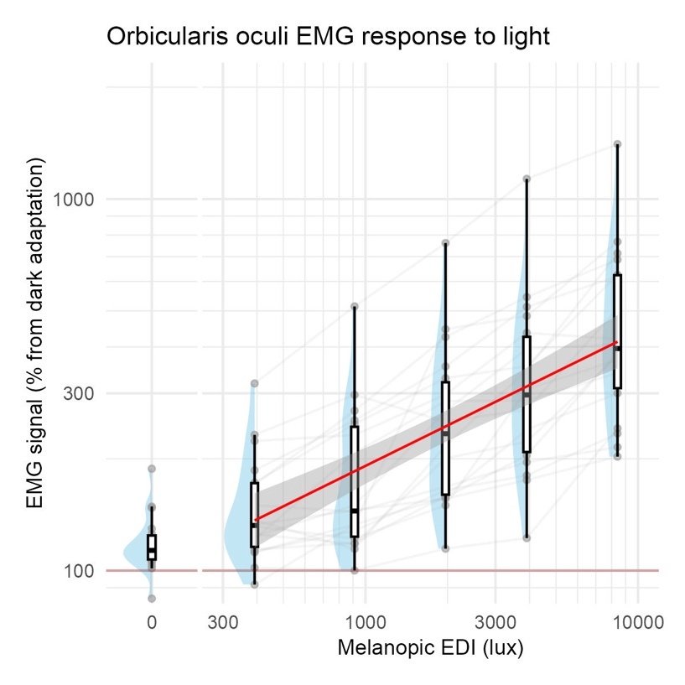
Figure 2. Dose-response curve of the orbicularis oculi (blinking/squinting) muscle sEMG response to light (melanopic EDI), N=18. The red line shows linear fit to the data and the grey ribbon its confidence interval.

The orbicularis oculi muscle was chosen over the other facial muscles, since it was shown to be the most reliable proxy for visual discomfort, and is not as sensitive to cognitive input as the other viable candidate, the corrugator supercilii^{20,24–27}.
For modelling, using a linear mixed model (LMM) was determined to be the best approach, because the data contain repeated measurements nested within participants, which induces correlations that ordinary linear regression cannot handle. The LMM allows each participant to have their own intercepts and/or slopes while still estimating a coherent group-level trend. This leads to more accurate uncertainty estimates, better handling of inter-subject variability, and a generative model that can simulate realistic new datasets with subject-specific variation.
The calculations were performed on R version 4.4.0²⁸ using the lme4 R package version 1.1-37²⁹, specifically using the lmer() function for model fitting.
The baseline models response as a function of melanopic EDI (log₁₀ transformed) while allowing for participant-dependent (random) slopes and intercepts. Because of the log₁₀ transformation, the 0-lux condition cannot be modelled directly, so
EMG change score ~ log10Melanopic EDI+(log10Melanopic EDI | Participant ID)
an additional term $Z_{i}$ was added. Zi denotes a binary indicator variable, identifying whether the observation corresponds to the 0-lux condition (1), or one of the other conditions > 0-lux (0). This allows to retain the baseline information (0-lux condition) in the modelling approach. Participant-dependent slopes were dropped due to convergence issues in accordance with Barr et al.³⁰.
The final model was fitted using restricted maximum likelihood (REML) with the following formula according to the Wilkinson-Rogers notation³¹:
$\log_{10}\left(EMG response\right) \sim Z_{i}+ \log_{10}\left(Melanopic EDI\right)+ \left(1 \right| Participant ID)$
The linear mixed-effects model revealed a significant positive effect of melanopic EDI on the orbicularis oculi sEMG response (p < 0.001, β = 0.361 ± 0.025, 95% CI [0.311, 0.412], as well as a significant positive effect of $Z_{i}$ on the sEMG response (p < 0.001, β = 0.873 ± 0.088, 95% CI [0.699, 1.047]). The mixed-effects model included random intercepts for participants (SD = 0.149), and showed a marginal R² of 0.518, indicating that fixed effects explained 51.8% of the variance, and a conditional R² of 0.822, reflecting substantial additional variance explained by participant-level random intercepts. Notably, marginal R² reflects variance partitioning within the full model rather than improvement over a random-effects-only baseline.

Table 2. Mixed-effects model output for the orbicularis oculi sEMG response to light.
Dependent variable
Predictors | Estimates | CI | p
(Intercept) | 1.20 | 1.02 – 1.38 | <0.001
$Z_{i}$_TRUE | 0.87 | 0.70 – 1.05 | <0.001
log₁₀(Mel EDI) | 0.36 | 0.31 – 0.41 | <0.001
Random effects
σ² |  | 0.01
τ₀₀ _{participant_id} |  | 0.02
ICC |  | 0.63
N _{participant_id} |  | 18
Observations |  | 108
Marginal R² / Conditional R² |  | 0.518 / 0.822

Design

In this study, each participant will be enrolling for a total of maximum five weeks, consisting of one initial meeting for screening, and four in-laboratory visits. The study design is within-subjects, testing the same participants across all conditions, and participants will be blinded to which conditions they are exposed to.
We will recruit healthy volunteers aged 18-35 years (to minimize differences in lens transmittance) for our within-subjects laboratory study taking place across four one-hour experimental sessions. A sample size of 20 individuals was chosen, as resource limitations (money, time) prevent collecting data on more individuals. Within each session, light pulses from five narrowband wavelengths delivered through a spectrally tuneable LED (light-emitting diode) light engine (445, 465, 475, 505, 525, 545 nm) under homogenous, full-field stimulation at a fixed quantal radiance will be shown to participants in a counterbalanced sequence. Pupillometry and facial electromyography data will be recorded continuously (~120 Hz for pupillometry, 2048 Hz for the sEMG) during the trial, and subjective sensations (1-7 ratings for visual discomfort, facial sensations and lacrimation and associated confidence) reported. Prior to the sequence, participants undergo a ten-minute darkness adaptation period, followed by 36 trials of light stimulation, with each cycle consisting of 30 s of light exposure followed by 30 s of refractory darkness to examine post-illumination pupil responses.

Timeline

During the first session, the participant will complete the screening to verify eligibility to participate according to the inclusion and exclusion criteria, as described in the Sampling plan section.
For each laboratory visit, participants will come at the same time of the day, which they will decide (if possible). They will firstly be reminded of the instructions and the requirements to participate in the session.
At the beginning of each visit, they will complete a breathalyser and urine test, to ensure they are not under the influence of alcohol or drugs, and will report their subjective sleepiness. Next, the experimenter will set up the eye tracker and sEMG devices on the participant. The participants will be informed that the devices measure an eye response only, to avoid cueing the participant to the measurements focusing on discomfort. After that, the experimenter will ask them to sit in front of the integrating sphere.
The experiment will then begin. The lights in the room will be switched off. Pupillometry, sEMG and infrared (IR) video measurements will be started, and participants will go through the initial 10-minute dark adaptation period.
The light stimulation will then begin. 36 stimuli blocks will occur in total. After each stimulation cycle, the participant will have to answer the subjective feedback questions using the response device with the help of auditory feedback. In total they will answer the questions 36 times, after each stimulus.
After the stimulation phase, the recordings will be stopped, the lights switched back on and the pupil tracker and sEMG devices taken off. Participants report again their sleepiness and may also give consent to be contacted again for further studies. Finally, the participant may leave the laboratory.

Light stimuli

Participants will be exposed to light stimuli differing in intensity and wavelength (spectral composition), sitting in front of the integrating sphere and resting their head on a chinrest (Figure 3). The participants will go through an initial 10-minute dark adaptation period, before presentation of the stimuli. Light exposure prior to the laboratory visits is not controlled for. To avoid fixational eye movements, participants will be asked to fixate a point in front of them at the back of the sphere during the entirety of the trial. The stimuli play in a counterbalanced manner, defined by a de Bruijn sequence³² – for each trial, the sequence is randomly chosen among pre-generated counterbalanced sequences. The stimuli are presented as follows: a 3-second linear ramp-up, a 30-second plateau, a 3-second linear ramp down, and a 60-second refractory dark period. At each laboratory visit, participants will be shown light stimuli of one of four pre-set, log-spaced intensity levels (0.06, 0.32, 1.6, 8.8 W.m⁻²), in a random order determined programmatically for each participant during their first laboratory visit. Light stimuli will be generated using the SpectraTune Lab (Ledmotive Technologies S.L., Barcelona, Spain) 10-primary LED light source. Six primaries (#2 to #7) will be used, with respective peak emissions at 445, 465, 475, 505, 525 and 545 nm. The primaries were chosen based on their melanopic excitation potential. Each stimulus was calibrated so that so at each laboratory visit, all stimuli from the six primaries are of a fixed irradiance (measured at eye level out of the sphere), but of differing illuminance and melanopic EDI. The following design matrix summarises the described experimental approach. The calibration data (carried out using a Spectraval 1511 spectroradiometer from JETI Technische Instrumente GmbH, Jena, Germany), design matrix, and corresponding completed ENLIGHT checklist³³ are available on the associated GitHub repository (https://github.com/tscnlab/BickerstaffEtAl_PCIRRStage1_2026).

Table 3. Light stimuli properties.
Lab  visit | Primary | Peak wavelength [nm] | Colour | Light source setting (0-4095) | Irradiance [W/sqm] (380-780nm) | Illuminance [lx] | Mel EDI [lx] | Melanopic to photopic ratio
1 | 2 | 445 | Royal blue | 38 | 0.062 | 2.032 | 20.085 | 9.884
1 | 3 | 465 | Dark blue | 49 | 0.066 | 4.243 | 31.823 | 7.500
1 | 4 | 475 | Blue | 56 | 0.063 | 8.102 | 35.111 | 4.334
1 | 5 | 505 | Cyan | 57 | 0.064 | 22.355 | 27.585 | 1.234
1 | 6 | 525 | Green | 62 | 0.065 | 31.039 | 16.430 | 0.529
1 | 7 | 545 | Lime | 52 | 0.071 | 27.247 | 10.654 | 0.391
2 | 2 | 445 | Royal blue | 128 | 0.354 | 12.670 | 129.534 | 10.224
2 | 3 | 465 | Dark blue | 142 | 0.343 | 25.420 | 195.674 | 7.698
2 | 4 | 475 | Blue | 156 | 0.350 | 49.043 | 230.240 | 4.695
2 | 5 | 505 | Cyan | 166 | 0.283 | 111.794 | 147.206 | 1.317
2 | 6 | 525 | Green | 174 | 0.346 | 191.183 | 113.174 | 0.592
2 | 7 | 545 | Lime | 115 | 0.342 | 152.137 | 59.395 | 0.390
3 | 2 | 445 | Royal blue | 439 | 1.514 | 52.891 | 540.104 | 10.212
3 | 3 | 465 | Dark blue | 537 | 1.703 | 130.209 | 991.170 | 7.612
3 | 4 | 475 | Blue | 622 | 1.883 | 216.493 | 1207.548 | 5.578
3 | 5 | 505 | Cyan | 454 | 1.583 | 573.437 | 915.052 | 1.596
3 | 6 | 525 | Green | 577 | 1.654 | 876.532 | 647.720 | 0.739
3 | 7 | 545 | Lime | 367 | 1.936 | 883.469 | 345.831 | 0.391
4 | 2 | 445 | Royal blue | 3230 | 8.731 | 310.267 | 3157.139 | 10.176
4 | 3 | 465 | Dark blue | 3310 | 8.898 | 690.000 | 5175.748 | 7.501
4 | 4 | 475 | Blue | 3511 | 8.802 | 950.813 | 5552.074 | 5.839
4 | 5 | 505 | Cyan | 3196 | 8.884 | 2930.689 | 5366.997 | 1.831
4 | 6 | 525 | Green | 4095 | 8.837 | 4443.253 | 3787.380 | 0.852
4 | 7 | 545 | Lime | 1137 | 8.684 | 3979.285 | 1553.400 | 0.390

Measurements

For each participant, all experiment sessions should be carried out at the same time of day, and if not possible, in the same time window during the day. The sessions may occur in time slots between 10:00 and 19:00.

Screening

Questionnaires
During the whole study, participants will complete a series of questionnaires and surveys, implemented in the REDCap (Research Electronic Data Capture) platform^{34,35}, hosted at the Technical University of Munich. REDCap is a secure, web-based software platform designed to support data capture for research studies, providing 1) an intuitive interface for validated data capture; 2) audit trails for tracking data manipulation and export procedures; 3) automated export procedures for seamless data downloads to common statistical packages; and 4) procedures for data integration and interoperability with external sources.

Demographic variables
At screening, we will ask participants for their age, sex and gender identity.

Health variables
Physical health will be assessed using self-report questionnaires, aiming to screen for the variables described in the Sampling plan section.

Visual function
We will assess visual function using a variety of means. We will examine visual acuity using a Landolt C chart, and colour vision using HRR (Hardy Rand and Rittler)³⁶ plates (Richmond Products, Inc., Albuquerque, New Mexico, USA). The threshold for visual acuity is 20/40, which means 20/50 or worse will lead to exclusion from the study.

Alcohol use
Participants will complete the Alcohol Use Disorders Identification Test (AUDIT)³⁷, an instrument to examine substance and alcohol abuse, in the self-report version.

Reproductive status
Participants will complete a reproductive status questionnaire to determine their current hormonal functioning, and any hormonal medication intake.

Alcohol and drug tests
At the beginning of each laboratory evening, participants will be tested for alcohol and drug use. Participants will be asked to use a breathalyser (Alkoholtester ACE A, ACE Technik, Freilassing, Germany) to determine blood alcohol content (BAC). Participants will also be asked to produce a urine sample in a collection device, which will then be tested using a standard multi panel drug test (article number 620402, nal von minden GmbH, Moers, Germany) testing for amphetamines (1000 ng/mL cutoff), benzodiazepine (300 ng/mL cutoff), cocaine (300 ng/mL cutoff), morphine/opiates (300 ng/mL cutoff), and tetrahydrocannabinol (50 ng/mL cutoff). Should either test be positive, participants will not be able to participate that session.

Pupillometry measurements
Binocular pupillary data will be captured using the Pupil Core (Pupil Labs GmbH, Berlin, Germany) system³⁸, an infrared video-based eye tracker recording at ~120 Hz. The data is collected using Pupil Capture version 3.5.7. The software uses an algorithmic approach to fit an ellipse to the detected 2D pupil and output a pupil size estimate in pixels, and fit a 3D eyeball model to the image to provide absolute pupil size in millimetres. There is a short calibration step ahead of the start of the dark period, where the participants are asked to look around, in all directions, for 30 seconds (more if needed), in order to allow the software to create a good model fit. Once the model is fit, it is frozen for the entire experiment. In this scenario, we assume that the slippage occurring during the experiment – potentially leading to a slightly inaccurate model towards the end of the trial – is preferable in comparison to not freezing the model, which allows constant correction in the model leading to relative differences in pupil size measurements from the start to the end, in turn making baseline correction inefficient. Participants will be instructed not to move their heads during the whole experiment, and keep focus on the IR camera at the back of the integrating sphere. This will be monitored and acted upon by orally reminding participants to do so should they not follow the instructions during data collection, using the live feedback of the eye cameras. The recording will take place in complete darkness, with the only light source being the IR lights from the IR camera. After the experiment, post-hoc pupil detection will be run on the eye video recordings using the Pupil Player software (version 3.5.7) as it may improve the quality of the data.

Facial surface electromyography measurements

Facial electromyography data will be captured using the EMG-USB2+ (OTBioelettronica SRL, Turin, Italy) system. It measures electrical signal of muscles in the face, interfacing with the experimental machine using the proprietary OTBiolab Light software (included in OTBiolab+ version 1.5.8) to allow collecting EMG data directly from a USB socket via Python. This device is used to measure facial muscle activity with a 16-channel bipolar adapter (AD8x2JD) and small bipolar electrodes. Here, four channels will be used for each of the corrugator supercilii, orbicularis oculi, zygomaticus major and orbicualris oris facial muscles. A gain of 1000 is applied to the signal. The ground electrode is placed in the centre on the forehead, just before the hairline. To maximise signal-to-noise ratio, the skin will be gently wiped with some abrasive paste to remove dead skin and increase skin conductance. The facial regions of interest (especially around the eye) are very sensitive and will therefore not be shaved by the experimenter. The zygomaticus major and orbicularis oris muscles may not be measured in bearded individuals as we do not ask them to shave for the purpose of the experiment. As facial reaction to light exposure can be quite strong, tape may be applied on the electrodes to ensure they remain in position and measure accurately and consistently during the entire trial duration.

Subjective reporting

At the end of each light stimulation phase, participants will report their subjective sensations and associated confidence with a unified 1-7 integer rating scale, with 1 being the lowest and 7 the higher rating, using a MIDI device (Palette, Monogram, Kitchener, Ontario, Canada; controlled through the Monogram Creator Legacy version 4.1 software) that has knobs and buttons participant will use to give their ratings, with the help of automated auditory feedback. In total, participants give six ratings. First, they will report their visual discomfort – this is described as how uncomfortable the light they are being exposed to, is making them feel. Then, they will rate their facial sensations – this is described as the intensity of the sensations (such as tickling, itching, burning…) they are getting in their face as a result of light stimulation. Finally, they report lacrimation – this is described as how much lacrimation has been generated in their eyes from the light they have just been exposed to. For clarity, lacrimation is also described as eye watering. For each of the three rating modalities, participants will also report an associated confidence rating – this is described as how confident they are in each of the ratings they just gave.
The Karolinska Sleepiness Scale (KSS) scale³⁹ (10-point version) will be used to measure the subjective level of sleepiness before and after each laboratory trial via self-reporting.

Video recordings

Faces of the participants will be recorded using an infrared camera (model number ALP-USBFHD05MT-DL36-DD-GM, ELP, Shenzhen, Guangdong, China) during the entirety of the trial, for participant monitoring purposes.

Software

The whole device control system is handled through a unified, custom Python module and controlled using the same experimental machine. The pupillometry system and light engine are controlled through Python using the PyPlr package⁴⁰ which offers an interface to Pupil Core³⁸ and the SpectraTune Lab light source. Custom scripts were written for interfacing with the IR camera and EMG system. The latter collects timestamped data, which allows to synchronise the data stream with the pupillometry data (for more information see Analysis plan section).

Sampling plan

Recruitment and screening

This study opts for a fixed-N design – recruitment will be run until 20 healthy adults have successfully completed the entire study, aiming for a balanced distribution of female and male biological sexes. Still, should N=10 be reached for one of the two sexes, participants will not be excluded from participating. In the case subjects show very low data quality and need to be excluded based on the criteria laid down in the Analysis plan section, new subjects will be recruited as a replacement.
Recruitment will follow multiple strategies, including advertising the study using flyers and posters displayed in authorised public places and on social media, using email lists and word-of-mouth.
Participants will have the choice to conduct the study in either German or English, depending on their preference. Participant-facing materials will be made available in both languages.
Participants will be given the opportunity to ask any questions before providing written consent to participate in the study.

Table 4. Inclusion criteria.
Domain | Criterion | Assessment method
Age | ≥18, ≤35 years of age | Self-report
Physical health | Good physical health | Self-report
Mental health | Good mental health | Self-report
Visual acuity | Normal visual acuity (20/40 or better) | Landolt C chart
Colour vision | Normal colour vision | HRR plates

Table 5. Exclusion criteria.
Domain | Criterion | Assessment method
Medication use | Any use of medications, including antihistamines | Self-report
Smoking | Habitual smoking | Self-report
Epilepsy | Diagnosis of epilepsy or family history of epilepsy | Self-report
Migraine | Diagnosis of migraine | Self-report
Recreational drug use | Use of recreational drugs | Self-report
Substance abuse | Excessive alcohol use | AUDIT
Allergies | Known allergies | Self-report
Acute drug screening | Presence of drugs | Multi-panel drug test

Participant compensation

Participants will be remunerated on the basis on EUR15 per hour. Considering each session to be around one hour, and the initial meeting to be an hour too, participants can be expected to spend a total of five hours in the laboratory as part of their participation in the study, resulting in EUR75 of total remuneration.

Sample size calculation

A fixed-N BFDA was performed using the orbicularis oculi EMG pilot data. The aim was to determine the power obtained with this experimental design given a fixed sample size of 20.
The calculation was performed on R version 4.4.0²⁸ using the BayesFactor R package version 0.9.12-4.7⁴¹, using the lmBF() and extractBF() functions for model fits and model comparisons.
The orbicularis oculi EMG LMM fit parameters (described in the Pilot data section) were extracted and used to simulate data. From this study’s experimental design, a design matrix containing all conditions and associated melanopic EDI (predictor) values determined through calibration spectral measurements (Table 3) was generated, needed to compute corresponding output EMG responses (outcome).
Each BFDA run includes 1000 simulations. Bayes Factors (BF) are calculated by fitting two models – a “full” model and a “null” model – and comparing them.
The “full” model formula is as follows, using melanopic EDI as the predictor variable according to the Wilkinson-Rogers notation³¹:
$EMG response \sim \log_{10}\left(Melanopic EDI\right)+(\log_{10}\left(Melanopic EDI\right) | Participant ID)$
The “null” model formula uses photopic illuminance as a predictor instead:
EMG response ~ log10Illuminance+(log10Melanopic EDIIlluminance | Participant ID)
As a note, the Zi parameter present in the modelling of the EMG pilot data (see Pilot data section) does not appear here as there is no 0-lux condition anymore in this protocol.
Then, from all 1000 simulations, the True Positive Rate (TPR, i.e., power) is calculated from the proportion of BFs higher than 10 – indicating strong evidence in favour of the “full” model, i.e. the melanopsin model. BFDA was performed for a range of sample sizes (2 to 50) and noise scaling factor levels (1 to 10 times the residual noise when simulating data), indicating the conditions needed to properly capture the effect if it is present (a threshold of 0.8 for power is considered sufficient, which translates to an 80% chance of detection, given that the effect is true as parametrised).
The power analysis indicated very high power even for small sample sizes – for a noise scaling factor of 1, i.e. identical to the residual noise observed in the model used to generate the data, two participants are enough. If the residual noise observed in the actual data is three times higher than the noise observed in the pilot data, then four participants are enough to surpass the satisfactory power value of 0.8. If noise levels are ten times higher, it is not possible to achieve high enough power with reasonable sample sizes. The ceiling for satisfactory power with 50 participants is reached for noise levels five times higher than those observed in the pilot data.

Analysis plan

Software

For consistency, preprocessing and analyses of the data will be performed on Python 3.13⁴² and R version 4.4.0²⁸, building upon the existing pipeline developed for the pilot data.

Data preprocessing and outcome extraction

Pupillometry data pipeline

Before any analyses, the pupillary data is preprocessed using the following pipeline, which is applied separately on each recording of both eyes for each participant.
The eye tracking software outputs two pupil size metrics – 2D pupil size values in pixels, extracted from the frames only, and 3D pupil size values in millimetres, extracted from an eyeball model fit, which involves an extra computational step. Given that only relative changes are of interest for the purpose of this analysis, and that the extra computational step may introduce some extra error, 2D pupil size values will be used, predominantly for measurement reliability.
As mentioned in the Pupillometry measurements section, post-hoc pupil detection will be run on the eye video recordings, as it may improve the quality of the data. Also, for each participant, computations (preprocessing and analyses) are performed on one eye only, due to data quality considerations. The decision whether to use the original or the post-hoc data as well as the left or right eye will be made programmatically on a participant level based on which data exhibits the less data loss after the confidence masking step.
The first preprocessing step is masking. The raw data is first filtered out using thresholds on the first derivative (±0.5 standard deviations to the local mean, 5-sample window size). Then, a second filtering step is applied based on the confidence metric, which is an output quantifying certainty of measurement (0 = no confidence, 1 = perfect confidence). The eye tracking system manufacturer, Pupil Labs GmbH, states that pupil size values with associated confidence of 0.6 and above carry out useful information. In our case, the threshold is defined at the 60% quantile of all confidence values. This value needs to be between 0.6 and 0.71, i.e. if the 60% confidence value quantile is 0.8, then it is lowered to 0.71, and if it is 0.45, then it is increased to 0.6. In our experience running similar protocols, excluding data with confidence above 0.71 poses a risk of discarding meaningful data. The approach here maximises data cleaning and preserves as much meaningful data as possible. Finally, a final masking step involves deleting physiologically impossible pupil size values, i.e. negative values. The data is then resampled to 60 Hz using linear interpolation – the raw pupillary data has a variable sample rate, usually around 100 Hz. A third-order polynomial Savitzky-Golay filter⁴³ is then applied to the resampled pupillary data, using a smoothing window of 61 samples (i.e., around 1 s at 60 Hz). Given how noisy the signal is, resulting from participants squinting and blinking a lot making pupil detection harder, using a one second window helps with reducing noise, though at the expense of losing transient responses e.g., blinks. Divisive baseline correction is then applied to the pupil data. The baseline pupil size corresponds to the median of the highest 10% pupil size values across the entire recording is calculated – for each participant and for each of their eyes. The median of the pupil size values during the last five minutes of the initial dark period was considered as a candidate for the baseline, but was found to be unreliable because of inconsistent pupil size measurements during dark period in the pilot study, with participants often dozing off or losing focus. That means the best quality baseline pupil size data sometimes lies not during dark adaptation, but after, during the light stimulation cycles. A visual representation of all the data preprocessing steps for an example experiment run is available in the supplementary materials.
The individual trial traces (time course -10 s before light onset to 30 seconds after light offset) are also kept for visualisation purposes, as well as for calculating the 6-second PIPR response, which is defined as the mean relative pupil constriction from total light offset (i.e. after ramp-down) to six seconds after total light offset.
What then follows is the calculation of participant-level averages of pupil constriction and PIPR for each light condition and wavelength. The average pupil size during the 30-s plateau period is computed for all 36 trials of the four laboratory visits. A group average is finally computed for both metrics for each combination of wavelength and light intensity.

EMG data pipeline

Before any analyses, the sEMG data is pre-processed using the following pipeline.
The data is first zero centred to correct for any DC (direct current) offset. Rectification is then applied by taking the absolute values of all data points. The rectified signal is low-pass filtered with a cutoff of 0.5 Hz normalised to the Nyquist frequency – 2048/2 Hz – using a zero-phase (forward-backward), fourth-order Butterworth filter. 0.5 Hz corresponds to a 2-second period, so anything faster than a few seconds gets strongly suppressed – this choice was made on the basis that only the average EMG activity during light stimulation was of interest, and not transient responses (e.g. blinks). Divisive baseline correction is then applied. The baseline corresponds to the median sEMG activity during the last five minutes of the initial dark period (i.e. five to ten minutes after the start of dark adaptation). A visual representation of all the data preprocessing steps for an example experiment run is available in the supplementary materials.
The individual trial traces (time course -10 s before light onset to 30 seconds after light offset) are also kept for visualisation purposes.
What then follows is calculation of participant-level averages of EMG activity for each light condition and wavelength. The average EMG activity during the 30-s plateau period is computed for all 36 trials of the 4 laboratory visits. A group average is finally computed for each muscle for each combination of wavelength and light intensity.

Subjective reporting data pipeline

The processing of rating data will involve the calculation of participant-level average ratings for each light condition and wavelength. A group average is finally computed for each rating for each combination of wavelength and light intensity.

Synchronisation of data streams

The time series data for pupillometry and EMG will be synchronised using the following strategy. The pupillary data serves as the reference in terms of timestamps, as the Pupil Capture software – alongside the PyPlr Python package⁴⁰ – supports the introduction of precisely-timestamped annotations in the recording (e.g. for marking the start of the experiment, the end of the initial dark adaptation period, or light onsets). The custom EMG Python software collects timestamped data separately, which allows to synchronise the data stream with the pupillometry data.

Data exclusion

In certain cases, datasets (i.e., pupillary data for one eye and for one participant) may be rejected upon the following criteria. Exclusion might result from issues during data collection – in cases where the experimenter reports relevant issues that may impact the reliability of the collected data, e.g. moving the eye tracker, or electrodes disconnecting during the experiment. Missing data would be the other reason – if the data presents obvious issues upon visual inspection, i.e., non-physiological responses, or, in the case of pupillometry data, if the percentage of remaining data after preprocessing falls below 10% of the original datasets (threshold defined from pilot data).

Statistical analysis

The same approach will be adopted here as the one described in the Sample size calculation section, where the data will be fit using LMMs and model fits compared using Bayesian statistics.
The calculation will be performed on R version 4.4.0²⁸ using the BayesFactor R package version 0.9.12-4.7⁴¹, using the lmBF() and extractBF() functions for model fits and model comparisons.
For each measurement modality – i.e. pupil constriction, PIPR, facial muscle EMG response, subjective reporting ratings – a Bayes Factor (BF) is calculated by fitting two models – a “full” model and a “null” model – and comparing them.
The “full” model formula is as follows, using melanopic EDI as the predictor variable, according to the Wilkinson-Rogers notation³¹:
$$Response \sim \log_{10}\left(Melanopic EDI\right)+(\log_{10}\left(Melanopic EDI\right) | Participant ID)$$
The “null” model formula uses photopic illuminance as a predictor instead:
Response ~ log10Illuminance+(log10Melanopic EDIIlluminance | Participant ID)
As a note, the Zi parameter present in the modelling of the EMG pilot data (see Pilot data section) does not appear here as there is no 0-lux condition anymore in this protocol.
We will use the following criteria to determine evidence for the full model⁴⁴: 1/3<BF<3 as anecdotal evidence in favour of the “full” model, 3<BF<10 as substantial evidence in favour of the “full” model, 10<BF<30 as strong evidence for in favour of the “full” model, and BF>100 as very strong evidence in favour of the “full” model. If BF<1, the data support the “null” model instead.

Relevance of reporting guidelines

The final report will aim, where feasible, to confirm to the following relevant reporting guidelines: SPIRIT for interventional designs⁴⁵, the ENLIGHT checklist for light exposure documentation³³, the minimal reporting guideline for research involving eye tracking⁴⁶, the publication guidelines and recommendations for pupillary measurement in psychophysiological studies⁴⁷, and the guidelines for human electromyographic research⁴⁸.

Data availability statement

The data generated for this study will be made openly available on an online repository for free – Edmond (Max Planck Digital Library) – under an open license.
The complete pilot data set will be made available as part of another publication.
The data necessary to run the computations and generate the figures included in this manuscript are available on the GitHub repository associated with this Registered Report (https://github.com/tscnlab/BickerstaffEtAl_PCIRRStage1_2026).

Code availability statement

The code generated for this study will be made openly available on an online repository for free – GitHub – under an open license.
The code necessary to run the computations and generate the figures included in this manuscript are available on the GitHub repository associated with this Registered Report (https://github.com/tscnlab/BickerstaffEtAl_PCIRRStage1_2026).

AI use disclosure

The authors declare that ChatGPT (OpenAI) version 5.2 (latest at the time this report is being written) – a Large Language Model (LLM) – is used as part of this research for the following matters:
- Generating, formatting, correcting and improving software code
- Generating small, isolated portions of text
- Correcting and formatting text
AI tools are not used to generate large portions of text (i.e. entire paragraphs) or illustrations.
Authors reviewed and edited all AI-assisted content, and carefully checked that there is no plagiarism, hallucinations or other errors. Authors take full responsibility for accuracy, originality, and interpretation.

Author contributions

We report author contributions using the CRediT taxonomy⁴⁹:

Conceptualisation: M.S., L.B., J.T., S.M.
Data curation (pilot study): L.B.
Formal analysis: L.B., J.Z., M.S.
Funding acquisition: M.S.
Investigation: L.B., J.T., M.S.
Methodology: L.B., M.S., J.Z.
Project administration: L.B., M.S.
Resources: M.S., L.B., J.T., S.M.
Software: L.B., J.Z.
Supervision: M.S.
Validation: -
Visualisation: L.B., M.S., J.Z.
Writing – original draft: L.B.
Writing – review & editing: L.B., M.S., J.T., J.Z., S.M.

Conflicts of interest

L.B., J.T., and S.M. have no conflict of interest to declare.

J.Z. declares the following potential conflicts of interest in the past five years (2022-2026).
Academic roles: Member of Joint Technical Committee 20 (JTC20) of the International Commission on Illumination (CIE); Member of Research Data Alliance Working Group Optical Radiation and Visual Experience Data; Speaker of group 2 (melanopic effects of light) of the Technical Scientific Committee (TWA) of the German Society of Lighting Technology and Design (LiTG)
Remunerated roles: Examiner, Swiss Lighting Society; Teacher, LiTG; Teacher, University of Applied Sciences, Munich, Teacher, Technical University of Applied Sciences, Rosenheim. Associated partner, 3lpi lighting design + engineering, Munich. Tool- and 3D-model design, Zumtobel Lighting GmbH; Course design, University of Applied Sciences, Munich & Virtual University Bavaria. Honoraria for talks: Received honoraria from LiTG; Lamilux (Heinrich Strunz GmbH); Robert-Bosch Hospital Stuttgart; Ergotopia GmbH; German statutory accident insurance institution for the administrative sector (VBG); BRIXEN CULTUR, Italy; KITEO GmbH & Co.KG; University of Applied Sciences Augsburg.
Travel reimbursements: Daimler und Benz Stiftung.
Patents: Together with 3lpi holds a design patent for non-visually optimized luminaire (No 008194021-0001 through -0006) at the European Union Intellectual property office.

Funding: J.Z. position is funded by the "European Partnership on Metrology" with co-funding from the "European Union's Horizon Europe Research and Innovation Programme" and the participating member states; , Wellcome Trust, and Reality Labs Research.

M.S. declares the following potential conflicts of interest in the past five years (2021–2025):
Academic roles: Member of the Board of Directors, Society of Light, Rhythms, and Circadian Health (SLRCH); Chair of Joint Technical Committee 20 (JTC20) of the International Commission on Illumination (CIE); Member of the Daylight Academy; Chair of Research Data Alliance Working Group Optical Radiation and Visual Experience Data.
Remunerated roles: Speaker of the Steering Committee of the Daylight Academy; Ad-hoc reviewer for the Health and Digital Executive Agency of the European Commission; Ad-hoc reviewer for the Swedish Research Council; Associate Editor for LEUKOS, journal of the Illuminating Engineering Society; Examiner at the University of Manchester, Flinders University, and the University of Southern Norway.
Funding: Received research funding and support from the Max Planck Society, Max Planck Foundation, Max Planck Innovation, Technical University of Munich, Wellcome Trust, National Research Foundation Singapore, European Partnership on Metrology, VELUX Foundation, Bayerisch-Tschechische Hochschulagentur (BTHA), BayFrance (Bayerisch-Französisches Hochschulzentrum), BayFOR (Bayerische Forschungsallianz), and Reality Labs Research.
Honoraria for talks: Received honoraria from ISGlobal, Research Foundation of the City University of New York, and the Stadt Ebersberg, Museum Wald und Umwelt.
Travel reimbursements: Daimler und Benz Stiftung.
Patents: Named on European Patent Application EP23159999.4A ("System and method for corneal-plane physiologically-relevant light logging with an application to personalized light interventions related to health and well-being").
With the exception of the funding source supporting this work, M.S. and J.Z. declares no influence of the disclosed roles or relationships on the work presented herein. The funders had no role in study design, data collection and analysis, decision to publish, or preparation of the manuscript.

References

1. Berson, D. M., Dunn, F. A. & Takao, M. Phototransduction by Retinal Ganglion Cells That Set the Circadian Clock. Science 295, 1070–1073 (2002).
2. Blume, C., Garbazza, C. & Spitschan, M. Effects of light on human circadian rhythms, sleep and mood. Somnologie 23, 147–156 (2019).
3. Mahoney, H. L. & Schmidt, T. M. The cognitive impact of light: illuminating ipRGC circuit mechanisms. Nat. Rev. Neurosci. 25, 159–175 (2024).
4. Lucas, R. J. et al. Measuring and using light in the melanopsin age. Trends in Neurosciences 37, 1–9 (2014).
5. Provencio, I., Jiang, G., De Grip, W. J., Hayes, W. P. & Rollag, M. D. Melanopsin: An opsin in melanophores, brain, and eye. Proc. Natl. Acad. Sci. U.S.A. 95, 340–345 (1998).
6. Duda, M. et al. Melanopsin: From a small molecule to brain functions. Neuroscience & Biobehavioral Reviews 113, 190–203 (2020).
7. Brown, T. M. et al. Melanopsin-Based Brightness Discrimination in Mice and Humans. Current Biology 22, 1134–1141 (2012).
8. Cao, D., Chang, A. & Gai, S. Evidence for an impact of melanopsin activation on unique white perception. J. Opt. Soc. Am. A 35, B287 (2018).
9. Zele, A. J., Adhikari, P., Feigl, B. & Cao, D. Cone and melanopsin contributions to human brightness estimation. J. Opt. Soc. Am. A 35, B19 (2018).
10. Chellappa, S. L. Aging, light sensitivity and circadian health. Aging 13, 25604–25606 (2021).
11. Spitschan, M. & Santhi, N. Individual differences and diversity in human physiological responses to light. EBioMedicine 75, 103640 (2022).
12. Hammond, B. R. & Buch, J. Individual differences in visual function. Experimental Eye Research 199, 108186 (2020).
13. Schulte, L. H., Allers, A. & May, A. Visual stimulation leads to activation of the nociceptive trigeminal nucleus in chronic migraine. Neurology 90, (2018).
14. Sasayama, D. et al. Possible association between photic sneeze syndrome and migraine and psychological distress. Neuropsychopharm Rep 39, 217–222 (2019).
15. Spitschan, M., Garbazza, C., Kohl, S. & Cajochen, C. Sleep and circadian phenotype in people without cone-mediated vision: a case series of five CNGB3 and two CNGA3 patients. Brain Communications 3, fcab159 (2021).
16. Wang, M., Sun, X., Shi, Y., Song, X. & Mi, H. A genome-wide association study on photic sneeze reflex in the Chinese population. Sci Rep 9, 4993 (2019).
17. Langer, N., Beeli, G. & Jäncke, L. When the Sun Prickles Your Nose: An EEG Study Identifying Neural Bases of Photic Sneezing. PLoS ONE 5, e9208 (2010).
18. Everett, H. C. Sneezing in response to light. Neurology 14, 483–483 (1964).
19. Trinkl, J., Bickerstaff, L., Munkwitz, S. & Spitschan, M. Stimulus conditions eliciting sneezing in response to bright light. Exp Brain Res 243, 56 (2025).
20. Kaiser, E. A. et al. Reflexive Eye Closure in Response to Cone and Melanopsin Stimulation: A Study of Implicit Measures of Light Sensitivity in Migraine. Neurology 97, (2021).
21. CIE. CIE S 026/E:2018 CIE System for Metrology of Optical Radiation for ipRGC-Influenced Responses to Light. doi:10.25039/S026.2018.
22. Schönbrodt, F. D. & Wagenmakers, E.-J. Bayes factor design analysis: Planning for compelling evidence. Psychon Bull Rev 25, 128–142 (2018).
23. Stefan, A. M., Gronau, Q. F., Schönbrodt, F. D. & Wagenmakers, E.-J. A tutorial on Bayes Factor Design Analysis using an informed prior. Behav Res 51, 1042–1058 (2019).
24. Hackley, S. A. & Johnson, L. N. The photic blink reflex as an index of photophobia. Biological Psychology 184, 108695 (2023).
25. Van Boxtel, A. & Jessurun, M. Amplitude and bilateral coherency of facial and jaw‐elevator EMG activity as an index of effort during a two‐choice serial reaction task. Psychophysiology 30, 589–604 (1993).
26. Nahar, N. K., Gowrisankaran, S., Hayes, J. R. & Sheedy, J. E. Interactions of visual and cognitive stress. Optometry - Journal of the American Optometric Association 82, 689–696 (2011).
27. Gowrisankaran, S., Sheedy, J. E. & Hayes, J. R. Eyelid Squint Response to Asthenopia-Inducing Conditions. Optometry and Vision Science 84, 611–619 (2007).
28. R Core Team. R: A Language and Environment for Statistical Computing. (R Foundation for Statistical Computing, Vienna, Austria, 2024).
29. Bates, D., Mächler, M., Bolker, B. & Walker, S. Fitting Linear Mixed-Effects Models Using lme4. J. Stat. Soft. 67, (2015).
30. Barr, D. J., Levy, R., Scheepers, C. & Tily, H. J. Random effects structure for confirmatory hypothesis testing: Keep it maximal. Journal of Memory and Language 68, 255–278 (2013).
31. Wilkinson, G. N. & Rogers, C. E. Symbolic Description of Factorial Models for Analysis of Variance. Applied Statistics 22, 392 (1973).
32. Aguirre, G. K., Mattar, M. G. & Magis-Weinberg, L. de Bruijn cycles for neural decoding. NeuroImage 56, 1293–1300 (2011).
33. Spitschan, M. et al. ENLIGHT: A consensus checklist for reporting laboratory-based studies on the non-visual effects of light in humans. eBioMedicine 98, 104889 (2023).
34. Harris, P. A. et al. Research electronic data capture (REDCap)—A metadata-driven methodology and workflow process for providing translational research informatics support. Journal of Biomedical Informatics 42, 377–381 (2009).
35. Harris, P. A. et al. The REDCap consortium: Building an international community of software platform partners. Journal of Biomedical Informatics 95, 103208 (2019).
36. Hardy, L. H., Rand, G. & Rittler, M. C. H–R–R Polychromatic Plates*. J. Opt. Soc. Am. 44, 509 (1954).
37. Saunders, J. B., Aasland, O. G., Babor, T. F., De La Fuente, J. R. & Grant, M. Development of the Alcohol Use Disorders Identification Test (AUDIT): WHO Collaborative Project on Early Detection of Persons with Harmful Alcohol Consumption‐II. Addiction 88, 791–804 (1993).
38. Kassner, M., Patera, W. & Bulling, A. Pupil: an open source platform for pervasive eye tracking and mobile gaze-based interaction. in Proceedings of the 2014 ACM International Joint Conference on Pervasive and Ubiquitous Computing: Adjunct Publication 1151–1160 (ACM, Seattle Washington, 2014). doi:10.1145/2638728.2641695.
39. Shahid, A., Wilkinson, K., Marcu, S. & Shapiro, C. M. Karolinska Sleepiness Scale (KSS). in STOP, THAT and One Hundred Other Sleep Scales (eds Shahid, A., Wilkinson, K., Marcu, S. & Shapiro, C. M.) 209–210 (Springer New York, New York, NY, 2011). doi:10.1007/978-1-4419-9893-4_47.
40. Martin, J. T., Pinto, J., Bulte, D. & Spitschan, M. PyPlr: A versatile, integrated system of hardware and software for researching the human pupillary light reflex. Behav Res 54, 2720–2739 (2021).
41. Morey, R. D. & Rouder, J. N. BayesFactor: Computation of Bayes Factors for Common Designs. (2023).
42. van Rossum, G. & de Boer, J. Interactively testing remote servers using the Python programming language. CWI Quarterly 4, 283–304 (1991).
43. Savitzky, Abraham. & Golay, M. J. E. Smoothing and Differentiation of Data by Simplified Least Squares Procedures. Anal. Chem. 36, 1627–1639 (1964).
44. Jeffreys, H. Theory of Probability. (Clarendon Press ; Oxford University Press, Oxford [Oxfordshire] : New York, 1998).
45. Chan, A.-W. et al. SPIRIT 2025 statement: updated guideline for protocols of randomized trials. Nat Med 31, 1784–1792 (2025).
46. Dunn, M. J. et al. Minimal reporting guideline for research involving eye tracking (2023 edition). Behav Res 56, 4351–4357 (2023).
47. Steinhauer, S. R., Bradley, M. M., Siegle, G. J., Roecklein, K. A. & Dix, A. Publication guidelines and recommendations for pupillary measurement in psychophysiological studies. Psychophysiology 59, e14035 (2022).
48. Fridlund, A. J. & Cacioppo, J. T. Guidelines for Human Electromyographic Research. Psychophysiology 23, 567–589 (1986).
49. NISO CRediT Working Group. ANSI/NISO Z39.104-2022, CRediT, Contributor Roles Taxonomy. doi:10.3789/ansi.niso.z39.104-2022.

Supplementary materials

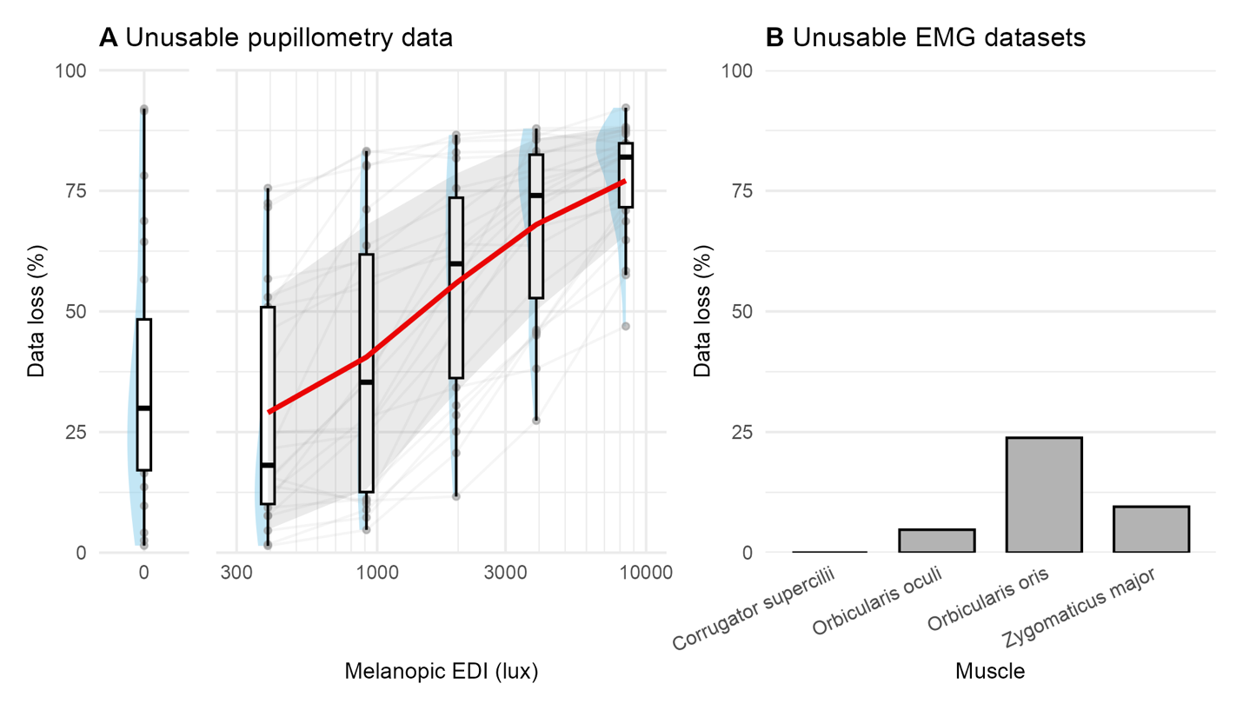
Figure 3. Data loss for pupillometry and EMG modalities, N=18. (A) For pupillometry, data loss is expressed as the proportion of pilot data remaining after filtering out data points with an associated confidence value inferior to a threshold of 0.7. Red line shows group averages and the grey ribbon the standard deviation. (B) For EMG, data loss is expressed as the proportion of pilot data sets that needed to be excluded due to an issue during data collection (electrodes detaching from the skin or computer-related error).

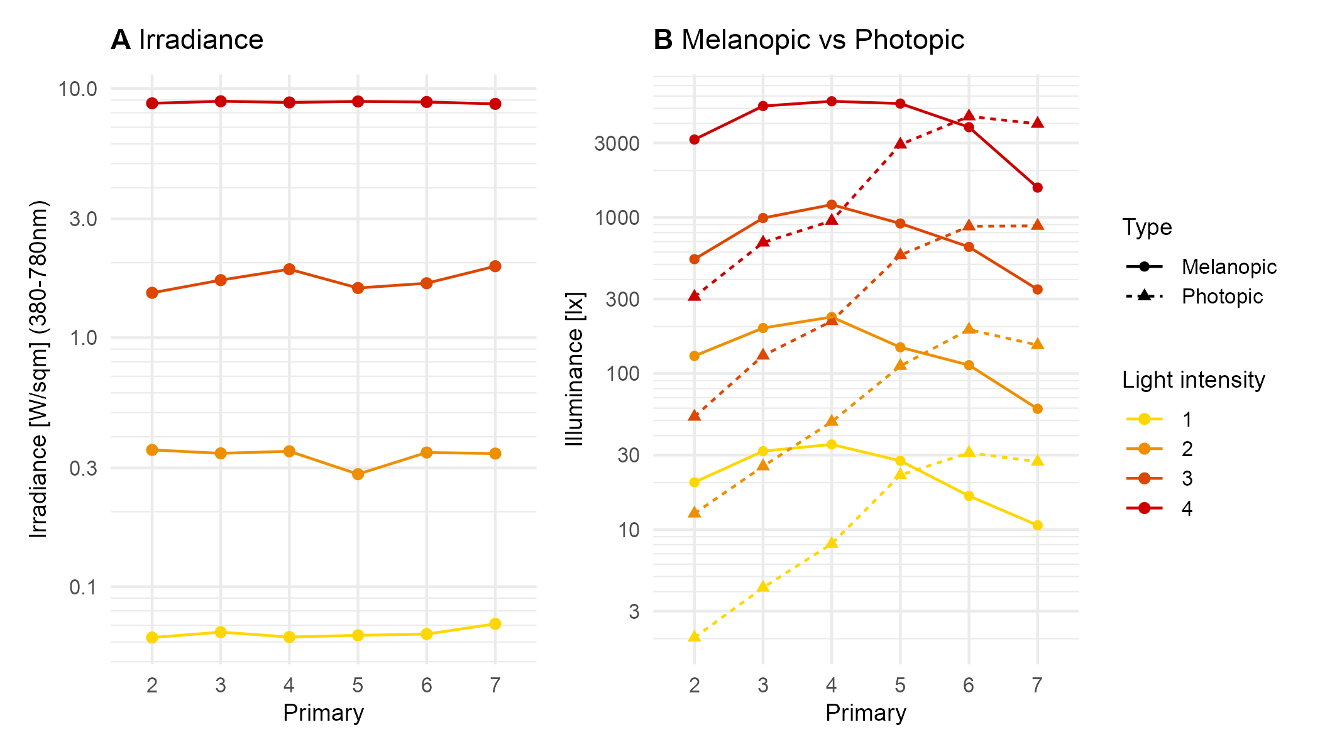
Figure 4. Calibration measurements of the light stimuli, across all possible light intensities that participants will get randomly during each of their laboratory visits. (A) Irradiance stays constant across primaries, and so for each light intensity setting. (B). Primaries with peaks at lower wavelengths show higher melanopic excitation (melanopic EDI, tuned to ipRGCs) than photopic excitation (illuminance, tuned to L+M cones) than primaries at higher wavelengths. As the wavelength increases, the trend reverses – photopic excitation increases and surpasses melanopic excitation.

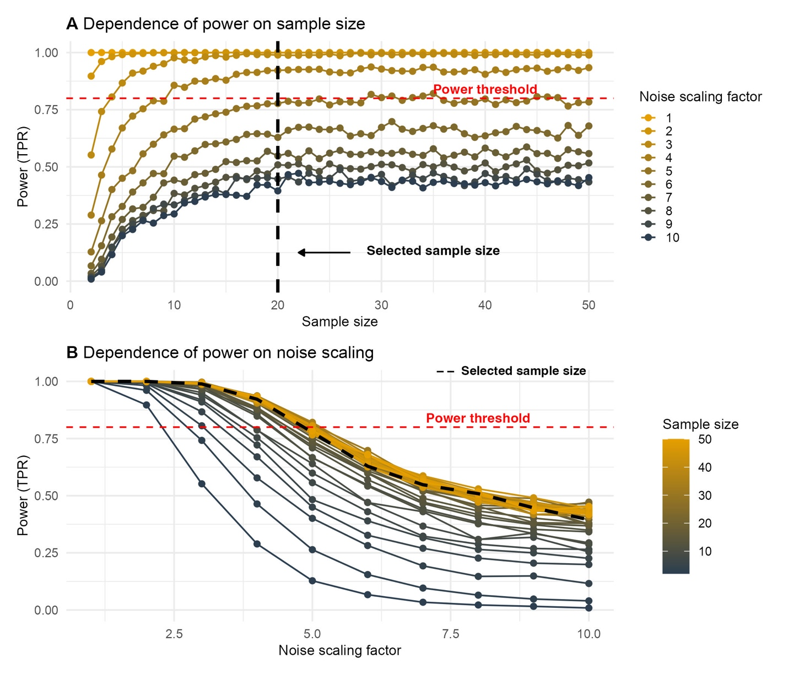
Figure 5. (A) Relationship between sample size and resulting power, using BFDA on data simulated using pilot data. The dashed red line indicates the minimum required power value of 0.8, and the dashed black line indicates the selected sample size of N=20. (B) Relationship between residual noise scaling factor and resulting power, using BFDA on simulated data. The dashed red line indicates the minimum required power value of 0.8, and the dashed black line indicates the selected sample size of N=20.

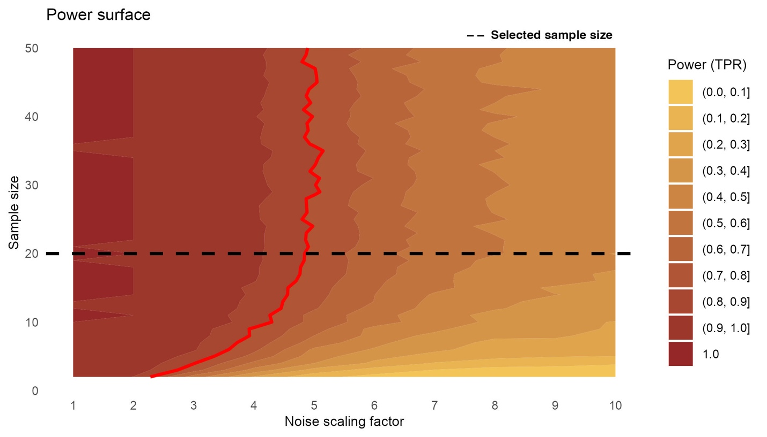
Figure 6. Power surface across the design grid. The contour map indicates power levels (10 equally spaced contour levels) for noise scaling factors ranging from 1 to 10 and sample sizes from 2 to 50. The dashed red line indicates the minimum required power value of 0.8, and the dashed black line indicates the selected sample size of n=20.

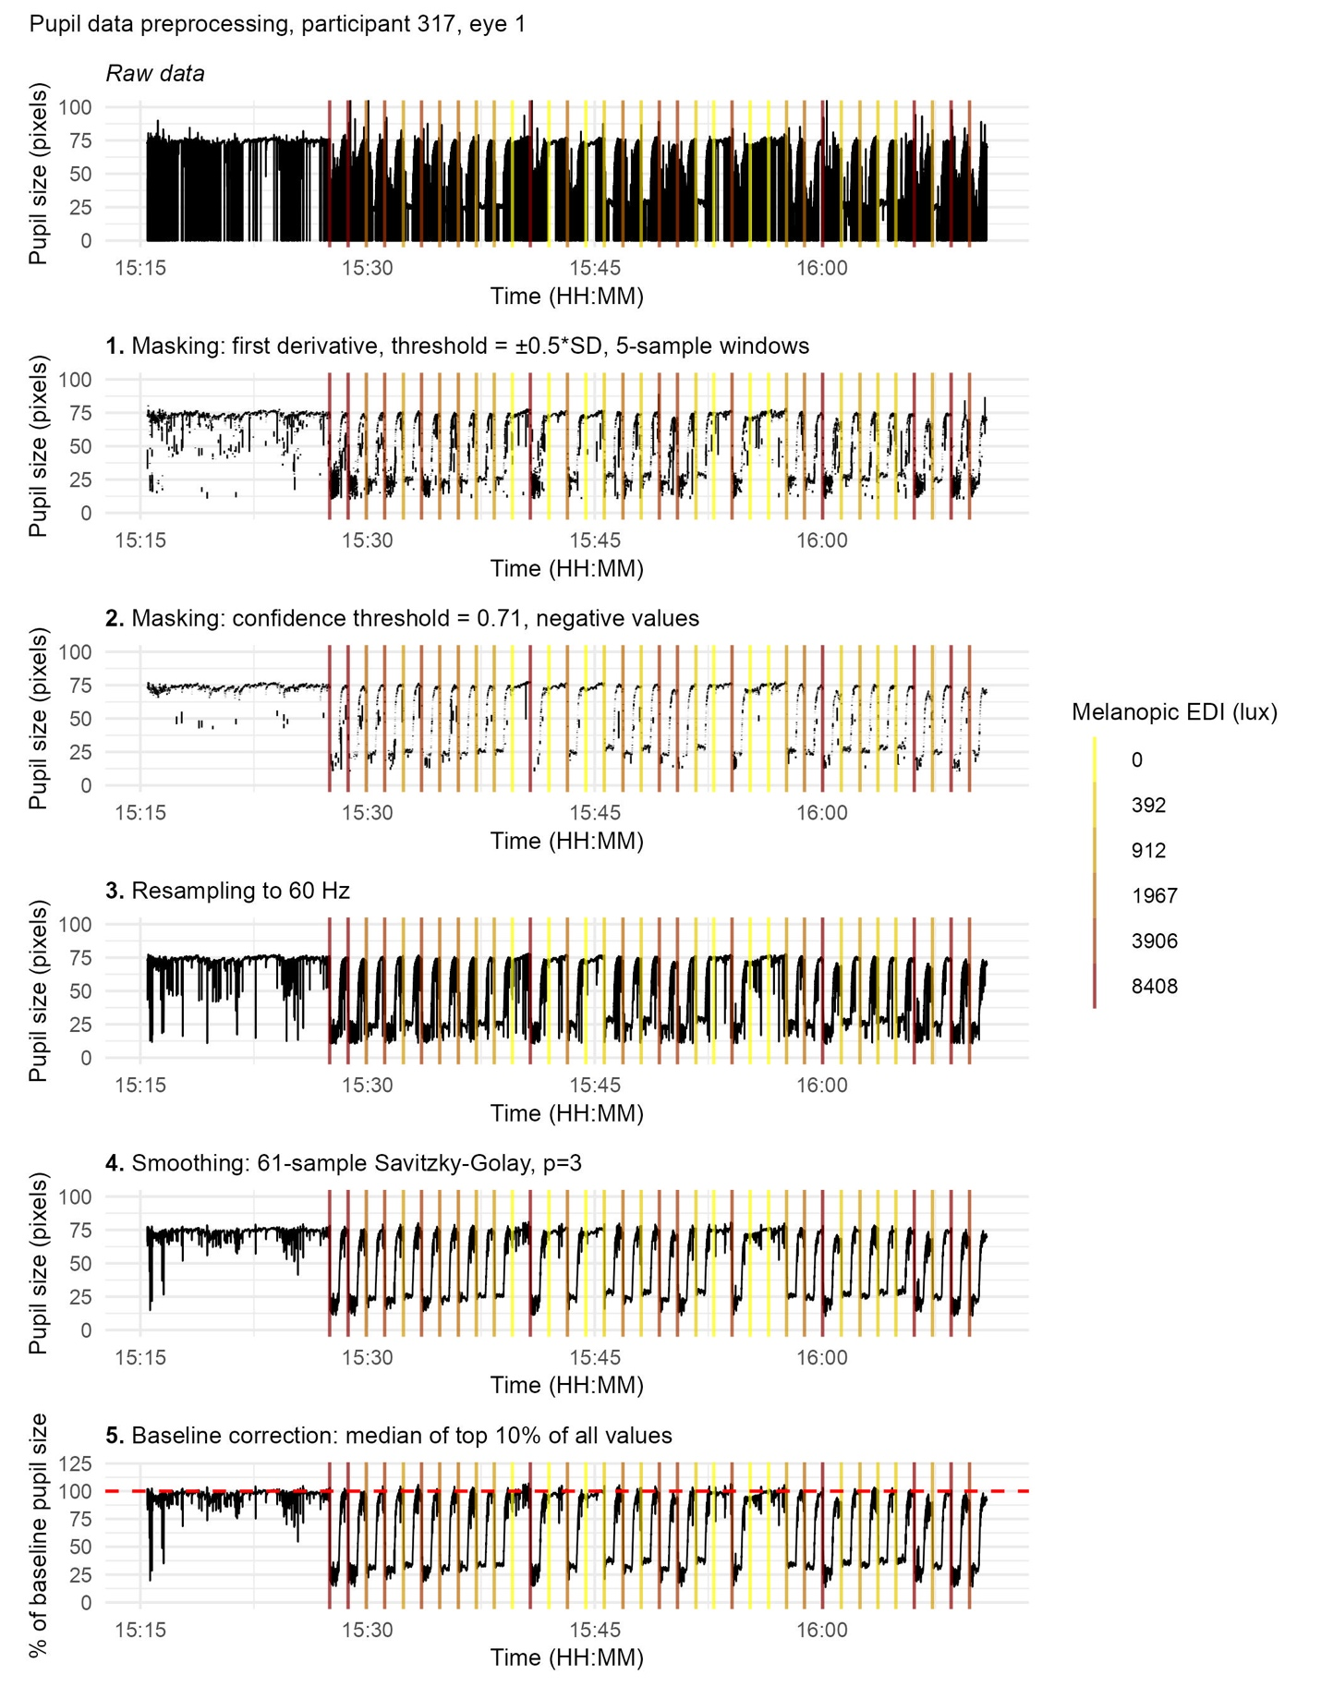
Figure 7. Pupillometry data preprocessing pipeline, for an example data set from the pilot data. Panels show (from top to bottom): raw pupillary signal; masking based on the first derivative with a threshold of ±0.5*SD to the local mean for 5-sample windows; resampling to 60 Hz; masking based on confidence threshold, defined programmatically as the 60% quantile of all confidence values in the dataset, with a set maximum at 0.71, and masking based on physiologically impossible values, i.e. negative values, resampling to 60 Hz, smoothing using a third-order polynomial Savitzky-Golay filter with 61-sample windows; and baseline-corrected pupil size expressed as a percentage of baseline, corresponding to the median of the top 10% values of the whole recording used for normalisation. Vertical lines indicate light onset times, colour-coded by melanopic equivalent daylight illuminance (EDI). All panels share a common time axis.

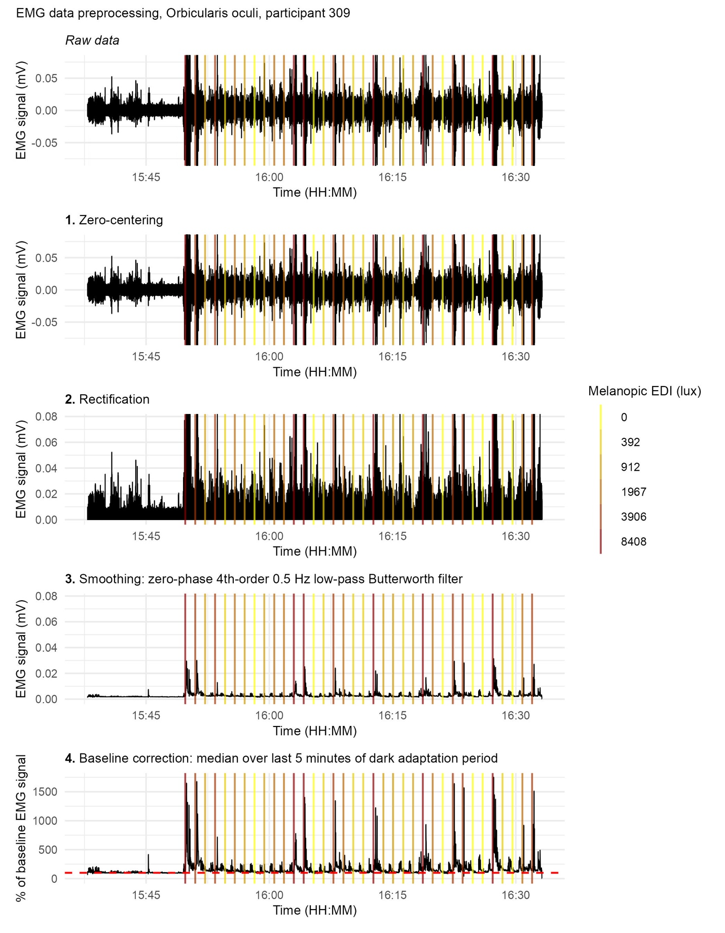
Figure 8. sEMG data signal preprocessing pipeline, for an example data set from the pilot data. Panels show (from top to bottom): raw EMG signal; zero-centred signal; rectified signal; smoothed signal obtained via zero-phase forward–backward fourth-order Butterworth low-pass filtering at 0.5 Hz; and baseline-corrected EMG expressed as a percentage of baseline, corresponding to the final five minutes of the dark adaptation period used for normalisation. Vertical lines indicate light onset times, colour-coded by melanopic equivalent daylight illuminance (EDI). All panels share a common time axis, and y-axis limits are constrained to the upper 99.99th quantile of the data to improve visualisation (removing frequent extreme outliers) while preserving relative signal dynamics.

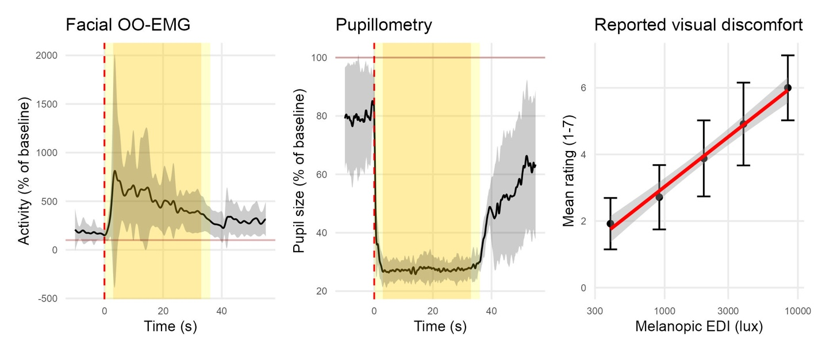
Figure 9. Pilot data, showing group averages, N=18. Panels show (from left to right): trace obtained for orbicularis oculi sEMG activity from 10 seconds before light onset to 30 seconds after light offset; typical trace obtained for pupil size from 10 seconds before light onset to 30 seconds after light offset, and self-reported visual discomfort ratings as a function of light intensity (melanopic EDI).

Table 6. Study design template
Question | Hypothesis | Sampling plan | Analysis plan | Rationale for deciding the sensitivity of the test for confirming or disconfirming the hypothesis | Interpretation given different outcomes | Theory that could be shown wrong by the outcomes
What photoreceptor mechanisms underlie subjective and objective physiological responses to bright light in humans? | We predict that the spectral sensitivity of physiological responses (pupillometry outcomes, EMG outcomes, subjective reporting outcomes) to bright light is better fit by melanopsin than by L+M opsins (photopic) | 20 participants will be recruited, allowing for power >0.8 (determined using BFDA on pilot data). | Bayesian Model Comparison, Linear Mixed Models  Fixed effects: Melanopic EDI for full model, Photopic illuminance for null model  Random effects: intercepts and slopes for participant ID (categorical with levels corresponding to participant number) | Inconclusive evidence: 1<BF<3 = anecdotal  evidence  3<BF<10 = moderate evidence  Conclusive evidence:  10<BF<30 = strong evidence  BF>30 = very strong evidence | Conclusive evidence would mean the physiological responses measured as a response to bright light are mainly melanopsin-driven. | There is a growing body of evidence suggesting that melanopsin is the main driver of many visual functions, including visual discomfort. Our study will contribute to further characterise the biological system at play and may suggest that melanopsin is only partially, or not all, involved in visual discomfort responses in humans.

