LightLogR: Reproducible analysis of personal light exposure data

07 October 2024

# Summary

Light plays an important role in human health and well-being, which necessitates the study of the effects of personal light exposure in real-world settings, measured by means of wearable devices. A growing number of studies incorporate these kinds of data to assess associations between light and health outcomes. Yet with few or missing standards, guidelines, and frameworks, setting up measurements, analysing the data, and comparing outcomes between studies is challenging, especially considering the significantly more complex time series data from wearable light loggers compared to controlled stimuli used in laboratory studies. In this paper, we introduce LightLogR, a novel resource to facilitate these research efforts in the form of an open-source, GPL-3.0-licenced software package for the statistical software R. As part of a developing software ecosystem, LightLogR is built with common challenges of current and future datasets in mind. The package standardizes many tasks for importing and processing personal light exposure data, provides quick as well as detailed insights into the datasets through summary and visualization tools, and incorporates major metrics commonly used in the field (61 metrics across 17 metric families), while embracing an inherently hierarchical, participant-based data structure.

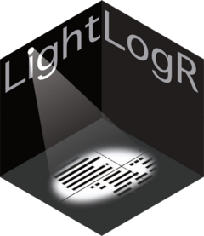

LightLogR logo

# Statement of need

Personalized luminous exposure data is progressively gaining importance across various domains, including research, occupational affairs, and lifestyle tracking. Data are collected through a proliferating selection of wearable light loggers and dosimeters, varying in size, shape, functionality, and output format (Hartmeyer, Webler, and Andersen 2023). Despite or potentially because of numerous use cases, the field still lacks a unified framework for collecting, validating, and analyzing the accumulated data (Hartmeyer, Webler, and Andersen 2023; Spitschan et al. 2022). This issue increases the time and expertise necessary to handle such data and also compromises the FAIRness (findability, accessibility, interoperability, reusability) (Wilkinson et al. 2016) of the results, especially for meta-analyses (Vries et al. 2024).

LightLogR () was designed to be used by researchers who deal with personal light exposure data collected from wearable devices. These data are of interest for various disciplines, including chronobiology, sleep research, vision science and epidemiology, as well as for post-occupancy evaluations in architecture and lighting design. The package is intended to streamline the process of importing, processing, and analysing these data in a reproducible and transparent manner. The package is available on GitHub (Zauner, Hartmeyer, and Spitschan (2023b)) and CRAN (Zauner, Hartmeyer, and Spitschan (2024a)), has a dedicated website for documentation and tutorials (Zauner, Hartmeyer, and Spitschan (2023a)), and releases are archived on Zenodo (Zauner, Hartmeyer, and Spitschan (2024b)).

LightLogR’s key features include:

* a growing list of supported devices with pre-defined import functions tailored to their data structure (17 at the time of writing, see ),
* preprocessing functions to combine different time series, aggregate and filter data, and find and deal with implicitly missing data,
* visualization functions to quickly explore the data. These function are based on the popular ggplot2 (Wickham 2016) plotting package and are designed to be easily customizable to construct publication-ready figures (see, ),
* a large and growing set of metrics that cover most if not all major approaches found in the literature (at the time of writing 61 metrics across 17 metric families, see )), accessible via a consistent function interface.

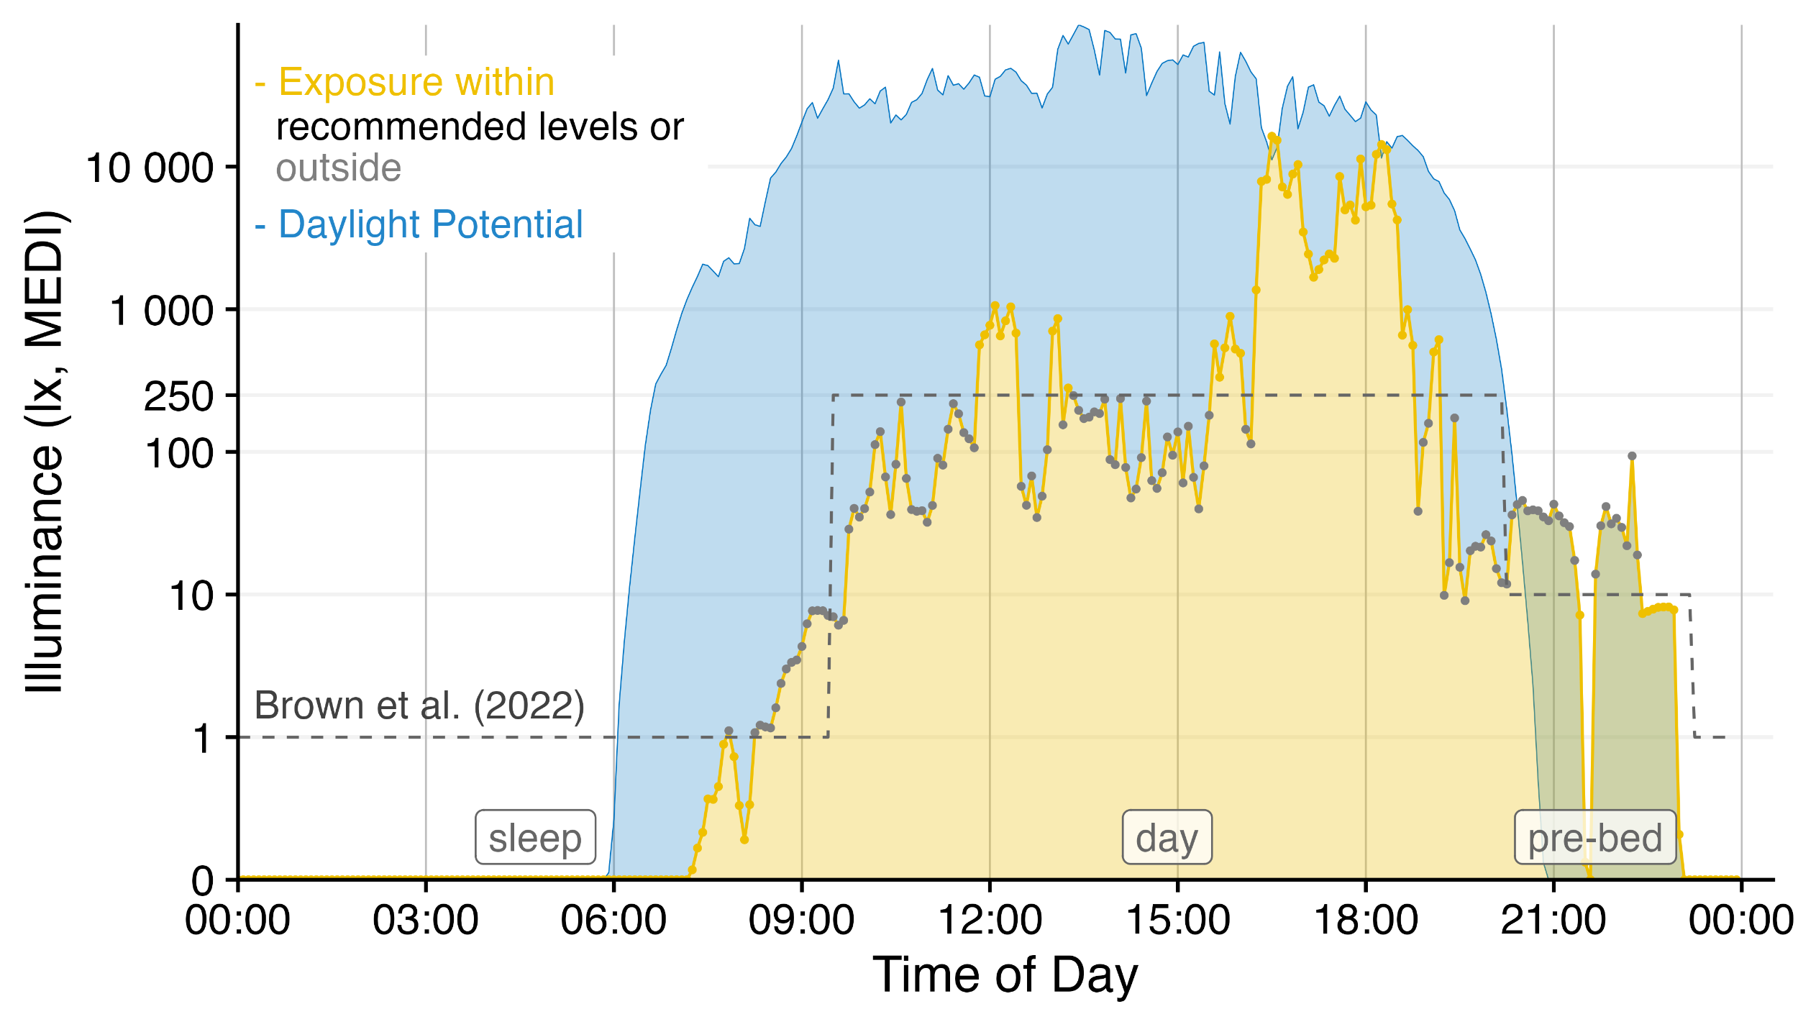

Light logger data can powerfully convey insights into personal light exposure and health-related outcomes. LightLogR facilitates the import and combination of different data sources into a coherent data structure, as seen here by combining environmental daylight availability and personal light exposure with data from a sleep diary. The visualization functions in the package further allow customization to produce publication-ready figures. This figure was created with the ‘gg_day()’ function. The creation process is part of a tutorial (Zauner, Hartmeyer, and Spitschan 2023c) on several key functions in the package.

| Device Name | Manufacturer |
| --- | --- |
| Actiwatch Spectrum | Philips Respironics |
| ActLumus | Condor Instruments |
| ActTrust | Condor Instruments |
| DeLux | Intelligent Automation Inc. |
| GENEActiv[1] | Activeinsights |
| Kronowise | Kronohealth |
| Lido | Lucerne University of Applied Sciences and Arts |
| LightWatcher | Object-Tracker |
| LIMO | École nationale des travaux publics de l’État (ENTPE) |
| LYS Button | LYS Technologies |
| Motion Watch 8 | CamNtech |
| melanopiQ Circadian Eye | Max Planck Institute for Biological Cybernetics |
| XL-500 BLE | NanoLambda |
| OcuWEAR | Ocutune |
| Speccy | Monash University Malaysia |
| SpectraWear | University of Manchester |
| VEET | Meta Reality Labs |

Devices supported for import in version 0.4.1

| Metric Family | Submetrics | Note | Documentation |
| --- | --- | --- | --- |
| Barroso | 7 |  | barroso_lighting_metrics() |
| Bright-dark period | 4x2 | bright / dark | bright_dark_period() |
| Centroid of light exposure | 1 |  | centroidLE() |
| Disparity index | 1 |  | disparity_index() |
| Duration above threshold | 3 | above, below, within | duration_above_threshold() |
| Exponential moving average (EMA) | 1 |  | exponential_moving_average() |
| Frequency crossing threshold | 1 |  | frequency_crossing_threshold() |
| Intradaily Variance (IV) | 1 |  | intradaily_variability() |
| Interdaily Stability (IS) | 1 |  | interdaily_stability() |
| Midpoint CE (Cumulative Exposure) | 1 |  | midpointCE() |
| nvRC (non-visual circadian response) | 4 |  | nvRC(), nvRC_circadianDisturbance(), nvRC_circadianBias(), nvRC_relativeAmplitudeError() |
| nvRD (non-visual direct response) | 2 |  | nvRD(), nvRD_cumulative_response() |
| Period above threshold | 3 | above, below, within | period_above_threshold() |
| Pulses above threshold | 7x3 | above, below, within | pulses_above_threshold() |
| Threshold for duration | 2 | above, below | threshold_for_duration() |
| Timing above threshold (TAT) | 3 | above, below, within | timing_above_threshold() |
| **Total:** |  |  |  |
| **17 families** | **61 metrics** |  |  |

: metrics available in version 0.4.1

LightLogR is already being used in several research projects across scientific domains, including:

* an ongoing cohort study to collect light exposure data across different geolocations (Guidolin et al. 2024),
* an ongoing cohort study to collect year-long datasets of various types of environmental and behavioral data (Biller et al. 2024),
* a novel power analysis method for personal light exposure data (Zauner, Udovicic, and Spitschan 2023),
* an intervention study on the effects of light on bipolar disorder (Roguski et al. 2024),
* an intervention study on exposure to bright light during afternoon to early evening on later evening melatonin release in adolescents (Lazar et al. 2024),
* an observational study on the wearing compliance of personal light exposure (Stefani et al. 2024),
* an observational study on the differences in light exposure and light exposure related behavior between Malaysia and Switzerland (preregistration in progress),
* an intervention study on sex and seasonal changes in human melatonin suppression and alerting response to moderate light (publication in progress),
* an observational study on light exposure, sleep, and circadian rhythms in hospital shift workers (publication in progress).

# Funding Statement

The development of LightLogR is funded by MeLiDos, a joint, EURAMET-funded project involving sixteen partners across Europe, aimed at developing a metrology and a standard workflow for wearable light logger data and optical radiation dosimeters (Spitschan et al. 2024). Its primary contributions towards fostering FAIR data include the development of a common file format, robust metadata descriptors, and an accompanying open-source software ecosystem.

The project (22NRM05 MeLiDos) has received funding from the European Partnership on Metrology, co-financed from the European Union’s Horizon Europe Research and Innovation Programme and by the Participating States. Views and opinions expressed are however those of the author(s) only and do not necessarily reflect those of the European Union or EURAMET. Neither the European Union nor the granting authority can be held responsible for them.

# Acknowledgements

We thank Carolina Guidolin (Max Planck Institute for Biological Cybernetics) and Dr. Anna Magdalena Biller (Technical University of Munich) for testing the software during development and providing feature ideas, and the entire Translational Sensory & Circadian Neuroscience Unit (MPS/TUM/TUMCREATE) for its support.

# References

Biller, Anna M., Nayab Fatima, Chrysanth Hamberger, Laura Hainke, Verena Plankl, Amna Nadeem, Achim Kramer, Martin Hecht, and Manuel Spitschan. 2024. “The Ecology of Human Sleep (EcoSleep) Cohort Study: Protocol for a Longitudinal Repeated Measurement Burst Design Study to Assess the Relationship Between Sleep Determinants and Outcomes Under Real-World Conditions Across Time of Year.” *Journal of Sleep Research*, e14225. <https://doi.org/10.1111/jsr.14225>.

Guidolin, Carolina, Sam Aerts, Gabriel Kwaku Agbeshie, Kwadwo Owusu Akuffo, Sema Nur Aydin, David Baeza Moyano, John Bolte, et al. 2024. “Protocol for a Prospective, Multicentre, Cross-Sectional Cohort Study to Assess Personal Light Exposure [Preprint].” *medRxiv*. <https://doi.org/10.1101/2024.02.11.24302663>.

Hartmeyer, S. L., F. S. Webler, and M. Andersen. 2023. “Towards a Framework for Light-Dosimetry Studies: Methodological Considerations.” *Lighting Research & Technology* 55 (4-5): 377–99. <https://doi.org/10.1177/14771535221103258>.

Lazar, Rafael, Fatemeh Fazlali, Marine Dourte, Christian Epple, Oliver Stefani, Manuel Spitschan, and Christian Cajochen. 2024. “Afternoon to Early Evening Bright Light Exposure Reduces Later Melatonin Production in Adolescents [Preprint].” *bioRxiv*. <https://doi.org/10.1101/2024.10.02.616112>.

Migueles, Jairo H., Alex V. Rowlands, Florian Huber, Severine Sabia, and Vincent T. van Hees. 2019. “GGIR: A Research Community-Driven Open Source R Package for Generating Physical Activity and Sleep Outcomes from Multi-Day Raw Accelerometer Data.” *Journal for the Measurement of Physical Behavior* 2 (3). <https://doi.org/10.1123/jmpb.2018-0063>.

Roguski, A, N Needham, T MacGillivray, J Martinovic, B Dhillon, RL Riha, L Armstrong, et al. 2024. “Investigating Light Sensitivity in Bipolar Disorder (HELIOS-BD).” *Wellcome Open Research* 9 (February): 64. <https://doi.org/10.12688/wellcomeopenres.20557.1>.

Spitschan, Manuel, Karin Smolders, Benjamin Vandendriessche, Brinnae Bent, Jessie P Bakker, Isaac R Rodriguez-Chavez, and Céline Vetter. 2022. “Verification, Analytical Validation and Clinical Validation (V3) of Wearable Dosimeters and Light Loggers.” *Digital Health* 8: 20552076221144858. <https://doi.org/10.1177/20552076221144858>.

Spitschan, Manuel, Johannes Zauner, Maria Nilsson Tengelin, Constantinos A. Bouroussis, Patrik Caspar, and Fabien Eloi. 2024. “Illuminating the Future of Wearable Light Metrology: Overview of the MeLiDos Project.” *Measurement* 235: 114909. <https://doi.org/10.1016/j.measurement.2024.114909>.

Stefani, Oliver, Reto Marek, Jürg Schwarz, Sina Plate, Johannes Zauner, and Björn Schrader. 2024. “Wearable Light Loggers in Field Conditions: Corneal Light Characteristics, User Compliance and Acceptance [Preprint].” *Preprints*. <https://doi.org/10.20944/preprints202409.1285.v1>.

Vries, SW de, M Gkaintatzi-Masouti, J van Duijnhoven, J Mardaljevic, and MPJ Aarts. 2024. “Recommendations for Light-Dosimetry Field Studies Based on a Meta-Analysis of Personal Light Levels of Office Workers.” *Lighting Research & Technology* 55 (May): 14771535241248540. <https://doi.org/10.1177/14771535241248540>.

Wickham, Hadley. 2016. *Ggplot2: Elegant Graphics for Data Analysis*. Springer-Verlag New York. <https://ggplot2.tidyverse.org>.

Wilkinson, Mark D., Michel Dumontier, IJsbrand Jan Aalbersberg, Gabrielle Appleton, Myles Axton, Arie Baak, Niklas Blomberg, et al. 2016. “The FAIR Guiding Principles for Scientific Data Management and Stewardship.” *Scientific Data* 3: 160018. <https://doi.org/10.1038/sdata.2016.18>.

Zauner, Johannes, Steffen L. Hartmeyer, and Manuel Spitschan. 2023a. “LightLogR: Process Data from Wearable Light Loggers and Optical Radiation Dosimeters. Documentation and Tutorials.” <https://tscnlab.github.io/LightLogR/index.html>.

———. 2023b. “LightLogR: Process Data from Wearable Light Loggers and Optical Radiation Dosimeters. Github Repository.” <https://github.com/tscnlab/LightLogR>.

———. 2023c. “LightLogR: Tutorial: The Whole Game.” <https://tscnlab.github.io/LightLogR/articles/Day.html>.

———. 2024a. “LightLogR: Process Data from Wearable Light Loggers and Optical Radiation Dosimeters. CRAN Package.” <https://doi.org/10.32614/CRAN.package.LightLogR>.

———. 2024b. “Tscnlab/LightLogR: V0.4.1. Archive.” Zenodo. <https://doi.org/10.5281/zenodo.13839724>.

Zauner, Johannes, Ljiljana Udovicic, and Manuel Spitschan. 2023. “Power Analysis for Personal Light Exposure Measurements and Interventions [Preprint].” *Research Square*. <https://doi.org/10.21203/rs.3.rs-3771881/v1>.

1. Available after processing of the data using GGIR (Migueles et al. 2019).