SECTION | UNSATISFACTORY  Grade: 3.7 – 4.0 | DEVELOPING  Grade 2.7 – 3.0 – 3.3 | GOOD  Grade 1.7 – 2.0 – 2.3 | EXCELLENT  Grade: 1.0 – 1.3 | Grade
Introduction/  Background: | - No summary of background and course content  - No vocabulary  - No definition of key terms  - No purpose of the report given | - Brief summary of background and course content  - Vocabulary not defined or complete  - Definition of key terms is brief or incorrect  - Purpose of report is brief/unclear/incorrect | - Good summary of background and course content  - Vocabulary defined within text  - Good definition of key terms  - Purpose of report is stated | - Excellent summary of background and course content  - Vocabulary integrated throughout text  - Excellent definition of key terms  - Purposes of report is clearly, concisely, and completely stated
Deep Dive Topic | - No organization, no clear presentation  - No relevant content  - No content beyond of what the presenter covered (i.e. only a summary of the speaker’s content)  - No charts/tables/drawings  - No descriptions | - Poorly organized and missing clarity  - Content slightly relevant  - No content beyond of what the presented covered (i.e. only a summary of the speaker’s content)  - Incomplete descriptions of display items  - Graphs present but missing key pieces of information | - Organized and clear presentation  - Relevant content well presented  - Content only slightly beyond of what the presenter covered  - Clear descriptions of display items  - Graphs are titled, labeled, properly scaled, and data appropriate (if applicable) | - Well organized and concisely presented  - Relevant content very well presented  - Content beyond of what the presenter covered  - Thoughtful and complete descriptions of display items (if applicable)  - Graphs are titled, labeled, properly scaled, and data appropriate (if applicable)
Discussion and Conclusion | - No summary  - No conclusions  - No outlook/future research | - Insufficient summary  - Conclusions are drawn but not supported by content  - Outlook/future research is stated but not adequate | - Good summary  - Conclusions are drawn and mostly supported  - Outlook/future research is stated but too general | - Excellent summary  - Conclusions are drawn and well supported  - Sensible and precise outlook/future research
Referencing | - No references in-text or list at the end | - Inconsistent format in-text/in list  - Limited resources | - A few mistakes in format in-text/in list following the agreed reference style  - Several diverse sources listed | - Perfect format in-text/in list following the agreed reference style  - Several diverse sources listed
Mechanics/  Style/  Language/  Originality | - No cover page or all necessary information missing  - Messy, rushed job, illegible  - Sections are not separated  - Grammar needs editing  - Nothing cited  - No terminology and no scientific language  - Language impossible to understand  - Abbreviations not explained and used excessively  - No originality  - Lots of supervision required | - Cover page is missing several of the following: name, TUM ID, word count and a clear title  - Includes handwritten sections  - Sections not labeled  - Many typos, grammar mistakes  - Few references  - Wrong use of terminology and no scientific language  - Language not clear  - Abbreviations not explained and used too often  - Only little originality  - Lots of supervision required | - Cover page does not include one of the following: name, TUM ID, word count and a clear title  - Presented neatly  - Labeled sections  - A few typos, grammar mistakes  - Mostly cited  - Mostly correct use of terminology and scientific language  - Mostly clear language  - Abbreviations mostly explained but sometimes used too often  - Original and creative content  - Mostly autonomously conducted, little help required | - Cover page includes name, TUM ID, word count and a clear title  - Presented perfectly  - Sections carefully laid out  - No typos, grammar mistakes  - Correct use of terminology and scientific language  - Clear and concise language  - Abbreviations explained and only carefully used where necessary  - Very original and creative content  - Very autonomously conducted
Interim grade
Extra points
Final grade

Strengths:

Suggestions for improvement:
- Layout and Design:
- Language:
- Content:
- Supervision:

Student Name and ID:
Report Title:

Place and Date: München, 14/08/2023
1st Examiner: | Dr. Anna Biller | 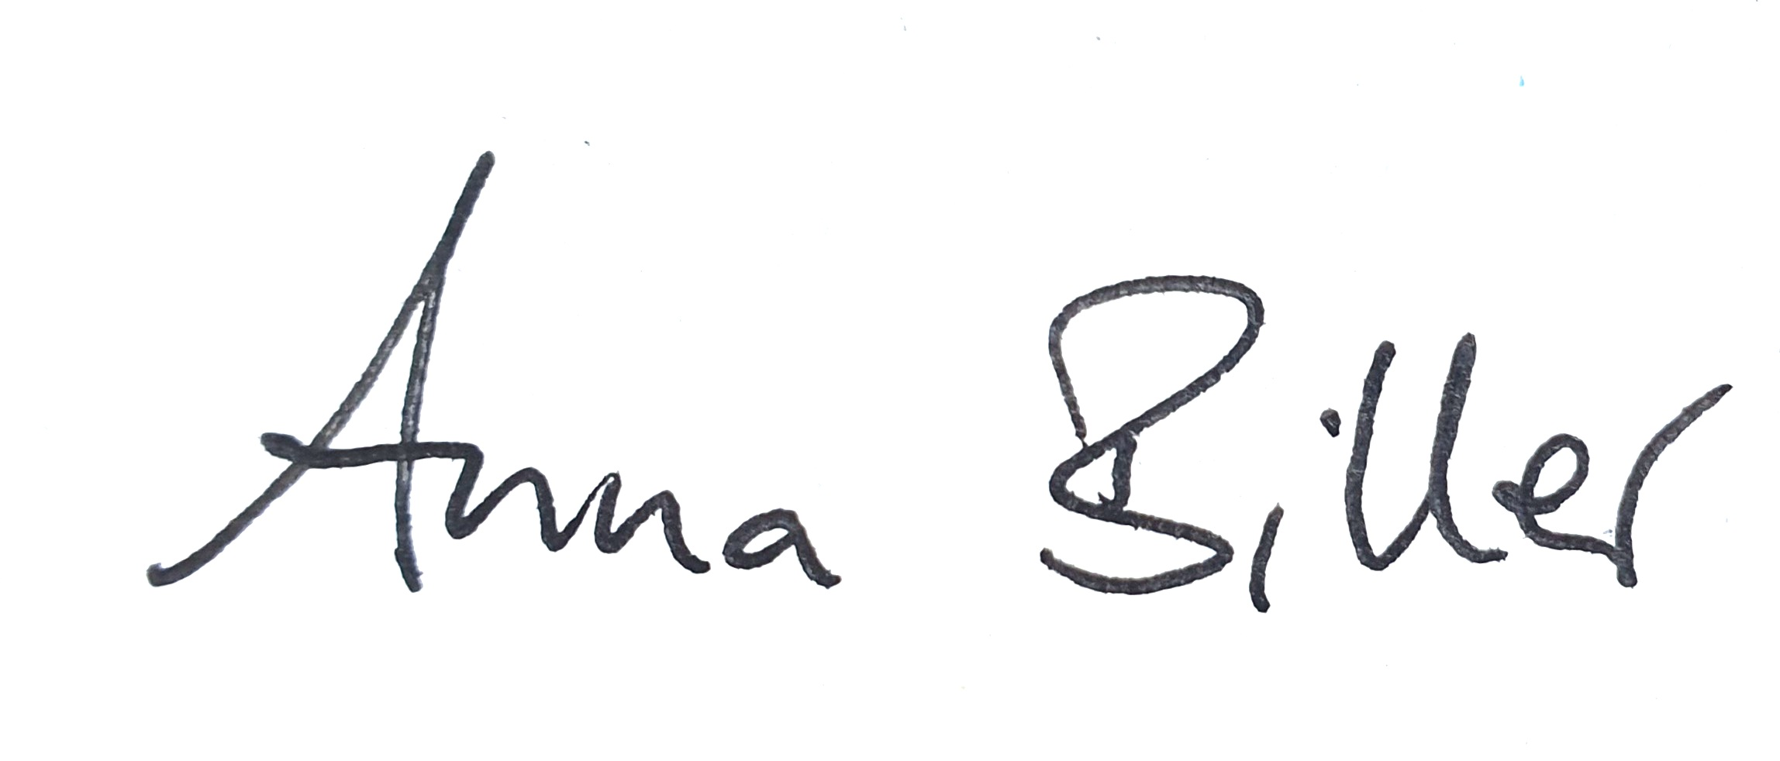
2nd Examiner: | André Andonian

