Environmental and behavioural determinants of the personal light exposome
Johannes Zauner^{1,✉}, Altug Didikoglu^{2,3}, Sam Aerts⁴, Gabriel Kwaku Agbeshie⁵, Kwadwo Owusu Akuffo⁵, Sena Gulsum Akgun³, Sema Nur Aydin³, David Baeza Moyano⁶, Daan Boesten⁴, John F.B. Bolte^{4,7}, Kai Broszio⁸, Guadalupe Cantarero García⁶, Roberto Alonso González Lezcano⁶, Carolina Guidolin⁹, Sarina Hilden¹, Nico Hogervorst⁴, Astrid Jansen⁴, Zeynep Kayar³, Stefan Källberg¹⁰, Suyoun Lee¹, Sofía Melero Tur⁶, Maria Nilsson Tengelin¹⁰, María Concepción Pérez Gutiérrez⁶, Andrea Sancho-Salas¹¹, Oliver Stefani¹², Ingemar Svensson¹⁰, Helga von-Breymann¹¹, and Manuel Spitschan^{1,9,13,14}
2026-06-16
¹ Department Health and Sports Sciences, TUM School of Medicine and Health, Chronobiology & Health, Technical University of Munich, Munich, Germany
² Division of Diabetes, Endocrinology, and Gastroenterology, School of Medical Sciences, Faculty of Biology, Medicine and Health, The University of Manchester, Manchester, UK
³ Faculty of Science, Department of Neuroscience, Izmir Institute of Technology, Izmir, Turkey
⁴ Smart Sensor Systems research group, The Hague University of Applied Sciences, Delft, The Netherlands
⁵ Department of Optometry and Visual Science, College of Science, Kwame Nkrumah University of Science and Technology, Kumasi, Ghana
⁶ Fundación Universitaria CEU San Pablo, Boadilla del Monte, Madrid, Spain
⁷ Centre for Sustainability, Environment and Health of the National Institute for Public Health and the Environment (RIVM), The Netherlands
⁸ Federal Institute for Occupational Safety and Health (BAuA)
⁹ Max Planck Institute for Biological Cybernetics, Max Planck Research Group Translational Sensory & Circadian Neuroscience, Tübingen, Germany
¹⁰ RISE Research Institutes of Sweden
¹¹ School of Architecture, University of Costa Rica, Costa Rica
¹² Lucerne University of Applied Sciences and Arts, Lucerne, CH
¹³ TUM Institute for Advanced Study (TUM-IAS), Technical University of Munich, Garching, Germany
¹⁴ TUMCREATE Ltd., Singapore, Singapore
✉ Correspondence: Johannes Zauner <johannes.zauner@tum.de>

Abstract
Personal light exposure is a modifiable component of the health exposome, but its everyday determinants remain poorly understood. We conducted an observational, harmonised, multi-country wearable study of ocular light exposure in 191 adults across nine sites in Sweden, the Netherlands, Germany, Spain, Turkey, Costa Rica, and Ghana, comprising 1,480 participant-days. Participants wore calibrated light loggers near the corneal plane and at chest level and completed repeated contextual assessments. Average daytime exposure remained below recommended melanopic levels, with adherence varying by site, daily phase and photoperiod. Exposure generally increased with latitude despite greater year-round sunlight at lower latitudes, consistent with behavioural filtering through shade-seeking, indoor living or heat avoidance. Individual and activity-level differences explained more variation than site. Daylight access, outdoor activity and micro-environment were the strongest correlates. These findings support personalized, context-sensitive light interventions and establish ocular light exposure as a measurable exposomic factor relevant to health.

Introduction
Human behaviour and physiology are organised around the 24-hour light-dark cycle^{1–6}. Light reaching the eye provides a primary environmental signal for circadian entrainment, sleep-wake timing, alertness and other non-visual responses, yet the ocular light exposure people receive in daily life remains incompletely characterised^{7,8}. This gap is increasingly important because personal light exposure can be understood as part of the health-relevant exposome: a temporally structured environmental input that is shaped not only by daylight availability, but also by behaviour, architecture, work schedules, social routines, technology use and cultural practices^{9–12}. In this sense, the relevant exposure for human health is not simply the outdoor light environment, but the light that reaches individuals as they move through daily contexts.
Evidence from large observational cohorts has strengthened the case that everyday light exposure is related to health. In UK Biobank, wrist-worn light recordings have linked brighter daytime exposure, darker nighttime exposure and stronger day-night contrast to sleep timing, sleepiness, psychiatric disorders, type 2 diabetes and mortality risk^{13–16}. Smaller field studies and targeted naturalistic protocols further indicate that light exposure varies with season, occupational schedules, ageing, shift work and evening behaviour^{17–25}. Together, these studies suggest that personal light exposure is health-relevant at population scale. However, they do not fully explain why individuals differ in the light they receive, or which features of daily life generate those differences.
This explanatory gap limits translation. Current recommendations for daytime, evening and nighttime light exposure are expressed in physiologically relevant quantities, including melanopic equivalent daylight illuminance (melanopic EDI), which better reflects retinal input to the non-visual system than conventional photopic illuminance alone^{7,26,27}. Yet translating such recommendations into public health guidance, clinical advice, workplace design or urban planning requires evidence about real-world exposure patterns. If exposure depends strongly on activity, location, daylight access and individual routines²⁸, then population-level guidance may need to be complemented by personalised and context-sensitive strategies¹². The key question is therefore not only whether light exposure is biologically important, but how daily life shapes the health-relevant personal light exposome.
Existing field studies have provided important foundations, but remain difficult to synthesise. Many have been conducted at single sites, in specific occupational groups, or in pairwise comparisons between locations^{17,18,20–22,28}. Others rely on wrist-worn sensors or summary measures that approximate, but do not directly capture, the stimulus reaching the eye^{13–16}. Measurement protocols, sensor positions, outcome metrics and reporting standards also vary substantially across studies, and underlying time-series data are rarely available in forms that permit re-analysis^{8,29}. As a result, it remains unclear how much real-world light exposure varies between countries and sites, how much is attributable to individual routines and micro-environments, and which contextual factors most strongly structure ocular exposure.
Here, we address these limitations using a harmonised, multi-country field study from the MeLiDos project^{30,31}. Participants in Sweden, the Netherlands, Germany, Spain, Turkey, Costa Rica, and Ghana, wore calibrated light loggers for one week while completing smartphone-based experience sampling and daily questionnaires. Light was measured near the corneal plane, providing an ocular-level estimate of the stimulus most relevant to non-visual photoreception, and at chest level for comparison. The study combines temporally resolved melanopic light exposure with repeated contextual reports on sleep, mood, alertness, activity, work patterns, location and light-related behaviour. The resulting dataset, published alongside this study³², provides a basis for comparing personal light exposure across diverse everyday environments and geographical contexts.
Rather than testing the effect of light exposure on a single health outcome, this study asks how the health-relevant personal light exposome is structured in daily life. We examine whether ocular light-exposure profiles differ across sites, how much variation is explained by site compared with individual behaviour and micro-environments, and which participant characteristics and daily activities are associated with systematic differences in exposure. By positioning personal light exposure as a measurable behavioural and environmental phenotype, shaped by social routines, physical context and lighting practices, this work complements mechanistic and laboratory studies of the non-visual effects of light. Understanding how the relevant ocular stimulus is distributed in real life is a necessary step towards designing light-health interventions that are biologically informed, behaviourally realistic and sensitive to individual routines and cultural contexts.

Results

A unique dataset capturing exposure to light around the world
Figure 1 summarises the study and collected data. The final dataset comprised 191 participants and 1,480 participant-days. Of these, 1,416 participant-days met the predefined completeness criterion of >80% valid light-exposure data coverage. Near-corneal, or ocular, measurements were available for 811 participant-days, and chest-level measurements for 1,249 participant-days. Chest-level measurements were unavailable in the Tübingen cohort, whereas ocular measurements were available for only 6 of 39 participants in the Costa Rica cohort. Table 1 provides site-level descriptive statistics. Unless otherwise specified glasses-level data and derived metrics are reported. Further, lux refers to melanopic equivalent daylight illuminance, or melanopic EDI, not photopic illuminance.
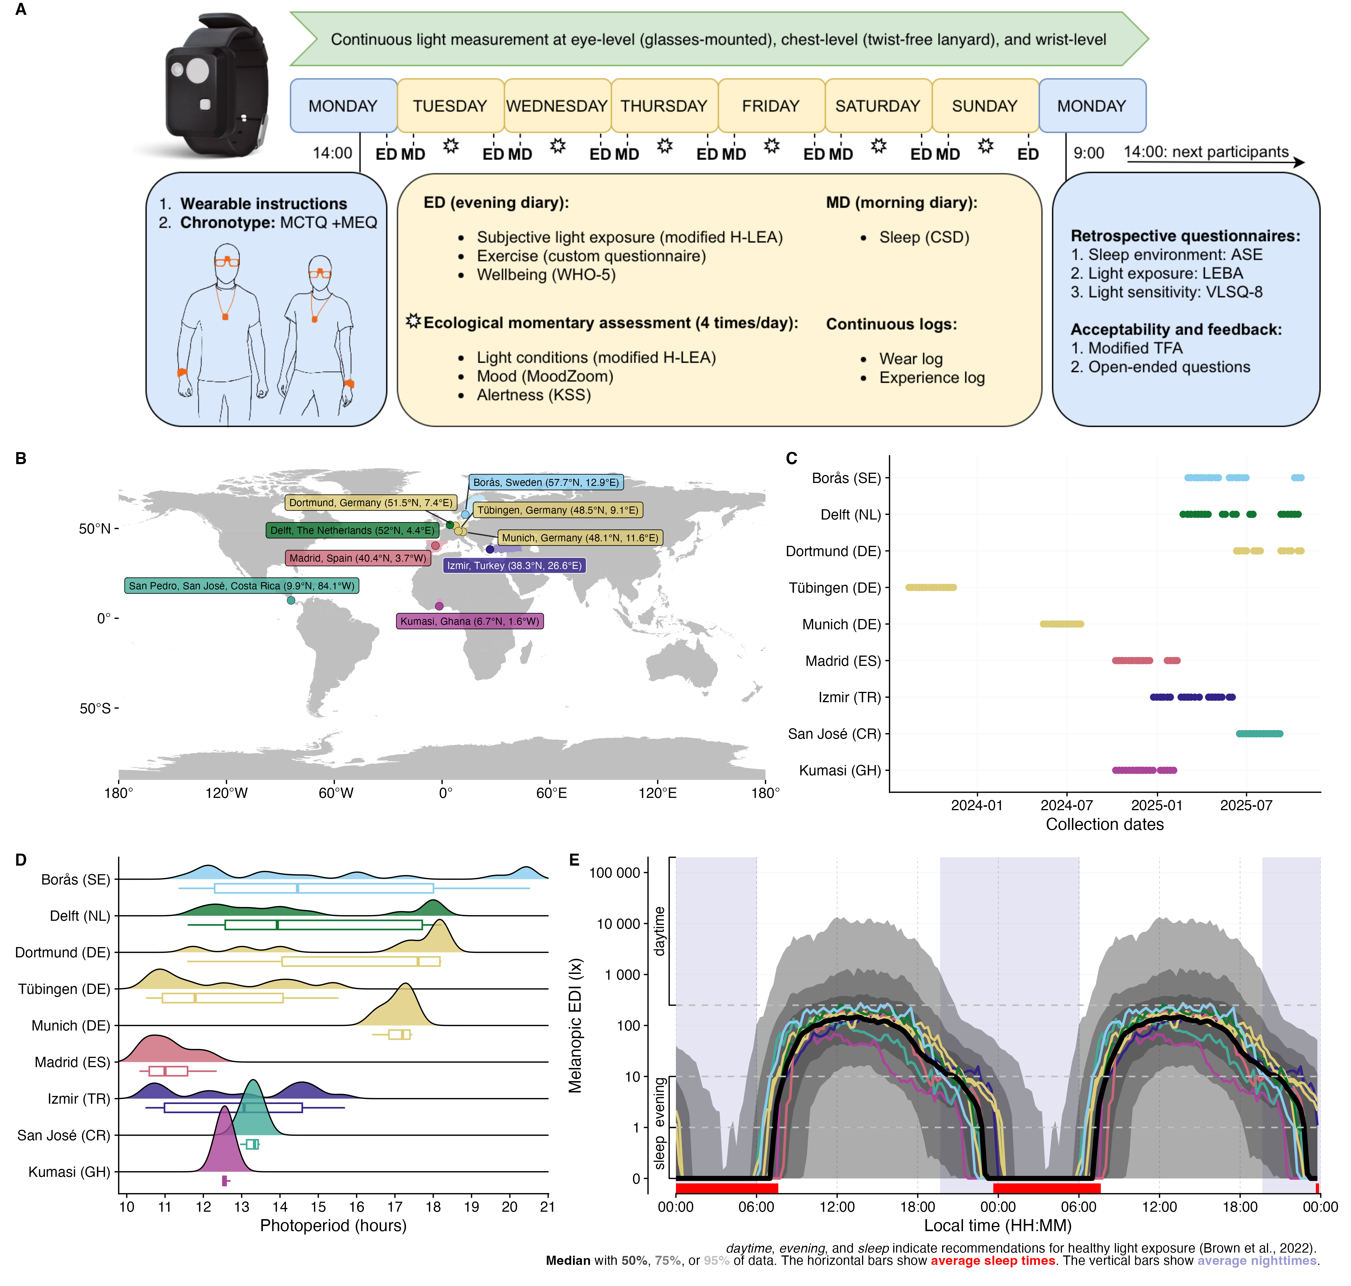
Figure 1: Overview of the study. (A) Study protocol, including used instruments, light logger, and sensor positions. (B) Location of the data collection sites. (C) Timing of the data collection. Sites are arranged in decreasing latitude. (D) Distribution of photoperiod (timespan from dawn until dusk) across sites. (E) Doubleplot of average daily light exposure patterns for each site and overall (black trace)

Table 1: Summary table of site, data collection, and participant-specific information. Sites are arranged from left to right by decreasing latitude.
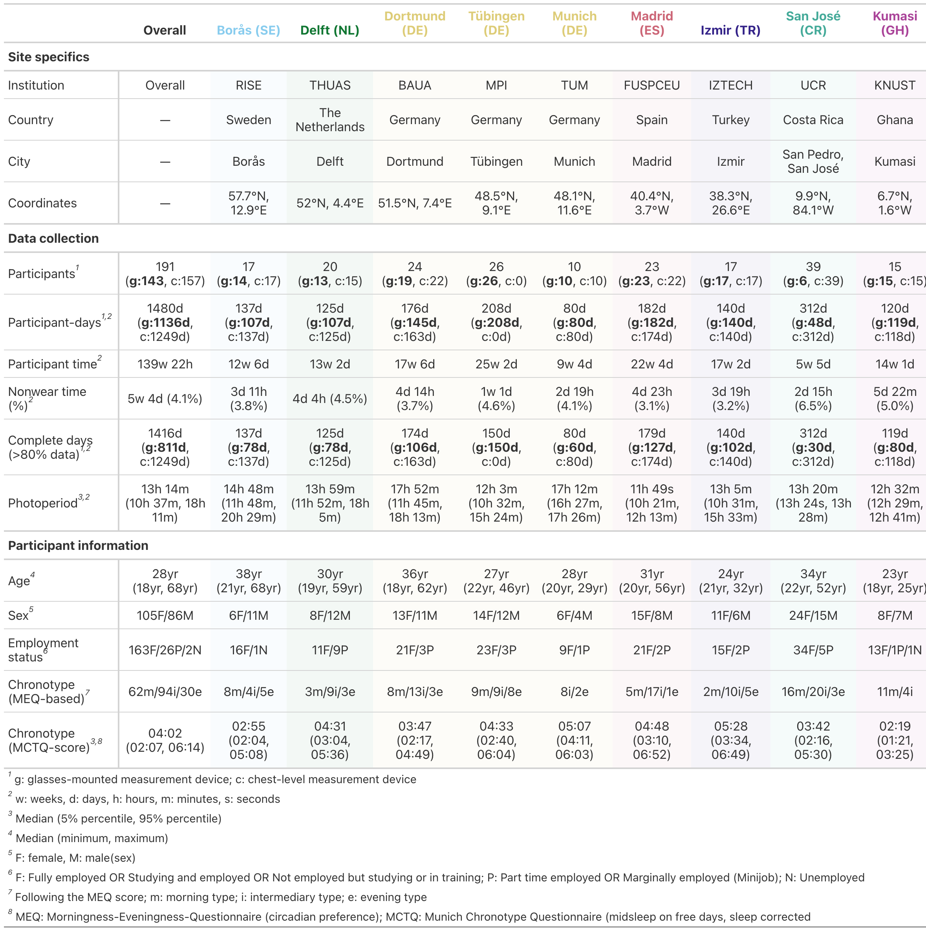

Light exposure metrics capture specific, physiologically based aspects of personal light exposure
Study data were analyzed both as light-exposure time series and as derived metrics. Supplementary Figure S1 illustrates their conceptual relationship for one example metric, and Supplementary Table S1 summarizes the results for all light-exposure metrics.

Daytime recommendations were not reached on average
Participants did not, on average, meet the recommended minimum daytime exposure of 250 lx melanopic EDI during waking hours²⁷, indicating that typical real-world ocular light exposure remained below levels proposed to support circadian synchronisation and daytime alertness (see Table 2).
Across all observations, the 250 lx daytime recommendation was met during 24% of wake time, ranging from 14% in Kumasi (GH) to 33% in Borås (SE). During the three hours before sleep, exposure was below the recommended maximum of 10 lx melanopic EDI in 63% of observations, ranging from 56% in Izmir (TR) to 75% in Kumasi (GH). During sleep, exposure was below the recommended maximum of 1 lx melanopic EDI in 88% of observations, ranging from 72% in Munich (DE) to 95% in Kumasi (GH). Across the full 24-hour day, recommendations were met for 52% of observations, ranging from 45% in Izmir (TR) to 58% in Borås (SE). As shown in Table 2, wake-time adherence broadly decreased with latitude.
Table 2: Summary table of adherence to recommendations for healthy light exposure according to Brown et al. Sites are arranged by latitude.
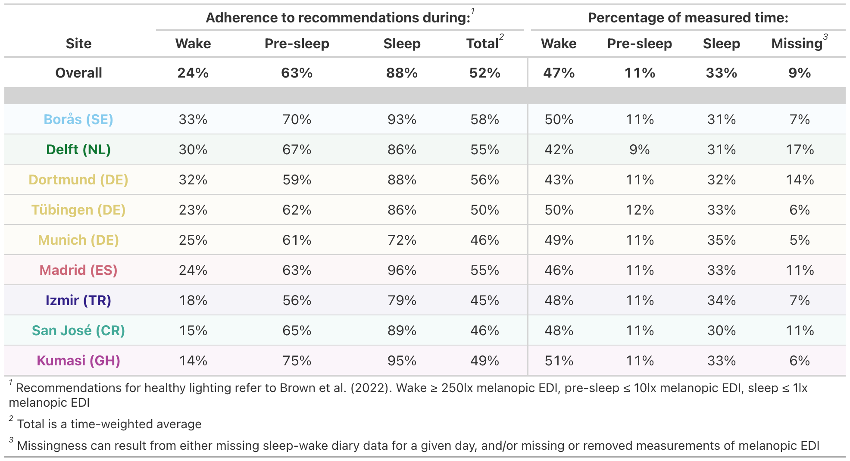
Wake periods, excluding the three hours before sleep, accounted for 47% of observations, pre-sleep periods for 11%, and sleep periods for 33%. The remaining 9% were missing because of incomplete light-exposure or sleep–wake timing data.

Sites differed in environment, behaviour, chronotype, and age
Photoperiod differed significantly between sites (p < 0.001). Only Delft (NL) and San José (CR) did not differ from the overall average (13h 14m). Dortmund (DE), Borås (SE), and Munich (DE) had longer photoperiods by 2.5, 2.0, and 2.9 h, respectively, whereas Madrid (ES), Izmir (TR), Kumasi (GH), and Tübingen (DE) had shorter photoperiods by −3.1, −1.2, −1.6, and −1.7 h.
Light exposure-related behaviour, assessed with the LEBA, differed by site for F2: Spending time outdoors and F5: Using light in the morning and during daytime. In post hoc tests, only San José (CR) for F2 and Dortmund (DE) for F5 differed from the overall mean, both scoring approximately 2–3 points lower.
Primary light-source reports differed between sites (p < 0.001), as did activity diaries (p < 0.001). Proportion tables of light source and activity by site are provided in the supplementary analysis scripts. Day type (p = 0.277), exercise (∆AIC > −2), and sleep duration (p = 0.108) did not differ significantly between sites.
Chronotype, operationalised as sleep-corrected midsleep on free days, differed significantly between sites after controlling for photoperiod (p < 0.001). Borås (SE), Dortmund (DE), San José (CR), and Kumasi (GH) showed earlier chronotypes than the overall average (04:02), with midsleep advanced by −0.5, −0.2, −0.7, and −1.9 h. Delft (NL), Tübingen (DE), Munich (DE), Madrid (ES), and Izmir (TR) showed later chronotypes, with midsleep delayed by 0.3, 0.2, 1.3, 0.4, and 1.0 h. Photoperiod also had a significant effect (p < 0.001): each 1 h increase was associated with approximately 6.6 min advance in midsleep.
Age differed significantly between sites (p < 0.001). Participants in Borås (SE) and Dortmund (DE) were older than the overall average (28 yrs) by 9.4 and 4.7 years, whereas those in Izmir (TR) and Kumasi (GH) were younger by −6.3 and −8.0 years. Sex did not differ significantly between sites (p = 0.54).

Research Question 1: Sites differ, but individual patterns dominate

Sites differed in exposure level and timing
After controlling for photoperiod, level- and timing-based metrics showed significant site-specific differences (all p ≤ 0.04). For level-based metrics, Kumasi (GH) showed consistently lower daytime (brightest 10h mean), nighttime (darkest 10h mean), and full-day (mean) exposure, with estimates 0.40–0.67 times the overall mean. Izmir (TR) showed higher nighttime light levels by a factor of 1.48, and Tübingen (DE) showed higher nighttime and overall levels by factors of 1.34–1.47 (see Supplementary Table S2).
For timing-based metrics, first light timing above 250 lx melanopic EDI ($FLIT_{250}$) was the only metric without significant site-specific differences (p = 0.40). Across site-specific metrics, Kumasi (GH) exposure timing was shifted earlier by −00:57 to −01:40 HH:MM. In San José (CR), mean and last timing above 250 lx melanopic EDI ($MLIT_{250}$ and $LLIT_{250}$) occurred earlier by −01:53 and −02:05. Madrid (ES) and Izmir (TR) showed later $MLIT_{250}$ and $LLIT_{250}$ timing (Madrid: +00:53 and +01:23; Izmir: +00:53 and +00:54), and Delft (NL) showed later $MLIT_{250}$ timing (+00:32). Although the midpoint of the brightest 10 hours showed significant site specificity (p = 0.002), no individual site differed from the overall mean; the effect was driven by selected pairwise differences not reported here.
Duration-, dynamics-, exposure-history-, and spectrum-based metrics showed no significant site-specific differences (all p ≥ 0.062).

Site effects were usually specific
Site was supported as a random effect in only 5 of 7 models in which it was otherwise supported as a fixed effect (see Supplementary Table S2). The random-effect specification was preferable to the fixed-effect specification only for overall and nighttime light levels, suggesting that meaningful site effects were usually site-specific rather than well described as draws from a common random-effect distribution.

Latitude explained daytime levels better than site
For overall and daytime light levels, latitude provided a better fit than site based on ΔAIC, with both comparisons controlling for photoperiod. Each 10-degree increase in latitude was associated with 1.15-fold higher overall 24h light levels and 1.24-fold higher daytime light levels. Although latitude was significant for some timing-based metrics, site-specific models showed stronger support based on ∆AIC in all timing-related model comparisons. Latitude was not significant for duration-, dynamics-, exposure-history-, or spectrum-based metrics. (see Supplementary Table S2)

Photoperiod predicted several metric classes
Photoperiod was significant in most models (all p < 0.05), except for dynamics-based metrics, most timing-based metrics, specifically the midpoints of the brightest and darkest 10 hours and $FLIT_{250}$, and duration below 1 lx melanopic EDI during sleep (see Supplementary Table S2).
For duration-based metrics, each additional hour of photoperiod increased time above 250 lx melanopic EDI during wake, the longest continuous period above 250 lx melanopic EDI, and time above 1000 lx melanopic EDI by factors of 1.10–1.17. Conversely, time below 10 lx melanopic EDI before sleep decreased by a factor of 0.97 per additional photoperiod-hour.
For exposure-history-based metrics, each additional hour of photoperiod increased cumulative melanopic EDI dose by a factor of 1.19. For level-based metrics, it increased exposure during the brightest 10 hours by a factor of 1.25, during the darkest 10 hours by 1.09, and across the full day by 1.18. For spectrum-based metrics, it increased the melanopic daylight efficacy ratio (MDER) by 0.02, indicating a shift towards shorter-wavelength exposure. For timing-based metrics, $MLIT_{250}$ and $LLIT_{250}$ occurred later with longer photoperiods, shifting by +00:07 and +00:20 HH:MM per additional hour.

Site and photoperiod were not dominant drivers
Across light-exposure metrics, conditional $R^{2}$ ranged from 25% to 62% with a mean of 40% (see Supplementary Table S3). Explanatory power was highest for duration-, spectrum-, and level-based metrics, particularly duration above 250 lx melanopic EDI during wake, overall and nighttime light levels, and MDER (all $R^{2}$ > 50%). Fixed effects explained 2%–24% of variance (mean: 12%), indicating that site, photoperiod, and latitude contributed meaningfully but were not dominant drivers.
Participant-level differences explained 9%–42% of variance (mean: 28%) and often exceeded the contribution of fixed effects. Exceptions were $MLIT_{250}$ and $LLIT_{250}$, for which participant-level differences explained 9% and 17% of variance, while fixed effects explained 17% and 23%. When significant, site effects explained more variance than photoperiod effects on average (10% vs. 7%). Latitude added limited explanatory value beyond photoperiod (2%–7%; mean: 5%). Residual variance remained high across metrics (38%–75%), indicating substantial unexplained within-person or day-to-day variability.

Sites diverged mainly around morning and afternoon
Decomposing daily patterns of 30-minute-binned melanopic EDI into contributions of time, photoperiod, site, participant, and participant-day showed that sites deviated from the overall daily pattern mainly before and after solar noon (see Figure 2). Compared with the average, Borås (SE) showed approximately 2- to 5-fold higher exposure during these windows. Dortmund (DE) and Munich (DE) showed similar but smaller deviations of approximately 2- to 3-fold. In Borås, the increase was strongest in the morning, whereas in the German sites it was more pronounced in the evening.
Madrid (ES) showed the inverse pattern, with approximately 5-fold lower exposure around dawn and approximately 2-fold lower exposure around dusk. Izmir (TR) showed approximately 2-fold lower exposure around dawn but 3- to 4-fold higher exposure in the evening. San José (CR) tended towards higher morning and lower afternoon exposure, although this was not significant, likely because few participants wore glasses-mounted sensors. Kumasi (GH) was the only site differing significantly around noon, with approximately 3-fold lower exposure than average. Exposure in Kumasi was also reduced by approximately 2- to 3-fold in the morning and by approximately 3- to 10-fold during the afternoon and evening.
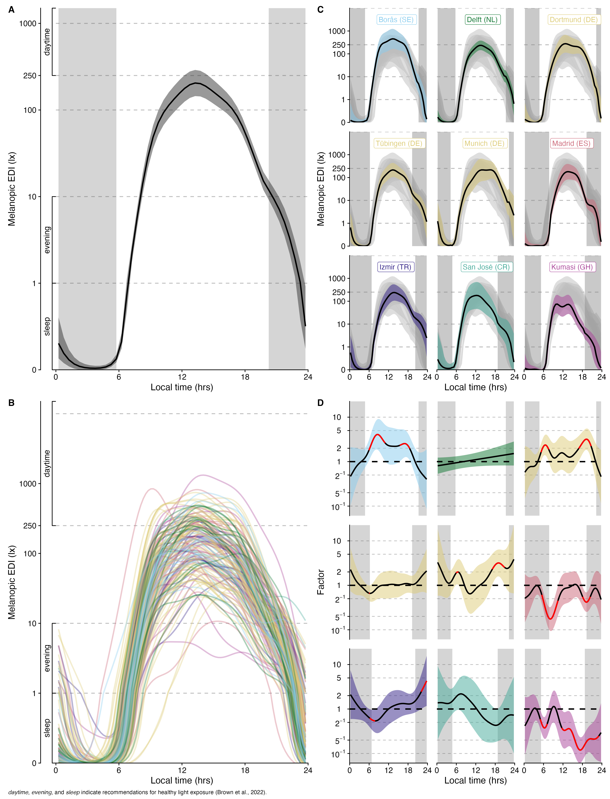
Figure 2: Model results from H2, showing the decomposition of daily light exposure patterns into an average smooth of time (A), participants (B), and site (D). Combinations of time and site are shown in panel (B). Panels A, C, and D show 95% confidence intervals as ribbons, whereas each trace in panel B indicates an individual participant. Grey shaded areas indicate average nighttimes. Red traces in panel D indicate significant deviations from the average trend of time.

Participant patterns outweighed site patterns
Pattern decomposition showed that participant-specific differences explained substantially more unique variance than site. Participant-level contributions explained 11.18% of smooth variance, compared with 4.87% for site, corresponding to an approximately 2.3-fold larger contribution. This mirrors the metric-based analyses, in which participant-specific variance was, on average, approximately 2.8 times larger than site-attributable variance.

Research Question 2: Behaviour and micro-environment shape exposure

Daylight access matters
Primary light source strongly predicted personal light exposure (p < 0.001, $R^{2}$ = 0.69), with small but significant site variation (site: p < 0.001, $R^{2}$ = 0.05; interaction with primary light source: p < 0.001, $R^{2}$ = 0.02). For indoor electric lighting, the reference exposure was approximately 75 lx melanopic EDI. Relative to this, exposure was higher in Borås (SE), Delft (NL), and Madrid (ES), by factors of 2.04, 2.16, and 1.48, and lower in Tübingen (DE) and Kumasi (GH), by factors of 0.56 and 0.50. Full model results are shown in Supplementary Table S4, and interaction effects in Supplementary Figure S2.
Indoor daylight was associated with 2.31-fold higher exposure than indoor electric lighting, corresponding to approximately 172 lx melanopic EDI. Kumasi (GH) was the only site deviating significantly, with indoor daylight levels 0.40 times lower than elsewhere. Outdoor daylight showed the largest increase, with exposure 9.47 times higher than indoor electric lighting, corresponding to approximately 707 lx melanopic EDI and exceeding the 250 lx daytime recommendation. Outdoor daylight exposure was higher in Borås (SE) and Delft (NL), by factors of 3.06 and 1.95, and lower in Kumasi (GH) and San José (CR), by factors of 0.42 and 0.52.
When emissive displays were reported as the primary light source, exposure was 0.28 times that under indoor electric lighting, corresponding to approximately 21 lx melanopic EDI. Display-related exposure was lower in Borås (SE), Tübingen (DE), and Munich (DE), by factors of 0.54, 0.15, and 0.08, and higher in Delft (SE), Dortmund (DE), Madrid (ES), and Izmir (TR), by factors of 6.30, 3.42, 5.10, and 1.99.
Darkness during sleep corresponded to approximately 2% of indoor electric-light exposure, reaching below 1 lx melanopic EDI (but see below in the limitation section for accuracy of low melanopic EDI levels). Madrid (ES) and Kumasi (GH) showed lower sleep-period exposure than other sites, by factors of 0.54 and 0.14, whereas Munich (DE) showed 6.42-fold higher exposure in the sleep environment.
Supplementary Figure S3 extends the H2 pattern decomposition (see Figure 2) by including the primary light source context, illustrating when lightsource categories occur, how lightsource-related deviations contribute to daily exposure patterns.

Activity and micro-environment strongly shaped exposure
Activity and micro-environment strongly affected personal light exposure (p < 0.001, $R^{2}$ = 0.58), with small but significant site-specific variation (site: p < 0.001, $R^{2}$ = 0.09; interaction with activity: p < 0.001, $R^{2}$ = 0.04). Being awake at home corresponded to approximately 59 lx melanopic EDI. Relative to this, Borås (SE), Delft (NL), and Dortmund (DE) showed higher values by factors of 1.77, 2.37, and 2.04, whereas Tübingen (DE) and Kumasi (GH) showed lower values by factors of 0.46 and 0.33. Full model results are shown in Table 3 and interaction effects in Supplementary Figure S2.
Table 3: Summary table of model results for Hypothesis 4
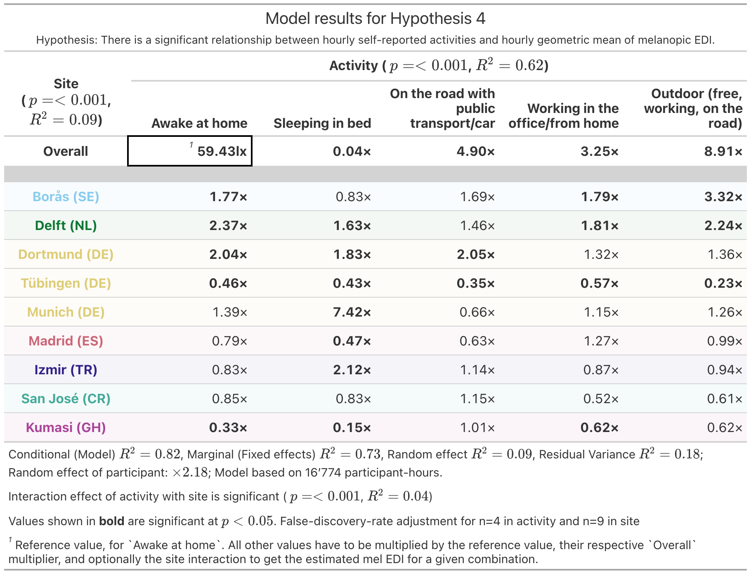
Sleeping in bed corresponded to approximately 4% of exposure while awake at home, or approximately 2 lx melanopic EDI. This differs from the sleep-environment estimate above, likely because the activity category also captured periods with light entering the sleep environment, rather than only periods classified as darkness during sleep. Delft (NL), Dortmund (DE), Munich (DE), and Izmir (TR) showed higher sleep-period exposures than average, by factors of 1.63, 1.83, 7.42, and 2.12, whereas Tübingen (DE), Madrid (ES), and Kumasi (GH) showed lower exposures, by factors of 0.43, 0.47, and 0.15.
Travelling by public transport or car was associated with 4.90-fold higher exposure than being awake at home, corresponding to approximately 291 lx melanopic EDI. Dortmund (DE) showed even higher values, by a factor of 2.05, whereas Tübingen (DE) showed lower values, by a factor of 0.35.
Working in the office or from home was associated with 3.25-fold higher exposure than being awake at home, corresponding to approximately 193 lx melanopic EDI. Borås (SE) and Delft (NL) showed higher work-related exposure, by factors of 1.79 and 1.81, whereas Tübingen (DE) and Kumasi (GH) showed lower workplace exposure, by factors of 0.57 and 0.62.
Being outdoors, including free time, work, or travelling without cover, was associated with 8.91-fold higher exposure than being awake at home, corresponding to approximately 530 lx melanopic EDI. Borås (SE) and Delft (NL) again showed higher levels, by factors of 3.32 and 2.24, whereas Tübingen (DE) showed substantially lower values, by a factor of 0.23.
Figure 3 extends the previous pattern decomposition (see Figure 2) by including activity context, showing when activity categories occur and how activity-related deviations contribute to observed daily patterns.
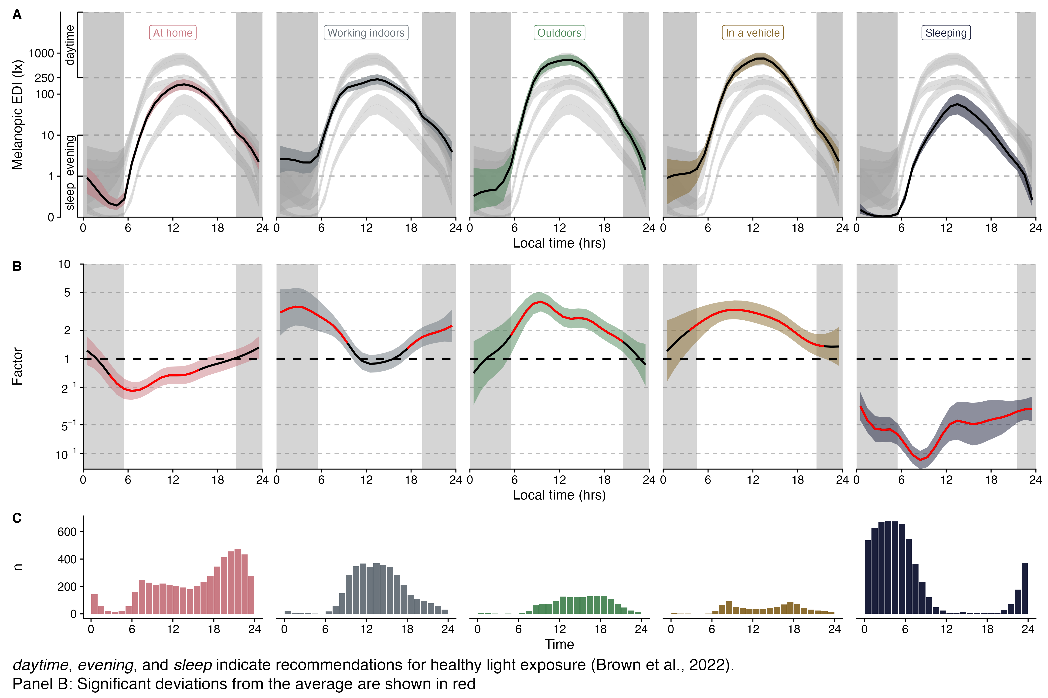
Figure 3: Model results from H4, showing daily light exposure patterns depending on activity and micro-environment (A), deviations from the average (B), and number of observations for a given context and time of day, e.g., the low number of sleeping participants between 12:00-20:00 (C). Panels A, and B, show 95% confidence intervals as ribbons. Grey ribbons in panel A show all other categories for direct comparison. Grey shaded rectangular areas indicate average nighttimes. Red traces in panel B indicate significant deviations from the average trend of time.

LEBA factors were weakly related to exposure
Of 68 comparisons between 17 light-exposure metrics and four LEBA factors, only two correlations were significant. F2: Spending time outdoors was positively correlated with melanopic EDI dose (p = 0.013, r = 0.27) and duration above 1000 lx melanopic EDI (p = 0.032, r = 0.29). The full correlation matrix is shown in Supplementary Figure S4. Correlations were performed independently of site.

Day type, exercise, and sleep showed small associations
Day type, defined as workday versus free day, showed a significant but small association with personal light exposure (p < 0.001, $R^{2}$ = 0.01), driven mainly by an interaction with site. On workdays, average exposure was 76 lx melanopic EDI and did not differ significantly by site, with exercise set to none and sleep duration to the average of 7.9 h. On free days, exposure was higher in Borås (SE), Delft (NL), and Dortmund (DE), by factors of 2.23, 2.62, and 2.24, and lower in San José (CR) and Kumasi (GH), by factors of 0.37 and 0.54. Exploratory analyses in Supplementary Figure S5 indicate that higher workday exposure occurred mainly before noon, when exposure was up to five times higher than on free days, and to a lesser extent in the afternoon, when exposure was consistently approximately two times higher. Exposure was lower after midnight on workdays, likely reflecting earlier bedtimes. An exploratory weekday–weekend model showed similar but weaker patterns and substantially less support, with an AIC approximately 33 points higher than the day-type model.
Daily exercise level also showed a significant but small association with exposure (p < 0.001, $R^{2}$ = 0.05). On days without exercise, average exposure was 76 lx melanopic EDI, with day type set to work day and sleep to 7.9 h. Borås (SE) and Dortmund (DE) showed higher values, by factors of 2.14 and 2.08, whereas Kumasi (GH) showed lower values, by a factor of 0.15. Light-exercise days were associated with a 1.85-fold increase in exposure; Borås (SE) and Delft (NL) showed higher values, by factors of 2.38 and 3.07, and Kumasi (GH) lower values, by a factor of 0.45. Moderate-exercise days were associated with a 1.74-fold increase; Delft (NL) was higher by a factor of 2.20, and San José (CR) lower by a factor of 0.23. Vigorous-exercise days were associated with a 1.50-fold increase and no significant site-specific deviations.
Prior sleep duration had a significant but small association with daily exposure (p < 0.001, $R^{2}$ = 0.02). Each additional hour of sleep was associated with a factor of 0.92 in average daily exposure, corresponding to an 8% reduction, likely reflecting reduced opportunity for light exposure through shorter wake duration. Delft (NL) and Tübingen (DE) showed little evidence of this effect, with compensatory factors of 1.15 and 1.10, whereas Munich (DE) showed a stronger effect, with an additional factor of 0.88.
Model results for day type, exercise, and prior sleep are shown in Supplementary Table S5. All associations remained significant after controlling for activity context (all p ≤ 0.001), indicating that factors beyond recorded activity and micro-environment contributed to exposure.

Photoperiod showed ceiling effects
Photoperiod showed ceiling effects for selected metrics. For level-based metrics, exposure no longer increased significantly beyond approximately 14.7–16.4 h of photoperiod. A comparable ceiling occurred for duration above 1000 lx melanopic EDI, plateauing at approximately 16.6 h. In contrast, the longest continuous period above 250 lx melanopic EDI and cumulative melanopic EDI dose showed no ceiling within the observed photoperiod range. Supplementary Figure S6 shows these nonlinear relationships.

Research Question 3: Participant characteristics showed limited associations

Light sensitivity was not associated with exposure
Duration-, exposure-history-, and level-based metrics were not significantly associated with self-reported visual light sensitivity, assessed using the VLSQ-8 (all p > 0.9). Results are summarised in Supplementary Table S6.

Chronotype shifted exposure timing
Chronotype predicted timing-based exposure metrics. For each 1 h later $MSF_{sc}$, participants experienced the midpoint of the brightest 10 hours 0.31 h later, the midpoint of the darkest 10 hours 0.40 h later, $MLIT_{250}$ 0.32 h later, and $FLIT_{250}$ 0.44 h later (all p < 0.001). $LLIT_{250}$ was not significantly associated with chronotype (p = 0.12). Effect sizes were modest, with marginal $R^{2}$ values of 0.05–0.08. Model results are shown in Supplementary Table S7 and Supplementary Figure S7.

Sex and age showed weak effects
Across all 17 metrics, none were significantly associated with sex (all p ≥ 0.7). Only one metric was significantly associated with age, with all other age associations non-significant (all p ≥ 0.2). No significant age-by-site interactions were observed (all p ≥ 0.3).
Duration above 1000 lx melanopic EDI was significantly associated with age (p = 0.017), although the effect was modest ($R^{2}$ = 0.07). Each additional year of age was associated with a 0.024 h, or 1.44 min, increase in daily duration above 1000 lx melanopic EDI. Given an average duration of 39 min across sites, this corresponds to approximately 3%–4% per year. Model results are shown in Supplementary Table S8 and Supplementary Figure S8.

Females showed behaviourally driven lower morning exposure
Males and females showed broadly similar daily exposure patterns. However, females had significantly lower melanopic EDI exposure between 08:00 and 10:00, by approximately a factor of 2 (see Supplementary Figure S9). This difference appeared behaviourally driven: after controlling for activity context, sex no longer added significant explanatory value.

Chest-level analysis were broadly consistent with eye-level findings, but larger sample in Costa Rica makes a difference
Chest-level analyses were broadly consistent with the ocular-level findings, while providing additional evidence for the Costa Rica cohort owing to its larger sample size at this wearing location. In the chest-level data, Costa Rica showed up to five-fold higher morning light exposure than the other sites and approximately two-fold lower exposure in the afternoon approaching dusk. Duration above 1000 lx melanopic EDI was 1.40 times higher, and duration above 250 lx melanopic EDI was 1.28 times higher than the average across sites. This led to a daytime adherence level to recommendations of about 23% (compared to only 15% in the smaller glasses-level sample). Contextual light-source analyses further indicated lower exposure under indoor electric lighting (0.69×) and higher exposure under indoor daylight (1.59×), amongst others. The larger number of chest-level observations makes it expected that more Costa Rica-specific effects reached significance in this analysis. Overall, the only substantive discrepancy between the samples concerned daylight exposure in Costa Rica: ocular data showed lower outdoor (0.42×) and indoor (0.90×) daylight, while chest-level data trended higher for both outdoor (1.18×) and indoor daylight (1.59×). The increased daylight levels in Costa Rica further challenge the latitude dependency of daytime and overall 24h light levels, which was no longer significant. Apart from these differences, results across the 11 hypotheses were remarkably stable despite differences in sample size and sensor placement, supporting the robustness of the main findings.

Discussion
This study positions personal ocular light exposure as a measurable component of the human exposome. Across 9 sites in 7 countries^{32–42}, harmonised near-eye light logging and repeated contextual reports showed that everyday melanopic exposure is not determined by geography alone. Site, latitude and photoperiod contributed to exposure structure, but participant-level patterns, activity context and micro-environment accounted for a larger share of variation. These findings support the central premise of the introduction: the health-relevant light environment is not simply the ambient outdoor exposure potential, but the light that reaches the eye as people move through homes, workplaces, transport systems and outdoor spaces. In this sense, personal light exposure is a modifiable environmental phenotype shaped by the interaction of biology, behaviour, built environments and social routines^{9,10}.
A clinically and public-health relevant finding is that participants did not, on average, reach the recommended daytime melanopic light exposure of 250 lx during waking hours²⁷. This extends field studies showing limited daytime light exposure and elevated evening or night exposure in daily life^{13,17,21,24,28,43}. It also complements large cohort analyses linking brighter daytime light, darker nights and stronger day-night contrast to sleep, psychiatric, metabolic and mortality outcomes^{13–16}. The translational implication is that insufficient daytime light should not be treated only as an individual behavioural shortfall. It is also an environmental and systems-level exposure problem, reflecting how daylight is filtered by architecture, work schedules, mobility, climate, culture and access to outdoor space. By moving beyond earlier single-site or pairwise comparisons, adherence to recommendations is shown to differ systematically across sites and daily phases: daytime adherence broadly increased with latitude, whereas pre-sleep and sleep adherence were more stable across latitudes with individual dips in single sites. This illustrates why multi-site data are essential. The relevant exposure problem is not uniform across contexts; daytime, evening, and sleep-period exposure may each be shaped by different combinations of outdoor availability, indoor environments, schedules, and behaviour.
The geographical findings further illustrate this distinction between ambient availability and personal exposure. Daytime pattern decomposition showed that sites diverged mainly in the morning and afternoon. Photoperiod predicted several classes of exposure metrics, and latitude explained some level-based metrics better than site-specific coefficients, but neither factor dominated the data structure. Contrary to a simple availability model, light exposure tended to increase with latitude, despite greater year-round solar availability at lower-latitude and tropical sites. This pattern is consistent with behavioural filtering: in brighter, hotter or higher-UV environments, people may seek shade, remain indoors, avoid direct sunlight or structure activities around thermal comfort and sun protection. Similar dissociations between ambient radiation and personal exposure have been described in work on UV exposure, shade use, outdoor thermal comfort and sun-protective behaviour^{44–47}. The larger chest-level Costa Rica dataset partly challenged this trend, showing higher-than-average morning light levels, but afternoon exposure remained comparatively low. Together, these results suggest that climate and latitude provide the exposure opportunity, whereas behaviour and built environments determine the realised ocular dose.
The clearest modifiable determinants were immediate activity context and lighting micro-environment. Access to daylight, especially outdoor daylight, produced the largest increases in melanopic exposure and was the only lighting context that clearly exceeded the recommended daytime threshold on average. Indoor daylight also substantially increased exposure relative to electric lighting, whereas display-dominated contexts were associated with markedly lower exposure. Further time-of-day decomposition, however, shows a weak separation of self-reported indoor electric and daylight conditions at a given hour (see Supplementary Figure S3). Being outdoors, travelling and working were generally associated with higher exposure than being (awake) at home, although these associations varied by site. These findings identify concrete intervention targets: increasing daylight access in homes, workplaces, schools and care settings; supporting outdoor time during biologically relevant morning and daytime windows; and reducing reliance on low-intensity, display-centred environments during the day can meaningfully improve exposure. They also explain why broad self-reported light-related behaviour (LEBA) showed only weak correlations with objective exposure (Supplementary Figure S4). For health translation, the timing, location and optical properties of behaviour matter more than general behavioural tendency.
Participant-specific patterns were a major source of variation and should be central to future light-exposure research. Across metric-based models, participant-level variance often exceeded fixed effects, and in the pattern decomposition it explained more than twice as much unique smooth variance as site. Chronotype was associated with timing-based exposure metrics, with later chronotypes showing later bright and dark exposure timing, consistent with circadian theory and prior evidence linking light exposure and sleep timing^{24,28,48–52}. By contrast, visual light sensitivity, sex and age showed limited associations with summary metrics. These results argue against relying on demographic categories alone to identify people at risk of suboptimal light exposure. More informative predictors are likely to involve time use, occupation, housing, mobility, daylight access, care responsibilities and culturally patterned routines.
This study also advances exposure assessment. Large cohort studies using wrist-worn light sensors have provided critical evidence that naturalistic light exposure is associated with sleep, psychiatric, metabolic and mortality outcomes^{14–16,19,22}. However, wrist-worn measurements only approximate the stimulus reaching the eye and may be affected by posture, sleeve occlusion and device-specific limitations^{53–56}. By measuring near the corneal plane, the present study more directly captures the input relevant to non-visual photoreception and melanopic exposure. This is important for precision prevention: if light is to be treated as a modifiable environmental determinant of health, then exposure assessment should correspond as closely as possible to the biological target. The harmonised multi-country design³¹, integration of objective time-series data with contextual reports, and publication of the dataset^{32–42} provide a basis for reproducible, comparative exposome research.
Several limitations temper the interpretation. First, although the dataset is unusually broad for ocular light-dosimetry research, site-level sample sizes remain modest. Larger studies with more participants and participant-days are needed to stabilise site estimates, test interactions and evaluate subgroups. Second, the study population consisted of healthy working-age adults, limiting generalisability to children, adolescents, older adults, clinical populations, shift workers, unemployed or retired people, and people with restricted mobility or atypical living conditions. Third, the sampled latitude-by-photoperiod space remains sparse (Supplementary Figure S10), and future studies should include more sites, seasons and climate conditions to separate latitude, seasonality, culture, climate and built-environment effects. Fourth, activity and primary light-source reports were intentionally broad and collected retrospectively at an hourly scale. This enabled cross-site harmonisation but limited fine-grained analyses, for example distinguishing different activities within the same space, different types of work environments, or specific behaviours during home, office, or transport periods. Fifth, very low sensor readings, especially at night, should be interpreted cautiously. Although the light logger is rated by the manufacturer down to 1 lx, single-digit values should be understood as approximate low-light exposure rather than precise measurement⁵⁷.
In conclusion, everyday ocular light exposure is structured, measurable and strongly shaped by behaviour and micro-environment, but cannot be reduced to site, latitude or photoperiod. The findings extend the light-and-health literature from demonstrating biological relevance to identifying real-world determinants of exposure. Light exposure is a modifiable exposomic factor: it can potentially be improved through clinical advice, occupational health, building design, urban planning and public-health guidance, but only if interventions account for the contexts in which people actually receive light. Near-eye, time-resolved exposure measurement therefore offers a practical route from circadian biology to precision prevention and context-sensitive environmental health.

Methods
The current study was preregistered with AsPredicted (#273407)⁵⁸. Deviations from the preregistration are documented in Section 5.10.

Research questions and hypotheses
We assessed the following research questions and hypotheses, as specified in the preregistration⁵⁸ and Section 5.10:
Research Question 1: Do sites differ in objectively measured personal light exposure? If so, does an individual’s behaviour and micro-environment have a stronger effect than site?
H1: There is a significant difference in personal light-exposure metrics across sites, even after accounting for latitude and photoperiod.
H2: The variance of personal light exposure patterns (30-minute-binned geometric mean of melanopic EDI) by participants within sites is greater than the variance between sites.
Research Question 2: Is there a relationship between personal light exposure and participants’ behaviour and environment?
H3: There is a significant relationship between hourly self-reported light exposure categories and hourly geometric mean of melanopic EDI.
H4: There is a significant relationship between hourly self-reported activities and hourly geometric mean of melanopic EDI.
H5: There is a significant relationship between LEBA-factors and pre-selected personal light exposure metrics.
H6: There is a significant relationship between day type, daily exercise, sleep, and the hourly geometric mean of light exposure.
H7: There is a ceiling effect of photoperiod on level-, duration-, and exposure-history-based metrics.
Research Question 3: Is personal light exposure related to participant characteristics?
H8: Duration, exposure-history, and level-based metrics of personal light exposure are significantly associated with personal light sensitivity (VLSQ-8)
H9: Timing-based metrics of personal light exposure are significantly associated with chronotype.
H10: Personal light exposure metrics depend on age and sex
H11: Personal light exposure patterns depend on sex

Study design
This publication reports analyses from the MeLiDos field study, which is a multinational observational study examining associations between real-world ocular light exposure and personal and behavioral characteristics across diverse geographic and sociocultural contexts³⁰. The MeLiDos consortium collected multimodal longitudinal data using harmonised assessment protocols across participating study sites. The present analyses focused on the decomposition of melanopic light exposure under naturalistic conditions into individual, behavioural, and environmental contributing factors. The study design is described in detail in the protocol paper by Guidolin et al.³¹ and will be summarized in the following sections.
Participants completed an 8-day ambulatory monitoring protocol comprising continuous personal light exposure assessment, repeated ecological momentary assessments, and daily diary measures under free-living conditions. The protocol started with an in-person visit to the local research centre, during which participants provided written informed consent, received detailed study instructions, and were equipped with wearable light-monitoring devices. Participants returned to the research centre after the monitoring period for device return and completion of end-of-study assessments. At most sites, monitoring began on a Monday and ended the following Monday; in Dortmund, data collection was conducted from Tuesday to the following Tuesday. Continuous recordings were collected over seven consecutive days between the two visits. When participants were unable to attend the scheduled return visit, they were instructed to continue the protocol until formal study termination and device retrieval.
Participants were recruited across nine study sites in seven countries (sorted by latitude): Borås, Sweden^{41,59}; Delft, the Netherlands⁴²; Dortmund³⁶, Tübingen³⁸, and Munich⁴⁰, Germany; Madrid, Spain³⁵; Izmir, Türkiye³⁷; San José, Costa Rica³⁹; and Kumasi, Ghana^{33,34}. These sites covered a broad range of latitudes, photoperiods, climates, built environments, and sociocultural contexts. The choice of sites was an opportunity sample determined by the location of project partners and partners that joined the consortium (Türkiye, Costa Rica, and Ghana). Recruitment and questionnaire administration were conducted in the native language of each study site, except in Tübingen and Kumasi, where study procedures were conducted in English. Self-report instruments were translated, culturally adapted, and harmonised using the TRAPD framework (Translation, Review, Adjudication, Pretesting, and Documentation), involving at least two independent translators per language version⁶⁰.
Data collection was conducted between August 2023 and October 2025, depending on local logistics and seasonal scheduling. All participants provided written informed consent before participation. Ethical approval for the overarching study protocol was obtained from the Ethics Committee of the Technical University of Munich (2023-115-S-KK), with local implementation procedures harmonised across participating centres. Additional ethical approvals were obtained from the respective research ethics committees at participating study sites.

Inclusion and exclusion criteria
Eligible participants were adults between 18 and 65 years who were engaged in full-time employment or part-time employment exceeding 80% workload. Participants were recruited through local advertisements and institutional mailing lists.
Exclusion criteria included diagnosed psychiatric disorders, diagnosed sleep disorders, regular tobacco use, regular recreational drug use, shift work within the preceding two months, and use of medication known to affect photosensitivity. Further exclusion criteria were visual impairments incompatible with the wearable light-monitoring devices and residence outside the predefined local study region during the recording period.
A minimum target sample size of 15 participants per study site was defined based on prior power analyses for real-world light exposure studies⁶¹. This target was intended to provide sufficient statistical power for planned light exposure metrics while accounting for expected dropout and incomplete recordings of up to one third.

Data collection procedures
At the registration visit, participants received detailed instructions for the ambulatory monitoring protocol, completed baseline questionnaires, and were fitted with wearable light-monitoring devices. Depending on device availability and local research capacity, multiple participants could be assessed concurrently within the same measurement week at a given study site.
Participants were instructed to wear the light-monitoring devices continuously during waking hours. During sleep, devices were placed facing upward on a bedside surface near head level to capture nocturnal ambient light exposure in the sleep environment. Participants also documented device removals using a dedicated wear log implemented in the mobile assessment platform²⁹. During waking non-wear periods, they were instructed to place the devices in a provided opaque black bag to minimise light contamination^{29,62}.
Throughout the monitoring period, participants completed repeated smartphone-based ecological momentary assessments. Momentary sleepiness⁶³ and mood⁶⁴ were assessed four times daily at scheduled time points: 11:00, 14:00, 17:00, and 20:00. Participants additionally completed morning sleep diaries after awakening⁶⁵ and evening questionnaires assessing daily wellbeing⁶⁶ and physical activity²⁹, as well as hourly light exposure⁶⁷ and activity²⁹. Baseline and end-of-study questionnaires assessed demographic characteristics, chronotype⁶⁸, habitual light exposure behaviours⁶⁹, sleep environment characteristics⁷⁰, and self-reported visual light sensitivity⁷¹. All participant-reported data were collected via the MyCap⁷² smartphone application integrated with REDCap⁷³ servers, except for the paper-based evening diaries assessing hourly light exposure and activity contexts. These paper-based diaries were photographed and uploaded daily by participants.

Wearable light logger
Light exposure was recorded using spectrally sensitive ActLumus devices, Condor Instruments, São Paulo, Brazil^{57,74}. Devices recorded continuously at 10-second intervals. Multispectral measurements across eight visible-band channels were processed internally by the device to derive photopic and α-opic quantities, including melanopic equivalent daylight illuminance, or melanopic EDI. The devices were factory calibrated to an operating range between 1 and 10^5 lx (precision 10% at 1k lx).
The ActLumus devices used in this study have recently been independently benchmarked against a criterion spectrometer under indoor LED and outdoor daylight conditions, showing broad detection range (100% of the tested range of 2-100k lx), low inter-device variability, and higher photopic accuracy (+3.3 ±13.4%, mean ±SD) than several commonly used wearable light sensors⁵⁷.
Participants wore a near-corneal light logger mounted centrally on non-prescription spectacle frames and a chest-level pendant-mounted logger. Depending on site specific limitations for participant-recruitment and device-availability, only one position was assessed (see Section 5.10. Specifically, some participants were hesitant to wear the glasses-mounted logger for a week, which hindered some sites to reach the target number of participants, while the chest-position was more acceptable⁷⁵. The near-corneal configuration was designed to approximate retinal light exposure during daily activities and was therefore treated as the primary measurement configuration in the present analyses. The chest-mounted configuration provided an ambulatory estimate of personal environmental light exposure and was used in supplementary robustness analyses.
Participants also wore an ActLumus device configured as a wrist-mounted monitor during the MeLiDos protocol. Wrist-derived light exposure data were not included in the present analyses because the wrist position provides a limited approximation of ocular light exposure^{53–56}.

Surveys
Daily sleep parameters were assessed each morning using the core Consensus Sleep Diary⁶⁵. Participants reported bedtime, time attempting to sleep, sleep onset latency, nocturnal awakenings, wake after sleep onset, final awakening time, and subjective sleep quality. Subjective sleep quality was rated on a five-point Likert-type scale ranging from “very poor” to “very good”.
Hourly light exposure and activity contexts were assessed using evening questionnaires. Light exposure context was assessed with a modified version of the Harvard Light Exposure Assessment (mH-LEA)⁶⁷. For each hour of the day, participants reported the primary light source to which they were exposed, defined as the main light source in their environment. They could choose from the following categories:
- Electric light source indoors
- Electric light source outdoors
- Daylight indoors
- Daylight outdoors (including shade)
- Emissive display light
- Darkness during sleep
- Light entering from outside during sleep
If participants perceived a substantial combination of light sources within the same hour, they could additionally report a secondary light source using the same set of categories.
Activity context was assessed in parallel²⁹. For each hour of the day, participants reported the activity they had primarily performed during that hour. They could choose from the following categories:
- Sleeping in bed
- Awake at home
- On the road with public transport/car
- On the road with bike/on foot
- Working in the office/from home
- Working outdoors (including lunch break outdoors)
- Free time outdoors (e.g. garden/park etc.)
- Other: please specify (e.g. sport)
Momentary sleepiness was assessed four times daily using the Karolinska Sleepiness Scale⁶³, a single-item measure of current alertness and sleepiness. Ratings were provided on a 10-point Likert-type scale ranging from 1, “extremely alert”, to 10, “extremely sleepy”.
Momentary mood was assessed concurrently with sleepiness using a modified version of the MoodZoom questionnaire⁶⁴. Participants rated their current affective state across six dimensions: anxious, elated, sad, angry, irritable, and energetic. Responses were recorded using seven-point Likert-type scales, with higher scores indicating stronger endorsement of the respective affective state.
Daily wellbeing was assessed each evening using a modified WHO-5 Wellbeing Index⁶⁶. Question four was reframed to indicate last nights sleep, instead of referring to multiple days. Item scores were summed and normalised to a maximum score of 100, with higher scores indicating better subjective wellbeing. Evening diary measures additionally included self-reported physical activity, from which a binary indicator of daily exercise participation was derived.
Logs to record non-wear periods, timespans outside the 60 km radius around the site, and experiences with the light loggers were available to participants at all times through the smartphone application of the study.^{29,62}
Baseline questionnaires assessed age, biological sex, gender, employment status, and chronotype. Chronotype was assessed using the Munich Chronotype Questionnaire⁷⁶ and the Morningness–Eveningness Questionnaire⁷⁷. The Munich Chronotype Questionnaire was used to derive corrected midsleep on free days, representing an estimate of biological timing adjusted for accumulated sleep debt on workdays. The Morningness–Eveningness Questionnaire quantified circadian preference, with higher scores indicating greater morning preference.
End-of-study questionnaires assessed subjective visual light sensitivity, sleep environment characteristics, and habitual light exposure behaviours. Visual light sensitivity was assessed using the Visual Light Sensitivity Questionnaire-8⁷¹. Sleep environment characteristics were assessed using the Assessment of Sleep Environment questionnaire⁷⁰. Habitual light exposure behaviours were assessed using the Light Exposure Behaviour Assessment⁶⁹. Four LEBA factor scores were used: spending time outdoors, use of phones and smart devices in bed before sleep, controlling and using ambient light before bedtime, and use of light during the morning and daytime. The LEBA factor relating to filtered or tinted glasses was not administered because participants wore study-specific spectacle frames without optical filters during monitoring.

Primary and co-variates
The primary light exposure quantity was melanopic EDI, expressed in lux²⁶. The primary source of light exposure data was the near-corneal device, because it most closely approximates ocular light exposure. Chest-level light exposure data were used for supplementary robustness analyses.
Habitual light exposure was characterised using participant-level and participant-day-level metrics. Participant-level dynamics-based metrics included interdaily stability, reflecting day-to-day regularity of light exposure timing, and intradaily variability, reflecting fragmentation and temporal variability of daily light exposure patterns.^{78,79}
Participant-day-level metrics were grouped into level-based, duration-based, timing-based, exposure-history-based, and spectrum-based measures. Level-based metrics included the geometric mean melanopic EDI across the day, the geometric mean melanopic EDI during the 10 brightest hours of the day, and the geometric mean melanopic EDI during the 10 darkest hours of the day. Duration-based metrics included time above 1000 lx melanopic EDI, time above 250 lx melanopic EDI during wake periods, time below 10 lx melanopic EDI during the three hours before attempted sleep, time below 1 lx melanopic EDI during sleep periods, and the longest continuous period above 250 lx melanopic EDI. Timing-based metrics included first light timing above 250 lx melanopic EDI, last light timing above 250 lx melanopic EDI, and mean timing of exposure above 250 lx melanopic EDI. Exposure-history-based metrics included cumulative daily melanopic EDI dose. Spectrum-based metrics included melanopic daylight efficacy ratio, defined as the ratio between melanopic and photopic illuminance at a given moment.^{78,79}
For sleep-related analyses, sleep windows were defined based on the time participants reported attempting to sleep, rather than estimated sleep onset after adding sleep onset latency. This definition better represents the behavioural interval during which participants intended to sleep and is particularly relevant for analyses of pre-sleep and sleep-environment light exposure.
Self-reported light exposure and activity context variables include the primary lightsource, and the given activity, in an hourly resolution.
Environmental and behavioural covariates included study site, latitude, photoperiod duration, day type (work or free day), exercise level, chronotype, habitual light exposure behaviours, and subjective visual light sensitivity. Daily photoperiod duration was calculated as the interval between dawn and dusk, i.e., sun elevation above -6°.

Transformation of variables and preprocessing steps
Light exposure preprocessing and metric derivation were performed in R statistical software⁸⁰ using the LightLogR package⁸¹. Raw unaggregated light exposure recordings from near-corneal and chest-mounted devices were first trimmed according to participant-specific study start and end times. Physiologically implausible values exceeding 120000 lx were visually inspected and removed or recoded as missing values.
Non-wear periods were identified from participant wear logs⁶². Only non-wear periods that did not overlap with reported sleep windows were set to missing. Sleep-period recordings were retained because devices were placed beside the participant during sleep to quantify the sleep environment.
For habitual light exposure analyses, additional completeness criteria were applied. Hours with less than 50% valid data availability were excluded. Participant-days with less than 80% valid light exposure data after hourly filtering were removed from analysis. The resulting dataset was used to derive participant-level and participant-day-level light exposure metrics.
For analyses involving wake, pre-sleep, and sleep intervals, sleep diary data were merged with light exposure data at the participant-day level. Wake periods, the three-hour pre-sleep interval, and sleep periods were defined using diary-derived attempted sleep timing and final wake time. This operationalisation was used to align light exposure metrics with behaviourally meaningful sleep windows.
Because level-, duration-, and dose-related light exposure metrics were strongly right-skewed, these variables were log10-transformed before statistical analysis. When a metric contained zero values, an offset of 0.1 was added before transformation⁸². Timing variables were circularly linearised before modelling when they crossed midnight.
Due to the low number of observations for certain light-source and activity contexts within individual sites, some categories were combined or excluded before analysis. For primary light source, categories were excluded if they contained fewer than 0.1% of all observations within a site, corresponding to approximately 20 observations, and fewer than 1% of observations across all sites, corresponding to approximately 200 observations.
For primary lightsource, Electric light source outdoors, and Light entering from outside during sleep fell below those thresholds.
For activity context, Working outdoors (including lunch break outdoors), Free time outdoors (e.g., garden/park etc.), and On the road by bike/on foot were combined into a single Outdoors category, because the individual categories occurred infrequently or were absent at some sites.

Statistical analysis
All statistical analyses were performed in R version 4.5.0⁸⁰. Analyses used the tidyverse package (v2.0.0)⁸³ for data processing and visualisation, lme4 (v2.0-1)⁸⁴, glmmTMB (v.1.1.14)⁸⁵ and related mixed-modelling packages for linear and generalized linear mixed-effects models, mgcv (v1.9-4)⁸⁶, gratia (v0.11.2)⁸⁷, and itsadug (v2.5)⁸⁸ for generalized additive mixed models (HGAM), and LightLogR (v0.10.2)⁸¹ for light exposure preprocessing, visualisation, and metric derivation. All MeLiDos data were imported using the melidosData (v1.0.6)⁸⁹ package. The performance (0.16.0)⁹⁰ package was used for model diagnostics and mixed-effect $R^{2}$ calculations, and emmeans (v2.0.3)⁹¹ to calculate marginal effects. For H5, a correlation matrix of Spearman-rank correlations was constructed using the stats (v4.5.0)⁹² package.
Unless otherwise specified, hypothesis tests were two-tailed. Statistical significance was evaluated using a hypothesis-wide type I error threshold of α = 0.05. Where multiple related tests were performed within a hypothesis, false discovery rate correction according to the Benjamini–Hochberg procedure was applied, and adjusted p-values are reported⁹³. Model assumptions were evaluated using visual and quantitative model diagnostics. These included inspection of residual distributions, residuals plotted against fitted values, and method-specific diagnostics to assess homoscedasticity, linearity, approximate normality, mean-zero residual structure, distributional fit, and influential deviations. Where diagnostics indicated violations of model assumptions, model specifications were adjusted where possible.
For analyses using linear mixed-effects models (LMM) and generalized linear mixed-effects models (GLMM)⁸⁴, full models were specified based on the preregistered hypotheses (H1, H3, H4, H6, H8, H9, H10)⁵⁸ and adjusted for relevant demographic, behavioural, environmental, and sleep-related covariates where appropriate. Model selection was performed using backward and forward stepwise comparison of nested models. Nested models were compared using likelihood-ratio tests, with test statistics evaluated against a χ² distribution. If a model showed convergence problems, singularity, or unstable parameter estimates, the random-effects structure was simplified first by reducing random slopes. If instability persisted, higher-order interaction terms were reduced while retaining the main effects required for hypothesis testing. Depending on the distributional characteristics of each exposure metric and the corresponding model diagnostics, models were fitted using either a Gaussian or Tweedie error distribution. Where appropriate, metrics were modelled either on the original scale or after logarithmic transformation. A metric-specific overview of preprocessing transformations, the chosen error distribution family, and modelling engines, either lmer or glmmTMB, is provided in the supplementary analysis documentation for Research Question 1, Hypothesis 1.
Generalized additive mixed models (HGAM)^{94–96} were constructed following the approach described by Pedersen and colleagues⁹⁷ (H2, H7, H11). These models included smooth functions of time of day to describe daily patterns of personal light exposure. For factor-specific temporal patterns, smooth terms were specified to estimate deviations from the overall temporal profile where appropriate (e.g., site, or participant). Model selection for GAMs and HGAMs was based on Akaike’s Information Criterion^{97,98}. A difference in AIC of at least 2 was interpreted as sufficient evidence favouring the model with the lower AIC, including when the lower-AIC model had greater complexity. Temporal autocorrelation was assessed as part of model diagnostics. First-order autocorrelation of residuals was significant and ranged between 0.4 and 0.8, depending on the model and underlying dataset. This was handled by an AR1 correction after which no significant autocorrelation remained. For GAM-based analyses, differences in smooth relationships were evaluated using difference smooths for comparisons between factor levels and derivative smooths for changes within a smooth over time. This approach allowed inference on both between-group differences in temporal exposure profiles and within-profile periods of significant increase or decrease. HGAMs were fitted using a Gaussian error distribution, with melanopic EDI transformed before modelling. Following the recommendations by Zauner et al.⁸², values were offset by +0.1 before logarithmic transformation.
Linear models, LMM, GLMM, and HGAM were used for exploratory analyses.

Deviation from the preregistration and protocol
This section summarizes deviations from the preregistration (https://aspredicted.org/te3zw2.pdf)

General
- Glasses-level data were used for the primary analyses instead of chest-level data, because the glasses-mounted sensor position is closer to the corneal plane and therefore provides a more biologically relevant approximation of ocular light exposure. Chest-level data were retained for supplementary exploratory analyses.
- Site-specific traces of personal light exposure have been removed, due to the journal limit of 8 items of plots and tables in total. Site traces are still part of Figure 1
- The protocol exclusion criteria state ages between 18 and 65 years old with full-time employment or part-time employment exceeding 80% workload. One participant (Swedish site) exceeded the age criteria (68 yrs), two participants were not employed (one each from the Swedish and Ghana site), and seven participants were only marginally employed (one each from Dortmund, Germany; Madrid, Spain; Kumasi, Ghana; and Delft, the Netherlands; three from San José, Costa Rica). These exceptions were made due to difficulties reaching the required sample sizes (except for Costa Rica, where they are not part of the participant sample wearing glasses). Removing these participants from the analysis did not meaningfully change the results, thus they were retained.
- All study sites reached this targeted sample size, except Munich (n=10). However, the available sample from Munich remained within the dropout-adjusted range considered sufficient for most calculated light exposure measures (n=15 - 33%). The site in Costa Rica had the highest sample size overall (n=39), but the lowest with glasses-level measurements (n=6) due to limited access to measurement devices and participant aquisition willing to use the near-corneal devices. The site in Tübingen, Germany, only used eye-level ActLumus devices (n=26), as these data were collected as part of a pilot run of the protocol³¹.

Preprocessing
- During preprocessing, only non-wear periods that did not occur within a sleep window were set to NA.
- For sleep-environment-related analyses, sleep windows were defined based on the time at which participants reported trying to sleep, rather than the estimated sleep onset time (timing of sleep preparation + sleep delay). This distinction primarily affects analyses related to the Brown recommendations for healthy light exposure during wake, pre-sleep, and sleep periods. This change aligns the requirements for the sleep environment with the intention to sleep.
- Metric update: the geometric mean of melanopic EDI during the 10 darkest hours of the day (lx) was used instead of the 5 darkest hours. This approach is consistent with the midpoint of the darkest 10 hours of the day and provides a more stable time frame. Regularly a participant-night would contain more than 5 hours of darkness, making the choice of which 5-hour period is chosen somewhat arbitrary. Using a longer timeframe avoids this effectively.
- Metric update: the midpoint of the longest period above 250 lx melanopic EDI was replaced by the mean timing of exposure above 250 lx melanopic EDI, because the latter does not reduce the day to a single event.

RQ1
- In H1, latitude had to be accounted for separately from site. Including both terms in the same model is problematic because each site is associated with a specific latitude, which effectively removes the estimable effect of latitude. Therefore, model comparison based on AIC was used to assess which model provided the better fit.
- In H2, an sz basis was used to model the smooth interaction between time and site instead of a cyclic spline. Although this approach does not force the estimates and derivatives at the boundaries of the spline, that is, midnight to midnight, to be identical, the sz basis addresses identifiability issues in these models that would otherwise persist.
- In H2, a main effect of time was added so that the site-specific smooths model only deviations from the overall temporal pattern.
- In H2, average melanopic EDI per 30-minute interval was used instead of the hourly geometric mean. This was because model diagnostics indicated that the model captured the average on a logarithmic scale substantially better than the geometric mean. To reduce potential bias introduced by arithmetic averaging, the aggregation window was shortened from 1 hour to 30 minutes.

RQ2
- In H3 and H4, site was included as a fixed effect rather than a random effect to improve the stability of model fitting.
- In H3 and H4, generalized linear mixed-effects models with a Tweedie error distribution were used because they provided better model performance.
- In H6, the hourly geometric mean was used instead of derived exposure metrics. This decision was made because the large number of candidate metrics, combined with the number of predictors, did not yield a parsimonious or interpretable model structure. The revised hypothesis is: There is a significant relationship between day type, daily exercise, sleep, and the hourly geometric mean of light exposure.
- In H7, only parameter combinations that were significant in H2 were retained. In addition, an interaction model was not used because the joint parameter space of latitude and photoperiod was sparse. Therefore, only photoperiod was included, and the hypothesis was revised to: There is a ceiling effect of photoperiod on level-, duration-, and exposure-history-based metrics.

Statements

Acknowledgements
The authors would like to express gratitude to the participants who volunteered in this study, whether they completed the experiment or not, and to MeLiDos partners Iberoptics and LNE for lending some of the wearable devices used in this study.

Funding statement
The project MeLiDos (22NRM05 MeLiDos) has received funding from the European Partnership on Metrology, co-financed from the European Union’s Horizon Europe Research and Innovation Programme and by the Participating States. Views and opinions expressed are however those of the author(s) only and do not necessarily reflect those of the European Union or EURAMET. Neither the European Union nor the granting authority can be held responsible for them.
A.D. was also supported by TÜBİTAK - Scientific and Technological Research Council of Türkiye (Project No. 224S740).

Statement of Author contributions
Conceptualization: JZ, AD, SA, JB, OS, MS
Methodology: JZ, AD, DBM, MCPG, RAGL, MNT, SMT, OS, GCG, MS
Study design: JZ, AD, KOA, KB, CG, RAGL, DBM, DBM, MNT, SMT, OS, MS
Data collection: AD, GKA, SA, SGA, SNA, ZK, MCPG, RAGL, SL, DBM, MNT, SMT, NH, SH, AJ, CG, DB, IS, ASS, HvB, KB, SK, MS
Participant recruitment: AD, GKA, SA, SGA, SNA, ZK, MCPG, RAGL, SL, DBM, MNT, SMT, SH, NH, AJ, CG, DB, IS, ASS, HvB, KB, SK, MS
Project administration: JZ, AD, GKA, SA, SGA, SNA, KOA, DBM, JB, ASS, KB, KB, AJ, MS
Data curation: JZ, AD, GKA, SA, SGA, SNA, ZK, DBM, MNT, SMT, NH, SH, AJ, DB, ASS, MS
Software: JZ
Formal analysis: JZ
Visualization: JZ
Validation: JZ, AD, MS
Resources: JZ, AD, GKA, KOA, JB, KB, ASS, MS
Funding acquisition: AD, KOA, KB, DBM, MNT, JB, SK, ASS, MS
Supervision: JZ, AD, SA, JB, MS
Writing – original draft: JZ
Writing – review and editing: All authors
All authors reviewed and approved the final manuscript.

Statement of data availability
All data used in this study are available at https://github.com/MeLiDosProject and are archived on Zenodo (https://zenodo.org/communities/22nrm05_melidos/), accessed through the melidosData R package (https://melidosproject.github.io/melidosData/).
All analyses are available on GitHub (https://github.com/tscnlab/ZaunerEtAl_bioRxiv_2026), hosted on GitHub pages (https://tscnlab.github.io/ZaunerEtAl_bioRxiv_2026/), and archived on Zenodo (https://doi.org/10.5281/zenodo.20547314).
The individuals site data are available from:
Institution (site Abbr.) | City | Country | Repository | DOI
KNUST | Kumasi | Ghana | AkuffoEtAl_Dataset_2025 | 10.5281/zenodo.15576731
UCR | San José | Costa Rica | Sancho-SalasEtAl_Dataset_2025 | 10.5281/zenodo.17289456
IZTECH | Izmir | Turkey | DidikogluEtAl_Dataset_2025 | 10.5281/zenodo.16568109
FUSPCEU | Madrid | Spain | BaezaEtAl_Dataset_2025 | 10.5281/zenodo.16834951
TUM | Munich | Germany | HildenEtAl_Dataset_2025 | 10.5281/zenodo.16893901
MPI | Tübingen | Germany | GuidolinEtAl_Dataset_2025 | 10.5281/zenodo.16895188
BAUA | Dortmund | Germany | BroszioEtAl_Dataset_2025 | 10.5281/zenodo.18111232
THUAS | Delft | The Netherlands | AertsEtAl_Dataset_2025 | 10.5281/zenodo.17979893
RISE | Borås | Sweden | NilssonTengelinEtAl_Dataset_2026 | 10.5281/zenodo.18925834

Statement of AI use
During manuscript preparation, generative artificial intelligence tools (ChatGPT 5.5) were used to support language editing, structural refinement, and condensation of text. AI assistance was used to improve clarity, coherence, concision, and journal fit, but not to generate, analyse, or interpret primary data. All AI-assisted text was critically reviewed, edited, and approved by the authors, who take full responsibility for the content, accuracy, integrity, and conclusions of the manuscript.
During data analysis, AI assistance was used to bugfix code sections, support figure and table styling, and resolve modelling convergence and singularity issues. Further, participant comments in their native language were translated in English with AI-assistance. All translations were reviewed and approved or corrected by the respective site authors. AI assistance was not used to develop the analysis strategy, write analysis scripts, or interpret results.

Statement of competing interests
M.S. declares the following potential conflicts of interest in the past five years (2021–2025): academic roles as Member of the Board of Directors of the Society of Light, Rhythms, and Circadian Health (SLRCH), Chair of Joint Technical Committee 20 (JTC20) of the International Commission on Illumination (CIE), Member of the Daylight Academy, and Chair of the Research Data Alliance Working Group Optical Radiation and Visual Experience Data; remunerated roles as Speaker of the Steering Committee of the Daylight Academy, ad-hoc reviewer for the Health and Digital Executive Agency of the European Commission, ad-hoc reviewer for the Swedish Research Council, Associate Editor for LEUKOS, examiner for the University of Manchester, Flinders University, and the University of Southern Norway, and consultant for LyS Technologies and RoX Health; research funding and support from the Max Planck Society, Max Planck Foundation, Max Planck Innovation, Technical University of Munich, Wellcome Trust, National Research Foundation Singapore, European Partnership on Metrology, VELUX Foundation, Bayerisch-Tschechische Hochschulagentur (BTHA), BayFrance/Bayerisch-Französisches Hochschulzentrum, BayFOR/Bayerische Forschungsallianz, and Reality Labs Research; honoraria for talks from ISGlobal, the Research Foundation of the City University of New York, and the Stadt Ebersberg, Museum Wald und Umwelt; travel reimbursements from the Daimler und Benz Stiftung; and being named on European Patent Application EP23159999.4A, “System and method for corneal-plane physiologically-relevant light logging with an application to personalized light interventions related to health and well-being.” M.S. declares that the disclosed roles and relationships had no influence on the work presented herein. The funders had no role in study design, data collection and analysis, the decision to publish, or preparation of the manuscript.
J.Z. declares the following potential conflicts of interest in the past five years (2021–2025): academic roles as Member of Joint Technical Committee 20 (JTC20) of the International Commission on Illumination (CIE), Member of the Research Data Alliance Working Group Optical Radiation and Visual Experience Data, and Speaker of group 2, melanopic effects of light, of the Technical Scientific Committee (TWA) of the German Society of Lighting Technology and Design (LiTG); remunerated roles as examiner for the Swiss Lighting Society; teacher for LiTG, the University of Applied Sciences Munich, and the Technical University of Applied Sciences Rosenheim; associated partner at 3lpi lighting design + engineering, Munich; tool and 3D-model designer for Zumtobel Lighting GmbH; and course designer for the University of Applied Sciences Munich and Virtual University Bavaria; honoraria for talks from LiTG, Lamilux/Heinrich Strunz GmbH, Robert-Bosch Hospital Stuttgart, Ergotopia GmbH, the German statutory accident insurance institution for the administrative sector (VBG), BRIXEN CULTUR, KITEO GmbH & Co. KG, and the University of Applied Sciences Augsburg; travel reimbursements from the Daimler und Benz Stiftung; and, together with 3lpi, holding a design patent for a non-visually optimized luminaire, No. 008194021–0001 through -0006, at the European Union Intellectual Property Office.
A.D. declares the following potential conflicts of interest in the past five years. Academic roles: Member of Joint Technical Committee 20 (JTC20) of the International Commission on Illumination (CIE); Division reporter (DR6-50) of the International Commission on Illumination (CIE) to report outcomes of the “4th Manchester Workshop on Light Metrics for Biology – Light Pollution”. A.D. declares no influence of the disclosed roles or relationships on the work presented herein.
D.B. is also owner of Minus 15 B.V., a company active in the lighting sector.
All other authors declare no potential conflicts of interest

References
1. Aschoff, J. Circadian rhythms in man. Science 148, 1427–1432 (1965).
2. Krauchi, K. & Wirz-Justice, A. Circadian rhythm of heat production, heart rate, and skin and core temperature under unmasking conditions in men. American Journal of Physiology-Regulatory, Integrative and Comparative Physiology 267, R819–R829 (1994).
3. Czeisler, C. A. & Gooley, J. J. Sleep and circadian rhythms in humans. Cold Spring Harbor Symposia on Quantitative Biology 72, 579–597 (2007).
4. Dijk, D.-J. & Archer, S. N. Light, sleep, and circadian rhythms: Together again. PLoS Biology 7, e1000145 (2009).
5. Blume, C., Garbazza, C. & Spitschan, M. Effects of light on human circadian rhythms, sleep and mood. Somnologie 23, 147–156 (2019).
6. Wirz-Justice, A. How daylight controls the biological clock, organises sleep, and enhances mood and performance. in 191–200 (Springer International Publishing, 2022). doi:10.1007/978-3-031-04108-2_10.
7. Brown, T. M. Melanopic illuminance defines the magnitude of human circadian light responses under a wide range of conditions. Journal of Pineal Research 69, (2020).
8. Spitschan, M. et al. Ocular light and optical radiation exposure as a modifiable environmental determinant of health: Expert consensus on research gaps and priorities. BMC Medicine 24, (2026).
9. Argentieri, M. A. et al. Integrating the environmental and genetic architectures of aging and mortality. Nature Medicine 31, 1016–1025 (2025).
10. Lucock, M. D. A brief introduction to the exposome and human health. Exploratory Research and Hypothesis in Medicine 000, 1–6 (2020).
11. Biller, A. M., Balakrishnan, P. & Spitschan, M. Behavioural determinants of physiologically-relevant light exposure. Communications Psychology 2, (2024).
12. Spitschan, M. & Zauner, J. Light exposure as a modifiable determinant of mental health. Current Psychiatry Reports 28, (2026).
13. Didikoglu, A. et al. Associations between light exposure and sleep timing and sleepiness while awake in a sample of UK adults in everyday life. Proceedings of the National Academy of Sciences 120, (2023).
14. Burns, A. C. et al. Day and night light exposure are associated with psychiatric disorders: An objective light study in >85,000 people. Nature Mental Health 1, 853–862 (2023).
15. Windred, D. P. et al. Personal light exposure patterns and incidence of type 2 diabetes: Analysis of 13 million hours of light sensor data and 670,000 person-years of prospective observation. The Lancet Regional Health - Europe 42, 100943 (2024).
16. Windred, D. P. et al. Brighter nights and darker days predict higher mortality risk: A prospective analysis of personal light exposure in >88,000 individuals. Proceedings of the National Academy of Sciences 121, (2024).
17. Price, L. L. A., Khazova, M. & Udovičić, L. Assessment of the light exposures of shift-working nurses in london and dortmund in relation to recommendations for sleep and circadian health. Annals of Work Exposures and Health 66, 447–458 (2021).
18. Esaki, Y. et al. Effect of evening light exposure on sleep in bipolar disorder: A longitudinal analysis for repeated measures in the APPLE cohort. Australian & New Zealand Journal of Psychiatry 55, 305–313 (2020).
19. Obayashi, K., Saeki, K. & Kurumatani, N. Ambient light exposure and changes in obesity parameters: A longitudinal study of the HEIJO-KYO cohort. The Journal of Clinical Endocrinology & Metabolism 101, 3539–3547 (2016).
20. Kim, M. et al. Light at night in older age is associated with obesity, diabetes, and hypertension. Sleep 46, (2022).
21. Lok, R. et al. Timing of outdoor light exposure is associated with sleep-wake consolidation in community-dwelling older men. Frontiers in Sleep 2, (2023).
22. Lok, R., Weed, L., Winer, J. & Zeitzer, J. M. Perils of the nighttime: Impact of behavioral timing and preference on mental health in 73,888 community-dwelling adults. Psychiatry Research 337, 115956 (2024).
23. Gubin, D. et al. Light environment of arctic solstices is coupled with melatonin phase-amplitude changes and decline of metabolic health. Journal of Pineal Research 77, (2024).
24. Stefani, O. et al. Wearable light loggers in field conditions: Corneal light characteristics, user compliance, and acceptance. Clocks & Sleep 6, 619–634 (2024).
25. Huss, A. et al. Shedding some light in the darka comparison of personal measurements with satellite-based estimates of exposure to light at night among children in the netherlands. Environmental Health Perspectives 127, (2019).
26. CIE s 026/e:2018 CIE system for metrology of optical radiation for ipRGC-influenced responses to light. doi:10.25039/s026.2018.
27. Brown, T. M. et al. Recommendations for daytime, evening, and nighttime indoor light exposure to best support physiology, sleep, and wakefulness in healthy adults. PLOS Biology 20, e3001571 (2022).
28. Biller, A. M. et al. Physiologically-relevant light exposure and light behaviour in switzerland and malaysia. Journal of Exposure Science & Environmental Epidemiology 36, 409–422 (2025).
29. Zauner, J. et al. Auxiliary data, quality assurance and quality control for wearable light loggers and optical radiation dosimeters. npj Biological Timing and Sleep 3, (2026).
30. Spitschan, M. et al. Illuminating the future of wearable light metrology: Overview of the MeLiDos project. Measurement 235, 114909 (2024).
31. Guidolin, C. et al. Protocol for a prospective, multicentre, cross-sectional cohort study to assess personal light exposure. BMC Public Health 24, (2024).
32. Zauner, J. et al. MeLiDos project data hub. https://doi.org/10.5281/ZENODO.19678543 (2026) doi:10.5281/ZENODO.19678543.
33. Agbeshie, G. K. et al. Physiologically relevant real-world light exposure and its behavioural and environmental determinants in kumasi, ghana. Open Research Europe 5, 300 (2025).
34. Akuffo, K. O., Agbeshie, G. K., Zauner, J. & Spitschan, M. Personal light exposure dataset for kumasi, ghana. https://doi.org/10.5281/ZENODO.15576731 (2025) doi:10.5281/ZENODO.15576731.
35. Baeza Moyano, D. et al. Personal light exposure dataset for madrid, spain. https://doi.org/10.5281/ZENODO.16834951 (2025) doi:10.5281/ZENODO.16834951.
36. Broszio, K., Zauner, J. & Spitschan, M. Personal light exposure dataset for dortmund, germany. https://doi.org/10.5281/ZENODO.18111232 (2025) doi:10.5281/ZENODO.18111232.
37. Didikoglu, A. et al. Personal light exposure dataset for izmir, türkiye. https://doi.org/10.5281/ZENODO.16568109 (2025) doi:10.5281/ZENODO.16568109.
38. Guidolin, C., Zauner, J. & Spitschan, M. Personal light exposure dataset for tuebingen, germany. https://doi.org/10.5281/ZENODO.16895188 (2025) doi:10.5281/ZENODO.16895188.
39. Sancho-Salas, A., von-Breymann, H., Zauner, J. & Spitschan, M. Personal light exposure dataset for san pedro, san josé, costa rica. https://doi.org/10.5281/ZENODO.17289456 (2026) doi:10.5281/ZENODO.17289456.
40. Hilden, S., Lee, S., Zauner, J. & Spitschan, M. Personal light exposure dataset for munich, germany. https://doi.org/10.5281/ZENODO.16893901 (2025) doi:10.5281/ZENODO.16893901.
41. Nilsson Tengelin, M., Svensson, I., Källberg, S., Zauner, J. & Spitschan, M. Personal light exposure dataset for borås, sweden. https://doi.org/10.5281/ZENODO.18925834 (2026) doi:10.5281/ZENODO.18925834.
42. Aerts, S. et al. Personal light exposure dataset for delft, the netherlands. https://doi.org/10.5281/ZENODO.17979893 (2025) doi:10.5281/ZENODO.17979893.
43. Savides, T. J., Messin, S., Senger, C. & Kripke, D. F. Natural light exposure of young adults. Physiology & Behavior 38, 571–574 (1986).
44. Diffey, B. A behavioral model for estimating population exposure to solar ultraviolet radiation†. Photochemistry and Photobiology 84, 371–375 (2008).
45. Middel, A., Selover, N., Hagen, B. & Chhetri, N. Impact of shade on outdoor thermal comforta seasonal field study in tempe, arizona. International Journal of Biometeorology 60, 1849–1861 (2016).
46. Huang, K.-T., Lin, T.-P. & Lien, H.-C. Investigating thermal comfort and user behaviors in outdoor spaces: A seasonal and spatial perspective. Advances in Meteorology 2015, 1–11 (2015).
47. Raymond-Lezman, J. R. & Riskin, S. Attitudes, behaviors, and risks of sun protection to prevent skin cancer amongst children, adolescents, and adults. Cureus https://doi.org/10.7759/cureus.34934 (2023) doi:10.7759/cureus.34934.
48. Roenneberg, T., Pilz, L. K., Zerbini, G. & Winnebeck, E. C. Chronotype and social jetlag: A (self-) critical review. Biology 8, 54 (2019).
49. Roenneberg, T. Having trouble typing? What on earth is chronotype? Journal of Biological Rhythms 30, 487–491 (2015).
50. Tortello, C. et al. Chronotype delay and sleep disturbances shaped by the antarctic polar night. Scientific Reports 13, (2023).
51. Bonatto, F. S. et al. Daylight exposure and mood in real life: Direct association and mediating role of sleep and routine regularity. Chronobiology International 41, 1128–1141 (2024).
52. Costa Lopes, L. da, Ribeiro da Silva Vallim, J., Tufik, S., Louzada, F. & D’Almeida, V. Associations between real-life light exposure patterns and sleep behaviour in adolescents. Journal of Sleep Research 34, (2024).
53. De vries, S. W., Mardaljevic, J. & Van duijnhoven, J. CHARACTERISING INTER-INDIVIDUAL VARIABILITY IN SIMULATED PERSONAL LIGHT EXPOSURE: IMPACT OF BODY MORPHOLOGY ON LIGHT-DOSIMETRY. CIE x051:2025 Proceedings of the CIE 2025 Midterm Meeting Vienna, Austria, July 4-11, 2025: Scientific Conference (July 7-9, 2025) 207–216 (2025) doi:10.25039/x051.2025/62xbgg.
54. Vries, S. W. de, Mardaljevic, J. & Duijnhoven, J. van. Impact of wear position on dosimeter performance: A hybrid measurement-simulation approach to quantify in-situ factors. npj Biological Timing and Sleep 3, (2026).
55. Vries, S. W. de, Mardaljevic, J. & Duijnhoven, J. van. Impact of wear position on dosimeter performance: Measurement validity under simulated indoor illumination. npj Biological Timing and Sleep 3, (2026).
56. Gibaldi, A., Harb, E. N., Wildsoet, C. F. & Banks, M. S. A child-friendly wearable device for quantifying environmental risk factors for myopia. Translational Vision Science & Technology 13, 28 (2024).
57. Ishihara, A. et al. Performance of wearable light sensors for measuring photopic and melanopic illuminance under laboratory and free-living conditions. SLEEPJ 49, (2025).
58. Zauner, J., Didikoglu, A. & Spitschan, M. MeLiDos Project – Multi-country determinants of personal light exposure. (2026).
59. Tengelin, M. N. & Källberg, S. Initial results from the swedish cohort in a wearable light logger field study. 2025 IEEE Sustainable Smart Lighting World Conference &amp; Expo (LS25) 1–4 (2025) doi:10.1109/ls2566125.2025.11467681.
60. Walde, P. & Völlm, B. A. The TRAPD approach as a method for questionnaire translation. Frontiers in Psychiatry 14, (2023).
61. Zauner, J., Udovicic, L. & Spitschan, M. Power analysis for personal light exposure measurements and interventions. PLOS ONE 19, e0308768 (2024).
62. Guidolin, C., Zauner, J., Hartmeyer, S. L. & Spitschan, M. Collecting, detecting, and handling non-wear intervals in longitudinal light exposure data. Behavior Research Methods 58, (2026).
63. Kaida, K. et al. Validation of the karolinska sleepiness scale against performance and EEG variables. Clinical Neurophysiology 117, 1574–1581 (2006).
64. Tsanas, A. et al. Daily longitudinal self-monitoring of mood variability in bipolar disorder and borderline personality disorder. Journal of Affective Disorders 205, 225–233 (2016).
65. Carney, C. E. et al. The consensus sleep diary: Standardizing prospective sleep self-monitoring. Sleep 35, 287–302 (2012).
66. Sischka, P. E., Costa, A. P., Steffgen, G. & Schmidt, A. F. The WHO-5 well-being index validation based on item response theory and the analysis of measurement invariance across 35 countries. Journal of Affective Disorders Reports 1, 100020 (2020).
67. Bajaj, A., Rosner, B., Lockley, S. W. & Schernhammer, E. S. Validation of a light questionnaire with real-life photopic illuminance measurements: The harvard light exposure assessment questionnaire. Cancer Epidemiology, Biomarkers & Prevention 20, 1341–1349 (2011).
68. Kantermann, T., Sung, H. & Burgess, H. J. Comparing the morningness-eveningness questionnaire and munich ChronoType questionnaire to the dim light melatonin onset. Journal of Biological Rhythms 30, 449–453 (2015).
69. Siraji, M. A. et al. An inventory of human light exposure behaviour. Scientific Reports 13, (2023).
70. Grandner, M. A. et al. Development and initial validation of the assessment of sleep environment (ASE): Describing and quantifying the impact of subjective environmental factors on sleep. International Journal of Environmental Research and Public Health 19, 13599 (2022).
71. Verriotto, J. D. et al. New methods for quantification of visual photosensitivity threshold and symptoms. Translational Vision Science & Technology 6, 18 (2017).
72. Harris, P. A. et al. MyCap: A flexible and configurable platform for mobilizing the participant voice. JAMIA Open 5, (2022).
73. Patridge, E. F. & Bardyn, T. P. Research electronic data capture (REDCap). Journal of the Medical Library Association 106, (2018).
74. Duijnhoven, J. van et al. Measuring light exposure in daily life: A review of wearable light loggers. Building and Environment 274, 112771 (2025).
75. Zauner, J., Biller, A. M. & Spitschan, M. Impact of light logger and dosimeter placement on wearability and appeal in real-life settings. Open Research Europe 5, 293 (2025).
76. Roenneberg, T. & Merrow, M. Entrainment of the human circadian clock. Cold Spring Harbor Symposia on Quantitative Biology 72, 293–299 (2007).
77. Horne, J. A. & Östberg, O. A self-assessment questionnaire to determine morningness-eveningness in human circadian rhythms. International Journal of Chronobiology 4, 97–110 (1976).
78. Hartmeyer, S. & Andersen, M. Towards a framework for light-dosimetry studies: Quantification metrics. Lighting Research & Technology 56, 337–365 (2023).
79. Hartmeyer, S., Webler, F. & Andersen, M. Towards a framework for light-dosimetry studies: Methodological considerations. Lighting Research & Technology 55, 377–399 (2022).
80. R Core Team. R: A language and environment for statistical computing. https://www.R-project.org/ (2025).
81. Zauner, J., Hartmeyer, S. & Spitschan, M. LightLogR: Reproducible analysis of personal light exposure data. 10, 7601 (2025).
82. Zauner, J., Guidolin, C. & Spitschan, M. How to deal with darkness: Modeling and visualization of zero-inflated personal light exposure data on a logarithmic scale. Journal of Biological Rhythms 40, 480–490 (2025).
83. Wickham, H. et al. Welcome to the tidyverse. 4, 1686 (2019).
84. Bates, D., Mächler, M., Bolker, B. & Walker, S. Fitting linear mixed-effects models using lme4. 67, (2015).
85. Brooks, M. E. et al. glmmTMB balances speed and flexibility among packages for zero-inflated generalized linear mixed modeling. 9, (2017).
86. Wood, S. N. Fast stable restricted maximum likelihood and marginal likelihood estimation of semiparametric generalized linear models. 73, (2011).
87. Simpson, G. L. Gratia: An r package for exploring generalized additive models. 9, 6962 (2024).
88. Rij, J. van, Wieling, M., Baayen, R. H. & Rijn, H. van. Itsadug: Interpreting time series and autocorrelated data using GAMMs. (2025).
89. Zauner, J. & Spitschan, M. melidosData: Load data from the MeLiDos field study. https://melidosproject.github.io/melidosData/ (2026).
90. Lüdecke, D., Ben-Shachar, M. S., Patil, I., Waggoner, P. & Makowski, D. Performance: An r package for assessment, comparison and testing of statistical models. 6, 3139 (2021).
91. Lenth, R. V. & Piaskowski, J. Emmeans: Estimated marginal means, aka least-squares means. https://doi.org/10.32614/CRAN.package.emmeans (2026) doi:10.32614/CRAN.package.emmeans.
92. R Core Team. R: A language and environment for statistical computing. https://www.R-project.org/ (2025).
93. Benjamini, Y. & Hochberg, Y. Controlling the false discovery rate: A practical and powerful approach to multiple testing. Journal of the Royal Statistical Society Series B: Statistical Methodology 57, 289–300 (1995).
94. Zauner, J., Plischke, H. & Strasburger, H. Spectral dependency of the human pupillary light reflex. Influences of pre-adaptation and chronotype. PLOS ONE 17, e0253030 (2022).
95. Hastie, T. & Tibshirani, R. Generalized additive models. Statistical Science 1, (1986).
96. Hastie, T. & Tibshirani, R. Generalized additive models for medical research. Statistical Methods in Medical Research 4, 187–196 (1995).
97. Pedersen, E. J., Miller, D. L., Simpson, G. L. & Ross, N. Hierarchical generalized additive models in ecology: An introduction with mgcv. PeerJ 7, e6876 (2019).
98. Bozdogan, H. Model selection and akaike’s information criterion (AIC): The general theory and its analytical extensions. Psychometrika 52, 345–370 (1987).

Supplementary Materials

Figures
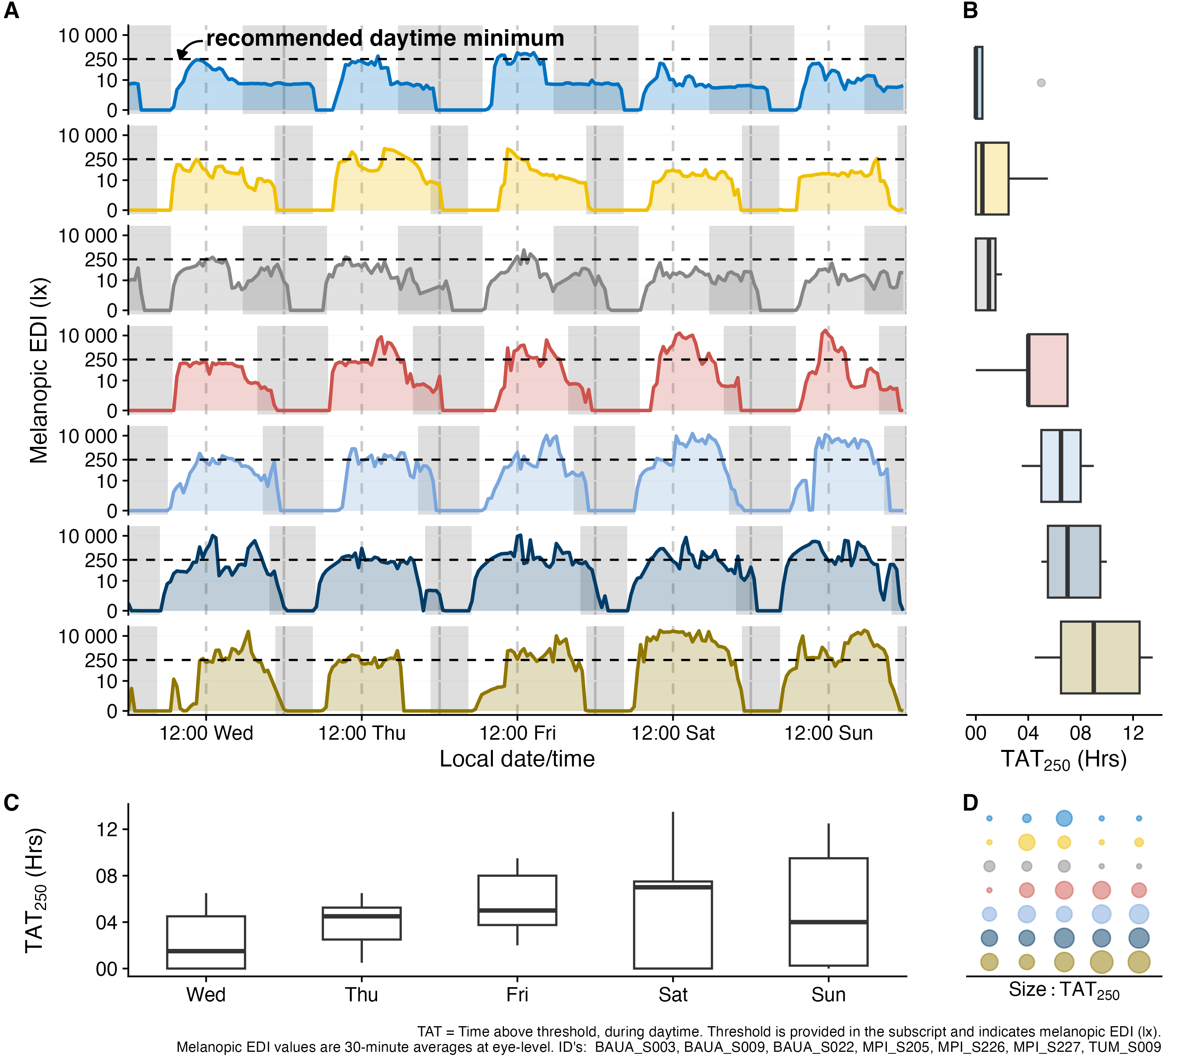
Supplementary Figure S1: Light-exposure metrics extract specific features from personal light-exposure time series. For example, time above 250 lx melanopic EDI ($TAT_{250}$) quantifies the daily duration above the recommended threshold for daytime activation and circadian synchronization. (A) Seven diverse light-exposure profiles from similar geographical locations, all German participants, shown across five days per participant. The dashed line indicates the recommended daytime threshold. (B) Boxplots of $TAT_{250}$ for each participant, illustrating pronounced intraindividual variability in some participants and relatively stable exposure patterns in others. (C) Boxplots of $TAT_{250}$ for each of the five days, showing substantial interindividual variability within days. (D) Combined participant-by-day representation of panels B and C, with circle size indicating $TAT_{250}$. This panel visualizes both interindividual and intraindividual differences.

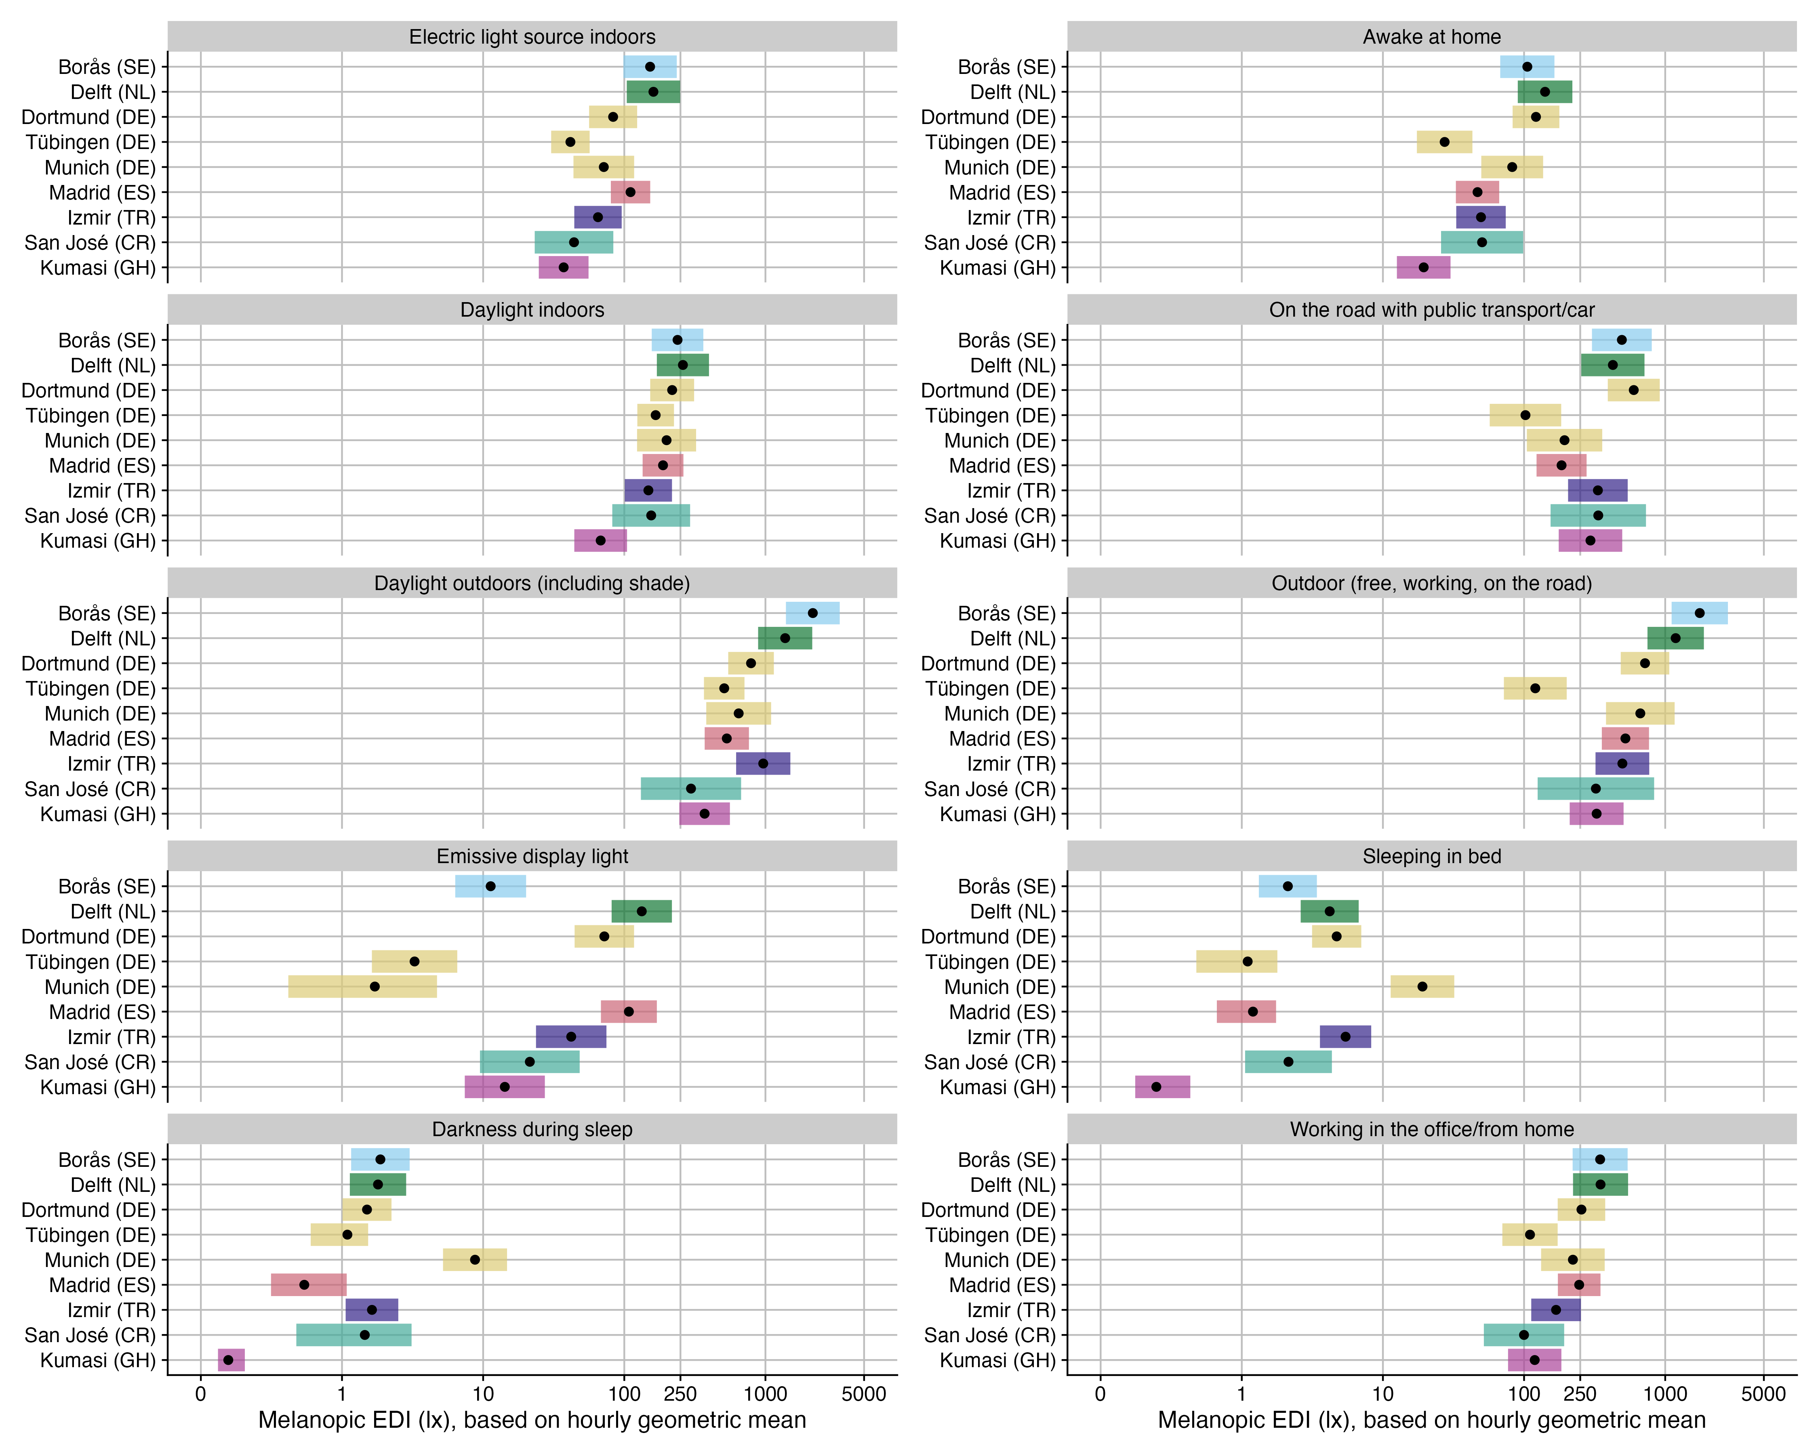
Supplementary Figure S2: Model results from H3 and H4, showing predicted interaction effects for primary light source (left panels) and activity (right panels). Black dots indicate the predicted value for a given site, with 95% confidence intervals as colored bands. .

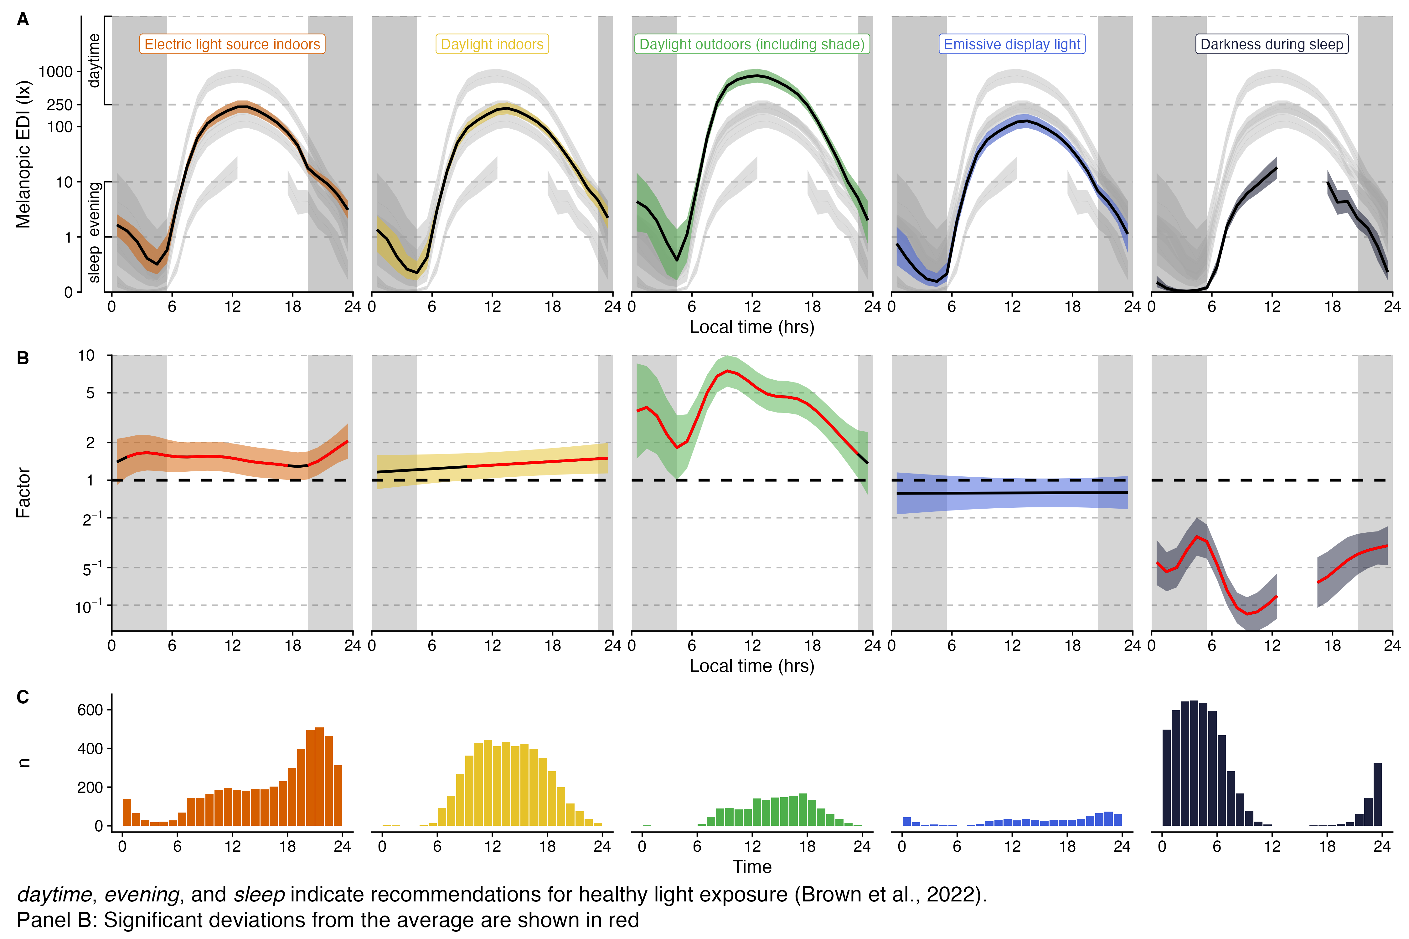
Supplementary Figure S3: Model results from H3, showing daily light exposure patterns depending on primary light source (A), deviations from the average (B), and number of observations for a given light source and time of day (C). Panels A, and B, show 95% confidence intervals as ribbons. Grey ribbons in panel A show all other categories for direct comparison. Grey shaded rectangular areas indicate average nighttimes. Red traces in panel B indicate significant deviations from the average trend of time.

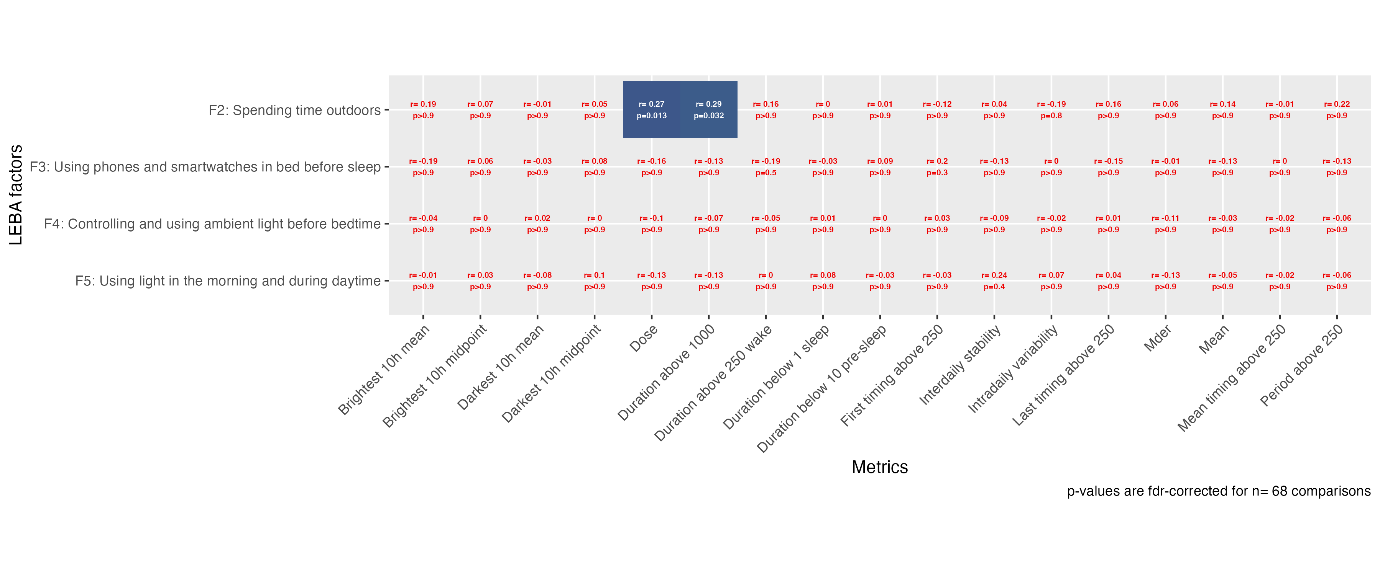
Supplementary Figure S4: Model results from H5, showing the correlation matrix of LEBA factors by exposure metrics. Correlation coefficients and p-values are shown at every grid point. Significant values are highlighted.

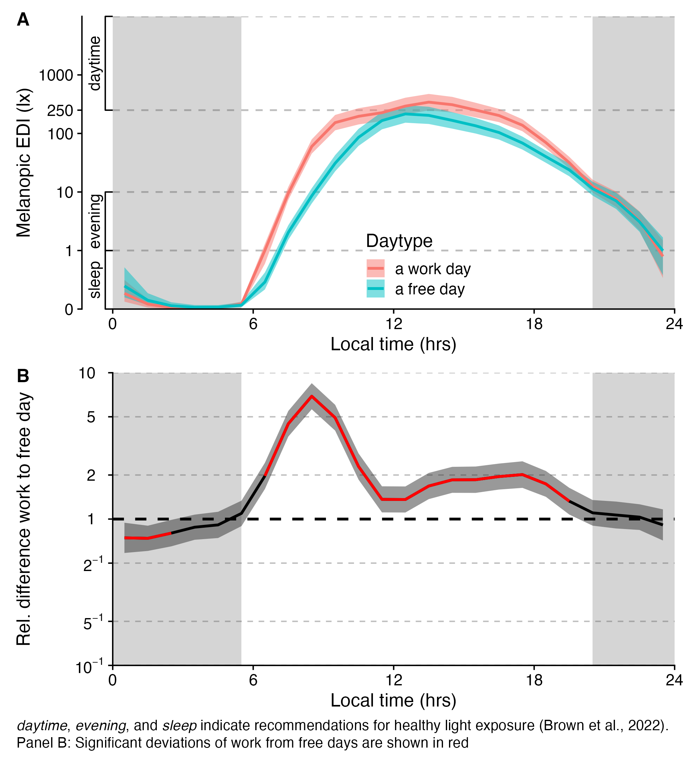
Supplementary Figure S5: Model results from H6, showing daily light exposure patterns depending on daytype (A) and differences between work-days and free days (B). Ribbons show 95% confidence intervals. Grey shaded areas indicate average nighttimes. Red traces in panel B indicate significant differences between the two daytypes.

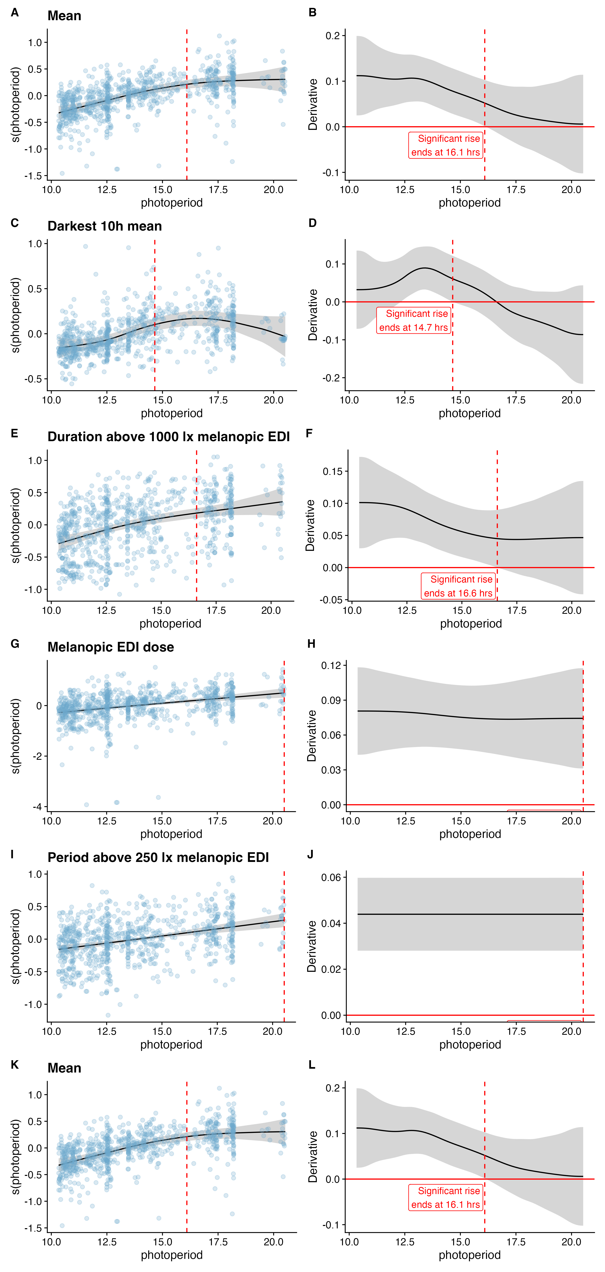
Supplementary Figure S6: Model results from H7, showing the nonlinear dependency of a given metric on photoperiod (left panels, A, C, E, G, I, K), as well as the smooth derivative of the relationship (right panels, B, D, F, H, J, L). Labels of panels H and J are deliberately cut, as no plateau was reached for these metrics.

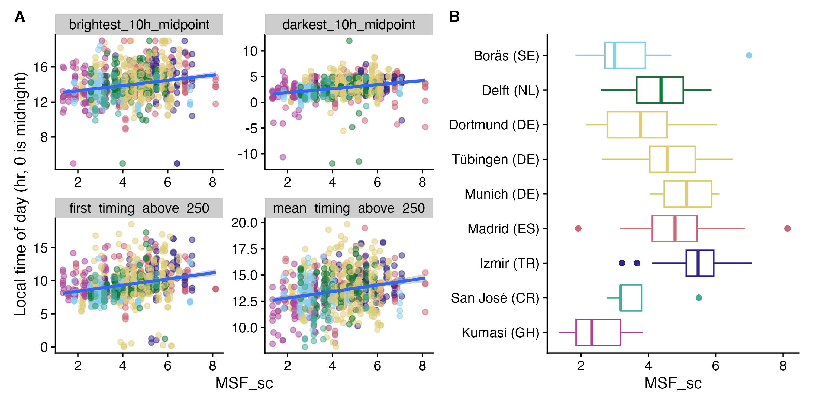
Supplementary Figure S7: Model results from H9, showing significantly associated timing metrics with chronotype. (A) scatter plots with linear smooths of metric value against midsleep on free days (sleep corrected) $MSF_{sc}$. (B) Distribution of $MSF_{sc}$ across sites.

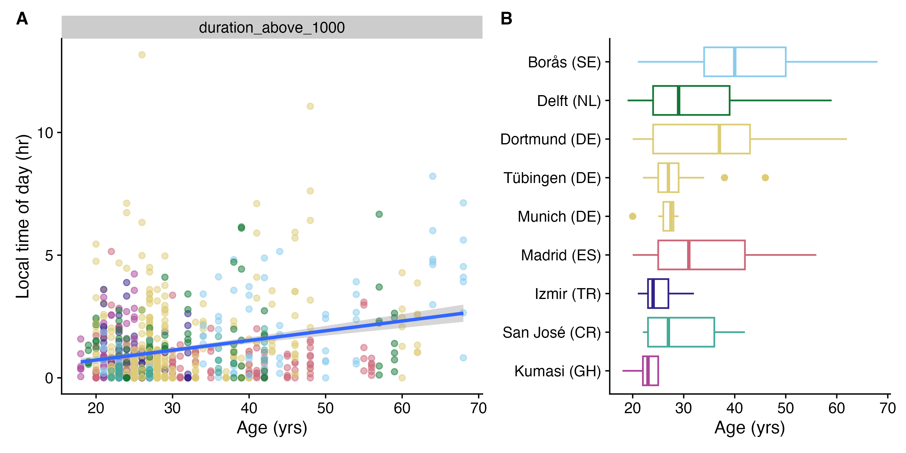
Supplementary Figure S8: Model results from H10, showing significantly associated metrics with age. (A) scatter plot with linear smooth of metric value against age. (B) Distribution of age across sites.

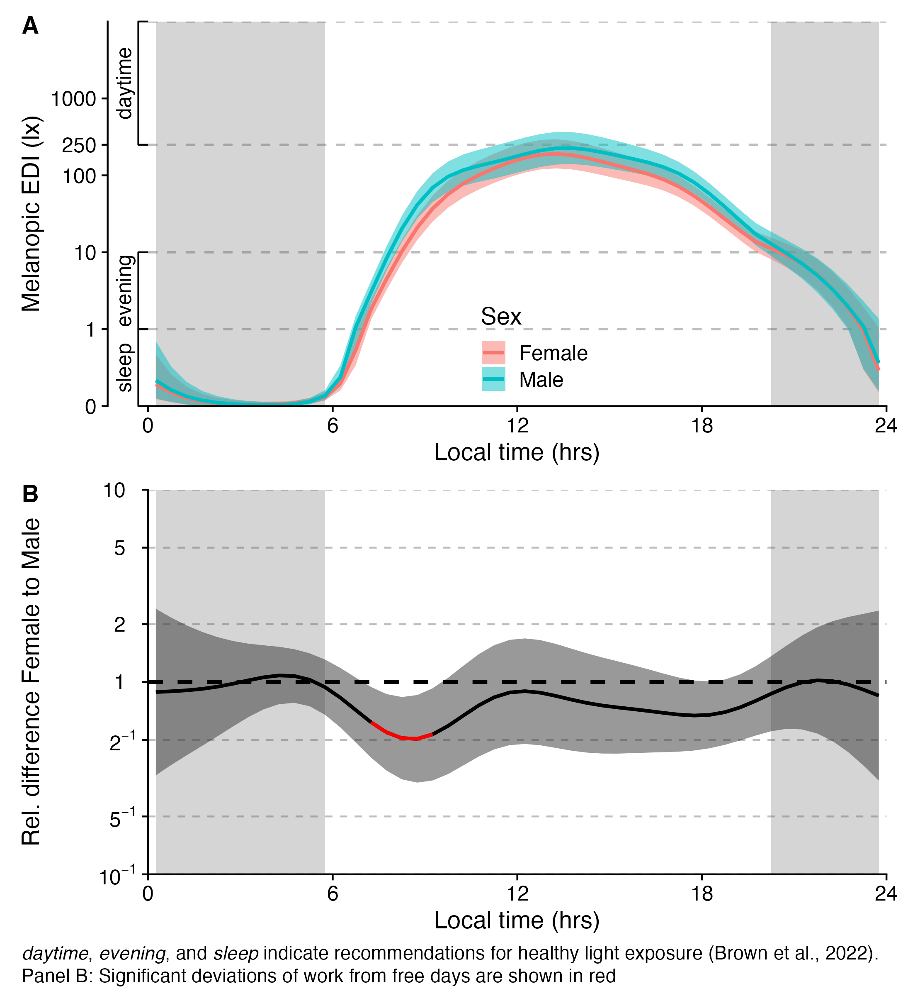
Supplementary Figure S9: Model results from H11, showing daily light exposure patterns depending on sex (A) and differences between the sexes (B). Ribbons show 95% confidence intervals. Grey shaded areas indicate average nighttimes. Red traces in panel B indicate significant differences between the sexes.

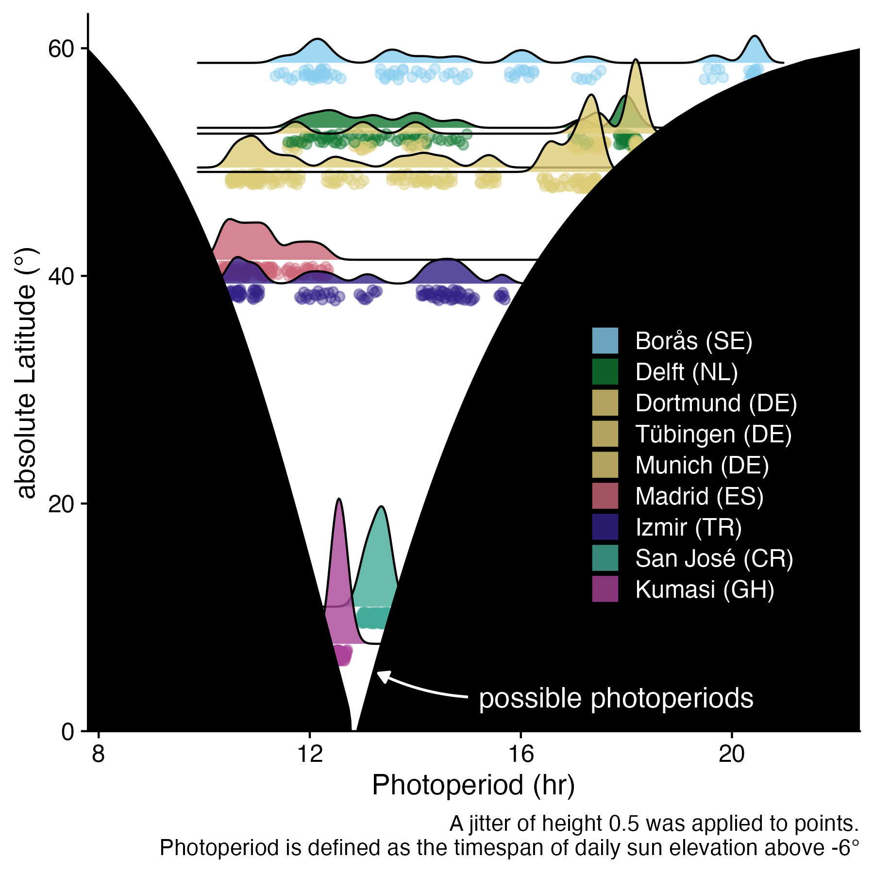
Supplementary Figure S10: Distribution of sampled photoperiod across sites shown as absolute latitude against photoperiod. The x-axis shows the photoperiod length as the duration from civil dawn until dusk. The white cone shows the possible range of photoperiods at a given (absolute) latitude. E.g., Kumasi (GH) has photoperiods between 12.5 and 13.3 hours in length, whereas Borås (SE) has photoperiods between 8.2 and 20.5 hours. The plot highlights the need and potential for future assessments across the available space.

Tables
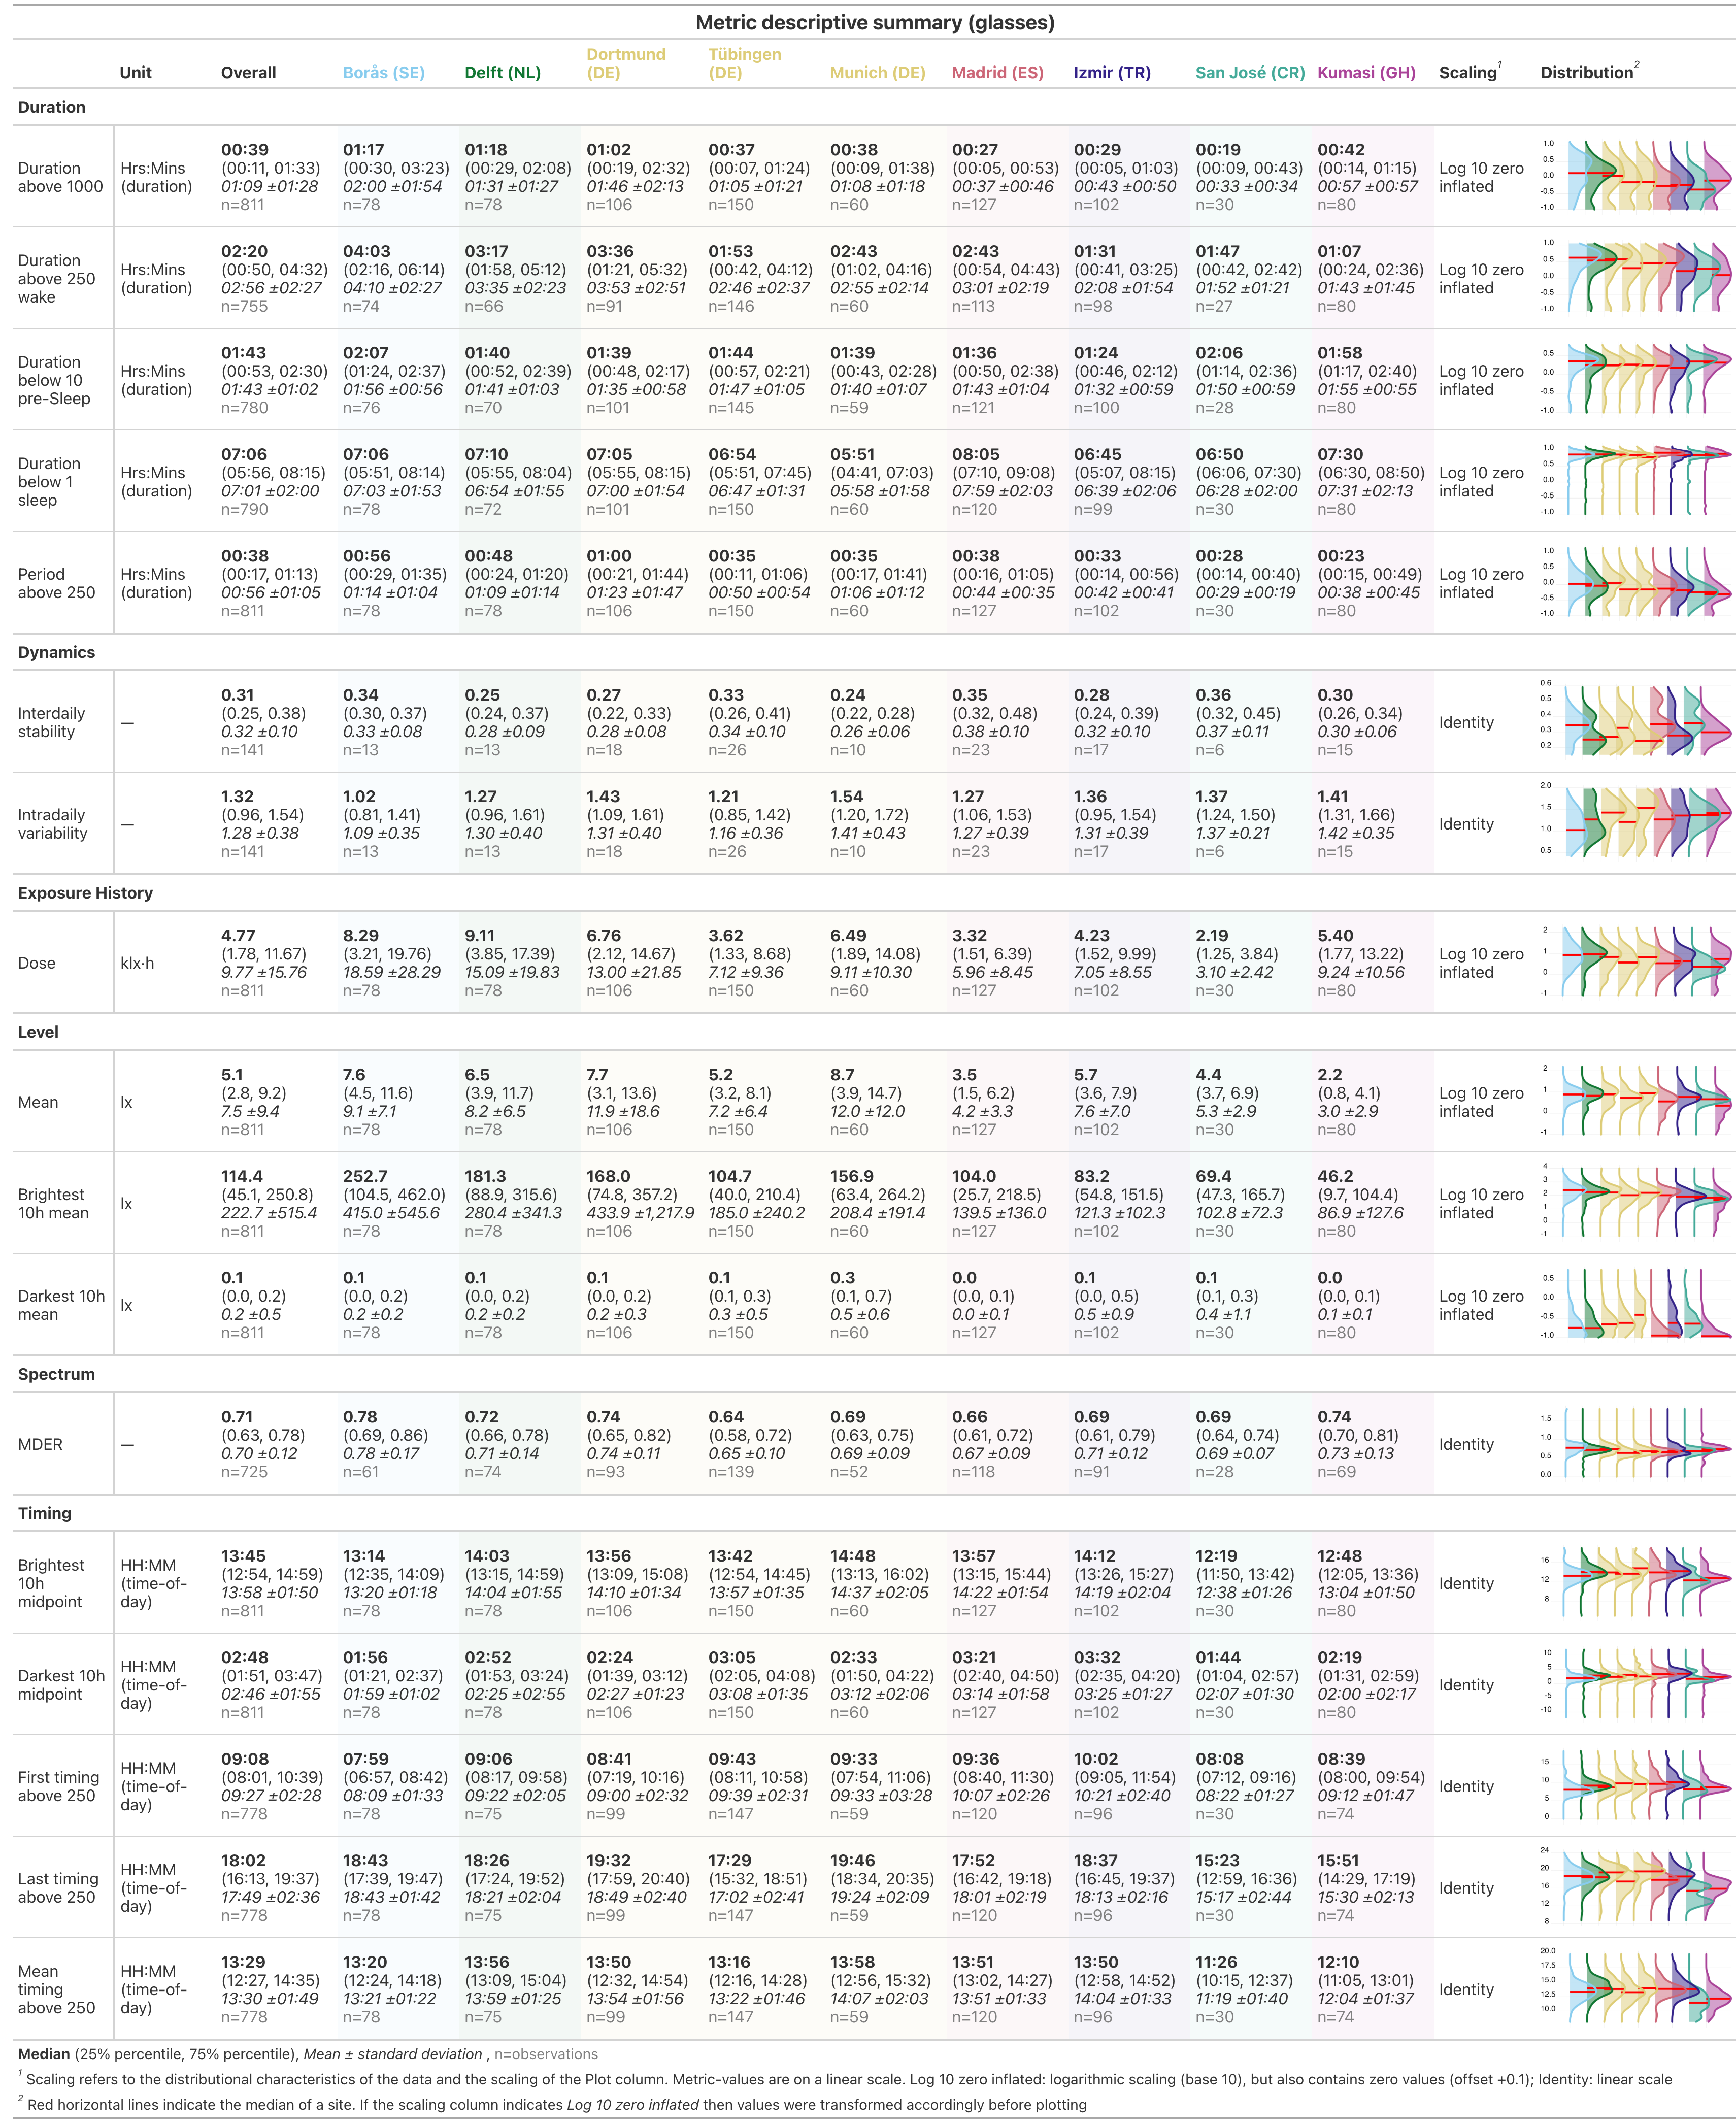
Supplementary Table S1: Summary table personal light exposure metrics for the glasses measurements. Sites are arranged from left to right by decreasing latitude.

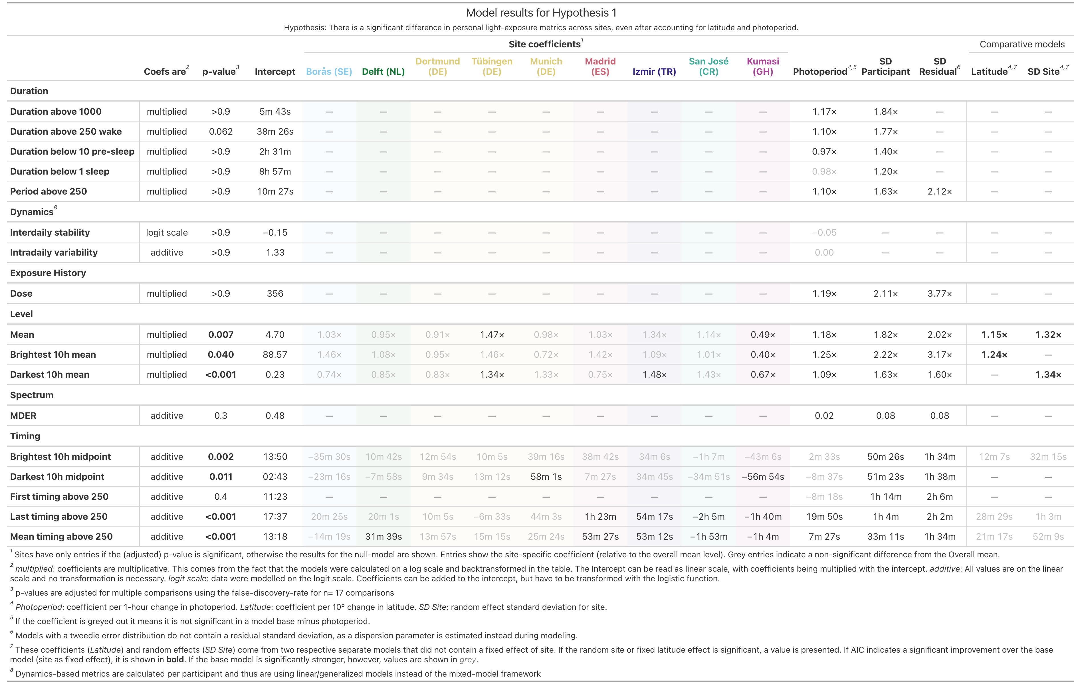
Supplementary Table S2: Model results for Hypothesis 1

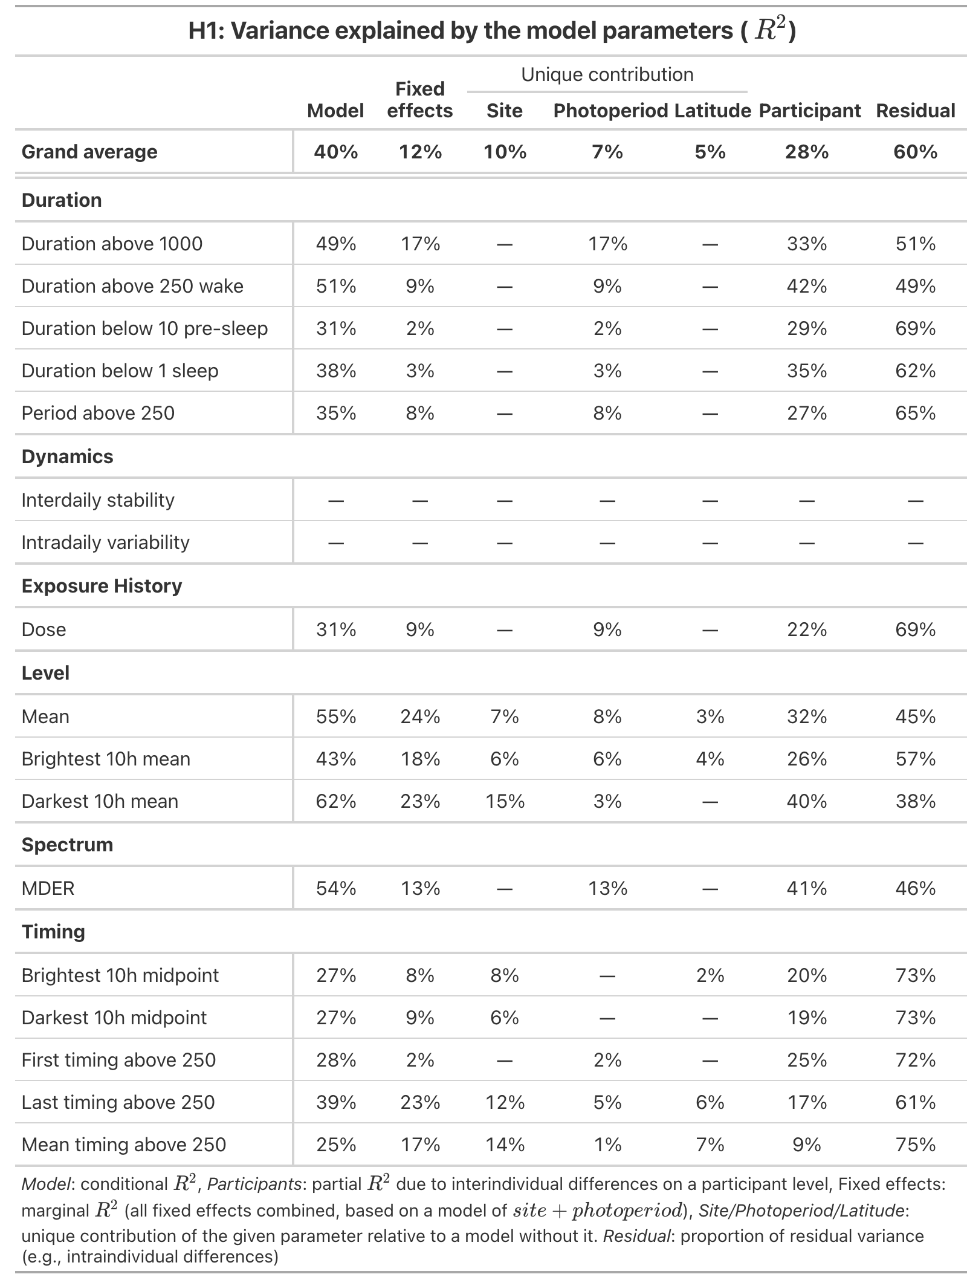
Supplementary Table S3: Summary table of $R^{2}$ for models in Hypothesis 1

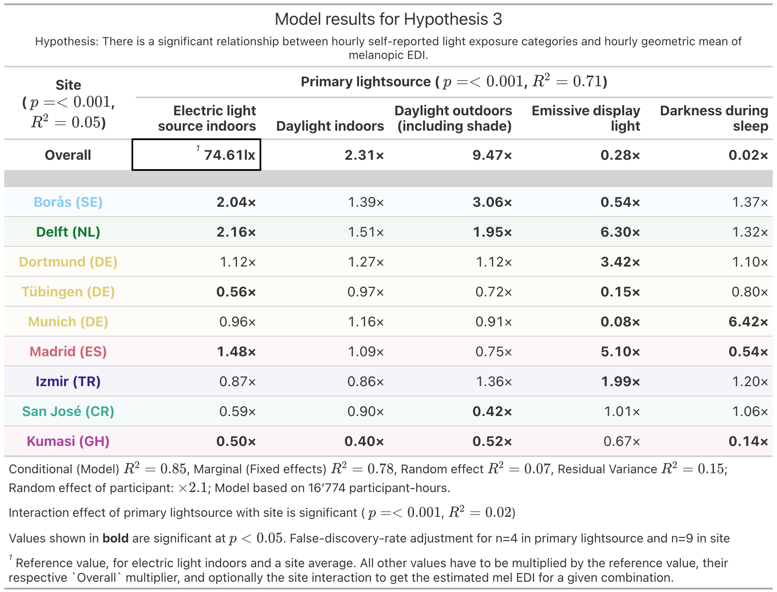
Supplementary Table S4: Model results for Hypothesis 3

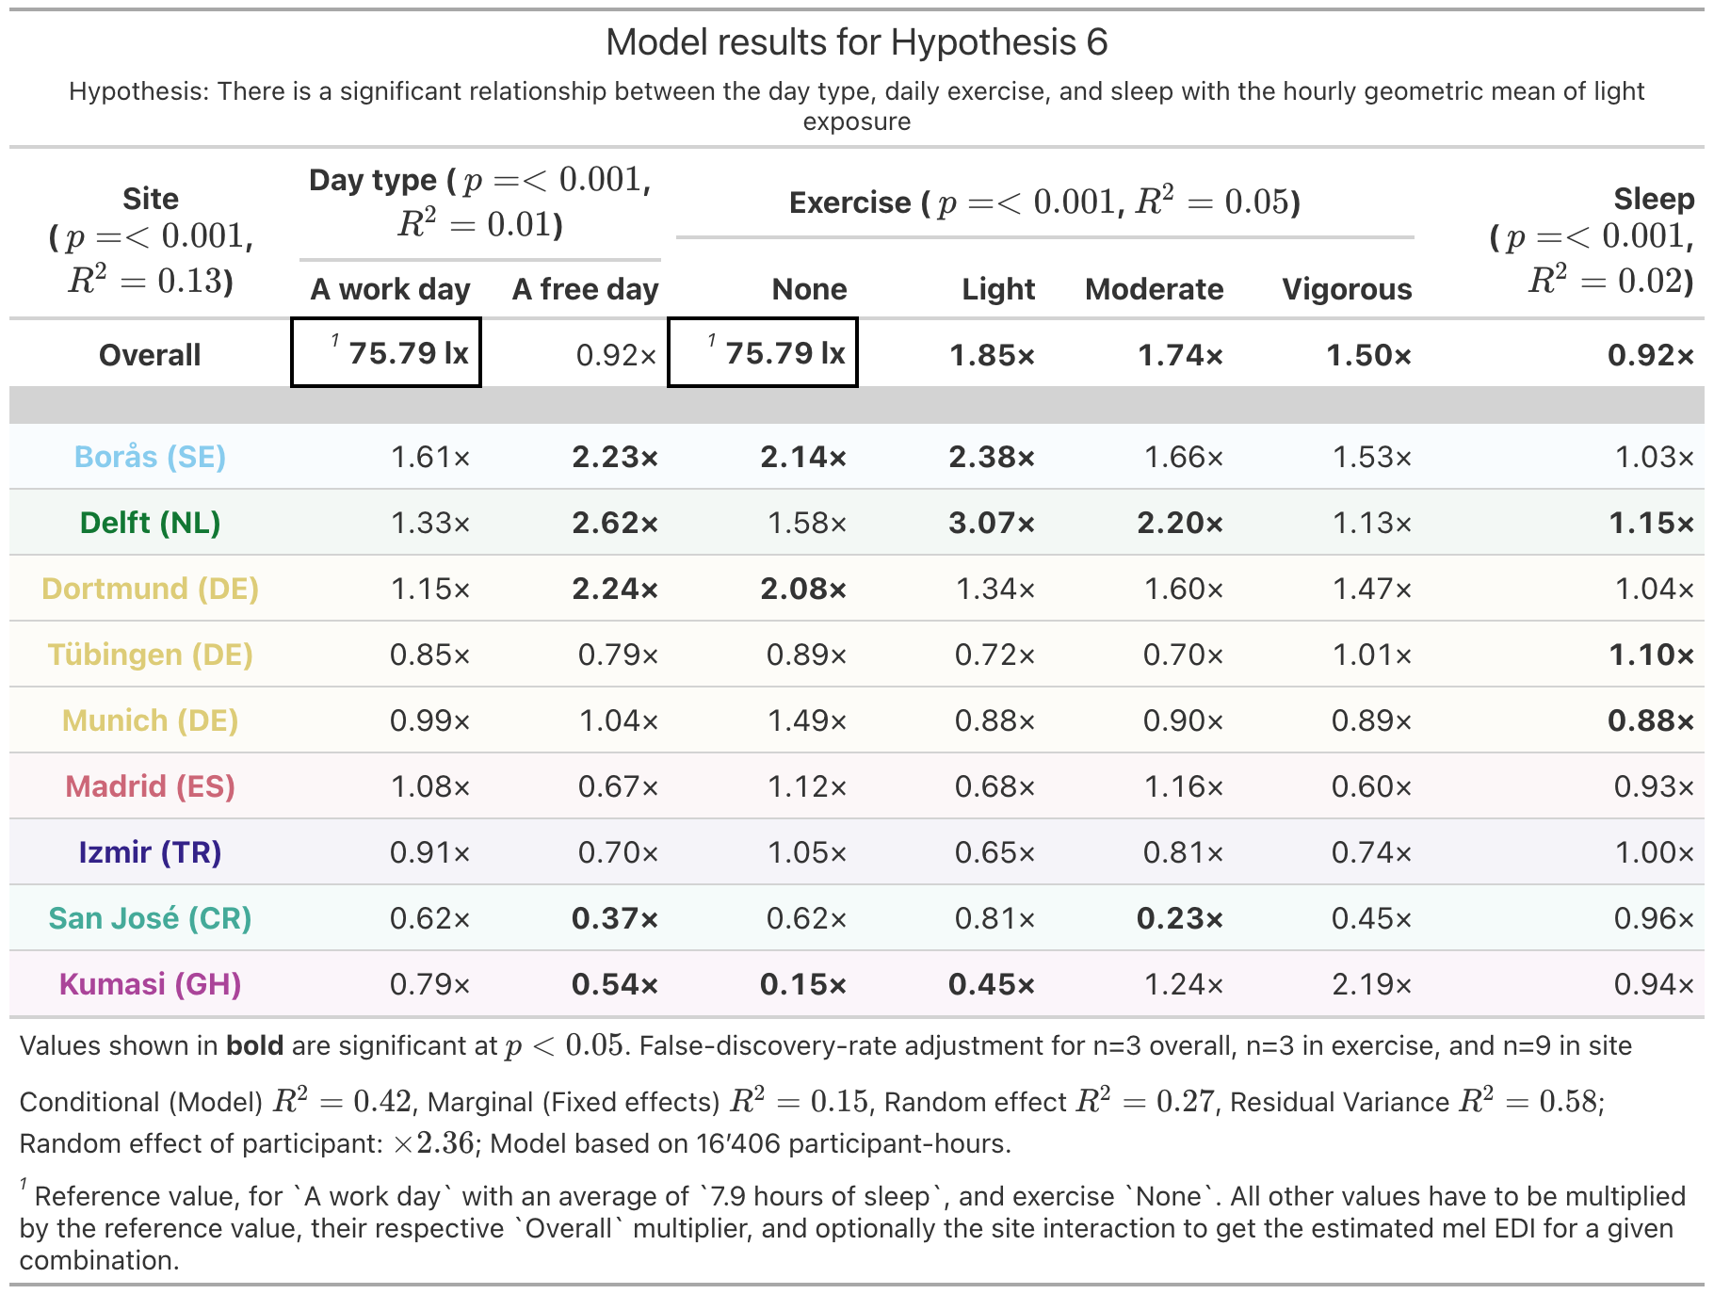
Supplementary Table S5: Model results for Hypothesis 6

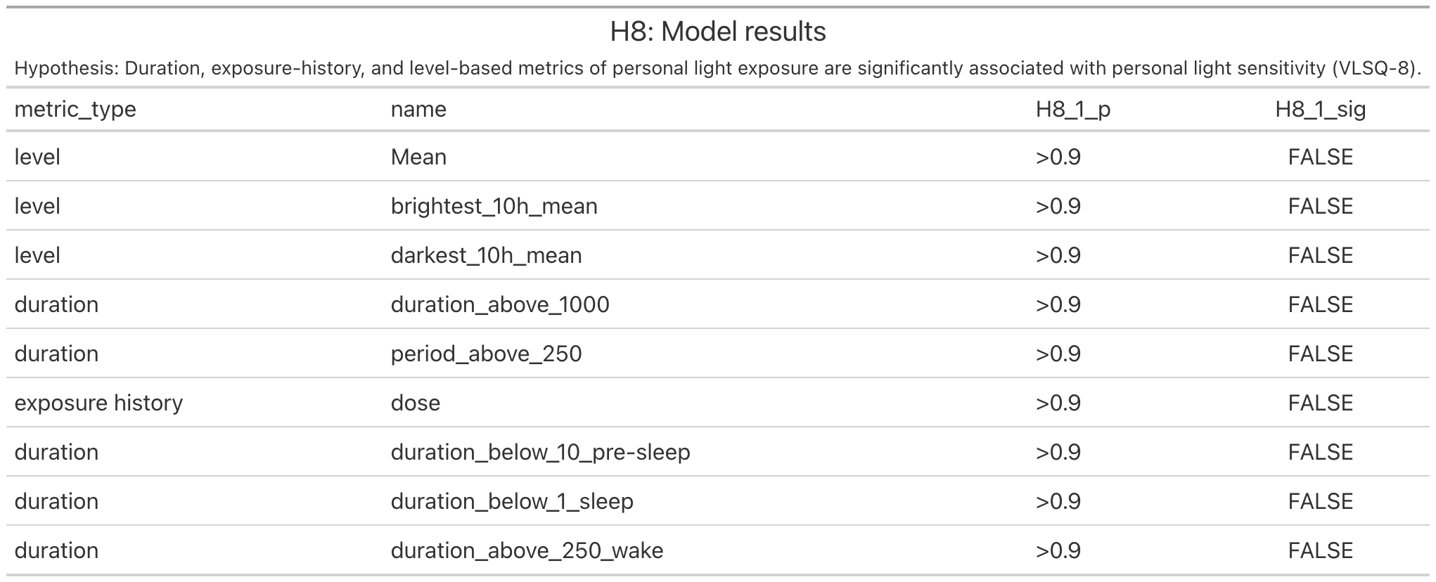
Supplementary Table S6: Model results for Hypothesis 8

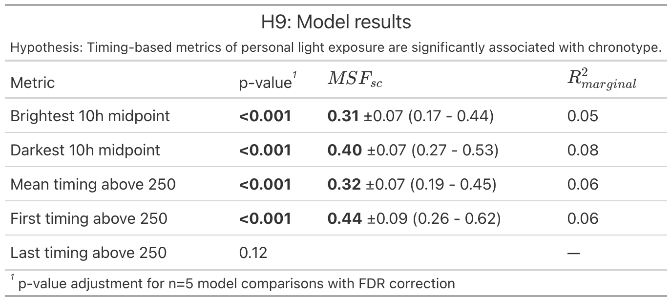
Supplementary Table S7: Model results for Hypothesis 9

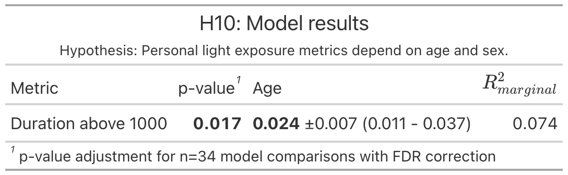
Supplementary Table S8: Signiciant model results for Hypothesis 10

