Table 3. Near-eye metrics and geographic and photoperiod context
Table 3: Near-eye personal light-exposure metrics and their geographic and photoperiod context. Descriptive exposure values are medians with interquartile ranges (25th to 75th percentiles). Density plots show site distributions and are descriptive. Metrics are grouped into thematic streams and describe distinct features of the daily exposure pattern rather than interchangeable health-response estimates. Model cells report overall-site evidence, civil-photoperiod associations with 95% confidence intervals, FDR decisions, participant-associated model information and model-specific R² summaries where applicable. Site and photoperiod part-R² values may contain overlapping fitted information and must not be summed. Associations are observational. Absolute latitude is fixed within and confounded with study site, so separate models containing either site or latitude are reported; complete latitude and model-adequacy results are provided in the Supplementary Information.
Near-eye personal light-exposure metrics and their geographic and photoperiod context
 | Definition/relevance | Descriptive summary |  | Association evidence |  | Modelled variation
 | Definition/relevance | Overall distribution | Site distribution | Overall site | Civil photoperiod | R² summary
Duration
Time above 1,000 lx melEDI | Bright-light exposure duration; relevant to daytime alerting and circadian entrainment. | Unit h  Median 0.683  IQR 0.183 to 1.558  Participants 141  Days 816 | 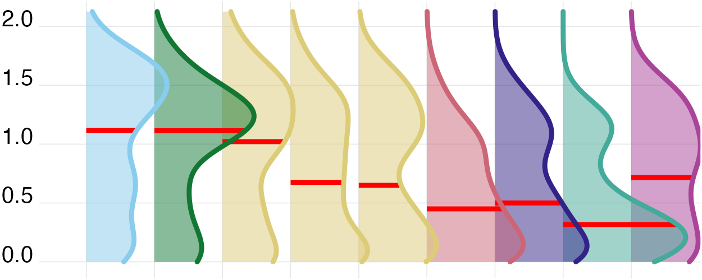 | FDR not supported; adjusted p 0.071  Part R-squared 4.7% (2.6% to 12.1%) | Estimate Ratio per 1 h: 1.206 (1.128 to 1.288)  FDR supported; adjusted p <0.001  Part R-squared 9.0% (3.7% to 15.7%) | Marginal 21.5% (16.3% to 32.3%)  Conditional 50.1% (40.2% to 57.6%)  Participant-associated 28.6% (17.7% to 34.2%)
Time above 250 lx melEDI during wake | Waking time in recommended daytime light; relevant to alertness, entrainment, and subsequent sleep. | Unit h  Median 2.417  IQR 0.850 to 4.617  Participants 141  Days 737 | 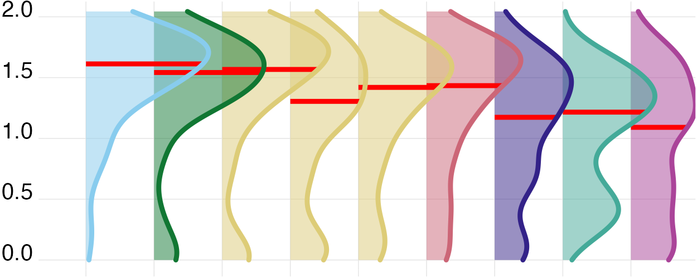 | FDR supported; adjusted p 0.007  Part R-squared 8.6% (5.2% to 18.7%) | Estimate Ratio per 1 h: 1.136 (1.073 to 1.202)  FDR supported; adjusted p <0.001  Part R-squared 6.4% (2.0% to 12.7%) | Marginal 18.0% (12.9% to 29.1%)  Conditional 50.1% (41.6% to 58.0%)  Participant-associated 32.1% (20.7% to 36.7%)
Time below 10 lx melEDI before sleep | Low-light time before bed; limits evening melatonin suppression and circadian delay. | Unit h  Median 1.883  IQR 1.025 to 2.583  Participants 139  Days 655 | 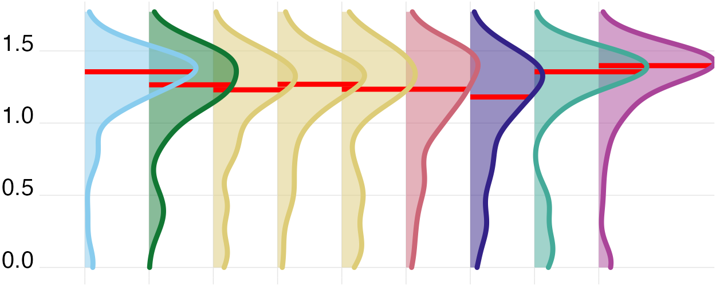 | FDR supported; adjusted p 0.049  Part R-squared 5.4% (3.2% to 13.4%) | Estimate Difference per 1 h: -0.134 (-0.201 to -0.066)  FDR supported; adjusted p <0.001  Part R-squared 4.9% (1.2% to 10.5%) | Marginal 7.6% (4.6% to 17.2%)  Conditional 38.3% (31.8% to 48.5%)  Participant-associated 30.7% (21.7% to 38.1%)
Time below 1 lx melEDI during sleep | Darkness during sleep; supports nocturnal melatonin and an undisturbed sleep environment. | Unit h  Median 7.133  IQR 5.967 to 8.250  Participants 141  Days 778 | 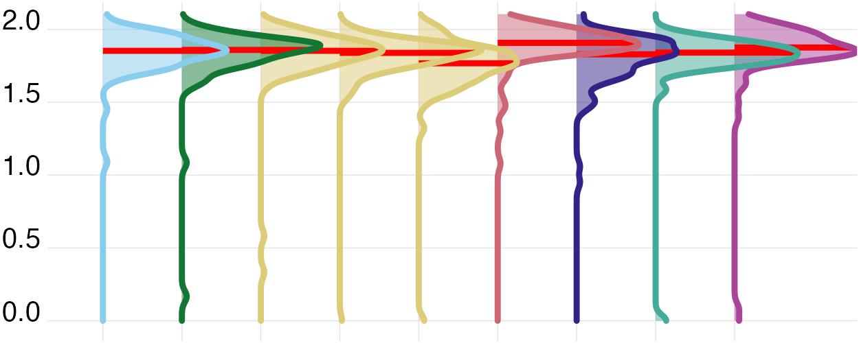 | FDR not supported; adjusted p 0.058  Part R-squared 5.4% (3.2% to 14.2%) | Estimate Ratio per 1 h: 0.987 (0.968 to 1.006)  FDR not supported; adjusted p 0.227  Part R-squared 0.6% (0.0% to 3.8%) | Marginal 8.0% (5.1% to 18.2%)  Conditional 40.9% (32.8% to 48.5%)  Participant-associated 32.9% (22.0% to 37.8%)
Longest period above 250 lx melEDI | Longest sustained bright-light bout; captures continuity of daytime circadian stimulation. | Unit h  Median 0.633  IQR 0.283 to 1.204  Participants 141  Days 816 | 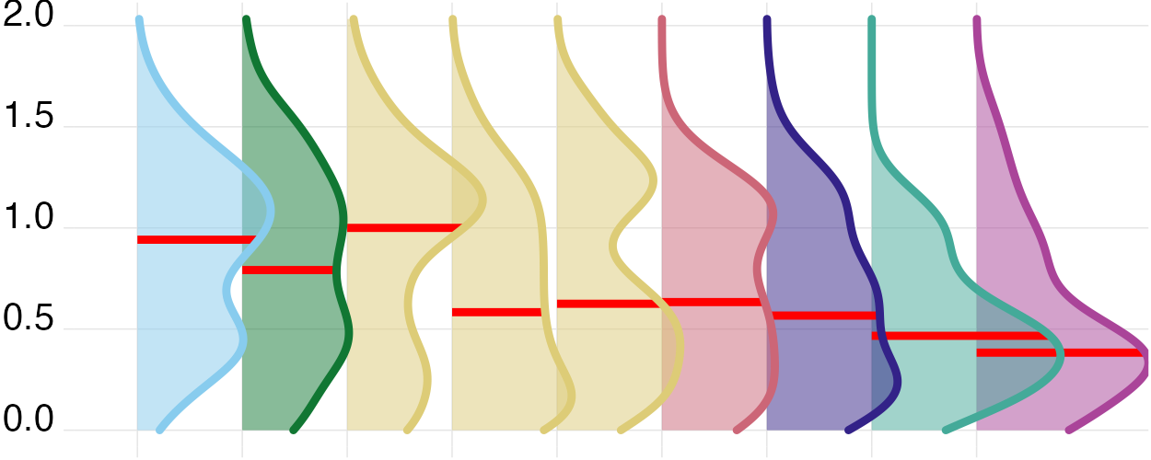 | FDR not supported; adjusted p 0.398  Part R-squared 2.2% (1.4% to 8.1%) | Estimate Ratio per 1 h: 1.125 (1.065 to 1.187)  FDR supported; adjusted p <0.001  Part R-squared 4.9% (1.3% to 9.6%) | Marginal 10.0% (6.1% to 17.9%)  Conditional 36.3% (29.9% to 45.3%)  Participant-associated 26.3% (18.7% to 33.0%)
Dynamics
Interdaily stability | Day-to-day regularity of the light–dark pattern; higher regularity supports circadian stability. | Unit dimensionless  Median 0.308  IQR 0.248 to 0.380  Participants 141  Days 816 | 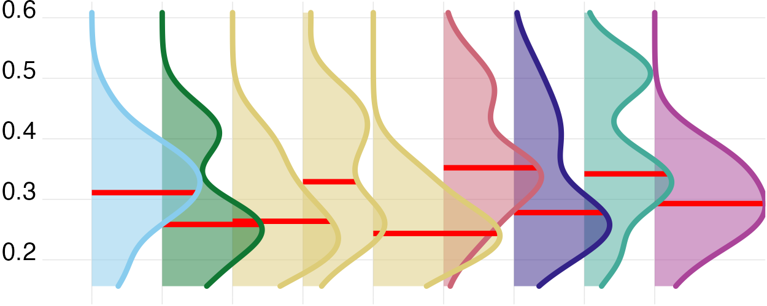 | FDR not supported; adjusted p 0.228  Part R-squared 6.9% (4.1% to 20.4%) | Estimate Odds ratio per 1 h: 0.983 (0.944 to 1.024)  FDR not supported; adjusted p 0.401  Part R-squared 0.4% (0.0% to 4.6%) | Marginal 15.4% (10.4% to 30.8%)  Conditional 15.4% (10.4% to 30.8%)  Participant-associated Not available
Intradaily variability | Within-day fragmentation of light exposure; higher values indicate less consolidated light–dark input. | Unit dimensionless  Median 1.253  IQR 0.930 to 1.502  Participants 141  Days 816 | 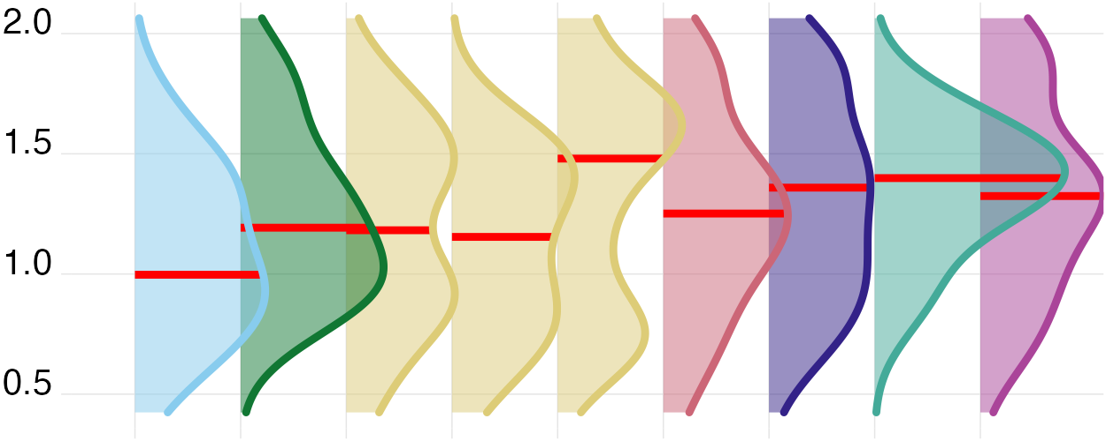 | FDR not supported; adjusted p 0.483  Part R-squared 5.1% (3.8% to 18.7%) | Estimate Difference per 1 h: -0.019 (-0.056 to 0.019)  FDR not supported; adjusted p 0.327  Part R-squared 0.7% (0.0% to 5.7%) | Marginal 5.9% (4.6% to 21.2%)  Conditional 5.9% (4.6% to 21.2%)  Participant-associated Not available
Exposure history
melEDI dose | Intensity–duration-weighted melanopic exposure; summarizes cumulative non-visual retinal light input. | Unit klx·h  Median 4.960  IQR 1.936 to 12.313  Participants 141  Days 761 | 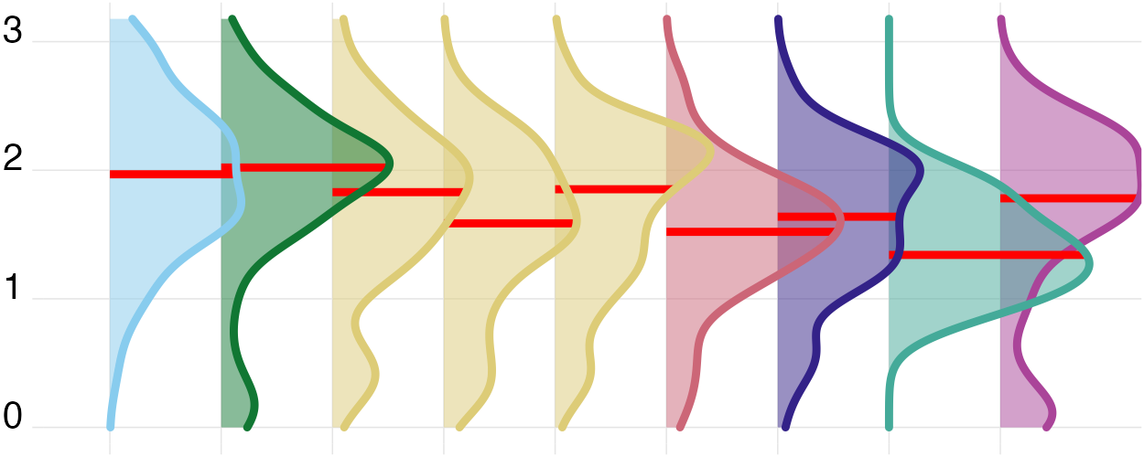 | FDR not supported; adjusted p 0.209  Part R-squared 2.8% (1.7% to 8.6%) | Estimate Ratio per 1 h: 1.275 (1.169 to 1.391)  FDR supported; adjusted p <0.001  Part R-squared 7.5% (3.1% to 12.9%) | Marginal 11.8% (7.7% to 19.7%)  Conditional 33.8% (26.7% to 42.8%)  Participant-associated 22.0% (14.5% to 28.7%)
Level
Mean melEDI | Geometric average of daily melEDI values, including zeros; summarizes overall exposure while reducing peak influence. | Unit lx  Median 5.154  IQR 2.831 to 9.225  Participants 141  Days 816 | 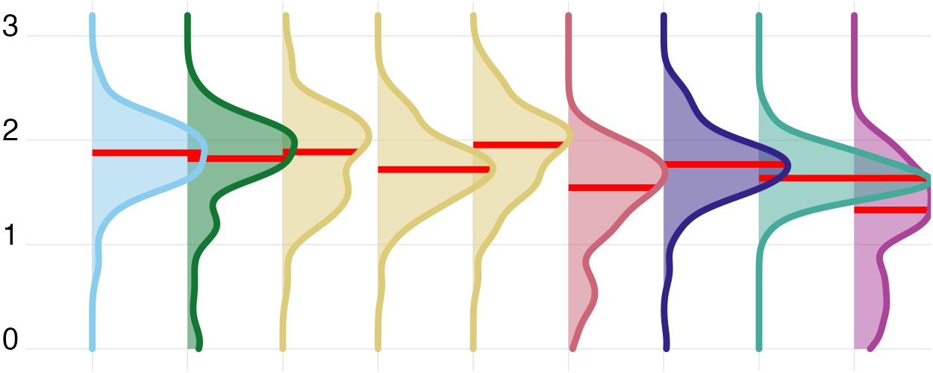 | FDR supported; adjusted p <0.001  Part R-squared 8.4% (4.8% to 16.6%) | Estimate Ratio per 1 h: 1.181 (1.109 to 1.257)  FDR supported; adjusted p <0.001  Part R-squared 7.7% (2.9% to 13.9%) | Marginal 25.4% (18.6% to 34.4%)  Conditional 57.7% (51.9% to 65.1%)  Participant-associated 32.3% (24.5% to 39.4%)
Brightest 10 h geometric mean | Offset geometric mean melEDI in the brightest supported 10-hour window; describes the strength of the main sustained daily exposure. | Unit lx  Median 110.566  IQR 41.513 to 243.212  Participants 141  Days 816 | 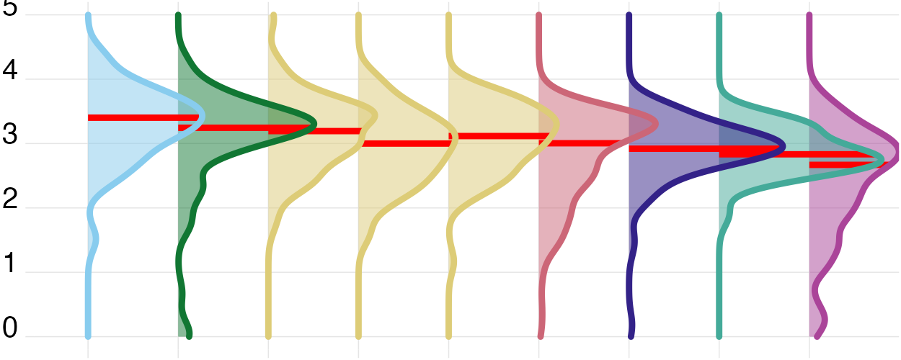 | FDR supported; adjusted p 0.011  Part R-squared 5.7% (3.3% to 12.7%) | Estimate Ratio per 1 h: 1.243 (1.133 to 1.363)  FDR supported; adjusted p <0.001  Part R-squared 5.8% (1.9% to 11.1%) | Marginal 17.6% (12.1% to 26.0%)  Conditional 46.0% (39.6% to 54.3%)  Participant-associated 28.4% (20.9% to 35.4%)
Darkest 10 h geometric mean | Offset geometric mean melEDI in the darkest supported 10-hour window; describes the sustained low-light period. | Unit lx  Median 0.103  IQR 0.020 to 0.253  Participants 141  Days 816 | 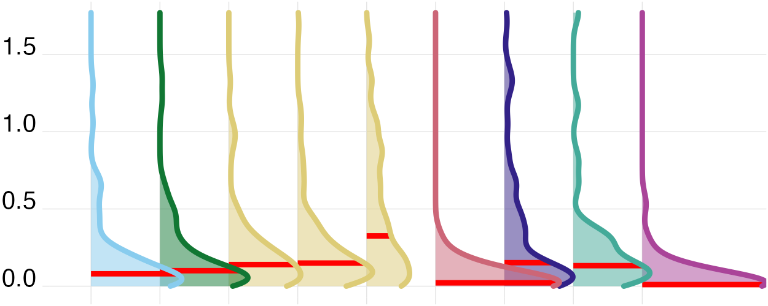 | FDR supported; adjusted p <0.001  Part R-squared 13.7% (9.2% to 23.9%) | Estimate Ratio per 1 h: 1.088 (1.034 to 1.144)  FDR supported; adjusted p 0.002  Part R-squared 3.4% (0.5% to 8.3%) | Marginal 22.0% (15.8% to 31.8%)  Conditional 61.1% (55.3% to 68.1%)  Participant-associated 39.1% (30.4% to 46.2%)
Spectrum
Melanopic daylight efficacy ratio | Mean of viable one-minute melEDI/illuminance ratios; indicates melanopic efficacy relative to visual light. | Unit dimensionless  Median 0.724  IQR 0.643 to 0.795  Participants 137  Days 687 | 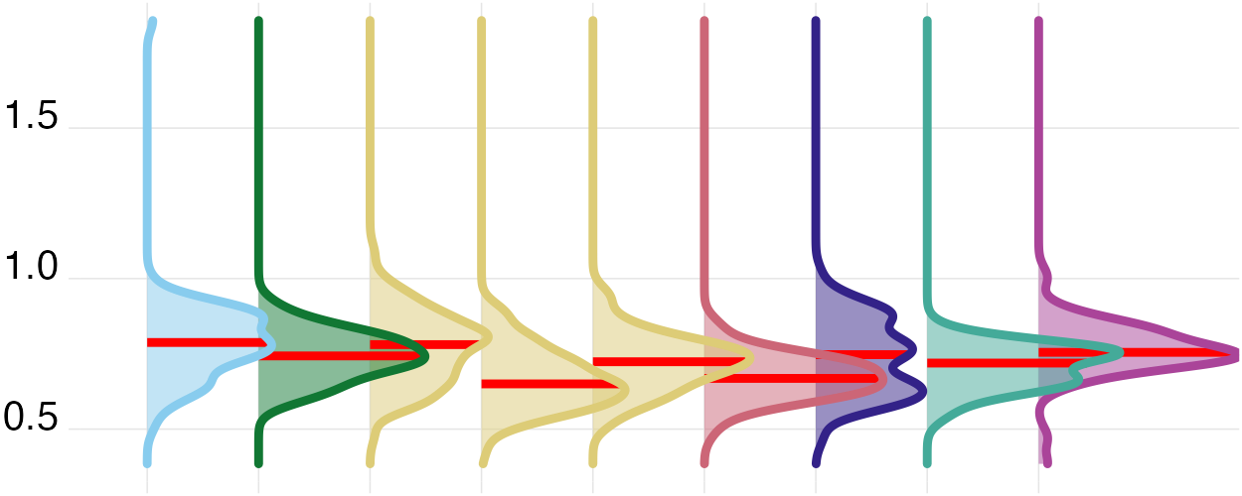 | FDR supported; adjusted p <0.001  Part R-squared 9.6% (6.0% to 17.8%) | Estimate Difference per 1 h: 0.024 (0.017 to 0.031)  FDR supported; adjusted p <0.001  Part R-squared 13.0% (6.7% to 20.6%) | Marginal 27.8% (21.3% to 38.1%)  Conditional 60.5% (54.6% to 68.2%)  Participant-associated 32.7% (24.1% to 40.0%)
Timing
Midpoint of the brightest 10 hours | Centre time of the brightest 10 hours; indexes the main daily circadian light cue. | Unit clock time  Median 13:44  IQR 12:48 to 15:00  Participants 141  Days 816 | 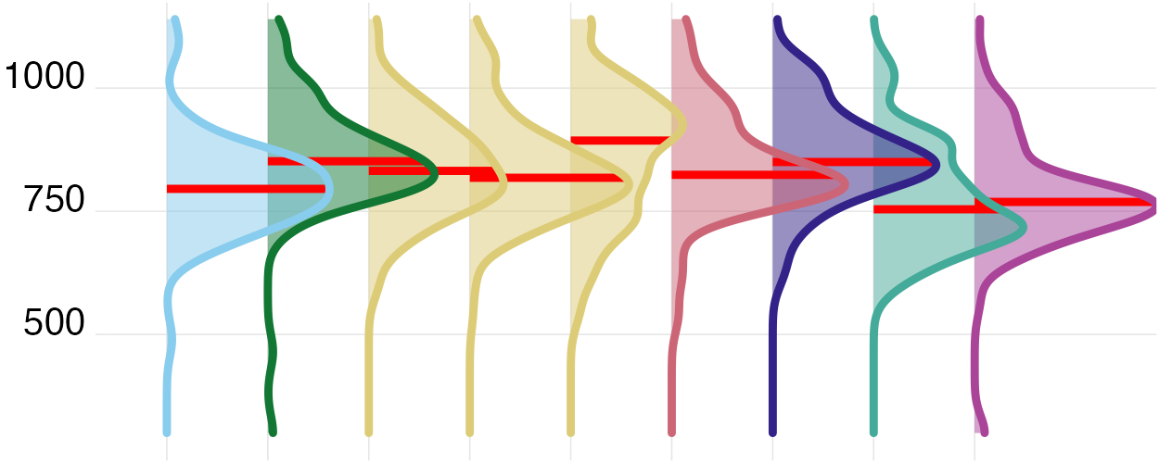 | FDR supported; adjusted p <0.001  Part R-squared 6.5% (4.4% to 12.6%) | Estimate Difference per 1 h: 0.054 (-0.045 to 0.153)  FDR not supported; adjusted p 0.305  Part R-squared 0.2% (0.0% to 1.8%) | Marginal 6.7% (4.6% to 13.0%)  Conditional 22.9% (16.9% to 31.6%)  Participant-associated 16.2% (9.6% to 22.4%)
Midpoint of the darkest 10 hours | Centre time of the darkest 10 hours; indexes the main daily darkness cue. | Unit clock time  Median 02:54  IQR 02:01 to 03:50  Participants 141  Days 816 | 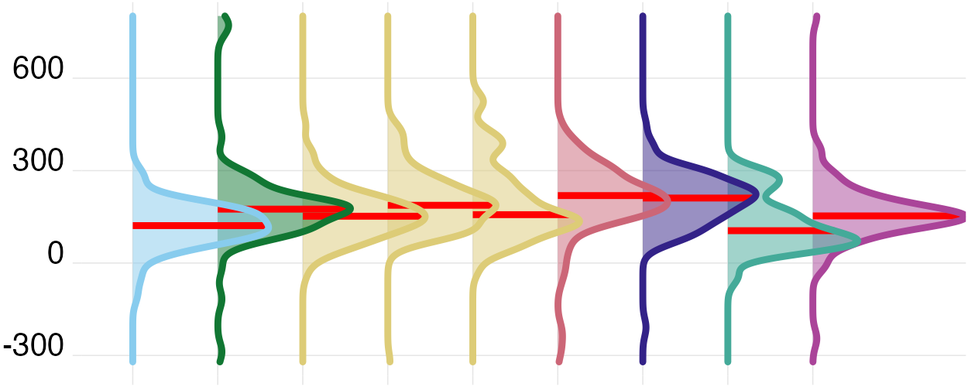 | FDR supported; adjusted p 0.020  Part R-squared 4.6% (3.0% to 10.5%) | Estimate Difference per 1 h: -0.148 (-0.245 to -0.050)  FDR supported; adjusted p 0.004  Part R-squared 2.1% (0.3% to 5.6%) | Marginal 8.6% (5.9% to 15.8%)  Conditional 28.2% (22.1% to 36.7%)  Participant-associated 19.6% (12.6% to 25.8%)
First light timing above 250 lx melEDI | First waking bright-light exposure; morning timing can advance circadian phase and promote alertness. | Unit clock time  Median 09:08  IQR 08:02 to 10:40  Participants 140  Days 727 | 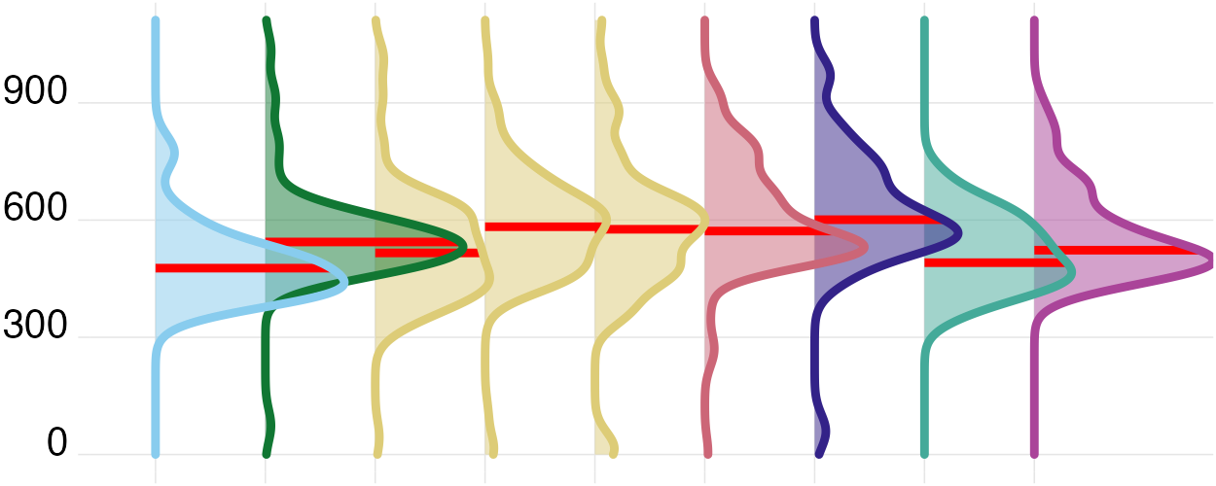 | FDR not supported; adjusted p 0.112  Part R-squared 3.8% (2.3% to 10.2%) | Estimate Difference per 1 h: -0.097 (-0.247 to 0.053)  FDR not supported; adjusted p 0.227  Part R-squared 0.5% (0.0% to 2.8%) | Marginal 6.8% (4.4% to 14.4%)  Conditional 31.0% (24.6% to 40.5%)  Participant-associated 24.2% (16.2% to 31.5%)
Last light timing above 250 lx melEDI | Last bright-light exposure; later timing may delay circadian phase and sleep onset. | Unit clock time  Median 18:08  IQR 16:27 to 19:42  Participants 141  Days 687 | 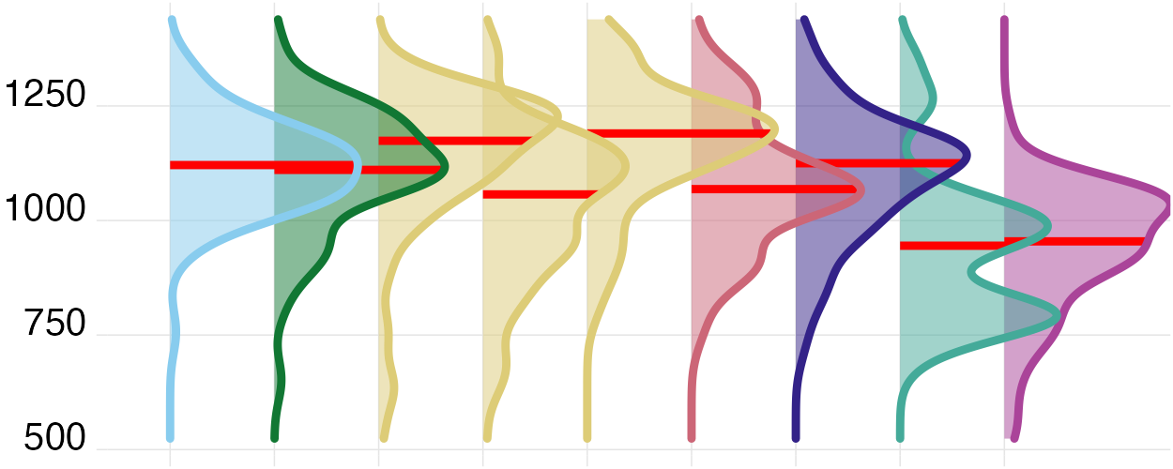 | FDR supported; adjusted p <0.001  Part R-squared 11.6% (8.3% to 18.6%) | Estimate Difference per 1 h: 0.323 (0.186 to 0.460)  FDR supported; adjusted p <0.001  Part R-squared 4.5% (1.5% to 8.5%) | Marginal 22.2% (17.0% to 30.2%)  Conditional 37.9% (31.6% to 46.3%)  Participant-associated 15.8% (9.7% to 22.3%)
Mean timing of exposure above 250 lx melEDI | Average bright-light timing; summarizes the phase of daily circadian stimulation. | Unit clock time  Median 13:29  IQR 12:29 to 14:39  Participants 141  Days 742 | 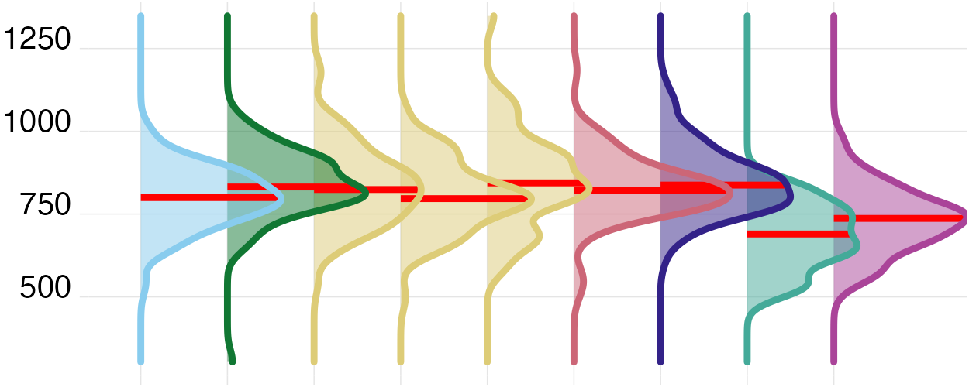 | FDR supported; adjusted p <0.001  Part R-squared 12.7% (9.4% to 19.2%) | Estimate Difference per 1 h: 0.121 (0.028 to 0.213)  FDR supported; adjusted p 0.013  Part R-squared 1.2% (0.1% to 3.6%) | Marginal 14.7% (10.7% to 21.9%)  Conditional 25.7% (19.8% to 34.2%)  Participant-associated 11.0% (5.3% to 17.2%)
Overall distributions are median (interquartile range). Participants is the participant count and Days is the participant-day count. Site and photoperiod part-R² values can contain overlapping fitted information and must not be summed. Participant-associated R² is the conditional-minus-marginal contribution associated with the participant random intercept and is undefined for participant-level outcomes. The MDER uses the mean of viable minute-level ratios in both the descriptive summary and geographic-association model cells.

