Table S2. Full near-eye metric dictionary and distributions
Metric descriptive summary (near eye)
Metric¹ | Unit | Overall | Borås  (SE) | Delft  (NL) | Dortmund  (DE) | Tübingen  (DE) | Munich  (DE) | Madrid  (ES) | Izmir  (TR) | San José  (CR) | Kumasi  (GH) | Scaling² | Distribution³
Duration
Time above 1,000 lx melEDI  Bright-light exposure duration; relevant to daytime alerting and circadian entrainment. | HH:MM | 00:41  (00:11, 01:33)  01:10 ± 01:28  N=141; d=816 | 01:18  (00:31, 03:24)  02:00 ± 01:54  N=13; d=78 | 01:18  (00:29, 02:12)  01:33 ± 01:28  N=13; d=78 | 01:03  (00:20, 02:32)  01:48 ± 02:14  N=18; d=107 | 00:40  (00:07, 01:25)  01:06 ± 01:22  N=26; d=150 | 00:39  (00:10, 01:46)  01:09 ± 01:18  N=10; d=60 | 00:27  (00:06, 00:53)  00:38 ± 00:47  N=23; d=129 | 00:30  (00:06, 01:04)  00:44 ± 00:51  N=17; d=101 | 00:19  (00:09, 00:43)  00:32 ± 00:33  N=6; d=32 | 00:43  (00:17, 01:14)  00:58 ± 00:57  N=15; d=81 | Symlog (base 10; threshold 1) | 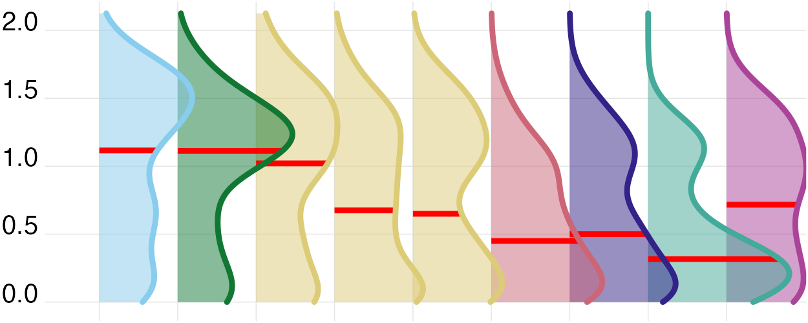
Time above 250 lx melEDI during wake  Waking time in recommended daytime light; relevant to alertness, entrainment, and subsequent sleep. | HH:MM | 02:25  (00:51, 04:37)  03:00 ± 02:29  N=141; d=737 | 04:06  (02:30, 06:15)  04:21 ± 02:24  N=13; d=73 | 03:29  (02:03, 05:16)  03:39 ± 02:25  N=13; d=64 | 03:42  (02:05, 05:58)  04:05 ± 02:51  N=18; d=90 | 02:01  (00:47, 04:20)  02:52 ± 02:39  N=26; d=141 | 02:38  (00:55, 04:19)  02:57 ± 02:19  N=10; d=54 | 02:43  (00:54, 04:43)  03:02 ± 02:19  N=23; d=113 | 01:30  (00:41, 03:26)  02:09 ± 01:57  N=17; d=94 | 01:39  (00:33, 02:40)  01:48 ± 01:21  N=6; d=30 | 01:14  (00:25, 02:37)  01:45 ± 01:46  N=15; d=78 | Symlog (base 10; threshold 1) | 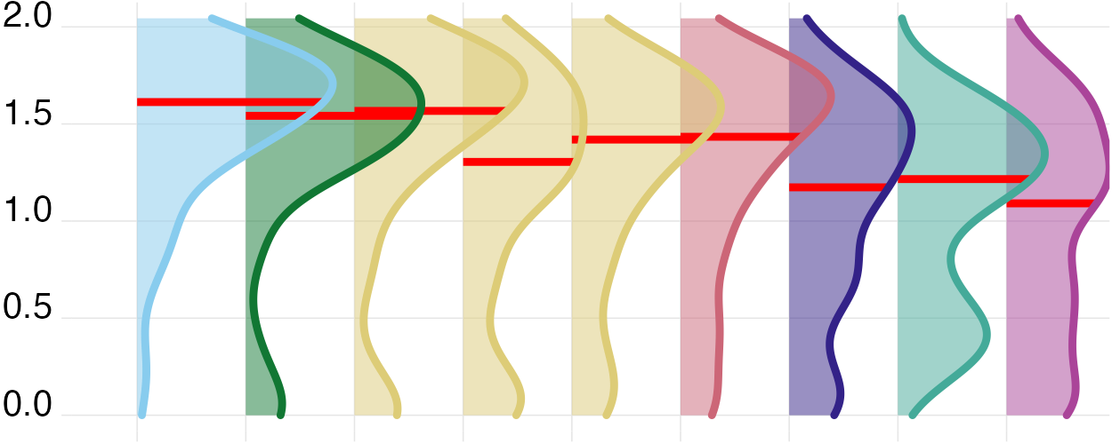
Time below 10 lx melEDI before sleep  Low-light time before bed; limits evening melatonin suppression and circadian delay. | HH:MM | 01:53  (01:01, 02:35)  01:51 ± 01:02  N=139; d=655 | 02:16  (01:30, 02:39)  02:05 ± 00:53  N=13; d=67 | 01:50  (01:21, 02:52)  01:59 ± 00:57  N=12; d=50 | 01:42  (00:53, 02:17)  01:41 ± 00:58  N=18; d=84 | 01:52  (01:04, 02:25)  01:52 ± 01:06  N=26; d=132 | 01:43  (00:42, 02:32)  01:45 ± 01:10  N=10; d=52 | 01:43  (00:58, 02:50)  01:50 ± 01:05  N=23; d=105 | 01:31  (00:49, 02:15)  01:38 ± 01:00  N=17; d=82 | 02:16  (01:15, 02:39)  01:56 ± 01:00  N=6; d=25 | 02:30  (01:28, 02:52)  02:09 ± 00:57  N=14; d=58 | Symlog (base 10; threshold 1) | 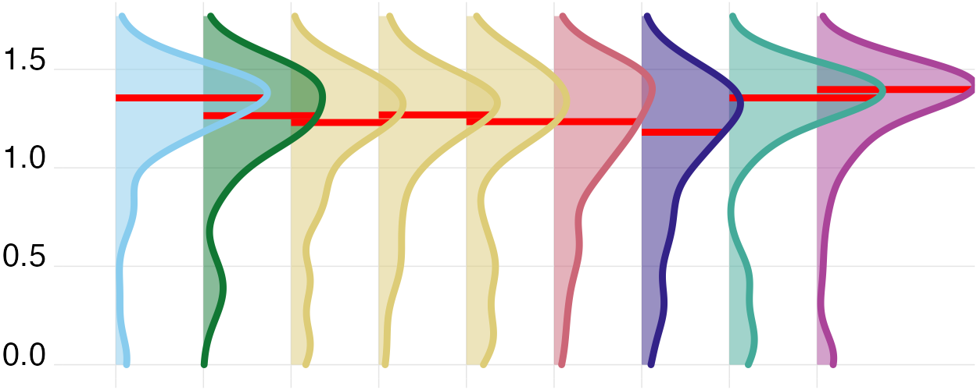
Time below 1 lx melEDI during sleep  Darkness during sleep; supports nocturnal melatonin and an undisturbed sleep environment. | HH:MM | 07:08  (05:58, 08:15)  07:04 ± 01:57  N=141; d=778 | 07:08  (06:03, 08:18)  07:12 ± 01:46  N=13; d=76 | 07:14  (05:56, 08:06)  07:01 ± 01:50  N=13; d=68 | 07:08  (05:56, 08:16)  07:05 ± 01:50  N=18; d=95 | 06:54  (05:51, 07:46)  06:47 ± 01:30  N=26; d=150 | 05:52  (04:41, 07:03)  05:58 ± 01:58  N=10; d=60 | 08:06  (07:10, 09:10)  08:02 ± 01:57  N=23; d=118 | 06:45  (05:08, 08:15)  06:40 ± 02:07  N=17; d=99 | 06:56  (06:06, 07:36)  06:39 ± 01:43  N=6; d=31 | 07:31  (06:31, 09:00)  07:35 ± 02:15  N=15; d=81 | Symlog (base 10; threshold 1) | 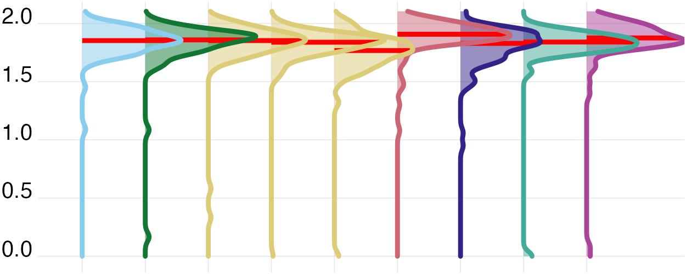
Longest period above 250 lx melEDI  Longest sustained bright-light bout; captures continuity of daytime circadian stimulation. | HH:MM | 00:38  (00:17, 01:12)  00:55 ± 01:00  N=141; d=816 | 00:57  (00:28, 01:27)  01:12 ± 01:02  N=13; d=78 | 00:48  (00:23, 01:20)  01:09 ± 01:15  N=13; d=78 | 01:00  (00:21, 01:40)  01:20 ± 01:31  N=18; d=107 | 00:35  (00:13, 01:06)  00:50 ± 00:54  N=26; d=150 | 00:38  (00:17, 01:32)  01:01 ± 01:02  N=10; d=60 | 00:38  (00:16, 01:04)  00:45 ± 00:36  N=23; d=129 | 00:34  (00:14, 00:55)  00:43 ± 00:41  N=17; d=101 | 00:28  (00:16, 00:43)  00:30 ± 00:20  N=6; d=32 | 00:23  (00:15, 00:49)  00:38 ± 00:45  N=15; d=81 | Symlog (base 10; threshold 1) | 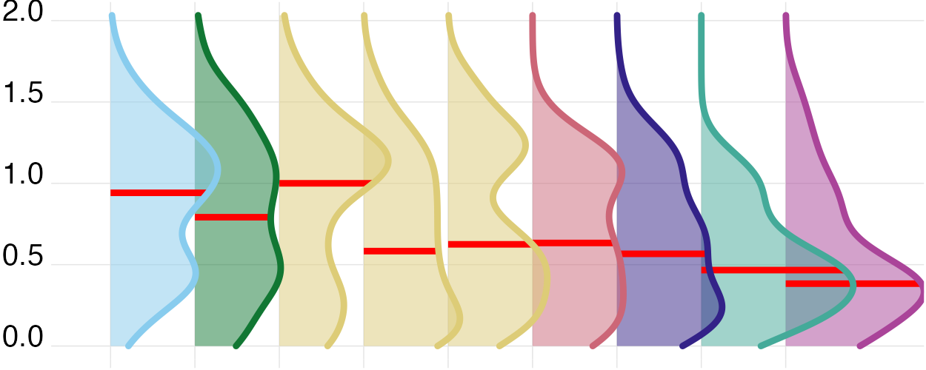
Dynamics
Interdaily stability  Day-to-day regularity of the light–dark pattern; higher regularity supports circadian stability. | — | 0.308  (0.248, 0.38)  0.318 ± 0.095  N=141; d=816 | 0.311  (0.272, 0.367)  0.315 ± 0.078  N=13; d=78 | 0.258  (0.239, 0.389)  0.288 ± 0.094  N=13; d=78 | 0.264  (0.219, 0.319)  0.274 ± 0.074  N=18; d=107 | 0.329  (0.263, 0.424)  0.344 ± 0.107  N=26; d=150 | 0.244  (0.218, 0.277)  0.252 ± 0.058  N=10; d=60 | 0.352  (0.321, 0.455)  0.368 ± 0.092  N=23; d=129 | 0.278  (0.254, 0.394)  0.323 ± 0.104  N=17; d=101 | 0.342  (0.315, 0.473)  0.37 ± 0.118  N=6; d=32 | 0.293  (0.255, 0.354)  0.299 ± 0.062  N=15; d=81 | Identity | 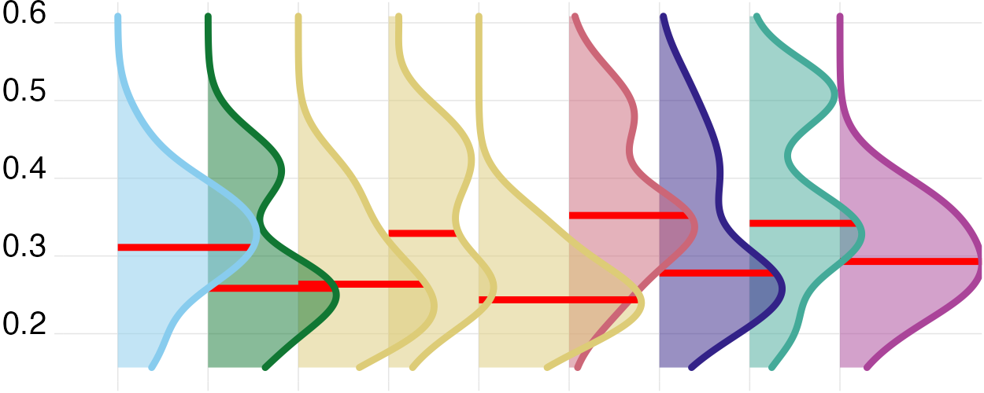
Intradaily variability  Within-day fragmentation of light exposure; higher values indicate less consolidated light–dark input. | — | 1.253  (0.93, 1.502)  1.229 ± 0.389  N=141; d=816 | 0.997  (0.818, 1.388)  1.088 ± 0.343  N=13; d=78 | 1.193  (0.96, 1.389)  1.238 ± 0.345  N=13; d=78 | 1.182  (0.928, 1.49)  1.177 ± 0.407  N=18; d=107 | 1.154  (0.801, 1.442)  1.125 ± 0.354  N=26; d=150 | 1.48  (0.869, 1.642)  1.332 ± 0.477  N=10; d=60 | 1.251  (0.999, 1.497)  1.251 ± 0.413  N=23; d=129 | 1.359  (0.95, 1.546)  1.307 ± 0.415  N=17; d=101 | 1.399  (1.282, 1.483)  1.355 ± 0.256  N=6; d=32 | 1.324  (1.029, 1.595)  1.344 ± 0.413  N=15; d=81 | Identity | 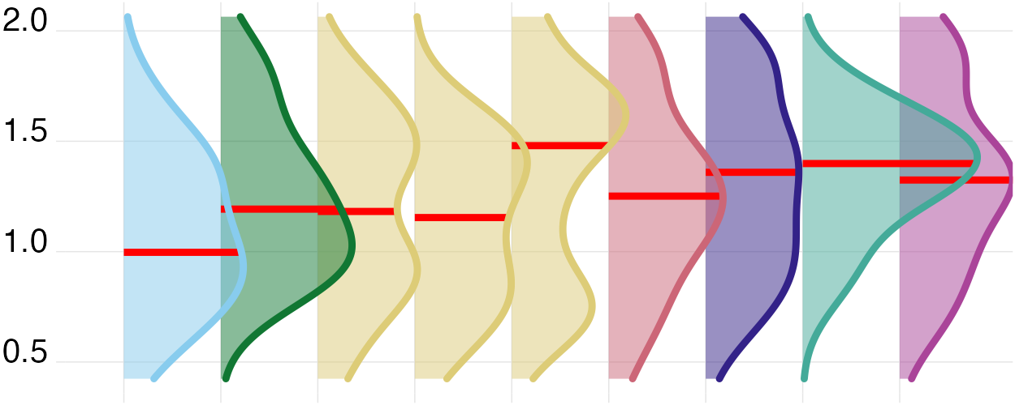
Exposure history
melEDI dose  Intensity–duration-weighted melanopic exposure; summarizes cumulative non-visual retinal light input. | klx·h | 4.96  (1.936, 12.313)  10.358 ± 16.216  N=141; d=761 | 9.296  (3.892, 21.895)  19.923 ± 27.784  N=13; d=71 | 10.495  (3.855, 17.395)  15.881 ± 20.395  N=13; d=74 | 6.751  (2.469, 14.435)  13.809 ± 23.711  N=18; d=97 | 3.862  (1.411, 10.217)  7.719 ± 9.847  N=26; d=137 | 7.11  (1.897, 15.789)  10.055 ± 11.237  N=10; d=55 | 3.317  (1.703, 6.29)  6.115 ± 8.79  N=23; d=125 | 4.35  (1.791, 10.625)  7.49 ± 8.898  N=17; d=96 | 2.195  (1.339, 4.117)  3.281 ± 2.573  N=6; d=30 | 6.045  (2.49, 14.907)  10.016 ± 10.799  N=15; d=76 | Symlog (base 10; threshold 1) | 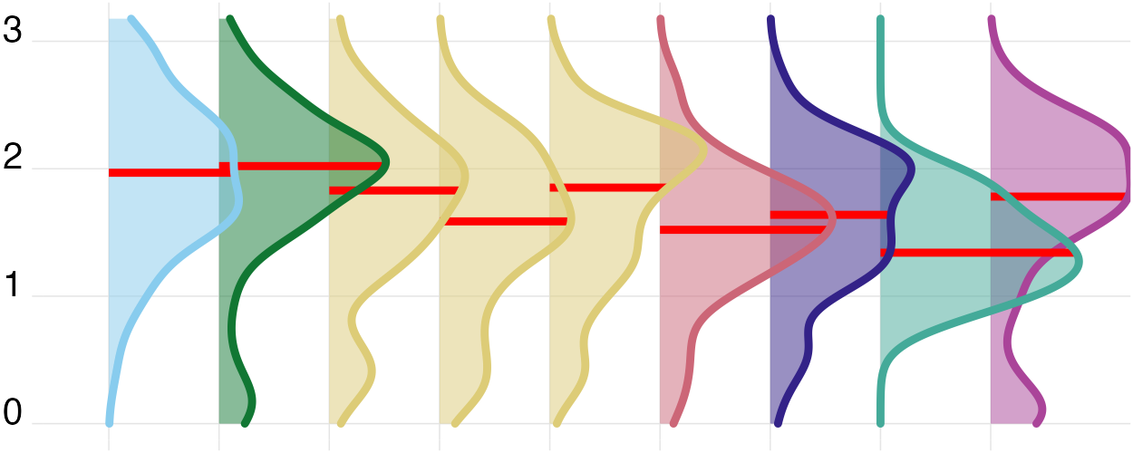
Level
Mean melEDI  Geometric average of daily melEDI values, including zeros; summarizes overall exposure while reducing peak influence. | lx | 5.154  (2.831, 9.225)  7.587 ± 9.496  N=141; d=816 | 7.569  (4.55, 11.613)  9.171 ± 7.111  N=13; d=78 | 6.659  (4.18, 11.674)  8.274 ± 6.558  N=13; d=78 | 7.704  (3.081, 13.924)  12.017 ± 18.865  N=18; d=107 | 5.232  (3.224, 8.188)  7.221 ± 6.33  N=26; d=150 | 9.013  (4.011, 15.089)  12.102 ± 12.013  N=10; d=60 | 3.505  (1.469, 6.211)  4.166 ± 3.272  N=23; d=129 | 5.857  (3.726, 7.986)  7.778 ± 6.946  N=17; d=101 | 4.325  (3.585, 6.77)  5.248 ± 2.85  N=6; d=32 | 2.144  (0.744, 4.042)  3.019 ± 2.896  N=15; d=81 | Symlog (base 10; threshold 1) | 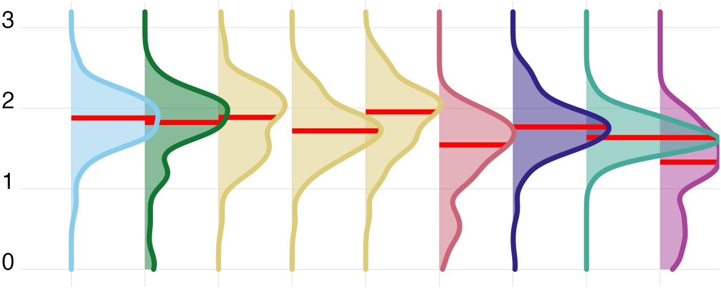
Brightest 10 h mean  Mean of the brightest 10 hours; reflects the strength of the main daytime light episode. | lx | 110.566  (41.513, 243.212)  214.866 ± 508.56  N=141; d=816 | 252.689  (104.514, 461.953)  399.302 ± 518.102  N=13; d=78 | 175.974  (78.625, 299.106)  262.206 ± 329.201  N=13; d=78 | 156.184  (67.783, 339.731)  422.54 ± 1,209.616  N=18; d=107 | 100.057  (33.255, 209.904)  179.372 ± 241.53  N=26; d=150 | 130.78  (54.044, 259.726)  201.947 ± 194.042  N=10; d=60 | 101.102  (24.355, 218.457)  136.312 ± 134.07  N=23; d=129 | 83.24  (53.17, 151.786)  120.172 ± 101.545  N=17; d=101 | 68.143  (45.331, 132.458)  96.735 ± 72.311  N=6; d=32 | 46.66  (9.242, 103.175)  82.489 ± 115.07  N=15; d=81 | Symlog (base 10; threshold 1) | 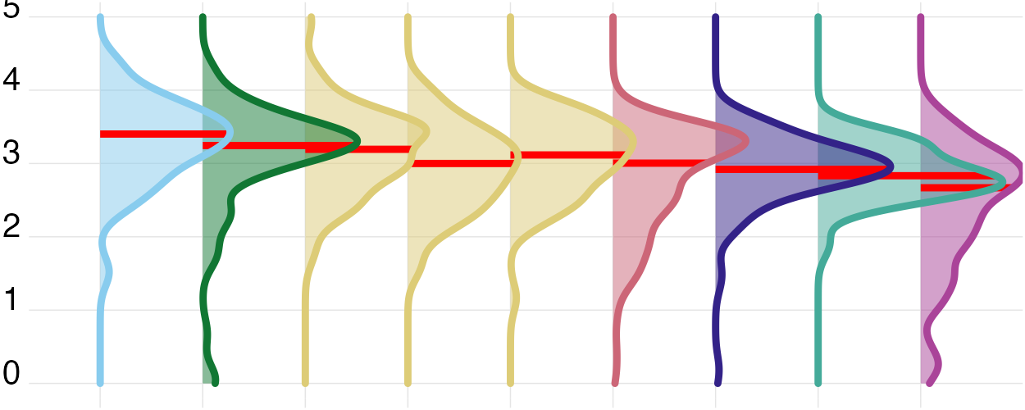
Darkest 10 h mean  Mean of the darkest 10 hours; lower values during the biological night favour melatonin preservation and sleep. | lx | 0.103  (0.02, 0.253)  0.243 ± 0.513  N=141; d=816 | 0.08  (0.016, 0.191)  0.183 ± 0.299  N=13; d=78 | 0.1  (0.035, 0.23)  0.2 ± 0.332  N=13; d=78 | 0.14  (0.036, 0.282)  0.223 ± 0.299  N=18; d=107 | 0.149  (0.074, 0.309)  0.273 ± 0.465  N=26; d=150 | 0.325  (0.119, 0.71)  0.515 ± 0.653  N=10; d=60 | 0.022  (0, 0.08)  0.054 ± 0.075  N=23; d=129 | 0.152  (0.052, 0.481)  0.475 ± 0.882  N=17; d=101 | 0.133  (0.055, 0.309)  0.411 ± 1.044  N=6; d=32 | 0.01  (0, 0.092)  0.059 ± 0.104  N=15; d=81 | Symlog (base 10; threshold 1) | 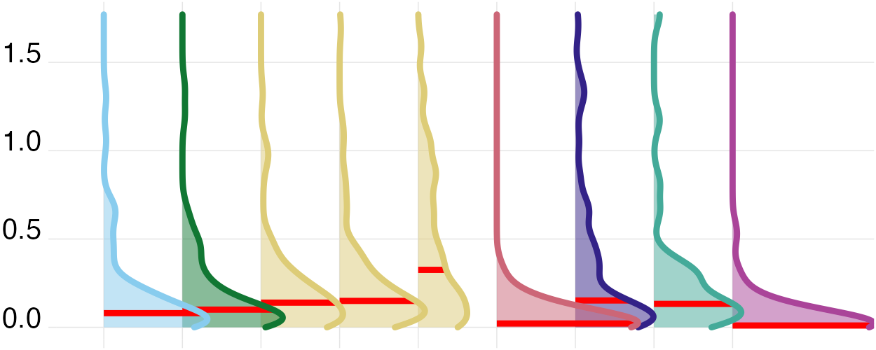
Spectrum
Melanopic daylight efficacy ratio  Mean of viable one-minute melEDI/illuminance ratios; indicates melanopic efficacy relative to visual light. | — | 0.724  (0.643, 0.795)  0.724 ± 0.116  N=137; d=687 | 0.788  (0.725, 0.872)  0.796 ± 0.162  N=13; d=74 | 0.743  (0.699, 0.796)  0.743 ± 0.077  N=13; d=65 | 0.781  (0.675, 0.853)  0.768 ± 0.118  N=18; d=97 | 0.65  (0.592, 0.728)  0.667 ± 0.098  N=26; d=144 | 0.724  (0.652, 0.773)  0.72 ± 0.093  N=10; d=55 | 0.668  (0.629, 0.721)  0.673 ± 0.07  N=22; d=83 | 0.747  (0.634, 0.834)  0.735 ± 0.122  N=17; d=91 | 0.719  (0.661, 0.761)  0.706 ± 0.067  N=6; d=30 | 0.755  (0.729, 0.82)  0.758 ± 0.097  N=12; d=48 | Identity | 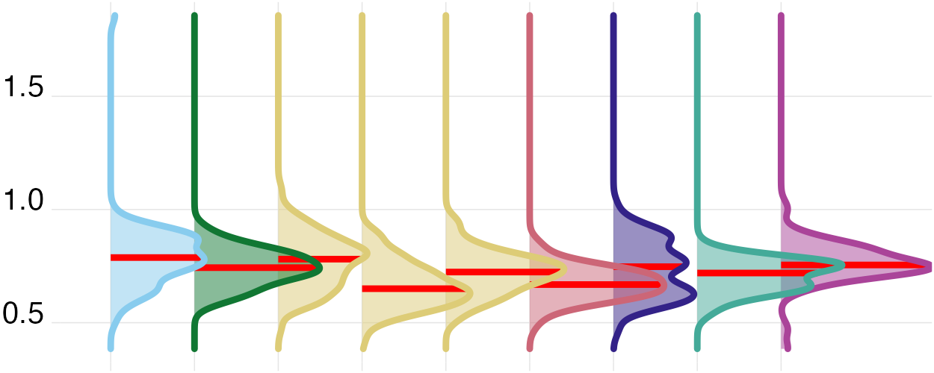
Timing
Midpoint of the brightest 10 hours  Centre time of the brightest 10 hours; indexes the main daily circadian light cue. | HH:MM  clock time | 13:44  (12:48, 15:00)  13:56 ± 01:51  N=141; d=816 | 13:16  (12:28, 14:10)  13:20 ± 01:33  N=13; d=78 | 14:12  (13:23, 15:18)  14:22 ± 01:51  N=13; d=78 | 13:52  (12:54, 15:04)  14:00 ± 01:42  N=18; d=107 | 13:38  (12:47, 14:44)  13:52 ± 01:42  N=26; d=150 | 14:54  (12:50, 16:03)  14:31 ± 02:14  N=10; d=60 | 13:44  (13:06, 15:20)  14:10 ± 01:51  N=23; d=129 | 14:10  (13:32, 15:21)  14:25 ± 01:37  N=17; d=101 | 12:34  (11:49, 14:02)  12:55 ± 01:44  N=6; d=32 | 12:49  (12:06, 13:39)  13:03 ± 01:58  N=15; d=81 | Circular clock | 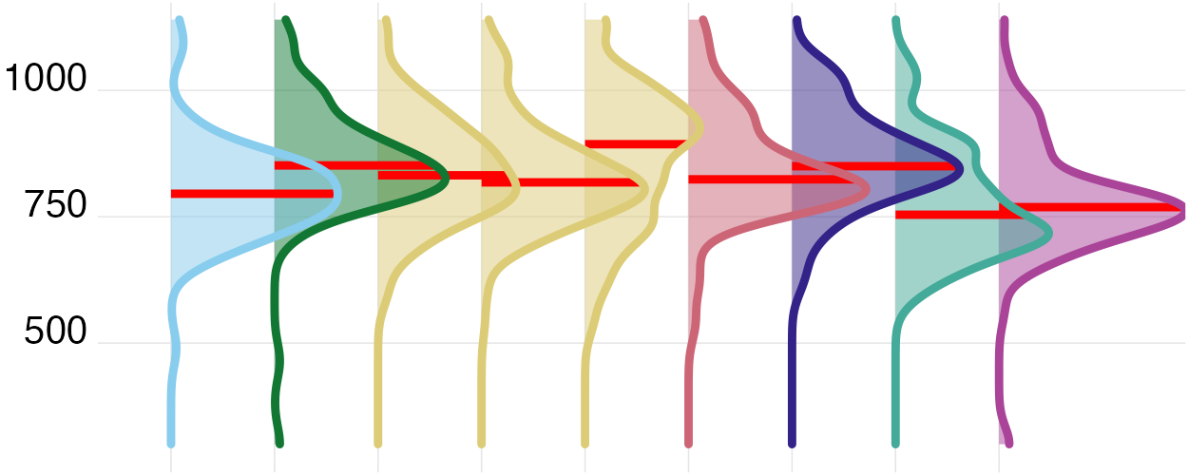
Midpoint of the darkest 10 hours  Centre time of the darkest 10 hours; indexes the main daily darkness cue. | HH:MM  clock time | 02:54  (02:01, 03:50)  02:58 ± 01:41  N=141; d=816 | 02:02  (01:25, 02:48)  02:03 ± 01:07  N=13; d=78 | 02:55  (02:01, 03:27)  02:50 ± 02:05  N=13; d=78 | 02:32  (01:45, 03:22)  02:37 ± 01:19  N=18; d=107 | 03:08  (02:11, 04:10)  03:16 ± 01:34  N=26; d=150 | 02:37  (01:54, 04:17)  03:10 ± 02:00  N=10; d=60 | 03:39  (02:43, 04:34)  03:34 ± 01:49  N=23; d=129 | 03:31  (02:33, 04:14)  03:26 ± 01:25  N=17; d=101 | 01:45  (01:05, 03:01)  02:10 ± 01:27  N=6; d=32 | 02:33  (02:04, 03:17)  02:36 ± 01:36  N=15; d=81 | Circular clock | 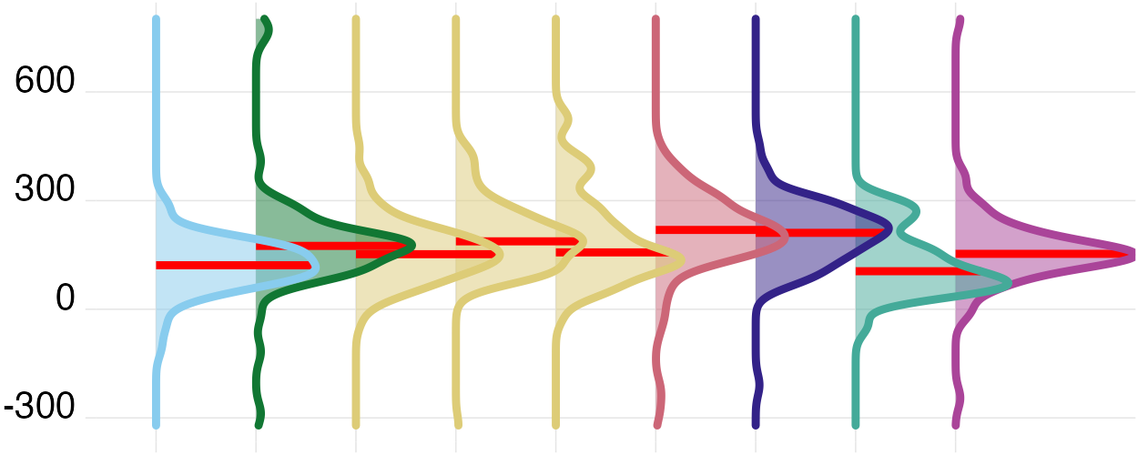
First light timing above 250 lx melEDI  First waking bright-light exposure; morning timing can advance circadian phase and promote alertness. | HH:MM  clock time | 09:08  (08:02, 10:40)  09:26 ± 02:22  N=140; d=727 | 07:57  (06:56, 08:33)  08:03 ± 01:32  N=13; d=74 | 09:04  (08:18, 09:52)  09:17 ± 01:56  N=13; d=68 | 08:36  (07:10, 10:13)  08:45 ± 02:21  N=18; d=93 | 09:43  (08:13, 10:53)  09:45 ± 02:21  N=25; d=133 | 09:36  (07:58, 10:53)  09:39 ± 03:12  N=10; d=56 | 09:32  (08:40, 11:21)  10:05 ± 02:18  N=23; d=118 | 10:01  (09:06, 11:52)  10:26 ± 02:28  N=17; d=95 | 08:11  (07:26, 09:57)  08:36 ± 01:30  N=6; d=29 | 08:43  (08:01, 10:10)  09:19 ± 01:52  N=15; d=61 | Circular clock | 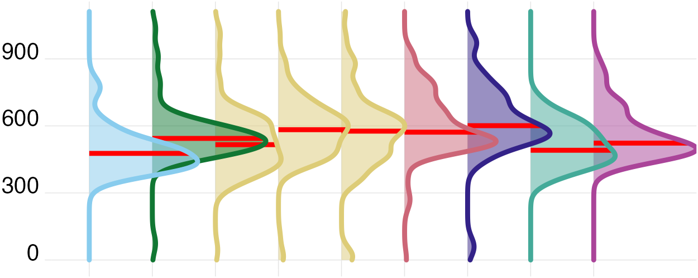
Last light timing above 250 lx melEDI  Last bright-light exposure; later timing may delay circadian phase and sleep onset. | HH:MM  clock time | 18:08  (16:27, 19:42)  18:03 ± 02:36  N=141; d=687 | 18:41  (17:38, 19:38)  18:39 ± 01:38  N=13; d=73 | 18:30  (17:37, 19:59)  18:37 ± 02:08  N=13; d=62 | 19:34  (18:04, 20:42)  19:16 ± 02:28  N=18; d=89 | 17:37  (15:35, 19:09)  17:18 ± 02:44  N=26; d=121 | 19:50  (18:37, 20:50)  19:33 ± 02:11  N=10; d=53 | 17:48  (16:46, 19:19)  18:01 ± 02:21  N=23; d=106 | 18:45  (17:02, 19:38)  18:23 ± 02:15  N=17; d=89 | 15:45  (13:20, 16:38)  15:22 ± 02:38  N=6; d=28 | 15:54  (14:34, 17:25)  15:46 ± 02:13  N=15; d=66 | Circular clock | 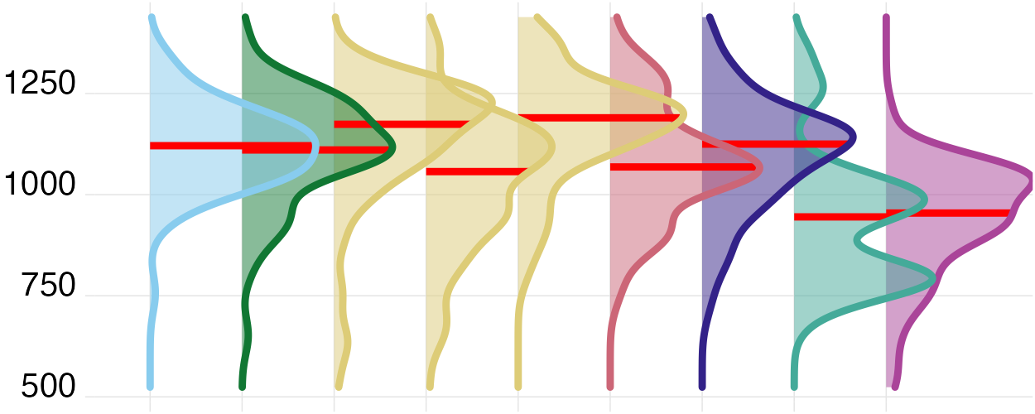
Mean timing of exposure above 250 lx melEDI  Average bright-light timing; summarizes the phase of daily circadian stimulation. | HH:MM  clock time | 13:29  (12:29, 14:39)  13:31 ± 01:52  N=141; d=742 | 13:20  (12:29, 14:24)  13:21 ± 01:25  N=13; d=72 | 13:52  (13:13, 15:06)  14:02 ± 01:41  N=13; d=71 | 13:44  (12:28, 14:55)  13:51 ± 01:56  N=18; d=93 | 13:17  (12:17, 14:31)  13:24 ± 01:45  N=26; d=138 | 14:04  (12:58, 15:25)  14:09 ± 02:22  N=10; d=55 | 13:43  (12:55, 14:29)  13:47 ± 01:33  N=23; d=117 | 13:58  (12:54, 14:58)  14:04 ± 01:39  N=17; d=94 | 11:30  (10:28, 12:38)  11:26 ± 01:36  N=6; d=31 | 12:17  (11:04, 13:04)  12:11 ± 01:36  N=15; d=71 | Circular clock | 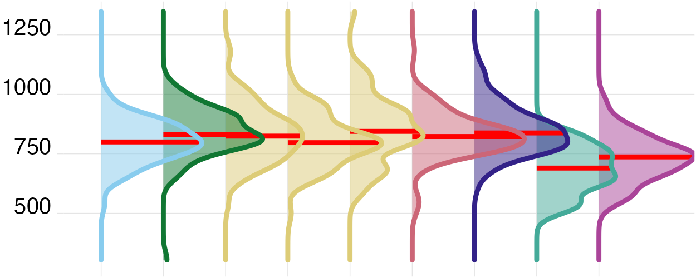
Median (25th percentile, 75th percentile), circular or arithmetic mean ± standard deviation, N=participants; d=participant-days with a finite value for that metric.
¹ The brief meaning and relevance notes describe established physiological constructs; this descriptive table does not estimate individual health effects.
² Scaling describes the distribution column only; printed values remain on their stated scale. Symlog uses base 10 with a linear region through 1 in the stated unit; Identity is linear; Circular clock unwraps values around the metric-specific clock centre.
³ Red lines indicate site medians. Symlog and circular-clock rows are transformed only for plotting.
Supplementary Table S2. Definitions, exact support, median (interquartile range) summaries, and density displays for the 17 near-eye personal light-exposure metrics overall and by site. Values use three decimal places where applicable. Metrics are distinct summaries and should not be interpreted as interchangeable outcomes.

