Unified wearable file format
Johannes Zauner
Salma Thalji
Manuel Spitschan
Table of contents
1 Preface 1
1.1 Overview of the proposed format 2
2 Validator 3
3 Data format considerations 4
3.1 Base format 4
3.2 Tabular data 4
3.3 Headers 5
3.4 Consistency of variables 6
3.5 Record ordering and uniqueness 7
3.6 Timestamps 7
3.7 Missing data 8
3.8 Complex data 8
3.9 Python-specific implementation notes 9
4 About the creation and funding of the Unified wearable file format 9

1 Preface
In the MeLiDos project (Section 4), a jointly accessible and interoperable data format for light dosimetry data was developed, alongside a metadata descriptor. The metadata descriptor, described in this publication, separates the overall format into a data part and a metadata part. The metadata part contains information about the dataset itself (e.g., column names, variables, units, and value definitions) as well as information about the device, participant, and study. The metadata schema is explained in detail in the Global Light Commons (GLC) website.
This separation keeps the device data file simple and flexible. It does not mean, however, that the data file is arbitrary.
For the MeLiDos analysis package LightLogR, file formats from 19 devices were reviewed, and substantial variation in both file structure and preprocessing requirements was found. Moving forward, device manufacturers are encouraged to standardize wearable export formats and to adopt the dual structure of data plus metadata, even if only part of the metadata is embedded directly with the export.
library(LightLogR)
supported_devices()
[1] "Actiwatch_Spectrum" "ActLumus" "ActTrust"
[4] "Circadian_Eye" "Clouclip" "DeLux"
[7] "GENEActiv_GGIR" "Kronowise" "LiDo"
[10] "LightWatcher" "LIMO" "LYS"
[13] "MiEye" "MotionWatch8" "nanoLambda"
[16] "OcuWEAR" "Speccy" "SpectraWear"
[19] "VEET"
This document focuses on the data part and summarizes relevant design considerations derived from existing formats. The goal is to optimize, across files and devices, for:
- readability
- consistency
- unambiguity
- machine-readability
- cross-language interoperability
 Note
In this document, the term record is used interchangeably with observation and refers to one written row in an export file for a given time point or event.

1.1 Overview of the proposed format
The proposed structure separates wearable exports into a simple tabular data file and a metadata descriptor (see Figure 1). The data file contains the observations themselves, while the metadata descriptor defines how those observations should be interpreted.
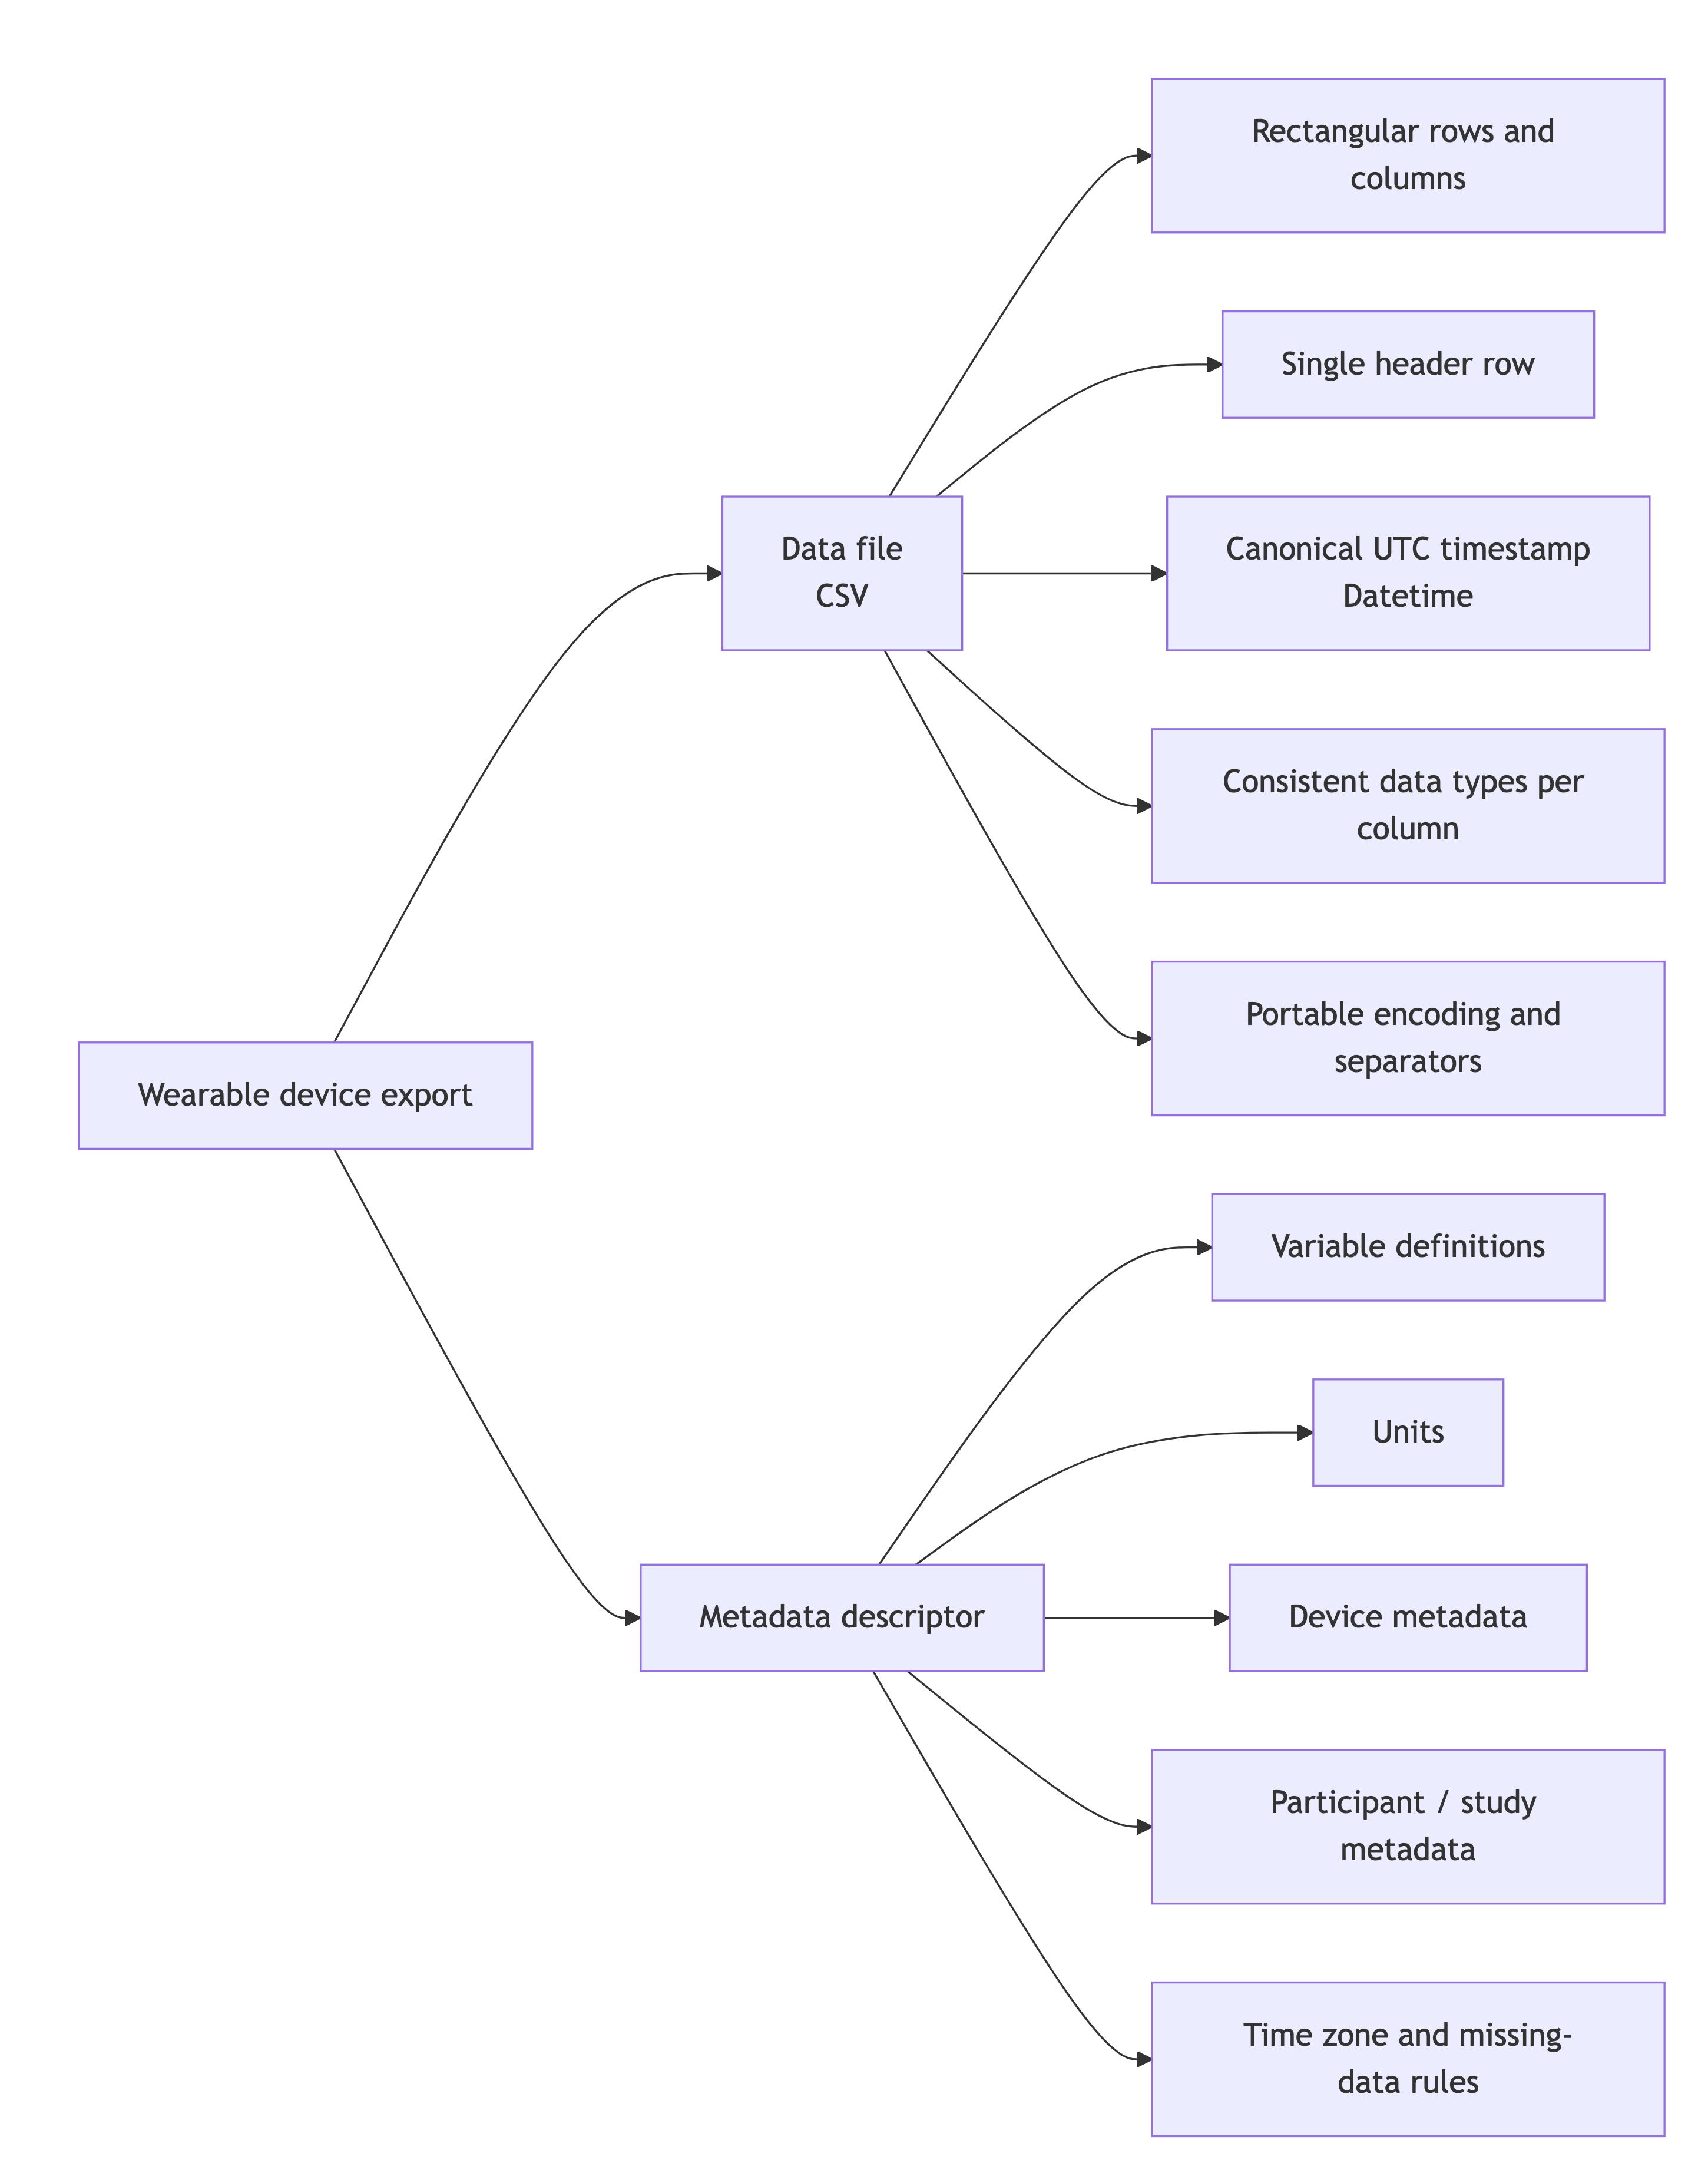
Figure 1: Structure of a wearable device export with a CSV data file and accompanying metadata descriptor.

2 Validator
In the web-version of this document, a file validator application is embedded. The web-version is hosted on GitHub pages.
The validator application runs in the browser. Provided datasets will not be uploaded outside the users computer and thus ensure privacy. Please see the sections below for more context on the validator.

3 Data format considerations
An example file can be downloaded here: ⬇ Download CSV

3.1 Base format
We recommend comma-separated values (CSV) as the base format. See the full specification for details. In summary:
- variables (columns) are separated by a single comma (,)
- records (rows) are separated by line breaks
- every row must contain the same number of fields
- fields containing commas, double quotes, or line breaks must be enclosed in double quotes
- double quotes inside quoted fields must be escaped according to CSV rules
- rows must not end with a trailing comma
For maximum interoperability across R, Python, spreadsheets, databases, and command-line tooling, exported files should additionally follow these requirements:
- file encoding must be UTF-8
- files should be written without a UTF-8 byte order mark (BOM)
- line endings may be LF or CRLF, but must be used consistently within a file
- the delimiter must always be a comma and must not vary by locale
- decimal values must always use . as the decimal separator
 Warning
Exported files must not contain locale-dependent variations. The file format must remain identical regardless of the locale settings of the exporting computer.

3.2 Tabular data
Wearable data are typically analyzed as time series. Such analyses are best supported by rectangular tabular data, with variables in columns and observations in rows (see Figure 2). In rectangular data, each row has the same number of fields and each column represents the same variable throughout the file. Cells may be empty to indicate missing data, but the structure itself must not vary across rows.
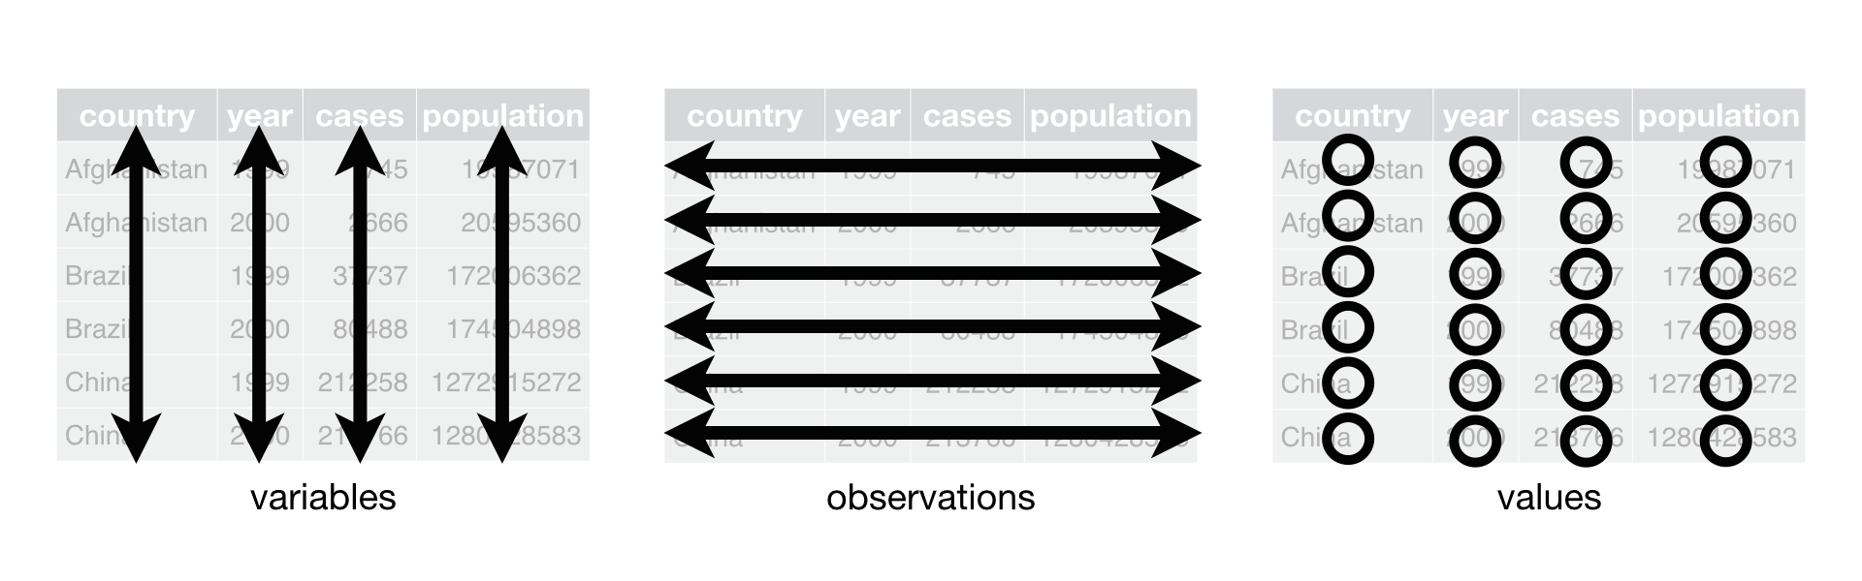
Figure 2: Rectangular tabular data structure with a tidy arrangement. From R for Data Science

 Note
This structure can be inefficient when not all variables are recorded for every observation. This may occur when a device contains multiple sensors or modalities sampled at different intervals, or when irregular event records occur (e.g., button presses).
In such cases, three approaches can preserve a rectangular structure:
- add an observation (row) that is empty for variables not recorded at that time point; this is appropriate when such cases are rare
- aggregate irregular events into the next regular observation (e.g., store the number of button presses since the previous sample); this is appropriate when the recording interval is short and aggregation is scientifically acceptable
- split the export into multiple rectangular files, for example one file per sensor or modality, or one file for regular samples and one for irregular events; this is appropriate when irregularity is common

3.3 Headers
Each file must contain exactly one header row containing the variable names. Data records begin on the following row.
Additional lines above the column names are strongly discouraged. In fact, the file validation in the Global Light Commons (GLC) only supports data files without additional headers.
 Note
Variable names should be syntactic so that they can be imported directly into data analysis software without renaming.
For best interoperability across R and Python, variable names should:
- use only ASCII letters (a-z, A-Z), digits (0-9), _, and .
- start with a letter
- avoid spaces and special characters
- not start with a digit
- not duplicate any other column name within the file
- avoid reserved words in common analysis environments where possible
For easier ingestion into both R and Python data pipelines, snake_case is recommended for general variables. A documented exception may be used for canonical field names such as Datetime.

3.4 Consistency of variables
Within a column, values must be consistent with the declared variable type. Otherwise, users must manually correct types after import, which introduces avoidable error sources.
General requirements:
- a column must contain values of one logical type only (e.g., numeric, integer, string, boolean, datetime)
- numeric values may contain only digits, an optional leading minus sign, and the decimal separator
- . must be used as the decimal separator, independent of locale
- thousands separators must not be used
- text values containing commas, double quotes, or line breaks must be quoted according to the CSV specification
- missing values should be encoded as empty fields rather than implementation-specific strings where possible
Recommended canonical encodings:
- boolean values: true and false
- missing values: empty field
- categorical values: documented controlled vocabulary in metadata
- units: defined in metadata, not embedded in the cell value
Python-specific interoperability requirements:
- columns should not mix numeric values with strings such as error, off, or n/a
- vendor-specific missing-value strings such as NA, N/A, null, NULL, -, or 9999 should be avoided in raw exports unless they are explicitly documented in metadata
- if integer columns can contain missing values, this must be documented, as some Python tooling may otherwise infer floating-point types during import
- where practical, one physical quantity should map to one column and one dtype
 On sentinel values
Some devices use sentinel values to indicate special information, like sleep, or out of bounds. This behavior is discouraged within the same column as other (measurement) information is contained. Instead, a new variable containing the status information (if necessary as a sentinal value) should be used and the measurement column be set to missing for a given observation.

3.5 Record ordering and uniqueness
Records should be ordered by ascending timestamp within each file and timestamps need to be unique.
If a file represents a single continuous stream, each row should be uniquely identifiable by the timestamp.

3.6 Timestamps
Timestamps in wearable data must contain date and time information in a consistent, unambiguous, and machine-readable format. Because time handling is complex, timestamps require special care.
A time zone should not be confused with a UTC offset. For any given moment, a time zone maps to a specific offset, but a time zone also captures daylight saving time rules and policy changes. Therefore, local time plus time zone contains more information than local time plus offset alone.
Date and time values should follow ISO 8601. A practical internet profile is described in RFC 3339, Section 5.6.
At the time of writing, many devices do not include UTC offsets in exported timestamps, which can create ambiguity around daylight saving transitions. This ambiguity can be avoided if:
- datetimes follow ISO 8601 / RFC 3339 conventions
- timestamps in the data file are stored in UTC
- UTC timestamps are encoded with the Z suffix (for example, 2026-03-09T14:30:00Z)
- the participant’s or device’s local time zone is stored in metadata using an IANA time zone identifier such as Europe/Berlin
Recommended practice:
- include one canonical timestamp column named Datetime
- store Datetime in UTC in full datetime format with seconds
- if sub-second precision is available and scientifically relevant, use a fixed precision consistently throughout the file
- do not mix naive local timestamps and UTC timestamps in the same column
- if a local device timestamp is required in addition to UTC, store it in a separate column and document it clearly in metadata
 Note
Time-series analysis often requires a regularly spaced, uninterrupted time series. Manufacturers can support researchers in a major way by ensuring that observations are stored in regular and consistent intervals (e.g., every 60 seconds), and that gaps in the data collection are explicit (i.e., timestamped missing data).

3.7 Missing data
Missing data should be represented explicitly and consistently.
Requirements:
- a missing value must not change the number of fields in a row
- missing values should be encoded as empty fields
- the meaning of missingness should be documented in metadata where relevant (e.g., sensor saturation, device off-body, battery depletion, or processing failure)
If a distinction between different types of missingness is scientifically required, that distinction should be represented in separate status or quality-control columns rather than by mixing ad hoc string tokens into measurement columns.

3.8 Complex data
In some cases, wearable device output is too complex to be fully represented in a single CSV file. Examples include images, videos, binary sensor payloads, or unavoidable proprietary sidecar files.
In such cases, the CSV file should contain:
- a timestamp column representing the relevant time point or start time
- a file reference column containing the file name or relative path of the associated object
- any required modality or event-type columns needed to interpret the referenced file
Associated files should be stored in a documented directory structure and described in metadata. File references should be relative rather than absolute so that datasets remain portable across systems.

3.9 Python-specific implementation notes
The requirements above are language-agnostic, but the following conventions are especially important for robust Python ingestion with tools such as pandas, polars, and pyarrow:
- UTF-8 encoding should be used consistently
- column names should be unique and stable across software versions
- each column should have a single intended dtype
- datetimes should be parseable without custom locale settings
- delimiters, decimal separators, and missing-value encodings should be fixed across all exports from a device family
- very large files may optionally be distributed in compressed form (e.g., .csv.gz) provided the contained file remains a standards-compliant CSV
- schema changes between firmware or software versions should be versioned and documented in metadata
A minimal interoperable export should therefore provide:
- one CSV file with a single header row
- UTF-8 encoding
- one canonical UTC timestamp column named Datetime
- consistent rectangular rows
- stable column names
- metadata that defines variables, units, missingness rules, and time zone context

4 About the creation and funding of the Unified wearable file format
The file format considerations described above are developed as part of the MeLiDos project. MeLiDos is a joint, EURAMET-funded project involving sixteen partners across Europe, aimed at developing a metrology and a standard workflow for wearable light logger data and optical radiation dosimeters. Its primary contributions towards fostering FAIR data include the development of a common file format, robust metadata descriptors, and an accompanying open-source software ecosystem.

The project (22NRM05 MeLiDos) has received funding from the European Partnership on Metrology, co-financed from the European Union’s Horizon Europe Research and Innovation Programme and by the Participating States. Views and opinions expressed are however those of the author(s) only and do not necessarily reflect those of the European Union or EURAMET. Neither the European Union nor the granting authority can be held responsible for them.

