Assignment 10.1: Milestone 3

Wade Eckert
Trenten Coffman
Bellevue University
CSD 310: Database Development and Use
Dr. Mortoza Abdullah
February 26, 2026

Assignment 10.1: Milestone 3

Running Wilson_financial_generate_report.py:

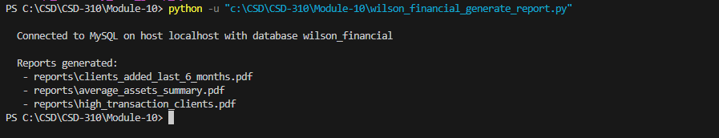

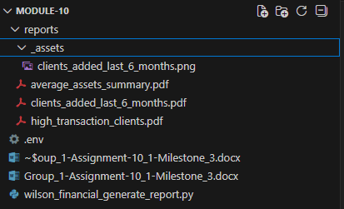

Report 1 - New Clients Added for Each of the Past 6 Months:
What the report generates:
This report produces a month-by-month table showing how many new clients were added over the last six months. The PDF includes a clean table (Month, New Clients) and a simple trend line chart that makes it easy to see whether growth is steady, increasing, or slowing down.
Why it’s useful for Wilson Financial:
In the case study, Jake and Ned know their customer list has grown, but they have been too busy to step back and measure that growth. This report gives them that view in a way that is easy to discuss and act on. If the last six months show accelerating growth, they can justify operational decisions like increasing administrative coverage (more scheduling support, more paperwork capacity), shifting advisor calendars to protect planning time, or even planning for additional hires. If growth is inconsistent, they can start asking why (seasonal patterns, referral flow, marketing effort, or capacity bottlenecks). This report and chart directly support the question from the case study, “How many clients have been added for each of the past six months?”
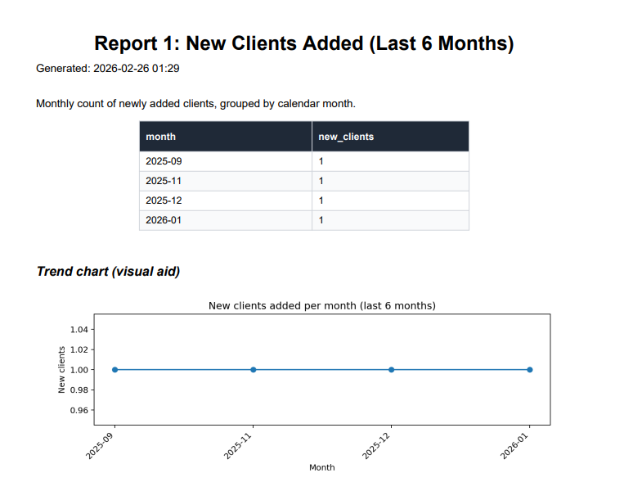
Report 2 - Assets Under Management (AUM) Snapshot, Totals and Averages:
What the report generates:
This report creates a summary “AUM snapshot” using the holdings data. It finds the most recent value of a holding at the current date, then total that holding at that snapshot to estimate overall assets under management. It also calculates:
- Total active clients
- Total active accounts
- Total assets (USD)
- Average assets per client (USD)
- Average assets per account (USD)
Why it’s useful for Wilson Financial:
The case study describes Jake and Ned evaluating the client list and assets as part of keeping the business profitable, and especially deciding whether to adjust billing. AUM is a big indicator because it is strongly tied to revenue potential in most advisory billing models. Even if Wilson Financial is not currently billing strictly by AUM, this report helps them understand the overall scale of client assets and whether the business is trending toward higher-value portfolios or many smaller portfolios. This report directly addresses the case study question, “What is the average amount of assets (in currency) for the entire client list?”
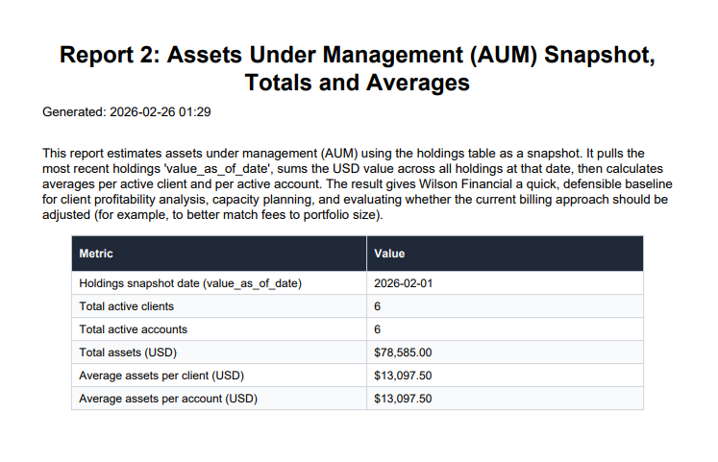
Report 3 - High-Transaction Clients (More Than 10 Transactions in a Month):
What the report generates:
This report identifies clients who exceeded 10 transactions in any single month during the past six months. It joins transactions → accounts → clients, then groups transactions by client and month, and lists:
- Client ID
- Client Name
- Month (YYYY-MM)
- Transaction count
Why it’s useful for Wilson Financial:
Transaction-heavy clients often create disproportionate workload. More transactions can mean more advisor communication, more trade processing, more compliance documentation, more time spent explaining changes, and more operational overhead overall. This report helps Wilson Financial quantify that workload. Once identified, these high-activity clients can inform practical business decisions: whether the firm needs transaction-based service tiers, whether certain clients should be scheduled differently, whether Phoenix (or future staff) need more support, and whether billing should better reflect the effort required for high-volume activity. This report directly supports the case study question, “How many clients have a high number (more than 10 a month) of transactions?”
