Trenten Coffman

Module 4.2 Assignment – MySQL Install

January 18, 2026
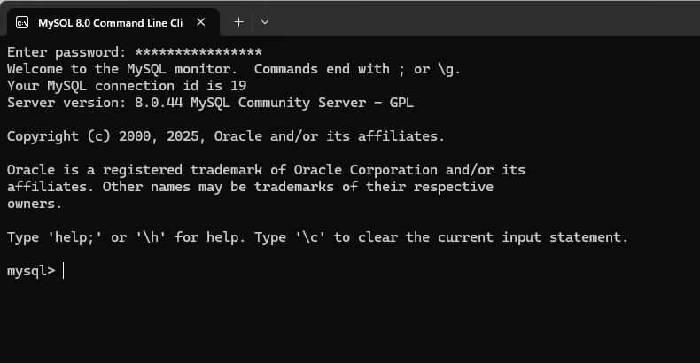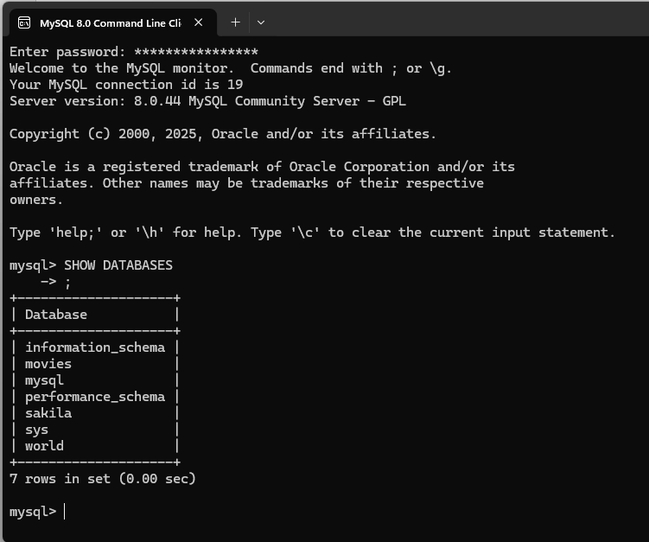

Functions:
CURRENT TIMESTAMP
Use – returns the current date and time of the database’s system which you could use to keep track of when changes are made
Alias – time
SELECT CURRENT_TIMESTAMP() AS time;
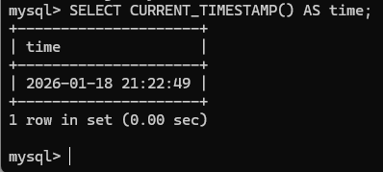

FORMAT
Use – formats numbers with specified decimal places. Can be used for dollar values and displaying results of math operations.
Alias – balance
SELECT FORMAT(1234.567, 2) AS balance;
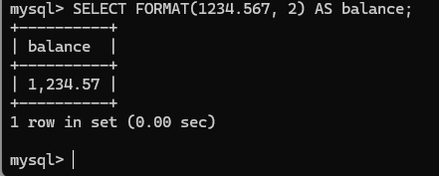

TRIM
Use- removes extra spaces from the beginning and end of a string. Users can accidentally add extra spaces so this can be used to clean user input before adding it to the database.
Alias- trimmed_string
SELECT TRIM(' Test ') AS trimmed_string;
