Title: PFAS, but not Cadmium, Confounds the Stress Response in Largemouth Bass (Micropterus nigricans)

Authors:
Anthony Ryan Johnson¹, Tyler Steven Coleman², Jasmine B. Nasser³, Maggie McGreal⁴, Kyle R. Piller⁵, and Christopher M. Murray⁶

¹Southeastern Louisiana University, Department of Biological Sciences, Hammond, Louisiana, USA; email; ORCID 0009-0005-9381-9510
²Southeastern Louisiana University, Department of Biological Sciences, Hammond, Louisiana, USA; tscoleman3@gmail.com; ORCID 0000-0001-7472-1976
³Southeastern Louisiana University, Department of Biological Sciences, Hammond, Louisiana, USA; email; ORCID 0009-0003-0083-9498
⁴Southeastern Louisiana University, Department of Biological Sciences, Hammond, Louisiana, USA; email; ORCID 0009-0005-9745-8265
⁵Southeastern Louisiana University, Department of Biological Sciences, Hammond, Louisiana, USA; email; ORCID 0000-0003-1289-9351
⁶Southeastern Louisiana University, Department of Biological Sciences, Hammond, Louisiana, USA; email; ORCID 0000-0003-4500-9052

*Corresponding author

Keywords:
Leukocyte Profiles, Perfluoropentanoic Acid, Cadmium, Largemouth Bass, Per- Polyfluoroalkyl Substances, Stress

Abstract:
Informative physiological biomarkers for organismal and population health are critical to effective conservation implementation and comparative study. Immune, endocrine or performance-based response variable are commonly used in natural systems to test hypotheses regarding anthropogenic change. Anthropogenic disturbances involving the release of toxic substances into aquatic environments, however, can adversely affect the immune, endocrine, and nervous systems of vertebrates, and confound testing of alternative hypotheses. In this study, we investigated the effects of perfluoropentanoic acid (PFPeA), a member of the PFAS chemical group, and Cadmium (Cd) on baseline leukocyte profiles in largemouth bass (Micropterus nigricans) using the neutrophil-to-lymphocyte ratio (NLR) as a proxy for stress under controlled laboratory conditions. Additionally, we evaluated the potential interaction of these substances with the vertebrate stress response following exposure to a suspected stressor (e.g., an abrupt increase in salinity). We designated fish into five groups: control, Cd low (0.034 ppm), Cd high (0.34 ppm), PFPeA low (3.4 mg/L), and PFPeA high (34 mg/L). We collected blood samples i) after a 48-hour acclimation period, ii) after treatments were applied, iii) shortly after exposure to an environmental stressor, and iv) one week after exposure to the stressor. Results suggest that high PFPeA levels, but not Cd, impact the leukocyte profile response in largemouth bass. This study has implications for understanding the confounding affects of ecotoxin exposure on stress-based comparative physiology as well as PFAS toxicity in the context of climate change and saltwater intrusion. The NLR is identified as a robust proxy for stress and exhibits conservation across vertebrate taxa; therefore, the feasibility of predicting a similar response in other aquatic taxa remains.

1. Introduction
The impacts of human disturbance on aquatic environments are widespread, numerous and well documented (Gangloff et al., 2016; Sabater et al., 2018). Biologists and conservationists employ physiological metrics to assess the degree of damage, organismal responses and natural impacts of both localized and widespread perturbations on vertebrate populations (XXXX). Metrics such as comparative leukocyte profiles (XXXX), endocrine markers (XXXX) and relative performance (XXXX) are utilized to assess disturbance to aquatic systems. While the lack of physiological independence among these response variables provides logistic ease and comparative utility to other studies (XXXX), the lack of independence in perturbations themselves provides confounding results and hinders comparison. For instance, assessing the affects of saltwater intrusion on alligator stress proxies among natural populations (Murray et al. XXXX) may be confounded by variation in pollutant exposure among sites.
Human activities (e.g., mining, agriculture, industrialization, and urbanization have increased the presence and diversity of soil and groundwater xenobiotic contamination (Ritter, 2002; K. S. Murray et al., 2004; Cannon & Horton, 2009; Santana et al., 2020). Aquatic systems are frequently plagued by heavy metals and synthetic compounds to varying degrees and in varying combinations (XXXX). Heavy metals are naturally occurring elements in the earth’s crust and oceans, but can be carcinogenic, non-essential metals with no known biological function (Kubier et al., 2019). Despite efforts to limit and regulate heavy metal contamination throughout the last decade (Marini et al., 2020), these natural toxins persist in our aquatic environments and will continue to progress within aquatic food webs (Croteau et al., 2005). Humans have intentionally and unintentionally released synthetic chemicals into natural systems, exposing organisms to adverse effects. For instance, DDT and its metabolites have been intentionally released to control pests and the spread of diseases, but have also been unintentionally released due to chemical spills, all of which are reported to cause adverse effects on wildlife (L. J. Guillette et al., 2005; Milnes & Guillette, 2008).

Unfortunately, many xenobiotic substances end up in water systems, where they are often translocated away from the original point source. Once in the water, these toxins pose a risk to many aquatic organisms as toxins can actively enter the body through digestion or passively through contact with skin or gills (Subaramaniyam et al., 2023). Exposure to xenobiotic substances may elicit a “stress response” in aquatic organisms (Hontela et al., 1992; Wilson et al., 1998; Silvestre, 2020) that may result in suppressed growth, reduced reproductive capacity, and even death (Pankhurst & Van der Kraak, 1997; Schreck, 2010). Understudied is the interaction between xenobiotic exposure and other exogenous stressors and their potential synergistic or potentiative affects on stress biomarkers. Further, while xenobiotics are released into our freshwater aquatic ecosystems at unpredictably high rates, cause concern for freshwater fisheries management of socioeconomically important fishes is warranted.
The largemouth bass (Micropterus nigricans; referred to hereafter as bass; Lacépède, 1802; Lesueur, 1822; Kim et al., 2022) is an ecologically, socioeconomically, culturally, and nutritionally valued freshwater fish worldwide. As the most sought-after and heavily managed fish in North America (Allen et al., 2008; Bonvechio et al., 2014; Carlson & Isermann, 2010; Claussen, 2015; Coleman et al., 2024), black basses (Micropterus spp.) are top-level piscivores that generate tens of billions United States dollars annually for the U.S. economy (USDOI 2018). The bass native range extends from southeastern Canada to northeastern Mexico (Tringali et al., 2015; Taylor et al., 2019). Despite the insane popularity and the introduction of bass to freshwater systems globally (Gratwicke and Marshall, 2001; Lowe et al., 2004; Takamura 2007; Boucek et al. 2017), bass are considered one of the world’s most problematic invaders due to their trophic position and capability of altering the diversity and abundance of aquatic biota (Cambray, 2003; Weyl et al., 2010; Hargrove et al., 2019), amplifying the research importance of this species. Lastly, bass successfully reproduce easily (i.e., have high fecundity and growth rates and low mortality; Davis and Lock, 1997; Coleman et al., 2024), allowing for sustainable use in research.

Here, we investigate the interactive effects of salt stress and two xenobiotic ecotoxicological substances, Cd and perfluoropentanoic acid (PFPeA; a PFAS chemical used in consumer products) independently, on leukocyte profiles, a bass stress biomarker. While previous studies have assessed the effects of xenobiotic substances on stress proxies in fishes (Hontela et al., 1992; Wilson et al., 1998, Seriani et al., 2015; Corrêa et al., 2017; Witeska et al., 2023), no studies have investigated the interaction between xenobiotics and other physiological stressors in aquatic organisms. Cadmium (Cd), is among the environment’s most hazardous and mobile elements (Alloway & Jackson, 1991; Nies, 1999, 2003; Kubier et al., 2019) and research on Cd has increased dramatically over the last 20 years (Irfan et al., 2023), with heightened attention focused on Cd toxicity due to human health and wildlife exposure concerns (Genchi et al., 2020; Y. Liu et al., 2022; H. Liu et al., 2023). PFPeA is an example of a per- and polyfluorinated substances (referred to hereafter as PFAS), which include over 4,000 chemicals (T. C. Guillette et al., 2020; Ma et al., 2023). PFAS chemicals are lipophobic and hydrophobic with resistance to degradation and, thus, have been used in a variety of industrial applications (Abunada et al., 2020; Buck et al., 2011; Gaines, 2023), resulting in their prevalence in natural systems. However, only the toxic effects of a few PFAS chemicals are well understood (Fenton et al., 2021). More specifically, Cd was associated with negative impacts on the endocrine, immune, and nervous systems, leading to significant reductions in fitness and, in some cases, mortality (Liu et al., 2022). Like Cd, the harmful effects of several PFAS chemicals on fishes include disregulation of endocrine function (Coperchini et al., 2021; Nayak et al., 2023), modulation of the immune system (Fang et al., 2013; Guillette et al., 2020), and harm to the nervous system, altering brain function and behavior (Starnes et al., 2022).

Interest in leukocyte profiles as a chronic stress biomarker has been highlighted in the literature because, unlike glucocorticoids, leukocyte profiles do not attenuate when a stressor persists chronically and are less influenced by metabolic fluctuation (Davis et al., 2008; Goessling et al., 2015). Understanding chronic stress in an organism is critical for conservation and management, as persistently stressful conditions could negatively influence all life stages and increase mortality (Tokarz and Summers, 2011). Thus, leukocyte profiles have been used to understand the affects of riparian landscape alteration, hydrology, and storm surge (Litmer et al. XXXX; Murray et al. XXXX) on vertebrate stress.
The specific objectives of our study were to (1) examine if varying concentrations of Cd or PFPeA exposure induced changes in neutrophil to lymphocyte ratios (NLR), (2) investigate if Cd or PFPeA increase NLR when interacting with an abruptly introduced environmental stressor (salt), and (3) assess differences in NLR among Cd or PFPeA exposed fish after enduring a salt stressor. We hypothesize that exposure to Cd or PFPeA will result in elevated NLR values particularly in groups receiving higher doses of each toxin. Furthermore, we expect NLR to be highest following exposure to an abruptly introduced environmental stressor (Figure 1). Understanding how xenobiotic substances affect aquatic organisms is critical to the conservation and management of freshwater ecosystems worldwide and elucidates interacting effects of xenobiotics and other hypothesized stressors that must be considered when practicing in situ conservation physiology.

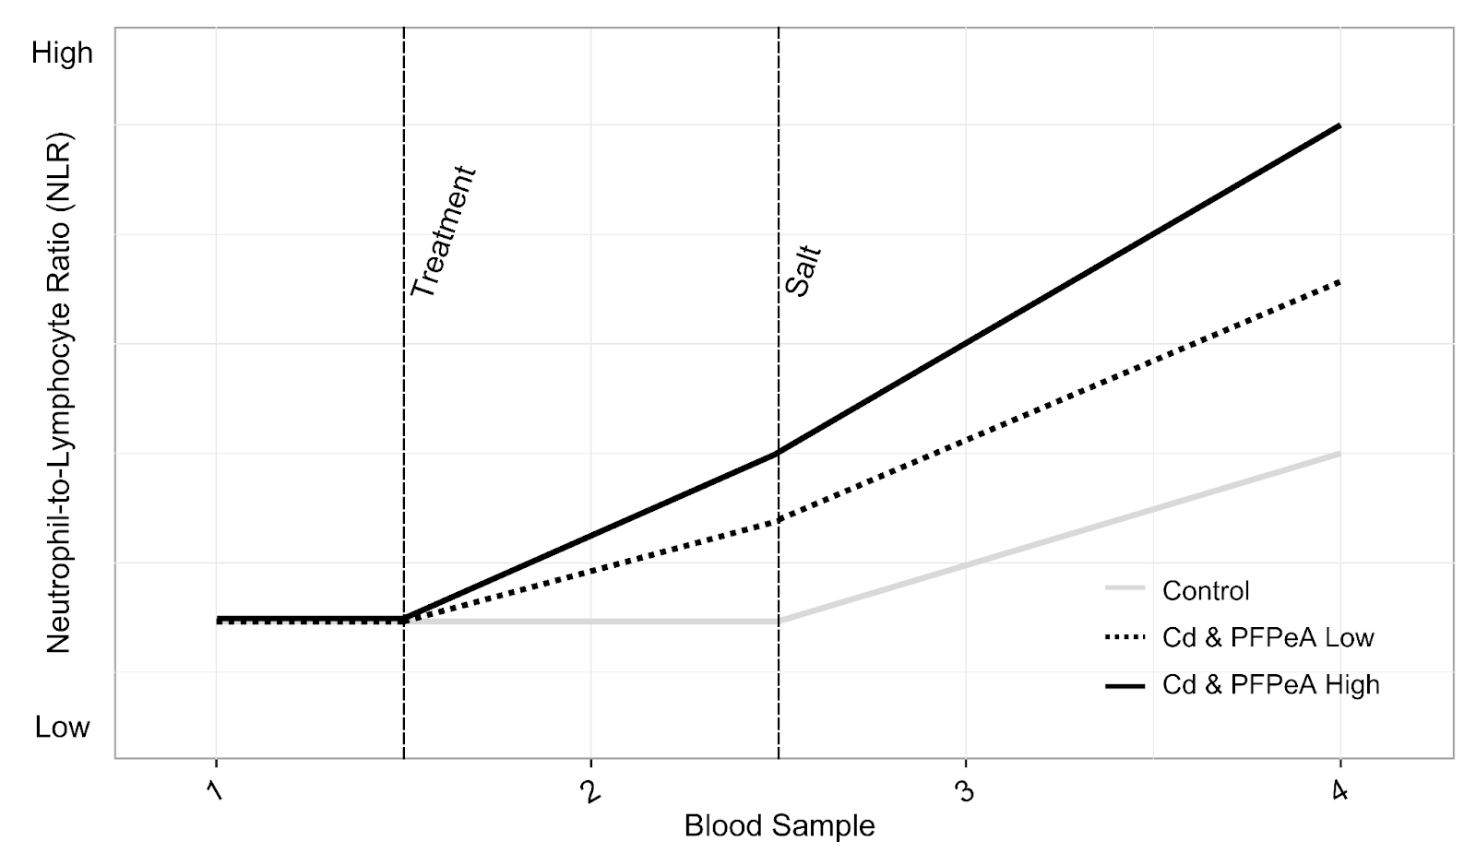
Figure 1. Hypothesized relationships among bass NLR, low and high levels of Cd and PFPeA, and an environmental stressor represented by salt addition. We anticipated that exposure to Cd or PFPeA, indicated by the dashed "Treatment" line between blood samples 1 and 2, would result in elevated NLR values, particularly in groups receiving higher doses of each toxin. Additionally, we expected the allostatic load to be greatest following exposure to an abruptly introduced environmental stressor, represented by the dashed "Salt" line between blood samples 2 and 3.

2. Materials and Methods
2.1 Aquaculture Tank Design
We assembled 15-37.9 liter (L) rectangular tanks on three shelves, five tanks per row (Figure 2). We positioned opaque barriers on the elongated sides of each tank and a fine mesh cover on top. We filled each tank with 34.6 L of tap water treated with Seachem Prime concentrated conditioner and placed 25-millimeter (mm) bubblers in each (multiport air pump; Aquatic Ecosystems Inc., Apopka, FL, USA). We kept the room at a constant low-indirect-light condition throughout the study. Lastly, we assigned each tank to one of five groups—control, Cd low 0.034 ppm, Cd high 0.34 ppm, PFPeA low 3.4 mg/L, PFPeA high 34 mg/L—with three replicates per group using a random number generator (Figure 2).

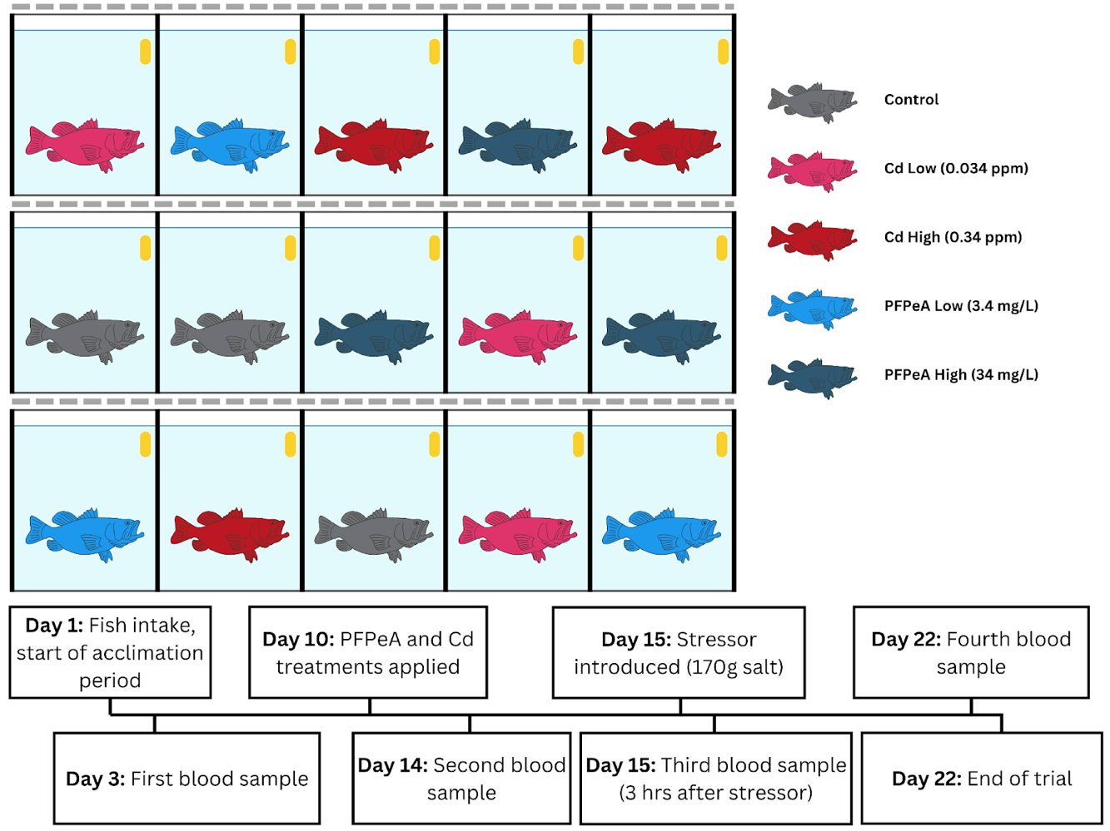
Figure 2. Study design and experimental timeline overview. We placed 15-37.9 L rectangular tanks in three rows, including opaque boundaries on the elongated sides (represented by thick solid black bars) and a mesh top (represented by dashed gray bars). Each tank included 37.6 L of conditioned tap water (light blue) with aerators (yellow bubbler). We randomized the treatment order among the tanks (five groups represented by each color). Below the tank design, in connecting boxes, we show the chronological order of relevant daily events from the start (day 1) to the end of the trial (day 22).

2.2 Experimental Timeline
Our study persisted for 22 days (Figure 2). On day 1, the Louisiana Department of Wildlife and Fisheries (LDWF) supplied bass collected using boat electrofishing from holding ponds at the Huey P. Long Fish Hatchery, Lacombe, Louisiana, USA. The LDWF immediately transferred the bass in their boat’s aerated livewell to Southeastern Louisiana University, Hammond, Louisiana, USA. On arrival, we recorded total length (TL) and weight (Wt) of 15 bass. We then placed each of these 15 bass into their own 37.9 L tank (aquaculture design described above; Figure 2). After we recorded TL and Wt and placed fish in individual tanks on day 1, we allowed a two-day acclimation period. On day 3, we collected the first blood sample from the caudal vein of each fish within 3 minutes of handling—minimizing any effect of newly induced anthropogenic stress—using a 1 mL syringe and 25-gauge needle and re-recorded TL and Wt. On day 8, we partially changed each tank’s water using a DEKO Tools water pump (model CSP9028) to maintain water conditions. To examine if differing levels of Cd or PFPeA alter baseline NLR (objective 1), we applied low and high Cd (0.034 ppm and 0.34 ppm, respectively) and PFPeA (3.4 mg/L and 34 mg/L, respectively; Sigma Aldrich, Darmstadt, Germany) treatments directly to water on day 10, while the control tanks were left undisturbed. On day 14, after four days of treatment exposure, we collected TL, Wt, and a second blood sample. Furthermore, to evaluate if treatment exposure would cause an altered stress response with a salinity increase (objective 2), we abruptly changed water salinity in all tanks from approximately 0 ppt to 5 ppt on day 15 (Figure 2; Figure 3). Three hours after salt introduction, we collected TL, Wt, and a third blood sample. On day 22, 12 days post-treatment and 7 days post-salt, we collected a final blood sample and euthanized all bass using MS-222.

2.3. Neutrophil/Lymphocyte Ratio
After we collected each blood sample, we immediately made blood smears using approximately 5-10 µl of whole blood on standard glass microscope slides (75 X 25 mm; 1 mm thick) with a two-slide wedge method (Houwen, 2002; C. M. Murray et al., 2013). After the smears air-dried, we fixed and stained them with Giemsa-Wright (Fisherbrand, Pittsburgh, PA, USA). Later, we examined the blood smears under light microscopy using 40X magnification to identify the first 100 leukocytes and calculated the NLR by dividing the observed number of lymphocytes by the number of neutrophils. The same person identified leukocytes in all blood smears, and this person was unaware of the treatment groups.

2.4. YSI Measurements
We collected water quality data—temperature (℃), dissolved oxygen (mg/L), pH, and salinity (ppt)—using a YSI Pro DSS as per user guidelines (Yellow Springs Instruments, Xylem Inc., Washington, D.C., USA) to ensure consistency among tanks. We collected YSI data on days 2, 3, 10, 11, 14, and 15, all before we increased salinity, and on day 17 to verify the intentional salinity increase. We double-rinsed the YSI instrument in tap and reverse osmosis water between samples to eliminate contamination among tanks. We used the water quality data to visually assess variation among tanks.

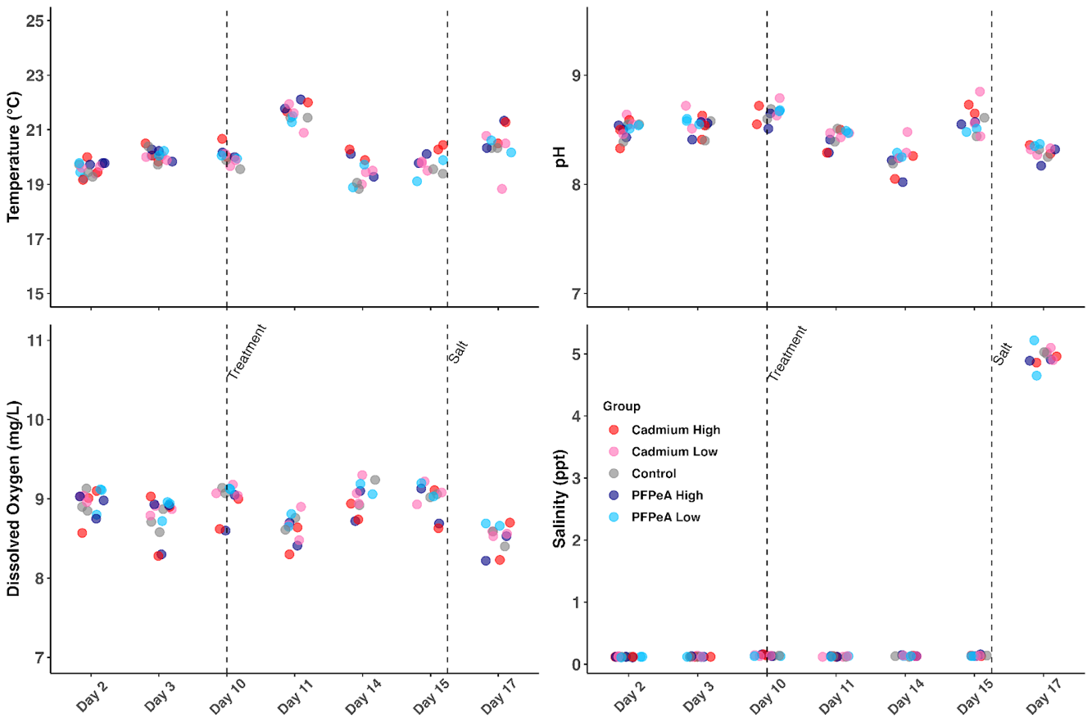
Figure 3. Individual tank water quality data (temperature, pH, dissolved oxygen, and salinity) we collected from a YSI Pro DSS on each sampling day (Figure 2). Color denotes the treatment group. The first vertical dashed line represents the day we added treatments, and the second indicates the day we added salt. Note that we recorded YSI data before salt addition on day 15.

2.5. Statistical Analyses
We visualized and analyzed all data using R in Posit’s RStudio Integrated Development Environment (R Core Team, 2024). We used an alpha value of 0.05 for statistical testing. Between day 4 and day 7, one fish in the control, Cd high, and PFPeA high group died; on day 14, one fish in the PFPeA low group died (four fish total). We included blood and water quality data from all four of these fish until day 7 but then removed the fish and their respective water quality data from the dataset.
First, we qualitatively assessed water quality variables throughout the study (days 2, 3, 10, 11, 14, 15, 17) to ensure temporal consistency among all tanks. We used the length and weight data to calculate each individual’s relative weight (Wᵣ), a commonly used condition metric of freshwater fishes (Neumann & Allen, 2007; equation 1).
Wᵣ = (W ⁄ Wₛ) * 100 equation 1
We used the regression equation for largemouth bass in Anderson and Neumann (1996) to calculate the standard weight (Wₛ) needed in the relative weight equation (the other parameter, W, is fish weight; equation 1). Then, we used a generalized linear mixed-effects model (GLMM) to analyze (1) the effect of varying rates of Cd and PFPeA on NLR (the proxy for bass stress; objective 1), (2) the interaction among treatment effects and the introduced environmental stressor’s effect on NLR (objective 2), and (3) the difference in NLR among groups with a persistent environmental stressor (objective 3). We determined the best-fitting distribution to the NLR data using the fitdistrplus package (Delignette-Muller & Dutang, 2015). We included fixed effects of treatment group (control, Cd low 0.034 ppm, Cd high 0.34 ppm, PFPeA low 3.4 mg/L, PFPeA high 34 mg/L), blood sample (1-4), and their interaction, and a random effect of individual (i.e., tank) to account for any autocorrelation within individual in the GLMM. We assessed our objectives by examining specific beta coefficient estimates within the GLMM: (objective 1) each treatment line’s slope between blood 1 and blood 2, (objective 2) each treatment line’s slope between blood 2 and blood 3, and (objective 3) each treatment line’s slope between blood 3 and blood 4 and each treatment’s mean at blood 4.

