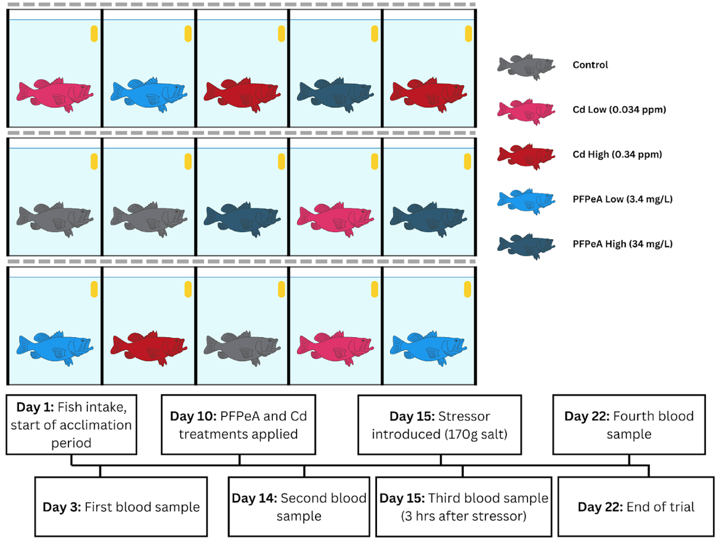
3. Results
3.1. Largemouth Bass
3.2. Water Quality
3.3. Toxins
3.3.1. Blood samples 1 versus 2
3.3.2. Blood samples 2 versus 3
All bass NLR significantly increased post-known-stressor introduction (Table 2; Figure 4). Interestingly, the control, Cd low, Cd high, and PFPeA low bass NLR increased more than the PFPeA high NLR after salinity introduction (Figure 4). The control bass NLR increased 78% (-21–301%; 95% CL) more than the PFPeA high group (Z15,48 = 1.40; p = 0.16). The Cd low (Z15,48 = 1.75; p = 0.080) and Cd high (Z15,48 = 1.95; p = 0.051) bass NLR increased 94% (-8–307%; 95% CL) and 127% (-1–418%; 95% CL) more than the PFPeA high group, respectively. The PFPeA low bass NLR increased 173% (21–515%; 95% CL) more than the PFPeA high group, the only statistically significant increase (Z15,48 = 2.42; p = 0.016).
3.3.3. Blood samples 3 versus 4
Seven days after the known environmental stressor introduction (blood samples 3 to 4), bass NLR declined in all groups, except PFPeA high—where bass NLR continued to increase (Table 3; Figure 4). More specifically, the PFPeA high bass NLR significantly increased 271% (75–688%; 95% CL), 223% (42–635%; 95% CL), and 526% (176–1319%; 95% CL) more than the Cd low (Z15,48 = 3.42; p < 0.001), Cd high (Z15,48 = 2.80; p = 0.0051), and PFPeA low (Z15,48 = 4.40; p < 0.001) groups, respectively, from blood sample 3 to 4. Bass NLR in the PFPeA high group increased 123% (-2–407%; 95% CL) compared to the control group from blood sample 3 to 4, although this was not statistically significant (Z15,48 = 1.92; p = 0.054; Figure 4). At the end of the study when the final blood sample was collected, PFPeA high bass NLR was significantly higher than the other four groups (all p < 0.001; Figure 4).

