Table 1.
Impoundments sampled, surface area (ha), years of spring electrofishing, and year(s) of shoreline rotenone application, if any (c.f., “control”).
Impoundment | Size (ha) | Years Electrofished | Year(s) Treated
Lee County Lake | 48 | 2017, 2018 | control
Anderson | 2.8 | 2017, 2018 | control
Barbour County Lake | 34 | 2017, 2018 | 2017
Washington County Lake | 38 | 2017, 2018 | 2017
Dale County Lake | 36 | 2017, 2018, 2019 | control
AE1 | 1.6 | 2017, 2018, 2019 | control
Big Pit | 11 | 2017, 2018, 2019 | control
FP3 | 0.7 | 2017, 2018, 2019 | control
Monroe County Lake | 34 | 2017, 2018, 2019 | 2017, 2018
Little Pit | 4 | 2017, 2018, 2019 | 2017, 2018
S3 | 4 | 2017, 2018, 2019 | 2017, 2018
Horseshoe | 1.3 | 2017, 2018, 2019 | 2017, 2018
Drummond3 | 8.8 | 2018, 2019 | control
Meriwether | 3.4 | 2018, 2019 | control
Williams | 3.3 | 2018, 2019 | control
Promise | 1.9 | 2018, 2019 | control
Drummond1 | 8.7 | 2018, 2019 | 2018
Britton | 2.2 | 2018, 2019 | 2018
Zachry | 5.3 | 2018, 2019 | 2018
Dead | 2.2 | 2018, 2019 | 2018

Figure 1.
Map of small impoundments studied. Controls are grey triangles and treatments are black circles. All names ending with “County Lake” represent the large-sized impoundments, while all the other names are the small-sized impoundments.

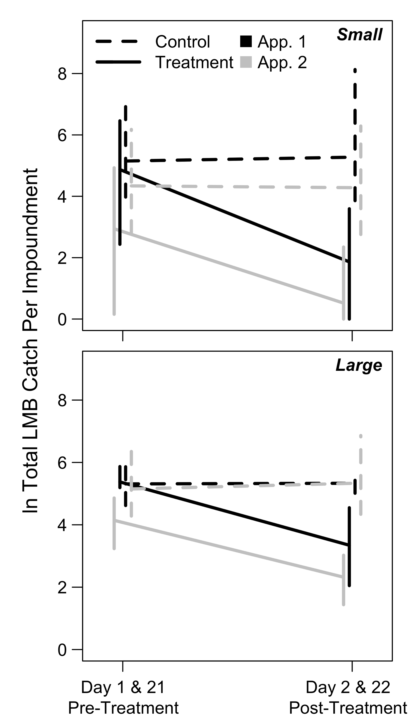
Figure 2.
Largemouth Bass log_{e} total seine catches immediately before (days 1 and 21) and after (days 2 and 22) the first (“App. 1”; black lines) and second (“App. 2”; grey lines) shoreline rotenone applications in small (<12 ha; upper panel) and large (>33 ha; lower panel) impoundments. Solid lines denote treated impoundments and dashed lines denote controls. Observations were pooled across years (2017 and 2018) and error bars represent the 2.5th and 97.5th percentiles (95% confidence intervals).

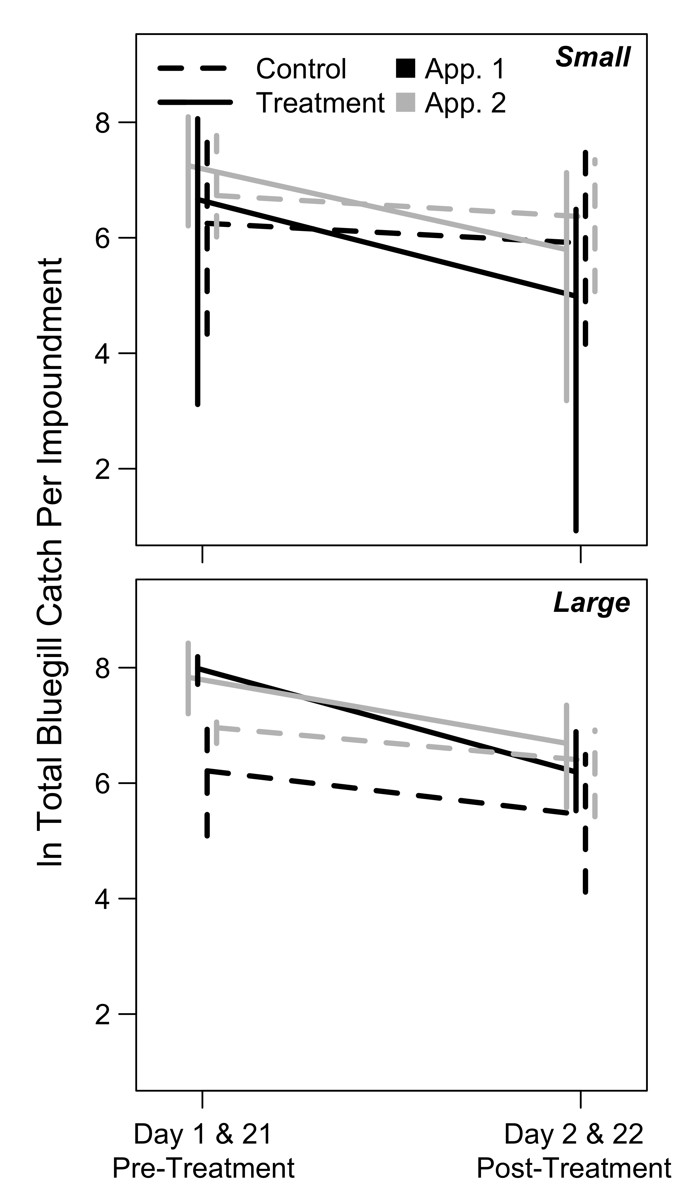
Figure 3.
Bluegill log_{e} total seine catches immediately before (days 1 and 21) and after (days 2 and 22) the first (“App. 1”; black lines) and second (“App. 2”; grey lines) shoreline rotenone applications in small (<12 ha; upper panel) and large (>33 ha; lower panel) impoundments. Data are presented as in Figure 2.

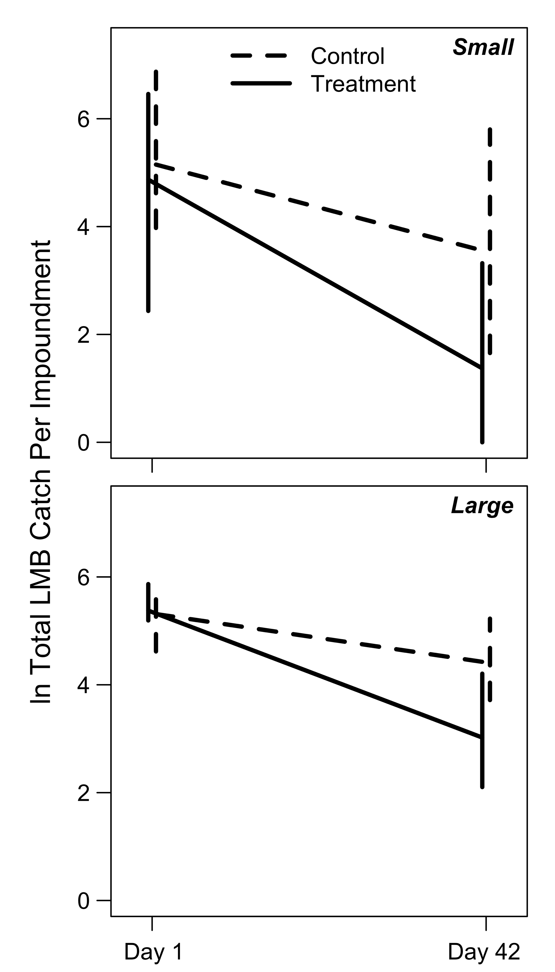
Figure 4.
Largemouth Bass log_{e} total seine catches in small (<12 ha; upper panel) and large (>33 ha; lower panel) impoundments immediately before rotenone application (day 1) and at mid-summer after both rotenone applications (day 42). Solid lines denote impoundments that received shoreline rotenone treatments, and dashed lines denote controls. Data were pooled across years (2017, 2018) and error bars represent 95% confidence intervals.

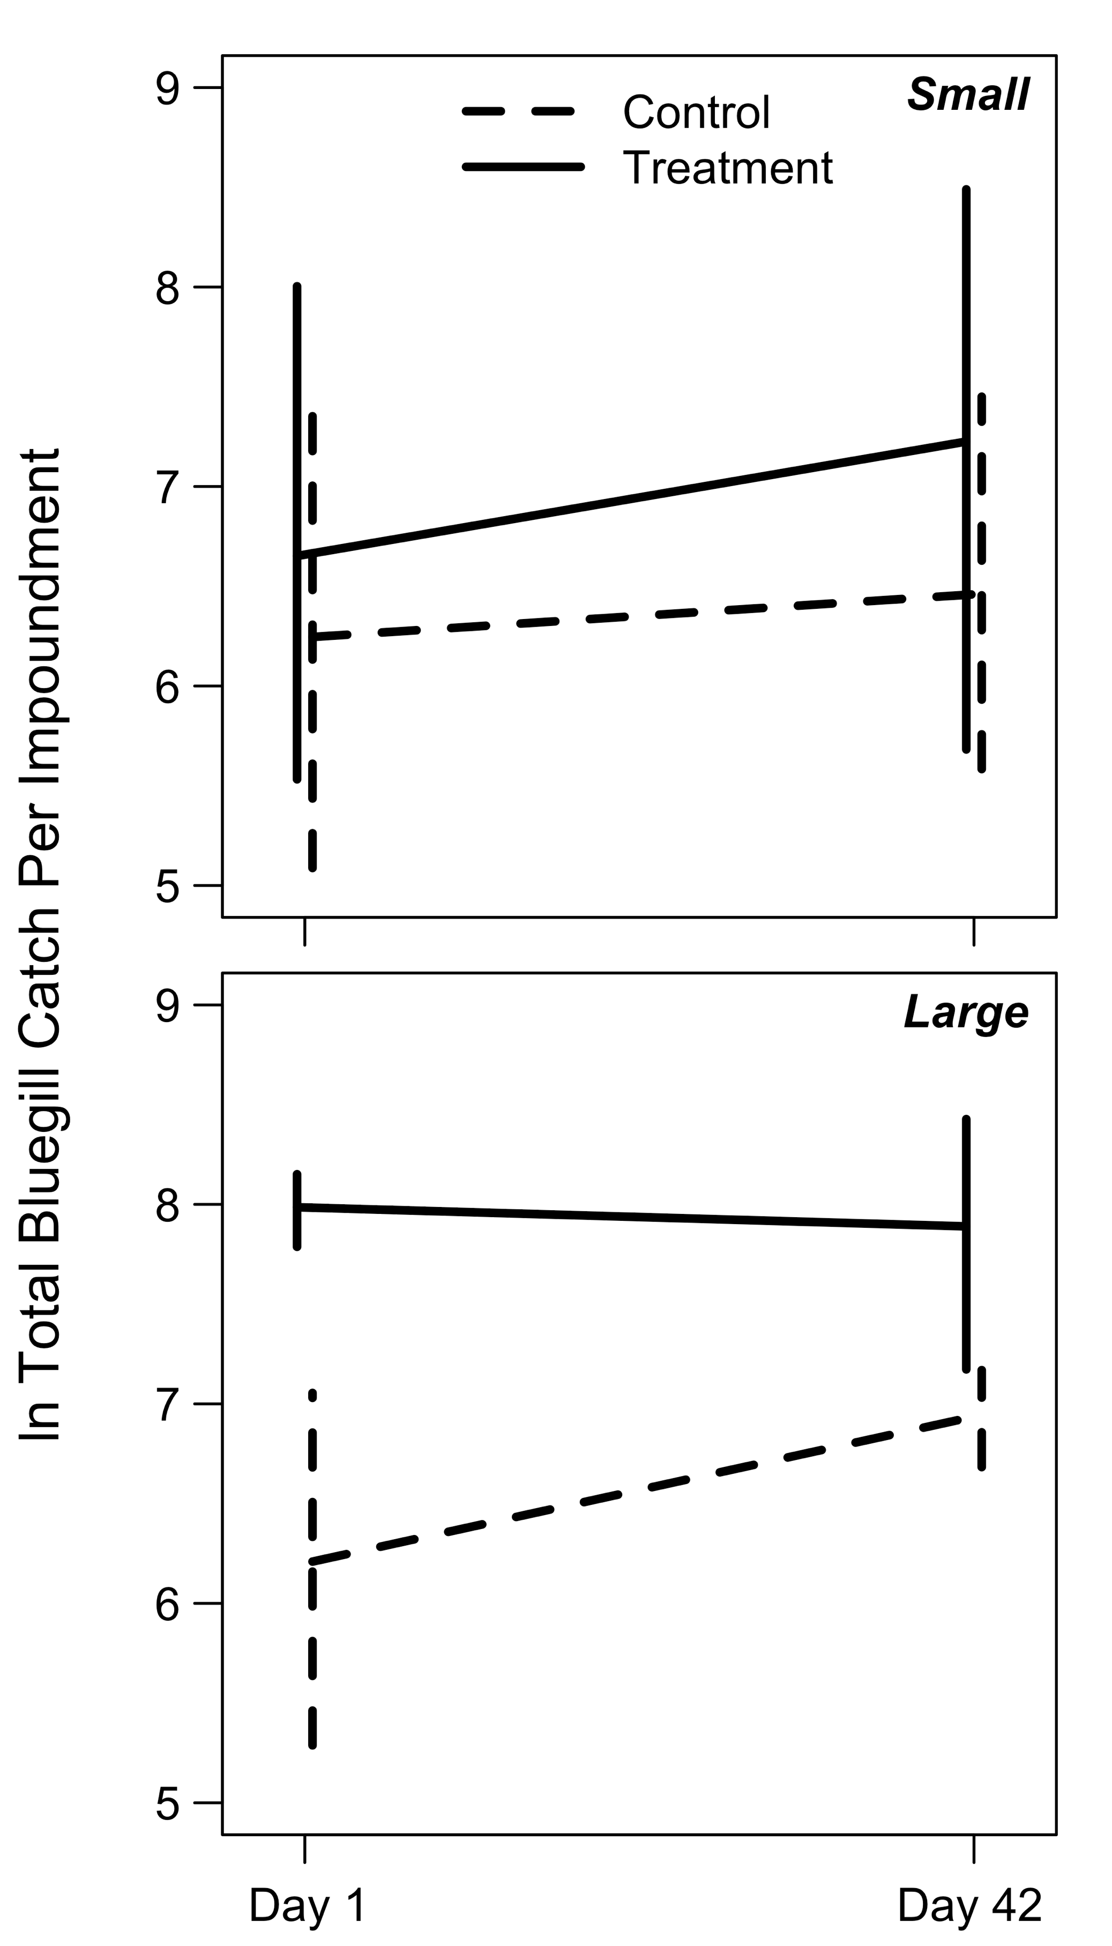
Figure 5.
Bluegill log_{e} total seine catches in small (<12 ha; upper panel) and large (>33 ha; lower panel) impoundments immediately before rotenone application (day 1) and at mid-summer after both rotenone applications (day 42). Data are presented as in Figure 4.

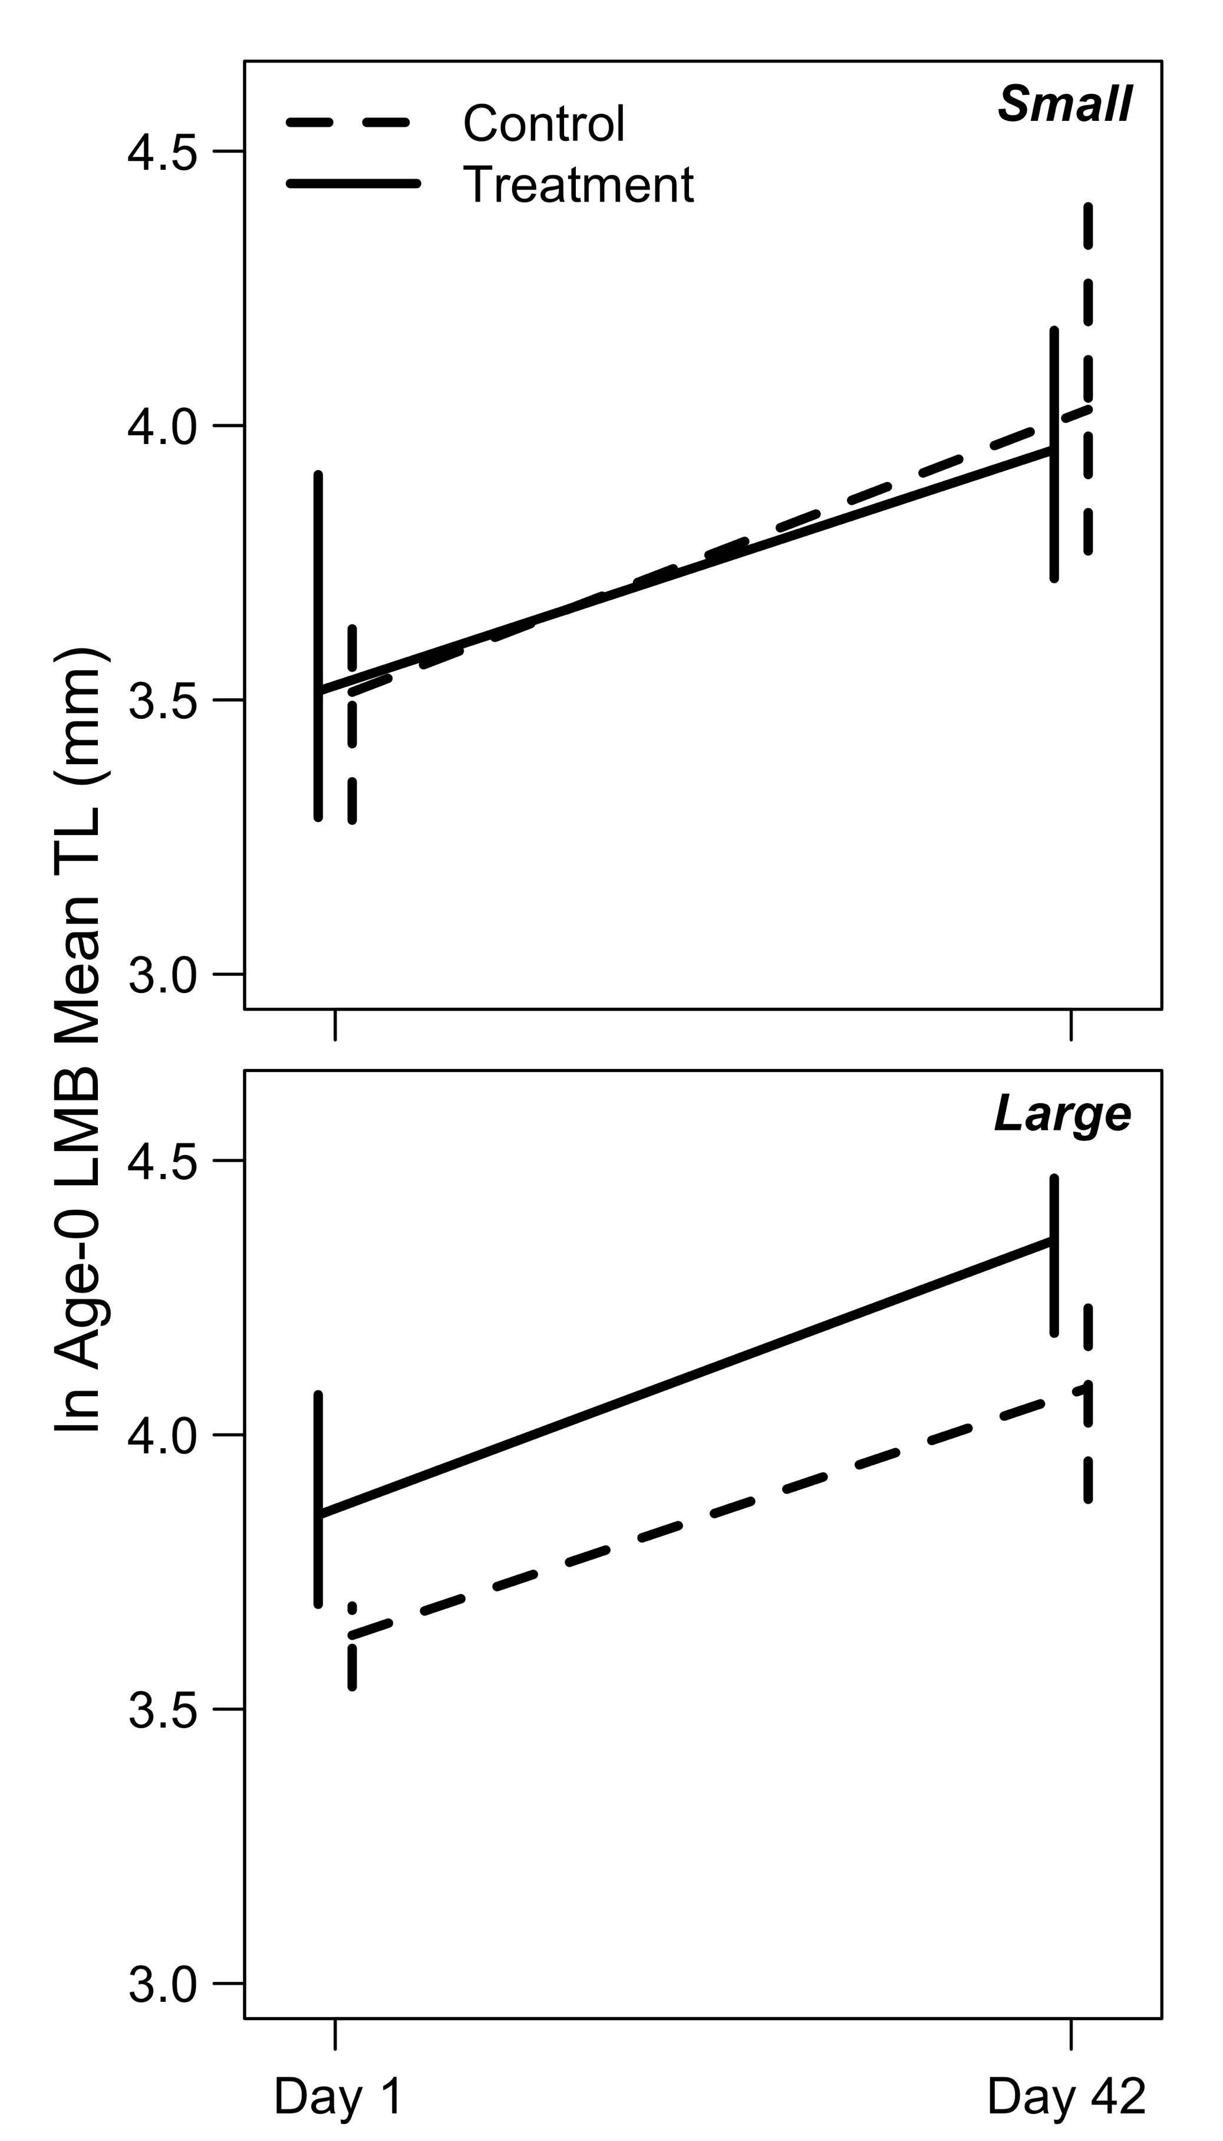
Figure 6.
Largemouth Bass log_{e} MLA-0 in small (<12 ha; upper panel) and large (>33 ha; lower panel) impoundments immediately before rotenone application (day 1) and at mid-summer after both rotenone applications (day 42). Data are presented as in Figure 4.

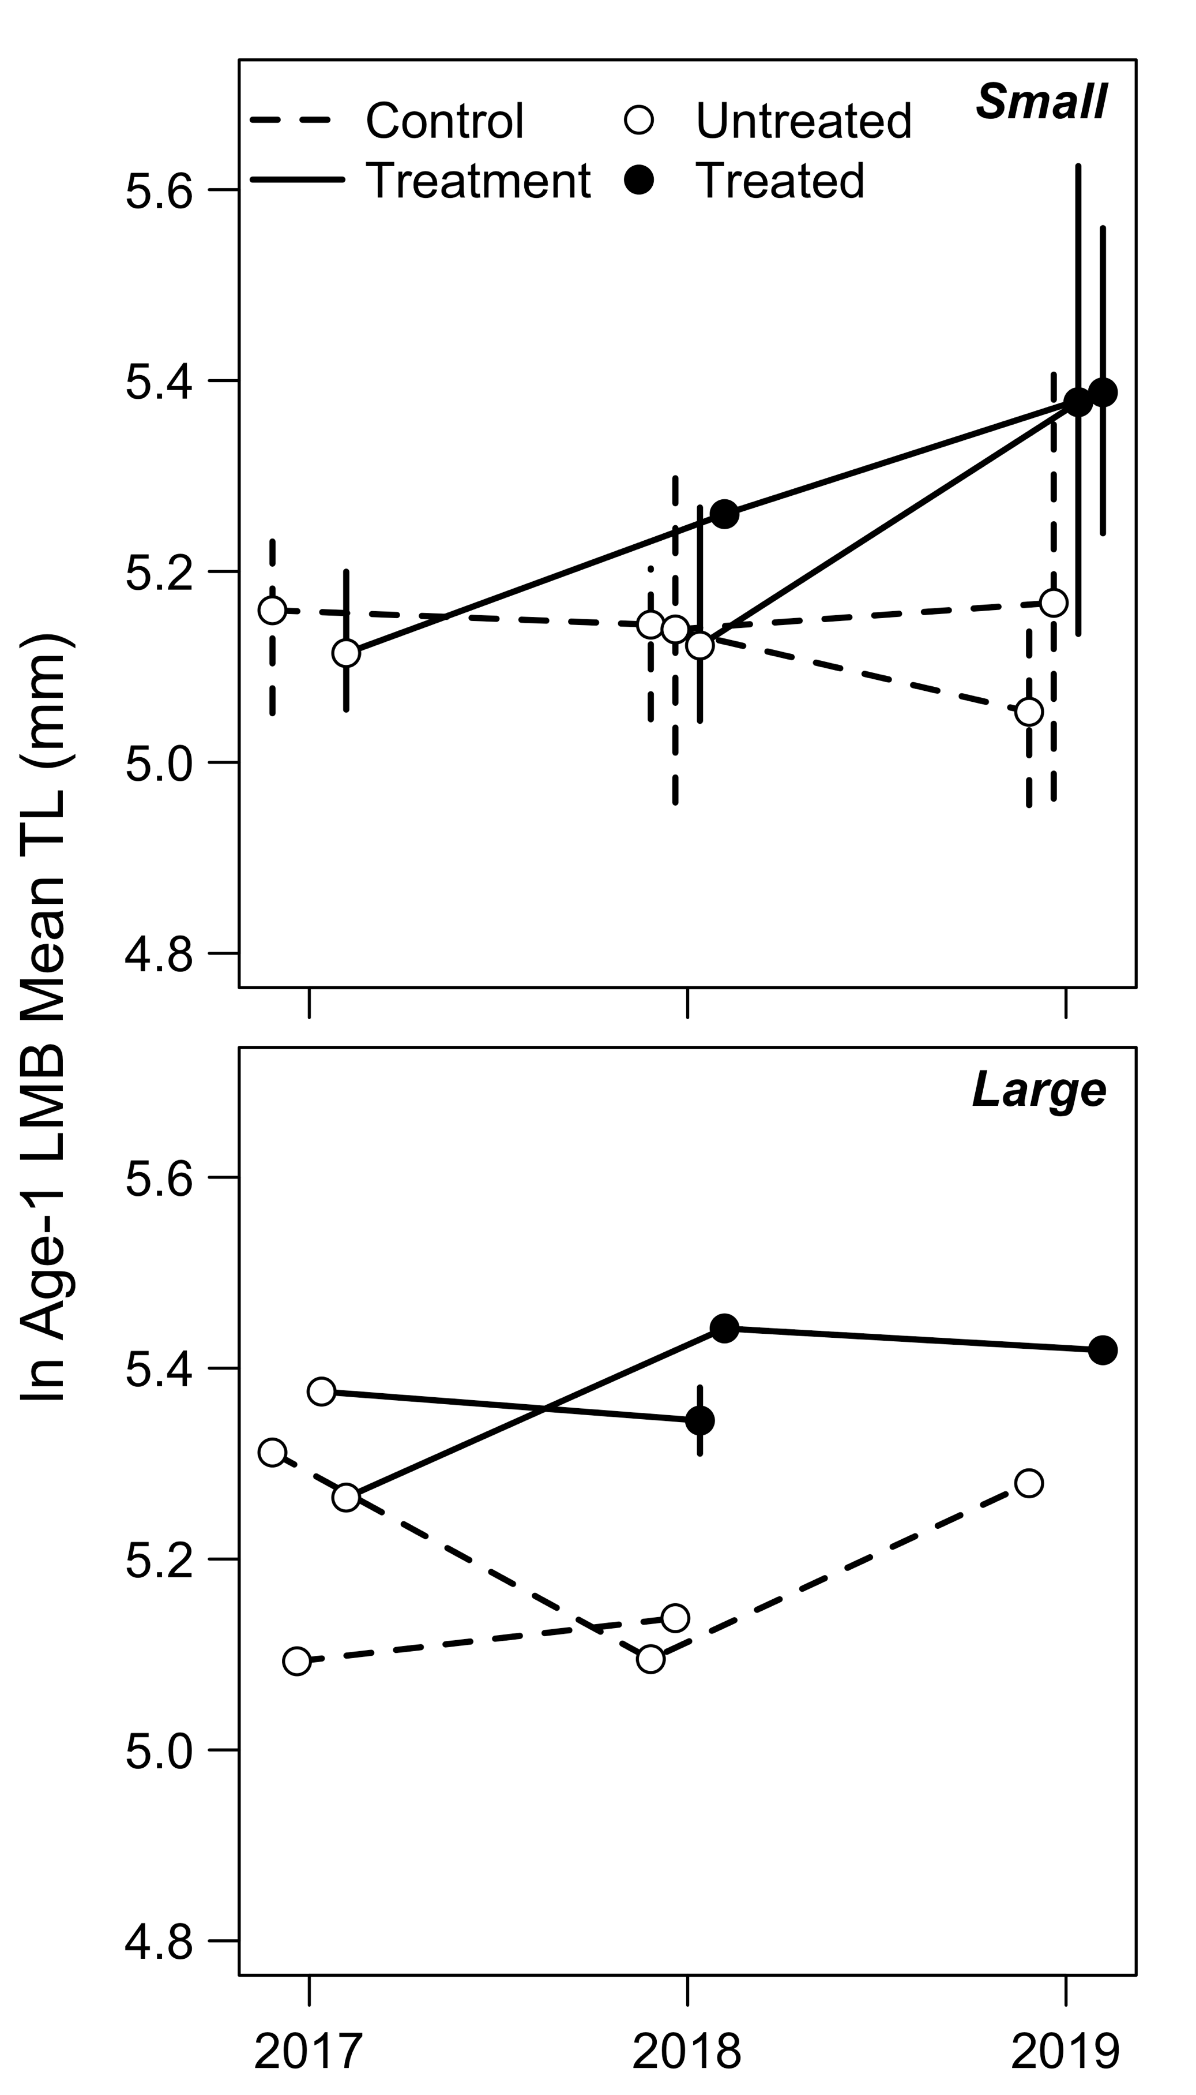
Figure 7.
Temporal trends in Largemouth Bass log_{e} MLA-1 in small (<12 ha; upper panel) and large (>33 ha; lower panel) impoundments in control (dashed lines) and treatment (solid lines) impoundments. Open circles denote untreated impoundments, while closed circles denote treated impoundments. Solid lines leading from a closed circle to another closed circle represent the impoundments that were treated twice (e.g., see Table 1). Times treated (untreated control, once, twice) was the variable of interest in our model, and this portrays how the model compared those different levels of treatment. Error bars represent the 95% confidence intervals of the data when the sample size for that year was greater than two impoundments.
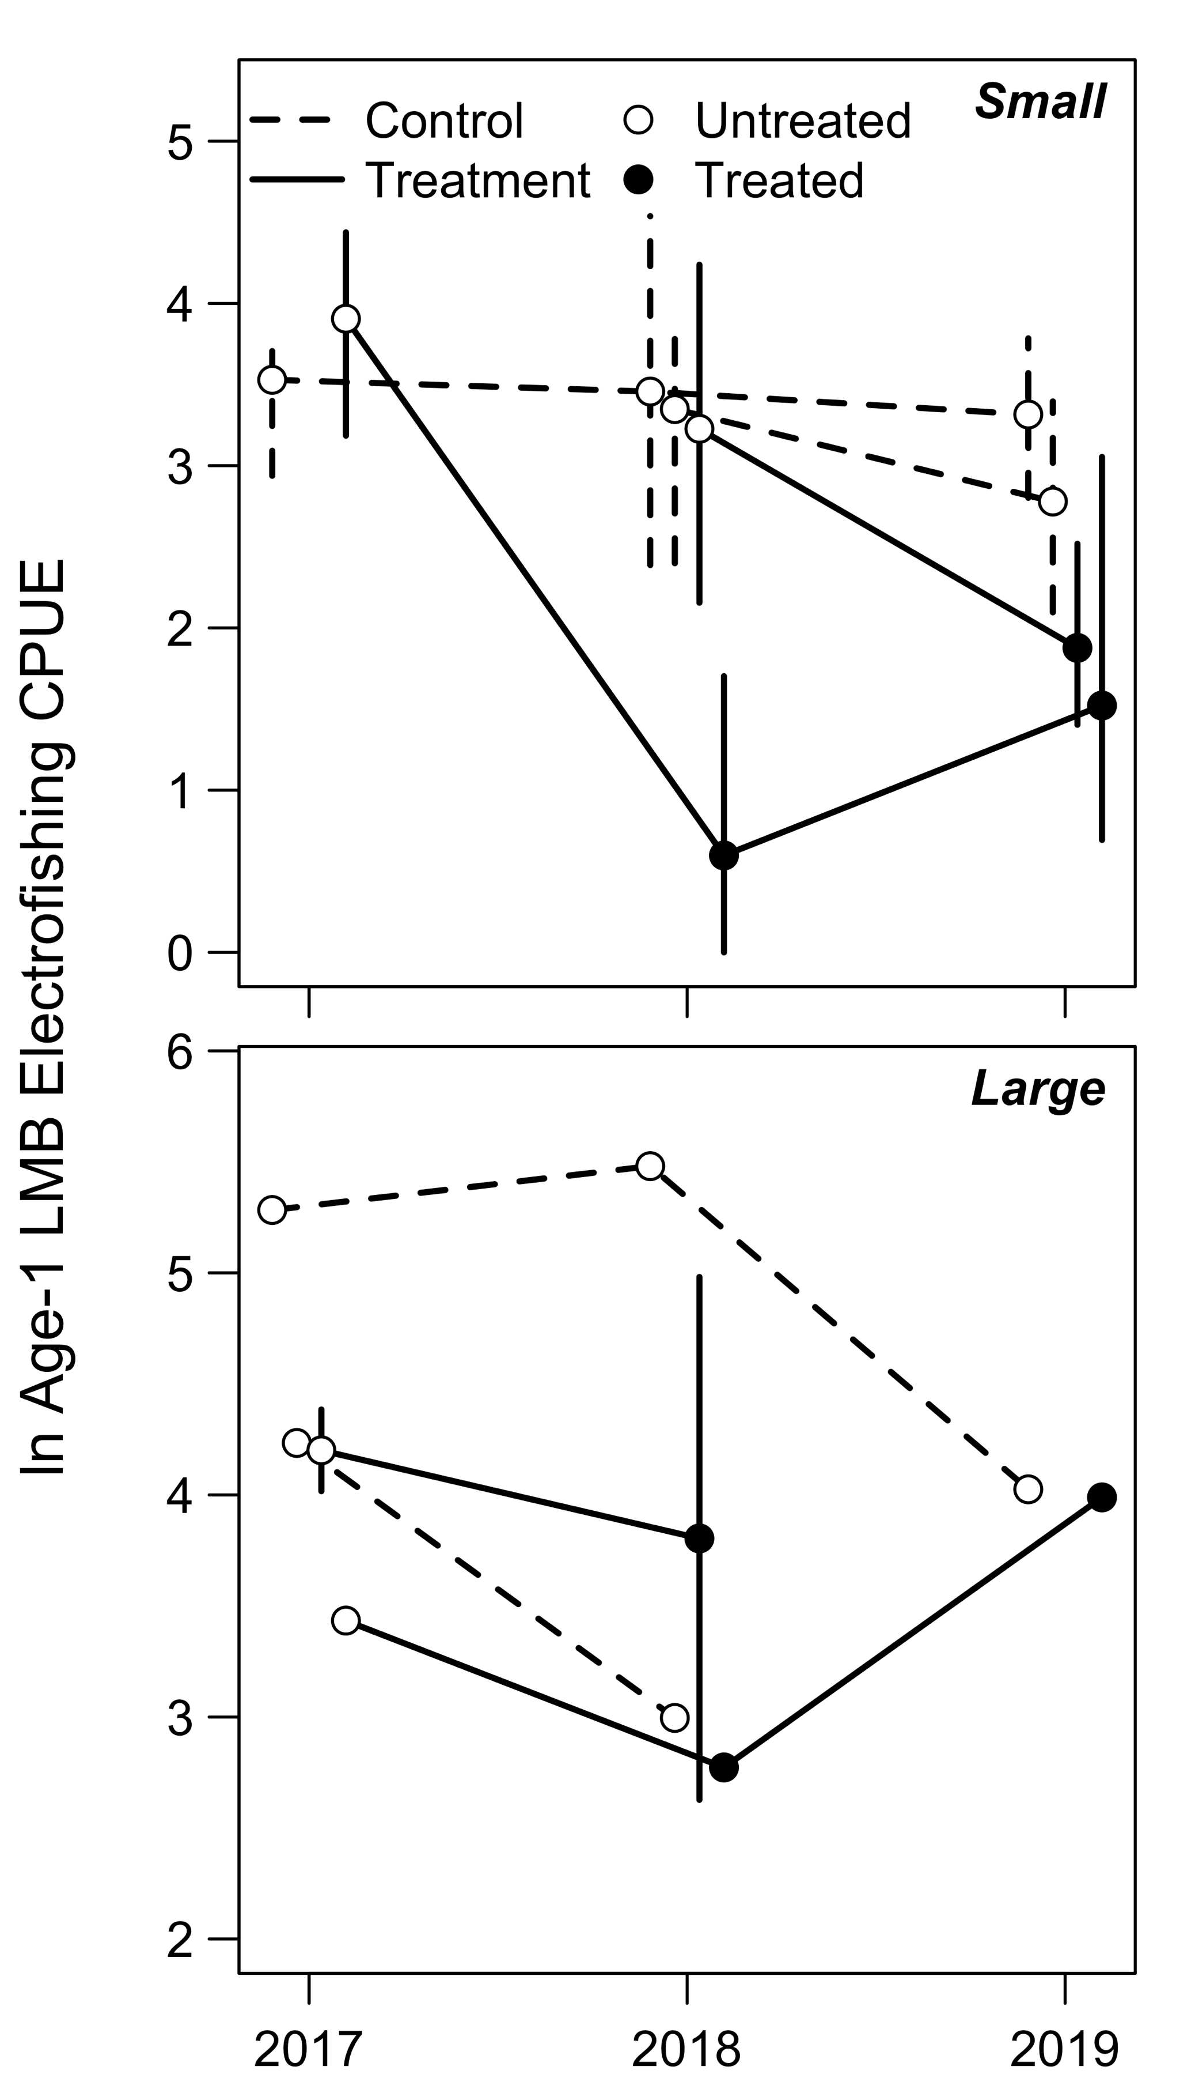
Figure 8.
Temporal trends in age-1 Largemouth Bass log_{e} electrofishing CPUE (fish caught per 30 minutes electrofishing)—as a proxy for recruitment—in small (<12 ha; upper panel) and large (>33 ha; lower panel), and control (dashed lines) and treatment (solid lines) impoundments. Open circles denote untreated impoundments, while closed circles denote treated impoundments. Data are presented as in Figure 7.
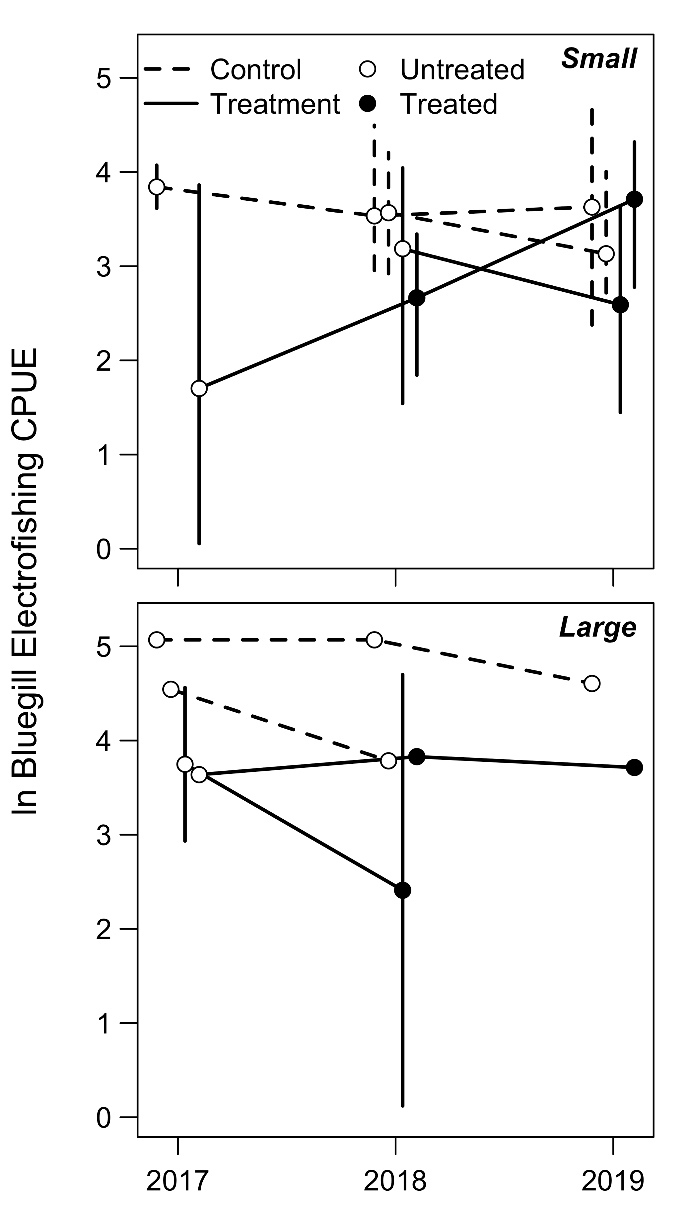
Figure 9.
Temporal trends in Bluegill (>80 mm) log_{e} electrofishing CPUE (fish caught per 30 minutes electrofishing) in small (<12 ha; upper panel) and large (>33 ha; lower panel), and control (dashed lines) and treatment (solid lines) impoundments. Open circles denote untreated impoundments, while closed circles denote treated impoundments. Data are presented as in Figure 7.

