For our test code, we created a method that check for login verification by using the username and password and comparing it to our data that is located in our info.txt

verification.java

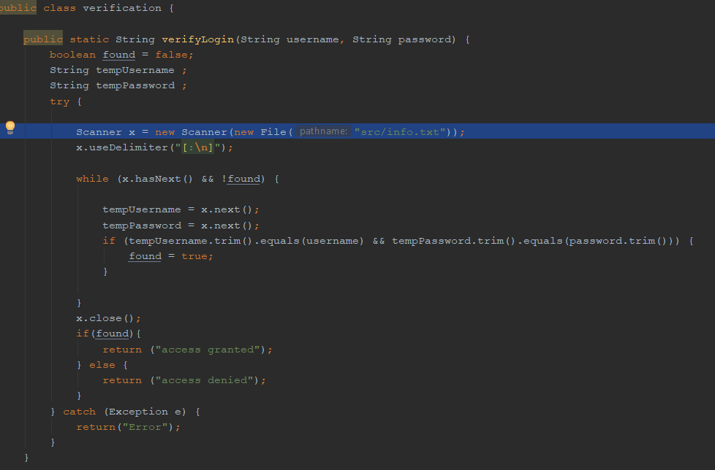

Info.txt

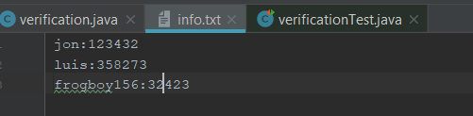

This is the method that compares the users input and verifies whether both username and password are present. If both cases are present our method returns the string “access granted”, otherwise it returns “access denied”.

verificationTest.java

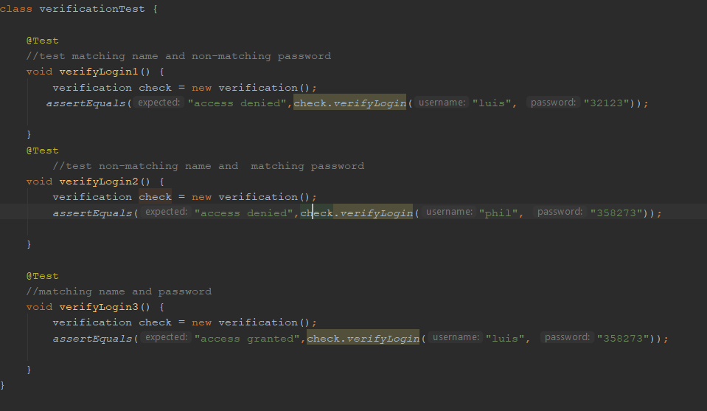

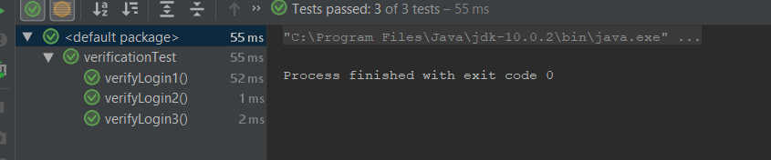

For verfiylogin1 we test matching name and non-matching password, and use assertEquals() to check if the output equals “access denied”. Test verifylogin2 tests a non-matching name and a matching password, and checks if the output equals “access denied. Finally we test a matching username and matching password and use asserEquals() to check if the output equals “access granted”. As we see on the last image our test methods passed all our tests as we predicted.