Around The Clock Cleaning LLC.
Ph. 502.356.7761
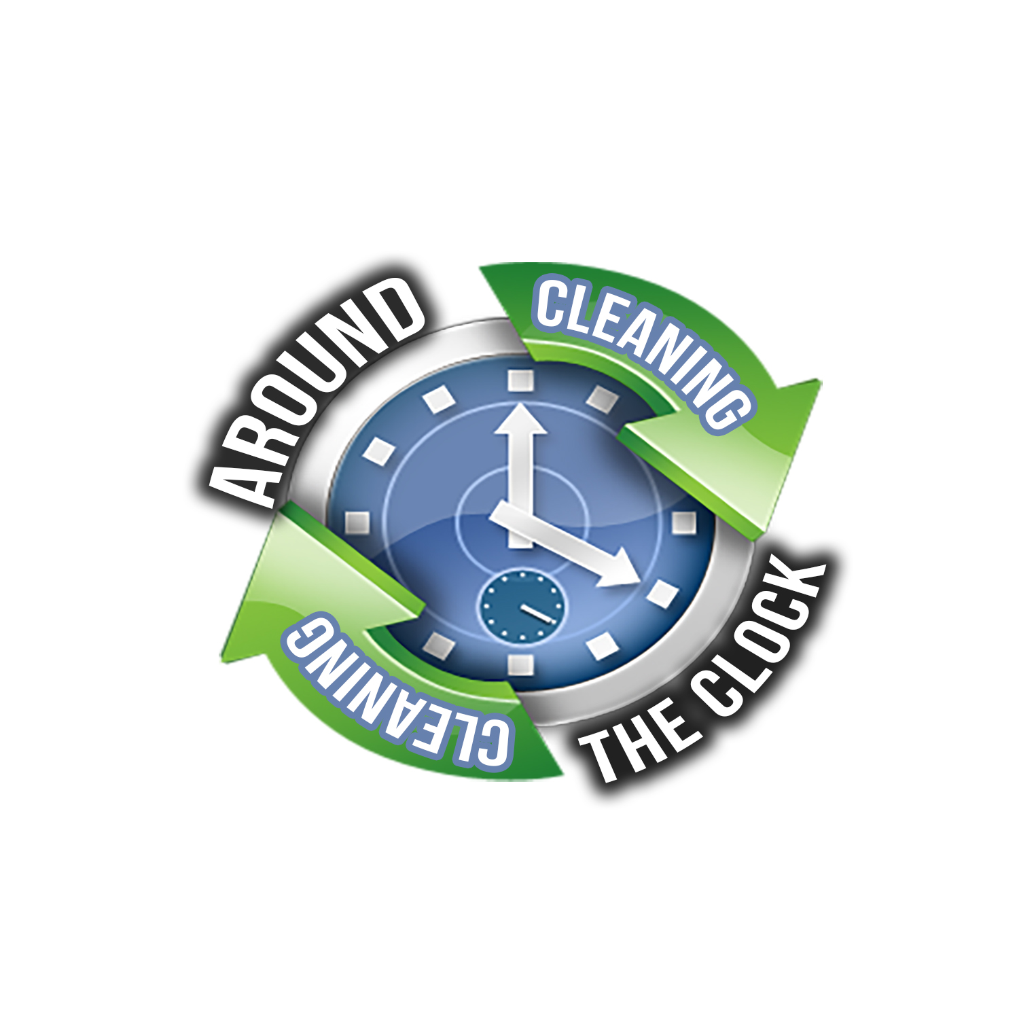
info@aroundtheclockcleaning.net
Window Cleaning Checklist
00004 | 4921 Dixie Hwy, Unit B&C | Louisville | KY | 40216

Interior Only Window Cleaning
The Cleaning Process
- Cobwebs removed from window and door frames
- Window glass cleaned
- Window frames and sills wiped clean
- Window tracks brushed and wet towel cleaned

Exterior Only Window Cleaning
The Cleaning Process
- Cobwebs removed from window and door frames
- Exterior window glass cleaned
- Exterior window frames and sills wiped clean

Manager’s Signature:________________________ Date: ________________

Window Cleaner’s Signature: _________________ Date: _________________

