一、目标客户列表：

1. 客户编号(34698个)
2. 数据日期（11个月的）

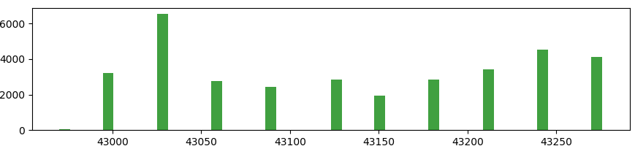

1. Label：3337（违规）

二、客户基本信息：211360个

1. DATA_DAT数据日期（211360条，16个）

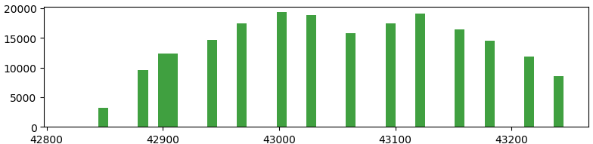

1. CUST_NO客户编号（211360条，34114个）
2. PROV_CD省市代码（210139条,40种）

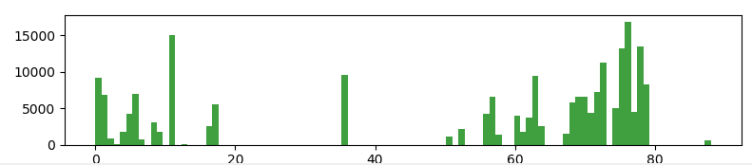

1. REG_ORG_NO开户机构编号（5359种类）
2. CUST_SEX_CD客户性别代码（211256条，{'9.0', '1.0', '2.0', 'nan', '0.0'}）

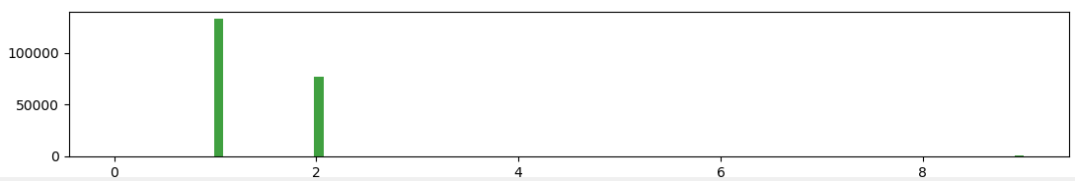

1. IPT_EXT_CERT_TYP_CD参与人外部证件类型代码（211325条，{'776665.0', '776667.0', '776660.0', 'nan', '776663.0'}）没意义了

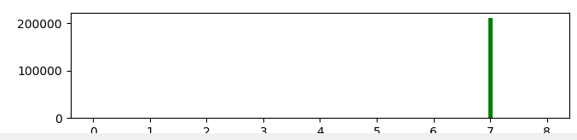

1. CUST_EXT_OFFL_NO客户外部官方编号（34185种）
2. FST_ARG_CRT_DAT首份合约建立日期（211360条）

有特别小的

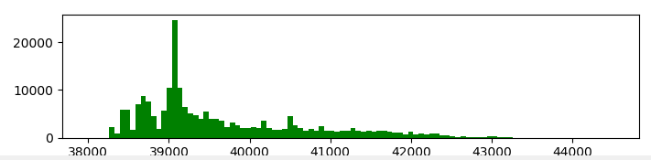

1. MRGE_STS_CD婚姻状态代码（201826条，6种）

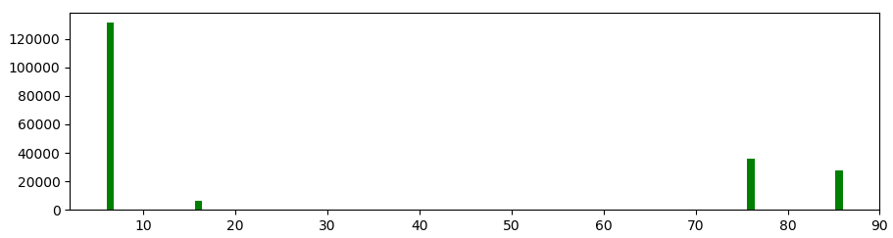

1. CULT_DGR_CD文化程度代码（48种类）
2. DGR_CD学伪代码(199168条，15种类)

{'67.0', '170.0', '164.0', '888.0', '66.0', '882.0', '566.0', '562.0', '160.0', '166.0', '766.0', '163.0', '560.0', '162.0', 'nan'}

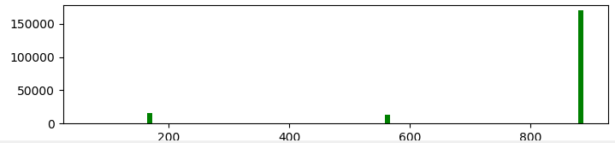

1. GC_BRTH公历生日有脏数据，小于-300000的

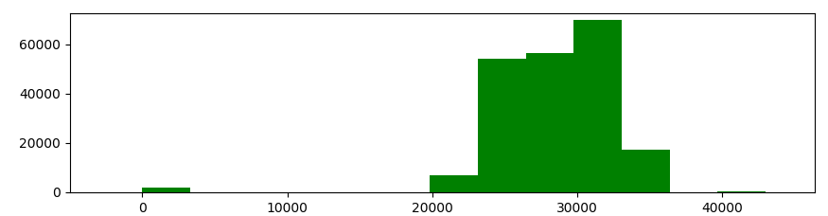

1. YEAR_INCM年收入(75%+ 0 值，没有意义)
2. FMLY_YEAR_INCM家庭年收入

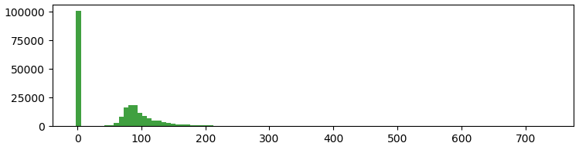

三、定期存款账户信息（160428条）

1.数据日期DATA_DAT

{'43000', '42939', '42911', '42819', '43153', '43031', '42970', '43184', '43276', '43123', '43092', '43061', '42880', '42849', '43245', '43214'}

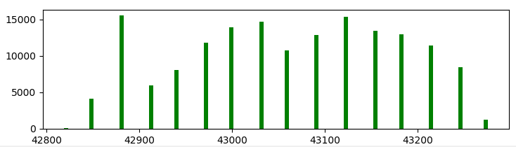

2.省市代码PROV_CD

3.机构编号ORG_NO

4.客户编号CUST_NO

5.合约建立日期ARG_CRT_DAT

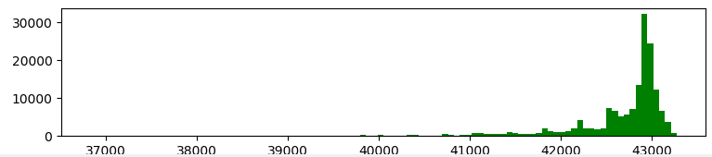

6.销户日期CLS_ACCT_DAT(793种，有0值有﹣值)

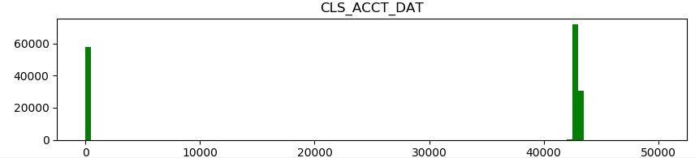

7.到期日期MATU_DAT（2006种）

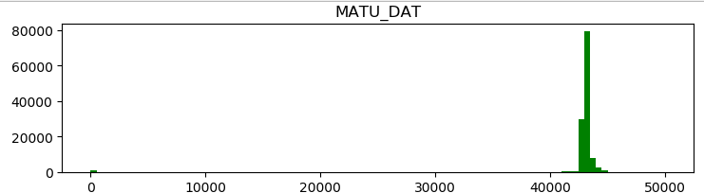

8.开户本金REG_CAP

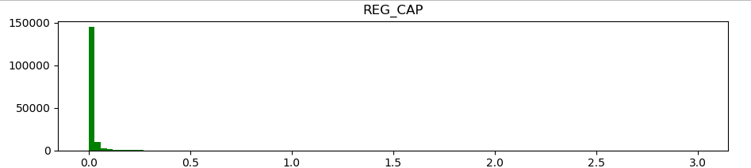

9.执行利率EXEC_RATE

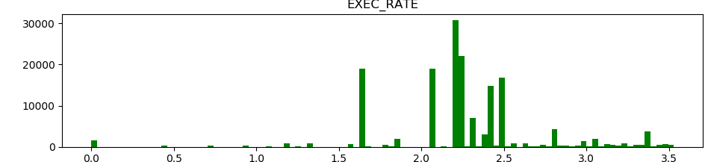

10.贷方余额CRBAL

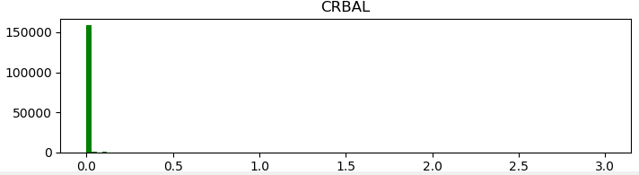

11.月内贷方积数MOTH_CR_ACCM

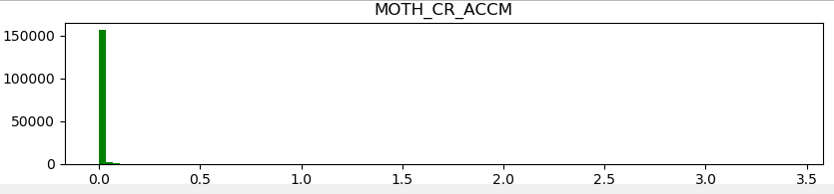

12.本月实际天数累计MTH_ACT_DAYS_TOT{'30', '28', '31'}

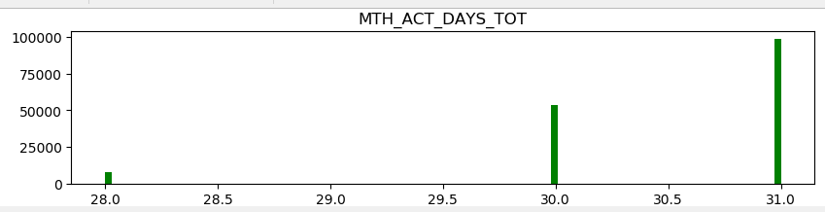

8):

train_A['TR_CD'].value_counts()

0 903409

7 563673

1 215417

3 1935

8 1488

75 889

7)

relationship between FLAG and DATA_DT :

-0.03556898719989809

relationship between FLAG and ARG_NO :

0.05634168264771823

relationship between FLAG and ARG_CRT_DAT :

0.009229681427380943

relationship between FLAG and CHANL_CD :

relationship between FLAG and CHANL_CD : not avaliable

relationship between FLAG and FUD_PROD_TYP_CD :

-0.00841710538183312

relationship between FLAG and RSK_RANK_CD :

0.0116184288283592

relationship between FLAG and FUND_BAL :

-0.013408769479869753

9)

RSK_CLS_CD:

没有违规

76.0 150289

6.0 284

16.0 36

56.0 14

36.0 12

违规

76.0 19159

6.0 43

56.0 8

relationship between FLAG and DATA_DT : 0.047586049343558534

relationship between FLAG and ARG_NO : -0.044919097261954866

relationship between FLAG and PROV_CD : -0.044730451416204596

relationship between FLAG and MATU_DAT : 0.05207234689114135

relationship between FLAG and LN_TERM : 0.04619079082413117

relationship between FLAG and ARG_CRT_DAT : -0.0009977525754051072

relationship between FLAG and RSK_CLS_CD : -0.0016318724948699663

relationship between FLAG and FORM_STS_CD : 0.0009850611365033511

relationship between FLAG and NML_CAP_BAL : 0.06973448895899104

relationship between FLAG and TOT_PRVD_AMT : -0.06048696506650435

relationship between FLAG and TOT_REVK_AMT : -0.10255994083809135

relationship between FLAG and MTH_NML_CAP_ACCM : -0.03377766660690572

relationship between FLAG and MTH_ACT_DAYS_TOT : 0.008611348684481808

15-14：-0.16

10)

11)

relationship between FLAG and CUST_CYC_CR_IND :

0.11652700760395687

relationship between FLAG and CUST_CD_VLU :

0.0022054849926701984