**Mobile support web application**

**1. Registration form**

**In this project we have mobile supported web application.**

**It is include 4 part:**

**Part 1: Registration form**

**[Design is done, auto fields calculations are done, Forensic Evidence Collection Options is left]**

**[submit two forms with one button left]**

This part include two forms “registration” and “checklist”

Both of forms must be submitted by one button.

Record all fields, convert to PDF and send to an email address.

Story: ‘registration’ form showing first.

At the end of form, there is some options: ‘Forensic Evidence Collection Options:’

Its 20 options… Better to be show in check boxes… by calculations as below table: should be show checked or unchecked…

**Highlight the options below when time since assault is <= to the time in the column**

|  |  |  |  |  |  |
| --- | --- | --- | --- | --- | --- |
| Peri-oral swab (lips) | ≤48hrs | Low Vaginal Swab | ≤120hrs | Skin swab (saliva) | ≤48hrs |
| Oral swab (inside mouth) | ≤24hrs | High Vaginal Swab | ≤120hrs | Skin swab (blood) | ≤48hrs |
| Oral rinse | ≤24hrs | Endocervical Swab | ≤120hrs | Skin swab (semen) | ≤48hrs |
| Oral spit (saliva) | ≤24hrs | Perianal Swab | ≤48hrs | Urine toxicology | ≤48hrs |
| External Labial (digital penetration) - If hasn't washed | ≤12hrs | Anal Swab | ≤48hrs | Blood toxicology | ≤48hrs |
| External Labial (penile penetration) | ≤48hrs | Rectal Swab | ≤48hrs | Penile swab | ≤48hrs |
| External Labial (cunnilingus) | ≤24hrs | Skin Swab (touching) - If hasn't washed | ≤12hrs |  |  |

By clicking ‘NEXT’ the other form ‘checklist’ is appearing and finally by clicking on ‘submit button’ should record all fields from two forms, convert them into PDF format and send it to an email address. Finally give ‘successful’ notification to the user.

**Part 2: Calculation**

There is one input date and time field and one button

By clicking on button, should calculate different time between current time and the field. And show in the page.

**Part 3: Documents**

**[It is working on PC bowsers but not on mobile devices… think something wrong to reading and presenting PDF files on mobile devices]**

Read documents from Drop Box

**Part 4: Contacts**

**[It is working with no problem]**

Read documents from Drop Box

** All coding must be in HTML-CSS-JS and JQUERY formats. No PHP file supported

** must check and pass in mobile devices (some codes does not work properly on mobile devices)

** Pictures for better understanding is presenting at the end of this document

|  |  |
| --- | --- |
|  |  |

Table 1:Form 1 “Registration” by clicking next store all data and go to next step

|  |  |
| --- | --- |
|  |  |

Table 2: Checklist form by clicking submit store all data from registration form and checklist form, convert it to the PDF format and send it to an email address

**2. Validation form**

**Highlight the options below when time since assault is <= to the time in the column**

|  |  |  |  |  |  |
| --- | --- | --- | --- | --- | --- |
| Peri-oral swab (lips) | ≤48hrs | Low Vaginal Swab | ≤120hrs | Skin swab (saliva) | ≤48hrs |
| Oral swab (inside mouth) | ≤24hrs | High Vaginal Swab | ≤120hrs | Skin swab (blood) | ≤48hrs |
| Oral rinse | ≤24hrs | Endocervical Swab | ≤120hrs | Skin swab (semen) | ≤48hrs |
| Oral spit (saliva) | ≤24hrs | Perianal Swab | ≤48hrs | Urine toxicology | ≤48hrs |
| External Labial (digital penetration) - If hasn't washed | ≤12hrs | Anal Swab | ≤48hrs | Blood toxicology | ≤48hrs |
| External Labial (penile penetration) | ≤48hrs | Rectal Swab | ≤48hrs | Penile swab | ≤48hrs |
| External Labial (cunnilingus) | ≤24hrs | Skin Swab (touching) - If hasn't washed | ≤12hrs |  |  |

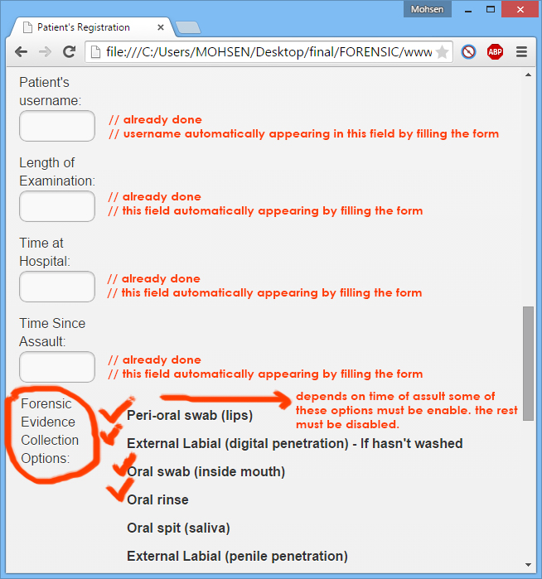

Table 3: depends on time of assault, the options should be appear or disappear.  
the table above is helping you