# Tips

* To handle events like button clicks inside of Dojo modules, use “dojo/dom” and on(dom.byId(*button ID*), “click”, *callback function*(evt))
  + (see **test_Dojo_addTab.html** on Macbook)
* By default, the **this** object in an event handler points to the DOM object triggering the event. To specify a different **this** object (say *thisObject*), add “.bind(*thisObject*)” to the end of the function name.
  + For example, to use the current module’s current **this**, then something like:
    - **this**.**queryTask**.on(**"complete"**,**this**.checkData.bind(**this**));
    - **[QueryBasedPanelWidget,** runQuery **function]**
  + (instead of:
    - **this**.**queryTask**.on(**"complete"**,**this**.checkData);
* **To find class name and other HTML element info, right-click object in browser (Chrome, anyway), and select Inspect**
* 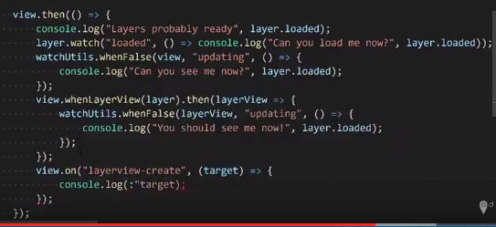
* Quick Tip: ArcGIS API 4 for JS - When stuff is ready?
* Create CSS class in code:

var sheet = document.createElement('style')

sheet.innerHTML = "div {border: 2px solid black; background-color: blue;}";

document.body.appendChild(sheet);

* To get rid of CORS error (in Chrome), right-click the  icon in the upper browser panel, select **Options**, and enter the URL pattern in the box. For example:
  + [https://alaskafisheries.noaa.gov/*](https://alaskafisheries.noaa.gov/*)
* If working in a SceneView, **polygons** are only supported when their vertices are defined in **clockwise** order.
* When using SceneView, WebStorm brings up this error:

GET http://localhost:63342/FDFA6052-1C12-4655-B658-0DBF2414422D/214/aHR0cDovL2pzLmFyY2dpcy5jb20vNC4zL2Vzcmkvd29ya2Vycy9tdXRhYmxlV29ya2VyLmpz 404 (Not Found)

But if you run just by opening index.html, it runs fine and doesn’t generate the error