Predicting Hospital Readmission Risk in Diabetic Patients
FUSE AI-201 — Module 5: AI Project Implementation (Group 2)
All numbers in this report come from the group’s own run of module5_ai_project_colab.ipynb in Google Colab (Python 3.13, scikit-learn 1.6.1). Where something was not verified, the text says so.

1. Project title
Predicting Hospital Readmission Risk in Diabetic Patients — FUSE AI-201, Module 5, Group 2 (group leader: Surafel Asmamaw). The project continues the approved Module 4 proposal: same problem, users, dataset and target; the changes are listed in Section 9.

2. Problem statement
Diabetic patients are sometimes readmitted to hospital within 30 days of discharge. This is costly, burdens patients and families, and is partly preventable with extra discharge planning. Discharge teams currently decide who needs extra follow-up by manual, time-pressured judgment, which is inconsistent and cannot weigh dozens of record fields at once. The project builds a model that ranks patients by risk of 30-day readmission at the time of discharge, to help staff decide where limited follow-up resources go first. It is decision support: it does not replace clinical judgment and does not claim to prevent readmissions.

3. Target users
- Primary: discharge-planning nurses and case managers — they would see a risk tier and score at discharge and use it to prioritise follow-up calls, appointments and education.
- Secondary: attending physicians / endocrinology teams, and hospital quality or administrative staff.

4. Proposed AI solution
Task: supervised binary classification (target readmitted_30d = 1 if the record says readmitted <30 days, else 0). Inputs: 46 features known at discharge — 8 numeric (stay length, lab/procedure/medication/diagnosis counts, prior-year outpatient/emergency/inpatient visits) and 38 categorical (age band, race, gender, admission and discharge codes, payer, specialty, glucose/A1C results, 23 medication columns, diagnosis groups). Output: a model score between 0 and 1, a Low / Medium / High risk tier, and a disclaimer.
Workflow: User → interface (in-notebook form) → input validation → preprocessing → trained model → prediction → result for human review.
Models compared: Logistic Regression (baseline), Random Forest, HistGradientBoosting (tuned), XGBoost (Chen & Guestrin, 2016) and LightGBM (Ke et al., 2017) (fixed settings). All use class weighting.
Success criteria (set in Module 4): ROC-AUC ≥ 0.68; recall ≥ 0.50; PR-AUC ≥ 0.20; ROC-AUC at least 5% above the logistic baseline; top 20% of patients by risk capture ≥ 40% of readmissions; single prediction in ≤ 2 seconds; invalid inputs never crash the system; all test cases pass.
Is AI appropriate? There are about 99,000 labelled encounters, so supervised learning is feasible, and the data show a real but moderate pattern (Section 7). A simple rule such as “flag anyone with 2 or more prior inpatient visits” is a legitimate alternative and would capture part of the signal — which is why a linear baseline was built first and the extra gain from complex models is measured honestly.

5. Dataset
Item | Information
Name | Diabetes 130-US Hospitals for Years 1999–2008
Source | UCI Machine Learning Repository (dataset 296), files diabetic_data.csv and IDS_mapping.csv
Size | 101,766 encounters × 50 columns; 71,518 unique patients
Target | readmitted (<30, >30, NO) recoded to a binary 30-day target
Format | CSV; mixed numeric and categorical; missing values coded ? or blank
License | CC BY 4.0 (stated on the UCI page). Citation: Clore, Cios, DeShazo & Strack (2014), DOI 10.24432/C5230J
The data are de-identified U.S. hospital records from 1999–2008. The notebook downloaded the file from UCI automatically in the Colab run.

6. Data preparation
Problems found and actions (all measured in the notebook):
Problem | Evidence | Action and reason
weight mostly missing | 96.9% ? | Column dropped — too sparse to impute
payer_code, medical_specialty | 39.6%, 49.1% ? | Kept as category “Unknown” — too large to delete rows
race | 2.2% ? | Category “Unknown”
Blank A1Cresult, max_glu_serum | 83.3%, 94.7% blank | Recoded “Not tested” — a test not ordered is informative
Duplicates | 0 duplicated rows | Nothing to remove
Invalid gender | 3 rows “Unknown/Invalid” | Excluded
Expired / hospice discharges | 2,423 encounters (codes 11, 13, 14, 19, 20, 21) | Excluded — these patients cannot be readmitted (label leakage)
Repeat patients | 23.5% of patients have more than one encounter | Patient-grouped split (below)
Imbalanced target | 11.39% positive after exclusions | Class weights; ROC-AUC / PR-AUC / recall instead of accuracy
After exclusions 99,340 rows remain (2,426 excluded); 11,314 are positive (11.39%). encounter_id and patient_nbr are never predictors (patient_nbr is used only to keep a patient’s rows together). ICD-9 diagnosis codes were grouped into 9 categories with one transparent rule. Numeric features are median-imputed and standardised; categorical features are most-frequent-imputed and one-hot encoded, giving 268 columns. Imputers, scaler and encoder are fitted on training data only. Outliers were kept: heavy-tailed visit counts are real high-utilisation patients.
Split: 70 / 15 / 15 train / validation / test, grouped by patient (seed 42) instead of the typical stratified 80/20, because the same patient must never appear on both sides and a validation set is needed to choose the model and threshold without touching the test set. Result: 69,613 / 14,868 / 14,859 rows (48,990 / 10,498 / 10,499 patients), positive rate 0.1137 / 0.1156 / 0.1131, and zero patient overlap (checked by an assertion).

7. Exploratory data analysis
Finding | Evidence | Impact on modelling
Strong imbalance | 88.6% vs 11.4% | Class weights; do not rely on accuracy
Prior inpatient visits strongly track readmission | Rate rises from 8.6% (0 visits) to 37.1% (5 or more) | Expected top feature
Emergency visits and stay length differ modestly | Mean number_emergency 0.36 vs 0.18; number_inpatient 1.22 vs 0.55 (readmitted vs not) | Keep as numeric features
Age effect is non-monotonic | Lowest in children, 14.3% at 20–30, roughly 10–13% from 30 up | Keep age as a categorical band
Features only moderately correlated | Largest absolute correlation r ≈ 0.46 (medications vs. stay) | No feature dropped for collinearity
“A1C not tested” higher than tested | 11.7% vs about 10% | Keep “Not tested” as a category (association, not cause)
Insulin “Down” / “Up” higher than “No” | 14.2% / 13.3% vs 10.2% | Keep as categorical feature
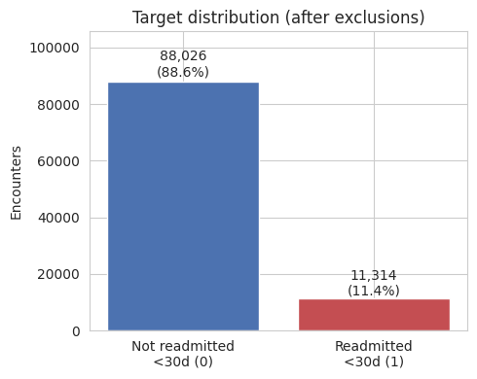
Target distribution
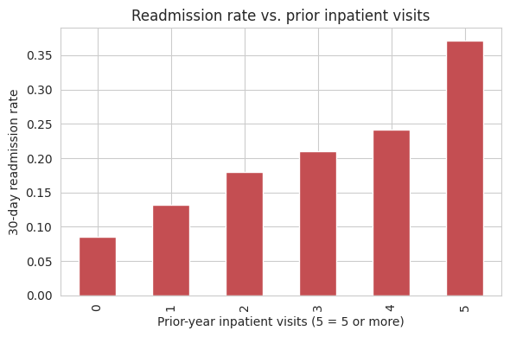
Readmission rate by prior-year inpatient visits
Descriptive statistics (mean / median / max): stay 4.38 / 4 / 14 days; medications 15.98 / 15 / 81; prior inpatient visits 0.63 / 0 / 21. Visit counts are strongly right-skewed. Summary: the most informative variables are prior-year utilisation, then discharge disposition and stay length; keep in mind imbalance, leakage risk (patient-grouped split) and a modest overall signal.

8. Baseline model
Logistic Regression, class-weighted, with the shared preprocessing. It suits a binary outcome with many one-hot features, trains in about 22 seconds, and is interpretable; its limit is that it cannot capture interactions automatically. Trivial reference: always predicting “no readmission” gives 88.4% accuracy but finds no readmissions (recall 0.0, ROC-AUC 0.50).
Model (validation, threshold 0.5) | Accuracy | ROC-AUC | PR-AUC | Recall | Precision | F1
Always “no readmission” | 0.8844 | 0.5000 | 0.1156 | 0.0000 | 0.0000 | 0.0000
Logistic Regression (baseline) | 0.6699 | 0.6673 | 0.2228 | 0.5471 | 0.1854 | 0.2770
The baseline is clearly above chance and finds a bit over half of readmissions, but most of its flags are false alarms (precision 0.19), the usual price of a rare outcome.

9. Model improvement
Candidates (same split, same metrics, validation set):
Model | Val ROC-AUC | Val PR-AUC | Recall | Precision | F1 | Train ROC-AUC | Train–val gap
Logistic Regression (baseline) | 0.6673 | 0.2228 | 0.5471 | 0.1854 | 0.2770 | 0.6744 | 0.0072
Random Forest (200 trees, depth 10) | 0.6643 | 0.2102 | 0.5221 | 0.1868 | 0.2752 | 0.7484 | 0.0840
HistGradientBoosting (tuned) | 0.6673 | 0.2270 | 0.5501 | 0.1806 | 0.2719 | 0.7240 | 0.0567
XGBoost (fixed settings) | 0.6739 | 0.2332 | 0.5675 | 0.1868 | 0.2811 | 0.7205 | 0.0466
LightGBM (fixed settings) | 0.6743 | 0.2378 | 0.5262 | 0.1944 | 0.2839 | 0.8036 | 0.1292
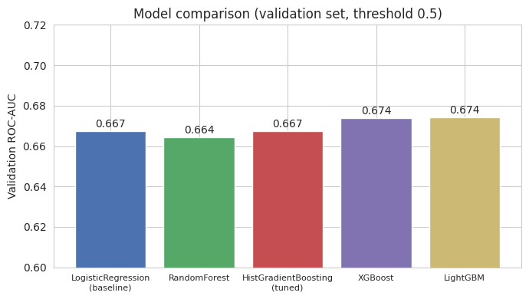
Validation ROC-AUC of the five candidates
Tuning log (HistGradientBoosting, 6 random configurations × 3 patient-grouped folds, ROC-AUC): min_samples_leaf 20 → 50, learning_rate unchanged at 0.1, l2_regularization 0.0 → 1.0, max_leaf_nodes 31 and max_depth None unchanged; class_weight None → balanced; max_iter 100 → 150 (fixed, not tuned). Best CV ROC-AUC 0.6661. The search is small because of runtime limits; a larger search was not tried. XGBoost and LightGBM were not tuned (fixed 300 trees, learning rate 0.05, subsample 0.8).
Imbalance: class weighting inside every model (no resampling), applied to training data only.
Experiments that did not help: Random Forest scored below the baseline; tuned HistGradientBoosting only tied it (0.6673); absolute risk-tier cut points (0.10/0.30) chosen before seeing scores were meaningless because class weighting inflates scores and were replaced by validation percentiles.
Changes from Module 4: (1) HistGradientBoosting was added as a third boosted-tree candidate and is the only boosted model that was tuned (6 random configurations, limited by runtime); XGBoost and LightGBM, which Module 4 named as the planned boosted-tree candidates, were run with fixed settings, so the planned hyperparameter tuning was done only in part. (2) The split is patient-grouped (GroupShuffleSplit) but not explicitly stratified; class balance across splits is close (0.1137 / 0.1156 / 0.1131). (3) Expired and hospice discharges were excluded as a leakage safeguard. (4) SHAP was run on the XGBoost candidate, not on the final LightGBM model. (5) The prototype is an in-notebook form; the Streamlit app is an optional extra rather than a hosted web application. An earlier Colab run excluded XGBoost/LightGBM from selection and therefore picked Logistic Regression on a tie; the notebook was changed so all five compete.

10. Final model
LightGBM (class-weighted; 300 trees, learning rate 0.05, 31 leaves, subsample 0.8, column sample 0.8), chosen by the rule “highest validation ROC-AUC”. Honest caveats about this choice:
- LightGBM beat XGBoost by only 0.0004 validation ROC-AUC — a tie in practice.
- LightGBM has the largest overfitting gap (training 0.804 vs validation 0.674); XGBoost’s gap is 0.047. XGBoost was one of Module 4’s two planned boosted-tree candidates and would be a defensible choice. The rule was fixed beforehand and the test set has been evaluated once, so the choice was not changed afterwards.
- Gains over the logistic baseline are small (about 0.007 validation ROC-AUC), and the baseline remains the most interpretable option.
Decision threshold: 0.51, chosen on the validation set as the threshold with the highest precision among those with recall ≥ 0.50 (validation recall 0.5070, precision 0.2012). Risk tiers: Low below 0.42, Medium 0.42–0.60, High from 0.60 — the 50th and 85th percentiles of validation scores (demonstration values, not clinically validated).

11. Evaluation
The untouched test set (14,859 encounters, 10,499 patients with no overlap with training) was evaluated once.
Metric | Result | What it means
ROC-AUC | 0.6856 | A readmitted patient is scored above a non-readmitted one 68.6% of the time: clearly above chance (0.50), far from perfect
PR-AUC | 0.2390 | About twice the no-skill level (0.113)
Recall | 0.5289 | 889 of 1,681 actual readmissions were found; 792 missed
Precision | 0.2014 | Of 4,414 patients flagged, 889 were truly readmitted; most flags are false alarms
F1 | 0.2917 | Modest, because precision is low
Accuracy | 0.7095 | Not informative here (88.7% of cases are negative)
Brier score | 0.2028 | Worse than always predicting the base rate (0.1003)
Confusion matrix: true negatives 9,653, false positives 3,525, false negatives 792, true positives 889.
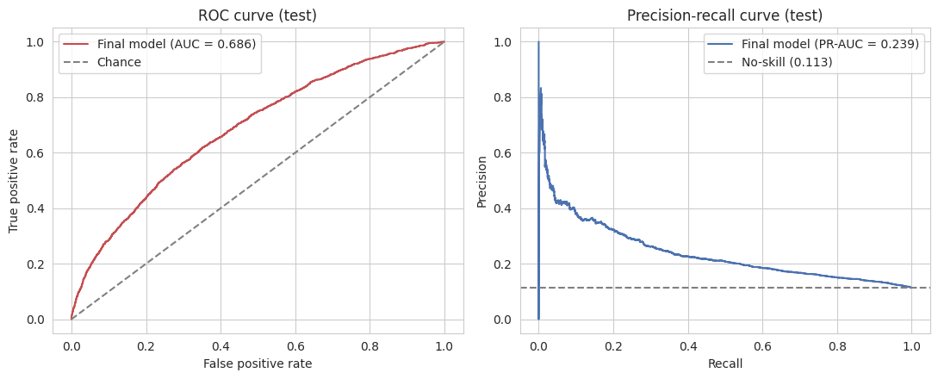
ROC and precision–recall curves (test)
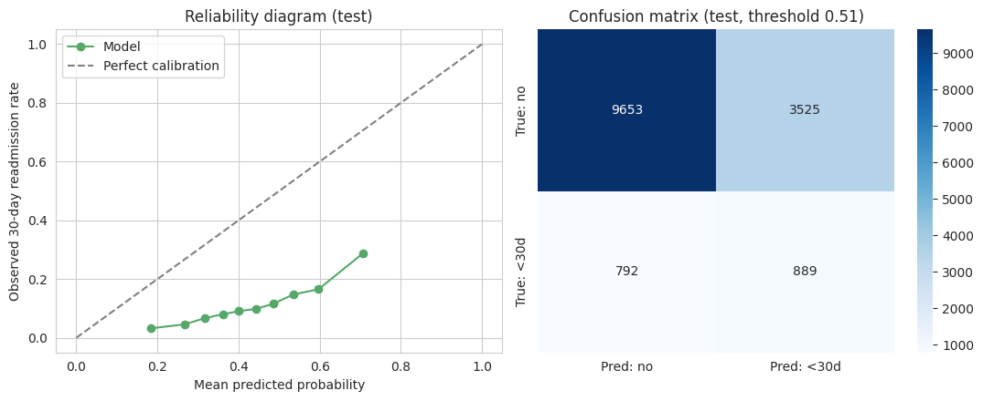
Calibration and confusion matrix (test)
Calibration: the reliability curve lies far below the diagonal (predicted 0.18–0.71, observed 0.03–0.29). Class weighting inflates the scores, so they are useful for ranking patients but must not be read as real probabilities. Recalibration (Platt or isotonic) is the top future-work item.
Success criteria — 5 of 6 met:
Criterion | Target | Actual | Met
ROC-AUC | ≥ 0.68 | 0.6856 | Yes (narrow: +0.006)
Recall | ≥ 0.50 | 0.5289 | Yes
PR-AUC | ≥ 0.20 | 0.2390 | Yes
ROC-AUC gain over logistic regression | ≥ 5% | 1.71% (baseline test ROC-AUC 0.6741) | No
Top-20% risk capture | ≥ 0.40 | 0.4010 | Yes (narrow: +0.001)
Single-prediction latency | ≤ 2 s | 0.0178 s | Yes
Two criteria are met by very thin margins and could flip on a different split. A likely (untested) reason the 5% gain is missed: most usable signal lies in a few near-monotonic effects such as prior inpatient visits, which a linear model already captures.
Error analysis. False positives outnumber false negatives about 4.5 to 1 — the expected result of a recall-first threshold. Of the 792 missed readmissions, 769 (97%) had zero or one prior inpatient visit: the model’s strongest signal says little about a patient’s first high-risk admission. False negatives are most common at ages 70–80 (202), 60–70 (183) and 50–60 (140). False positives mirror the volume (3-day stays 576, 4-day 522; emergency admissions 2,046 of 3,525).
Subgroups (test set, one split, not a fairness audit). Recall by race: African American 0.539, Caucasian 0.527, Hispanic 0.553, Other 0.545, Unknown 0.500, Asian 0.286 (only 7 positive cases). By gender: female 0.554, male 0.500. By age: 0.829 for 20–30 (41 positives), 0.375 for 10–20 (8 positives), 0.42–0.58 for the main adult bands. Small groups give very noisy estimates; no claim of equitable performance is made.
Interpretability. Permutation importance (drop in validation ROC-AUC when a feature is shuffled) ranks number_inpatient first (0.0427), then time_in_hospital (0.0196), discharge disposition 1 = home (0.0186), disposition 22 = rehabilitation facility (0.0124), disposition 6 = home with home health service (0.0063) and number_emergency (0.0060). SHAP on the XGBoost candidate shows the same leaders (prior inpatient visits, discharge to home, number of diagnoses, emergency visits, stay length). These show contribution to prediction, not causal effect — a rehab transfer reflects patient acuity, not a cause of readmission.
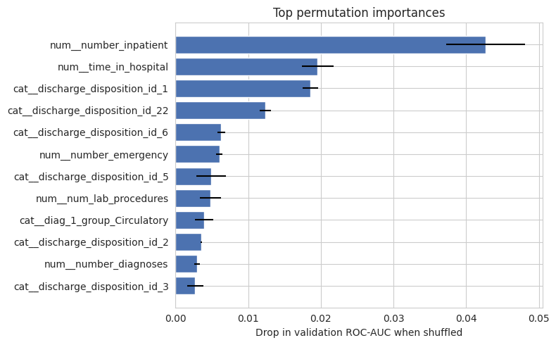
Permutation importance (validation sample)
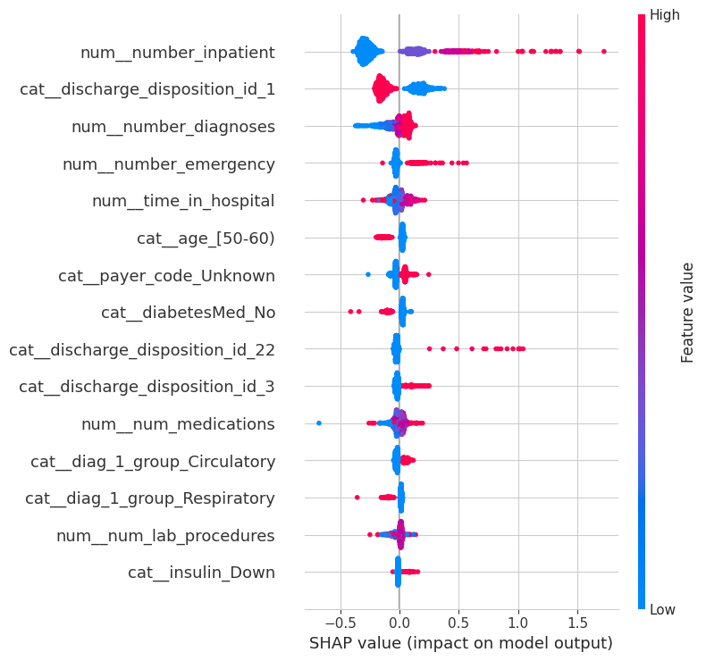
SHAP summary (XGBoost candidate)

12. Testing
The whole chain (input → validation → preprocessing → model → prediction → output) was tested with seven cases through predict_one() on the model saved to disk and reloaded. All seven passed.
Test case | Input | Expected | Actual | Result
Normal, complete | Real test-set row (65th percentile) | Valid score and tier, no warnings | p = 0.4857, Medium, no warnings | Pass
Missing value | number_inpatient omitted | Clear message, no crash | p = 0.4857; “Missing required field: number_inpatient” | Pass
Invalid number | num_medications = “not_a_number” | Handled safely | p = 0.4838; warning that the field must be numeric | Pass
Unexpected category | race = “Martian”, insulin = “Sideways” | Handled with warning | p = 0.4882; two “unexpected category” warnings | Pass
Extreme value | 60-day stay, 300 medications, 90 prior inpatient, 500 labs | Handled and warned | p = 0.8845, High; 4 out-of-range warnings | Pass
Higher-risk case | Real row (95th percentile) | High tier, higher score | p = 0.69, High | Pass
Lower-risk case | Real row (10th percentile) | Low tier, lower score | p = 0.2377, Low | Pass
Ten in-notebook unit tests (ICD-9 grouping, target recoding and exclusions, missing markers, tier boundaries, no identifiers as features, no patient leakage, prediction format, missing/invalid input, out-of-range and unexpected-category warnings, ranking) all passed. An invalid number is accepted with a warning (treated as missing and imputed), not hard-rejected.

13. Working prototype
The prototype is an ipywidgets form in the notebook (Section 8.4): choose a sample case, edit key fields (age band, days in hospital, medications, prior inpatient/emergency visits, diagnoses, insulin, A1C), press Predict, and receive the score, tier, flag and disclaimer. The cell ran without error in Colab. The project zip also contains a Streamlit app (app.py) that loads the same saved final model (models/final_model.joblib, regenerated by the re-run described in Section 14) and the same prediction code as the tests. It was run headlessly with Streamlit’s test runner on the three sample cases and returned the same scores and tiers as the notebook (Section 12); a group member also ran it in a web browser (Streamlit, Python 3.12) and it ran without errors. The notebook saves and downloads the final model (final_model.joblib, model_metadata.json).

14. Limitations and responsible-use notes
- Not a clinical tool. Research/educational prototype; no external or clinical validation; U.S. data from 1999–2008 may not reflect modern hospitals or other countries.
- Modest performance: ROC-AUC 0.69, precision 0.20 — about four of five flags are false alarms; about half of readmissions are missed, mostly first-time high-risk patients.
- Scores are not probabilities (poor calibration); tiers express relative risk only.
- Overfitting and near-ties: the selected model has the largest train–validation gap and beats the runner-up by 0.0004.
- Fairness: subgroup results are noisy; no audit was done. Race is a model input; its use should be reviewed before any real use.
- Associations, not causes: importance and SHAP values do not show that changing a feature would prevent readmission.
- Reproducibility: results depend on library versions. The Colab run used Python 3.13, scikit-learn 1.6.1 and pandas 2.2.3; the XGBoost/LightGBM/SHAP versions were not printed. The notebook was also re-executed from scratch in a separate environment (Python 3.12, scikit-learn 1.6.1, pandas 2.2.3, LightGBM 4.7.0; versions listed in requirements.txt). It selected LightGBM again and reproduced the test metrics, confusion matrix, threshold and tier cut points exactly, and the validation metrics of the other four models; only the logistic baseline’s validation metrics differed, in the fourth decimal (ROC-AUC 0.6670 vs 0.6673). An earlier Colab run could not mount Google Drive (files went to the temporary session folder); in the final Colab re-run Drive mounted and the results were identical.
- Human oversight: every flag must be reviewed by a clinician; the tool must not drive automatic decisions.

15. Future improvements
Recalibrate the scores (Platt/isotonic); tune XGBoost and LightGBM with cross-validation and compare repeated splits to see whether the near-tie holds; add features to help first-time patients; test additional fairness metrics; validate on newer or external data; extend the Streamlit app to the final model; add per-patient SHAP explanations to the interface.

16. Conclusion
The group carried the approved Module 4 idea through the full process: problem, data, exploration, baseline, improvement, evaluation, testing and a working prototype. On a held-out, patient-disjoint test set the final LightGBM model reaches ROC-AUC 0.6856, PR-AUC 0.2390 and recall 0.5289; five of six success criteria are met and the “5% better than logistic regression” criterion is not (gain 1.71%). The result shows a real but moderate predictive signal, useful for ranking patients but not for confident individual prediction, and the limitations above must be kept in view.

17. Team contributions
Participating members, by area, following the responsibility table in the approved Module 4 proposal:
Area | Members
Domain / problem research — problem framing, clinical context, references | Fisehatsion Adisu, Birhan Getachew, Asmelash Abriham, Fasikaw Lakew
Data discovery / preparation — cleaning, encoding, EDA, patient-grouped split | Daniel Asele, Tsegaye Abate
ML/DL development — baseline and candidate models, tuning, evaluation | Fisehatsion Adisu, Addis Misgana
Application implementation — prediction function and prototype interface | Tewoderos Adare
Deployment / testing — test cases and end-to-end workflow testing | Abrham Mekbib, Asmelash Abriham
Documentation / presentation — report, README, discussion posts | Abraham

Group reflection
Reflection on the project and the work:
- What did we learn? That the evaluation set-up matters as much as the model. Many patients have several encounters (23.5% of patients), so a random row split would have leaked patients across the training and test sets; we split by patient. Accuracy is misleading here (always predicting “no readmission” scores 88.4%), so we judged models by ROC-AUC, PR-AUC and recall. A more complex model did not automatically help: the five models were within about 0.01 ROC-AUC of each other, and most of the signal comes from prior inpatient visits, which logistic regression already captures.
- What was the most difficult part? Judging the results honestly. The final model beats the logistic baseline by only 1.71%, two success criteria are met by thin margins, the scores are poorly calibrated, and 97% of the missed readmissions were patients with zero or one prior inpatient visit. Reporting this plainly, rather than presenting the model as a success, was the hardest part.
- What technical problem did we encounter and how did we solve it? Three problems came up when running the notebook in Colab. (1) Google Drive failed to mount in one run, so files went to the temporary session folder; the notebook now retries once and explains the fallback, and a re-run with Drive mounted gave identical results. (2) An early run left XGBoost and LightGBM out of model selection and picked logistic regression on a tie; we changed the notebook so all five models compete. (3) The model-comparison chart failed with a shape mismatch because three bar labels were hard-coded for five models; the labels and colours are now built from the comparison table.
- What would we improve with more time? Recalibrate the scores (Platt or isotonic), tune XGBoost and LightGBM with cross-validation and compare repeated splits to see whether the near-tie holds, add features that help first-time high-risk patients, run a fuller fairness check with larger subgroups, validate on newer or external data, and add per-patient SHAP explanations to the app.
- What did we learn about working as a team? Agreeing early on the scope and the dataset made the later work smoother, and outside review improved the result: feedback on the Module 4 proposal led us to add calibration, a not-clinically-validated disclaimer and more careful wording about the data. Roles are easiest to carry out when each person confirms the area they will work on, and the contribution list should match who actually took part.

References
Chen, T., & Guestrin, C. (2016). XGBoost: A scalable tree boosting system. In Proceedings of the 22nd ACM SIGKDD International Conference on Knowledge Discovery and Data Mining (pp. 785–794). ACM. https://doi.org/10.1145/2939672.2939785
Clore, J., Cios, K., DeShazo, J., & Strack, B. (2014). Diabetes 130-US hospitals for years 1999–2008 [Data set]. UCI Machine Learning Repository. https://doi.org/10.24432/C5230J
Ke, G., Meng, Q., Finley, T., Wang, T., Chen, W., Ma, W., Ye, Q., & Liu, T.-Y. (2017). LightGBM: A highly efficient gradient boosting decision tree. Advances in Neural Information Processing Systems, 30, 3146–3154.
Lundberg, S. M., & Lee, S.-I. (2017). A unified approach to interpreting model predictions. Advances in Neural Information Processing Systems, 30, 4765–4774.
Pedregosa, F., Varoquaux, G., Gramfort, A., Michel, V., Thirion, B., Grisel, O., Blondel, M., Prettenhofer, P., Weiss, R., Dubourg, V., Vanderplas, J., Passos, A., Cournapeau, D., Brucher, M., Perrot, M., & Duchesnay, É. (2011). Scikit-learn: Machine learning in Python. Journal of Machine Learning Research, 12, 2825–2830.
Strack, B., DeShazo, J. P., Gennings, C., Olmo, J. L., Ventura, S., Cios, K. J., & Clore, J. N. (2014). Impact of HbA1c measurement on hospital readmission rates: Analysis of 70,000 clinical database patient records. BioMed Research International, 2014, Article 781670. https://doi.org/10.1155/2014/781670

