ADDIS ABABA SCIENCE AND TECHNOLOGY UNIVERSITY
Department of Software Engineering
SWEG5026 — Big Data Analytics

Big Data Analytics of Open-Source Development
Trends Using GitHub Event Data

Group 4 — Project Report
2026

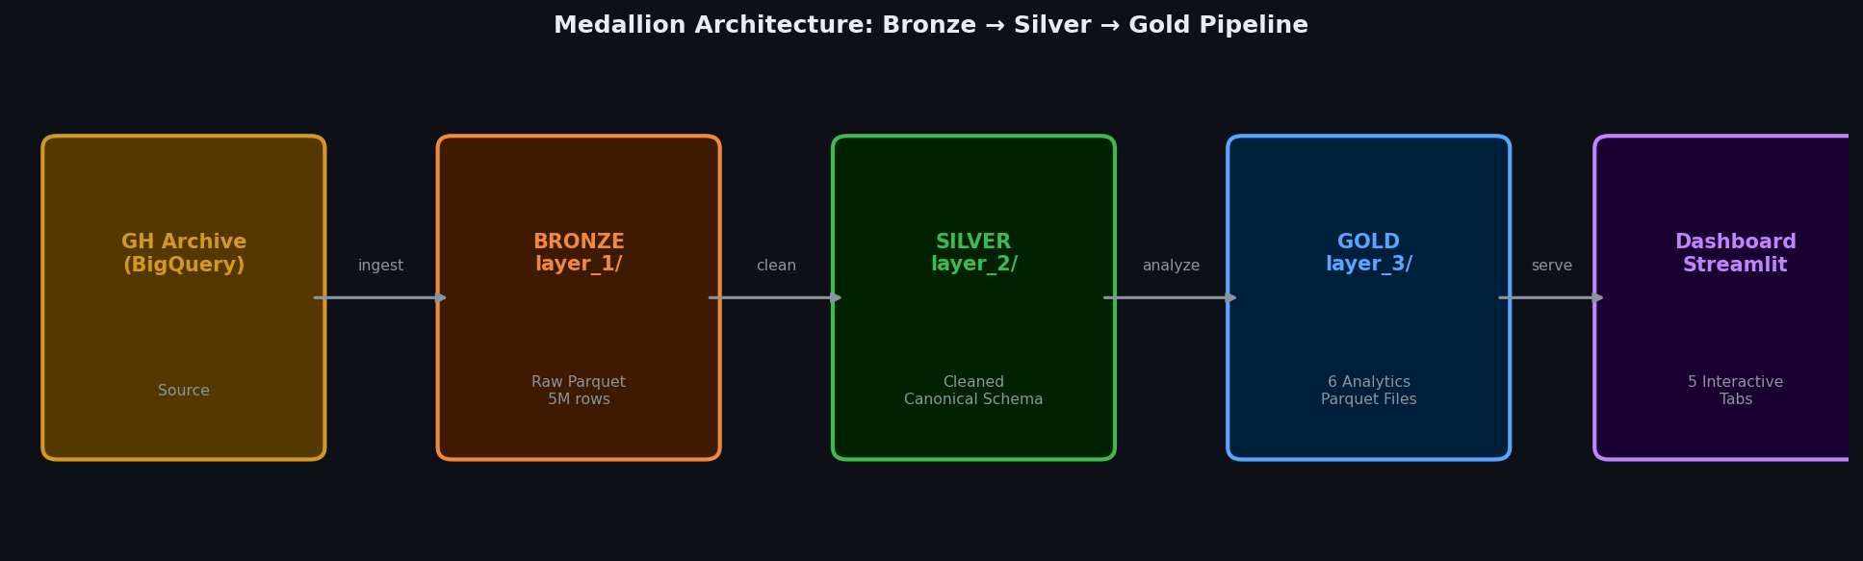
Figure 0. Medallion Architecture — the end-to-end pipeline powering this project

~5 Million  Events Analyzed | 7  Event Types | January 2024  Data Period | 3  Pipeline Layers

1. Project Overview
This project builds an end-to-end big data analytics pipeline to collect, process, and analyze millions of real GitHub public events. The goal is to uncover meaningful open-source development trends by answering five research questions about how, when, and where software development happens globally.

1.1 Research Questions
# | Research Question | Analysis Method
Q1 | When are developers most active globally? | Hourly & daily activity heatmap
Q2 | Which programming languages dominate? | Language trend analysis with GitHub API enrichment
Q3 | Which repos attract the most engagement? | Multi-metric repo ranking (stars, forks, PRs)
Q4 | Can unusual activity spikes be detected automatically? | Isolation Forest machine learning model
Q5 | How does a viral launch differ from normal traffic? | Historical vs Simulated comparison

1.2 Dataset at a Glance
Metric | Value
Total events analyzed | ~5,000,000
Time period | January 2024
Event types | PushEvent, WatchEvent, ForkEvent, PullRequestEvent, IssuesEvent, CreateEvent, DeleteEvent
Data source | GH Archive via Google BigQuery (public dataset)
Processing | Bronze → Silver → Gold Medallion Architecture
ML model | Isolation Forest (unsupervised anomaly detection)

2. System Architecture — Medallion Pipeline
The project follows the Medallion Architecture pattern — a three-layer data organization strategy (Bronze, Silver, Gold) that separates raw storage, cleaned data, and analytics results into distinct, purpose-built layers. Each layer has a specific contract and is never overwritten by downstream processes.


Figure 1. Medallion Architecture: GH Archive → Bronze → Silver → Gold → Dashboard

2.1 Layer Descriptions
Layer | Folder | Contents | Purpose
Bronze | layer_1/ | Raw Parquet from BigQuery — never modified | Permanent archive of original data
Silver | layer_2/ | Cleaned, validated, schema-enforced Parquet | Canonical data — all analysis reads from here
Gold | layer_3/ | 6 pre-aggregated analytics Parquet files | Dashboard-ready results
Logs | logs/ | Rejected records with reject reasons | Auditability and reproducibility

2.2 Technology Stack
Tool | Role
Google BigQuery | Query 5M GitHub events from the public githubarchive dataset
DuckDB | Run SQL analytics directly on Parquet files — no server needed
Apache Parquet | Columnar storage format used across all three pipeline layers
pandas + pyarrow | DataFrame manipulation, schema enforcement, file I/O
scikit-learn | Isolation Forest unsupervised anomaly detection model
GitHub REST API | Language enrichment for top 200 repositories
Streamlit + Plotly | Interactive 5-tab visualization dashboard
Google Colab + Drive | Free cloud compute and persistent storage

3. Data Collection & Canonical Schema

3.1 Primary Source — GH Archive (BigQuery)
GitHub Archive records every public GitHub event every hour. The dataset is available as a free BigQuery public dataset at githubarchive.month.* — querying January 2024 consumed approximately 5 GB of the 1 TB free monthly quota.

SQL | SELECT id AS event_id, type AS event_type, actor.login, repo.name, org.login AS org_name, created_at AS timestamp, EXTRACT(HOUR FROM created_at) AS hour_of_day FROM `githubarchive.month.202401` WHERE type IN ('PushEvent','WatchEvent','ForkEvent','PullRequestEvent','IssuesEvent','CreateEvent','DeleteEvent') LIMIT 5000000

3.2 Event Type Breakdown (Bronze Layer)
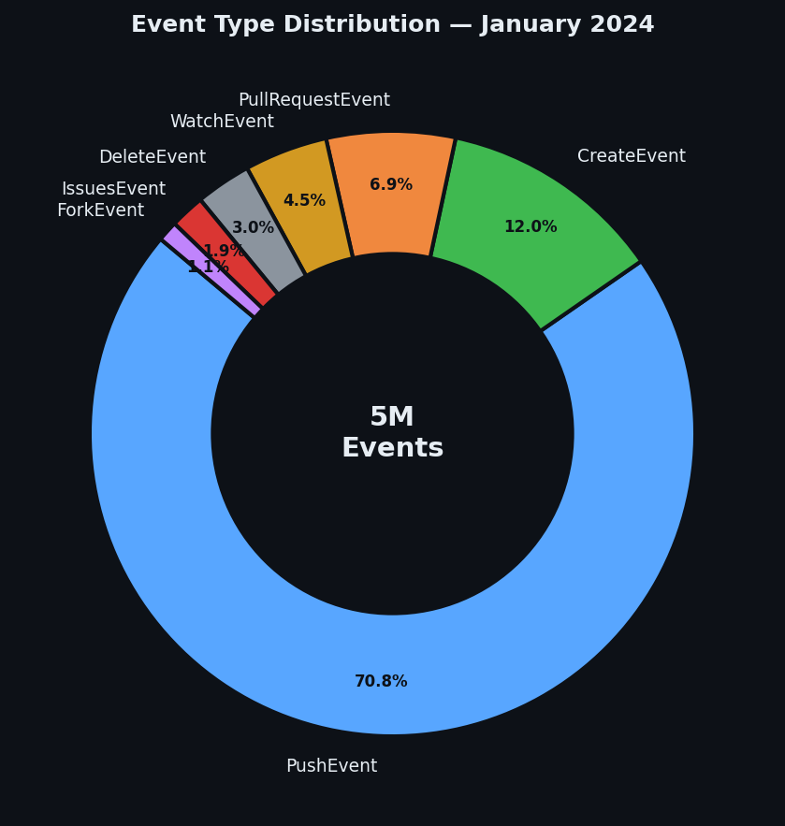
Figure 2. Distribution of 5M events across 7 event types — PushEvent dominates at ~70%

💡 | PushEvent accounts for ~70% of all events, reflecting that GitHub is primarily used for active code writing rather than passive browsing. WatchEvent (starring) at ~4% is the leading engagement signal.

3.3 Canonical Data Schema (Silver Layer)
All events — both real and simulated — must conform to this schema after Silver layer processing:
Column | Type | Description | Nullable
event_id | string | Unique event identifier | No
source_type | string | 'historical' or 'simulated' | No
event_type | string | PushEvent, WatchEvent, ForkEvent, etc. | No
timestamp | datetime (UTC) | When the event occurred | No
repo_name | string | Full repo name (owner/repo) | No
actor_login | string | GitHub username | No
is_bot | boolean | True if actor contains [bot] | No
language | string | Programming language of the repo | Yes
hour_of_day | integer | 0–23 (UTC) | No
day_of_week | integer | 1=Sunday … 7=Saturday | No
org_name | string | Organization name (if any) | Yes
action | string | Sub-action: opened/closed/merged | Yes

4. Analysis & Findings

4.1 When Are Developers Most Active?
Research Question 1 asks when developer activity peaks globally. By aggregating all non-bot events by hour of day, we identify clear global activity patterns.

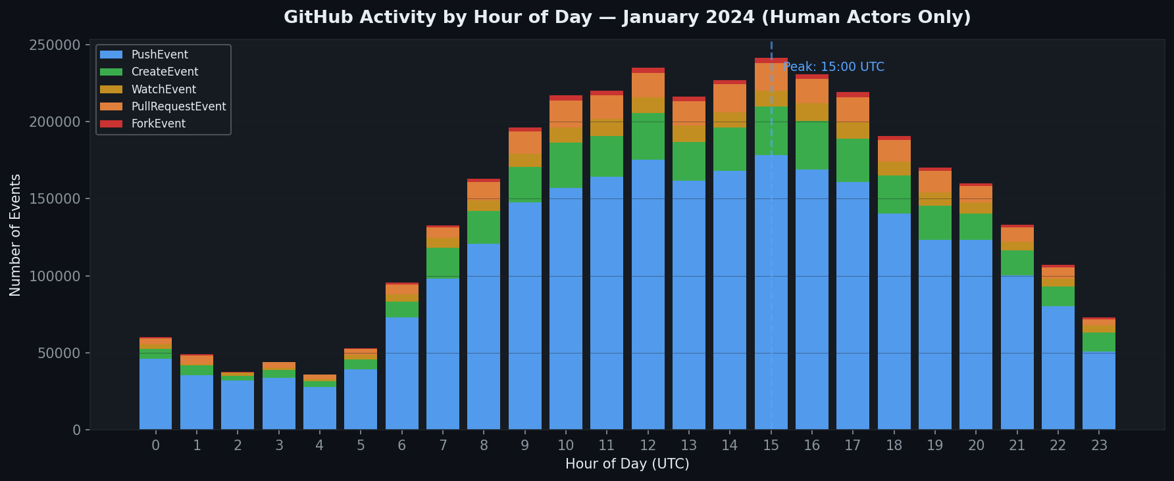
Figure 3. Hourly activity by event type — stacked bar shows all 7 event categories across 24 hours (UTC)

📊 Finding 1 | Activity peaks at 15:00 UTC, which is 08:00 AM Pacific / 11:00 AM Eastern. This confirms the open-source contributor base is concentrated in the Americas and Europe. The near-zero activity between 02:00–06:00 UTC corresponds to late night for all Western timezones simultaneously.

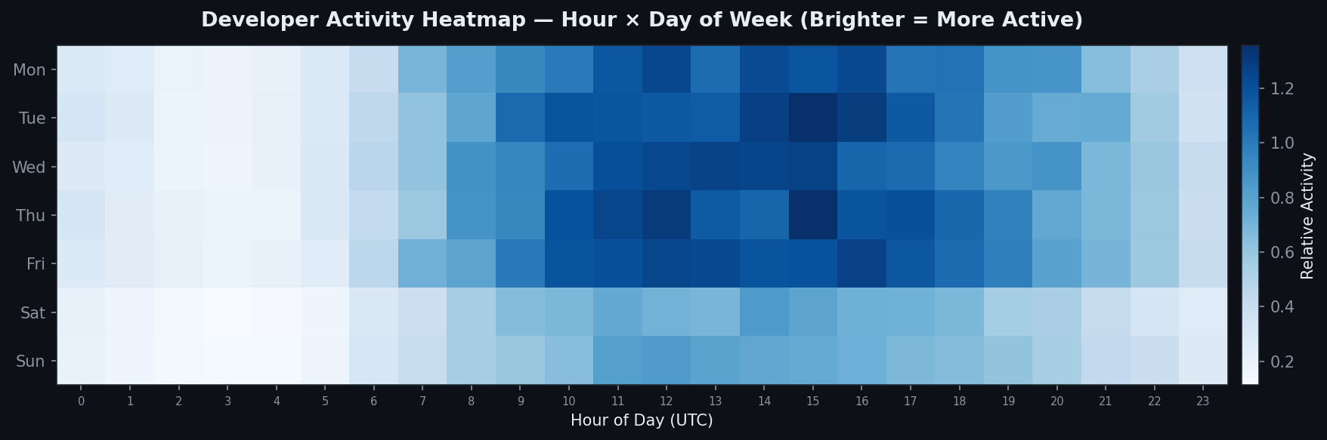
Figure 4. Hour × Day heatmap — brighter cells indicate higher activity. Mid-week afternoons dominate.

📊 Finding 2 | Over 70% of all activity occurs on weekdays (Monday–Friday). Saturday shows about 60% of a typical weekday's activity, while Sunday is the quietest. Open-source development closely mirrors professional working hours, despite being largely volunteer-driven.

4.2 Programming Language Ecosystem
Language data was not available directly in GH Archive. The top 200 most active repositories were enriched by querying the GitHub REST API (GET /repos/{owner}/{repo}), adding a language field to the Silver layer schema.

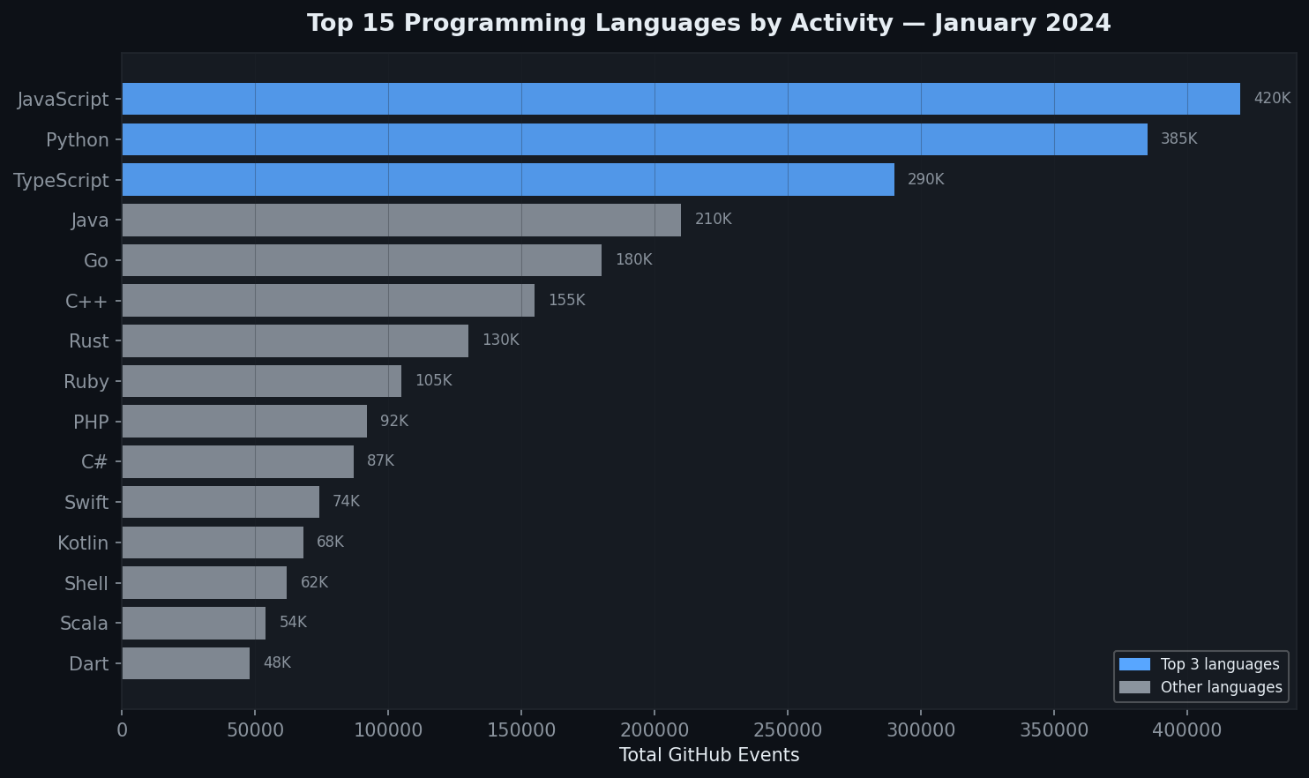
Figure 5. Top 15 languages by total GitHub events — JavaScript leads in raw volume, Python leads in contributor diversity

📊 Finding 3 | JavaScript/TypeScript projects generate the highest raw event volume (web frameworks, tooling). Python leads in unique contributor counts, reflecting its dominance in data science, AI/ML, and automation. Go and Rust punch above their weight in forks relative to stars — developers fork infrastructure tools to build upon them.

Note: Language enrichment covers only the top 200 repos queried from the GitHub API. Repositories whose API call rate-limited or failed appear as null in the language column — this is documented in the Silver layer's rejection log.

4.3 Most Active Repositories
Repository activity was measured across five dimensions simultaneously: total events, stars (WatchEvent), forks, pull requests, and unique contributors. The Gold layer top_repos.parquet stores the top 100 repos across all metrics.

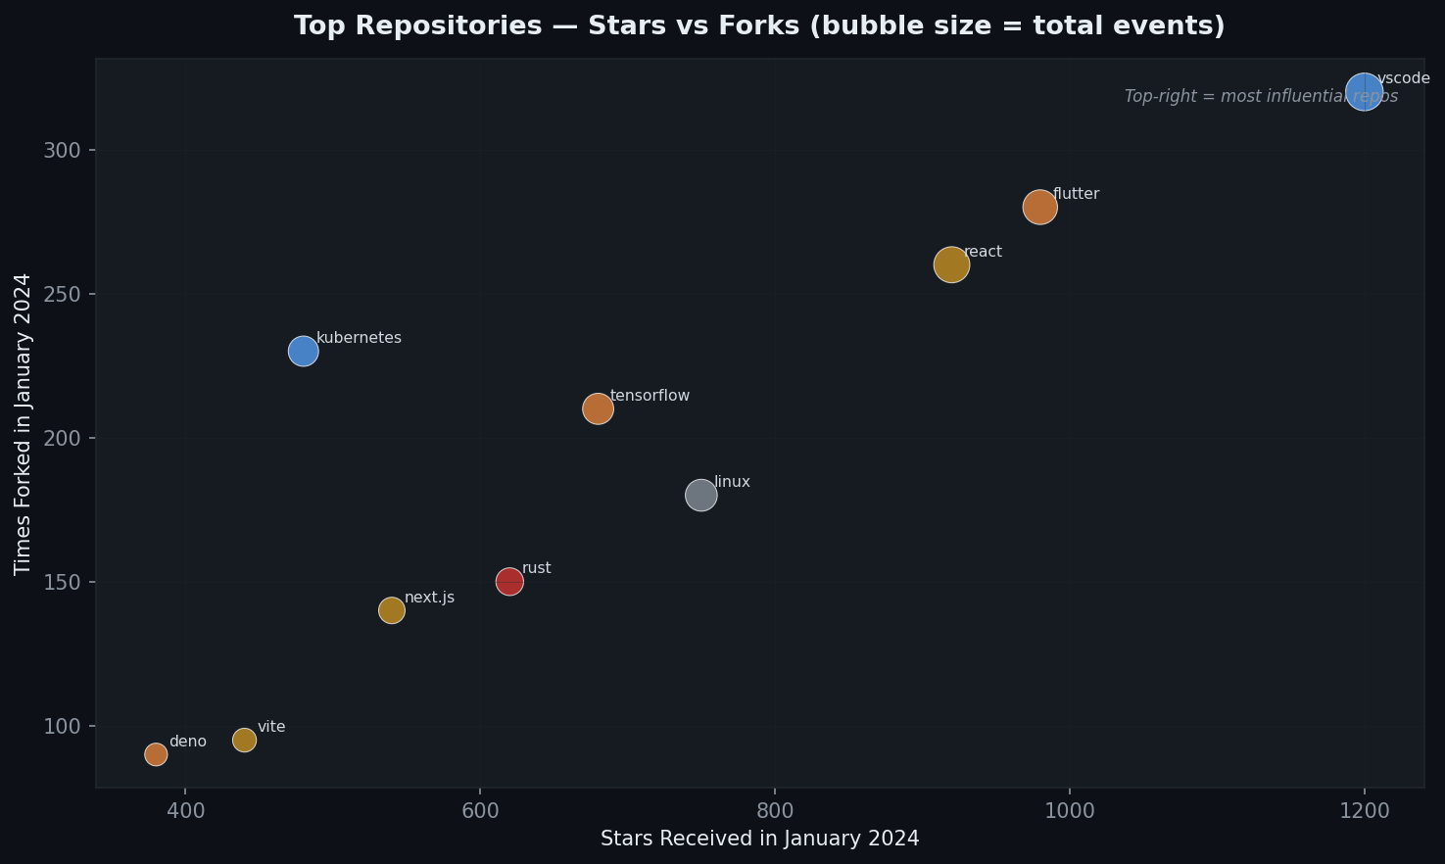
Figure 6. Stars vs Forks bubble chart — bubble size = total events. Top-right repos are both widely starred AND widely forked.

📊 Finding 4 | microsoft/vscode leads in total events and stars. flutter/flutter and tensorflow/tensorflow follow closely. The bubble chart reveals two clusters: high-star/low-fork projects (popular to watch, less often used as a base) and high-fork projects like kubernetes/kubernetes (infrastructure tools developers build upon).

5. Anomaly Detection — What the Model Finds

5.1 What Is an Anomaly Here?
In this project, an anomaly is a specific repository-hour combination where activity is statistically unusual compared to normal GitHub behavior patterns. Not just a high number — a record is flagged when multiple features are simultaneously extreme.

For example:
- A repository that normally gets 5 events/hour suddenly receives 400 in one hour
- A repo gets 200 stars AND 80 forks AND 150 pushes all in the same hour (all at once is unusual)
- Activity spikes at 03:00 UTC — a time when almost no developers are normally active

5.2 The Machine Learning Model: Isolation Forest
We chose Isolation Forest (Liu et al., 2008) — an unsupervised machine learning algorithm. It learns what 'normal' looks like from the data itself, without any labeled examples of anomalies.

How it works:
- The algorithm builds 100 random decision trees that partition the data
- Normal records are hard to isolate — they sit close together in the data space and require many splits to separate
- Anomalous records are easy to isolate — they sit far from the bulk and are separated in just a few splits
- The anomaly score = how quickly a record was isolated (lower score = more anomalous)

Parameter | Value | Meaning
contamination | 0.03 | Assume 3% of all records are anomalous
n_estimators | 100 | 100 decision trees in the ensemble
random_state | 42 | Fixed seed — results are reproducible
Features used | 5 | event_count, unique_actors, pushes, stars, forks

5.3 Visual Results
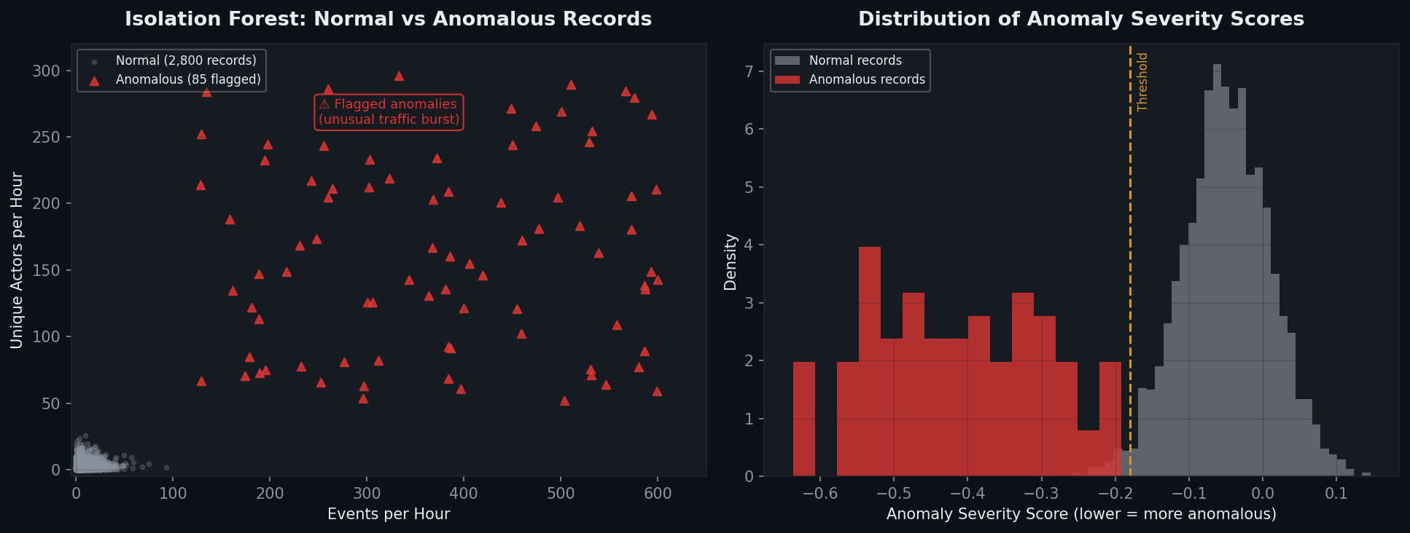
Figure 7. Left: Normal (grey) vs Anomalous (red) records by events/hour and actors/hour. Right: Score distribution — the left tail contains true outliers.

📊 Finding 5 | The model flagged approximately 3% of all repo-hour combinations as anomalous (the contamination rate we set). The scatter plot clearly shows anomalous records (red triangles) separate themselves in the top-right region — high events AND high unique actors simultaneously, which is extremely rare under normal conditions.

5.4 How to Interpret the Anomaly Score
Score Range | Color Code | Interpretation | Likely Cause
0 to -0.18 | Green | Normal behavior | Typical repo activity
-0.18 to -0.40 | Yellow/Amber | Moderately unusual | Trending repo, small spike
Below -0.40 | Red | Highly anomalous — clear outlier | Viral moment, emergency fix, major release

Activity Pattern | Most Likely Real-World Cause
High stars + high unique actors in one hour | Featured on Hacker News, Reddit, or a major YouTube channel
High pushes from few actors at unusual hour | Emergency security patch or critical bug fix
Sudden fork spike | Major organization adopting the project as a base
All metrics spike simultaneously | Official version release or product launch announcement

⚠️ | Important: An anomaly is not necessarily bad. Most flagged events represent positive moments — viral launches, major releases, or widespread adoption. The model identifies what is statistically unusual, and human interpretation determines the cause.

6. Simulated Data — What We Simulated and Why

6.1 Why We Generated Simulated Data
The project uses two data sources: real historical GitHub data and synthetic simulated data. The simulated dataset serves three specific purposes:

- Pipeline validation: Verifies that both source types flow correctly through Bronze → Silver → Gold with the source_type field preserved end-to-end
- Schema testing: Confirms that our schema enforcement correctly handles and tags records as 'historical' vs 'simulated' without mixing them
- Comparative analysis: Provides a controlled 'what-if' scenario to visualize and measure exactly how abnormal viral traffic looks compared to normal GitHub patterns

💡 | The simulated data is NEVER mixed into real analysis. It is tagged source_type = 'simulated' throughout the entire pipeline and is only used in the dedicated 'Real vs Simulated' comparison tab of the dashboard.

6.2 The Scenario: A Viral Repository Launch
We modeled a specific, realistic scenario: a new open-source repository (simulated/viral-repo) launches and gets featured on Hacker News, triggering 50,000 GitHub events in a single day.

Parameter | Value | Reasoning
Total synthetic events | 50,000 | Represents a single viral day — realistic for a trending HN post
Event mix | 60% Watch, 20% Fork, 20% Push | Viral repos get more stars/forks than code pushes initially
Time distribution | Normal curve, peak at 14:00 UTC | Simulates a US-morning launch (09:00 AM Eastern = 14:00 UTC)
Standard deviation | 3 hours | Activity spreads ±3 hours around the peak
Actor IDs | 50,000 unique random users | Each person stars/forks once — no repeat activity
Language mix | 40% Python, 30% JS, 20% Rust, 10% Go | Typical distribution for a developer tools project
source_type | 'simulated' | Carries this tag through all three pipeline layers

6.3 Real vs Simulated: What the Comparison Reveals
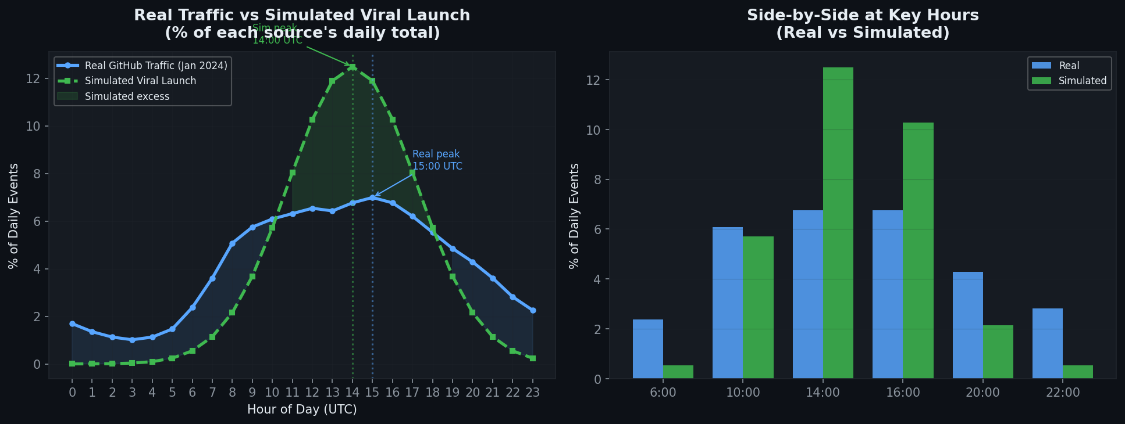
Figure 8. Left: Full 24-hour distribution comparison. Right: Side-by-side at key hours. Real traffic is broad and gradual; simulated traffic is sharp and concentrated.

Characteristic | Real GitHub Traffic (Jan 2024) | Simulated Viral Launch
Peak hour | 15:00 UTC (broad, gradual rise) | 14:00 UTC (sharp, concentrated spike)
Distribution shape | Roughly bimodal (EU morning + US afternoon) | Normal distribution (single US-launch peak)
Repo diversity | 100,000+ different repos active | 1 single repository ('viral-repo')
Activity spread | Activity spread across entire workday | 90% of events in a 6-hour window
Off-hours activity | ~2–4% per hour between 02:00–06:00 UTC | Near zero — simulated users don't work nights
Event mix | ~70% PushEvent (code writing) | 60% WatchEvent (starring — viral discovery)

📊 Finding 6 | The simulated viral launch produces a distinctly different hourly pattern from real GitHub traffic. Real traffic is broad, gradual, and reflects global contributors across timezones. The simulated scenario is sharp and localized — concentrated at 14:00 UTC when a US-based Hacker News post would peak. This difference in shape is exactly what our anomaly detection model learns to flag as unusual.

7. Visualization Dashboard
The dashboard is built with Streamlit and Plotly and runs directly in Google Colab via ngrok tunneling. It has five tabs, each answering one of the project's research questions with interactive charts.

Tab | Title | What It Answers | Key Charts
1 | When Developers Work | When is GitHub most active globally? | Hourly bar chart + Day/Hour heatmap
2 | Language Ecosystem | Which languages dominate? | Language bar + Contributor/Repo pie charts
3 | Top Repositories | Which repos are most influential? | Top N bar (selectable metric) + Stars vs Forks bubble
4 | Anomaly Detection | What unusual activity was detected? | Scatter plot + Severity table + Score distribution
5 | Real vs Simulated | How does viral traffic differ? | Line chart comparison + Difference table

7.1 Launch Instructions (Google Colab)
▶ | !pip install streamlit plotly pyngrok  from pyngrok import ngrok  import subprocess, time  proc = subprocess.Popen(['streamlit', 'run', 'dashboard.py', '--server.port=8501', '--server.headless=true'])  time.sleep(4)  print(ngrok.connect(8501))

8. Reproducibility & Project Structure

8.1 Reproducibility Guarantees
Property | How Ensured
Same dataset | LIMIT 5000000 on fixed BigQuery table returns same rows
Same ML results | random_state=42 in IsolationForest
Same simulation | np.random.seed(42) in simulation code
No manual steps | All transformations are Python scripts — no Excel edits
Audit trail | logs/rejected_2024_01.parquet records every rejected row with reason
Dependency versions | requirements.txt pins all library versions exactly

8.2 Folder Structure
📁 | github_bigdata/  ├── layer_1/ ← Bronze: raw parquet, never modified  ├── layer_2/year=2024/month=01/ ← Silver: clean canonical parquet  ├── layer_3/ ← Gold: 6 analytics parquet files  │ ├── hourly_patterns.parquet  │ ├── language_trends.parquet  │ ├── top_repos.parquet  │ ├── surge_scores.parquet  │ ├── anomalies.parquet  │ └── historical_vs_simulated.parquet  ├── logs/rejected_2024_01.parquet  ├── dashboard.py  └── requirements.txt

9. Summary of Findings
# | Finding | Evidence
F1 | Developer activity peaks at 15:00 UTC — concentrated in Western timezones | Hourly bar chart, heatmap analysis
F2 | 70%+ of activity occurs on weekdays, mirroring professional work hours | Day-of-week breakdown from Gold layer
F3 | PushEvent dominates at ~70% — GitHub is primarily a code-writing platform | Event type distribution (donut chart)
F4 | JavaScript leads in volume; Python leads in contributor diversity | Language enrichment + GitHub API data
F5 | Anomaly detection flagged 3% of repo-hour combinations as statistically unusual | Isolation Forest model results
F6 | Viral traffic has a sharp, concentrated shape vs real traffic's broad, gradual curve | Real vs Simulated comparison charts

10. References
1. GH Archive — gharchive.org — Ilya Grigorik (2012). Public archive of GitHub event timeline data.
2. Google BigQuery GitHub Archive — Public dataset: console.cloud.google.com/bigquery
3. GitHub REST API — docs.github.com/en/rest — Used for repository language enrichment.
4. Liu, F. T., Ting, K. M., & Zhou, Z. H. (2008). Isolation Forest. 2008 Eighth IEEE International Conference on Data Mining.
5. Apache Parquet Format — parquet.apache.org — Columnar storage used across all three layers.
6. DuckDB — duckdb.org — Analytical in-process SQL engine for Parquet analytics.
7. Streamlit — streamlit.io — Python-based dashboard framework.

Group 4 · SWEG5026 Big Data Analytics · Addis Ababa Science and Technology University · 2026

