May 26, 2021

* Checked if the Simon Says algorithm recognizes joint locations of a person facing backwards
  + It does work! However, the head gets cropped off.

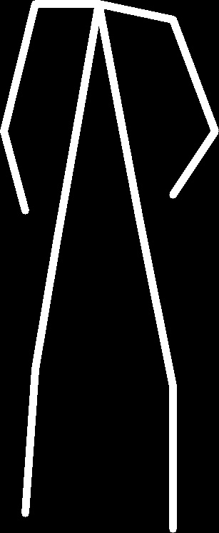

* Check if the algorithm recognizes joint locations of a person standing sideways
  + Um, kinda works…

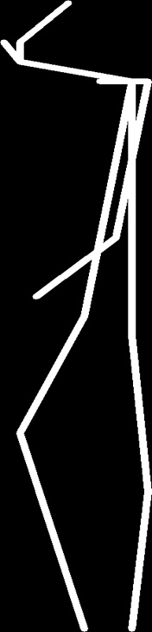

* Check if the algorithm recognizes joint locations of a person sleeping
  + It does not work.

