Part III

Part a

Number of mislabeled points out of a total 30 points : 2

Non-private test accuracy : 93.33333333333333

Part b

Results:

epsilon: 1.0

Number of mislabeled points out of a total 30 points : 9

Differentially private test accuracy : 70.0

Explanation:

Deriving Sensitivity

In the case of numeric attributes, the probability P (X = x′ | c ) depends on the mean μj and standard deviation σj, where the mean μj and variance σ2j are calculated for class j based on the values of attribute X from the training set. Therefore, we need to derive the sensitivity for both the mean and standard deviation.

Algorithm

Now that we have derived how to compute the sensitivity, the actual differentially private Naive Bayes procedure is quite simple. As described earlier, the key idea is to derive the sensitivity for each attribute appropriately. Following this, laplacian noise is added to the parameters. The parameters are then used to classify the test dataset using Naive Bayes.

Part c

To prove epsilon-differential privacy for the algorithm in part b, we need to show that for every pair of input that differ in one row, let's say given D1 and D2, and for every output, the adversary should not be able to distinguish between any D1 and D2, based on any output O.

From class lecture notes, the formula below must be fulfilled in order to ensure epsilon-differential privacy.

log (Pr[A((D1) = O] / Pr[A((D2) = O]) <= epsilon such that epsilon > 0

From part b, we use epsilon = 1 to test on the classifier.

log (Pr[A((D1) = O] / Pr[A((D2) = O]) <= epsilon such that epsilon > 0

0.0953101798043249 <= epsilon

This shows the maximum calculated differential privacy probabilistic between pairs of inputs, which is 0.09531, which is less than epsilon, since epsilon used here is equal to 1. Therefore, this ensures that the algorithm is epsilon-differential private.

Part d

epsilon: 0.5

Number of mislabeled points out of a total 30 points : 18

Differentially private test accuracy : 40.0

Precision: 0.3858363858363858

Recall: 0.39999999999999997

epsilon: 1.0

Number of mislabeled points out of a total 30 points : 9

Differentially private test accuracy : 70.0

Precision: 0.7111111111111111

Recall: 0.7000000000000001

epsilon: 2.0

Number of mislabeled points out of a total 30 points : 7

Differentially private test accuracy : 76.66666666666667

Precision: 0.7859362859362861

Recall: 0.7666666666666666

epsilon: 4.0

Number of mislabeled points out of a total 30 points : 5

Differentially private test accuracy : 83.33333333333334

Precision: 0.8350168350168351

Recall: 0.8333333333333334

epsilon: 8.0

Number of mislabeled points out of a total 30 points : 4

Differentially private test accuracy : 86.66666666666667

Precision: 0.875

Recall: 0.8666666666666667

epsilon: 16.0

Number of mislabeled points out of a total 30 points : 2

Differentially private test accuracy : 93.33333333333333

Precision: 0.9333333333333332

Recall: 0.9333333333333332

Figure below illustrates the graph of differentially private Naive Bayes classification accuracy with different epsilon for part d.

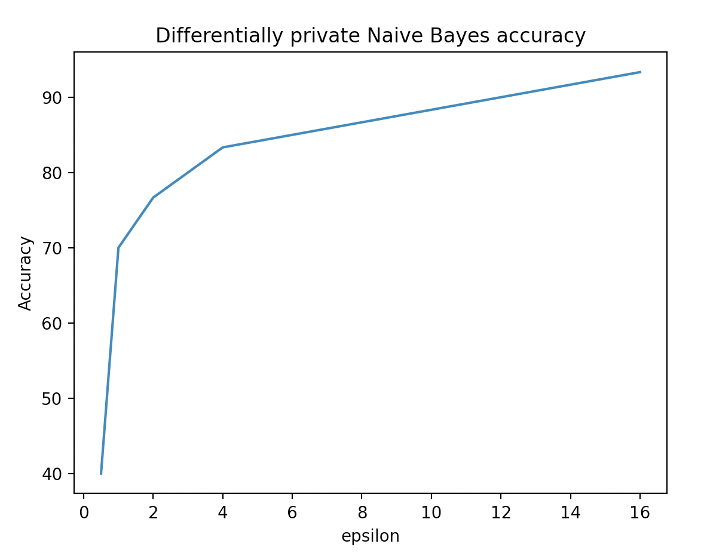

Summary

We can see that the differential privacy works best as the epsilon with value 16 because it is similar to the non-private test accuracy, only having two mislabeled data. As the epsilon gets larger, the better the classifier is able to predict the data. However, as the epsilon increases, the less privacy is preserved and data accuracy gets better. However, if epsilon is small, the more privacy is preserved and data accuracy gets worse.