* load data from csv (add json and geojson?)
* describe, info
* dtypes
* explain differences between df and series
* reset index...
* sort_values
* add column, remove column
* empty df
* rename
* change column type - astype...
* loc, iloc, condition,(only BMW, index 10-20, kmh>4) where
* isnull, isna, fillna, fillnull,
* unique
* duplicates
* merge

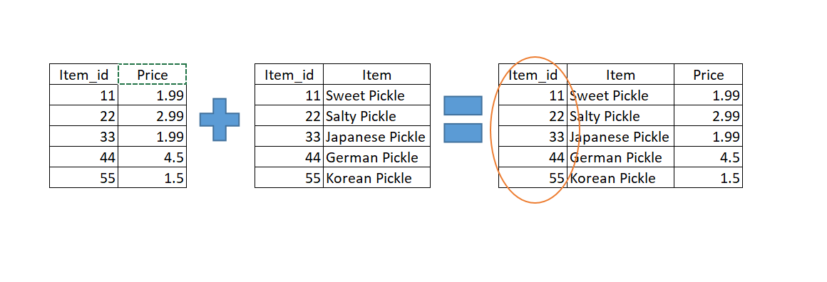

* concat

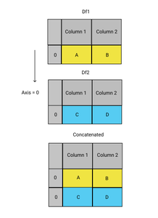

* (run on all df) iterrow, apply (anonymous and not)
* count_values
* show all columns - df.columns
* save to csv/xlsx
* for file in glob.glob("*_clean.csv")
* groupby and agg