

**Envirotech**

*DIY sensors for environmental research*

**Midterm Assignment**

*Report by Gill Tsemach*

*Department of Agroinformatics, The Remote Sensing Laboratory*

*Dr. Elad Levintal May, 2025*

*The Department of Environmental*

*Hydrology & Microbiology​, Levintal Lab*

**Project report:** your report should include the following sections: ~~a short introduction to the system and experimental design (not more than two paragraphs)~~, ~~a bill of materials table with links~~, ~~a photo of the system~~, ~~a connection diagram~~ ~~(using software or hand-sketch)~~, results (we suggest not more than 2-3 figures), a short conclusion paragraph.

**Project Report:**

**Section 1:** Short introduction

Environmental monitoring systems are used widely in academic, governmental and private sectors for various purposes such as; pollution monitoring, weather forecasting and climate-change related research. Each case study requires different measurement intervals, sensor accuracy and resolution, calibration methods, stability, structural durability, etc., according to the specific field. Usually, a sensor system will compose of data logger, sensor or multiple sensors, and a power source – respectively the price of the system will vary according to the components quality and the manufacturing company. The cost of these research grade pre-built systems can be expensive. And thus, the price of these systems can be a limiting factor for their abundance – and therefore, minimizing their application potential in terms of global monitoring and database creation. But in recent years, there is a growth in the use of low-cost open-source hardware DIY sensors for varying scientific research fields, Chan *et al.* (2020), Levintal *et al.* (2022), Nguyen *et al.* (2024) and Riddick *et al.* (2025) are only to name a few.

The purpose of this report is to produce a prototype of research-oriented system for monitoring temperature, relative humidity (RH) and CO2 concentration for a period of time at an arid region, by the use of open-source low-cost hardware. The system will be placed in a room (*Figure 2*), conduct measurements and store them every 10 seconds according to the diagram shown in *Figure 1*, operating on an Arduino code written in *C++* uploaded to the microcontroller. The system components with purchase links are listed in *Table 1*, and the layout is displayed in *Figure 3*. The data, code and supplementary materials can be found on the GitHub repository of this project at: <https://github.com/tsemachg/Envirotech_2025.git>.

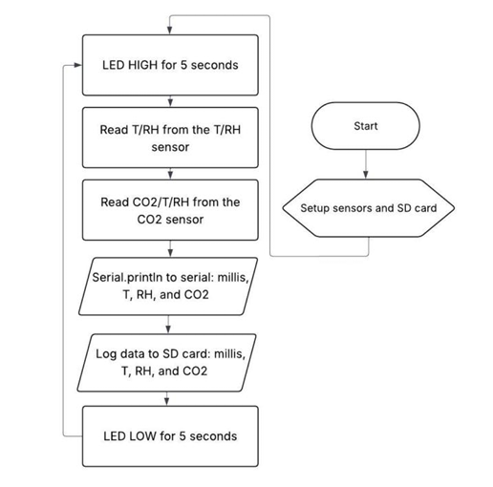

**Figure 1** Flowchart for Arduino code, as given in the assignment's instructions.

**Section 2:** Bill of materials*

**Table 1** Bill of materials

|  |  |  |  |  |
| --- | --- | --- | --- | --- |
| **Component** | **Company** | **Cost** | **Description** | **Link** |
| Uno R3 board | GeekCreit | $ 12 | Arduino-like Uno board | [tindie.com](https://www.tindie.com/products/mmm999/geekcreit-uno-r3-atmega328p-development-board/) |
| USB 2.0 cable A to B | - | $ 3 | For data transfer and supplying power. | [Amazon](https://www.amazon.com/DIYables-Cable-Arduino-Mega-Pieces/dp/B0DLM5JBZ8?source=ps-sl-shoppingads-lpcontext&ref_=fplfs&th=1) |
| Shifting microSD Breakout | SparkFun | $ 6.50 | Allow integration of storage unit, uses 5V. | [Sparkfun](https://www.sparkfun.com/sparkfun-level-shifting-microsd-breakout.html) |
| RTC DS3231 | Adafruit | $ 17.50 | Real-time-clock measures accurate time and capable of measuring temp. | [Adafruit](https://www.adafruit.com/product/3013) |
| SHTC3 | Adafruit | $ 6.95 | Sensor: temp and RH. | [Adafruit](https://www.adafruit.com/product/4636) |
| SCD40 + Stemma QT | Sensirion | $ 44.95 | Sensor: temp, RH and CO2 concentration. | [Adafruit](https://www.adafruit.com/product/5187) |
| Battery for RTC | VARTA | $ 9.70 | CR1220 lithium 3V battery compatible for RTC. | [eBay](https://www.ebay.com/itm/167167933682?_trkparms=amclksrc%3DITM%26aid%3D1110006%26algo%3DHOMESPLICE.SIM%26ao%3D1%26asc%3D285606%2C286222%2C285599%2C286024%26meid%3Dc9500721721a48a88c7c24163bd9673d%26pid%3D101875%26rk%3D4%26rkt%3D4%26sd%3D145311634144%26itm%3D167167933682%26pmt%3D1%26noa%3D0%26pg%3D2332490%26algv%3DSimVIDwebV3WithCPCExpansionEmbeddingSearchQuerySemanticBroadMatchSingularityRecallReplaceKnnV4WithVectorDbNsOptHotPlRecallCIICentroidCoviewCPCAuto%26brand%3DVARTA&_trksid=p2332490.c101875.m1851&itmprp=cksum%3A167167933682c9500721721a48a88c7c24163bd9673d%7Cenc%3AAQAKAAABgG96wQ16jds4VFcrhy1F3d4mbwZUJI9Fs%252BgdXYAHIzlX2e3YaNh7x%252BEnKA3G%252BCqSl1Xn4McfcWFK1GytmS2qxJ87mtE8Gm3iR1Ja4WBwh0hNHJrJx3Ki5mp04ow4CO7lP%252BooCybZDDU%252BbbSwmg7CbTin%252BBzBzbCYVnbjvyQAHu6--HI4MB7SvJl5IJqlyvomgoLMlgT6qAJzX0SANJhty2dJcd4YOd%252BxP7rY6QGtoIFZgHiysA6OsjxFBtO33ENGSd4JegPioNHW246J5iwylQziU7KXifYBLzCUamjc%252Bm%252B%252FDvrvROpncFveT6Rm%252B8QL5L6FP6Jw3a7iBfMeDPuY%252FeBCbHwGjdCNE%252Fq5tjo9DOj7OQlNirxPd57QH%252BHsW1DA1fAHyO3EVnkMRUWnyNnjw0RdYacgA1FuYOYtV9lAX4auOtRVQQ1Hrq6fCZMEhWuYmHW5IVjPFTt10J%252FceY7Y2dWlLVEB04HdVFkbFY%252BswRpg9CTiyqxt0HELX69Fk1X4uQ%253D%253D%7Campid%3APL_CLK%7Cclp%3A2332490&itmmeta=01JVDN2VJNM8Z2AKKBRYKB3JVW) |
| MicroSD card | SanDisk | $ 9.64 | Ultra 32GB micro SD card | [Amazon](https://www.amazon.com/SanDisk-Ultra-microSDHC-Class-SDSDQUA-032G-A11A/dp/B007JTKLEK/ref=asc_df_B007JTKLEK?mcid=68d551c4acfb3a9a82e17b44c5bba246&tag=hyprod-20&linkCode=df0&hvadid=693392565994&hvpos=&hvnetw=g&hvrand=13525153973692378347&hvpone=&hvptwo=&hvqmt=&hvdev=c&hvdvcmdl=&hvlocint=&hvlocphy=9058138&hvtargid=pla-613868574658&psc=1&hvocijid=13525153973692378347-B007JTKLEK-&hvexpln=0) |
| SPL 84 | Leaka | $ 0.75 | Splitter 4-in 8-out. | [Alibaba](https://www.alibaba.com/product-detail/Supplier-SPL84-electrical-4-in-8_1600379482886.html) |
| Jump wires | Various | - | MicroSD – X7 wires  RTC – X4 wires  SHTC3 – X4 wires  SPL84-to-Uno – X4 wires  Total: 19 wires (excluding QT) | - |

*\* All materials and components were supplied by the Envirotech lab.*

*\*\* Prices are correct as of the time of creating the document, and may change with time and depending on the supplier.*

**Section 3:**  Photo of the system

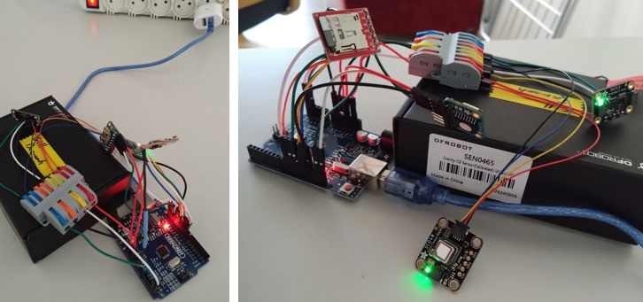

**Figure 2** The low-cost open-source hardware environmental monitoring system. SPL 84 and sensors are placed on a box to keep pressure off the connection points at the microcontroller board.

**Section 4:** Connection diagram

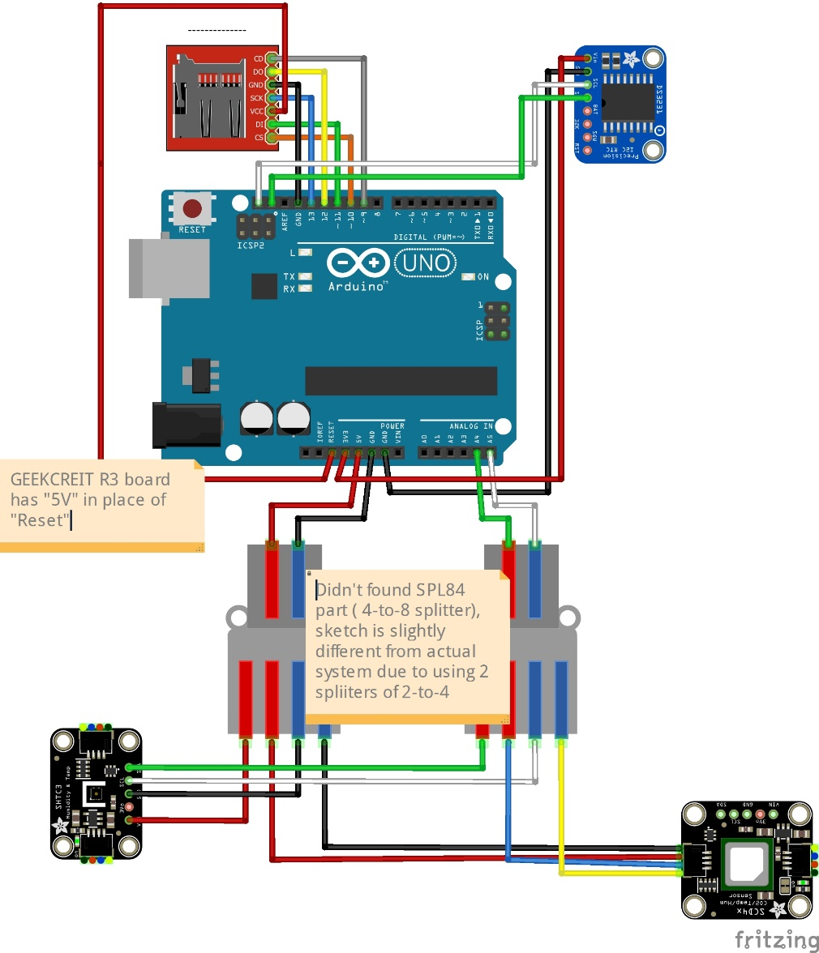

**Figure 3** Connection diagram, made in Fritzing software.

**Section 5:** Results (add captions)

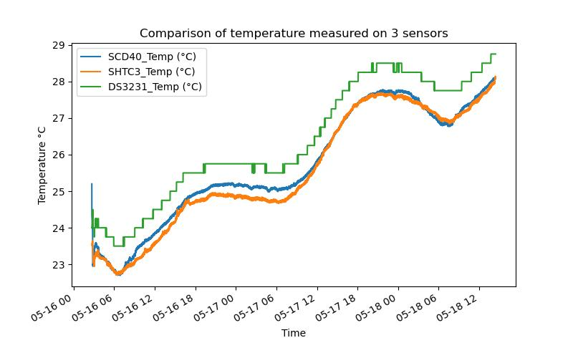

Figure Temp measured by 3 sensors.

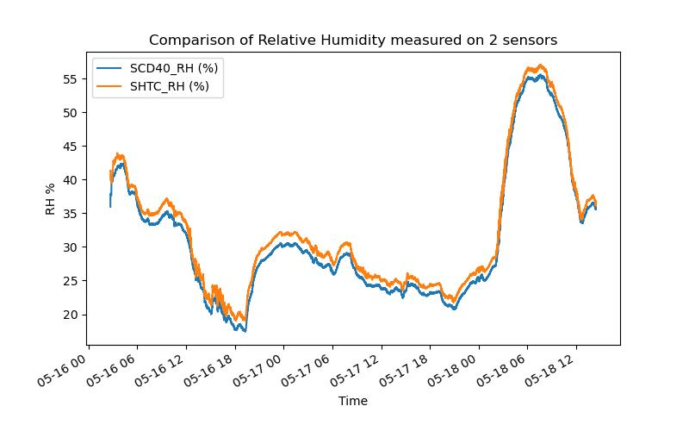

Figure RH measured by 2 sensors.

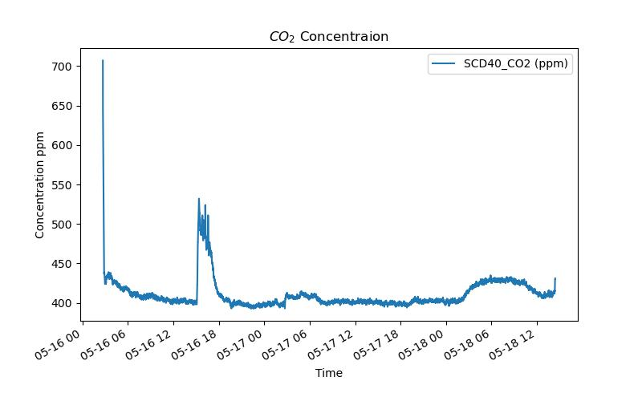

Figure CO2 concentration.

It can be seen that the measured temperature and RH are in accordance with the climate and the region the measures were preformed, considering the system is paced indoors. The RH is low and the fluctuations in temperature are typical, being high during the day and drop night – considering the last hot days. Additionally there was a power drop at 2025-5-16 between 2:42 and 2:48 which caused the sensor to restart. The room was aerated, with windows and backdoor left open (with net) and without presence of people, and as such the CO2 concentration stayed relatively stable.

**Section 6:** Conclusions

This project report aims to show the possibilities embedded in the process of learning “from zero” to implementing – in a relatively short time of half semester – the use of low-cost open-source hardware for environmental applications, while being research and academically oriented. As for the nature of this project having its own limitations being midterm in a course; there is definitely space for making improvements such as better sensor calibration, strict 10 seconds periodic measurements, longer measurement duration (weeks), printed PCB and enclosing box.

**References**

Chan, K., Schillereff, D. N., Baas, A. C., Chadwick, M. A., Main, B., Mulligan, M., O’Shea, F. T., Pearce, R., Smith, T. E., Van Soesbergen, A., Tebbs, E., & Thompson, J. (2020). Low-cost electronic sensors for environmental research: Pitfalls and opportunities. *Progress in Physical Geography Earth and Environment*, *45*(3), 305–338. <https://doi.org/10.1177/0309133320956567>

Levintal, E., Ganot, Y., Taylor, G., Freer-Smith, P., Suvocarev, K., & Dahlke, H. E. (2022). An underground, wireless, open-source, low-cost system for monitoring oxygen, temperature, and soil moisture. *SOIL*, *8*(1), 85–97. <https://doi.org/10.5194/soil-8-85-2022>

Nguyen, T. T., Bekin, N., Altman, A., Maier, M., Agam, N., & Levintal, E. (2024). Overcoming barriers in long-term, continuous monitoring of soil CO2 flux: A low-cost sensor system. *EGUsphere Preprint Repository*. <https://doi.org/10.5194/egusphere-2024-3156>

Riddick, S. N., Riddick, J. C., Kiplimo, E., Rainwater, B., Mbua, M., Cheptonui, F., Laughery, K., Levin, E., & Zimmerle, D. J. (2025). Design, build, and initial testing of a portable methane measurement platform. *Sensors*, *25*(7), 1954. <https://doi.org/10.3390/s25071954>